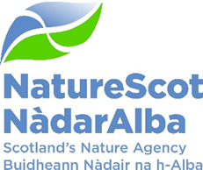

EXCEPTIONAL

Meeting of the Board of NatureScot

03 August 2026
Teams Meeting: Join meeting

AGENDA

13:30
- Opening remarks and apologies Chair
- Declarations of Interest
- Matters Arising

- Determination of Guga Licence Robbie Kernahan

14:30 END

Attendee List

Board Members
Colin Galbraith Chair
Jill Robbie Deputy Chair
Margaret Davidson
Ian Gambles
Jaboury Ghazoul (joining from abroad)
James Harrison
Pete Higgins
David Johnstone
Colin MacPhail
Wayne Powell
Heather Reid
Nikki Yoxall

Senior Leadership Team
Nick Halfhide Chief Executive
Robbie Kernahan Director of Green Economy
Marie Hernandez Deputy Director of Business Service and Transformation
Claudia Rowse Deputy Director of Green Economy
David Maclennan Interim Deputy Director of Nature and Climate Change

NatureScot Staff
Sandy Middleton Chief of Staff
Sara Lewis Governance Support Manager (Minutes)
Katie Gillham Head of Marine Ecosystems (item 4)
Chris Dailly Head of Licensing (item 4)
Cat Synnot Head of Communications (observer)

External

Apologies
Jane Macdonald Director of Business Services and Transformation
Stuart MacQuarrie Interim Deputy Director of Nature and Climate Change
Jason Ormiston Head of External Affairs

