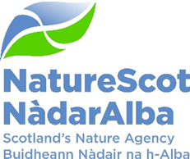

Title: Q4 Performance Report
Date: 14th May 2026

Purpose | Decision
How does this link with our corporate priorities of improving biodiversity or delivering nature-based solutions to climate change: | This paper presents Q4 progress towards delivery of our corporate priorities as laid out in our Business Plan, A Nature-Rich Future for All: Year 4.
Summary: | - The report highlights generally positive performance with challenges noted where appropriate.  - A revised approach to reporting people performance is presented in this report for the first time.  - As this is the last quarterly report of 2025/26 a summary is included in Appendix 5 regarding the year in review summarised by each “Foundation Block”. Again, this presents a generally positive picture.
Recommendations: | Board is asked to:  - review the achievements, challenges and forward look, together with the performance scorecards;  - discuss performance in the quarter and across the financial year against the objectives in the Business Plan for 2025/26; and,  - agree any areas for the executive to alter their approach in delivering the Business Plan for 2026/27.
Report Author(s): | Directors, Deputy Directors, Strategic Resource Managers, FP&P Team, P&OD Team
Sponsor: | Nick Halfhide
List of Appendices | Appendix 1: People Report  Appendix 2: Financial Report – Performance Detail  Appendix 3: Risk and Audit Report  Appendix 4: Detailed Performance Report  Appendix 5: Year in Review

Purpose

- This paper presents our performance for Q4 2025/26. It addresses delivery of our corporate priorities by reviewing performance against our Business Plan, progress towards maximising our available budget, assessing risks for delivery and information on how our people are supporting the resourcing of our work.

- The report also includes an additional section providing highlights from our delivery across the whole of 2025/26.

High Level Performance Summary

People
- Figure 1 shows the high-level overview of our People metrics. Overall, the picture is consistent with previous performance, with the main area of concern being our workforce size and composition, due to our predicted retirement profile. More detailed commentary is in Appendix 1.

Figure 1 – People Scorecard – Q4 2025/26
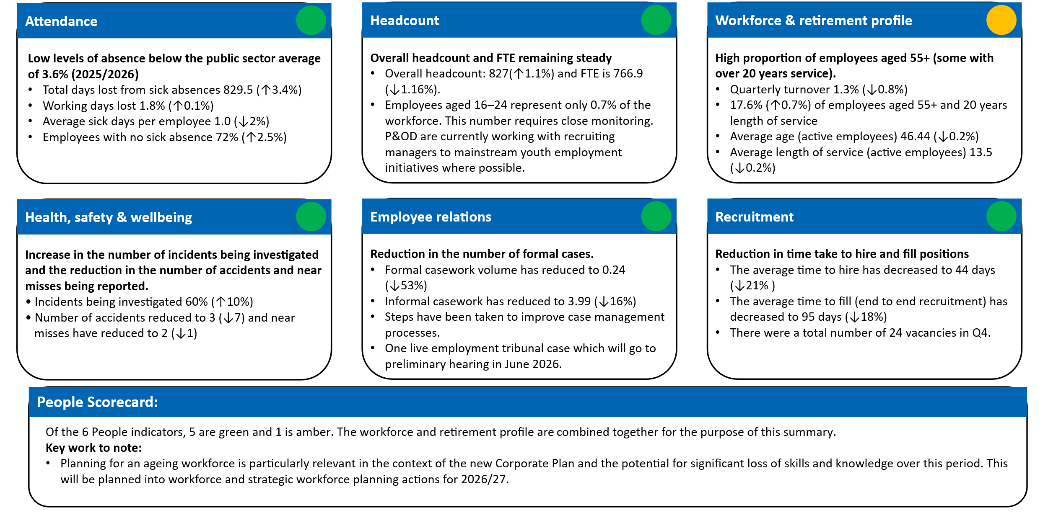

Finance
- Figure 2 shows the Finance metrics as at 16 April (details in Appendix 2). The key points to note are:
- Overall underspend of £1.9m is less than 2% of our budget and without the misunderstanding with SG between cash and non-cash direct capital this would be less than 1%.

- Overall underspend of £1.9m is less than 2% of our budget and without the misunderstanding with SG between cash and non-cash direct capital this would be less than 1%.
- The positive performance on eight out of the ten financial metrics.
- The budget for Peatland is £4.2m for resource and £15.9m for indirect capital (after a hand back of £1m in November), giving a total budget of £20.1m. The current indirect capital forecast is £15.5m, being an underspend of £0.4m. This forecast includes £0.6m paid to Scottish Water for Peatland Action restoration work completed in 2025/26, and a payment to Forestry and Land Scotland of £1.8m. On the resource budget our forecast is £3.6m which is net of the income from SIF giving an underspend of £0.6m. The overall Peatland Action underspend is therefore £1m. The latest position will be updated at the Board.
- There will continue to be movements in the forecast outturn until all final year end processing is concluded.

Figure 2: Finance Scorecard – Q4 2025/26
Metric (£m) | Measure * | Budget | Expected Outturn | Variance | Rating
Resource Budget | Outturn within 1% of final budget | 72.1 | 71.9 | 0.2 | On Track
Direct Capital | Outturn within 5% of final budget | 3.0 | 2.0 | 1.0 | Major Slippage
Indirect Capital | Outturn within 5% of final budget | 24.3 | 23.6 | 0.7 | On Track
Paybill | Outturn within 1% of final budget | 46.0 | 45.9 | 0.1 | On Track
Project Allocation | Outturn within 1% of final budget | 17.3 | 17.3 | 0.0 | On Track
Peatland Action | Outturn within 1% of final budget | 20.1 | 19.1 | 1.0 | On Track
Farming with Nature | Outturn within 1% of final budget | 0.8 | 0.8 | 0.0 | On Track
Nature Restoration Fund | Outturn within 1% of final budget | 11.3 | 11.2 | 0.1 | On Track
FIRNS | Outturn within 1% of final budget | 1.6 | 1.6 | 0.0 | On Track
Rainforest Restoration Fund | Outturn within 1% of final budget | 1.7 | 1.6 | 0.1 | Minor Slippage
Total |  | 99.4 | 97.5 | 1.9
*Resource under 1% - on track, up to 10% minor slippage, over 10% major slippage (** Capital under 5%/up to 10%)

Risk
- Figure 3 provides a high-level summary of corporate risk movement. More detail is in Appendix 3.

- Following ARC and Board horizon scanning workshops, changes have been made to 9 existing risks. Further changes were made to Risk 645: Biodiversity Loss to reflect our role in delivery amongst multiple stakeholders. Two strategic risk themes are under development including a new data and evidence risk and a risk to reflect the shift in our regulatory landscape.

- The impact of 393: Future Funding and Financial Sustainability remains high but work to refresh our Medium to Long Term Financial Plan, develop income generation, and deliver efficiencies reduced the likelihood score and overall risk rating from very high to high. This will be reviewed in the light of policy shifts in the new Scottish Parliament.

- A new risk relating to wildlife management and regulation is being considered which will also capture the growing risk of direct action being taken by campaigning groups.

Figure 3: Corporate Risk Register Summary
Risk Status | 7 Red | 5 Amber | 0 Green
Movement in Risk Rating | 2 | 7 | 3

Delivery

Achievements in the Quarter
- The new Corporate Plan was successfully delivered, with high levels of external and internal engagement ensuring that our people understood the shifts in emphasis and the principles and measures of success.

- We had our largest ever budget settlement this year which looks very close to the outturn forecast being met. There have been specific challenges in certain areas about ensuring spend to profile but the overall position emerging at the end of Q4 is extremely encouraging.

- We established the approach and finalised processes to successfully launch charging for off-shore wind advice from 1 April 2026. This is a major step in progressing our cost recovery and wider income generation ambitions.

- We provided expert input to the Programme Advisory Group (PAG) detailing indicators to underpin assessment of targets in support of the Natural Environment Act.

- Our campaign on urban gulls appears to have had a beneficial impact in terms of public response to the new breeding season.

- Private sector finance has progressed well with the FIRNS round being delivered and the launch of the Nature Finance Exchange which elicited very positive feedback from a wide range of stakeholders.

- We received a credible offer for Kinloch Castle on Rum which is currently being considered.

Challenges in the Quarter
- Peatland delivery experienced major slippage largely due to contractors and agents not delivering on their earlier delivery assurances. We have reviewed these issues carefully and have a robust plan in place to address future slippage.

- There is pressure on the Biodiversity Metric team to ensure delivery of the draft tool in line with SG expectations and the project plan. We have agreed a risk-based approach to progress with consultation and publication of the tool.

- The increasing intensity of animal rights campaigns threatens our operations and raises concerns to staff about their personal safety. This has been particularly demonstrated through the Anti-Guga hunt campaign. We have seen complaints and FOIs remain at much higher than usual levels due to the Guga hunt.
- In light of the considerable expense involved in monitoring and data gathering we are reviewing how we gather data to ensure best value for money and avoid duplication. We recognise there are systemic issues relating to biodiversity monitoring which we are working with partners to tackle.

- There is continuing frustration at the slow pace of progress with the Single Scottish Estate review, and the impact it is having on making plans to rationalise our accommodation requirements in Inverness.

- An analysis of our retirement profile and the recent pattern of retirements highlights an increasing numbers of key staff retiring and leaving experience gaps.

Forward Look
- Work has been undertaken to review party manifestos and to consider various scenarios that follow on from the parliamentary elections. We will look forward to working with the new administration and making the case for nature to new and returning MSPs.

- We will hold quarterly meetings of the Nature30 Assessment Panel working work with staff and partners to create a pipeline of new sites.

- We will support the Scottish Government in the development of targets and monitoring for the Natural Environment Act.

- Addressing “technical debt” is an ongoing, multi-year process as current systems become legacy systems leading to technical obsolescence. A plan for adopting Scottish Government’s shared Amazon Web Services (AWS) platform will be developed.

- Budgetary pressures are increasing. It is likely that we will need to continue to review our resource allocation and efficiency savings across both paybill and projects to ensure that we retain our current balanced budget position, particularly if new demands are placed upon us after the election. There is also the ongoing risk of losing discretionary and charitable relief on business rates on the remaining buildings we have that benefit from this.
- Communications activity will focus on MSP engagement, along with our public facing campaigns Make Space for Nature, SOAC and a new campaign focusing on young people.

Operational Delivery Scorecard
- Figure 4 shows the RAG status of delivery plans and their alignment with the 4 foundation blocks and internal transformation. Key highlights for the quarter are noted, and further details are provided in Appendix 4.
Figure 4: Operational Delivery Scorecard
 | 1 | 2 | 3 | 4 | 5
 | Drive nature positive change | Achieve30x30 | Increase P&PS investment | Land & wildlife management | Transformation
30x30 |  | Finalised arrangements for Nature30 Panel and recognition process
Manage deer  & wildlife |  |  |  | Good progress on gulls, licensing developments and preparing for new deer powers
Planning &reg. |  |  | Slippage in biodiversity metric timescale and continued pressure on casework team
Marine trans. | Seabird conservation action plan team in place |  | Offshore wind cost recovery process rolled out
Peatland | On track to deliver just over 10,000ha of peatland, short of our stretch target to deliver 12,000ha
Transform Ag. | Over 1000 farmers and crofters engaged in Farm BioScot tool
Private sector inv. |  |  | Launch of Nature Finance Exchange at stakeholder event
Natural capital | Completed write up for Ecosystem Restoration Code Competent Mode'
NWW |  |  |  |  | Corp Plan launch

Figure 5 Longer Term Delivery Assessment
 | 1 | 2 | 3 | 4 | 5
 | Drive nature positive change | Achieve  30x30 | Increase P&PS investment | Land & wildlife management | Transformation
30x30 | - | AMBER | - | - | -
Manage deer  & wildlife | - | - | - | AMBER | -
Planning &reg. | - | - | AMBER | - | -
Marine trans. | GREEN | - | GREEN | - | -
Peatland | AMBER | - |  | - | -
Transform Ag. | AMBER | - |  | - | -
Private sector inv. | - | - | AMBER | - | -
Natural capital | AMBER | - | - | - | -
NWW | - | - | - | - | AMBER

Context for RAG ratings:
- 30x30 –we are at the early stages and will learn from experience. The rating may be escalated to red if things don’t move forward at the pace necessary, due to lack of incentives or buy in from land managers. The finalisation of arrangements for the Nature30 Panel has been a significant step forward.
- Marine – planned delivery for the next 2 years is on track, but a lot of activity is led by Marine Directorate, with our support, so there can be slippage outwith our control.
- Deer and WM – Change from red to amber due to greater clarity coming from the Natural Environment Act on the new policy and powers for us to intervene. Positive engagement over gull management measures. The rating remains amber recognising the challenge of the overall resource implications required to reduce deer numbers, and to manage stakeholder expectations across a range of species management issues.
- Private sector investment – Change from red to amber. We made good progress in Q4 with the launch of the Ecosystem Restoration Code (ERC) and Nature Exchange. Positive stakeholder engagement in both these mechanisms. The rating remains amber given future uncertainty over market confidence in the private investment sector.
- Peatland – change from green to amber - the outlook on meeting ambitions in the Climate Change Plan to deliver a 10% increase year on year by 2030 remains challenging.

Appendix 1 - People Report

Headcount
- Total headcount and FTE remain steady (Fig. 1a), indicating a stable workforce position. We continue to monitor variations in workforce data to ensure stability is maintained.

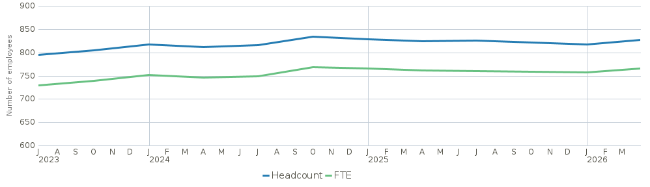
Figure 1a: change in organisational headcount (blue line) and FTE (green line) per quarter over the past 3 years.

- The workforce is 62% female, but women remain under-represented in older age groups and at senior grades. The gender pay gap was 7.3% in January 2026, a reduction of 0.2% since April 2023. This improvement is linked to initiatives including the Women into Leadership programme, targeted support through the Women’s Network, and increased flexible working. Progress is positive and will be reviewed in Q4 2026/27.

- Employees aged 16–24 represent only 0.7% of the workforce. This number requires close monitoring. P&OD are currently exploring targeted youth employment initiatives.

- Ethnicity data remains limited, with only 50% of employees having recorded their ethnicity in Fusion. Further work is planned for Q1 2026/27 to encourage employees to update their records and improve data completeness.

- Fixed-term appointments (FTA) have remained steady due to the FTA review, supporting greater workforce stability.

Employee Turnover
- Turnover remains stable and within target, driven by a rise in new starts (+40% vs Q3) and a reduction in leavers (-55% vs Q3).
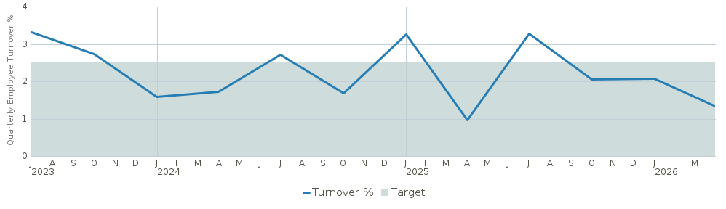
Figure 2a: change in organisational turnover per quarter, over the past 3 years. The green area is the target zone and is based on best practice guidelines.

- All leavers in Q4 were voluntary, with over half citing personal reasons.

- Eight leavers (73%) completed exit questionnaires in Q4. The average recommendation score was 6.9/10. Those leaving for personal or professional reasons reported feeling unsupported by the organisation, and only 25% of all leavers felt they had the resources and support needed to perform their roles. However, most leavers reported a positive relationship with their line manager.

- Analytics of historic data and monitoring of upcoming quarters will confirm whether these patterns are a one-off fluctuation or an emerging trend. This will be used to inform retention strategies by Q4 2026/27.

Retirement Profiling
- The proportion of employees aged 55+ with over 20 years’ service continues to exceed the target range (Fig. 3a). This indicates an increased likelihood of retirements, with associated risks to knowledge, capability, leadership and specialist skills gaps. This is being addressed in a structured manner, taking a holistic cross-organisational approach, as we take forward our Strategic Workforce Planning (SWP) project for 2026/27.

- Female employees account for a higher proportion of retirements, further impacting on our ability to remain balanced in terms of equality.

- The average retirement age is higher for women (63) than men (60.5), though both are below the State Pension age of 66. Men have slightly longer average length of service at retirement (24.5 years vs 23 years for women).

- Differences in retirement patterns may reflect pension accumulation and workforce composition. This will be considered in workforce and succession planning as part of the SWP project.

- We’ve continued to support colleagues impacted by the pension administration transition from MyCSP to Capita.

Figure 3a: change in percentage of all employees at NatureScot who are older than 55 years (blue line), have a length of service (LOS) over 20 years (green line), or who meet both these criteria (yellow line). The green target area is for 55+ years and 20+ LOS and is based on best practice guidelines)

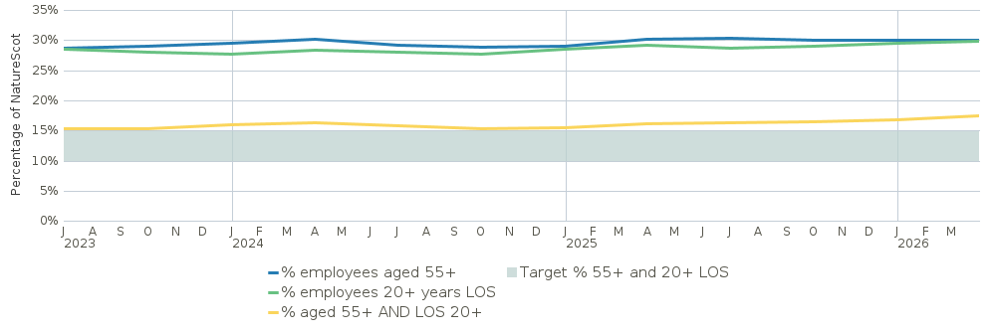

Recruitment
- Time to hire (candidate application to offer accepted) is now within target (< 45 days Fig. 4a), reflecting improved recruitment processes through our HR module on Fusion. Time to fill (end to end recruitment process) is decreasing but remains high at 95 days (Fig. 4a). This may lead to delays in onboarding and workforce capacity gaps. Fusion processes are being developed to reduce this process to within 60 days.
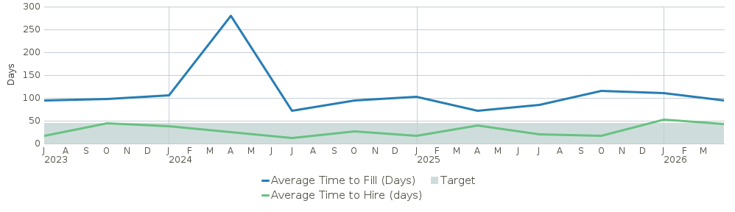
Figure 4a: change in average time to fill and hire to a position per quarter, over the past 3 years. The green target zone is for time to hire (green line) and is based on best practice guidelines.

Attendance
- Working time lost due to sickness absences is within recommended levels (shaded area in Fig. 5a).

- Long-term absences are primarily driven by work-related stress, consistent with UK trends. We are tackling this by continuing proactive interventions (e.g. HSE Workplace Stress Survey and associated action plan).
Figure 5a: change in the percentage of working time lost from sickness absences per quarter over the past 3 years
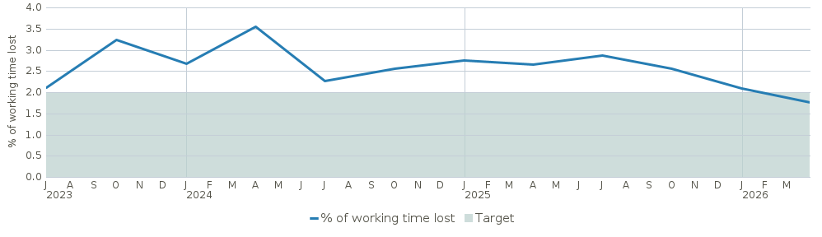

- For short term absences, cold, cough, and flu are the most common reason, which aligns with seasonal trends across Scotland.

- Females tend to have a higher number of sick days which is commonly observed across UK workforce data.

- Absence rates are broadly consistent across grades and age groups. Our continued tracking will help identify emerging risks early in specific groups.

Employee Relations
- Formal case volumes remain steady and within recommended levels, indicating no immediate escalation in high-risk or complex cases.

- Informal case volumes also remain low, with the most cases being opened due to absence issues. This is due to the proactive approach of P&OD to flag absences sooner.

Appendix 2 – Finance Report - Performance Detail

Resource Budget Performance
- An underspend of £0.2m is the expected outturn on the resource budget. This is made up an overspend on Core GIA of £0.2m, an underspend on Programme Funds of £0.5m and an overspend on non-cash depreciation of £0.1m.

- We are reviewing 2025/26, validating, adjusting and reconciling our accounts. This work continues until Q2 when the accounts are finalised and closed. Therefore, the exact final position is not known yet.

- The Farming with Nature budget is £0.8m. Full spend on this programme was achieved.

- The Facility for Investment Ready Nature in Scotland (FIRNS) budget is £1.6m; £1.2m from SG and £0.4m transferred from NRF. We are forecasting £1.6m spend.

- We have received £4.7m of income to date. Our current income budget is £5.9m. We are on track with our anticipated income compared to last year (80% v 85%).

Indirect Capital Performance
- Following the hand-back of £1.2m in Q3, the indirect capital budget is £24.3m. It is made up of £15.9m for Peatland Action, £7.3m for Nature Restoration, £1m for Rainforest Restoration, and £0.1m for SAOS Deer Larders.

- At the end of Q4, we are forecasting an underspend of £0.7m, made up of an underspend of £0.4m from Peatland Action and £0.3m from Nature Restoration.

Peatland Action
- Peatland Action has a resource budget of £4.2m. We have received £0.6m income from Shared Island Initiative. We were forecasting £4.2m before the income and with the income included, this gives us a forecast of £3.6m, an underspend of £0.6m on resource.

- The indirect capital budget is £15.9m after a hand back of £1m in November. The current forecast is £15.5m, being an underspend of £0.4m.

- The combined forecast of £19.1m includes £0.6m paid to Scottish Water for Peatland Action restoration work completed in 2025/26 and a payment to Forestry and Land Scotland (FLS) of £1.8m. We anticipate that the final underspend figure could reduce as final claims are processed.

- Indirect capital spend to date is at 82%. We expect a significant amount more to be claimed before the deadline of 05 May.
- The hectare target is 12,000 and to date we have completed 7,774. We anticipate achieving just over 10,000Ha once final figures are confirmed.

Nature Restoration Fund
- The Nature Restoration Fund (NRF) budget started out at £4.8m resource and £7.5m indirect capital. From resource, £0.4m was transferred to FIRNS, £0.4m reduced at SBR and £0.5m is funding SMEEF projects. From indirect capital, £0.2m was handed back at SBR and £0.9m is funding SMEEF projects.

- The updated budget of £11.2m is split £7.3m indirect capital and £4m resource. The overall current forecast gives an expected spend of £11.2m, splitting between indirect capital of £7.1m and resource £4.1m, an underspend of £0.1m.

- The forecast underspend has narrowed in recent weeks as funding officers have increased confidence in more of the large delivery projects achieving full spend.

- The SMEEF (NRF) programme of £0.9m indirect capital and £0.5m resource are progressing well with an underspend of £32k on indirect capital and £29k on resource. These are included in the forecast figures.

Budget Type | Budget | Forecast | Variance
Indirect Capital – NRF projects | 6,490,000 | 6,249,402 | 240,598
Indirect Capital – SMEEF projects | 850,000 | 818,473 | 31,527
Total – Indirect Capital | 7,340,000 | 7,067,875 | 272,125
Resource – NRF projects | 3,501,000 | 3,692,953 | (191,953)
Resource – SMEEF projects | 500,000 | 470,955 | 29,045
Total – Resource | 4,001,000 | 4,163,908 | (162,908)
Total NRF | 11,341,000 | 11,231,783 | 109,217

Rainforest Restoration Fund
- The Rainforest Restoration Fund (RRF) budget is £1.7m. This is split £0.8m resource and £0.9m indirect capital (after handing back £0.1m at SBR). We are forecasting £0.7m on resource and £0.8m on indirect capital, an overall underspend of £0.2m.

Direct Capital Budget Performance
- We received £1.8m plus £1.1m for direct capital. We understood that the £1.1m additional to our standard £1.8m was for IFRS16 and was therefore non-cash. We did not include the £1.1m on our cash tracker until SG told us in December to add it in after we sought clarity from them. At our December SG liaison meeting we agreed to hand this back but the full £3m is still showing on the Budget Monitoring Report (BMR ) so we are showing an underspend of £1m. SG is aware of this.

- On the current programme of capital projects, we are forecasting £1.8m of the previously presumed budget of £1.8m. This does not include the £0.2m for IFRS16 as it is non-cash.

Paybill
- The current paybill outturn is £45.9m which is £0.1m below the budget of £46m. Included within this are Directorate savings of £1m against a target of £0.9m.

- We are still to include the annual leave and flexi accrual to the outturn. This will be known later this month.

Appendix 3 - Risk and Audit Report

Corporate Risk Review Summary
- There are 12 live Corporate Risks (7 High, 5 Medium).

Corporate Risk Register Refresh
- Following ARC and Board horizon scanning workshops, changes have been made to 9 existing risks, and 1 new corporate risk has been developed. Further changes were made against 645: Biodiversity Loss to reflect our role amongst multiple stakeholders.

- 2 strategic risk themes remain under development including a new data and evidence risk initially presented to SLT in March 2026. The scope of a further corporate risk to reflect the shift in our regulatory landscape has also been agreed and both will be developed in Q1.

Changes to Corporate Risk Register
- Risk 53: Marine Protected Areas was de-escalated as despite delays impacting nature, this risk primarily focuses on stakeholders and their reaction to date does not indicate a collapse in confidence.

- A refreshed 2026 to 2030 Net Zero Plan resulted in the escalation of 808: Meeting 2035 ‘Net Zero’ target as the resource requirement to reverse current trends is significant.

- Significant slippage materialised so the likelihood of not meeting our 253: Peatland restoration target and budget rose from 3 (likely) to 4 (highly likely). Actions were taken to mitigate spend implications so confidence should increase. The PA Governance Board will undertake a lessons learnt before strengthening controls.

- Progress developing an evaluation framework for the new Corporate Plan, as well as developing and embedding the Conditions of Success into our Transformation Portfolio saw the score of Risk 85: Organisational Transformation fall from high to medium.

- The Risk Heat Map and change log below summarises all significant Q4 movements:

Risk Heat Map

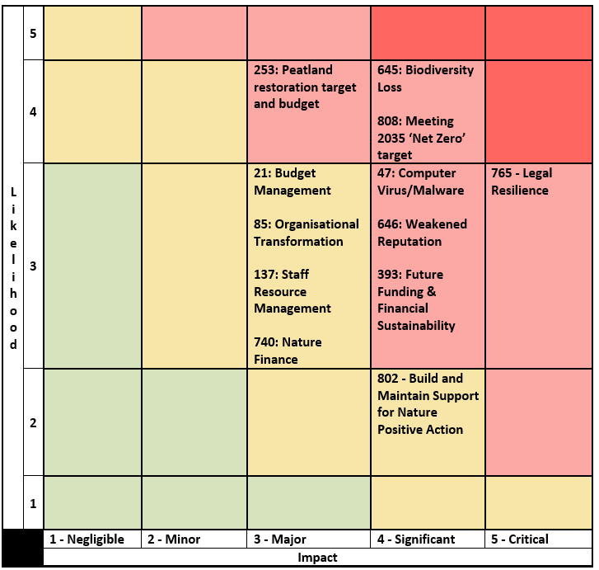

25/26 Q4 Corporate Risk Register Change Log
Change to Risk Register
↑ 1 NEW Corporate Risk Escalated
808: Meeting 2035 ‘Net Zero’ target
1 Risk De-Escalated
53: Marine Protected Areas
↑ 1 Risk Score Increased
253: Peatland restoration target and budget (remains High)
2 Risk Scores Decreased
85: Organisational Transformation (From High to Medium)
393: Future Funding and Financial Sustainability (From Very High to High)

Appendix 4 - Detailed Performance Report
Q4 BP Focus | Q4 BP deliverable
Lead the delivery of 30% of land and sea being protected by 2030
2.1 Publish and action the SPA review implementation plan. Design New Freshwater Pearl Mussel SACs.  2.2 Publish the UK Habitats Regulations report.  2.3 Finalise and commence implementation plan for Delivering Healthy Ecosystems. Support implementation of improvements to managing the Scottish MPA network.  2.4 Provide support to Scottish Government on next steps as required. | 2.1 Timescale for provision of advice to Scottish Ministers on SPA review agreed for Q1. Scientific case for designation of SACs drafted anticipating final advice to Scottish Ministers by Q2.  2.2 UK Habitat Regs report published.  2.3 Monitoring for DHE implementation schedule prepared, running throughout 2026/27 and operationalising approach in 2027/28.  2.4 NatureScot MPA advice has been published on NatureScot website. Pre-consultation with key stakeholders (fishing industry, local authorities, NGOs) progressing.
Build stronger collaboration reducing the impacts of deer and modernise our wildlife management and underpinning licencing functions to enable a net zero and nature positive future
4.1 Deliver female deer reduction incentive schemes.  4.2 Complete payments for Goose schemes.  4.3 Secure finance for priority INNS projects.  4.4 Delivery of licensing service within service standards.  Develop Trap Licensing and launch Q4 or early Q1. | 4.1 Deer incentive schemes supported in Cairngorms, Loch Lomond, South Loch Ness and Central Scotland.  4.2 All goose scheme payments made on time and within agreed budget.  4.3 Mink control and invasive plant control - Full funding grant approved for next two years with a partnership agreement to be established.  4.4 Licensing service delivered including area-based licences for Orkney ravens, and engagement ahead of gull breeding season. Licencing development reprioritised to reflect NE Act focus on Muirburn amendments and delivery of that framework for Sep 2026. Trap licensing will be developed 2026/27.
Online Licensing Performance Measure
Measure | Q3 | Q4 | RAG | Comment
Licences processed online | 355 | 404 | Amber | Continued fluctuation due to seasonality
Engage and influence planning and other regulatory systems to ensure they deliver for nature and climate
3.1 Launch a consultation on a draft biodiversity metric for planning.  3.3 Prepare draft tool guidance and materials for consultation. | 3.1 Consultation on MVP anticipated in Q2.  3.3 Preparation proceeding well in relation to the updated project plan and subject to the issues noted at 3.1.
Influence the transformation of marine management through new marine planning, protection and fisheries management frameworks, and working with the marine renewable energy sector
1.6 Begin implementing the coastal and marine ecosystem restoration plan.  3.2 Continue to support off-shore windfarm application processes. | 1.6 New Scottish Seabird Conservation Action Plan team have taken up post in NatureScot. Governance arrangements and a Delivery Pathway developed.  3.2 Advised on Marram, Ayre Offshore wind and EMEC Tidal stream developments. Advised on three seabird compensation plans. Commented on Scottish Government Habitat Regs Appraisal reform draft guidance.

Measure | Q3 | Q4 | RAG | Comment
Marine energy consultations | 90 | 80 | Green | Four significant consultations noted plus further work on other large projects

Scale up Peatland Restoration by delivering Peatland ACTION funding to projects
1.1 Demonstrate/evidence the multiple benefits of restoration to facilitate integration of peatland ambitions into land use plans and operations. | 1.1 On track to deliver just over 10,000ha of peatland, short of our stretch target to deliver 12,000ha

Demonstrate how agriculture can be transformed with new approaches to deliver targeted outcomes for nature and climate
1.2 Issue contracts to successful 2025 scheme applicants.  1.3 Farmers and crofters continuing on their transformation towards practising sustainable farming and regenerative agriculture.  1.4 Update tools released to users ahead of Single Application Form (SAF) date in 2026.  Support users ahead of SAF date of 15 May. | 1.2 AECS contracts for 2025 successfully delivered.  1.3 Over 1,000 farmers and crofters engaged in the FBS tool. Revised guidance on AECS issued. Input to SG’s code of sustainable and regenerative agriculture now published.  1.4 FarmBioScot tool mapping functionality revised based on user feedback.
Influence the regulatory, policy, market and institutional infrastructure needed to stimulate private sector investment into nature
3.4 Review success, uptake and evaluate the applicability of the approach.  3.5 Agree a list of six exemplar landscape scale nature restoration projects. Pay grant claims and transfer knowledge and experience gained through the publication of outcomes. | 3.4 FIRNS evaluation report – final draft under review. Carbon Contract Pilot review underway. Nature Finance into Action event in collaboration with the Scottish Forum on Natural Capital (SFNC) showed support and promising results. KPI list for Nature Finance projects established to help pilot projects.  3.5 Cabinet Secretary approved nine landscape scale projects. Exemplar projects were informed. Aim to undertake community consultation by end Q3 2026/27. Plans to work on a resource page on the Nature Finance Exchange platform, combine with FIRNS Community of Practice and join up with the SFNC or Ecosystems Knowledge Network.
Drive the establishment of Natural Capital as an integral part of public and private business planning and investment decisions at national, landscape and landholding/business scales
1.5 Release updated version of Natural Capital Tool incorporating changes following further piloting and co-design engagement. Agree with SG how NCT will support delivery of ARP.  3.6 Write-up the code. | 1.5 Updated version of Natural Capital Tool to be released in April.  3.6 Supported the write-up of the 'Ecosystem Restoration Code Competent Model' published March 25th.
Deliver new ways of working to stimulate achievement of our ambitions
5.1 Strategic Resource Planning: Continue to take forward Cornerstones, including interim time recording solution for 2026/27 and identify resource to lead delivery of Strategic Workforce Planning in support of new Corporate Plan.  5.2 Facilitate Perth Office move.  5.3 Review AI Trial and adopt/go to tender for solution. Start review of Business case for Objective Nexus suitability for next year. GIS Programme: Develop Infrastructure and web GIS application.  6.1 Review pilot people management skills and leadership programmes for collective and individual leadership linked to IDG for roll out 2026/27.  6.2 Seasonal promotion of Make Space for Nature campaign and The Scottish Outdoor Access Code.  Accessibility: Lead contractor support for continued work to meet evolving accessibility legislation.  7.1 Test new SharePoint Learning Hub (Digital skills).  Stress Indicator Tool Action plan delivery.  Roadmap for safety culture in place.  Equality outcome actions delivery. | 5.1 Interim time recording solution for 2026/27 in place and being used by offshore wind to facilitate cost recovery. Discussions around strategic workforce planning are continuing, plans to scope out approach to operational planning have commenced.  5.2 A firm relocation date for Perth has not been confirmed yet as there are operational issues, including EV charge points, to be worked through with P&K Council. However, it is likely to be Summer 2026. The Battleby User Group visited Pullar House on the 16 February 2026. Storage audit at Battleby for both file storage and external storage is ongoing. This will inform the space plan going forward. Staff visits were arranged for April. IT works are in hand awaiting confirmation of the relocation date.  5.3 Teams Premium licences procured and assigned to 34 users. MS Copilot Chat 6-week trial commenced prior to full roll-out early in Q1. CoPilot Pro (limited) trial will follow. Objective contract extended for a further 2 years to assess our business requirements and test the market. This will align our plans with Scottish Government, who also use Objective. GIS Transformation Programme has commenced with new Programme manager appointed and funding secured for discovery phase in 2026/27.  6.1 This is underway. We are also considering how to plug some of the gaps with a solution around people management skills and planning to roll out monthly online themed sessions to all managers from May 2026.  6.2 MSFN and SOAC Spring Campaigns successfully delivered. Accessibility champions identified and training secured in Q4.  7.1 Learning Hub growing as more skills clusters added and transfer to SharePoint underway. Four key recommendations arising from the Stress Indicator Tool have been agreed and are being rolled out commencing with the Respect Campaign. Roadmap for safety culture is underway following appointment of new H&S manager.

Measure | Q3 | Q4 | RAG | Comment
Sq meterage of Floorspace | 5335 | 5335 | Amber | Focus is on the Perth move and Inverness review
% of Implement Audit | 86% | 89% | Green | Focus in on Priority 1 implementation. Only 1 was delayed.
Complaints | 32 | 64 | Red | Vast majority relate to Guga Hunt. 57 (89%) complaints met timescale.
FOI | 100 | 86 | Red | Numbers received reduced but late response due in Q4 up to 13 from 4 in Q3

Appendix 5 - Year in Review

- Our 2025/26 Business Plan established, as a guiding principle, working collaboratively with the Scottish Government (SG) and partner agencies, so we welcomed the launch of the Scottish Biodiversity Strategy (SBS) and its six-year Delivery Plan. Our Business Plan reflected the vital importance of SBS getting off to the best possible start and set out four foundation blocks essential for its success that also provided focus and depth to our work.

- We have summarised our achievements in line with each of the foundation blocks.
Drive nature positive change in agricultural practice, land use and the marine environment
- We are forecasting to restore over 10,000ha of peatland. Final outturn figures will be verified in mid-May while we process and verify final claims.

- The issuing of contracts to successful applicants to AECS 2025 is largely completed. Over 1000 farmers and crofters engaged in the Farm BioScot tool FarmBioScot ‘Map’ and ‘Measure’ stages with over 700 app users thoroughly testing the App. New mapping functionality was released, and more farmers started to sign up to FarmBioScot tool to prepare their whole farm plan biodiversity audit requirement for SAF 2026 submission.

- The Marine and Coastal Restoration Plan was published by Scottish Government, setting out actions to accelerate active habitat restoration. The Scottish Seabird Conservation Action Plan and UK Cetacean Strategy were also published aimed at supporting the conservation of these species and building resilience through collaborative action.

Achieve our 30x30 commitment to safeguard 30% of our land and sea by 2030
- The recognition of the first Other Effective Area-based Conservation Measures (OECMs) in the UK, as Nature30 sites was a major milestone achieved. Responsibility for recognition of Nature30 sites is delegated by Scottish Government to NatureScot, including the formalisation of the recognition process and the establishment of the Nature30 assessment panel. We have over a hundred potential/suggested new sites at various stages in the process for recognition.

- We deployed the second phase of InformedDECISION to replace our aging casework management system. We were nominated for a joint award with InformedSolutions for Scotland IS Digital Awards (public sector innovation category).

- We launched Ecosystem Management Insights (EcoMI) as a cutting-edge tool for managing and prioritising our monitoring data to support a “Delivering Healthy Ecosystems” approach to site management. We prepared the schedule for monitoring for Delivering Healthy Ecosystems (DHE) implementation which will be running throughout 2026/27, and we will start monitoring using the DHE approach in 2027/28.

- We provided support and advice to SG policy teams and Ministers in progressing Natural Environment Act provisions, species support scheme funding and Minister’s Species and Land Management Forum. This included submitting our Marine Monitoring plan to Marine Directorate for seabed habitats and marine megafauna covering the period from 2026/27 to 2038/39.

Increase public and private sector investment in nature and ensure good development
- We deployed a number of initiatives to help increase the delivery of public and private sector investment. These included:
- Deploying Informed DECISION and making improvements to it
- Increasing specialist staffing capacities that are key issues for casework - ornithology, peat advice and landscape.
- Increasing case officer capacity in relation to energy casework
- Concentrating resources only on those cases of national interest which tend to be complex and time consuming.
- Scoping off-shore wind income generation work and to implement charging from the start of 2026/27.

- Several major offshore wind sites were consented using our advice, including Berwick Bank, West of Orkney and Salamander.

- Ongoing discussion on a number of key issues are continuing, in particular, regulator approaches to the delivery of mitigation offsite. This is a critical sticking point that we are trying to resolve with SG and the development community.

- Our proposed Nature Investment Partnership with investment advisers Aberdeen Asset management was not successful in establishing a fund. However, projects continue to progress and should provide opportunities for outcome buyers (i.e. Flow Country).

- A number of FIRNS projects progressed or are in advanced discussions. Landscape Enterprise Networks (LENs) in Scotland secured over £600k for Loch Lomond and an initial trade round on the Tweed progresses. The Esk and Dee being explored for their fit with the LENS approach. The Flow Country partnership is in the final stages of securing around £500k. The Scottish Rivers Fund was established and is preparing to launch by May 2026.

Promote nature positive land and wildlife management through strengthened regulation
- The Natural Environment Act provisions all progressed including:
- new NatureScot powers of intervention
- new deer code
- National Deer Plan and competency and occupier rights.

- Operational delivery focused on ensuring upland Deer Management Groups were meeting planned cull targets and census work to monitor progress and develop approaches to data gathering and analysis across more of Scotland.

- 2024-25 was the second highest recorded deer cull in Scotland, sustaining trends in higher culls over recent years. Data is produced a year in arrears. We maintained a landscape-scale focus aligning with SBS priority areas where incentives and regulation are being used to reduce deer populations and their impacts through higher culls.

- Species management schemes (Goose and Sea Eagle) have been delivered on time and within budgets. The policy review aspects of the management schemes were also progressed by publishing action plans, with work to review, simplify and align with future rural support mechanisms in 2030 underway.

- Full funding was agreed for two years of mink control which is new funding from the Scottish Invasive Species Initiative (SISI) project. A new Scottish INNS plan was launched in March 2026. Building on the Scottish INNS Plan, we will set out our lead responsibilities and actions.

- Our digital licensing service was delivered for Muirburn, but subsequent legislative changes have required further development work. A workplan and resourcing for Online Licensing was put in place for 2025/26.

- The Species Licensing Review has been completed and was subject to independent external review and submitted to Scottish Government for consideration and response.

New Ways of Working
- Our upgrade to Windows 11 was successfully delivered and our virtual private network (VPN) replacement was implemented, mitigating a major security risk and increasing available access times. FrontierConnect work to deliver high-speed, video conference (VC) capable, internet connections was completed for all offices.

- The quantity (352) of FOI requests received is an all-time record and a significant increase on previous years.

- The Board gave its approval to our Net Zero Plan for 2026-30.

- Changes were made to our Estate delivering savings and reducing carbon emissions. Key milestones included:
- The decision to relocate from Battleby to Pullar House in Perth was made. Plans to implement the decision are being taken forward, including for the sale of the site, for delivering in 2026/27.
- Facilitating the future sale of Kinloch Castle on Rum with a closing date set for the 9th of April 2026.

- The Inner Development Goals (IDG) Summit on “Bridging Polarities, From Inner Growth to Outer Change” was attended both in person and through staff events in Edinburgh, Inverness and Perth. A Leadership Exchange programme was established to provide a framework for offering an insight into different organisational cultures, constraints and opportunities.

- Stress Survey and People Survey response levels were excellent and staff engagement scores very high. We developed and launched our “Respect Campaign” in response to stress survey findings.

Communications
- Our new Corporate Plan was successfully delivered, including stakeholder events with high levels of engagement and the approval of the Cabinet Secretary.

- We more than doubled our previous year’s media reach to a total audience of over 4.59 billion (from 2.16 billion in 2024-25), with 2888 articles mentioning NatureScot.

- Our website content increased in size, relevance, design quality, functionality, and accessibility. We are now hosting over 4.5k pages, in tandem with rigorous retention and archiving policy. New functionality and designs were implemented. Page accessibility is consistently above 96% which exceeds legislative requirements.

- Our Make Space for Nature campaign 2025/26 exceeded targets for every quarter of this year’s campaign, engaging with diverse audiences including young adults, people living with chronic illness, and minority ethnic communities in Scotland. Paid-for activity delivered over 56k engagements with our campaign website. Seven influencer partners generated over 621k social media views.

- The Scottish Outdoor Access Code Summer 2025 campaign reached a radio audience of 1.5 million, achieving over 2 million impressions across digital platforms, nearly 200,000 views and high engagement rates on influencer partnership content.

