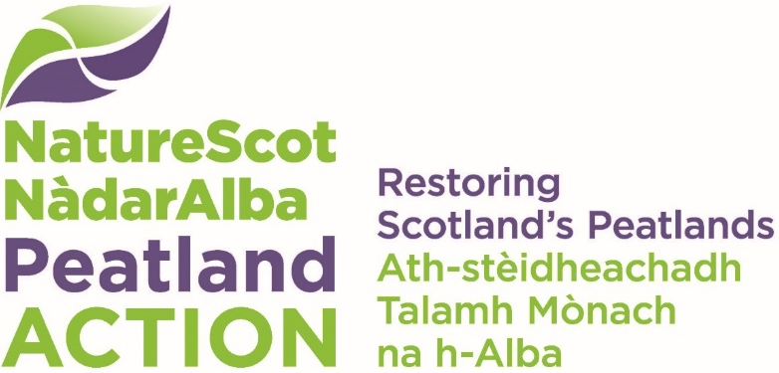

Peatland restoration internship scheme 26/27
  - Application form

Important information
You should read the information for applicants on our dedicated web page before filling in this form. This scheme is only for funding internships that meet the eligibility criteria outlined in the Information for Applicants.
Your completed application form and any supporting information must be submitted by 23:59 on 15th May 2026 to peatlandactiontraining@nature.scot

Section A – About you
Complete the section below to tell us about you.

Your details
This should be the person and / or organisation that is applying for the grant and who will manage the internship.

Table – your details
Topic | Applicant to add details
Applicant name
Name of Organisation
Position in Organisation
Website/Facebook/Twitter/Other (if applicable)
Address
Postcode
Landline number
Mobile phone number
e-Mail
Charity or business number (if applicable)
VAT registration number (if applicable)

About your organisation
Tell us about your organisation.
☐ Public ☐ Private business ☐ Voluntary/charity/trust ☐ Other
If Other, please describe the type of organisation:
(This text box will expand as you type your answer)

Partnership
Are you applying in a partnership with another organisation/other organisations?
☐ Yes ☐ No
If yes, please list the other partners who will be involved in the internship(s), summarising their role.
(This text box will expand as you type your answer)

Section B – Your internship proposal
Complete the section below to tell us about your internship proposal.

Internship title
(This text box will expand as you type)

Internship summary
Please provide a very brief summary of your proposal describing what training the intern will be offered. The summary will be what you will use to promote the internship (and what we will use in any communications about your internship).
(This text box will expand as you type)

Internship description
Please describe your internship proposal summarising what you are going to offer and what outcomes you hope to achieve for your organisation and for the intern, with specific reference to the Project Aims in the ‘Information for Applicants’. We will ask you for further details in the questions below.
(This text box will expand as you type)

Internship dates
Intended internship Start date:
Intended internship End date:
Note: The internships must start by beginning of September 2026 and be completed by end of February 2027, unless you are proposing a match funded longer post, in which case the 6 months of funding from NatureScot must be claimed before the end of February 2027.

Terms of employment
Please indicate the internship terms of employment below.
Number of hours per week:
Note: Part-time internships will be considered if they meet the other criteria for the internships (see Information for Applicants on our website)
Normal working pattern (e.g. Monday – Friday, 9-5pm/flexible):
Location:
Other – please add any other details on the conditions for employment for the intern.
(This text box will expand as you type)

Internship criteria
Please confirm that the internship will be offered only to those who meet the following criteria:
Resident in Scotland ☐ Yes ☐ No
Have the right to work in the UK for the duration of the internships they apply to
☐ Yes ☐ No

Advertising the internship
Please indicate how/where you plan to advertise the internship. (NatureScot may be able to help with or advise on this but you must provide contact details for applications and manage the recruitment process.)
(This text box will expand as you type)

Intern role requirements
Please describe the role requirements of the intern including their responsibilities, tasks and work-based experience that they will undertake during the internship, in the form of information you would provide to potential applicants for the internship.
(This text box will expand as you type)

Person specification for intern
Please describe the type of person you will be looking for the internship, i.e. person specification, including the criteria that you will use to assess applicants’ suitability for the internship, such as demonstrating that the internship will add to the intern’s existing skills and assist them in pursuing future employment opportunities in this sector.
(This text box will expand as you type)

Skills
Please select which skills, as set out in the ‘Information for Applicants’ guidance, will be enhanced as part of your internship proposal (tick all that apply):

☐ Landowner engagement and liaison
☐ Use of GIS (Desktop and field based) to create, analyse and visualise spatial data
☐ Habitat/species survey design, planning and fieldwork
☐ Peatland habitat identification and assessment including peat depth surveys
☐ Restoration management planning, including engagement with statutory organisations
☐ Engagement with the Prior Notification process
☐ Development of a comprehensive Statement of Requirements for delivery of restoration work
☐ Assessment of tenders and contract management
☐ Inception, management and oversight of operational sites
☐ Monitoring the effectiveness of restoration techniques
☐ Other
If ‘other’, please describe the skill(s):
(This text box will expand as you type)

Structured training
Will you provide access to any specific structured training (whether within your organisation or elsewhere). This includes training for which 50% funding may be available from the Peatland Training Fund. Do not include training offered directly to those on the intern scheme through NatureScot Peatland ACTION, which is the focus of the next question.
☐ Yes ☐ No
If yes, please describe what structured training or accreditation opportunity you will offer.
(This text box will expand as you type)

NatureScot Peatland ACTION training courses
Please indicate which of the following training courses likely to be offered through NatureScot Peatland ACTION as part of this Project your intern is likely to take up.
An indication is all that is required at this stage in order to help with planning.
☐ 2-day Theory and Principles of Restoration course (delivered by Crichton Carbon Centre)
☐ other tailored training opportunities – e.g peatland hydrology, peat slide risk assessments etc.

Management and mentoring arrangements
Please briefly outline what line management and mentoring arrangements will be provided for the internship, including the relevant skills and experience of the mentor(s). Please describe arrangements to be put in place for monitoring, evaluation and feedback between the line manager/mentor and the intern and vice versa.
(This text box will expand as you type)

Fair Work Practices and Equality and Diversity
Please outline how delivery of this internship will demonstrate alignment with Fair Work practices and your commitment to Equality and Diversity. A couple of sentences/short paragraph is all that is required; additional information, e.g. copies of People/HR policies, can be provided separately.
(This text box will expand as you type)

Dependencies
How ready are you to provide this internship opportunity/opportunities outline above? Please detail any specific action(s) not included within this application that is needed before the Internship can start and risks associated with these actions and/or other uncertainties (e.g. if there is an associated project that the internship is connected with that depends on other funding / practical issues / weather conditions).
(This text box will expand as you type)

Risks
What other risks are associated with whether your proposal will succeed? Please detail what steps you will take to prevent a risk and how it will be managed, e.g. sick absence by intern’s line manager.
(This text box will expand as you type)

Section C – Internship costs
Complete the section below to tell us about your internship costs.

We need to know the following costs
The amount of funding you are requesting from NatureScot Peatland ACTION. This must be no more than £21,400 per internship made up of 6 months direct employee costs (including NI, pensions, T & S etc) and a maximum of 7% staff overheads.
Total funding you are requesting from NatureScot Peatland ACTION (GBP £):

Payment schedule
If the application is successful and an intern is appointed, payments will be made monthly in arrears on receipt of satisfactory evidence of attendance signed by the intern and line manager (a timesheet template will be provided), with the final payment subject to receipt of a satisfactory end of internship evaluation report. Weekly payments may be available in exceptional circumstances. Please indicate if you would prefer to claim monthly or weekly.
(This text box will expand as you type)

Section D - Declaration
Section to be completed by the applicant.
- I am the Applicant and I am applying for a grant under the terms of the Natural Heritage (Scotland) Act 1991. I have the appropriate authority to submit this application.
- I confirm that the information I have given in this application is correct, to the best of my knowledge.
- I have read and accept Scottish Natural Heritage (NatureScot) Standard Terms and Conditions of Funding.

NatureScot will collect and hold your contact details. You should read our Funding Privacy Notice.

Applicant signature
We prefer to receive an electronic copy of your application.
You can either:
- insert a scanned copy of your hand-written signature, or
- insert your name and submit the application from an email address that is identifiable as you/your organisation.
Your signature:

Date:

Please email your completed application form and any supporting documents to PeatlandActionTraining@nature.scot by 23:59 on 15th May 2026.

More information on Fair Work practices can be found in the Fair Work tool: https://fairworktool.scot/

