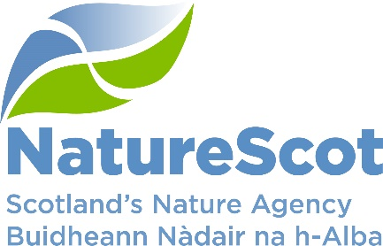

SCIENTIFIC ADVISORY COMMITTEE

INFORMATION PAPER

A review of Herbivore Impact Assessment (HIA) methods for upland open habitats in Scotland

Purpose
- This paper provides a further update to the SAC on a project to review the range of upland Herbivore Impact Assessment (HIA) methods commonly used in Scotland and advise that we will be asking, in autumn 2026, for the Committee to consider and endorse the revised methods.

Action
- The Committee is asked to note the update.

Preparation of the paper
- The paper was written by Helen Doherty. It is sponsored by Stuart MacQuarrie.

Background
- Information on the rationale and purpose for this work was provided to the SAC at their October 2025 meeting and had previously been discussed by the SAC deer sub-group prior to its disbandment.
- The project was commissioned as two separate contracts, both of which have been awarded to the James Hutton Institute.
- The project is currently on schedule to deliver in Autumn 2026.

Progress to date
- Phase 1 took place from July 2024 to March 2025 and included an analysis of all the indicators in the reviewed methods to identify commonly used indicators between methods and habitats (including blanket bog, dwarf shrub heath, tussock grassland, and smooth grassland). An online survey and stakeholder workshop were held to identify which indicators are useful and often used; uninformative or difficult; and occasionally helpful. A revised list of indicators for each habitat was created and a report detailing the decision process written. This report is currently in the process of being published by NatureScot.
- Based on the findings from the Phase 1 workshop and online survey, a revised method was proposed. This was tested at three sites by six James Hutton Institute staff completing the revised method, the MacDonald et al method and the Wild Deer Best Practice (WDBP) method at each sample location by each surveyor.
- All the data has now been cleaned and processed, and initial analysis has been completed.

Next steps
- Statistical analysis will address three questions:
- At the plot-level, what is surveyor consistency in plot-level HIA scores across MacDonald et al. and WDBP methods?
- At the indicator-level, what is surveyor consistency for shared individual indicators between HIA methods?
- Specifically for the revised HIA method, what is the surveyor variation for each indicator (where there is sufficient data collection)?
- Provisional results and analysis have been detailed in a report received from the James Hutton Institute. A copy of the report can be provided to SAC members on request.
- A further version of the revised method will be created for field testing over two weeks in early May 2026 at Dalnacardoch Estate, one week by consultant field surveyors and one by estate staff. In addition, NatureScot will further test the method using staff from both the Peatland Action and Agricultural teams to provide feedback from their perspectives. This will also provide additional data to benchmark the revised method against existing methods at higher impact sites, as these levels of impacts have been less well covered in testing so far.
- The testing and feedback from this testing will be used to further revise and interpret the method.
- The outputs from Phase 2 will be:
  - A user-friendly guide to HIA assessment and interpretation for key open upland habitats, including correspondence to Woodland HIA
  - A technical annex giving further information on assessment methods and analysis of the testing. This will be published as a NatureScot report.
- Publishing of reports from Phases 1 and 2 are seen as key to ensuring a clear final version of the HIA guidance and full transparency over the selection of indicators and their robustness, should future challenges arise.
- Involvement of stakeholders in the selection of indicators, commenting on the Phase 1 report and the testing in Phase 2 aims to ensure engagement with the revised method.

