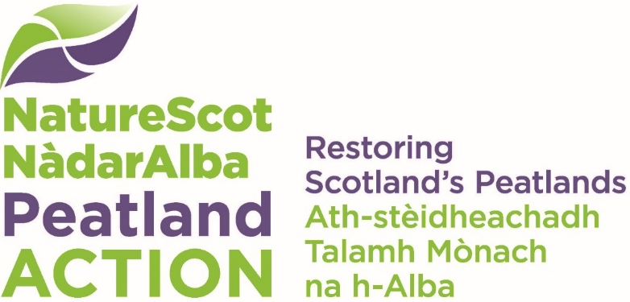

Forest-to-Bog Peatland Restoration training – Strathy South, Sutherland
  - Application form

Important information for applicants
You should read the Information for Applicants before filling in this form. The completed application form must be submitted by 12:00 on Friday 13th February 2026 to peatlandactiontraining@nature.scot

Your details
This should be the person who is applying as the trainee.
Topic | Applicant to add details
Applicant name
Address
Postcode
Landline number
Mobile phone number of trainee
Personal e-mail address

Your competence and experience in using a tracked excavator
Please provide information about your competence and experience in the operation of a tracked excavator, including confirmation of valid tickets held (CPCS/NPORS/FMOC) along with expiry date. Copies / photos of cards held must be attached to your application.
(This text box will expand as you type)

Your employment status
We are interested in knowing the capacity in which you will be present on the training site. For the purposes of the training, if you are applying as a sole trader (whether or not you are additionally employed in an unrelated field) please give your status as ‘self-employed’.
Employment status | Put an X in the row that applied to you
Employed (please answer Q4 and 5)
Self-employed (please go to Q6)

About your employer (please answer questions 4 & 5 if you will be on the training site as an employee)
Topic | Applicant to add details
Company name
Company contact
Address
Postcode
Landline number
Mobile phone number
e-Mail
VAT registration number (if applicable)

Company involvement in peatland restoration
Please tell us about any current involvement your company has in peatland restoration or any intentions to engage in the sector in the future, which would be helped by your attendance at this training
(This text box will expand as you type)

Sole trader involvement in peatland restoration (please answer question 6 if you will be on the training site as a sole trader)
Please tell us about any current involvement your business has in peatland restoration or any intentions to engage in the sector in the future, which would be helped by your attendance at this training
(This text box will expand as you type)

Interest in developing skills and knowledge in peatland restoration (all applicants to answer)
Please provide any relevant information about your interest in peatland restoration and specifically forest-to-bog restoration. This might include informal learning from peers, attendance at training or demonstration events, self-learning using online resources etc.
(This text box will expand as you type)

Training course dates (all applicants to answer)
Please indicate that date(s) when you would be available to attend training, bearing in mind that the training is 4 days in duration (Monday to Thursday) and payment of training allowance is dependent on you being able to attend all 4 days.
☐ 23rd – 26th March 2026
☐ 30th March – 2nd April 2026
☐ Either of the above training courses would potentially be possible

Public Liability Insurance
Please confirm that you will be covered by Public Liability Insurance held either by your employer or by yourself as a sole trader.
☐ Yes, I will be covered by Public Liability Insurance for the duration of the time I am on the training course

Meeting the requirements of the CDM Regs 2015
Please confirm that you are aware of the duties the Principal Contractor on the site has under the CDM Regs and that you will follow the Health and Safety requirements set out by the Principal Contractor, for the duration of the training course.
☐ Yes, I understand the restoration work falls under the remit of the CDM Regs and I will follow the requirements of the Principal Contractor for the duration of the training course.

Accommodation requirements
Please let us know if accommodation would be required and for which nights, e.g. Sunday night – Thursday morning, Monday night – Thursday morning etc. (This will have no bearing on the outcome of your application. It is so that we can source accommodation required for each week)
(This text box will expand as you type)

Dietary requirements
If your application is successful, lunch will be provided on each day of the training. Please detail any special dietary requirements you have.
(This text box will expand as you type)

Declaration
Section to be completed by the applicant.
- I confirm that the information I have given in this application is correct, to the best of my knowledge.
- I confirm that NatureScot may hold my contact details (ensuring compliance with GDPR) until the completion of the training project.

Applicant signature
Please insert your name and submit the application from an email address that is identifiable as you/your organisation. Please ensure that copies / photo of valid cards (CPCS/NPORS/FMOC) are attached to your email.
Your ‘signature’:
Date:

Please email your completed application form and any supporting documents to Peatlandactiontraining@nature.scot by 12:00 on Friday 13th February 2026.

