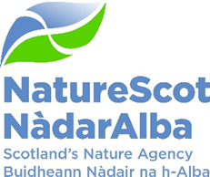

Title: Q3 Performance Report

Date: 11 February 2026

Purpose | Decision
How does this link with our corporate priorities of improving biodiversity or delivering nature-based solutions to climate change: | This paper presents Q3 progress towards delivery of our corporate priorities as laid out in our Business Plan, A Nature-Rich Future for All: Year 4.
Summary: | Overall, the Report highlights strong progress against our objectives. The report for Q3 has been streamlined following feedback from SLT. Further detail is provided in the appendices.
Actions: | Board members to review the achievements, challenges and forward look and agree whether we are on track to meet our BP objectives.
Recommendations: | Board is asked to:  - Note the significant progress in the report and advise on any corrective action for the remainder of Q4  - Discuss mitigation for the risks identified in the longer term delivery assessment to inform prioritisation in the Business Plan for 26/27
Report Author(s): | Directors, Deputy Directors, Strategic Resource Managers, FP&P Team, P&OD Team
Sponsor: | Nick Halfhide
List of Appendices | Appendix 1: People Report  Appendix 2: Financial Report – Performance Detail  Appendix 3: Risk and Audit Report  Appendix 4: Detailed Performance Report

Purpose
- This paper presents our performance for Q3 2025/26. It addresses delivery of our corporate priorities by reviewing performance against our Business Plan, progress towards maximising our available budget, assessing risks for delivery and information on how our people are supporting the resourcing of our work.

High Level Performance Summary

People
- Figure 1 shows the high-level overview of our People metrics. More detailed commentary is in Appendix 1.

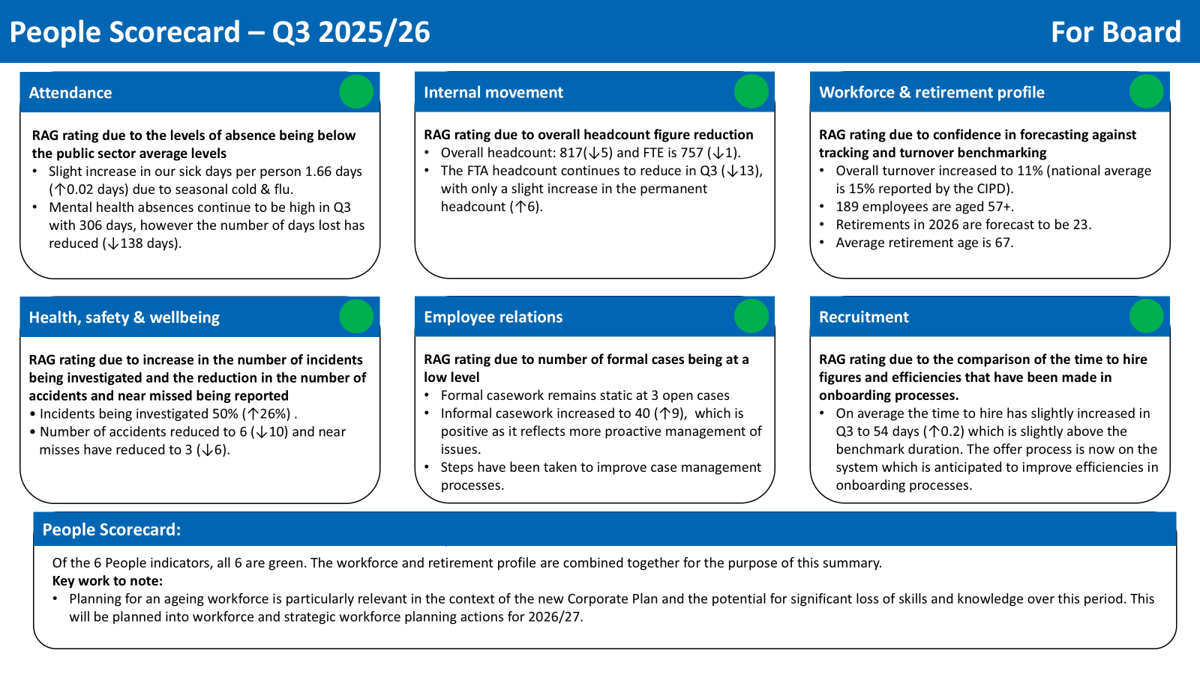

Finance
- Figure 2 shows the key Finance metrics with further details in Appendix 2. The key points for consideration are:
- The current over-spend position on resource budget.
- The outstanding performance on paybill and indirect capital.
- The direct capital misunderstanding with SG between cash and non-cash.

Figure 2: Finance Scorecard
Financial Metrics (£m) | Measure * | Budget | Expected Outturn | Variance | Rating
Resource Budget | Outturn within 1% of final budget | 72.1 | 73.2 | (1.1) | On Track
Direct Capital | Outturn within 5% of final budget | 3.0 | 2.9 | 0.1 | On Track
Indirect Capital | Outturn within 5% of final budget | 24.3 | 24.1 | 0.2 | On Track
Paybill | Outturn within 1% of final budget | 46.0 | 45.9 | 0.1 | On Track
Project Allocation | Outturn within 1% of final budget | 17.8 | 18.5 | (0.7) | Minor Slippage
Peatland Action | Outturn within 1% of final budget | 20.1 | 20.3 | (0.2) | On Track
Farming with Nature | Outturn within 1% of final budget | 0.8 | 0.8 | 0.0 | On Track
Nature Restoration Fund | Outturn within 1% of final budget | 11.3 | 10.8 | 0.5 | Minor Slippage
FIRNS | Outturn within 1% of final budget | 1.6 | 1.6 | 0.0 | On Track
Rainforest Restoration Fund | Outturn within 1% of final budget | 1.7 | 1.5 | 0.2 | Major Slippage
*Resource under 1% - on track, up to 10% minor slippage, over 10% major slippage (** Capital under 5% / up to 10%)

Risk
- Figure 3 shows the summary of the corporate risk register. Risk 802: Threat to Support for Nature Positive Action was added to the corporate risk register. This reflects the emphasis on strengthening public connection, understanding and access to nature. The impact score of 393: Future Funding and Financial Sustainability increased from 4 to 5 and flat cash scenario planning is underway.

- The Cabinet Secretary announced that consultation on MPA and PMF management measures would be delayed until after the May election so Risk 53: Marine Protected Areas impact score increased from 3 to 4.

Figure 3: Corporate Risk Register Summary
- Figure 3 provides a high-level summary of corporate risk movement. More detail is in Appendix 3.
Risk Status | 7 Red | 5 Amber | 0 Green
Movement in Risk Rating | 3 | 9 | 0
(The table provides a summary of progress against corporate risks in the quarter. 3 risks are increasing, 9 are static and none are decreasing)

Operational Delivery Scorecard
- Figure 4 shows the RAG status of delivery plans and their alignment with the 4 foundation blocks and internal transformation. Key highlights for the quarter are noted, and further details are provided in Appendix 4.

Figure 4: Operational Delivery Scorecard
 | 1 | 2 | 3 | 4 | 5
 | Drive nature positive change | Achieve30x30 | Increase P&PS investment | Land & wildlife management | Transformation
30x30 | - | Agreed principles of governance process for Nature30 sites with the PAC | - | - | -
Manage deer  & wildlife | - | - | - | SAOS larder fund oversubscribed with additional £150K provided by SG | -
Planning &reg. | - | - | Engaged in PfG key agency planning | - | -
Marine trans. | Finalising plans for cost recovery for Offshore wind advice | - | SG published Marine & Coastal restoration plan | - | -
Peatland | £17m committed to 25/26 targets | - |  | - | -
Transform Ag. | Ministerial approval for 2026 AECS | - |  | - | -
Private sector inv. | - | - | Prospectus developing to plan | - | -
Natural capital | Research completed on food provision model in NCT tool | - | - | - | -
NWW | - | - | - | - | CP achieved ministerial sign off
(The table gives a rating of our achievement in delivering our Q3 objectives. All objectives are green except Private Sector Investment which is amber)

- SLT have reviewed the operational delivery scorecard and assessed the risk of achievement of these objectives over the longer term. Figure 5 aims to provide an indication to the Board about SLT’s sense of where the risks are to future delivery across our objectives.

Figure 5 Longer Term Delivery Assessment

 | 1 | 2 | 3 | 4 | 5
 | Drive nature positive change | Achieve  30x30 | Increase P&PS investment | Land & wildlife management | Transformation
30x30 | - | RED | - | - | -
Manage deer  & wildlife | - | - | - | RED | -
Planning &reg. | - | - | AMBER | - | -
Marine trans. | AMBER | - | AMBER | - | -
Peatland | GREEN | - |  | - | -
Transform Ag. | AMBER | - |  | - | -
Private sector inv. | - | - | RED | - | -
Natural capital | AMBER | - | - | - | -
NWW | - | - | - | - | AMBER
(The table gives a rating the longer-term assessment of the likelihood of achieving our key objectives)

Context for Red RAG ratings:
- 30x30 – coalescing partners around our common goal of 30x30 is proving challenging. Early conversations with eNGOs are proving to be slower than hoped for.
- Managing deer & wildlife – deer numbers remains a persistent problem. New powers coming to us through the Natural Environment Bill will support progress but there remains a large gap between cull rates and what is required to reduce deer numbers. Although the recent Gull Summits have helped tackle the issues we were experiencing in Q2, we are still receiving complaints and FOIs about Guga.
- Private sector investment – The level of private investment into nature continues to lag behind our ambition. The prognosis, against a background of global uncertainty and investors seeking safe havens (notably the record increase in gold prices) is that attracting investments into the relatively risky and untested nature market will continue to be challenging. We have substantial work to do to convince investors of the need to add nature investments as part of their diversified risk portfolio strategies. The soon to be published investment portfolio will help us make progress.

Quarterly Commentary

Achievements in the Quarter
- We had a strong start to year 1 of the new SBS Action Plan with close to 50% of NatureScot led or co-led actions either completed or ‘Green’.

- We delivered high-quality responses for three complex Accelerated Strategic Transmission Investment (ASTI) energy transmission cases, meeting challenging deadlines set by Energy Consenting Unit (ECU).

- We completed the revised Muirburn Code and Muirburn licensing scheme ready for launch.

- We were granted a highly commended Nature of Scotland Award for our work on increasing workforce capacity for peatland restoration

- INNS action plan out for external engagement and successfully ran INNS finance summit.

- We established an internal project team to deliver cost recovery for offshore wind advice, following consultation and feedback from industry.

- We completed the Scottish Biodiversity List in consultation with eNGOs and partner agencies. The list is now much shorter as we started with a different premise (species we can take action to help rather than ones that are exceedingly rare) that has largely been accepted by partners.

- The Cabinet Secretary approved NatureScot’s Corporate Plan for 2022-26.

- SG signed off the Business case for the Perth office relocation.

Challenges in the Quarter
- Electricity Act energy casework continues to present high demand for individual cases and potential PLIs. We are working closely with ECU and DPEA (Planning and Environmental Appeals Division) in SG to better align at a strategic level.

- We are concerned about the lack of pace with Nature Finance work both in terms of the investor market being slow and cautious demand coming forward from landowners.

- Work on developing the Investment Prospectus is progressing well towards delivering the MVP. This is a novel area of work and we will allow time for testing and contingencies.

- The Marine Protection consultation was postponed, affecting our programme of work for staff and engagement with stakeholders. We are considering next steps with Marine Directorate.

- The cancellation of the second SBS Portfolio Board because of lack of availability raises concerns.

- Amendments passed at Stage 2 of the Natural Environment Bill could be challenging for NatureScot. We continue to liaise with the Bill team and provide information to support progress.

- Increase in the volumes of FOI up 27% to 100 received in the quarter. This is causing significant capacity issues and the level still relating to Guga poses a heightened reputational risk.

- Slow pace of Single Scottish Estate (Inverness and Dingwall) review.

- Managing transitions in key support services posts due to retirements and resignations.

- Discussions with eNGOs over 30x30 are not progressing as fast as we would like.

Forward Look
- Following the Gull Summit, we are preparing the Gull Action Plan via 4 regional events and a Local Authority grant scheme to support action on gulls ahead of the breeding season.

- 80% of Peatland Action delivery (i.e. c9,000 ha of active restoration project work) will take place in Q4. This is high value, high risk work. We are committed to ensuring that the planned £10m spend is achieved.

- We are working to secure SG AO approval to continue funding the Sea Eagle and Goose schemes.
- We will finalise charging rates and agreements for offshore wind cost recovery to enable implementation from 1 April 2026.

- We will finalise the governance process for Nature30 sites with the Protected Areas Committee (PAC) and rollout training on implementation for lead staff in each Ops area.

- SLT to review progress on NatureScot led actions in the SBS Delivery plan and consider corrective action for amber/red actions. However, around half of the actions we are responsible for are rated as green.

- Preparation of Business Plan for 2026/27 in a very compressed timescale with a number of decisions to be made regarding budgets and delivery models. Launch of new Corporate Plan and refreshed NatureScot Way.

- As the pre-election period approaches, we are considering the possibility that progress on key nature-based policy initiatives may begin to slow down.

Appendix 1 - People Report
Whilst the overall picture in terms of people metrics is positive, the People Programme rated amber due to capacity and skills pressures, alongside demands from transactional, business as usual work. We are investing in support and training to address some of these pressures, alongside refreshing the Programme for 2026/27 in response to the new Corporate Plan.

Measure | RAG | Performance Overview | Actual | Analysis | Comment
Attendance |  | 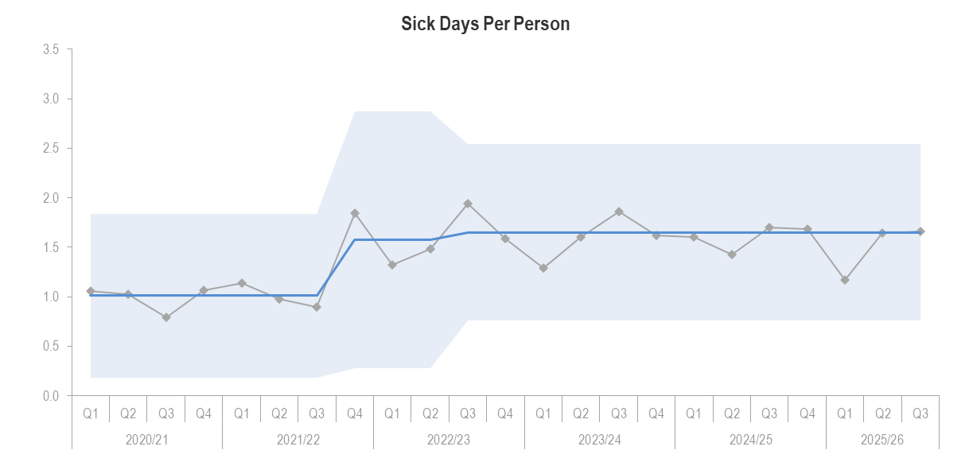  (This graph shows the number of sick days taken each quarter per employee from 2020 to date) | 1.66 ↑ days | There has been a slight increase in our sick days per person from 1.64 days to 1.66 days (↑0.02days).  Cold and flu absences are the bulk of lost time with 309 days lost, this is a significant increase from Q2 (↑125 days).  Mental health continues to be high (306 days), although the number of days lost has reduced (↓138 days). There has been a 6% increase in work-related stress absences. | The increase in absence levels due to cold/flu is consistent with the increase in cold & flu cases reported in Scotland.  P&OD will continue to work with team managers where workplace stress has been identified as an absence reason.
Workforce Profile |  | 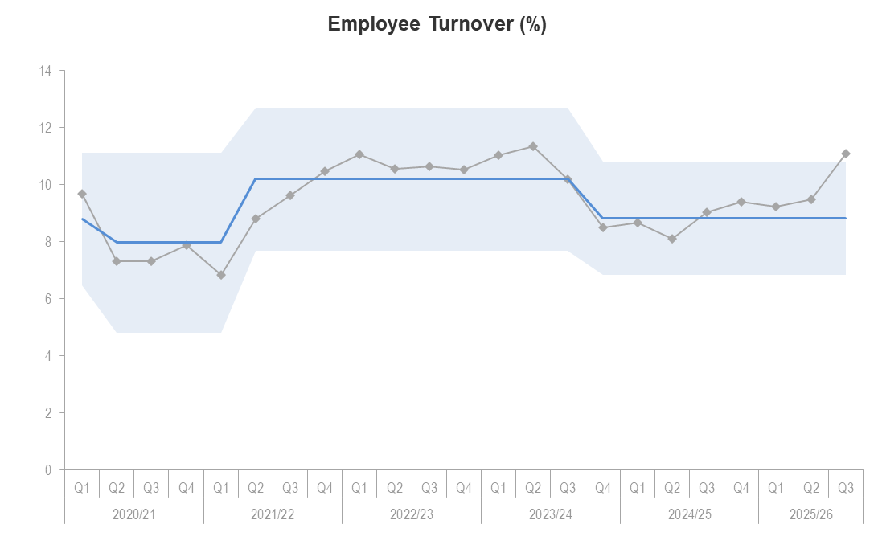  (This graph shows the pattern of employee turnover) | 11%↑ | Turnover has increased to 11% since Q3 24/25.  Our annual turnover by contract type is:  5% - Fixed Term Employees  6% - Permanent Employees.  There were 13 leavers, of which 15% were retirements, 39% left at the end of their contract and 46% were for personal reasons. | 11% is a healthy level of turnover. The national average annual turnover rate in the UK is 15%.  Although the number of retirements has reduced, it is predicted that these will exceed the forecast of 23 for 2026.
Employee Relations |  | 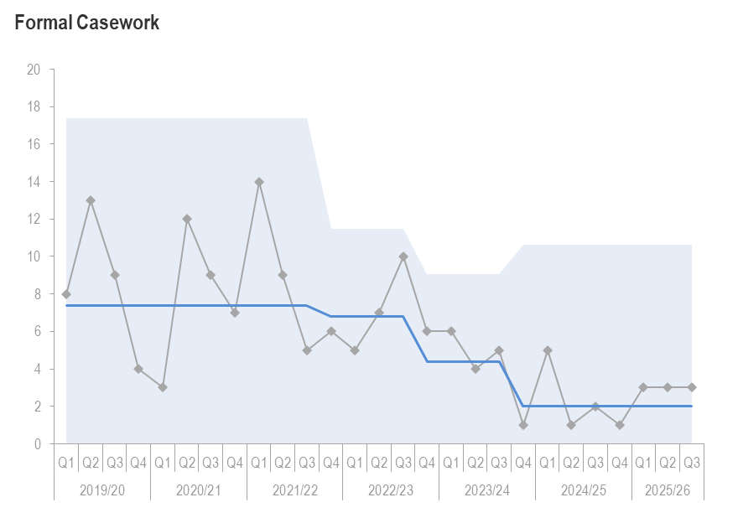  (This graph shows the number of formal employee relations cases raised)  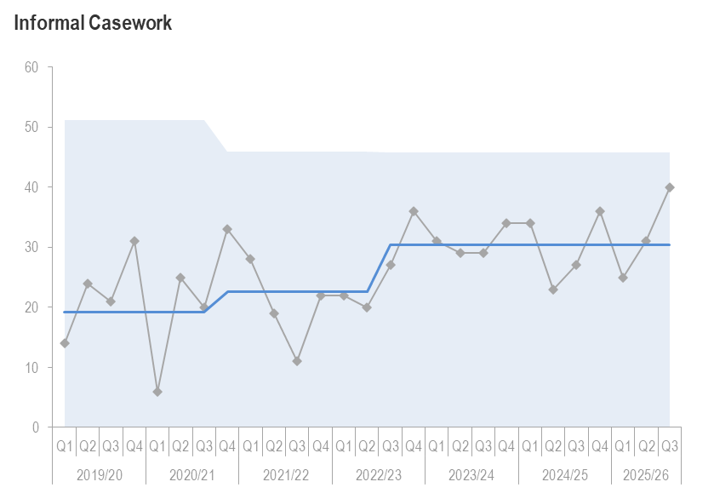  (This graph shows the number of informal employee relations cases raised) | 3 ↔  40↑ | Formal casework remained static from Q1 with 3 open cases, ranging from misconduct, performance, and grievance.  Informal casework has increased from 31 to 40 open cases. 16 new cases (37.5%) are short-term absence, 50% are miscellaneous as there are multiple reasons for the casework.  The average time to close cases was 3.4 weeks (68 working days). This is a significant reduction from Q2 by 21.6 weeks. This reduction may reflect the early intervention in cases by the P&OD team and managers. | P&OD are working with managers to be proactive in managing long term absences and encouraging referrals to Occupational Health as soon as triggers are hit.  The number of informal cases is increasing, which is reflective of the proactive approach being taken.
Internal Movement |  | 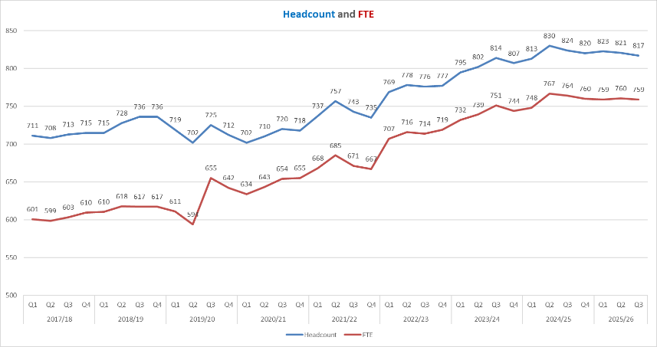  (This graph shows the trend of the organisations headcount and FTE to date) | 817↓ and 757↓ | Headcount is 817(↓5) and FTE is 757 (↓1). There were 10 new starters (6 on permanent contracts, 4 on FTAs).  The FTA headcount continues to reduce (↓13), with only a slight increase in the Permanent headcount (↑6) | The FTA review continues to raise awareness of the appropriate use of FTAs.
Retirement Profile |  | 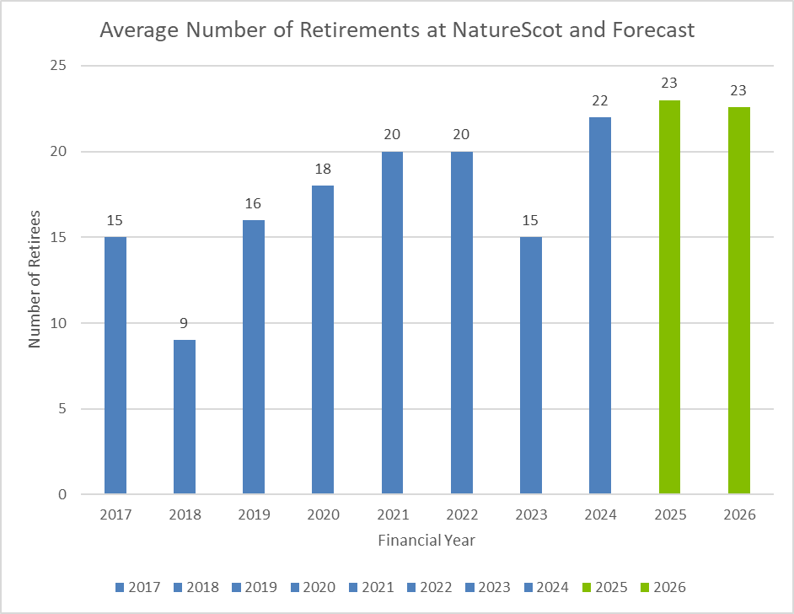  (This graph shows number of retirees and our forecasted retirements) |  | 189 employees are aged 57+ (23% of Q3 headcount).  This is predicted to reduce to 187 in Q1 2026/27.  2 employees retired (15% of Q3 leavers).  The average retirement age for is 67. | The retirement forecast is on track (74%).  The target for 2026 is now forecasted to be 23 retirements. P&OD will work with team managers to update retirement profiles in Q4. This information will support succession planning, to mitigate the risk of losing corporate knowledge.
Recruitment |  | (This graph shows the number of candidates who would consider applying for roles with NatureScot in the future) |  | On average the time to hire has slightly increased to 54 days (↑0.2) which is above the trend analysis across all sectors for which the average number of days to hire is 40 days.  A total of 26 candidates were interviewed, 3 internal and 23 external candidates. | 88% of applicants would apply for future roles at NatureScot, and 81% are content with the overall recruitment process. The offer process was launched in Fusion. This will improve time to hire and provide efficiencies in the onboarding process.

Appendix 2 – Finance Report - Performance Detail

Resource Budget Performance
- An overspend of £1.1m is currently forecast on the resource budget. This assumes £0.8m of surrenders will be achieved from the Objectives. To come in on budget, we would need to achieve £1.9m of surrenders.

- The current 4-year average level of surrenders is £1.7m and the 2024/25 value of surrenders received was £1.8m in Q4.

- At the same point in 2024/25 an overspend of £0.9m was forecast.

- The current Paybill forecast is £45.9m based on the agreed pay settlement of 4%.

- Finance team colleagues engage with Objective Leads monthly to review progress and financial performance for their objectives, advising them to make changes to the confidence level as commitments, spend and surrenders are progressed.

- The project budget and target are £17.8m with a current expected outturn of £18.5m. The Project Allocation Forecast Tracker does not include any ring-fenced funds, therefore NRF, Peatlands, FIRNS, SMEEF, RRF and FwN are excluded. The JNCC contribution is also not included.

- The Farming with Nature budget is £0.8m. We are currently forecasting full spend on this programme.

- The Facility for Investment Ready Nature in Scotland (FIRNS) budget is £1.6m, £1.2m from SG and £0.4m transferred from NRF. We are forecasting £1.6m on this programme.

- We have received £3.3m of income to date. Our current income budget is £6.2m. which includes the £0.6m Peatland Shared Island Fund income which we are to transfer to Scottish Water. We are behind with our anticipated income compared to last year (54% v 69%) but confident of achieving budget in Q4 (with the £600k Peatland income causing the skewed percentage attainment.)

Indirect Capital Performance
- Following the hand-back of £1.2m at SBR, the indirect capital budget is now £24.3m. It is made up of £15.9m for Peatland Action, £7.3m for Nature Restoration, £1m for Rainforest Restoration, and £0.1m for SAOS Deer Larders.

- At the end of Q3, we are forecasting an underspend of £0.2m, made up of an underspend of £0.4m from Nature Restoration and £0.1m from Rainforest Restoration and an overspend of £0.3m from Peatland Action.

Peatland Action
- Peatland Action has a resource budget for the year of £4.2m. We are currently forecasting an underspend of £56k, however this is after allowing for 10% slippage on the paybill forecast due to staff turnover which is considered to be very prudent. It is expected to finish the financial year on budget.

- The indirect capital budget is £15.9m after a hand back of £1m in November. The current forecast is £16.2m, being an overspend of £0.3m. Since the contract offers went out in August, the majority of projects have started on the ground. Spend has picked up as a result. In December actual spend was £1.7m which is approximately £0.5m higher than previous month which indicates that spend is speeding up as we enter Q4, however there is still £10m indirect capital to be spent.

- The forecast is made with the expectation that spend on restoration projects will suffer from 20% slippage which is in line with the rate of slippage in the prior year therefore it should be sufficiently prudent. This stage of the year is unpredictable due to the weather with further delays to projects likely, therefore we consider final outturn likely to be closer to the allocation of £15.9m.
 | Hectares | Resource spend | Indirect Capital spend
Target | 12,000 | 4,180,000 | 15,870,000
Completed/spent to date | 4,903 | 2,786,345 | 5,701,336
Remaining | 7,097 | 1,393,655 | 10,168,664

Nature Restoration Fund
- The Nature Restoration Fund (NRF) budget started out at £4.8m resource and £7.5m indirect capital. From resource, £0.4m was transferred to FIRNS, £0.4m reduced at SBR for FMS and £0.5m is funding SMEEF projects. From indirect capital, £0.2m was handed back at SBR and £0.9m is funding SMEEF projects.

- The updated budget of £11.3m is split £7.3m indirect capital and £4m resource. The overall current forecast for NRF before confidence levels is £12.5m, £8.1m on indirect capital and £4.4m on resource.

- The confidence levels give an expected overall spend of £10.9m, splitting between indirect capital of £7m and resource £3.9m, an underspend of £0.4m. Many of the projects are at 90% confidence levels. The forecast figures include an approval for projects at October award panel for an additional funding of £0.5m.

- The SMEEF (NRF) programme of £0.9m indirect capital and £0.5m resource is at full capacity for 2025-26 with an underspend of £12k on indirect capital and £13k on resource. These changes are included in the forecast figures.

Budget Type | Budget | Forecast | Variance
Indirect Capital | 7,340,000 | 6,942,000 | 398,000
Resource | 4,001,000 | 3,926,000 | 75,000
Total NRF | 11,341,000 | 10,893,000 | 473,000

Rainforest Restoration Fund
- The Rainforest Restoration Fund (RRF) budget is £1.7m. This is split £0.8m resource and £0.9m indirect capital. We are forecasting £0.7m on resource and £0.8m on indirect capital, an overall underspend of £0.2m on this programme.

Direct Capital Budget Performance
- Our budget for direct capital has been a constant £1.8m each year. Since 2023/24, we receive additional budget for IFRS-16 (which is non-cash). However, in January 2026 we were informed that there is a further £1.158m direct capital funding, which Finance had been querying with SG (and not including in our cash tracker or BMRs for the full financial year).

- We are currently exploring ways to try and utilise this before 31 March 2026, but it will be unlikely we can deploy all of this capital in Q4. This has been flagged back to SG and discussion instigated regarding return of monies.

- On the current programme of capital projects, we are forecasting £1.7m of the previously £1.8m presumed budget.

Paybill
- The current paybill forecast is £45.9m. This is following the agreed pay settlement of 4% in 2025/26. Whilst we await our finalised budget for 2026/27, we do not know what the full impact will be on projects. Although the paybill forecast for 2026/27 hasn’t been calculated yet in full, an early estimate is £51m. This is based on the current 2025/26 forecast of £45.9m plus 3.5% for the agreed pay settlement, plus £2.3m for additional demand posts approved in June 2025 SLT, giving an overall increase of £5.1m, which would need to be covered from project resource budget.

- At an organisational level the current paybill budget including all programmes is £46m so our current forecast is £0.1m below budget. Not included within this, Directorates were tasked with, and are working towards, making further in year savings (£0.7m already achieved with a target of £0.9m) so the forecast may reduce by a further £0.2m.

Medium to Long Term Financial Plan
- The Medium to Long Term Financial Plan was previously published in April 2021 for the period 2021-25 and is currently being reviewed and refreshed in Q4 by Head of Finance with a view to taking the refreshed plan to SLT in March for approval. The January 2026 Scottish Budget and impact on NatureScot Grant in Aid will drive the next period of the organisation and be fundamental for the Medium to Long Term Financial Plan.

Appendix 3 - Risk and Audit Report

Corporate Risk Review Summary
- There are currently 12 live Corporate Risks (1, very high, 6 high, 5 medium) on the Corporate Risk Register

Corporate Risk Register Refresh
- Risk 802: Threat to Support for Nature Positive Action was added to the corporate risk register. This reflects the emphasis on strengthening public connection, understanding and access to nature.

- Work will continue with activity leads to develop both outstanding ARC and Board risk themes (Data and Evidence and Statutory Work). An analysis of the current corporate risk register against the new “Nature thrives, People flourish” Corporate Plan was presented to SLT. This will be developed in Q4, including an initial proposal to ARC outlining our ambition for risk management and risk appetite during the next Corporate Plan period.

Changes to Corporate Risk Register

- Changes were made against 3 corporate risk scores, with risk scores all increasing.

- The impact score of 393: Future Funding and Financial Sustainability was increased from 4 (significant) to 5 (critical) pending the January SG Budget announcement. Flat cash scenario planning is underway, but this remains our highest scoring corporate risk.

- The Cabinet Secretary announced that consultation on MPA and PMF management measures would be delayed until after the May election. Although 53: Marine Protected Areas primarily focuses on consultation work which has now been delayed, this risk considers stakeholder engagement more broadly, so the impact score increased from 3 to 4. The risk will be monitored before deciding whether to manage it at a corporate or activity level.

- The likelihood score of 85: Organisational Transformation was also increased from 3 to 4 as Q4 is likely to be a period of transition between Corporate Plans, as well as prioritising transformational projects and/or programmes into 2026/27 and beyond.

- The Risk Heat Map and change log below summarises all significant Q3 movements:

Risk Heat Map
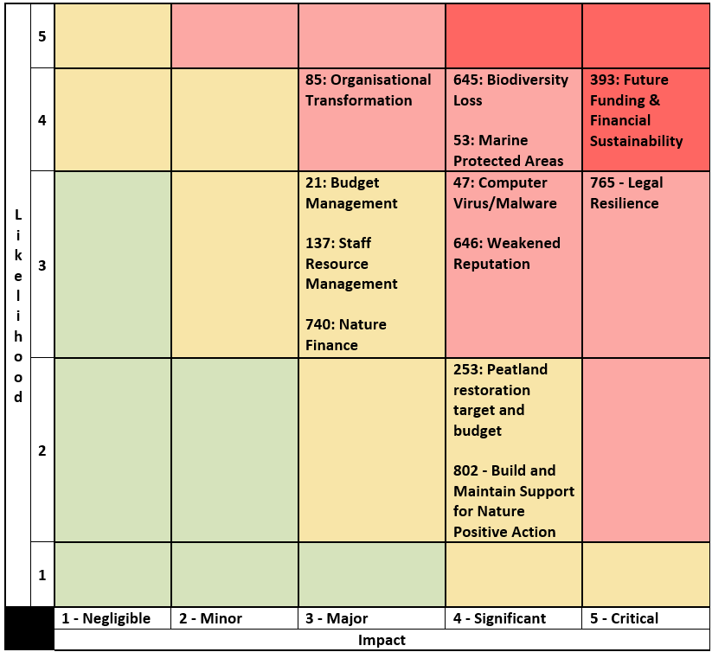

25/26 Q3 Corporate Risk Register Change Log
Change to Risk Register
↑ 1 NEW Corporate Risk Added
802: Threat to Support for Nature Positive Action
(Developed following ARC/Board Horizon Scanning Sessions)
↑ 3 Risk Scores Increased
53: Marine Protected Areas (From Medium to High)
85: Organisational Transformation (From Medium to High)
393: Future Funding and Financial Sustainability (From High to Very High)
Corporate Risk Register Refresh
- Following ARC and Board Workshops in Q2, 1 new corporate risk has been created, and 9 risks have been reviewed and updated.
- Q4 focus to develop outstanding ARC risk themes and support wider corporate plan development work.

Appendix 4 - Detailed Performance Report
Q3 BP Focus | Q3 BP deliverable
Lead the delivery of 30% of land and sea being protected by 2030
2.1 Finalise governance arrangements for Nature30 sites with PAC and Board. Undertake first Nature30 site process evaluation and refinement cycle. Agree arrangements for the new delivery model for 30x30 with Ops staff.  2.2 Launch final version of second (of six) Big Biodiversity Layer.  2.3 Publish Suite-level objectives for 30x30 sites, final Delivering Healthy Ecosystems Framework and complete pre-consultation stakeholder engagement on MPA management measures and publish NatureScot advice.  2.4 Provide support to Scottish Government on next steps as required including the stage 2 considerations of the National Park elements of the NEB. | 2.1 Scottish Government delegation of responsibility for Nature30 sites received. Process agreed in principle with Protected Areas Committee as has forward cycle of work to deliver this work. Heads of Operations have agreed delivery model.  2.2 Second BBL layer with GIG team ready for publishing  2.3 We completed internal briefings and planned external pre-consultation meetings (e.g. with local authorities) for the MPA management measures. Our MPA advice is ready to be published. (Consultation will not be launched until after the Scottish elections.)  2.4 Supporting Scottish Government as necessary

Build stronger collaboration reducing the impacts of deer and modernise our wildlife management and underpinning licencing functions to enable a net zero and nature positive future
4.1 Monitor and report on cull delivery in regulatory priorities. Submit Species Licensing Review to Ministers. Develop online licensing route map. Deliver deer incentive schemes and support SAOS larder and venison processing scheme.  4.2 Complete payments for Sea Eagle Management and goose management schemes.  4.3 Further development of the Scottish INNS Action Plan.  4.4 Delivery of licensing service within service standards, develop trapping licensing provisions and agree approach to licensing charging. | 4.1 Section 7 cull delivery being monitored and steering group held along with regular round of Autumn DMG meetings. Deer incentives scheme underway with deer app monitoring, increased support rates in CNPA and new scheme launched in LLTNPA. SAOS larder fund has been oversubscribed with additional £150K provided by Scottish Government. Species licensing review to be submitted by end Dec. Online licensing route map and approach to licensing system build reviewed by oversight board with resourcing for expanding twin track of maintenance and development being scoped.  4.2 Scheme MA offers all progressed and sent to applicants, with enhanced rates for SEMS scheme. Beaver release in Affric / Beauly Catchment, consultation underway in Ness – call for Expressions of Interests 28 responses collated throughout Scotland,  4.3 Scottish INNS action plan developed and out for consultation with stakeholders. INNS Funding seminar held.  4.4 We continue to deliver our licensing service in accordance with our Service Level Statement  An external review of our Species Licensing Review (SLR), which includes proposals for charging, has been completed and we have provided initial feedback on the review to SG. We are updating the SLR and will submit to SG in January. This will provide the basis for proposals for cost recovery.  A new Head of Licensing, was appointed in November 2025.

Online Licensing Performance Measure
Measure | Actual | RAG | Comment
Licences processed online | 355 | Amber | 73% reduction due to seasonal fluctuation in numbers

Engage and influence planning and other regulatory systems to ensure they deliver for nature and climate
3.1 Provide a report on our engagement with Renewables sector as part of Planning Performance Framework (PPF) reporting.  3.3 Develop a likely approach to peatland habitats. | 3.1 As part of the Annual Determination Timescales meeting with industry and Scottish Government, we participated in reporting our performance and have engaged in the Programme for Government of key agency planning services, the actions from which are due in late December.  3.3 The approach to the Scottish Planning Biodiversity Metric has evolved and the peatland approach is being developed with dependencies on other work in NatureScot. The expectation is that the development of an approach to peatland will continue into next year.

Influence the transformation of marine management through new marine planning, protection and fisheries management frameworks, and working with the marine renewable energy sector
1.6 Influence marine and coastal strategies and plans to deliver recovery and resilience of Scotland’s coasts and seas.  3.2 Deliver an effective programme of marine energy advice to secure compensation and nature positive development to meet Net Zero targets. | 1.6 Scottish Government published the Marine and Coastal Restoration Plan and (with other administrations) the UK Cetacean Conservation Strategy – both SBS actions. We had significant involvement in plan development and consultation. Shetland Regional Marine Plan also published following a lengthy development process.  3.2 We provided advice on 3 Offshore Wind applications with Supplementary Environmental Information, one S36 application and several cable applications. We also provided advice on draft Statutory Instruments as part of Energy Act reform and are finalising plans for Cost Recovery for Offshore Wind advice.

Marine Energy Consultation Performance Measure
Measure | Actual | RAG | Comment
Marine energy consultations | 90 | Green | Many pre-application and derogation consultations underway.

Scale up Peatland Restoration by delivering Peatland ACTION funding to projects
1.1 Manage and support £17m of grant offers to ensure project delivery will put 12,000 hectares of degraded peat on the road to recovery in 2025/26. Issue multi-year and new offers for project delivery in 2026/27. Continue to manage the Project Development Support Scheme to realise a longer-term pipeline of investable projects. Alongside technical work to develop the restoration sector, assess applications for piloting new Carbon Contract process to secure blended finance for projects in 2026/27 that will underpin acceleration of restoration with reduced public finance support. | 1.1 We committed £17m of grant offers/direct delivery agreements to meet 2025/26 target of putting 12,000 of degraded peatland on the road to recovery. We committed £8m of funds for project delivery in 2026/27. We continued to develop the restoration sector for further expansion and to develop our monitoring network and by exploring the scope of carbon contracts as a means of drawing in blended finance.

Peatland Performance Measure
Measure | Actual | RAG | Comment
Hectares of peatland recovery. | 4595 | Green | The figure is for projects completed to date in this quarter.

Demonstrate how agriculture can be transformed with new approaches to deliver targeted outcomes for nature and climate
1.2 Complete application assessments and make recommendations to Ministers. Secure Ministers’ approval for 2026 scheme and completed new amendments.  1.3 Help SG finalise the Tier 2 Greening measures to be launched in 2026. Secure ministerial approval for AECS 2025 budget and AECS 26 launch.  1.4 Participate in Technical Assurance Review with SG auditors. The recommendations will inform SG’s Agricultural Reform Programme (ARP) data strategy and whole farm plan development and how FarmBioScot App will be further piloted in 2025 and 2026. | 1.2 Completed AECS application assessments and made recommendations to Ministers.  1.3 Secured Ministers’ approval for 2026 AECS scheme and completed new amendments.  1.4 Completed Farm Biodiversity Scotland project ‘Measure’ phase testing and began developing ‘Management’ phase.

Influence the regulatory, policy, market and institutional infrastructure needed to stimulate private sector investment into nature
3.4 Continue to develop the prospectus.  3.5 Support continued FIRNS project delivery through technical advice and existing Community of Practice. | 3.4 Prospectus development progressing according to plan. Contract for the digital platform awarded to EOLAS and inception meeting covered. We aim to deliver the MVP by early March. The platform will connect with the Natural Capital tool, providing a deeper layer of data.  3.5 Contract to support FIRNS programme and projects awarded to SIS and first workshops/webinars delivered. FIRNS projects making progress and we will have good case studies to share next year. We are looking to the next round of funding.

Drive the establishment of Natural Capital as an integral part of public and private business planning and investment decisions at national, landscape and landholding/business scales
1.5 Scoping of food provision model as part of co-design process. Incorporate additional functionality into tool through further modules. Engage to promote the Natural Capital Tool.  3.6 Market infrastructure procurement: procure, contract and manage supplier. | 1.5 Task considered completed. Research done on what the food provision model would look like and the conclusion is that it wouldn't be a useful feature. Instead, we are adapting the tool to be more farmer friendly - changing our habitats to align with those used Farm BioScot and AECS.  3.6 Contracts effective and work ongoing.

Deliver new ways of working to stimulate achievement of our ambitions
5.1 Strategic Resource and workforce Planning: Deliver in time for start of the new Corporate Plan.  5.2 Conclude NatureScot Estate Strategy Review.  5.3 Implement back-office Information Management software. Prepare proposal for BI “Data Lake” and business case. GIS Programme: plan for migration of data, metadata, GIS services. Decommission end of life bespoke and on-prem applications.  6.1 Pilot: people management skills and leadership programmes for collective and individual leadership linked to IDGs, including IDG Leadership Labs Programme.  6.2 COP30: External and internal promotion. Virtual staff Conference. Nature of Scotland Awards: working with priority stakeholders to promote and support. Seasonal promotion of Make Space for Nature campaign and The Scottish Outdoor Access code’s 20th anniversary in 2025.  Accessibility: Lead contractor support for continued work to meet evolving accessibility legislation.  7.1 Test new SharePoint Learning Hub (People management skills). SIT Action plan delivery. | 5.1 Conditions for Success, which will guide transformation work including strategic resource and workforce (SWP) planning, are embedded in the new Corporate Plan. Cornerstones phase 1 to identify current resource deployment is well underway and scoping of SWP has begun.  5.2 SG signed off business case for Pullar House. Consultation with Battleby staff will start in 2026. The SG led space planning exercise for Inverness/Dingwall area is underway and a communication has been issued.  5.3 The upgrade to Windows 11 was successfully delivered. Virtual Private Network (VPN) replacement successfully implemented mitigating a major security risk and increasing available access times. GIS programme procurement/implementation is delayed, but migration plans are ongoing. Frontier Connect work to deliver office connectivity is substantially complete with visits proposed for Ayr and Bowmore (the last remaining offices) once BT complete the installations.  6.1 IDG Summit on “Bridging Polarities, From Inner Growth to Outer Change” was attended both in person and at “watch parties in Edinburgh, Inverness and Perth. Leadership Exchange programme Autumn cohort has been selected and provides a framework to offer an insight into different organisation cultures, constraints and opportunities.  6.2 Corporate Plan has received sign-off from Cabinet Secretary.  8 new SOAC 20 awards made including one to CEMVO. Successful SOAC network event hosted at Battleby with good coverage from Out of Doors. Preparation for spring MSFN campaign underway.  7.1 Learning Hub growing as more skills clusters added. Fusion data dashboards have been developed to support teams with people management. Four key recommendations arising from the Stress Indicator Tool have been agreed. Pay negotiations concluded and settlement agreed.

Measure | Actual | RAG | Comment
Sq meterage of Floorspace | 5335 | Amber | Slight drop in period due to review of space at Cupar
% of Implement Audit | 77% | Green | Priority 1 rate is 86%
Complaints | 32 | Amber | Around 75% still relate to Guga – numbers still high but reduced by two thirds
FOI | 100 | Red | A 27% increase in the quarter. Late to answer 4 requests.

