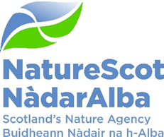

Title: Major Risk Themes to 2030
Date: 27 August 2025

Purpose: | Decision
Which of the current Business or Corporate Plan priorities does this topic drive forward and in what way? | Effective risk management is an integral part of our governance framework and is a cross-cutting activity that affects all of NatureScot’s business and corporate plan priorities.
Summary: | This paper presents key risk themes identified at an ARC workshop on the 10th June 2025, as well as areas of overlap with existing corporate risks. This horizon scanning exercise will inform a wider refresh of the corporate risk register as new risk areas are reviewed and consolidated against existing corporate risks to produce a single, refreshed strategic risk register alongside the publication of a new Corporate Plan.
Actions: | Consider which existing corporate risks and future risk areas may be especially significant over next corporate plan cycle. It is proposed that any future risk areas are reviewed and consolidated against the existing risks to produce a single, refreshed corporate risk register.
Recommendations: | The Board is asked to:  - note existing corporate risks;  - agree future risk areas identified by the ARC (paragraph 6 listed a to i);  - highlight any significant gaps and consider which of these may be especially significant over next corporate plan cycle; and,  - support a process to review and consolidate future risk areas against existing risks to produce a single, refreshed corporate risk register.
Report Author(s): | Philip Wilson (Risk Officer, Planning and Performance)
Sponsor: | Jane Macdonald (Director of Business Services and Transformation)
Appendices: Please note all appendices. | Annexe A: Corporate Risk Heatmap (end of Q1 25/26)  Annexe B: Corporate Risk Descriptions (end of Q1 25/26)

Background
- HM Treasury’s Orange Book (2023) frames risk against uncertainty and the possibility of an event which could impact the achievement of strategy and business objectives. Risk management is the systematic process of anticipating potential problems, evaluating their impact, and developing strategies to minimise or mitigate these risks.

- An ARC workshop was held on the 10th of June 2025. This included an open-ended discussion on key strategic risk areas which could significantly impact the next corporate plan cycle.

- This paper asks the board to review these additional risk themes, as well as existing corporate risks and consider which may be most significant, or if there are any critical gaps which could impact the next corporate plan cycle. This horizon scanning exercise will inform a wider refresh of the corporate risk register as new risk areas are reviewed and consolidated against existing corporate risks.

Current Corporate Risks
- At the end of Q1 25/26, there are 13 live corporate risks (See Annexe A Heatmap & Annexe B Risk Description). The public consultation exercise for inshore fishing activity management measures will also be added to the corporate risk register in Q2.

- Several existing risks will also be reviewed in the coming months as updated risk assessments could provide scope for consolidation:

- 3 financial themed risks - 21: Budget Management, 393: Future Funding & 761: Grant Funding Future Liabilities.
- 3 resourcing themed risks – 85: Adapting to Strategic Change, 137: Staff Resource Management & 755: Strategic Resource Management.

Key risk themes identified during ARC workshop
- Below is a minute of the key risk themes discussed at the ARC workshop on the 10th June 2025.

- Growth/economic agenda - nature based policies increasingly portrayed as a barrier to, and in competition with, economic growth so scope for our corporate objectives to become to less important, less relevant, and ultimately excluded, increasing the risk of reduced Grant in Aid (GiA) and private finance investment. What influence can we have? What levers do we have? How do we continue to have impact if this materialises?
- Polarisation of stakeholders – increasing polarisation will make it more challenging to make progress on delivering for nature. We try to walk the middle line – is this still the right positioning? Who are our allies? Likely to become increasingly difficult to engage with competing interests and build consensus to progress key objectives.
- Misinformation/disinformation/societal discord – how do we combat this? Difficult to counteract and increasingly hard to operate in this space. How do we persuade the public and be seen as the voice of truth on nature.
- Mission Creep - SG allocating work that is not within our core remit often carrying reputational risks. Potential to impact organisational coherence and drain resources from core work.
- Limitations of regulation – Land managers/owners already feel overregulated undermining capability and sustainability of state regulation as a tool to protect natural assets and strengthen climate resilience.
- Economic context shifts/supply chain changes – Linked to above in terms of the risk of losing levers to encourage land managers to act for nature.
- Cyber risk – will be ongoing and of increased risk.
- Underperformance over time – No clear consensus in terms of formulation and whether this was more of an internal matter, rather than an external risk for the organisation. Discussions focused on understanding how money is being spent, quantifying its impact and that investment aligns with what the organisation wants to achieve. It was discussed that there is a risk of not fully understanding performance which cumulatively over time could result in underperformance not being noticed until it is too late. The group also noted the role of delivery partners, as well as trusting and empowering them more.
- Public Sector Reform – although the group considered this unlikely in the current parliament, there could be a move towards significant redesign/amalgamation which would be resource intensive and impact our ability to deliver core objectives.

Analysis
- This section considers how the risk themes above link to current corporate risks.

- The first three themes all reflect external influences and a context of greater challenge and polarisation.

- Growth/economic agenda
- Polarisation of stakeholders
- Misinformation/ disinformation/societal discord

- This is not currently included on the corporate risk register but most closely links to Risk 646: Weakened Reputation. Other nature-based agencies have identified similar strategic risks. Natural Resources Wales position this in terms of strategic aims being relevant to stakeholders and communities. Natural England adopts a different geopolitical perspective. This has been regularly discussed at monthly Senior Leadership Team (SLT) risk reviews, and the current preference is to apply PESTLE analysis within existing risks rather than create a separate risk.

- Two themes highlight competing stakeholder perspectives, as well as multiple external factors which can prevent a bill becoming law in its intended form.
- Limitations of regulation
- Economic context shifts/supply chain changes

- This is not currently on the corporate risk register but is interconnected to several existing risks. For example, legislative approaches can provoke hostility and challenge so has a strong association with weakened reputation and legal resilience risks. Greater statutory responsibilities also impact systems and people so link to financial and resource themed risks. However, effectively monitoring any unintended consequences or behaviours is likely to require a suite of underpinning operational risks/indicators.

- Two risk themes highlight potential change to the organisational remit during the next corporate plan period.
- Public Sector Reform
- Mission Creep

- This could provide opportunities, whilst the production of a corporate plan should help provide focus over and above NatureScot’s Framework Agreement. This is likely to be a dynamic area of risk in the next corporate plan cycle and may be best captured against discrete or unforeseen pieces of work/changes.

- The risk of a cyber-attack is currently captured on the corporate risk register (47: Computer Virus/Malware) and will remain a key risk area.

- Currently, underperformance over time is not on the corporate risk register although non-delivery risks have been formulated against significant operational activities such as Peatland Action and Nature Finance. Although there was not a clear consensus amongst ARC members on including this as a risk theme, greater alignment of performance and risk could support the delivery of corporate plan objectives. In addition, this does link to business intelligence systems producing clear performance data which help to support sound decision making. This is under development as a mitigating action against 755: Strategic Resource Management.

Conclusions/Recommendations

- The aim of this exercise is to agree a finalised list of future risk areas. The Board is asked to:
- note existing corporate risks;
- agree future risk areas identified by the ARC (paragraph 6 listed a to i);
- highlight any significant gaps and consider which of these may be especially significant over next corporate plan cycle; and,
- support a process to review and consolidate future risk areas against existing risks to produce a single, refreshed corporate risk register.

- Monthly SLT meetings with risk management as a standing item will provide a forum to ensure oversight of this work.

Annexe A: Corporate Risk Heatmap (End of Q1 2025/26)

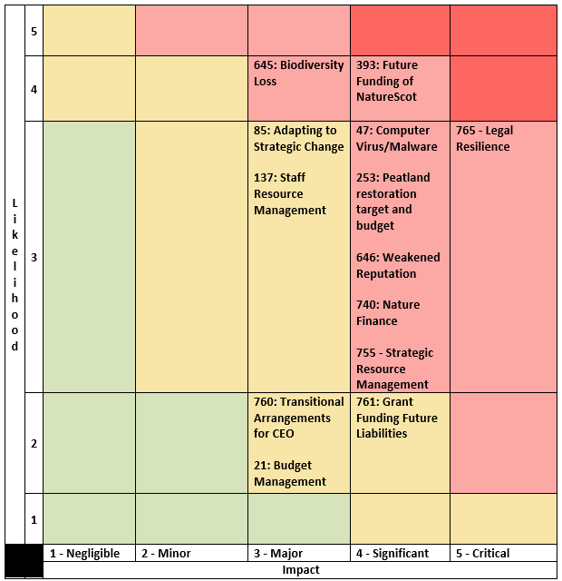

Annexe B: Corporate Risk Descriptions (End of Q1 2025/26)

Risk Description | Risk Score | Risk Rating
393: Future Funding of NatureScot  As a result of on-going reductions in public expenditure or new cost pressures there is a risk our grant-in-aid settlement may not match statutory and fixed costs as well as corporate plan priorities. Unless other funding sources are secured this could result in an inability to adequately resource delivery of agreed priorities, leading to failed outcomes and reputational damage.  Risk Owner: Jane Macdonald (Director of Business Services and Transformation) | 16 | High
765 - Legal Resilience  As result of complying with and overseeing existing legislation, as well as adapting to evolving or new policy, legislation and law, there is a risk that we do not have sufficient access to specialist legal advice nor utilise these services appropriately which may result in increased and potentially avoidable legal risk exposure and cost.  Risk Owner: Sandy Middleton (Chief of Staff) | 15 | High
47: Computer Virus/ Malware Attack  As a result of inadequate protection, or inappropriate system use, including accidental activation of email links by that lead to malware downloads, there is a risk that NatureScot systems becoming infected with a malware or virus agent, resulting in NatureScot systems and data become unavailable, encrypted or corrupted, significant system downtime and huge operational impacts.  Risk Owner: Kenny MacLean (Head of Information Management & Cyber Security) | 12 | High
253: Peatland restoration target and budget  As a result of a significant uplift in 25/26 funding and restoration targets (50% increase), there is a risk to climate, nature, and NatureScot’s credibility if NatureScot is unable to adapt at the pace and scale required to deliver this ambition within a complex operating environment.  Risk Owner: Peter Hutchinson (Head of Peatland Programme and Strategy) | 12 | High
645: Biodiversity Loss  As a result of not raising awareness, inspiring or persuading stakeholders to take the actions needed to reduce biodiversity loss that are within our influence, there is a risk that we will fail to demonstrate sufficient progress in tackling the biodiversity crisis.  Risk Owner: Katherine Leys (Head of Biodiversity and Geodiversity) | 12 | High
646: Weakened Reputation  As a result of NatureScot actions that are out of line with our strategic vision and purpose and goal as expressed through our Brand and Corporate Plan, there is a risk that our reputation would be weakened. If allowed to persist, it could result in the impairment of our ability to operate efficiently.  Risk Owner: Jason Ormiston (Head of External Affairs) | 12 | High
740: Nature Finance  As a result of any or all of poor governance; lack of due diligence; or poor communications, NatureScot’s reputation could be significantly damaged by misjudged or poorly delivered interventions to influence private investment in nature. There is also a risk that, if we do not proceed with the urgency required to stimulate private sector investment into nature, that significant nature restoration will be unachievable. There is therefore a balance of acting with due diligence, versus not acting at all. There are also specific risks attributed to individual projects or partnerships which are dealt with at the project level.  Risk Owner: Graham Neville (Head of Operations – North) | 12 | High
755 - Strategic Resource Management  As a result of inadequate strategic resource management there is a risk that NatureScot does not prioritise and allocate its staff resources effectively and efficiently. This could lead to NatureScot failing to achieve its Corporate and Business Plan outcomes.  Risk Owner: John Donnelly (Head of Finance) | 12 | High
85: Adapting to Strategic Change  As a result of unpreparedness for drivers of strategic change there is a risk that our responses may be misjudged or delayed. This could lead to increased costs in the future, poor outcomes for people and nature, and reputational damage.  Risk Owner: Marie Hernandez (Deputy Director, Business Services and Transformation) | 9 | Medium
137: Staff Resource Management  As a result of not understanding our strategic workforce requirements and how that matches with our available skills and training programmes there is a risk that NatureScot does not have the necessary staff skills and capacity to deliver its Corporate Plan outcomes.  Risk Owner: Carrie Strong (Head of People & Organisational Development) | 9 | Medium
761: Grant Funding Future Liabilities  As a result of annual funding from the Scottish Government and wider uncertainties relating to public finances, there is a risk that NatureScot takes on financial liabilities due to managing medium term ring-fenced SG funds (PA/NRF/FIRNS), as well as offering multiyear funding awards which would have to be met from Grant in Aid if Scottish Government’s ring-fenced funding streams were to reduce or not be renewed.  Risk Owner: John Donnelly (Head of Finance) | 8 | Medium
21: Budget Management  As a result of inadequate management and monitoring of the variables around the allocation and spending of NatureScot’s grant in aid budget, there is a risk of a significant underspend or overspend against our annual budget which would represent poor utilisation of public funds towards nature recovery with reduced confidence in our financial management and possible future budget restrictions/penalties.  Risk Owner: John Donnelly (Head of Finance) | 6 | Medium
760: Transitional Arrangements for CEO  As a result of an extended period without a formal appointment to the role of Chief Executive there is a risk that there is organisational uncertainty about the long term direction of NatureScot which may result in strategic drift and the risk that key organisational outcomes are not achieved.  Risk Owner: Sandy Middleton (Chief of Staff) | 6 | Medium

