Living with Wildlife: Intervention in Wildlife Management

Purpose
- Across public/private land management and conservation sectors there is a need to understand, further evolve and communicate current interventions to modernise wildlife management. Specifically:
  - Identify the strategic principles and policies
  - Identify the delivery mechanisms available
  - Prescribe and prioritise the approach to intervention.

Background
- Intervention should be related to the delivery or safeguarding of public interests and include:
- Biodiversity (halting loss and recovering)
- Carbon/climate change
- Agriculture
- Public safety
- Supporting socio-economic development
- Safeguarding public health

- Intervention may be undertaken through
  - Licensing or change to legislation,
  - Finance
  - Population management (both reduction and enhancement).

While a range of policies and legislation can provide a frame, that frame is perhaps more a reflection of where we have come from rather than where we want to get to. The predominant legislation dates back 40 years. We need to apply more dynamism to our actions in meeting the climate and biodiversity challenges. Does this existing frame support the ‘what, where and how’ surrounding intervention issues?

- There is a spectrum in terms of species protection and intervention dependant on the viable population level of a species, from strict protection, where NatureScot can in some circumstances provide the (licensing) tools for effective management through to opportunities for de-regulation and more effective management (lethal control of deer). Adaptive Management might use the data gathered to enable positive management to be introduced to protect a species (predator control), while local abundance may suggest that harvesting is sustainable (grouse). The tipping points in these decisions to intervene will vary in each situation and rely upon regular monitoring through information gathering.

- Finance in support of managing populations or mitigating impacts of some protected species such as geese, sea eagle and beaver on agriculture interests may be implemented under specific support schemes. Incorporating elements of wildlife management within future rural support could better integrate and facilitate land managers supporting species, increase opportunities for biodiversity benefits and support practices for living with nature and delivering a range of wider public benefits.

- Modernising wildlife management is challenging to all sides and will require movement as to how the precautionary principle is applied, particularly to at-risk species. Despite increasing efforts to secure better monitoring, decisions will continue to be made in the absence of complete robust data. As such wildlife management will need to better combine practical knowledge with data gathered through monitoring.

- When making decisions should we move to a less risk adverse position where the judgement is around on balance more good than harm is likely, rather than one of requiring certainty as to the outcome?

- Addressing misinformation and the inherent suspicions across the sector must be a key target for partners and developing a shared understanding and collective position is essential.

Action
- As a first stage, members are asked to consider and discuss the following:
- How do we decide when to intervene?
- What different tools are available?
- How do we set priorities?

Strategic Wildlife Land Manager’s Forum
3rd April 2025

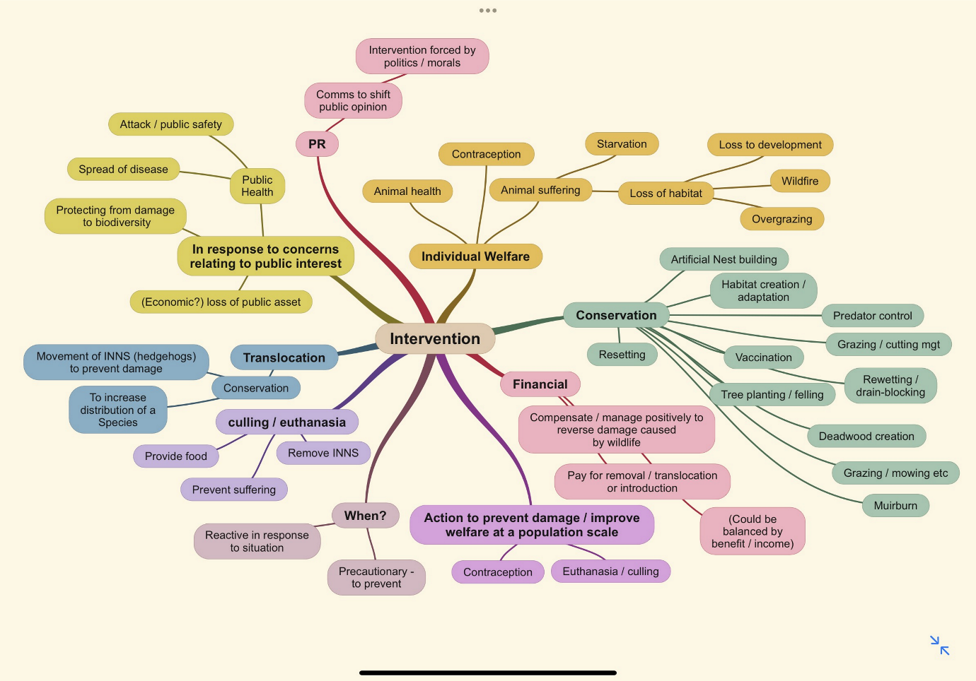
Fig 1. Intervention routes and purposes.

Intervention in this case is taken to range across incentives and regulation

