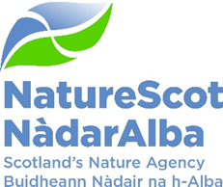

Title: Q4 Performance Report and 2024/25 summary
Date: 15th May 2025

Purpose | For Information
How does this link with our corporate priorities of improving biodiversity or delivering nature-based solutions to climate change: | This paper presents Q4 progress towards delivery of our corporate priorities as laid out in our Business Plan, A Nature-Rich Future for All: Year 3 and a brief summary of our achievements in 2024-25.
Summary: | At the end of Q4, performance for 11 of our Corporate Plan objectives is rated as green with 4 rated as amber. There is a small overspend forecast on the Resource and Paybill budgets reflecting in year surrenders to be made and an increase to the paybill forecast. Capital is currently on track and Indirect Capital is currently forecasting an underspend. Action is being taken to achieve full spend on funding programmes. Two new corporate risks have been added, and the score has increased for three risks. In the People Report, six indicators are green with one, ‘Capacity’, rated as amber.
Actions: | To agree the recommendations below
Recommendations: | Board is asked to:  - Note the overall performance of the Corporate Plan objectives (Performance Report)  - Note the performance summary and the selection of some of our key achievements for 2024-25  - Note the position of the resource and capital budgets (Finance Report)  - Note the performance of the corporate risks (notably the inclusion of two new risks and increased scores against five existing risks).  - Note the overall performance of the people measures (People Report)
Report Author(s): | Authors – Directors, Deputy Directors, Strategic Resource Managers, Finance, Planning and Performance Team, POD Team
Sponsor: | Jane Macdonald
Annexes | Annex 1 – Corporate Risk Register (High Risks)

Purpose
- This paper presents NatureScot’s performance for the final quarter of 2024/25 and provides a brief overview of achievements in 2024-25. It addresses delivery of our corporate priorities by reviewing performance against our Business Plan; progress towards maximising our available budget; assessing risks for delivery; and information on how our people are supporting the resourcing of our work.

- This year the Corporate Plan priorities were refined into 4 areas of focus for 2024-25 which stimulate the key actions towards delivering our 2030 and 2045 targets to reduce biodiversity loss and restore nature. These areas of focus align most closely with the objectives identified in brackets. In summary, the Areas of Focus are:
- Agricultural transformation and land use change (Objective 8).
- Directing effort into nature expanding out from land and marine Protected Areas, safeguarding 30% of Scotland’s special nature locations by 2030 (Objective 1).
- Creating the conditions for increasing public and private nature finance in Scotland, essential to stopping nature’s decline by 2030. (Objective 10).
- Strengthening approaches to species management such as deer, beaver, and invasive species for positive nature outcomes. (Objective 2).

Q4 Summary

- The report against our objectives, in common with previous quarters shows strong progress. We have delivered a range of foundational work which will set us up for success in the coming year. This has included continuing to build our online licencing capability, the successful delivery of peatland targets, progress with key actions to deliver 30x30 including approval of OECM draft criteria and approach approved with 20 pilot sites currently under assessment.
- Our financial outturn is positive in regard to resource expenditure. Figures are still being finalised, but we are showing a very slight overspend on our resource budget which shows the strong demand for our services and the effective stewardship of our funds.
- Our work in the Marine environment continues to be varied and complex so it was heartening to receive positive feedback about the quality of the work we are doing where our “thorough and productive” response was acknowledged in a major offshore project. This shows how our emphasis on providing a quality response remains despite the increasing volume and complexity of the work.
- However, we are beginning to see increasing risks to our longer-term position. This has been reflected in our dynamic approach to identifying and managing risk. We have increased the risk likelihood of a weakened reputation because of the increase in proactive issues management that we have been experiencing. We have also increased the risk score of the impact of the interim period for the Chief Executive due to the lengthening recruitment timetable and forecast turnover in SLT. We have introduced two new corporate risks relating to legal challenge to our work and longer-term financial liabilities related by Peatland Restoration funding.
- The UK and Scottish Governments’ ambition to rapidly increase the generation of offshore and onshore wind power has led to us commencing a review of our capacity. We have received an external consultancy report to look at Offshore implications. Other analysis documents are available from organisations, in particular, Scottish Renewables, which point to significant pinch points in Onshore across a number of different public sector organisations. The Chief Executive is leading representations to the Scottish Government about potential bottlenecks and the impact on resourcing, and our wider objectives, if we are to support the substantial increases which are forecast.
- The work on the new National Park is drawing to a close. A substantial number of consultation responses were received and have been reviewed. Recommendations for the Scottish Government are close to being finalised in line with NatureScot’s statutory duty as a Reporter.
- Quarter 4 has seen the development of the Business Plan for 2025-26 which is the last year (Year 4) of our current Corporate Plan “A Nature Rich Future for All”.
- The plan has further developed the focus on a reduced number of priority areas and is structured around four foundation blocks. Twenty key externally facing actions have been identified, which is a considerable reduction on the 62 “we will statements” in the Year 3 plan and that are presented in this report. A leaner suite of reports will be developed for SLT and Board scrutiny for 2025/26.
- A project board led by the Head of External Affairs has been established to guide the development of a new Corporate Plan and a Project Manager has been appointed.

- PRIORITY PERFORMANCE | NUMBER | CORPORATE RISK | NUMBER
Objectives | 15 | Corporate Risks | 14
On Track | 11 | Increased Score | 5
Minor Slippage | 4 | Decreased Score | 0

FINANCIAL METRICS | STATUS | PEOPLE METRICS | STATUS
Resource Budget | On Track | Health, Safety and Wellbeing | On Track
Capital | On Track | Attendance | On Track
Indirect Capital | Major Slippage | Workforce Profile | On Track
Paybill | Minor Slippage | Employee Relations | On Track
Project Allocation | Minor Slippage | Capacity | Minor Slippage
 |  | Retirement Profile | On Track
 |  | Employee Engagement | On Track

Summary of Performance for 2024-25

- Throughout the year the performance against our 15 delivery plan objectives has been consistently strong. Generally, Delivery Plans are marked as green indicating that we delivered what we have set out to achieve in our 2024-25 Business Plan and our 90-day plans. Where there has been the occasional slippage, triggering an amber rating, this has been due to delays elsewhere in the system, resource challenges or changing priorities. However, that no delivery plan has been marked as red at any point in the year, demonstrates the commitment, skill and the strong foundations on which NatureScot is built.
- We know that continuing to deliver such a strong performance will become increasingly challenging. Tighter budgetary settlements, growing urgency around the twin nature-climate crises, coupled with the ambition for sustainable economic growth, underpinned by renewable energy and increasing questions about the achievability of Net Zero, will place us under increasing pressure in the years ahead. As we have done this year, we will continue to focus on delivering, exceptionally well, the outcomes articulated in our business and corporate plans.

- A full account of our work and our impact will be available in our Annual Report and Accounts 2024/25, so what follows is a selection of some of our key achievements illustrating the breadth and depth of our outstanding work. This includes:
- The rollout of our artificial intelligence (AI) powered InformedDECISION™ planning advice tool, nationally in February 2025 transformed our management of our casework service. The platform harnesses AI to support and accelerate decision-making by expert case officers.
- We were consulted on 705 planning applications (excluding pre-application consultations) and we have been involved in two Public Local Inquiries for the Kirkton Wind Farm proposal and the Coul Links Golf Course proposal, both in Highland.
- We assisted with developing OSPAR’s best practice guidelines for seagrass restoration and published NatureScot’s guidance for Native Oyster Restoration in May 2024. Guidance is being developed for baseline monitoring for seagrass restoration to ensure comparability amongst the SMEEF/ SSEN seagrass fund projects.
- We increased deer culling and are working with the Strategic Deer Board to make the case for incentives for deer management. We successfully ran three trials in 2024/25 and will repeat them this year.
- We have focused on ensuring our licensing service meets our licensing service level statement. This has involved dealing with 5,004 licence applications and we issued 4,016 licences. Our online licensing functions have been developed which now services 5 application types; 63% of all licences are now delivered through the online licensing service (including deer).
- We developed the policy approach, published a code of practice and licensing scheme for grouse culminating in 258 applications being assessed and issued. Significant work has been progressed to develop the licensing approach and code of practice for Muirburn. The Scottish Government commissioned Species Licensing Review has been undertaken and will be submitted to Ministers.
- The number of complex marine consultations received has increased, with more scoping reports, s36 applications, additional information and derogation casework to manage which has required the recruitment of additional staff.
- We piloted the first stages of a farm biodiversity auditing process with a mobile app and web platform called Farm Biodiversity Scotland, supporting farmers and crofters to carry out a biodiversity audit. Around 250 farmers and crofters were engaged in testing the app in 2024 and were able to create a biodiversity audit habitat map for their farm or croft as part of the piloting process.
- A total of 68 projects supported through the Scottish Government’s Nature Restoration Fund (NRF) delivered activity this year including multi-year Transforming Nature projects continuing into 2025/26. The NRF decision panel met on a quarterly basis with 45 projects awarded funding. This included twenty new recipients to NRF, demonstrating a similar demand to the programme from both new and previous NRF recipients.
- Under the Agri-environment Climate Scheme (AECS), there were 375 applications submitted in the 2024 round, of which 131 were assessed by NatureScot staff. 110 of these have resulted in a 5-year AECS contract, with a value of £6.8m.
- In 2024/25 we welcomed over 1 million visitors to our National Nature Reserves. Over 15,000 people joined us on nature focused events, learning visits, demonstration days, training and volunteering. We funded large-scale projects to restore coastal habitats at Tentsmuir and Loch Fleet, planted over 3000 trees at Cairnsmore of Fleet and this year saw the highest annual counts of grey seals at Forvie and puffins on the Isle of May.
- We secured another round of funding for the FIRNS grant programme which is co-funded by the National Lottery Heritage Fund. The value of investment in grant awards will increase from around £4.6m to approximately £6.4m by the end of March 2026.
- The Natural Capital Tool has progressed to the testing stage. The tool has been designed to enable utilisation of a natural capital approach by identifying the benefits of interventions to maximise ecosystem services through a range of measures.
- We commissioned research into how we can attract more young people into game and wildlife and rural skills apprenticeships. We attended 27 career events targeted at students and graduates. The highlight was our ‘Meet the Professionals’ webinar, where Springwatch favourite Ajay Tegala provided an inspiring insight into life as a Wildlife Ranger.
- Our media reach climbed to its highest level ever this year, to over 2 billion for the first time, an increase of 17%. There are several reasons for the substantial increase including the media’s continued interest in climate change and nature and our reputation as a trusted, expert and reliable source.
- Under our Nature Scot Way delivery objective, we continue to support public sector reform specifically estates rationalisation and we have invested in the improvement of our digital services whilst ensuring we have robust safeguards against cyber threats. Our people programme continues to ensure we invest in our staff which this year included the roll out of career conversations, which are designed to ensure a longer-term focus on career development and the future skills and competencies required by NatureScot’s people.

Performance Report

WE HAVE PROTECTED NATURE
CORPORATE PLAN OBJECTIVE | SLT LEAD | RAG SCORE | Q4 UPDATE
1. Lead the delivery of 30% of land and sea being protected by 2030 | Eileen Stuart | Green | - 30x30 - OECM draft criteria and approach approved. c20 pilot sites currently under assessment.  - National Park - Consultation concluded, analysis of consultation responses begun and independent review of our engagement and consultation commissioned. With over 5300 responses received and over 1110 members of the public attending this consultation has been the largest and most challenging one NatureScot has undertaken.
2. Build stronger collaboration reducing the impacts of deer and modernise our wildlife management and underpinning licensing functions to enable a net zero and nature positive future | Robbie Kernahan | AMBER | - AMBER rating relates to resilience and capacity for online licensing and impact on delivery of muirburn licensing delivery.  - Deer – support to SG in developing Natural Environment Bill deer provisions, published in February, delivering DWG recommendations and including new powers for intervention to deliver enhancement and restoration.  - Regulatory approaches - Section 6 requests for plans, Section 7 agreement delivery and a Section 8 case with Ministers along with delivery of incentive pilot schemes in South Loch Ness, Central Scotland and in the Cairngorms National Park.  - Licensing - delivered and implemented new Grouse licensing provisions.  - Working to deliver muirburn licensing by September 2025.  - Preparations for Gull licensing to address ongoing concerns.  - The Species licensing review is progressing.  - Species Conflict - We have delivered Sea Eagle and Goose schemes on budget. A SEMS funding uplift was secured from SG and the scheme is being rolled out.  - The Goose Policy Action plan has been consulted on. We are reviewing comments prior to submission to SG and Ministers.  - Beaver management and mitigation scheme - beavers released in the Spey catchment along with some translocation to England.  - INNS - The Scottish INNS action plan commission has been agreed with SG.
3. Engage and influence planning and other regulatory systems to ensure they deliver for nature and climate | Robbie Kernahan | GREEN | - Development Planning - engagement with planning authorities on their topic papers and evidence reports. For the few authorities who were cleared at gatecheck, discussions are moving to site appraisals and how the key agencies will respond.  - Biodiversity Metric - Good progress made on addressing the array of issues associated with the metric and peatland. Work to provide interim public guidance on the differences between the English metric and the SSE metric has begun.  - Engagement with Renewables/Energy Sector - Input around the new arrangements for priority transmission projects has taken up time. The status of the SG Peatland Expert Advisory Group (PEAG) has been revisited by SG.  - Inquiries - Decision on Earraghail windfarm to refuse based almost entirely on our evidence at Inquiry on impacts to the NSA. Preparation is underway for Melvich inquiry and unexpected involvement in An Carr Dubh windfarm.  - Development Management - InformedDECISION rollout completed. Communicating with staff on ongoing improvements. We were unable to complete marine workflow.
4. Influence the transformation of marine management through new marine planning, protection and fisheries management frameworks, and working with the marine renewable energy sector | Eileen Stuart | GREEN | - Coastal adaptation and blue carbon - Delay to installation of flux tower but progress made in transfer of asset to UKCEH and review of site options in Caerlaverock.  - Communications - MD delayed stakeholder event until Ministerial announcement. Local Authority briefing sessions on MPA & PMF management measures complete.  - Data - Marine Recorder Online development sprints funded by NatureScot have been delivered by contractor.  - Marine energy - Responses submitted on Caledonia and Muir Mhor. Scoping advice for Cerulean Winds. Advice on draft assessments supporting the SMP OW. Workshop held with ENFOR colleagues re cost recovery report recommendations.  - Enhancement - Contributed to workshop for Marine and Coastal Restoration Plan and responded to SEA screening and scoping consultation. Baseline survey and monitoring guidance to be used on SMEEF SSEN seagrass projects.  - Monitoring - Inshore benthic and marine mammal monitoring programme submitted to Marine Directorate. Seabird colony monitoring plan agreed with SG.  - Marine protection - Delay to publication of outstanding Conservation and Management Advice documents and fisheries guidance notes.  - Marine reporting - Hab Regs reporting: Agreement on scope of marine elements of Scottish report not delivered, focus has been on coordinating delivery of the Hab Regs Article 9a assessments.  - Marine development - Provided robust advice on marine INNS casework in Loch Creran SAC. Working arrangements update was deferred by MD.  - Marine fisheries - Provided advice to MD on wrasse fishery assessment and finalising advice on razor clam trial.

WE HAVE RESTORED NATURE
CORPORATE PLAN OBJECTIVE | SLT LEAD | RAG SCORE | Q4 UPDATE
5. Co-lead the production of the new Scottish Biodiversity Strategy (SBS) and develop targets to include in a new Natural Environment Bill | Eileen Stuart | GREEN | - Work has begun work on the Scottish Biodiversity List for habitats and for commission sign-off. This has to be completed within 1 year of SBS publication.  - Completed one SBS action this quarter (plant genetics) and expect to conclude the work identifying) the 6 landscape areas by the end of the month
6. Scale up Peatland Restoration by delivering Peatland ACTION funding to projects | Robbie Kernahan | AMBER | - AMBER rating - on track to exceed target of 7,400ha by 20%, attracting £2.5m of private finance and £900k of external funding and reducing costs from £1300/ha to £850/ha. Amber score reflects underspend of budget by approximately £2.3m.  - Resource Spend projected to be £3.7m, 5% slippage on the £3.9m budget. Due to updating staff costs and slippage on the new grants management project.  - Indirect Capital Spend projected to be £9.1m, a 24% slippage on the £11.9m budget. This is primarily due to project slippage, reduced costs of projects due to £2.6m of private investment and £0/9m secured from the Shared Island Initiative.
7. Lead, enable and convene others around the development of ambitious and coherent actions to restore nature. Deliver a major Nature Restoration Fund (NRF) targeted at high impact nature recovery projects and seeding greater investment from the private sector | Eileen Stuart | GREEN | - The NRF panel approved further projects for the final year of NRF. All our funds committed and in discussion with SG about potential additional funds for next year.  - Worked with FLS and other government agencies to develop the long list of landscape partnerships and prioritise them.  - Completed standing guidance for wildcats but delayed publication so RZSS can hold an engagement session with stakeholders and incorporate any changes.  - Started on Scottish Biodiversity List (SBL) commission. Requested a SAC sub-group to provide support. Worked with marine colleagues to understand how the commission will align with marine developments.
8. Demonstrate how agriculture can be transformed with new approaches to deliver targeted outcomes for nature and climate | Robbie Kernahan | GREEN | - Further Biodiversity Audit habitat mapping functionality and associated guidance built into the app and released in March for end user testing.  - AECS 2024 application round - issued and concluded contracts for approved applications. Preparations ahead of 2025 AECS application round which opened in February. Work commenced on amendments for AECS 2026 application round.  - High Nature Value (HNV) Farming Indicator - Developed a case, and approvals, for delivering a HNV farming pilot project to commence in Q1 2025/26.

THE VALUE OF NATURE IS RECOGNISED
CORPORATE PLAN OBJECTIVE | SLT LEAD | RAG SCORE | Q4 UPDATE
9. Inspire people to connect with nature, increasing appreciation of nature’s value through impactful delivery and communication of our work | Eileen Stuart | GREEN | - National Nature Reserves - Strategic 10 year plan developed for Board consideration and a Scotland wide audit of all NNRs by the NNR Partnership completed. Infrastructure projects at St Cyrus (storage and workshop space), Taynish (visitor shelter), Ben Wyvis and Knockan Crag (large-scale path works) and St Cyrus (visitor centre refurbishment) completed and the car-park income generation pilot commenced.  - Learning for Sustainability - Greenspace survey of school grounds commissioned with Learning for Sustainability partners.  - SOAC promotion - Spring campaign progressed including celebration of SOAC 20th anniversary on 9th February 2025, a new tool-kit and new content creation.  - Access and visitor management - Preparation of the Visitor Management Strategy (VMS) Action Plan 2025 and input to a refreshed strategy led by Visit Scotland. Improved guidance on managing fires and access rights completed.  - Health and participation - Publication of Green Health Partnerships evaluation report and first meeting of the Public Health Scotland (PHS) led Greenhealth Learning Network.
10. Influence the regulatory, policy, market and institutional infrastructure needed to stimulate private sector investment into nature | Robbie Kernahan | AMBER | - AMBER rating owing to not having yet secured investment nor sold carbon ahead of end of FIRNS, meaning project risks being unable to "demonstrate price premium" via actual reported sales (as per FIRNS grant award).  - The Flow Country - The first pilot phase is complete ahead of schedule. Second pilot close to completion on schedule. Discussions focussed on agreeing scope of third pilot with common grazing. Funding secured via Peatland Action for capacity for pipeline development beyond end of FIRNS project.  - FIRNS - All Round 2 projects continuing delivery until March 2025, when final claims are due. Third and final block of Community of Practice events are underway, ending in April.  - Round 3 was approved by Ministers on 30th January and launched on 5th February 2025, with a mid-March application deadline.  - Round 1 evaluation being repurposed at request of SG. Six case studies drafted. Grants map ready for publishing on NatureScot FIRNS webpage.  - SMEEF - The first privately funded grant round remains ongoing, with £180,000 of £268,000 awarded now claimed. An additional £300,000 has been agreed with Scottish Hydro Electric Power Distribution for the Seagrass planting fund, increasing the fund to £2.4m, to be allocated over four years.  - PINC Peatland Programme - Drafted a pilot plan to give a route map of actions for the next phase of the project.  - Nature Investment Partnership: UKIB funding of £50m for Aberdeen Climate and Nature Impact Fund (acanif) confirmed in November 24. Abrdn now in discussions with major investors. Progress has been slow and no additional funds confirmed yet.
11. Drive the establishment of Natural Capital as an integral part of public and private business planning and investment decisions at national, landscape and landholding/business scales | Robbie Kernahan | GREEN | - Natural Capital Tool timeline pushed forward but still on track for Beta-Minimum Viable Product release in April  - Natural Capital Asset Index (NCAI) published in February on our website.  - NC policy and plans - Contributed to SG report to present all evidence of NC and supported NC Forum Roundtable on incorporating NC in policy and planning.
12. Promote understanding and awareness of skills and capacity needs for the nature-based sector | Eileen Stuart | GREEN | - Research on Rural Skills and Game and Wildlife Apprenticeships completed, publication likely to be end of April.  - Statement of Requirements in progress for future research into Building Capacity in the Agriculture Knowledge and Information Service (AKIS) to deliver practical advice on transforming farm systems to more regenerative models.  - Delivered successful 'how many deer' activity at the Dynamic Earth Green Careers event- c.1100 school children attended event  - 6 Working with Waders events delivered successfully  - 80% of the STEM Ambassador cohort have completed the training and enrolled.

WE HAVE TRANSFORMED HOW WE WORK
CORPORATE PLAN OBJECTIVE | SLT LEAD | RAG SCORE | Q4 UPDATE
13. Deliver new ways of working to stimulate achievement of our ambitions | Jane Macdonald | GREEN | Estates  - Galashiels – Relocation of the Galashiels office to Tweedside Park was completed. Dilapidations for the former office settled with the landlord.  - Stirling – Strathallan House suffered significant damage during the winter storms and the building has been closed since. Temporary office accommodation has been secured. SEPA are negotiating the lease at Strathallan House, with the possibility of NatureScot being given notice to terminate. An options review has commenced which includes affected staff.  ITIP  - A refreshed Information and Communications Technology (ICT) Strategy 2025-2028 has been launched.  - All SWAN1 sites have been replaced by FrontierConnect.  - Work on data replication/backup, to improve resilience and security, has been impacted by staff time diverted to assist with reactive/ technical and support issues during Q4. Data replication work will now roll over into Q1 2025/26.  - Win11 planning is complete. The update will impact the legacy Single Sign On (SSO) solution still used by legacy Apex and Java apps (e.g. Book-it, Flexi). Discussions are currently underway to address this critical issue.  Digital Delivery  - The 2025/26 programme has been developed to include addressing “technical debt” by reducing reliance on legacy applications and enhancing resilience within the development team.  - Ecosystems Management Insights (EcoMI) tool launched, improving the efficiency and quality of our protected areas monitoring.  - Informed Decision is live bringing the benefits of artificial intelligence and automation to the consultation and decision-making process.  Net Zero  - A review of the current Net Zero Plan (2019-2024) is almost complete, which identifies successes, areas for further work and gaps in knowledge.  - Fortnightly Net Zero ‘sprints’ have been set up with five of the key activity teams in NatureScot property, fleet, procurement, digital systems and land use.  Data  - Better Biodiversity Data (BBD) phase 1, to implement Scottish Biodiversity Information Forum (SBIF) recommendations to better store, manage and access valuable biological data complete and final claim submitted and approved.  - Land cover and habitat data project concluded and presentation of final report given to Steering Group.  Communications  - Make Space for Nature winter campaign exceeded targets, with 1.3 million radio listeners and 1.26 million digital impressions, and engaged with diverse audiences, particularly 'harder to reach' older, young adult and male demographics.  - Accessibility work progressed to meet legislation and ensure accessibility requirements are met. Accessibility Testing Policy published through Digital Delivery Programme.
14. Transform our individual and collective leadership capability | Jane Macdonald | AMBER | - Continue to embed IDGs into leadership development including work with Natural Resources Wales (NRW) to present IDGs to DEFRA, and agreement from the IDG foundation for NatureScot to become an IDG Centre.  - Strategic Workforce Plan paper is being drafted.
15. Sustain our focus on developing a happy and resilient workforce | Jane Macdonald | GREEN | - Fusion Recruitment and Learning sprint to improve implementation of recruitment and learning functionality has now concluded.  - Stress Indicator tool went live in March 2025. Analysis of results and action planning will take place in Q1.  - Career Conversation training continues, with further participation from our leadership community being encouraged.  - Skills framework scoping taking place. Nature skills live testing delayed due to issues digitising the product.  - POD Helpdesk has now been implemented

Performance Dashboard - Headlines
Protect
MPA Stakeholder interest is recovering from the change in data with improvement work still happening in the background. Marine Restoration projects continue to expand their area of work. License application standards still do not exist and have no KPIs so are not reported. Licence numbers processed through the online system have slowly been climbing as new licenses are added to the system. Beaver catchments numbers have flatlined with the slow negotiation with different landowners. Percentage of holding objections after recent fluctuations has also flatlined.
Restore
The biodiversity audit is continuing its trial leading to a delay in the confirmation of the measure. Marine Renewable consultations show a consistent pattern. NRF New Recipients will be developed to illustrate the new aspects of NRF. The SMEEF programme is ongoing and demonstrates a consistent amount of money raised each quarter. Peatland continues to show growth in their seasonal hectares with a growing number compared to previous years.
Value
The Make Space for Nature involvement has been progressing with relevant creators and an expansion of reach and viewership. Landscape Natural Capital has had ongoing delays so cannot report. Skill creation and engagement with young people has had a major boost with recent work showing successful outcomes. NNR Online engagement appears to have plateaued over the long term, but this has been affected by the change in Google analytics. Private Finance investment is developing metrics for future measurement.
Transform
It can be inferred that office floor space is showing a downward trajectory. The work currently underway should enable updated baseline statistics for future reporting.

WE HAVE PROTECTED NATURE
Measure | Performance Overview | Actual | Cause | Response
Stakeholder interest in MPA Information (hits on webpages) | 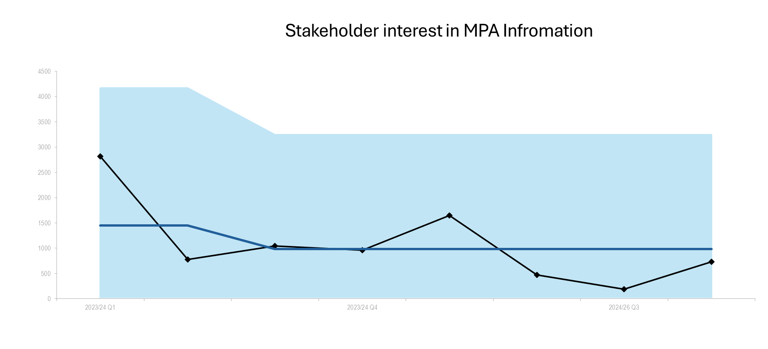 | 731 | The change in the way that website stats data is recorded, that led to the huge drop in page visits recorded over the last couple of quarters, has stabilised now the data only records "Engaged Visits", visits of more than a few seconds, as opposed to all visits. So, it has been a relatively good quarter, with more visits this quarter than the previous two combined. Although numbers are still relatively low, engagement is exceptionally high 91% for 2 pages and 96% for the other (compared to the world average of 70%). This shows that those who do visit the pages are spending time and reading the whole page. The breakdown this month is MPA - 352, PMF, 352, Enhancement - 27. | We aim to keep engagement high but to increase traffic to the marine webpages. We have recently created a landing page that brings all marine content together in one place, and we have placed buttons on our main pages that link to the landing page, to make it easier for users with a specific marine interest to get an overview of our marine work. We are well into to the process of transforming the 'Enhancement' page into our page for the PMF/MPA fisheries management measures consultation. Recording the stats on that page here should help give us an indication of the level of interest in the consultation and the supporting information our website will provide. We will also update the MPA and PMF pages as part of this process.
No. of restoration projects for which we’ve provided advice | 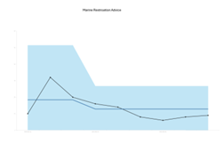 | 9 | In Q4, we have continued to advise projects actively engaged in marine and coastal restoration, as well as to provide advice to potential projects and in relation to developments involving enhancement activities. | We have also fed into areas of work led by Scottish Government colleagues (such as the proposed Marine and Coastal Restoration Plan and the Catalogue of Measures), and OSPAR. We expect the enhancement field to grow in the 2025/26 financial year with new projects starting to actively restore habitats.
License applications turnaround time within standards | Null | --- | We are not in a position to be able to advise whether or not the licences have been issued in accordance with an agreed turnaround time, because the database algorithm does not reflect the turnaround times defined in our service level statement (SLS). We may have missed the SLS agreed time but met the requested date on the licence application. | Aiming to look at a work-around to be able to conduct analysis of turnaround in Q1 to then report in Q2. Technical issues or lack of staff resource may prevent this.
No. and Types of licenses that are processed through the online system | 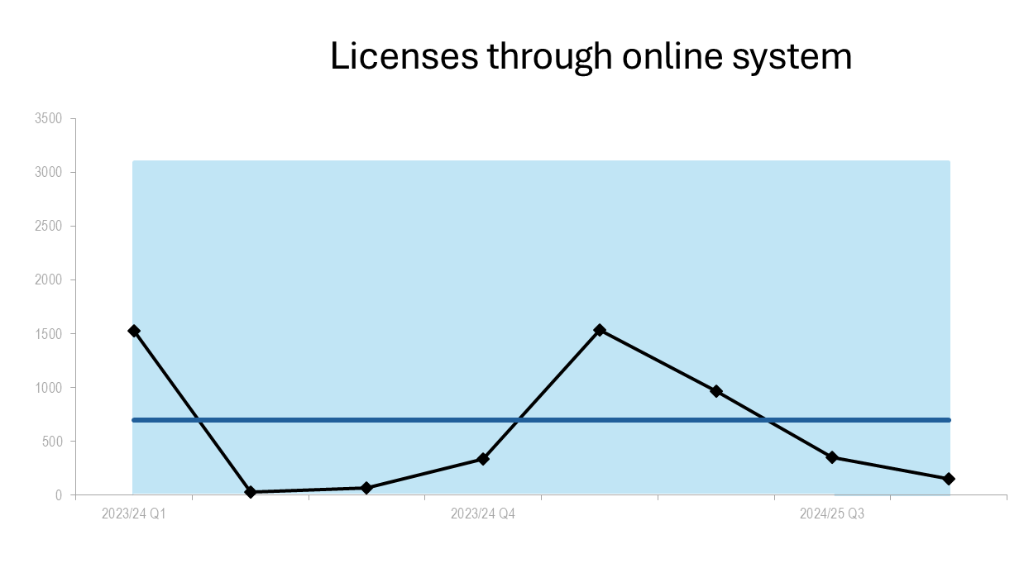 | 152 | As new licence application types can be applied for online the numbers will increase. | Numbers will continue to fluctuate due to seasonality.
No. of catchments with established beaver populations | 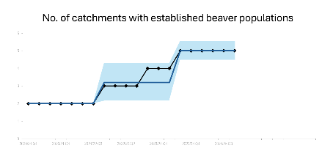 | 5 | The Upper Beauly application has been paused as more consultation is being sought with affected landowners. | It is anticipated that the application will proceed once further consultation on the main issues has been resolved.
% of holding objections for formal planning applications | 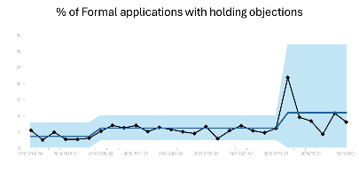 | 8.06% | Performance is within tolerance (4-9%) but at the higher end with a proportion of holding objections at 8.1%. Holding objections to SRN mast applications featured highly (5/15 or 33%) and also included 3 housing applications and a further 2 peatland restoration applications. The remaining 5 were single cases of various types. The overall figure for 24/25 is just within the AMBER RAG tolerance at 8.5% (72 holding objections out of 846 applications). | The overall figure for 24/25 is down slightly on the previous year and out of the RED and into the AMBER RAG tolerance. However, SRN mast applications accounted for a large proportion of the holding objections so we could see the number of holding objections fall as the programme comes to close. Still early still to assess any impact of the launch of InformedDECISION, but this will improve the quality and completeness of information we receive and reduce the need for holding objections.

WE HAVE RESTORED NATURE
Measure | Performance Overview | Actual | Cause | Response
No. of individual farm businesses that have completed a biodiversity audit | 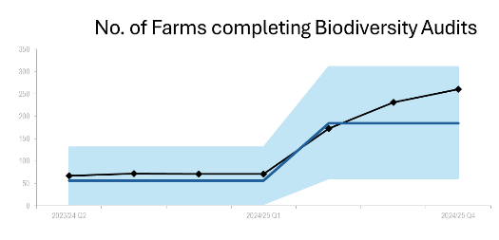 | 261 | After initial testing in 2023-24, a greater number of land managers took part in testing of the Biodiversity Audit in 2024-25. | Further testing will take place in 2025-26 and this is expected to involve a significant number of additional land managers.
No. of marine renewable energy consultations we provide advice on avoiding impacts on nature | 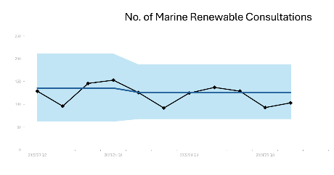 | 10 | Data includes the following significant consultation responses issued (which each constitute one response but take a considerable amount of time): Caledonia North & Caledonia South s36 Applications, Muir Mhor s36 Application, Ossian Offshore Transmission Infrastructure EIA Scoping, Aspen Scoping, Morven Hawthorn Pit Grid Connection Scoping. All overlapping.  Cenos s36 Application received and work on this underway in this quarter. | No response required.
NatureScot is in partnership with new recipients | 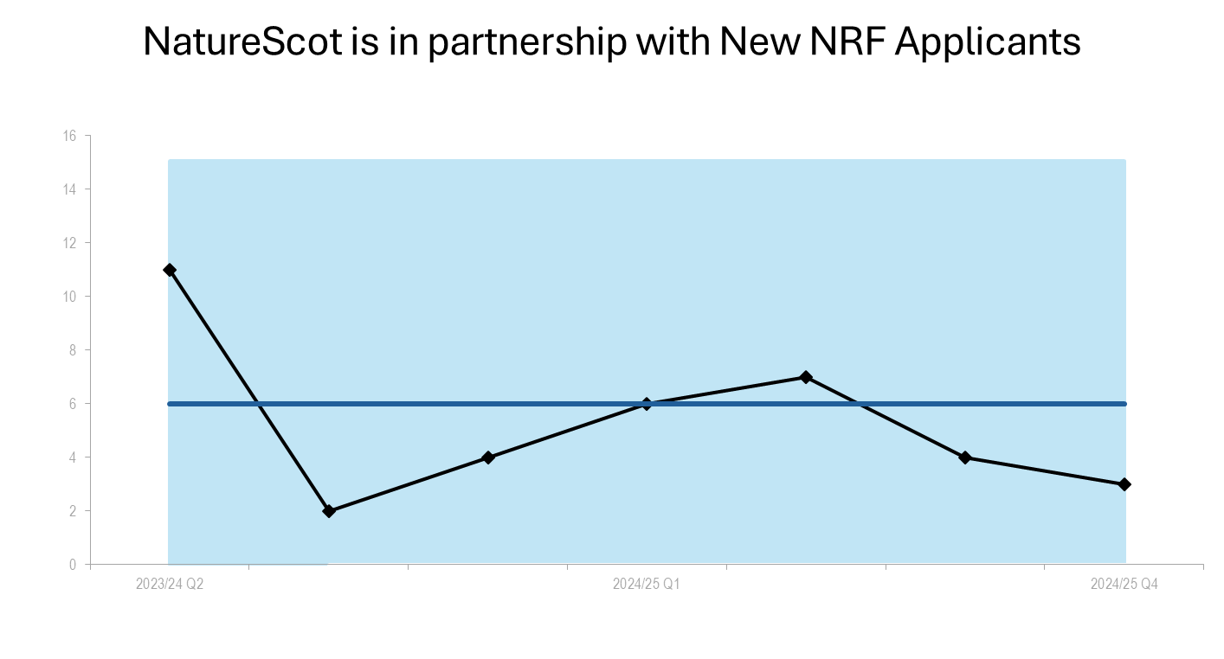 | 3 | 3 new Transforming Nature Development recipients (out of 9 new TN Development grants). | There was one NRF decision panel held in February 2025 for Transforming Nature development funding. This is the current final round of NRF decisions for projects taking place in 2025/26, committing the remaining NRF resource budget for this Financial Year. New recipients represent a third of the total awards.
External funds raised by SMEEF and the amount allocated to projects. | 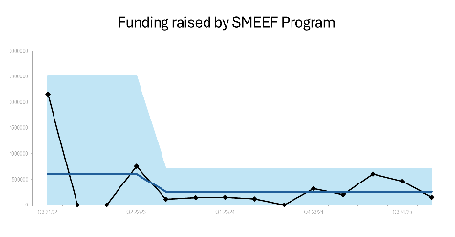 | £150,000 | £150,000 for Seabird Resilience Fund | £300,000 expected in Q4 for Seabird Resilience Fund.
Area (hectares) of peatland put on the road to recovery | 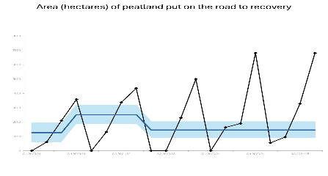 | 6816 | Completed projects to date in current financial year. | Current outturn is 6,816ha. We remain on track to exceed the 7,400ha target.

THE VALUE OF NATURE IS RECOGNISED
Measure | Performance Overview | Actual | Cause | Response
Engagement Rate on Make Space for Nature (MSFN) webpages | 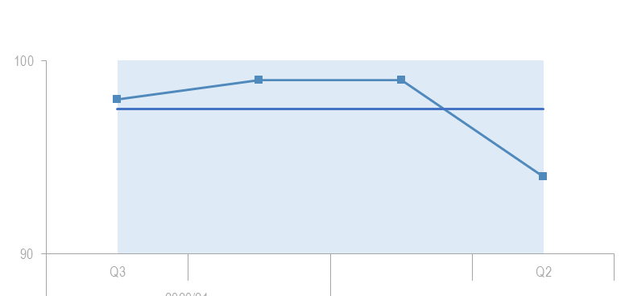 | 94% | Worked with 4 creators to connect with less engaged audiences: Chris Lawlor, The Chaotic Scot; disability blogger Simply Emma; and Tales By Josh (Scottish Black Adventurers). | Total 35,632 views, reach 45,077.
No. of Landscape partnerships that NatureScot is involved in that use a natural capital approach | N/A | --- | A survey has been sent to relevant Landscape Scale Partnerships to establish their attitude towards a Natural Capital Approach, we are awaiting the full results of this survey. | Preparations for the closed beta release of the tool in Q1.
Nature-restoration jobs and skill development opportunities created through our activity | 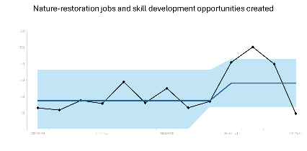 | 96 | Series of Working with Wader in person knowledge exchange offered in conjunction with Working for Waders and targeting farmers and contractors. | Excellent response to the programme over the course of the whole year, despite a seasonal drop off in activity in Q4. Great levels of engagement mean that this series of events will likely be on our programme for 2025/26.
Young People that we engage with on Skills | 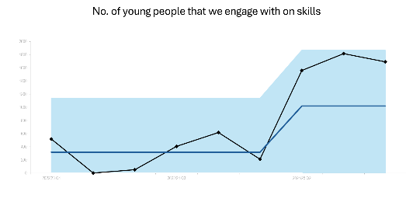 | 1690 | Dynamic Earth STEM event and greater traction via STEM invites - able to engage with 10+ schools in one venue. NatureScot Student Conference targeted high numbers of science graduates across two days. | Continue to get opportunity to engage with a wider range of stakeholders, now pulling from networking contacts, STEM contacts and careers advisor contacts to generate events and webinars
National Nature Reserve online engagement | 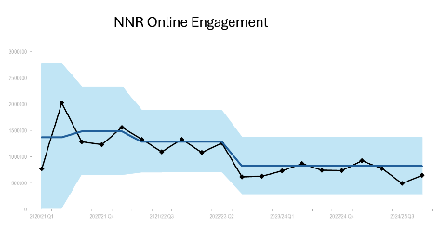 | 652220 | Engagement has increased more than expected in Q4. A couple of sites have seen a significant jump and this is attributed to specific topics that have caught visitors attention. | Meta measures no longer count engagement on shared NNR page as most posts are shares rather than written directly on page so seeing a significant drop in count for the central NNR page.
Private Finance Investment in Nature | 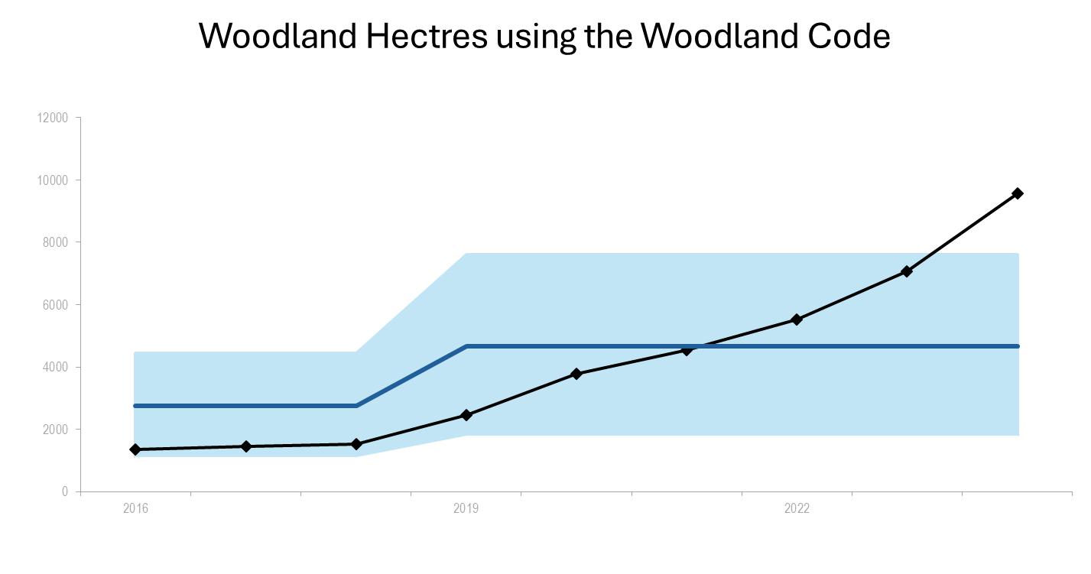 | 9559 | Woodland - 32,235 hectares. Peatland – 1445 hectares. Combined Validated hectares of woodland and peatland: 33,680. | The team has been focusing on delivering the PINC programme which includes developing the Ecosystem Restoration Code, a Nature Investment Prospectus (including procuring a platform for the Code), developing FIRNS 3, feeding into the BSI Nature Markets Standards, engaging with market stakeholders, and continuing with our outreach programme for NatureScot teams.

WE HAVE TRANSFORMED HOW WE WORK
Measure | Performance Overview | Actual | Cause | Response
Sq meterage of floorspace dedicated to NatureScot | N/A | 5583 | As noted in previous updates we appointed Savills to undertake a review of all of our space plans for the NatureScot offices, update all the drawings where required and provide revised benchmarking data reporting on the space that NatureScot occupy around the estate. This has now been completed with a baseline data set issued by Savills. | There have been changes in the NatureScot estate over the past two years. The relocation works carried out during the 2024/25 financial year at Dunoon, Cupar, Clydebank and Galashiels have delivered a reduction in office space of approximately 390m². The Clydebank office relocated in November 2024 and the Galashiels office in February 2025 so data for these new offices will be updated in the new baseline data set. Visit Scotland relocated to our Lerwick office in January so the space reduction of approximately 17m² at this location will be updated.  The Estate review programme has been prepared for 2025/26 with the primary focus being on the delivery of the Perth office relocation. There will also be location-based reviews at Stirling and Lochgilphead.
Workforce Diversity | 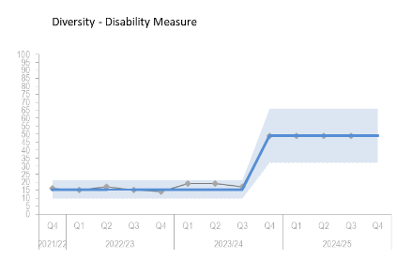 | 49 | Cultural norms remain. We continue to work in Partnership to tackle these. The measure relates to the amount of staff who have self-declared that they have a disability. | We have updated some of the equality outcomes for 2025-2027 so that they are more realistic, clear and easy to monitor. These will be published in April in the Equality and Mainstreaming Report.
% Of Implemented Audit Recommendations | 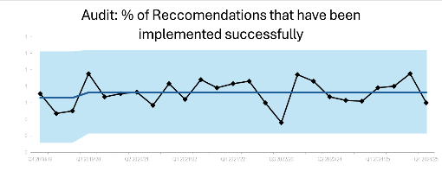 | 60% | The Priority 1 implementation rate remained at 100%, with a rolling average across the last four quarters of 88%, above the KPI target of 85%. The overall implementation rate did decrease to 60%, and the rolling average for the last four quarters is now 78%, but still above the KPI target of 75%. | There are only two delayed recommendations, and with such a small data set, implementation rates will fluctuate greatly.

Finance

Financial Metrics (£m) | Measure | Budget | Expected Outturn | Variance | Rating
Resource Budget | Outturn within 1% of final budget | 65.5 | 65.9 | (0.4) | ON TRACK
Capital | Outturn within 5% of final budget | 2.4 | 2.4 | 0.0 | ON TRACK
Indirect Capital | Outturn within 5% of final budget | 18.8 | 16.0 | 2.8 | MAJOR SLIPPAGE
Paybill | Outturn within 1% of final budget | 41.6 | 42.8 | (1.2) | MINOR SLIPPAGE
Project Allocation | Outturn within 1% of final budget | 18.0 | 17.6 | 0.4 | MINOR SLIPPAGE
Peatlands | Outturn within 1% of final budget | 15.8 | 13.3 | 2.5 | MAJOR SLIPPAGE
Farming with Nature | Outturn within 1% of final budget | 0.9 | 0.9 | 0.0 | ON TRACK
Nature Recovery Fund | Outturn within 1% of final budget | 9.7 | 9.0 | 0.7 | MINOR SLIPPAGE
FIRNS | Outturn within 1% of final budget | 1.5 | 1.4 | 0.1 | MINOR SLIPPAGE
*Resource under 1% - on track, up to 10% minor slippage, over 10% major slippage (** Capital under 5% / up to 10%)

Resource Budget Performance

- As at 21st April 2025, an overspend of £0.424m is the current expected outturn on the resource budget. At this point last year, an overspend of £0.187m was forecast.
- We have moved to reporting our position against outturn rather than forecast now that no budget changes to 2024/25 projects can be made on business planning. The adjusting period for project managers is now closed but Funding Officers have until the end of April to receipt grant commitments.
- We reported an overspend of £0.4m in the February Budget Monitoring Return to SG.
- Finance will now be working to review 2024/25; validating, adjusting and reconciling our accounts. This work continues until Q2 when the accounts are finalised and closed. Therefore, the final position is not yet fully established.
- Indirect capital expenditure for Peatland Action had been incorrectly coded to resource. The Business Support Accountant is working with the Peatlands Funding Officers to identify this spend and transfer it and is reflected in the above numbers.
- Surrenders received in 2024/25 were £4.4m, the highest month for surrenders was March with £0.826m actioned. The four-year average for March was £0.717m and the full year £4.7m.
- Reflected within the resource numbers is a de-commitment provision of £0.465m. This is for rejected sums which were not paid to us, further irregularities that have been billed and the required audits relating to Structural Funds. Without this release, our overspend would have been £889k.
- The actual outturn for paybill is £42.762m, which is £1.186m higher than the current budget of £41.576m. The paybill forecast at the start of 2024/25 was £41m.
- We are in the process of calculating the accrual for Annual Leave and Flexi. The impact on the 2024/25 outturn won’t be known until late April. An increase in unused Annual Leave and Flex carried forward when compared to the 2023/24 adjustment will adversely affect our outturn.
- The Corporation Tax bill was £0.165m due to losing charitable status. The budget from SG for Corporation Tax in 2024/25 was £0.02m, a difference of £0.145m which we had to fund from GIA. Work is ongoing with Azets with regards to our charitable status.
- Finance met Objective Leads monthly to advise and challenge commitments, spend and surrenders. In normal circumstances, the reallocation of funds can be made to high priority and achievable work by Objective Leads. Due to the ongoing and ever-increasing restrictions on in-year spend due to wider public sector financial issues and instructions from SG, approval of additional funds was scrutinised and decisions made by Allocations Group for the remainder of the year.
- The project budget and target are £18m with a current expected outturn of £17.6m. The Project Allocation Forecast Tracker does not include any ring-fenced funds: NRF, Peatlands, FIRNS, SMEEF and FwN are therefore excluded. The JNCC contribution is also not included.

Programme funding including Indirect Capital

- Indirect Capital Programmes are forecasting an underspend of £2.816m and Resource Programmes are forecasting an underspend of £0.479m. These forecasts take account of the confidence levels for Peatlands and NRF.
- In addition to the £14.9m approved by SG for Peatland Action (£10.99m indirect capital and £3.91m resource), a further £0.876m indirect capital funding in the budget received from the Shared Islands Fund is included. This gives total funding for the year of £15.776m. An underspend is forecast on Peatland Action of £2.526m (16%) which is made up of £0.193m on resource and £2.333m on indirect capital.
- On both Peatlands and NRF, these are over-allocated due to these large programmes having underspent in previous years. We have applied confidence levels, and both programmes are predicting an underspend. They are being closely project managed and have financial support from the Business Support Accountant.
  - Currently forecasting £13.25m against the budget of £15.776m for Peatland Action. We have been reporting an underspend on indirect capital to SG in the Monthly Budget Monitoring Returns since January.
  - The total Nature Restoration Fund (NRF) budget is £9.732m, this is split £2.75m Resource and £6.982m Indirect Capital. We are forecasting £9.017m with the confidence levels applied, a total underspend of £0.715m.
  - The Farming with Nature budget is £0.855m from SG and £0.073m from core GIA. The total spend on this programme is £0.938m.
  - The Facility for Investment Ready Nature in Scotland (FIRNS) budget is £1.5m, £1.2m from SG and £0.3m from core GIA. We are forecasting £1.41m on this programme.

Capital Budget Performance

- An overspend of £0.009m is the current expected outturn on the Capital budget.
- Despite some slippage on vehicles, overall spend is £0.009m above budget for Direct Capital. Additional spend originally understood to be resource was identified by the Financial Accounts team and transferred to capital. This value was £0.135m which helped with the capital slippage and relieved some of the pressure on resource.

Risk And Audit

Corporate Risk Review Summary

- Since January 2025, SLT has included a corporate risk review as a standing agenda item in monthly SLT meetings with a new reporting template to assess existing risks in response to issues/events, as well as proactively horizon scan new and emerging risks. To date, this approach does appear to have has resulted in greater dynamism.

- The Corporate Risk Register holds the high priority risks for NatureScot. There are currently 14 approved Corporate Risks (11 high and 3 medium) illustrated in the corporate risk heatmap exhibit below.
L i k e l i h o o d | 5
L i k e l i h o o d | 4 |  |  | 21: Budget Management  645: Biodiversity Loss | 393: Future Funding of NatureScot  759 - Reporter role for new Galloway National Park
L i k e l i h o o d | 3 |  |  | 85: Adapting to Strategic Change  137: Staff Resource Management | 47: Computer Virus/Malware  646: Weakened Reputation  755 - Strategic Resource Management | 253: Peatland restoration target and budget  765 - Legal Challenge
L i k e l i h o o d | 2 |  |  | 760: Transitional Arrangements for CEO |  | 740: Nature Finance  761: Grant Funding Future Liabilities
L i k e l i h o o d | 1
 |  | 1 - Negligible | 2 - Minor | 3 - Major | 4 - Significant | 5 - Critical
 |  | Impact

Changes to Corporate Risk Register

- Two new risks have been identified and added to the risk register:
- Risk no 765: Legal Challenge. This was approved by SLT in Feb 2025 as changes in legislation have and will continue to heighten the risk of legal challenge accentuating the need for clear and robust legal advice with strategic oversight and management of controls.
- Risk no 253: Peatland restoration target and budget. This was re-escalated by SLT in March following the level of projected underspend in 2024/25 and to reflect a significant increase in both 2025/26 funding and restoration target which is likely to be challenging to deliver.
- A further risk emerged in relation to the management of the Sea Eagle Management scheme in advance of full World Trade Organisation and Scottish Subsidy approval. The residual risk of successful challenge is low, therefore, it is recommended that this does not meet the threshold of a corporate level risk, but a watching brief will be maintained using the BP Risk Tool until approvals are in place.

Changes to Corporate Risk Scores

- During Q4, 5 risks moved from medium to high and SLT has agreed to raise the likelihood score from 2 to 3 for Risk 646 (Weakened Reputation).
- In February 2025, SLT increased the impact score of Risk no 645: Biodiversity following a deep dive in this area.
- In March 2025, SLT also noted increasing pressure in relation to both paybill and resourcing which is reflected by a change in the scores of Risks 21: Budget Management & 755: Strategic Resource Management. The likelihood of a 2024/25 resource overspend and Indirect Capital underspend increased, whilst strategic resource management appears to be crystallising as a risk to the delivery of core 2025/26 business objectives so will require renewed focus.
- As risk owner for Risk 646: Weakened Reputation, the Head of External Affairs has noted a number of issues which are prompting negative public interest, including in the media, as well as impaired stakeholder relationships so SLT agreed to increase the likelihood score for this risk from 2 (unlikely) to 3 (likely).
- SLT noted the ongoing process for recruitment of a new Chief Executive and raised the likelihood score to 2 and impact score to 3 to reflect the organisational uncertainty that the prolonged interim period is creating

- The table below summarises the key changes outlined above and notes future areas of focus in Q1 2025/26 identified following SLT horizon scanning. High risks are detailed in Annex 1.

Q4 Log Corporate Risk Log Summary
Change to Corporate Risk Register
↗ 2 New Corporate Risks (approved by SLT)
- 740: Legal Challenge & 253: Peatland restoration target and budget
Changes to Corporate Risk Scores
↑ 5 Increased
- 645: Biodiversity Loss (impact score increased from 3 to 4)
- 21: Budget Management (impact score increased from to 2 to 3, likelihood score increased from 2 to 4)
- 755: Strategic Resource Management (impact score increased from 3 to 4, likelihood score increased from 2 to 3)
- 646: Weakened Reputation (likelihood score increased from 2 to 3).
- 760: Transitional Arrangements for CEO (impact score increased to 2 to 3, likelihood score increased from 1 to 2)
↓ 0 Gone Down
Future Areas of Focus:
Use of AI, Natural Environment Bill, MPA Management Measures.

Audit

- The Priority 1 implementation rate increased to 100%. The rolling average across the last four quarters has remained at 84%, slightly below the KPI target of 85%. In relation to lower-level Priority 2 and 3 recommendations, there is one delayed recommendation that relates to the Project Management Office setting up an ELT communications plan.
Implementation Rate
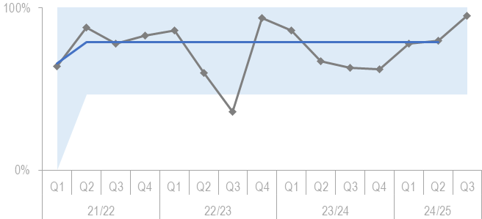

People

Measure | RAG | Performance Overview | Actual | Analysis | Comment
Health, Safety and Wellbeing |  | 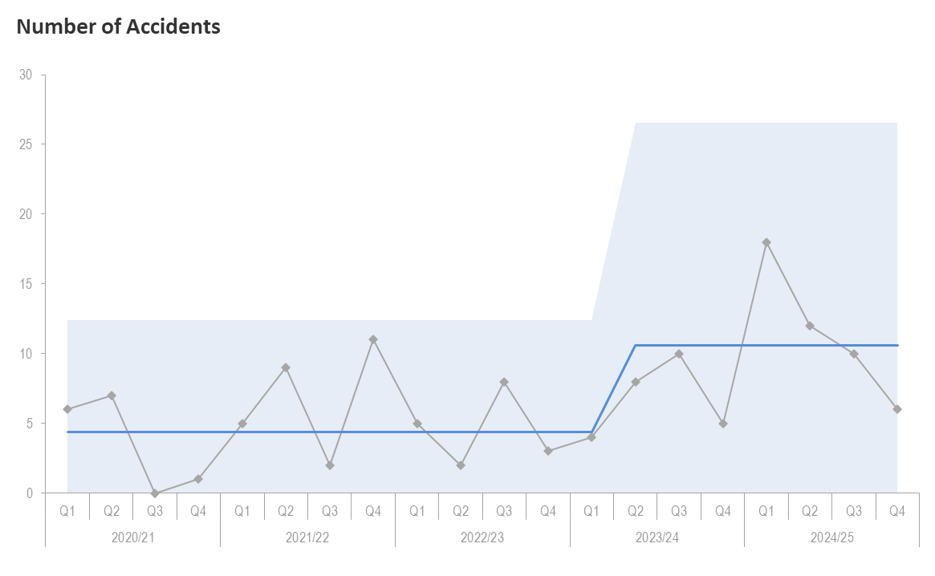  (This graph shows number of accidents) | 6 | There have been 6 accidents and 5 near misses. This is a decrease in accidents from 10 (Q3) down to 6 (↓4), and a decrease in near misses reported from 8 (Q3) to 5 (↓3).  The commonest incident cause was slip, trip or fall, with sprains or other being the commonest injury type. There were two near misses involving vehicles, one relating to road conditions and the other to vehicle condition. Given volume is low it is not possible to identify any underlying themes to the incidents. | A more robust approach to monitoring the completion of investigations will be undertaken to ensure lessons learnt are recorded and applied.
Health, Safety and Wellbeing |  | 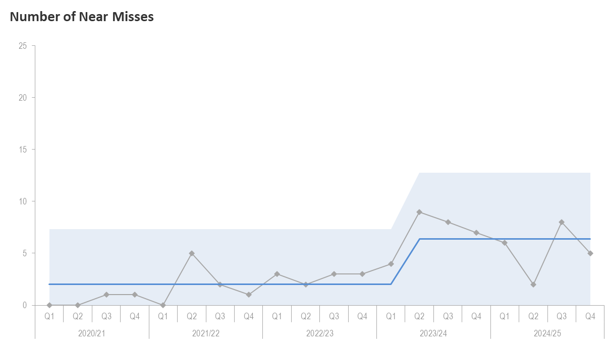  (This graph shows number of near misses) | 2
Attendance |  | 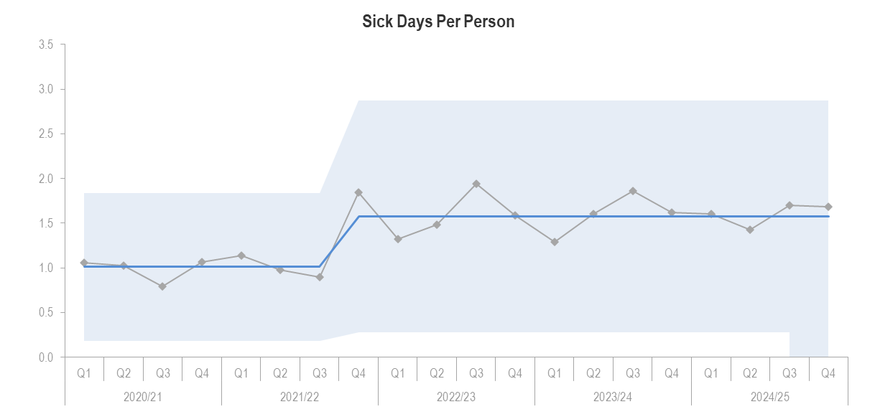  (This graph shows the number of sick day taken each quarter per employee from 2020 to date) | 1.59  days | There is a decrease in sick days per person from 1.71days to 1.59 days (↓0.12days).  Mental Health absences make up the bulk of lost time and have increased significantly since Q3 from 302.5 days to 414.5 days (↑112days). 30% were due to work-related stress.  Short-term absences continue to be the bulk of working time lost. The top reason for short-term sickness continues to be ear, nose, throat, mouth, and eye with 204 days lost (229.5 days in Q3, ↓ 25.5 days). | The implementation of the HSE Stress Indicator Tool will strengthen proactive action around stress, to help all colleagues identify and manage stress better.
Workforce Profile |  | 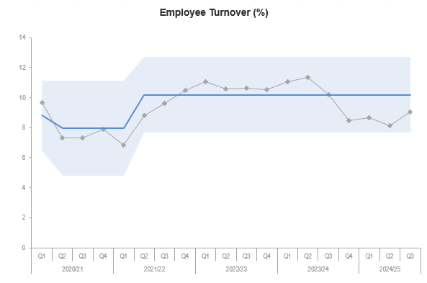  (This graph shows the employee turnover) | 9% | Annual Turnover was 9%.  Our annual turnover by contract type is:  5% - Fixed Term Employees  4% - Permanent Employees.  There were 19 leavers, of which 58% were leaving because their fixed term contracts were ending, 21% left due to personal reasons, 16% were retirements and 5% left to move to alternative employment.  Turnover since Q3 2023/24 has been consistently between 8-9%. | P&OD will continue to analyse exit survey data to identify any trends in relation to leavers.
Employee Relations |  | 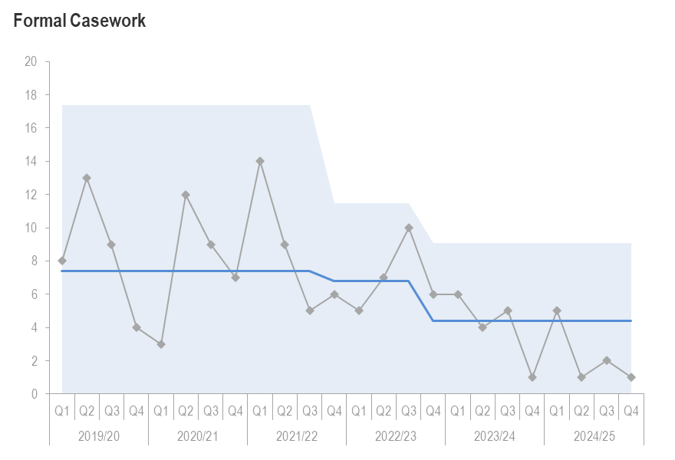  (This graph shows the number of formal employee relations cases raised)  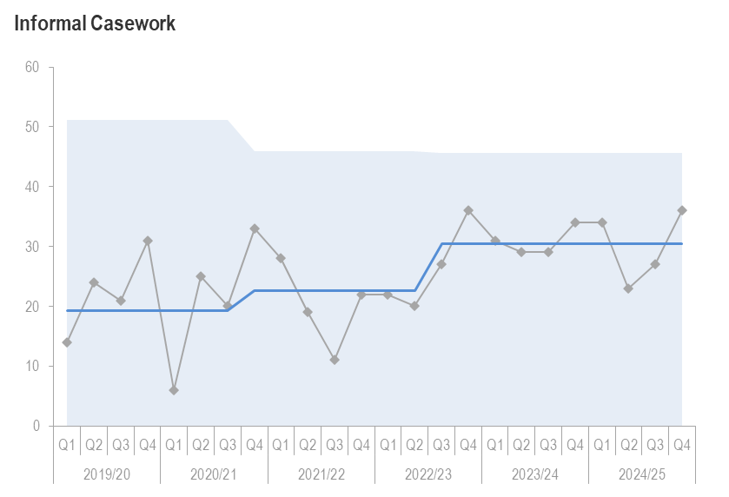  (This graph shows the number of informal employee relations cases raised) | 2  27 | Formal casework has decreased from 2 to 1 open case (↓1 case). This is an ongoing grievance case.  Informal casework has increased from 27 to 36 open cases, with a total of 9 new casework cases arising.  Most Informal cases relate to short- and long-term absences and health and wellbeing. | Given low levels of casework, we are shifting the measurement to the duration of casework (end to end), subject matter in terms of categorisation and teams. This will allow us to continue to be proactive around resolution. We will start this reporting from Q1.
Capacity |  | 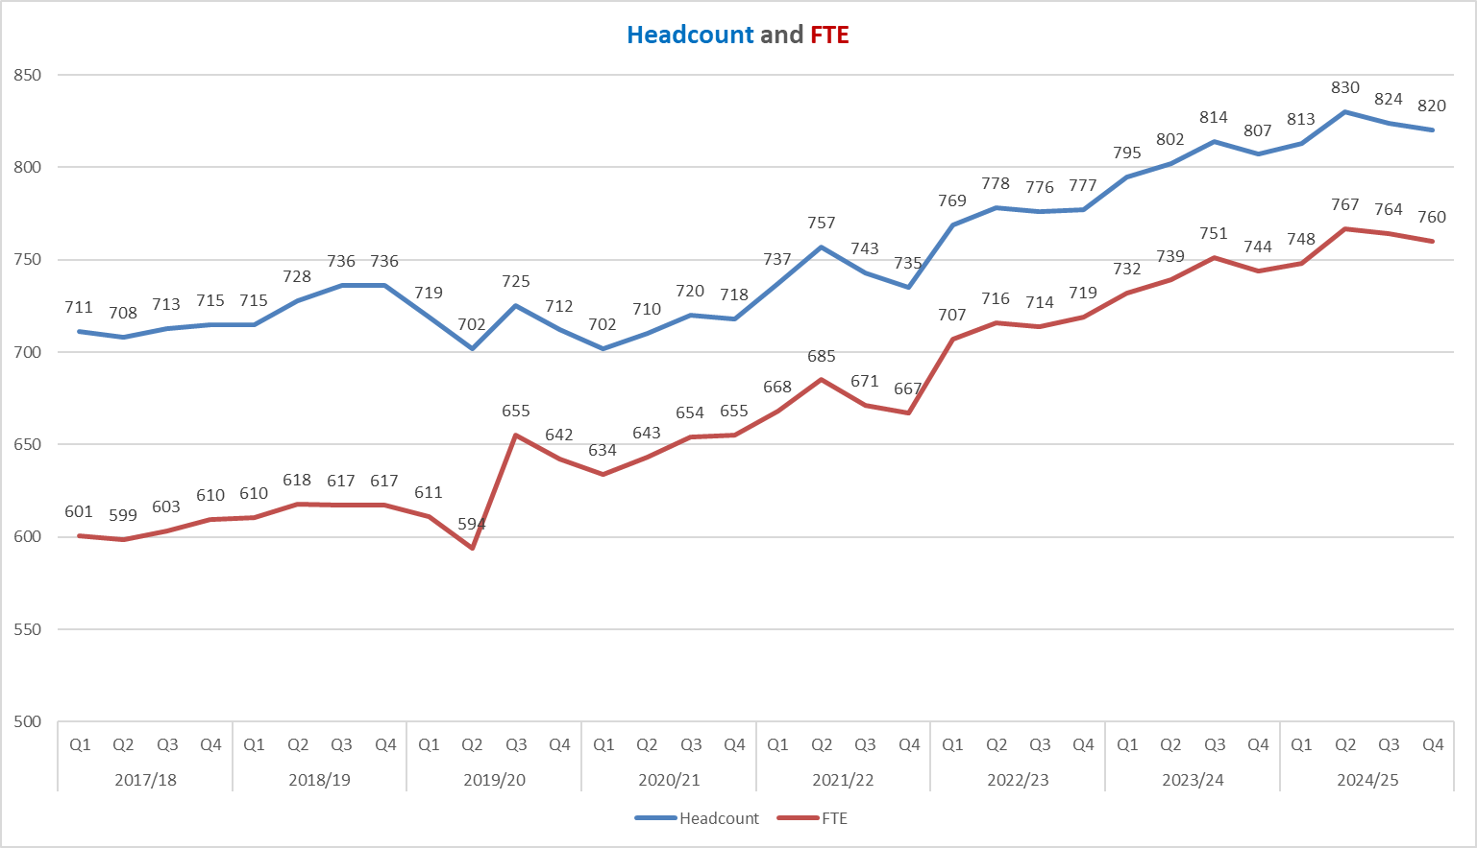  (This graph shows the trend of the organisations headcount and FTE to date) | 820 and 760 | Headcount is 820(↓4) and FTE is 760 (↓4). There were 3 new starts in Q4.  Permanent:  - Headcount – 686  - FTE - 630  Fixed Term:  - Headcount – 134  - FTE – 130  The 3 new starts in Q4 are all on permanent contracts.  The forecast is that headcount will reduce given the review of fixed term contracts throughout 2025/26. There will also be 15 permanent employees reverting to their substantive post in 2025/26. | A new paybill approval form will help scrutinise resourcing requests and improve decisions about permanent versus fixed term appointments.
Retirement Profile |  | 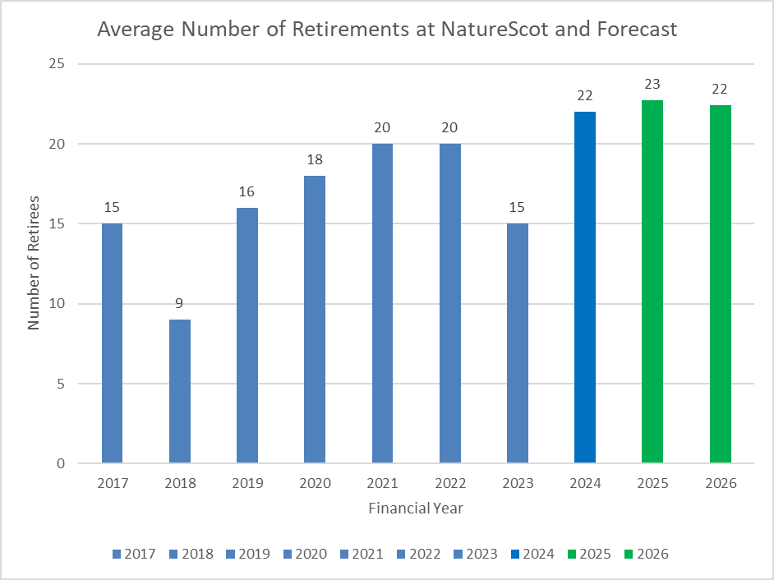  (This graph shows number of retirees and our forecasted retirements) * |  | 188 employees are aged 57+ (23% of Q4 headcount). This is predicted to rise to 209 in Q4 2025/26.  Three employees retired (16%). YTD there have been a total of 22 retirements, 28.6% of leavers in 2024/25.  The average retirement age for Q4 is 64. | The retirements in 2024/25 matched the forecast of 22; 23 retirements are predicted for 2025/26.

People – Headlines
People Programme | - Good progress has been made to embed Career Conversations training and support for all.  - The Skills project has progressed, moving from red to amber RAG rating, and some aspects of the ‘Nature Skills’ cluster are ready to launch.  - The Strengthening our Connections (hybrid working) project is now in place, with some initial quick wins planned and 4 workstreams scoped. A session on this was held with ELT to bring this leadership community up to speed on the project.  - A one-year, high level Workforce Plan will be drafted for 2025/26. The focus is to build strategic workforce planning into the business planning process for 2026/27, ensuring any new tools in advance of October 2025.
Employee Engagement Maxi Survey Results | - Positive results in terms of steadily increasing response rates over last two years, improved net promoter score and employee engagement. Some good indications of things to improve in terms of change management, more transparency around decision making and visibility of leadership. Results will be shared with the Board on 11th June.
Employer of Choice | - 32% return rate for exit questionnaires in Q4 (6 in total), (Q3; 48% ↓16%). The average return rate for 2024/25 was 56%. In 2024/25 the main reason which prompted leavers to look for alternative employment was due to fixed term contracts ending.

Annex 1 – Corporate Risk Register (High Risks)
Risk Title | DESCRIPTION | CONTROLS | IMPACT | LIKLE-HOOD | RISK LEVEL | Comment
47 - Computer Virus/Malware | As a result of inadequate protection, or inappropriate system use, including accidental activation of email links by that lead to malware downloads, there is a risk that NatureScot systems becoming infected with a malware or virus agent, resulting in NatureScot systems and data become unavailable, encrypted or corrupted, significant system downtime and huge operational impacts. | 1. All file servers are protected by Sophos anti virus protection. Upgrades are performed automatically and can also be applied in an ad-hoc manner  2. All PCs are protected by Sophos anti virus protection. Upgrades are received on a live basis but can be applied ad-hoc  3. All incoming emails are scanned for viruses.  4. All internet access, are scanned for viruses via Zscaler service.  5. Raise staff awareness of potential risks relating to email links and infected documents through regular communications.  6. Control/restriction of USB devices  7. Awareness raising with staff via Blogs and update articles  8. Incident Management Group in place  9. Corporate data backed up to cloud  10. Zfilter showing us user behaviour and stopping internet threats  11. regular meetings of TDS/ICS to check on patching levels and compliance issues.  12. Change control process implemented with minimum of three user sign off. | 4 | 3 | High | We are still high on compliance for Cyber training (around 94% at present), which remains the highest figures for the platform usage across public sector. We continue to review and test our business continuity plans to ensure they are fit for purpose and are about to start our updates for the coming financial year. We continue to rely on Zscaler to block malware/virus initially, then we have M365, then our internal firewalls. This layered approach helps give us assurance, but is not foolproof. Incidents identified on Zscaler are followed up with discussion with user, and a full scan of device.
21 – Budget Management | As a result of inadequate management and monitoring of the variables around the allocation and spending of NatureScot’s grant in aid budget, there is a risk of a significant underspend or overspend against our annual budget which would represent poor utilisation of public funds towards nature recovery with reduced confidence in our financial management and possible future budget restrictions/penalties. | 1. Financial planning, budget setting and reporting is integrated with Corporate and Activity planning (Business Planning and Oracle Fusion).  2. Budget is set within parameters stipulated by Scottish Government, we do not have confirmation for all budgets for 24/25  3. Budget efficiencies are being reviewed for future periods  4. Activity teams and Allocations Group monitor and control allocations process  5. Close monitoring of, and prompt action on, overallocation and budget surrenders reduces the risk of underspend or overspend.  6. Budget transfer and forecast updating tools available to project managers through Business Planning and integrated with Oracle Financials.  7. Activities have access to the Finance system (Oracle Fusion) to monitor progress  8. Paybill cost forecast refreshed monthly to allow visibility of paybill savings available for reallocation or pressures on paybill budget.  9. Summary financial information published monthly  10. Finance and Programme Planning regularly review financial information (commitment/spend levels, bids, surrenders) and engage with units where appropriate to take corrective action.  11. Finance Report presented to Senior Leadership Team on monthly basis.  12. Financial information included in the quarterly performance reports to Senior Leadership Team and Board.  13. NatureScot senior managers are in place to oversee each of the larger ring-fenced funds  14. Additional Funds are separated out in the weekly financial updates and the reports presented to Senior Leadership Team on a monthly basis and quarterly to Board  15. Risks associated with larger funds will be shared with SG, as well as concern over the late allocation of funding. Communication is ongoing to manage the expectations of SG. | 3 | 4 | High | Despite robust controls and governance, structural funds liabilities not materialising and delivering in year savings targets, the risk of a modest resource overspend has crystallised, largely on account of paybill pressures. However, Indirect Capital will be underspent by nearly £3m, largely in relation to PA slippage.  Therefore, it is recommended that the likelihood of an underspend or overspend against the 24/25 budget should be upgraded to 4 (highly likely). It is also recommended that the impact score be increased to 3 on account of the potential for reduced confidence in our financial management abilities and the level of uncertainty on the impact of a modest resource overspend. The update against risk 755 provides further context and detail on critical controls which need to be embedded or actioned.
253 - Peatland restoration target and budget | As a result of a significant uplift in 25/26 funding and restoration targets (50% increase), there is a risk to climate, nature and NatureScot’s credibility if NatureScot is unable to adapt at the pace and scale required to deliver this ambition within a complex operating environment. | Please note that the controls listed below remain under review and will be finalised by the PA Programme board upon conclusion of Internal Audit Work:  1. Significant forward commitment of funding via multi-year awards, deferred 24/25 projects, as well as 24/25 carry forward/slippage. This currently equates to approximately £7.6m of committed expenditure to deliver 7,000 ha.  2. Earlier application deadline (end of April 25) which also requires fully tendered projects to support issuing new funding offers earlier than in 2024 /25 to maximise the works delivery window.  3. We will increase consideration of the cumulative offers made to individual contractors prior to issuing grant offers and seek more robust assurance on capacity to deliver within the agreed timelines.  4. We will implement internal audit recommendations in relation to:  • Rationalising and linking spreadsheets used for reporting purposes with clear lines of accountability for maintaining accuracy.  • Review membership and increase the frequency of the Peatland ACTION Governance Board to ensure a renewed focus on delivery and dynamic programme management.  5. We will review our 110% overcommitment level throughout the year and consider adjusting limits, where this is appropriate with Finance and SLT. | 5 | 3 | High | Risk added to corporate register following March SLT Review. Please note that the risk description and controls remain under development and is pending completion of internal audit work and PA Programme Board sign off.
393 -  Future Funding of NatureScot | As a result of on-going reductions in public expenditure or new cost pressures there is a risk our grant-in-aid settlement may not match statutory and fixed costs as well as corporate plan priorities. Unless other funding sources are secured this could result in an inability to adequately resource delivery of agreed priorities, leading to failed outcomes and reputational damage. | 1. Ensure that our priorities are aligned with published Programmes for Government and ministerial portfolio priorities, specifically those aligned to the Programme for Government and Bute House Agreement  2. Provide realistic and evidenced assessment of the impact of possible cuts in our grant-in-aid budget through the annual Spending Review process.  3. Develop and put forward proposals, through the annual Spending Review process and other avenues with Scottish Government, for delivering more and better outcomes for nature and people through wider Scottish Government funding.  4. Reduce expenditure in some business areas through budget setting processes aligned to business planning cycle.  5. Identify efficiencies and savings in our current spending and ways of working to maximise the resources available for front line delivery.  6. Have an effective communications strategy in place which promotes the added value of our work.  7. Identify and implement opportunities to generate income from the services we provide.  8. Identify and implement opportunities for external funding of NatureScot-led work through the business planning process (including at Outcome and Activity levels) and at the project development stage for significant scale projects.  9. Develop proposals for new, preventative projects that can help deliver a wider set of SG priorities, and build awareness and support of these.  10. Develop and refresh a short, medium and longer term financial plan based on potential financial scenarios. | 4 | 4 | High | Discussions are ongoing with Scottish Government on the implications of new expectations on NatureScot specifically in relation to onshore and off-shore renewables, licencing and 30x30 work.
645 - Biodiversity Loss | As a result of not raising awareness, inspiring or persuading stakeholders to take the actions needed to reduce biodiversity loss that are within our influence, there is a risk that we will fail to demonstrate sufficient progress in tackling the biodiversity crisis. | 1. Support Scottish Government with joint-leadership of the Scottish Biodiversity Programme and the implementation of its activities  2. Provide a leadership role on sustainable and integrated land use through influencing the development of related national policies and through the actions we take on our own land to inspire others  3. Develop, promote and deliver nature-based solutions through actions such as peatland restoration, woodland regeneration etc  4. Demonstrate the benefits of a natural capital approach through playing an active role on the Scottish Forum on Natural Capital, implementation of the Natural Capital Pilot Programme, and further development of the Natural Capital Assets Index.  5. Enable the sustainable management of our wildlife through influencing national policies and working closely with landowners, relevant public bodies and eNGOs on implementing related activities, and through our work to regulate behaviours e.g. through licensing.  6. Activity promote the benefits of biodiversity through our communication channels and through pro-active engagement with stakeholders on the actions they can take to reverse biodiversity loss.  7. Co-ordinate existing funding and access new funding routes for biodiversity-related projects.  8. Maintain a robust evidence base through on-going research and survey work.  9. Support work on setting ambitious targets for halting biodiversity loss through COP15 and other international frameworks | 4 | 3 | High | The Natural Environment Bill is a critical event which will be a significant enabler in terms of NatureScot's ability to influence stakeholders. Should the bill not be enacted in the current parliament, then the likelihood of this risk current risk crystallising would increase.  Once SG's 12 week consultation has been concluded and the bill has progressed from Stage 1 to Stage 2 of the process there will be greater clarity and confidence in the final form and function of the Bill. Consequently, this risk will be reviewed at the end of Q1 of 25/26 with a view to updating the risk score of this current risk, as well as potentially drafting a further corporate risk in relation to the bill itself.
646 - Weakened Reputation | As a result of NatureScot actions that are out of line with our strategic vision and purpose and goal as expressed through our Brand and Corporate Plan, there is a risk that our reputation would be weakened. If allowed to persist, it could result in the impairment of our ability to operate efficiently | 1. Ensure alignment with strategic and brand expression with what we do (i.e. don't over promise)  2. SLT to ensure that the potential impact on NatureScot's reputation is a key consideration in decision making that can affect stakeholders.  3. Where there is a risk of significant impairment to our reputation, ensure advice is sought from the Communications Team or Head of External Affairs to support decision making and plan to mitigate any risk. | 4 | 3 | High | Despite, effective procedures for robust assessment of implications for reputation with appropriate escalation including SLT and Board discussion, there are a number of issues prompting negative public interest, including in the media, as well as impaired stakeholder relationships so the likelihood score for this risk has increased from 2 (unlikely) to 3 (likely).
740 – Nature Finance | As a result of any or all of poor governance; lack of due diligence; or poor communications, NatureScot’s reputation could be significantly damaged by misjudged or poorly delivered interventions to influence private investment in nature. There is also a risk that, if we do not proceed with the urgency required to stimulate private sector investment into nature, that significant nature restoration will be unachievable. There is therefore a balance of acting with due diligence, versus not acting at all. There are also specific risks attributed to individual projects or partnerships which are dealt with at the project level. | Our approach to managing this risk is directed by the Azets report (2022) against which there were 15 recommendations. These were discussed and approved by Audit and Risk Committee in a deep dive on 7th Feb 2024 and further refined, before being presented to Board on 13 March 2024. | 5 | 2 | High | Governance: Resourcing remains a challenge to support internal governance board; action with DP lead to source. Governance Board continues to evolve function and audit response actions are progressing well including creation of signatory framework and oversight of progress & risk management. Recommendations from Head of Internal Audit received to strengthen approach to  Reputation: Risk continues to be well managed with established reporting practice in place and generally low levels of negative reaction from any media reports (that said, few reports coming out as few deals being signed).
755 - Strategic Resource Management | As a result of inadequate strategic resource management there is a risk that NatureScot does not prioritise and allocate its staff resources effectively and efficiently. This could lead to NatureScot failing to achieve its Corporate and Business Plan outcomes. | 1. Stronger co-ordination of project and paybill allocations to achieve key deliverables across the outcomes with respect to workforce deployment  2. Business planning processes which enable Service and Project staff time to be monitored against Corporate Plan Outcomes, priorities and Business Plan key deliverables.  3. Development of new business planning system. | 4 | 3 | High | Across 24/25, there has been significant work undertaken with regards paybill and the allocations process which should result in greater confidence and assurance in terms of 25/26 baseline forecasting. Nonetheless, the ratio of paybill vs project spend, compounded by a rise in NICs will need to be closely monitored and managed throughout 25/26. This includes ensuring Directorate level savings targets which will be committed to projects are realised, as well as fully embedding new authority to recruit processes.  Urgency around strategic resource management is likely to intensify given new legislation with scope for additional casework pressures, as well as increasing the pace and scale of existing programmes. Therefore, robust business intelligence and business planning processes will be critical to delivering core 25/26 business objectives. Within this environment, it is recommended that the impact score of ineffective resource management is increased to 4 (significant) and the likelihood score is increased to 3 (likely or probable).
759 -Reputational risk due to statutory Reporter role for new National Park in Galloway proposal | NatureScot is the statutory Reporter commissioned to investigate the Scottish Government’s proposal for a National Park in the Galloway area. We are required to develop options for a possible park, consult on those, and report back to Ministers.  There is a reputational risk that we are viewed as running an ineffective and biased consultation which could gain traction and affect our ability to effectively engage with partners, stakeholders and the public. This will need to be closely monitored and managed throughout the consultation process. | 1. Encouraging engagement with the process through various avenues, including in person and online consultation events, leaflets delivered in the proposed area, an online information hub, a dedicated Reporter email address and stakeholder meetings.  2. Providing multiple options for responding to the consultation, including a long and short online survey, a paper survey and contributions at the consultation events.  3. Engaging independent consultants (Outside the Box) to run the in-person consultation events across the proposed area.  4. Commissioning independent consultants to support the analysis of responses.  5. Commissioning an independent evaluation of the overall consultation exercise.  6. Significant stakeholder engagement, both in person and online, including meetings with all three Councils in the proposed area and local councillors, MSPs and MPs. We have also met with various stakeholders, such as the National Farmers Union of Scotland, Scottish Land and Estates, CONFOR, Forestry and Land Scotland and Scottish Forestry and have engaged with local schools and community councils.  7. Addressing misinformation through media responses, correspondence, providing guidance for staff and meeting with and briefing MSPs and other elected representatives.  8. Providing robust responses to media requests.  9. Preparing a mid-term report to highlight progress to date, with the intention of giving elected representatives (eg MSPs and councillors) an update on progress and encouraging them to support the consultation process. | 4 | 4 | High | Risk profile remains high given the level of inherent risk. Key points to note in Q4:  • Request has been made to SG for a small extension period to reflect the extended response period and volume of responses (>5,000).  • Work is well underway with an independent data company to analyse survey responses using both quantitative statistical and qualitative thematic methods.  • An independent consultancy has now been commissioned to undertake an independent evaluation of the reporter role and process with baseline data to be captured from 25/26 Q1 onwards.  • SLT has attended a familiarisation event in D&G which will be critical to understanding next steps and facilitating leadership support for the process.
761 - Grant Funding Future Liabilities | As a result of annual funding from the Scottish Government and wider uncertainties relating to public finances, there is a risk that NatureScot takes on financial liabilities due to managing medium term ring-fenced SG funds (PA/NRF/FIRNS), as well as offering multiyear funding awards which would have to be met from Grant in Aid if Scottish Government’s ring-fenced funding streams were to reduce or not be renewed. | 1. Multi-year grant offers are limited to financial years where SG have publicly confirmed ring-fenced funding.  2. There is senior Finance representation on Funding Panel and Programme governance boards for both PA and SMEEF. This needs to be extended to include both NRF and FIRNS to ensure oversight of future liabilities across all grant funding streams.  3. NatureScot to dynamically commit future financial liabilities based on the confidence level of intelligence from the SG of future year(s) funding and PFG targets. In 24/25, PA and NRF committed a % of resource and indirect capital budgets against future years. However, prior to issuing multi-year grant offers for future funding rounds, Finance input is required to model liabilities against NatureScot’s wider financial settlement with consistent escalation and sign off via established corporate governance routes (eg. SLT and ARC).  4. All grant funding programmes are shared with the SG so they can both review and comment on both individual projects and future liabilities.  5. Nearly all staff administering and managing SG grant funds are employed on fixed term contracts running until the end of March 2026. Funding team leads need to develop workforce management plans to deliver both current and future state delivery models with input from the Finance Team to ensure oversight and management/escalation with regards future pay bill liabilities. | 5 | 2 | High | Controls in place and will remain closely monitored throughout Q1 as grant funding deadlines close and applications progress through assessment stages.  • Highest degree of uncertainty relates to NRF and FIRNS which are receiving 1 year funding extensions as a bridge between parliaments. However, SG are progressing AO templates and no formal funding offers will be issued in 25/26 for NRF and FIRNS until this process is concluded (anticipated late May/early June 25).  • Peatland Action has strong political commitment so the residual risk of future liabilities arising from forward commitments is considered low. However, the significant uplift in 25/26 PA funding when considered against the standard practice of overcommitting funds by 10% could result in a material 25/26 cost pressure. Consequently, the current impact score remains valid and slippage will need to be closely monitored and managed
765 - Legal Challenge | As a result of new policy and legislation increasing demand for legal advice, there is a risk that we do not have sufficient oversight, clarity and quality assurance of the service provided, which may result in greater exposure to successful legal challenge with significant financial and reputational damage. | 1. NatureScot to appoint named ‘lead(s)’ for handling legal advice within each of the core teams who regularly use NatureScot's legal services framework, to review the need and quality assure all requests for legal advise.  2. Appoint an operational contract/relationship manager with strategic oversight across all three directorates utilising NatureScot's legal services framework. This is likely to be the new Chief of Staff and would provide a clear escalation and reporting route to ensure visibility of all developing areas of contentious casework and legal challenge within the organisation, as well as a senior contract management function to maximise and provide assurance on the legal services received.  3. To review current statutory decision making practices and consider whether there is scope for greater openness and transparency to help mitigate the risk of legal challenge.  4. To appraise the current delivery model, as well as future needs to identify and assess whether alternative models could further reduce residual risk exposure and provide value for money. | 5 | 3 | High | Paper presented to SLT on the 25th Feb 2025 which accepted this as a corporate risk and endorsed the risk description and controls/action plan.  The appointment of a new Chief of Staff will be critical to implementing future controls and actions and it is hoped that once the postholder is in place, then the residual risk profile should decrease as actions/controls are implemented.

