Annexes

Annex 1
Form used in the 2022‒24 Adder Survey questionnaire.
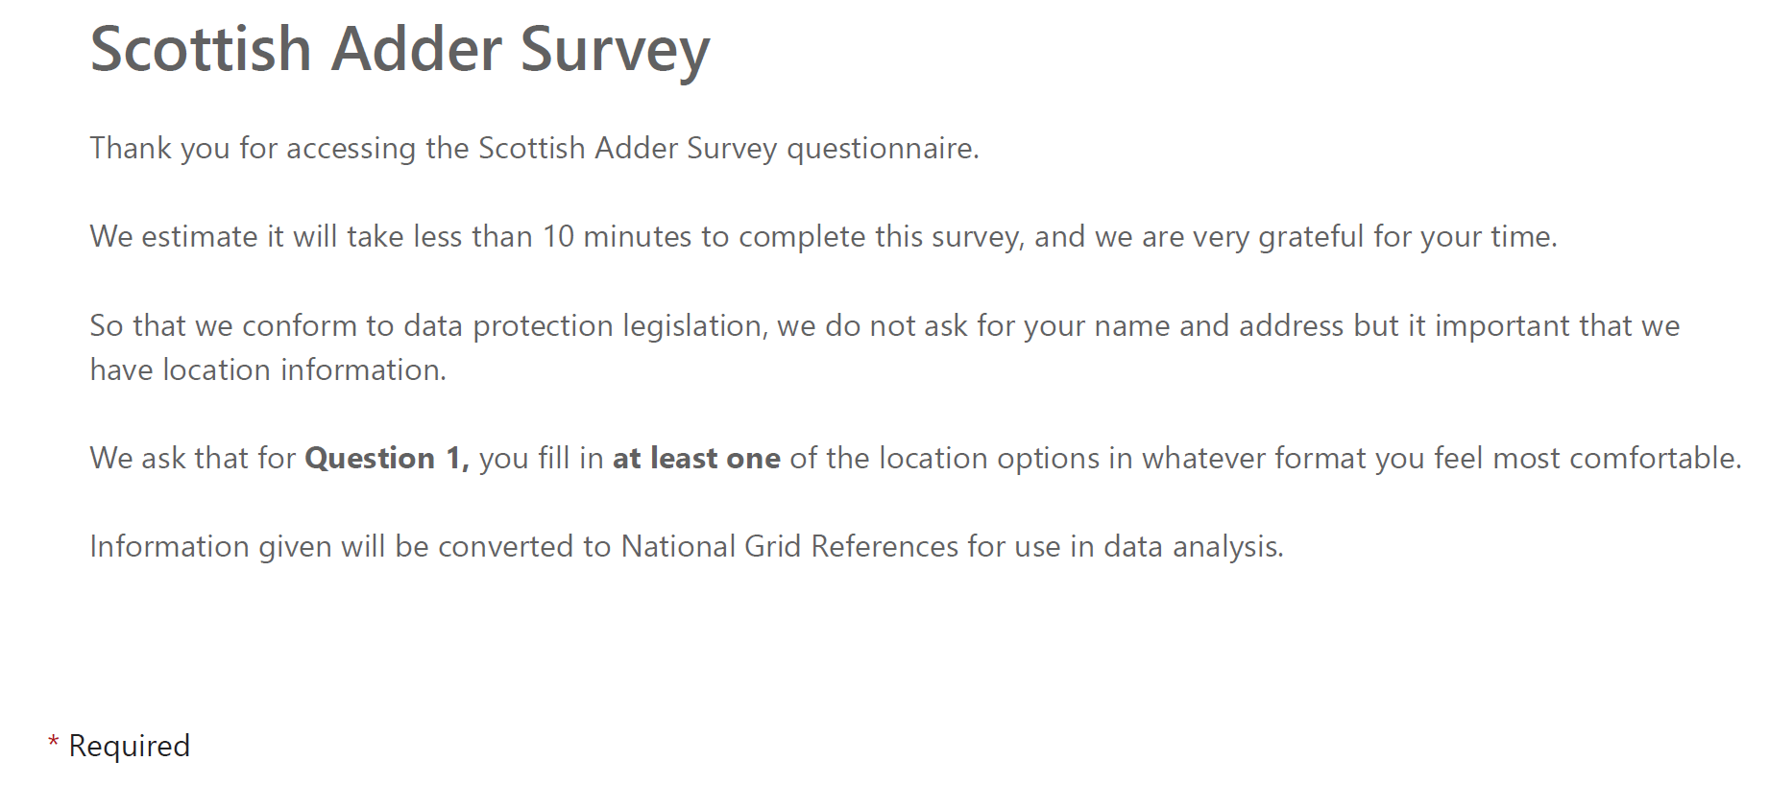
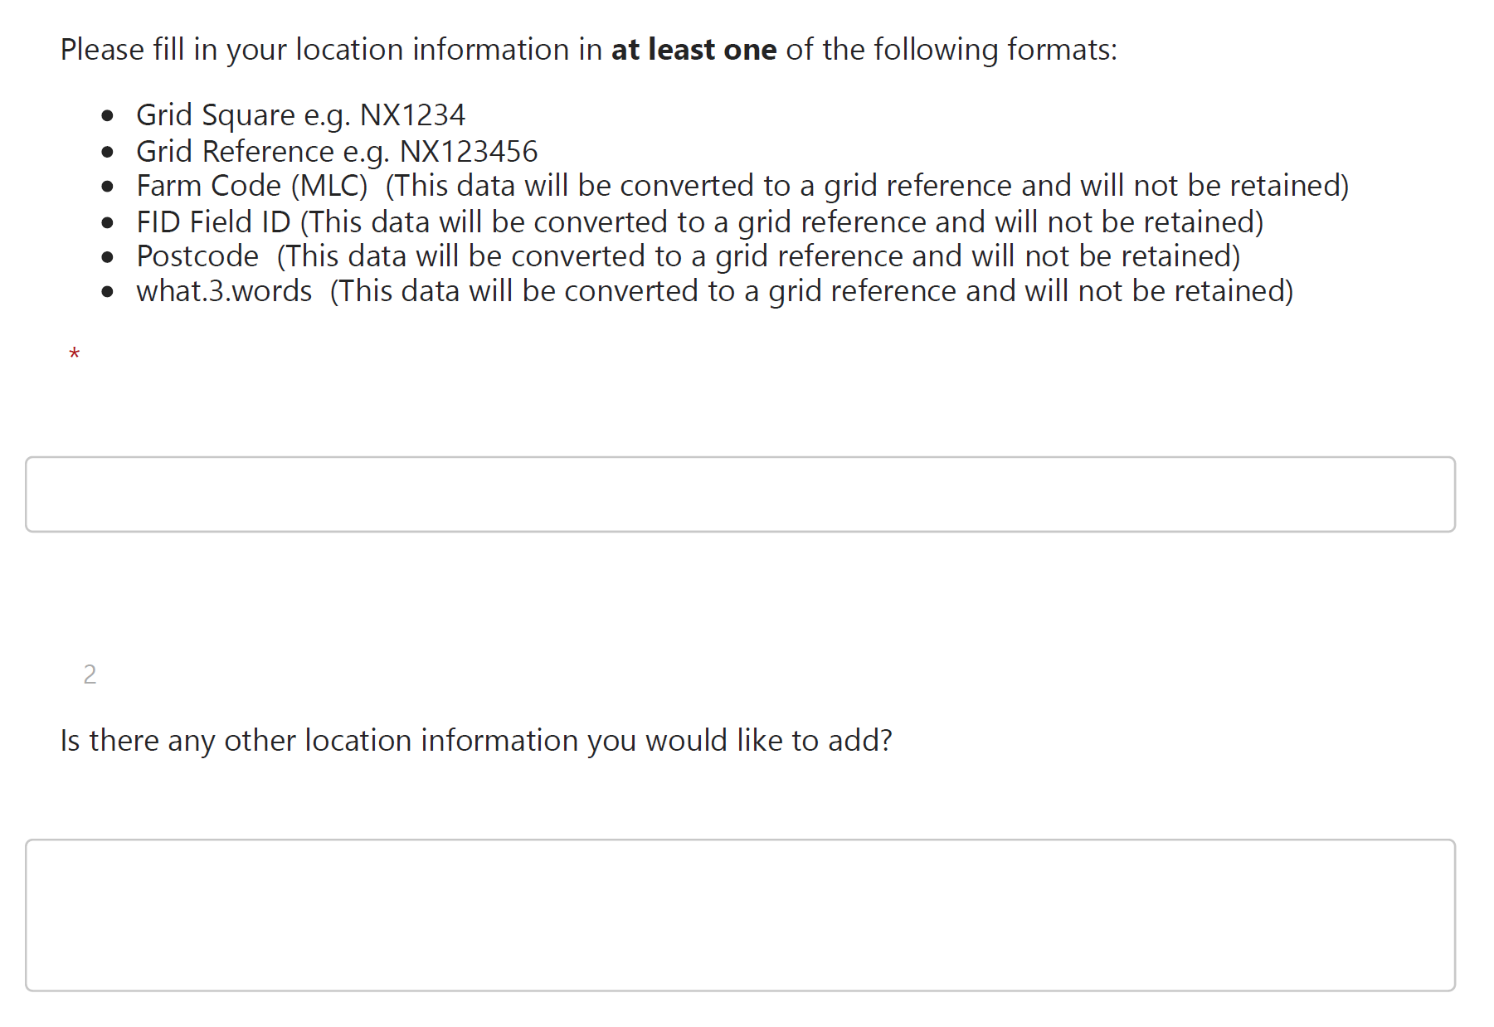
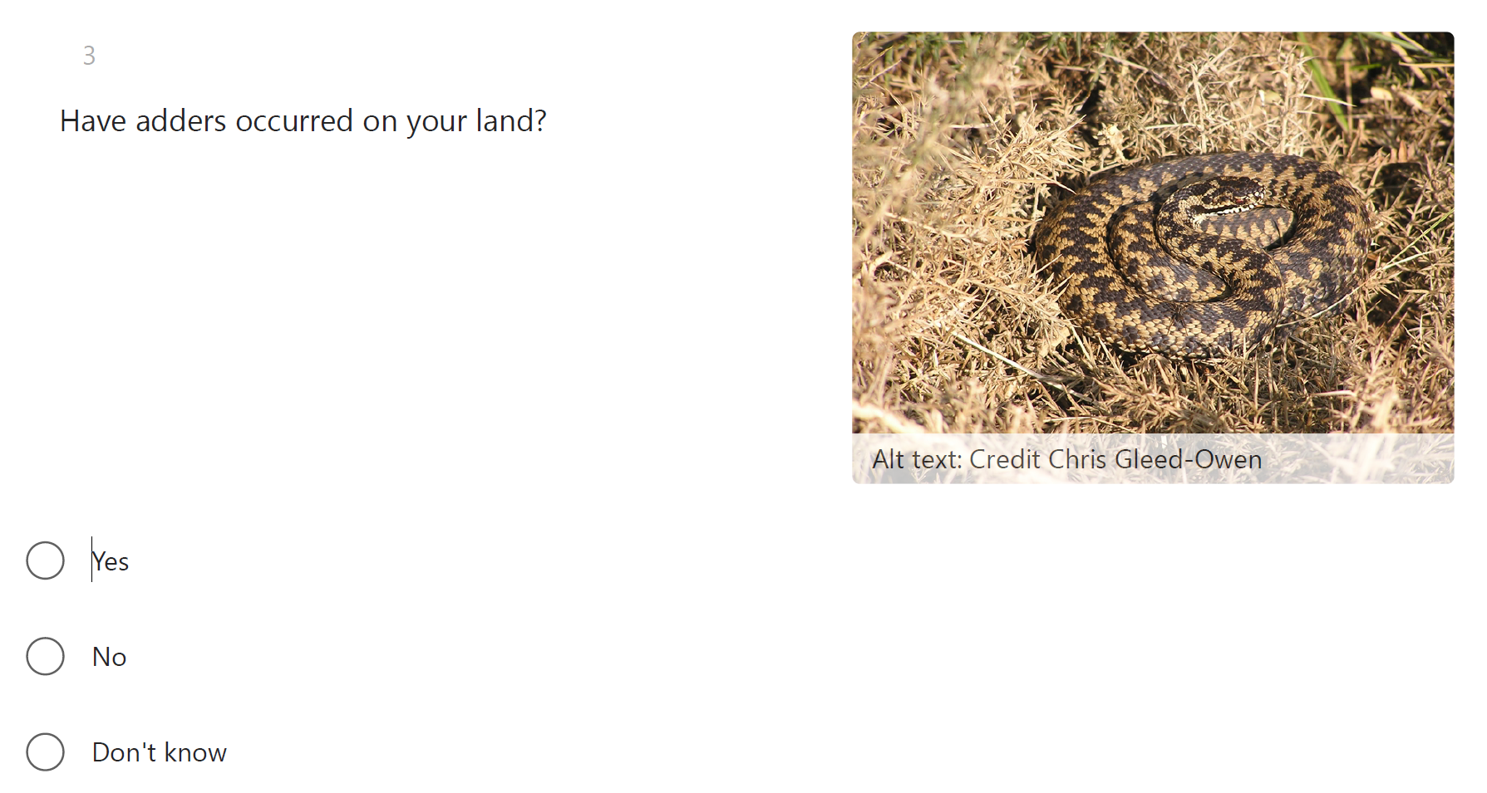
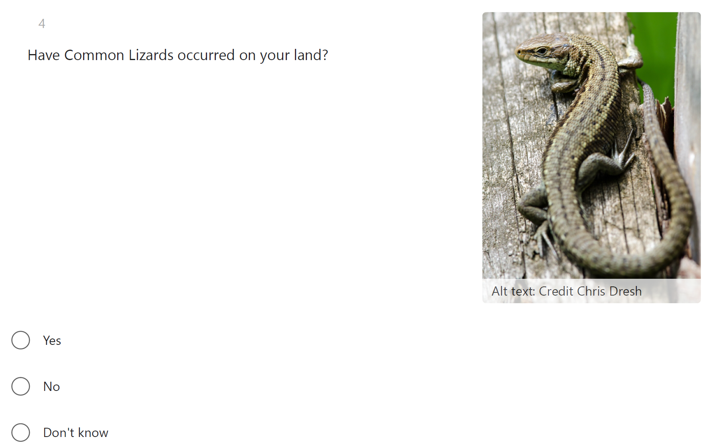
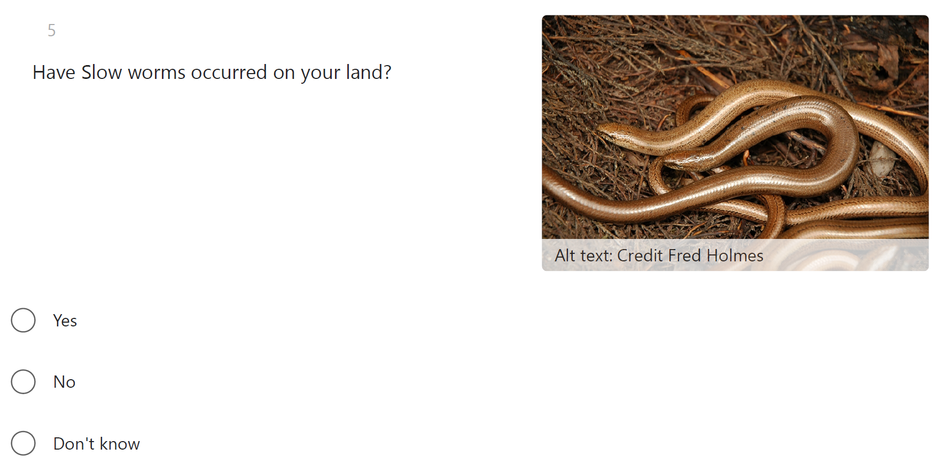
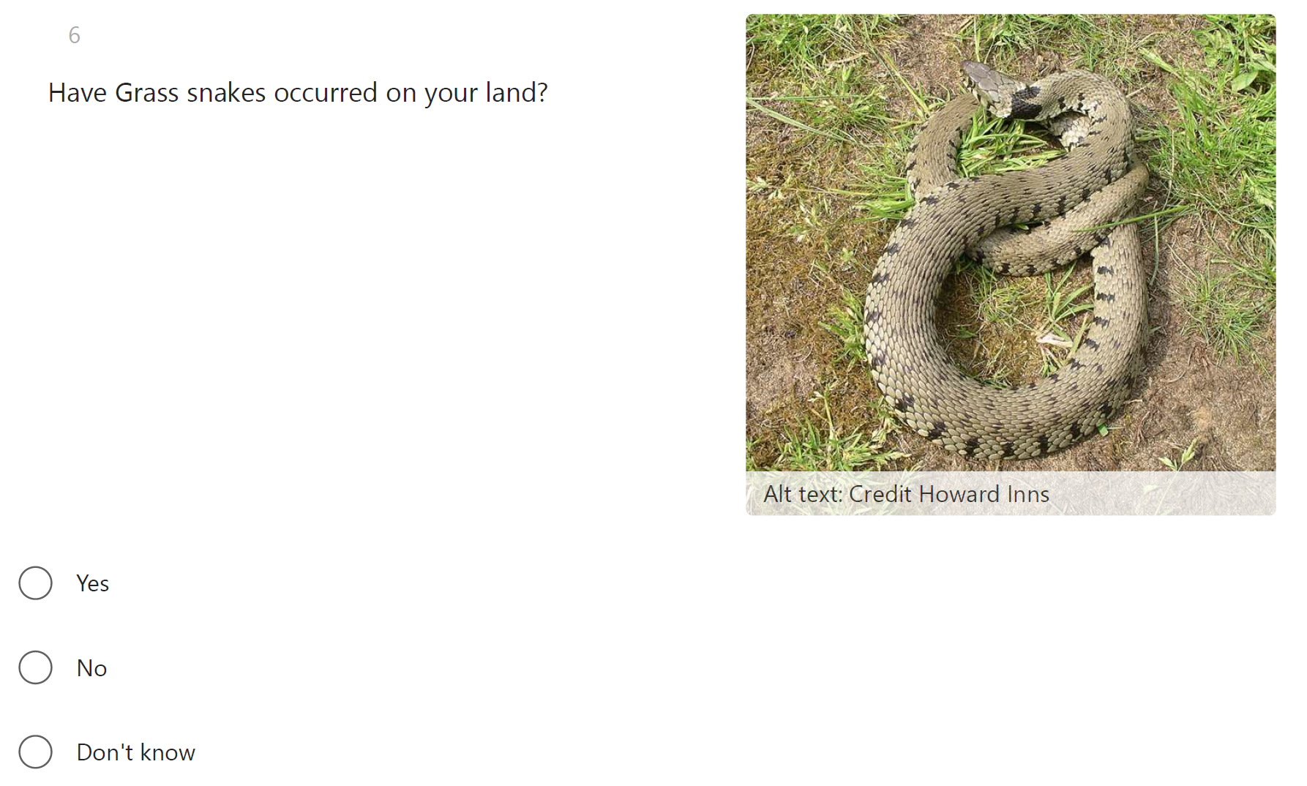
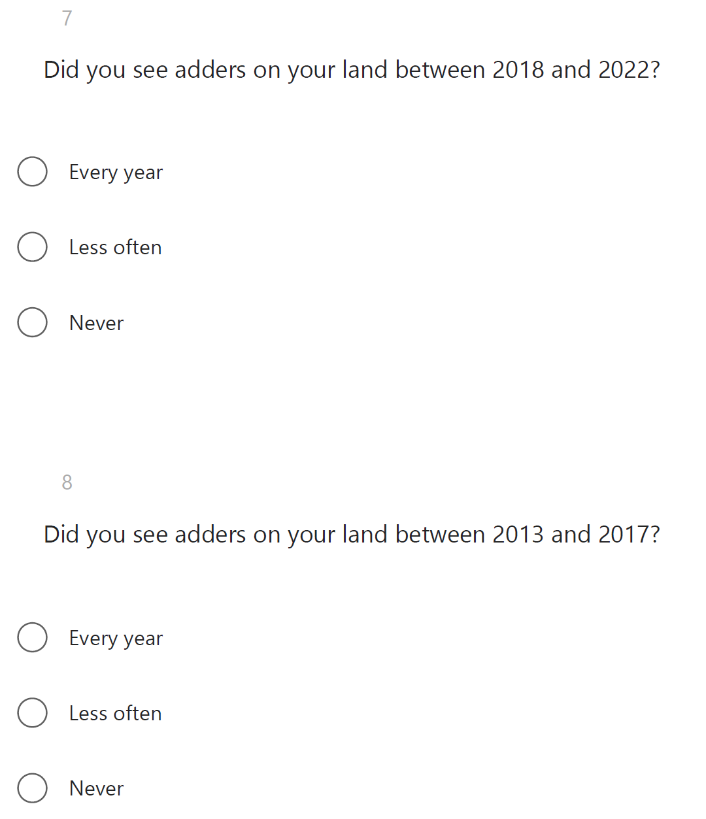
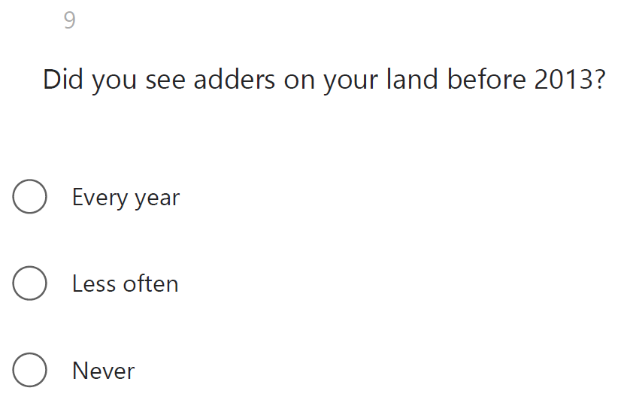
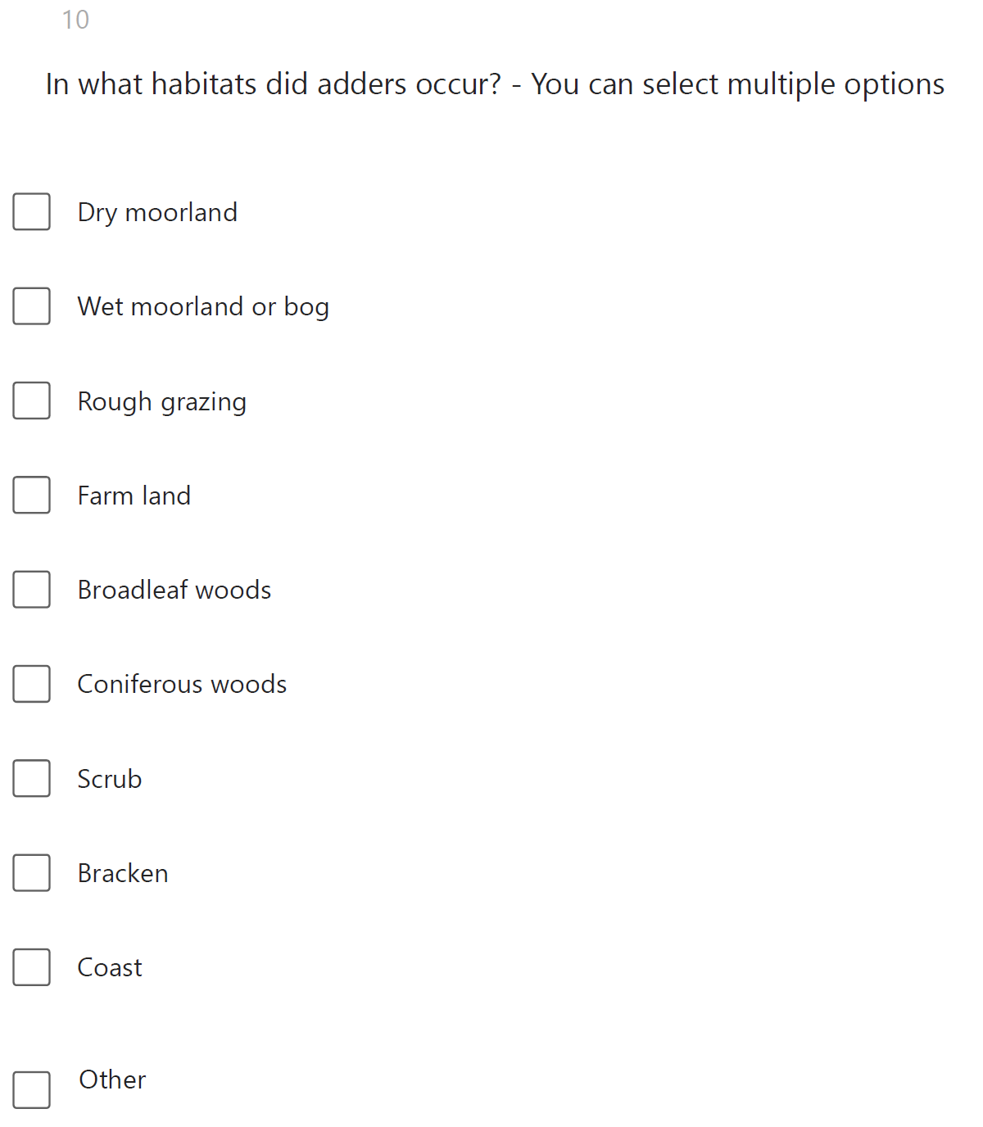
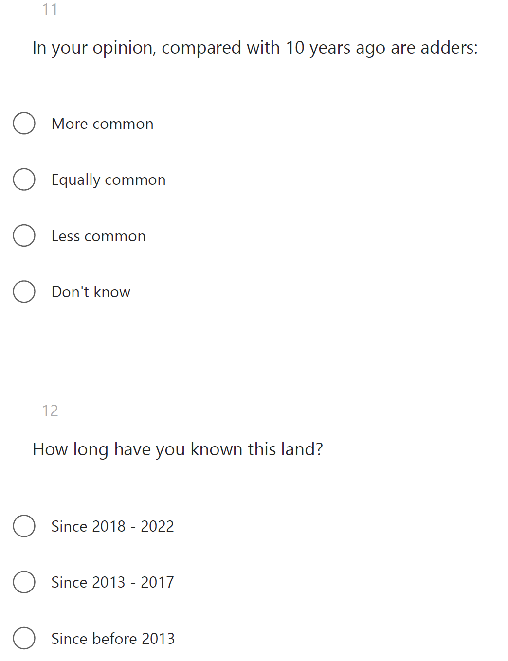
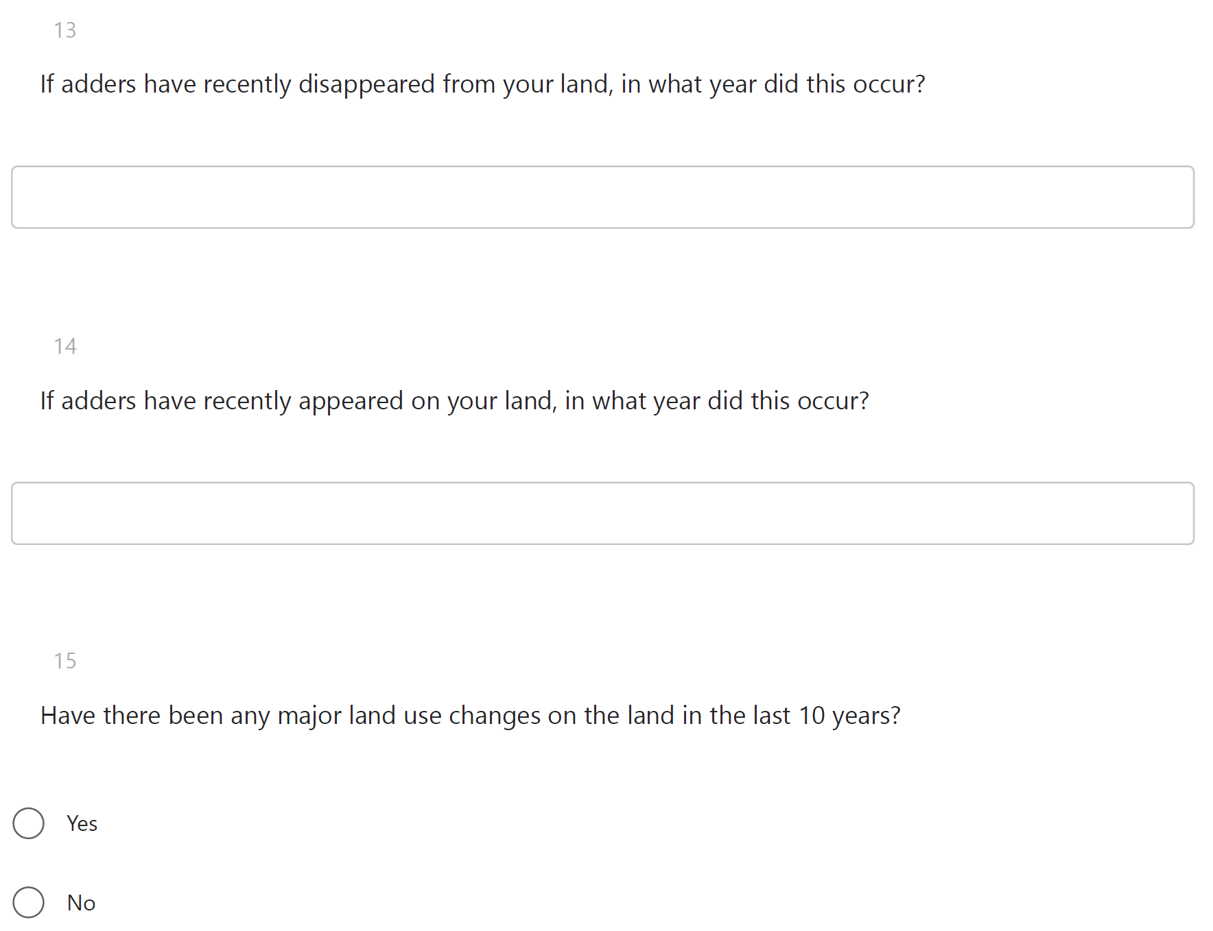
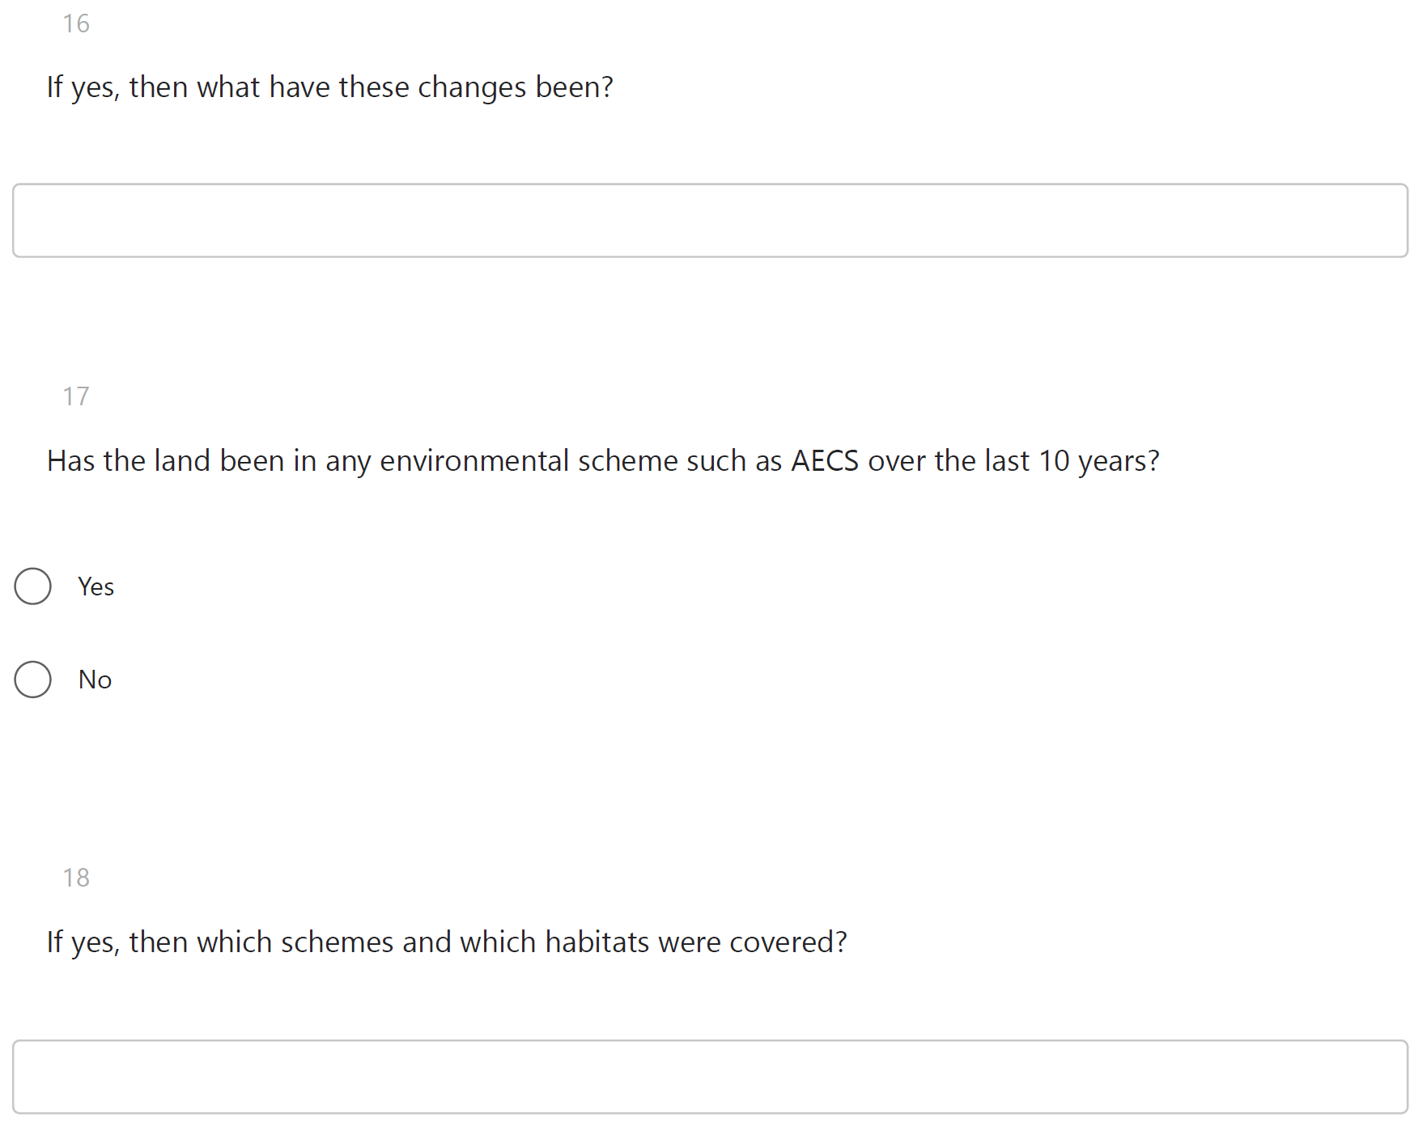
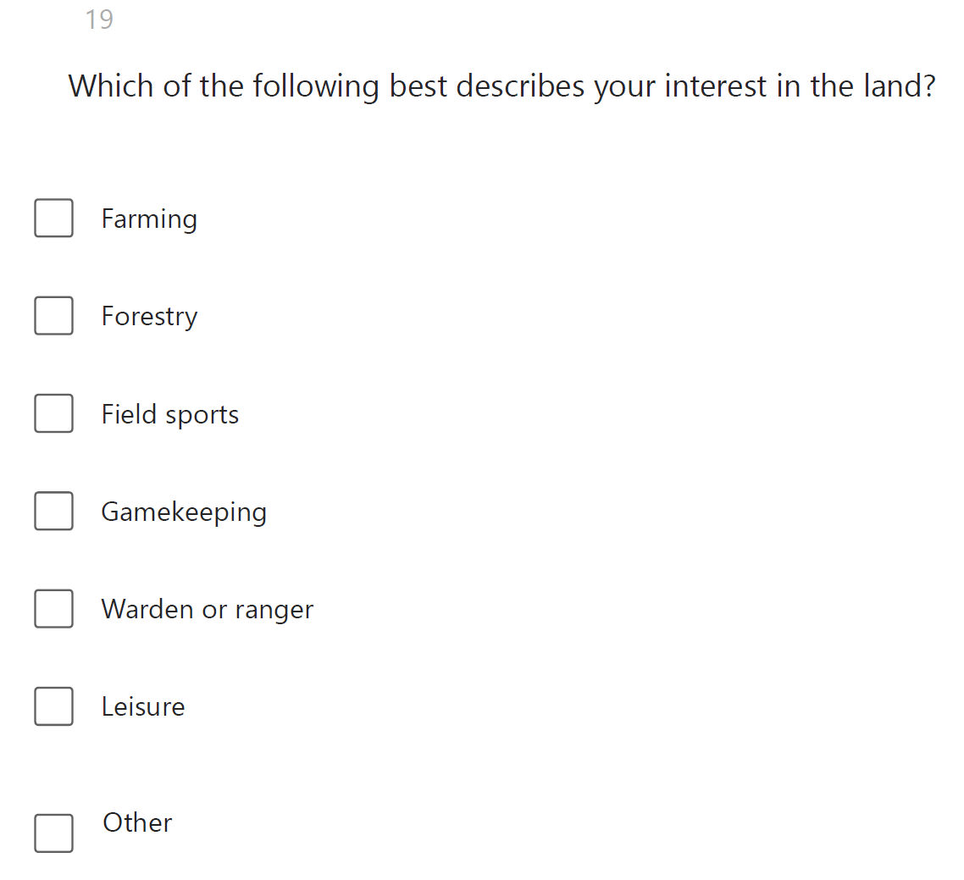
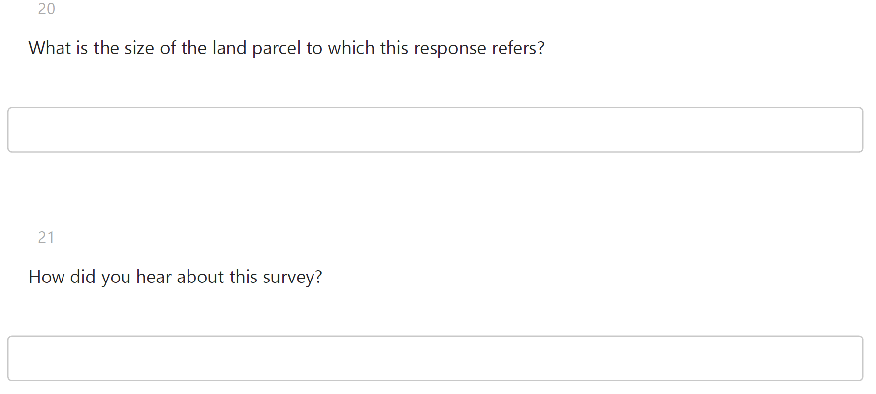

Annex 2
Terms used to categorise free-text responses for question 7 of the 2022‒24 Adder Survey questionnaire.
Category | Terms/phrases/keywords
Changes in agricultural method | Fenced/fencing
 | Changes to grazing intensity
 | Conservation grazing
 | Management change
 | Permanent pasture
 | Rest periods
 | Removal of sheep and cattle
 | Wildlife corridors
 | Spreading of slurry
Conservation projects | Natural regeneration
 | Rewild
 | Peatland restoration
 | Increasing hedgerows
Afforestation | Planting
 | Afforestation
 | Woodland creation
 | Commercial forestry
 | Reforestation
Deforestation | Commercial forestry
 | Clear-felling
 | Removal of non-native forestry
Construction | Windfarms
Increased recreation | House
 | Garden

Annex 3
Full citation for NBN Atlas download of reptile sightings used in this study.
NBN Atlas occurrence download at https://nbnatlas.org accessed on 20 September 2024.
Data provided by the following providers:
Amphibian and Reptile Conservation Trust (2024). Amphibian and Reptile Conservation species database. Occurrence dataset on the NBN Atlas (Creative Commons, with Attribution, Non-commercial v4.0 (CC-BY-NC) CC-BY-NC). For more information: email johnw.wilkinson@arc-trust.org, or https://registry.nbnatlas.org/public/show/dr236
Amphibian and Reptile Conservation and Biological Records Centre. 20/09/2024 Records verified via iRecord. (Creative Commons with Attribution 4.0 (CC-BY) CC BY Creative Commons Attribution). For more information: https://registry.nbnatlas.org/public/show/dr2769
ARG UK (2024). Record Pool. Occurrence dataset on the NBN Atlas (Creative Commons, with Attribution, Non-commercial v4.0 (CC-BY-NC)). For more information: https://registry.nbnatlas.org/public/show/dr2014
Argyll Biological Records Centre (2024). Argyll Biological Records Dataset. Occurrence dataset on the NBN Atlas (Creative Commons with Attribution 4.0 (CC-BY) CC-BY). For more information: https://registry.nbnatlas.org/public/show/dr819
Biological Records Centre (2024). Reptiles and Amphibians Dataset. Occurrence dataset on the NBN Atlas (Creative Commons with Attribution 4.0 (CC-BY) CC-BY). For more information: email brc@ceh.ac.uk, or https://registry.nbnatlas.org/public/show/dr1385
British Herpetological Society (2024). British records of herpetofauna published in the British Herpetological Society's journals. Occurrence dataset on the NBN Atlas (Creative Commons, with Attribution, Non-commercial v4.0 (CC-BY-NC)). For more information: https://registry.nbnatlas.org/public/show/dr2970
Caledonian Conservation (2024). Incidental herptile records 2005-16. Occurrence dataset on the NBN Atlas (Creative Commons with Attribution 4.0 (CC-BY) CC-BY). For more information: email chris.cathrine@caledonianconservation.co.uk, or https://registry.nbnatlas.org/public/show/dr1351
Froglife (2024). Froglife's amphibian and reptile records from the Dragon Finder App for Great Britain in 2016-2020 (inclusive). Occurrence dataset on the NBN Atlas (Creative Commons with Attribution 4.0 (CC-BY) Sensitive species (including smooth snake, sand lizard, adder, natterjack toad, north American bullfrog and pool frog) records are blurred to 10km.). For more information: https://registry.nbnatlas.org/public/show/dr1128
Highland Biological Recording Group (2024). HBRG P.F. Entwistle Colln and Notebooks Dataset (Creative Commons with Attribution 4.0 (CC-BY) CC-BY). For more information: https://registry.nbnatlas.org/public/show/dr875
Highland Biological Recording Group (2024). Vertebrates (not Badger) Dataset. Occurrence dataset on the NBN Atlas (Creative Commons with Attribution 4.0 (CC-BY) CC-BY). For more information: email records@hbrg.org.uk, or https://registry.nbnatlas.org/public/show/dr885
John Muir Trust (2024). Species Records for John Muir Trust Properties 2007-2009. Occurrence dataset on the NBN Atlas (Creative Commons, with Attribution, Non-commercial v4.0 (CC-BY-NC) CC-BY-NC). For more information: email Elizabeth@jmt.org , or https://registry.nbnatlas.org/public/show/dr762
John Muir Trust (2024). Species Records for John Muir Trust Properties Nevis, Sandwood, Quinag and Schiehallion 2010. Occurrence dataset on the NBN Atlas (Creative Commons, with Attribution, Non-commercial v4.0 (CC-BY-NC) CC-BY-NC). For more information: email Elizabeth@jmt.org, or https://registry.nbnatlas.org/public/show/dr777
Natalie Harmsworth's Records (2010-2019), TWIC (2019) (Creative Commons, with Attribution, Non-commercial v4.0 (CC-BY-NC) CC-BY-NC). For more information: email admin@wildlifeinformation.co.uk, or https://registry.nbnatlas.org/public/show/dr1510
Natural Resources Wales. (2024) Welsh Invertebrate Database (WID). Occurrence dataset accessed through the NBNAtlas (Open Government Licence (OGL) © CNC/NRW Data may be re-used under the terms of the Open Government Licence providing it is done so, acknowledging both the source and NRW's copyright. It is the recipient's responsibility to ensure the data is fit for the intended purpose. Attribution statement: Contains Natural Resources Wales information © Natural Resources Wales and Database Right. All rights Reserved.). For more information: https://registry.nbnatlas.org/public/show/dr1212
North East Scotland Biological Records Centre (2024). North East Scotland Amphibians & Reptiles 1850 - 2016. Occurrence dataset on the NBN Atlas (Creative Commons, with Attribution, Non-commercial v4.0 (CC-BY-NC) CC-BY-NC). For more information: email nesbrec@aberdeenshire.gov.uk, or https://registry.nbnatlas.org/public/show/dr1388
Records provided by Amphibian and Reptile Conservation, accessed through NBN Atlas website. (2024). For more information: email enquiries@arc-trust.org, or https://registry.nbnatlas.org/public/show/dp58
Records provided by Amphibian and Reptile Groups of the UK, accessed through NBN Atlas website. (2024). For more information: https://registry.nbnatlas.org/public/show/dp228
Records provided by Argyll Biological Records Centre, accessed through NBN Atlas website. (2024). For more information: email data@lnhg.org.uk, or https://registry.nbnatlas.org/public/show/dp59
Records provided by Biological Records Centre, accessed through NBN Atlas website. (2024). For more information: email brc@ceh.ac.uk, or https://registry.nbnatlas.org/public/show/dp77
Records provided by British Herpetological Society, accessed through NBN Atlas website. (2024). For more information: https://registry.nbnatlas.org/public/show/dp275
Records provided by Caledonian Conservation, accessed through NBN Atlas website. (2024). For more information: email info@caledonianconservation.co.uk, or https://registry.nbnatlas.org/public/show/dp4
Records provided by Froglife, accessed through NBN Atlas website. (2024). For more information: email info@froglife.org, or https://registry.nbnatlas.org/public/show/dp180
Records provided by Highland Biological Recording Group, accessed through NBN Atlas website. (2024). For more information: email chair@hbrg.org.uk, or https://registry.nbnatlas.org/public/show/dp7
Records provided by John Muir Trust, accessed through NBN Atlas website. (2024). For more information: email admin@johnmuirtrust.org, or https://registry.nbnatlas.org/public/show/dp41
Records provided by Natural Resources Wales, accessed through NBN Atlas website. (2024). For more information: email nbnadmin@cyfoethnaturiolcymru.gov.uk, or https://registry.nbnatlas.org/public/show/dp122
Records provided by North East Scotland Biological Records Centre, accessed through NBN Atlas website. (2024). For more information: email nesbrec@aberdeenshire.gov.uk, or https://registry.nbnatlas.org/public/show/dp123
Records provided by Scottish Wildlife Trust, accessed through NBN Atlas website. (2024). For more information: email kedata@scottishwildlifetrust.org.uk, or https://registry.nbnatlas.org/public/show/dp2
Records provided by South West Scotland Environmental Information Centre (formerly DGERC), accessed through NBN Atlas website. (2024). For more information: email mpollitt@swseic.org.uk, or https://registry.nbnatlas.org/public/show/dp104
Records provided by The Road Lab UK, accessed through NBN Atlas website. (2024). For more information: https://registry.nbnatlas.org/public/show/dp205
Records provided by The Wildlife Information Centre, accessed through NBN Atlas website. (2024). For more information: email info@wildlifeinformation.co.uk, or https://registry.nbnatlas.org/public/show/dp43
Scottish Wildlife Trust (2024). Commissioned surveys and staff surveys and reports for Scottish Wildlife Trust reserves - Verified data. Occurrence dataset on the NBN Atlas (Creative Commons with Attribution 4.0 (CC-BY) CC-BY). For more information: email kedata@scottishwildlifetrust.org.uk, or https://registry.nbnatlas.org/public/show/dr765
Scottish Wildlife Trust (2024). Survey and monitoring records for Scottish Wildlife Trust reserves from reserve convenors and Trust volunteers - Verified data. Occurrence dataset on the NBN Atlas (Creative Commons with Attribution 4.0 (CC-BY) CC-BY). For more information: email kedata@scottishwildlifetrust.org.uk, or https://registry.nbnatlas.org/public/show/dr766
South West Scotland Environmental Information Centre (2024). Amphibian and reptile data for Dumfries and Galloway. Occurrence dataset on the NBN Atlas (Creative Commons, with Attribution, Non-commercial v4.0 (CC-BY-NC) CC-BY-NC). For more information: email info@dgerc.org.uk, or https://registry.nbnatlas.org/public/show/dr1209
The Road Lab (2024). UK Roadkill Records. Occurrence dataset on the NBN Atlas (Creative Commons, with Attribution, Non-commercial v4.0 (CC-BY-NC)). For more information: https://registry.nbnatlas.org/public/show/dr1628
The Wildlife Information Centre (2024). A.T. Sumner's Records. Occurrence dataset on the NBN Atlas (Creative Commons with Attribution 4.0 (CC-BY)). For more information: https://registry.nbnatlas.org/public/show/dr2785
The Wildlife Information Centre (2024). Ron McBeath records (2010 - 2014). Occurrence dataset on the NBN Atlas (Creative Commons, with Attribution, Non-commercial v4.0 (CC-BY-NC) CC-BY-NC). For more information: email admin@wildlifeinformation.co.uk, or https://registry.nbnatlas.org/public/show/dr1515
The Wildlife Information Centre (2024). TWIC Biodiversity Field Trip Data (1995-present). Occurrence dataset on the NBN Atlas (Creative Commons, with Attribution, Non-commercial v4.0 (CC-BY-NC) CC-BY-NC). For more information: email admin@wildlifeinformation.co.uk, or https://registry.nbnatlas.org/public/show/dr922

