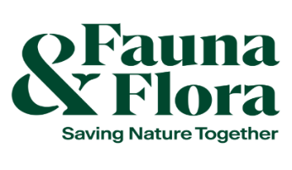

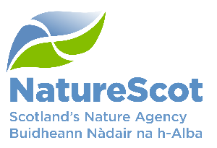

Community Marine Biodiversity Monitoring
Equipment Fund – 2025/2026

Fund criteria and information for applicants

ABOUT THE FUND
Coastal communities, local groups and individuals around Scotland’s coast are well-placed to lead on the active stewardship of their marine environment. They have expressed a wish for greater participation in the surveying of their inshore waters, and the collection of information and evidence that underpins marine management decisions.

Through the collaborative Community Marine Biodiversity Monitoring Project – a partnership between NatureScot, Fauna & Flora International, communities, groups and individuals with support from the William Grant Foundation – we aim to enhance participation in community collection of marine data through the surveying and monitoring of local inshore waters.

The Community Marine Monitoring Equipment Fund is a dedicated fund aimed specifically at supporting community and local groups with the purchase of marine survey equipment to participate in community-led marine biodiversity surveys and monitoring.

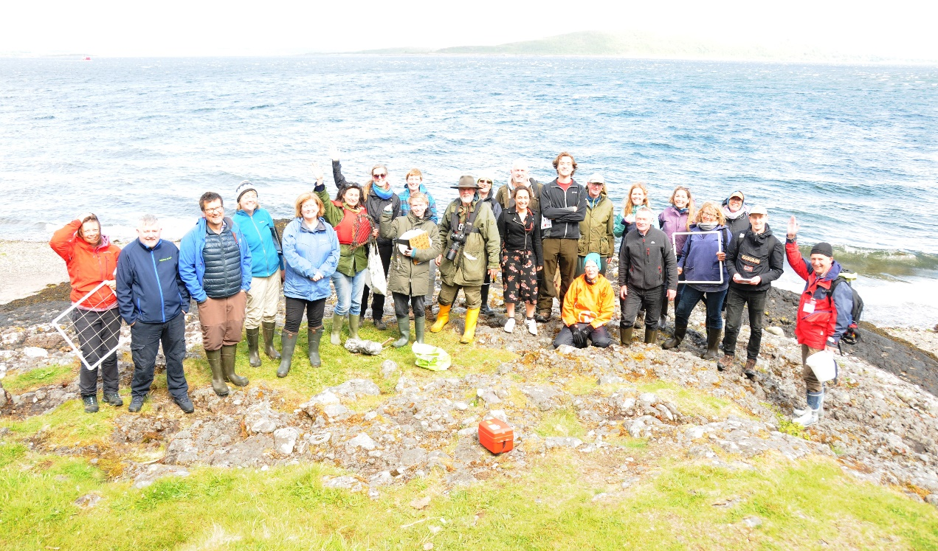
Image copyright: Cecilie Dohm/Fauna & Flora International

FUND AIMS
- Provide communities and local groups with the resources and equipment to participate in biodiversity surveys.
- Enable community and/or youth engagement in marine monitoring.

FUND USE
- Purchase equipment to be used for community-led marine biodiversity monitoring with a community and/or youth engagement element.
FUND DETAILS

- Individual grants will be offered up to £1,500. This should enable the purchase of entry level intertidal and subtidal kits (see equipment suggestions for ideas).
- Larger grants up to £3,000 are available for joint applications from two or more groups/individuals. Larger grants should enable the purchase of more technical survey equipment for groups or individuals within a common geographical area.
- The current fund is capped at £12,000 and it will be closed when the available funds are exhausted. There may be scope to release more funds if there is a demand.

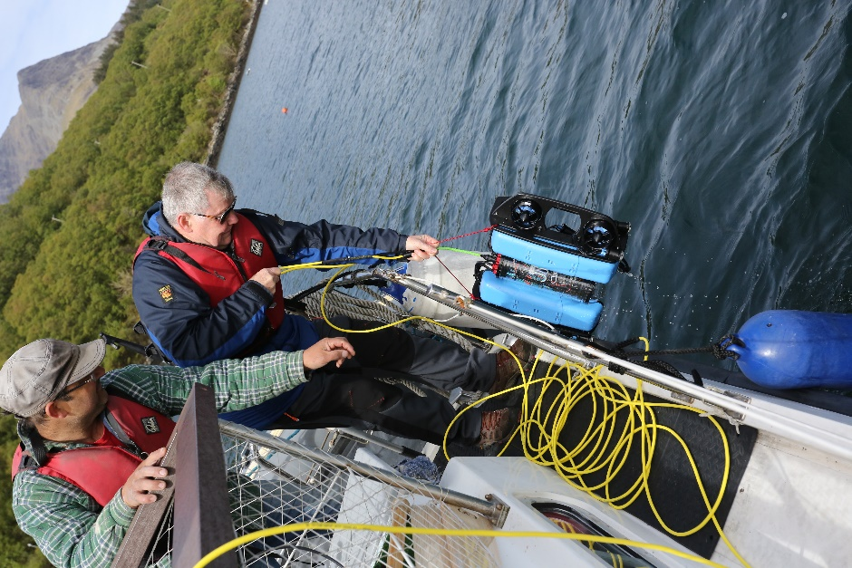
Image copyright: South Skye Seas initiative

WHO CAN APPLY?
Providing the applicant can meet the fund criteria below, applications are invited from organisations, including community and local groups, registered charities and trusts. Where applications are received from partnerships or organisations working collaboratively, a lead applicant must be identified.

Applications from the groups listed below will not be eligible, unless applicants can clearly demonstrate strong links to, and benefits for, communities and the community has been involved in the development of the proposed surveys. Links, benefits and involvement must be clearly highlighted in the application under question 2 in the application form.
- Local authorities and other public sector organisations
- Tertiary academic institutes
- Private individuals and companies (only eligible where there is significant public benefit)

The fund is intended for community-based organisations or similar groups and is especially targeted at supporting entry-level marine monitoring.

We have provided an eligibility checklist on page 5 to help you assess if you are eligible to apply. Please note that surveys which do not meet the eligibility criteria will not be considered further.

FUND CRITERIA
- The fund is available to communities and local groups based in Scotland that would like to participate in marine biodiversity monitoring.
- Surveys must help to achieve the following outcomes:
- Connect more people with Scotland’s seas through participation.
- Improve the skills, experience and knowledge of communities, local groups and individuals to participate in biodiversity surveys in Scotland.
- Improve knowledge of marine species and habitat distributions around Scotland.
- Surveys must demonstrate that they are community-led. Surveys are considered community-led if they are planned and carried out by a community/local group to achieve local aims.
- Surveys must demonstrate how they will engage communities and/or young people in marine monitoring.
- Applications from all communities and groups must provide evidence of an active volunteer base. The application must be endorsed by three members/volunteers for individual applications. Likewise, joint applications must be endorsed by three members/volunteers per group.
- Communities and groups may submit an application either individually or as a joint proposal. Simultaneous applications to the fund are not permitted.
- This funding is for the purchase of survey equipment (this can include a budget for spare parts). No additional funding will be made available for repairs, maintenance or storage.
- Groups must demonstrate an ability to maintain, upkeep and store the equipment.
- Data collected using the survey equipment must be made freely available to others and submitted to appropriate marine databases when possible.
- Groups must nominate at least one data representative per group. Data representatives will validate community data, participate in relevant training and contribute towards developing and testing the project’s data journey. No prior data experience or knowledge is required.
- Grantees must be open to engage in knowledge exchange and give demonstrations of the equipment purchased through the fund to groups within their geographical area.
- All grantees will be requested to submit a survey report within 12 months of receiving their grant, detailing survey activity. A survey report template will be issued with the grant award letter.
- Surveys must adhere to Covid-19 government restrictions at all times. If surveys cannot go ahead because of restrictions, grantees must get in touch with NatureScot staff at communitymarinesurvey@nature.scot to discuss options.
FUND GUIDELINES
- Funding applications will undergo a decision making process, considering the geographical spread of groups, equipment and funding granted on a project-wide scale. Applications will be reviewed by a panel against the fund criteria and fund aims.
- Funds will be paid to grantees upon a successful application. The funds must be spent as agreed within 60 days of receiving the funds, unless otherwise agreed, and proof of purchase must be submitted to communitymarinesurvey@nature.scot.
- If grant funds are not spent as agreed, NatureScot reserves the right to request repayment of any grant.
- Proof of purchase by receipt and photographic evidence of items are required after purchase.
- Applicants are responsible for the maintenance and insurance of their funded equipment, and equipment must be kept in reasonable condition for use for the stated amount of time on award letter (3, 5, or 10 years).
HOW TO APPLY
Please submit the completed application form, survey profile form, plus any further information you deem relevant, to communitymarinesurvey@nature.scot. Applicants are encouraged to contact us to discuss ideas before submitting an application to the fund.
Applications will be accepted on a rolling basis and will be reviewed at the end of every month.
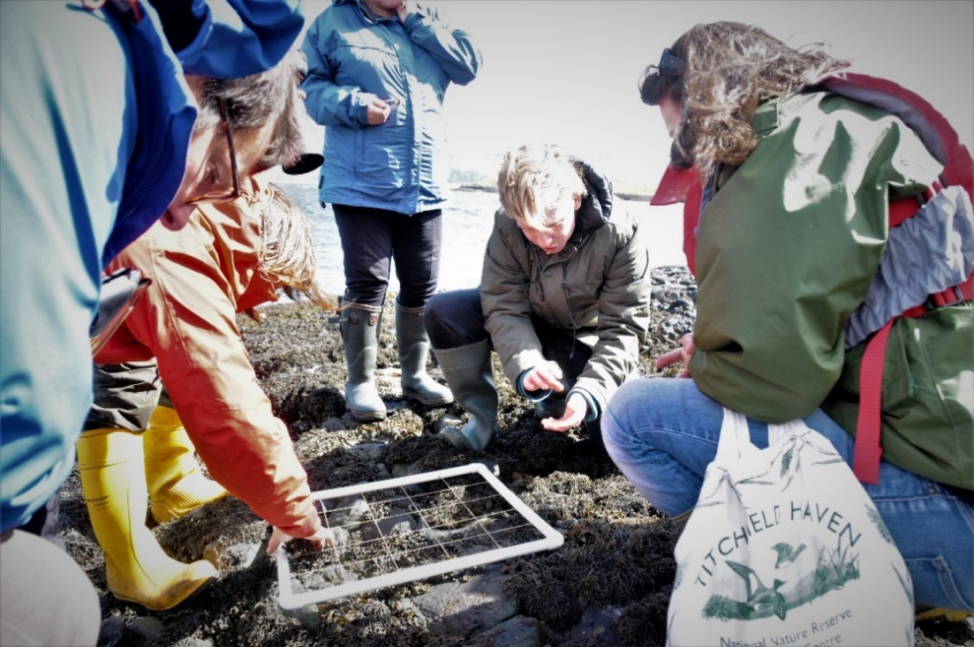
Image copyright: Cecilie Dohm/Fauna & Flora

Eligibility Checklist for Community Marine Biodiversity Monitoring Equipment Fund
Please use this list of questions to check that your surveys are eligible before applying.
☐ Is your organisation eligible for funding (see “Who can apply” section)?
☐ Do your surveys directly relate to surveying Scotland’s inshore waters?
☐ Do your surveys contribute to the outcomes set out in the Fund Criteria?
☐ Do your surveys fully meet the Fund Criteria?
☐ Are your surveys community-led?
☐ Have you demonstrated how your surveys will engage your community and/or young people?
☐ Have you provided evidence of an active volunteer base and is your application endorsed by three volunteers/members?
☐ Have you completed a survey profile form and is that attached to submit with your application? If you are submitting a joint application, one survey profile form must be completed per group.
☐ Is evaluation and reporting a planned and integral part of the survey (i.e. reporting survey data and results)?
☐ Do you have all other equipment, funding and in-kind contributions in place to deliver your surveys?
☐ Is the requested grant within the limit (£1,500 or up to £3,000 for a joint application)?
☐ Is the application form complete?

Equipment Suggestions
Within £1,500 grant budget:

Intertidal:
- Surveyor level
- ID guides
- Transect tape
- GPS device
- Quadrats

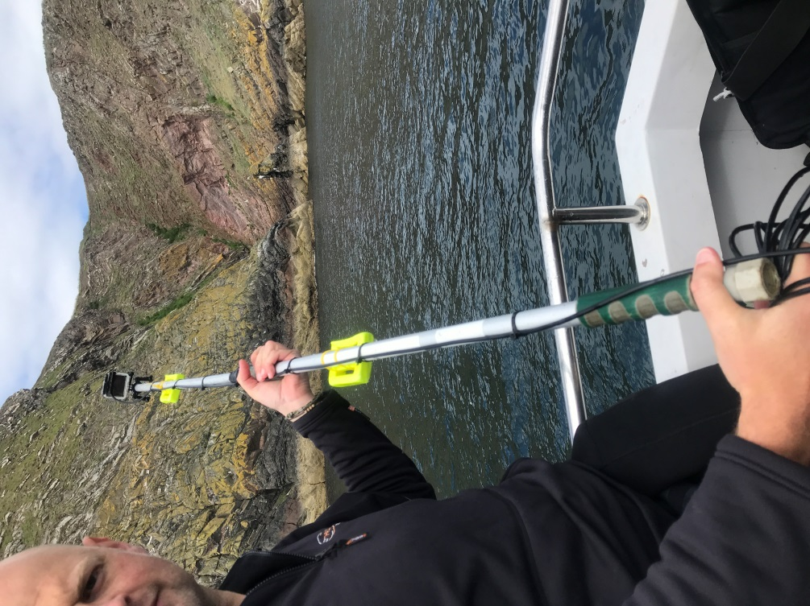
Subtidal:
- GoPro
- GoPro Diving Housing
- Underwater Wi-Fi cable from Cam-do in lengths 20ft, 125ft and 300ft. Link to Cam-do website. Alternatively, the cable can be homemade using an auxiliary cable. You can find instructions on how to do this online, such as on Paul Illsley's website.
- Tablet/surface interface
- Glass bottom underwater viewer
- ID guides
- GPS Device

Other ideas:
- First Aid and safety equipment
- External hard drives for data storage
- Clipboards, etc.

Between £1,500 and £3,000 grant budget:

- Drop-down video system
- Remotely Operated Vehicle (ROV)
Example system on the Blue Robotics website.
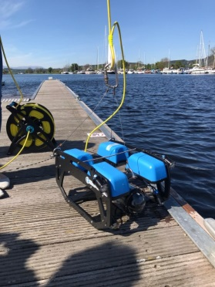

For more information or any questions, please email communitymarinesurvey@nature.scot.

NatureScot is the operating name of Scottish Natural Heritage.
The William Grant Foundation is a non-profit association established to support charitable causes in Scotland. Its work is funded by William Grant and Sons Ltd.

