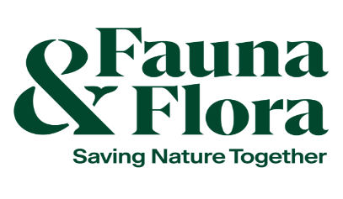

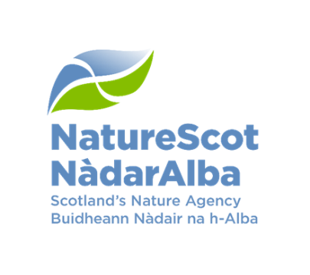

Community marine biodiversity monitoring equipment fund application form– 2025-2026

You should read about the fund and the fund criteria before filling in this form. This fund is only for purchasing equipment for community-led marine biodiversity surveys.

Please refer to the Community-led Marine Biodiversity Monitoring Project on the NatureScot website and the project’s Handbook for information on how to get started in community-led marine surveys.

NatureScot is the operating name of Scottish Natural Heritage.

Section A – About you
- Your details
This should be the person and/or organisation who is applying for the grant and who will manage the surveys.
Applicant name:
Name of Organisation:
Position in Organisation:
Website/Facebook/Twitter/Other (if applicable):
Address:

Postcode:

Landline phone number:
Mobile phone number:
Email:

Charity or business number (if applicable):
VAT registration number (if applicable):

- Is your organisation: (please check box)
☐ Registered Charity or Trust ☐ Community/Local Group ☐ Other
If ‘other’, state the type of organisation, your links to an eligible group, the community benefits and how the community has been involved in the development of the proposed surveys.

- Briefly state the main aims and activities of your organisation.

- Are you applying with another organisation/other organisations?
☐Yes ☐No
If yes, please list the other partner(s) who will be involved in delivering and managing the surveys, summarising their role(s).

If yes, please provide the details of the other organisation(s).
Lead applicant name:
Name of Organisation:
Position in Organisation:
Website/Facebook/Twitter/Other (if applicable):
Address:

Postcode:

Landline phone number:
Mobile phone number:
Email:

Charity or business number (if applicable):
VAT registration number (if applicable):

- If you have received funding from NatureScot in the past two years, or are currently receiving funding, please state the project name(s), identification number(s) and date(s).

- NatureScot will collect and hold your contact details as well as those for any agent you appoint. You and your collaborators should read our Funding Privacy Notice.

Section B – Your surveys
- Survey title

- Please describe your surveys by summarising what you are going to do and what you hope to achieve (maximum 400 words). You can provide more detail in Section C and within the Survey Profile Form (Question 10).

- Project start date:
Estimated completion date:

- Fill in the Survey Profile Form to plan and tell us about your surveys. A completed survey profile form must be submitted with your application form. If you are submitting a joint application, one survey profile form must be completed per group.

- Please describe how your surveys will engage your community and/or young people.

- Does your organisation have an active volunteer base? Please provide details about your organisation’s volunteer base.

Section C – Equipment required and activities
- Please provide details on the survey equipment required and activities that will be undertaken. If your application is successful, we will base any Funding Offer to you on these activities and outputs. Please take a realistic approach.

- What equipment is requested? Please provide specific details.

- How will this equipment help your community/group to achieve its survey objectives?

- Please describe your proposed activities.

- Please state what your survey outcomes (e.g. what changes will have taken place as a result of these activities) and outputs (e.g. the plan for the data generated) will be.

- How do you intend to store and maintain equipment?

- Total value requested (GBP £):
£

- VAT – NatureScot cannot pay any VAT that you are able to reclaim from HM Revenue and Customs. If you are not able to reclaim VAT from HM Revenue and Customs, NatureScot will pay for irrecoverable VAT and you should include any ‘irrecoverable VAT’ in your project costs.

Is the applicant registered for VAT?
☐ Yes ☐ No

Is the applicant able to reclaim VAT from HM Revenue and Customs?
☐ Yes ☐ No

Please note that if the applicant is not able to reclaim VAT from HM Revenue and Customs, then you should show ‘Irrecoverable VAT’ as a separate line in the cost tables below.

- Breakdown of equipment spend (cost per item):
Item | Quantity | Cost
Irrecoverable VAT (if any)

- Expected timescale – there must be planned marine surveys to be completed within one year of receiving funding, additional surveys can also be planned for longer timescales using the equipment. Surveys must adhere to Covid-19 government restrictions at all times. If surveys cannot go ahead because of restrictions, grantees will need to get in touch with NatureScot staff at communitymarinesurvey@nature.scot to discuss options.

- Do you have all other equipment, funding and in-kind contributions in place to deliver your surveys? Please provide details.

Section D – Terms and Conditions
I am the lead applicant and I am applying for funding under the terms of the Natural Heritage (Scotland) Act 1991. The lead applicant is responsible for ensuring the Terms and Conditions of the fund are adhered to.

I confirm that the information I have given in this application is correct, to the best of my knowledge. I have read and accept the NatureScot Standard Terms and Conditions of Funding.
Organisation name:

(Application completed by)
Name:

Date:

Signature:

We prefer to receive an electronic copy of your application. You can either:
- insert a scanned copy of your handwritten signature, or
- insert your name and electronic signature

Section E – Application endorsements
Applications from all communities and groups must provide evidence of an active volunteer base. The application must be endorsed by three members/volunteers for individual applications. Likewise, joint applications must be endorsed by three members/volunteers per group.

- Endorsed by:
Position/Role of Endorser:
Date:
Signature:

- Endorsed by:
Position/Role of Endorser:
Date:
Signature:

- Endorsed by:
Position/Role of Endorser:
Date:
Signature:

Joint Applications:
Organisation name:
- Endorsed by:
Position/Role of Endorser:
Date:
Signature:

- Endorsed by:
Position/Role of Endorser:
Date:
Signature:

- Endorsed by:
Position/Role of Endorser:
Date:
Signature:

Please email your completed application form, survey profile form(s) and any supporting documents to communitymarinesurvey@nature.scot.

Eligibility Checklist for Community Marine Biodiversity Monitoring Equipment Fund
Please use this list of questions to check that your surveys are eligible before applying.
☐ Is your organisation eligible for funding (see “Who can apply” section)?
☐ Do your surveys directly relate to surveying Scotland’s inshore waters?
☐ Do your surveys contribute to the outcomes set out in the Fund Criteria?
☐ Do your surveys fully meet the Fund Criteria?
☐ Are your surveys community-led?
☐ Have you demonstrated how your surveys will engage your community and/or young people?
☐ Have you provided evidence of an active volunteer base and is your application endorsed by three volunteers/members?
☐ Have you completed a survey profile form and is that attached to submit with your application? If you are submitting a joint application, one survey profile form must be completed per group.
☐ Is evaluation and reporting a planned and integral part of the survey (i.e. reporting survey data and results)?
☐ Do you have all other equipment, funding and in-kind contributions in place to deliver your surveys?
☐ Is the requested grant within the limit (£1,500 or up to £3,000 for a joint application)?
☐ Is the application form complete?

