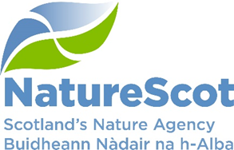

SCIENTIFIC ADVISORY COMMITTEE

DISCUSSION PAPER

Monitoring to Deliver Healthy Ecosystems

Purpose
- This paper updates on progress of our Monitoring to Deliver Healthy Ecosystems (DHE) approach and summarises the strengths, weaknesses, opportunities and threats associated with the approach and how risks will be mitigated.

Action
- The Committee is invited to note the paper and:
- approve the proposed approach
- provide comment on the risks, mitigation proposals and actions
- provide feedback on any support they could provide in taking this work forward.

Preparation
- This paper was written by Ben Ross and David Genney and sponsored by Eileen Stuart.

Background
- In February 2024, we updated the SAC on monitoring reforms on Protected Areas. The proposed approach, Monitoring to Deliver Healthy Ecosystems (DHE) was endorsed by the SAC.
- DHE will replace and improve upon the current Site Condition Monitoring process (SCM). It will better inform management interventions, prioritising monitoring, delivering efficiencies and future-proofing our approach, including capitalising on new technologies and data sources. This is particularly important as the current approach will become increasingly less fit-for-purpose as we move from a largely predictable/stable climate to a warming and more chaotic one (as described in the complementary SAC paper on Climate change and species implications).
- DHE has been developed as part of the wider transformation of our work on Protected Areas, with 30x30 acting as a catalyst for these reforms.

Key areas of work
- In the previous paper we highlighted the principles guiding the DHE approach. Subsequent work is underway using this to develop a framework for delivery, the detail of how it will be applied to different ecosystems, development of the IT systems to support the approach and the business changes to transition to the new approach.
- The DHE Framework is illustrated in Annex 1. It replaces the largely linear SCM approach with a cyclical process linking site-objectives to management requirements, understanding if management is being carried out and reducing pressures, and ultimately whether nature on that site is improving. The feedback loops throughout the process linking monitoring to management and pressures enable a more dynamic and forward-looking approach, able to adapt to change and deliver resilience.
- Ecosystem working groups are in place involving NatureScot and external experts to consider how the approach will work with different ecosystems. So far groups have been set up to cover woodland, freshwater and marine ecosystems.
- A new system, Ecosystem Management Insights (Eco-MI) has been developed through the CivTech process to replace the existing outdated Site Condition Monitoring system and facilitate monitoring reform. It enables more flexible ways of working, better ways to plan and allocate monitoring and resources and better use of new and existing evidence.
- The Eco-MI tool will support the transition from the current SCM approach to DHE. This will be supported by a business-change programme supporting staff and ensuring read-across between the old and new approach. The transition will be complete by 2028.

Issues arising
- The DHE approach proposes a shift of focus from monitoring notified features of sites to monitoring pressures acting on the site ecosystems (e.g. herbivore impacts) and the actions taken to reduce them (e.g. deer control). This enables the cyclical and adaptive approach shown in Annex 1 linking site objectives, management and monitoring.
- Currently Scotland, Wales, England and Northern Ireland follow a relatively standardised (but not identical) approach, Common Standards Monitoring. This involves systematic monitoring of multiple attributes (c10 on average) of every notified feature of a site. There are around 5000 features on our almost 2000 protected areas across Scotland. As described in the previous paper, we struggle to monitor all of these attributes and features within target cycles due to how resource intensive the process is, compounded by budget pressures. As a result, our evidence base on the health of our protected areas is increasingly weak (and challengeable) and the insights we can derive from it to support nature restoration are limited.
- The strengths, weaknesses, opportunities and threats presented by the shift in focus from features to healthy ecosystems are summarised in Table 1 below.
Table 1. SWOT Analysis of DHE Approach

Strengths | Weaknesses
- Enables reporting on condition at a site level rather than at (often multiple) feature levels  - Stronger link to management requirements for sites, including management of pressures operating at larger scales  - Supports delivery of a broader range of biodiversity outcomes within sites  - Supports a forward-looking approach to area-based conservation and delivery of resilience in warmer and more chaotic climate  - Increased efficiency of monitoring  - Insights into management interventions for restoration beyond site boundaries  - Supports new approaches to area-based conservation delivered by 30x30 (OECMs)  - Supports a more holistic and strategic approach to protected areas outcomes  - Enables adaptive management approaches  - Reduces system (IT) complexity | - Relies on assumptions  - May result in fewer/less robust data on certain features  - Will have implications on reporting on the National Statistic on protected areas  - Guidance and training for staff and others  - Requires re-framing of site objectives and documentation
Opportunities | Threats
- To utilise DHE, in conjunction with 30x30, as an opportunity to articulate a coherent and logic-based narrative around the respective roles of protected areas and the wider countryside in the delivery of SBS outcomes and supporting land-use planning  - Provision of more translatable approach to monitoring, interpretation and delivery of positive management at landscape, regional and national scales  - Enable development of an integrated monitoring approach to species and habitats within and outside of protected areas | - More flexible approach risks being perceived as less robust than the existing common standards monitoring approach  - May diverge from approach of other UK agencies  - Challenges more traditional thinking around protected area monitoring and management

Mitigating risk
- The magnitude of impact associated with these weaknesses and threats is, to some extent, dependent on the degree to which we shift from monitoring features to monitoring the health of the ecosystem. There therefore exists a spectrum of options from maintaining a full focus on features to solely measuring ecosystem health. In between these are various hybrid options together with potential action to mitigate risks.
- The weaknesses and threats described in Table 1 can be broadly split into 3 themes: science and evidence, resources, and perceptions and consistency. Approaches to mitigate the risks associated with each are presented in Table 2.
Table 2. Risk themes and mitigation

Risk | Mitigation
Theme 1: Science and Evidence
Incorrect assumption that we understand and identify the correct pressures acting on a particular site and that removing or reducing them will improve the health of the ecosystems present (and therefore the site) | - Use of expert working groups to shape monitoring objectives for particular ecosystems  - Cyclical approach provided by DHE enables adaptive management  - Use of sentinel sites for more intensive/targeted monitoring  - Bespoke research programmes/projects to address evidence gaps arising
Incorrect assumption that the resultant healthy ecosystem(s) will be beneficial for the features for which a site was originally notified | - Use of a risk-based approach to determining degree that individual features will be monitored (e.g. using conservation status, availability of data)  - Sentinel sites for targeted monitoring  - Bespoke research programmes/projects to address evidence gaps arising
Reduced monitoring effort on some features / attributes will reduce the amount of data collected on them at the site level and potentially lose important information that could support our objectives | - Use of a risk-based approach to determine degree to which monitoring individual features will be maintained (e.g. using conservation status, availability of data)
Changes to our monitoring of protected areas, away from individual notified features towards the health of the site will mean that the national statistic for Scottish Government’s National Performance Framework will change | - Eco-MI will allow for comparison between old and new monitoring results  - As a whole-site indicator, the DHE Approach will provide a much more meaningful assessment of the performance of individual sites and the suite of sites
Theme 2: Resources
New approaches require additional work both in terms of re-defining procedures, guidance, documentation and systems as well as training staff responsible for delivery | - 5yr resourcing plans have been prepared for delivery as part of 30x30 planning  - Extra cost offset (in long-term) by increased efficiency of the DHE monitoring process  - Business-change approaches embedded into DHE workstreams
Theme 3: Perceptions and consistency of approach
Approaches that shift monitoring focus away from features could be perceived as lessening the importance of those features in terms of conservation effort | - Take the opportunity to develop a more coherent and holistic narrative and vision for the respective roles of Protected Areas and the wider countryside both in terms of habitat and species conservation
DHE will involve deviation from Common Standards Monitoring and therefore runs risk of divergent approaches elsewhere in the UK | - Maintain as much alignment as possible with other agencies through chief scientist’s group and interagency groups (already in place)

Proposed approach
- We propose to proceed with a risk-based approach to monitoring whereby certain features (or specific attributes of them) will continue to be monitored but with an emphasis across the suite on monitoring to deliver healthy ecosystems. Despite the challenges, the DHE approach provides net benefits and opportunities not just in terms of monitoring but in delivering broader protected areas and 30x30 objectives.
- Timescales are provided in Annex 2. Specific elements of work relevant to some of the risks and mitigations discussed above include:
  - Prioritisation of notified features – We will conduct a review and prioritisation exercise of existing features to help decision-making on the level of monitoring focus. This could consider factors such as conservation status, uniqueness or degree of specialism, availability and quality of data and any other reporting needs or value.
  - Vision – As part of the 30x30 programme of work, an overarching vision for the role of the suite of protected and conserved areas will be developed this year. It will enable better conservation planning, monitoring and action at national, regional and local levels and allow a more holistic view in the context of the wider countryside. It will also help connect work on species and habitats in the face of climate change and improving ecological connectivity (via our work on Nature Networks).
  - Habitats and species monitoring programme – We will utilise existing work around biodiversity data flows and needs to develop an initial framework for an integrated ecosystem, habitat and species monitoring programme.
  - Risk register – The development of a risk register that can be used to identify and track risks and inform mitigation including science and evidence needs will form part of this work.

Action required
- The Committee is invited to consider the issues raised in this paper and:
- approve the proposed approach
- provide comment on the risks, mitigation proposals and actions
- provide feedback on any support they could provide in taking this work forward.

Contact: Ben Ross, Ben.Ross@nature.scot

Annex 1 – Delivering Healthy Ecosystems framework
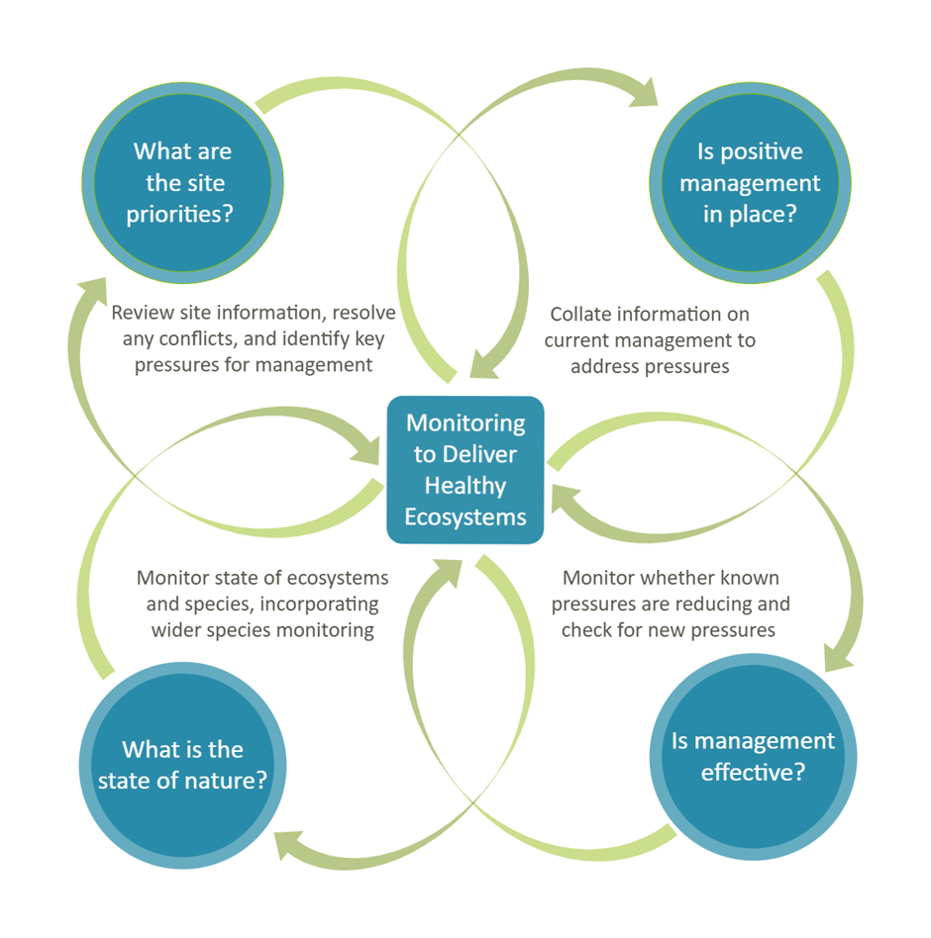

Annex 2 – Delivering Healthy Ecosystems routemap

