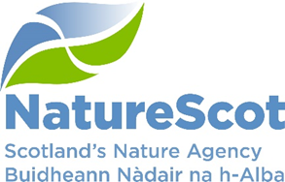

SCIENTIFIC ADVISORY COMMITTEE

DISCUSSION PAPER

Future climate scenarios and implications for species

Purpose
- This paper explores possible implications for species arising from climate change, including climatic factors, species responses and the role of NatureScot in responding. The paper is aligned with SAC/2025/03/03 on the role of monitoring in Delivering Ecosystem Health.

Action
- The SAC is asked to note and comment on the paper, including any notable gaps, further work required, with particular emphasis on:
- the checklist in paragraph 21, including whether, if top is higher priority, they should be listed in another order;
- evidence needs to support discussions on current species distributions as we shift our focus towards future diversity and resilience of species populations rather than mainly historical numbers.

Preparation
- The paper was written by Clive Mitchell with contributions from Debbie Bassett, Ben Ross and Kath Leys. It is sponsored by Eileen Stuart.

Background: climate
- Climate is warming rapidly. Most authorities consider it likely that 1.5°C will be reached in the 2040s, and 2°C by the 2050s, which is about three times faster than the first 1°C warming over the last 100 years. In addition, climate is not only warming but is more chaotic within and across years. Ecological (and social) change is driven partly by averages but mainly by extreme events and ‘unusual’ patterns of weather.
- The Earth system response to abrupt greenhouse gas emissions is determined mainly by two factors: the ambient levels of CO₂ in the atmosphere and the ease with which species can move through the land and sea. The lower the levels of ambient CO₂ before the abrupt emissions and the more difficult it is for species to move, the more severe the response. Geologically, atmospheric CO₂ at the 1850 baseline was lower than at any time over the last 450 million years, the continents are as dispersed as they ever have been, and our management of the land and seas has made it more difficult than ever for species to move. Now is the worst time for a rapid increase in atmospheric CO₂.
- During 2024, the world glimpsed how climate and weather might behave with 1.5°C warming because of an intense El Niño phase. The intensity of these events surprised many people in temperate latitudes where warming was not expected to be especially problematic up to 2°C. Extreme events and unusual patterns of weather observed are likely to be even more extreme and unusual by the 2030s and 2040s.
- The UK tends to lie on the global average temperature trend. On average, 2°C warming will shift the current climate in Barcelona to London, and in Paris to Edinburgh. In Scotland, average trends are towards warmer, wetter winters especially in the west and hotter, drier summers especially in the east. But the extremes matter. Extreme drought (e.g. Summer 2018) are currently 1-in-20-year events in Scotland but will be 1-in-3- or 2-in-3-year events in the worst affected parts of eastern Scotland by the 2040s. ‘Wetness’ is likely to arrive as localised intense events, with increased storminess and unseasonally strong winds. Freshwaters will warm, especially where they lack shading from riparian habitats, and hence are prone to deoxygenation, especially where nutrient levels remain high, with effects on species such as Atlantic salmon and freshwater pearl mussel. As well as storms, our seas will experience more intense and frequent marine heatwaves and associated thermal stratification and de-oxygenation, adding to pressures on diadromous fish in different parts of their lifecycle.
- Most of the policy and practice that governs uses of the land and sea, including conservation, has developed over the last 70 years and assumes a largely stable and predictable climate.
- The conditions outlined above present deep challenges for species in Scotland and will force some difficult management decisions especially between conservation objectives facing into near-future climate risks.

Implications for species
- This section first outlines some of the implications for species of a warming and more chaotic climate, and second, some of the consequences of actions to restore nature.

Implications of a warming climate for species
- Average changes can be described by ‘climate envelopes’ for species, which generally move polewards and upwards as temperatures increase (although local factors will introduce some variation on this). In Scotland, species that are towards the northern edge of their range, or altitude, will run out of space. Examples include Arctic Alpine vegetation communities and obligates such as ptarmigan. In addition to the availability of space to move into, slower breeding and more static species (such as trees) are more vulnerable to climate envelopes outpacing the rates at which they can move. Under current uses of the land and sea and left to respond ‘naturally’, the novel ecosystems that emerge from species movements may be characterised by the rates at which species can move, dominated by the highly mobile and adaptable.
- Range change or expansion will depend on the species and may be constrained by anthropogenic barriers, such as habitat loss and fragmentation in areas more intensively managed for productivity and yield, as well as roads and other linear infrastructure, towns and cities. Historical anthropogenic pressures have also resulted in a significant imbalance in the representation of different ecosystem-types at a national level (e.g. c.5% coverage of native woodland). Overall, post-War land use has become increasingly binary, for one purpose or another rather than for multiple purposes or benefits. Conservation policy and practice is also rooted in this approach to land use, assuming a largely stable and predictable climate. Baselines for conservation objectives, habitat classifications and responses to legislative drivers to meet targets are rooted in the past and can run contrary to building resilience through diverse, connected, complex land cover in a more dynamic climate.
- Nature networks and Other Effective Conservation Measures that are part of ‘30x30’ will help to ease some of these barriers and adopt more dynamic approaches to area-based conservation, but species movements through the landscape will be greatly assisted by the other 70% of land and sea being nature-friendly (the ‘porosity’ of land and sea use to species movement).
- Overall species diversity is likely to increase as a result of average warming trends, with more generalists arriving from the south (e.g. butterflies, moths, birds, fish), and more classified as invasive non-natives. This is not necessarily a change for the good. Overall, the effect of climate and other drivers is leading to homogenisation of species assemblages as generalists outcompete specialists, leading to less diversity and more vulnerability to risk overall.
- Individual species behaviour is also influenced by other species, and so species assemblages may impact ecological function and process. Although much conservation action centres on aspects of vulnerability to extinction risk, there is increasing awareness of the importance of declines in once abundant species (i.e. either contractions in geographical extent or number) in ecological function. This signals an imperative to act sooner to ensure that ecological functions are not lost or significantly changed. By the time species are at risk of extinction, their functional significance will be diminished or lost. See Figure 1.
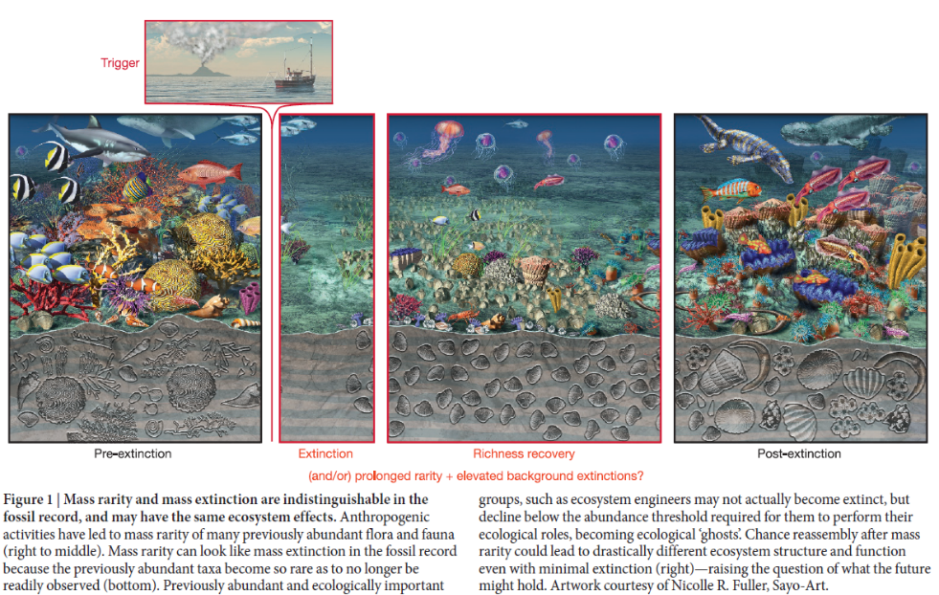

- Temperature, precipitation, extreme events and ‘unusual’ patterns of weather all affect species including breeding, feeding and migrations. Effects can include phenological mismatches, range changes, changes in flyways and other routes for migratory species. There may be changes in abundance, some losses and new arrivals and novel ecosystems.
- Climate change will exacerbate other biodiversity pressures such as habitat fragmentation, over exploitation, invasive non-native species and pollution. The cumulative impact of these pressures combined with climate change will have unprecedented impacts on species in Scotland.

Risks and possible consequences of climate-driven actions to protect or restore nature
- In most cases, the first best solution will be to remove pressures and establish nature-friendly uses of the land and sea to allow species to disperse naturally across their range. On land, shifting from more homogenous to more heterogenous vegetation cover, at a range of scales, is likely to be important to build resilience to a range of climate risks. This includes re-considering the make-up and representation of different ecosystems across landscapes, with fuzzier boundaries replacing sharp binary ones.
- Land use managements and change over time has resulted in net losses of species and changes in abundance. Examples include decline and grassland specialists such as corncrake and chough and increases in others including wintering populations of geese. More homogenous land cover and the loss of scrub and wetlands has contributed to declines in waders and other species. Grazing pressure has increased overall and shifted from mixed herbivores to single species (e.g. deer) playing significant roles in degraded habitat condition, especially woodlands, peatlands and riparian habitats. Proposed management for specific climate risks, such as fire, has led to contested evidence about the merits and risks of muirburn practices, but also leaves residual risks, notably pests, pathogens and disease in the resulting heather-dominated vegetation. In some places, restoring habitats for one set of interests, e.g. peatlands for climate change, may conflict with others, e.g. hen harriers.
- In teasing out these tensions it is important to clarify the underlying (distal) causes from the acute (proximate) ones. The further we look into the past (even a decade or more), the further we look into a largely stable and predictable climate as opposed to the increasingly warming and chaotic climate we are moving deeper into.
- In navigating these tensions we may directly choose to favour one cohort of species over others, based e.g. on conventional conservation priorities, or we may indirectly do so by promoting resilience to climate risks as our guiding principle. In the former, we aim to control populations and extent of target species. This has always been difficult, but those difficulties will magnify as climate becomes increasingly chaotic or restoration activities accelerate.
- Current live examples include restoration of managed moorland, where reduced burning and woodland creation are likely to lead to habitat less favourable to moorland specialists like curlew and hen harrier. This may lead to more dispersed populations at lower density, but possibly some reductions in populations of conservation concern. This poses challenges to traditional protected area policy and practice, but it is a choice of preferred management outcomes that we will increasingly have to consider.
- The following checklist might guide our decisions
Outcomes sought | Considerations
Delivering Healthy Ecosystems | To support natural processes and structural and species diversity – based on NatureScot Delivering Healthy Ecosystems framework
Addressing ultimate causes of biodiversity decline | Symptoms will persist for as long as the underlying causes continue to act.
Allowing for environmental change | Monitoring and adaptive learning based on clear, principled and dynamic objectives around land-use change that are aligned with the broad objectives of the SBS (healthy, diverse, resilient ecosystems and associated species populations). A shift away from numbers or extent to function, process, resilience and health.
Place-specific management objectives | All of the above are locationally specific. Modelling changes to species populations as a consequence of restoration activity should inform decisions.
Effective use of resources for nature restoration | Once these have been assessed then consider likely success of interventions, total costs, who pays and acceptability. We may be more willing to accept these costs sometimes, in some protected areas, especially as part of wider efforts to address underlying causes.
Urgency of action to halt declines | Especially in relation to addressing causes and resources. Restoring nature (e.g. peatlands) to build resilience to climate risks may be more important than species objectives.

- Responses may also include translocation of some species from further south into Scotland, and species from Scotland further north, although there are few endemics in Scotland. Sometimes this may be needed to retain ecological function, as argued for forest ecosystems in the UK, especially to assist slower moving and non-flying species across barriers and including the fungal and invertebrate communities that allow trees and woodlands to function.
- For large scale translocations, adaptive learning can help to manage invasive risks. We may need to re-think native and non-native labels or redefine the timescales over which we consider them as such. For example, not all non-natives are equally invasive with some near-natives less ecologically problematic than far-natives, and some native species adopting invasive characteristics as climate envelopes shift. In addition, for large-scale nature restoration, factors such as genetic integrity of populations (e.g. freshwater pearl mussel) will need to be considered alongside phenotypical diversity and resilience to local climatic and other factors. This involves questions about the source of stocks, including, potentially, local nursery facilities and other local sources, and biosecurity (e.g. pest and pathogens in plants and, in the sea, stocks for oysters and seagrass).
- The movement of species through the land and sea depends on nature-friendly management practices. Scottish Government’s vision to be a world leader in regenerative farming is a major opportunity to improve soils and water across landscapes and associated ecological functions and resilience. Policy instruments, including the reform of agricultural and forest support, amplified by Nature Networks to improve connectivity, can complement one another. Monitoring change to identify and reduce pressures at a range of scales, as described in the complementary paper to this one on Delivering Healthy Ecosystems, will be important and aided by existing and new technologies including LiDAR and aerial photographic coverage of Scotland. Crucially, managing multiple risks and building more resilient uses of the land and sea will require coherent strategic actions and stitching together multiple golden threads, including for species action and their assemblages and ecological functions. Scotland’s fourth Land Use Strategy will be developed over the next year and could set out the strategic direction required.
- The sum effect of policy, practice and market forces needs to inject more heterogeneity and diversity into landscapes at a range of scales, thereby better managing a range of risks at multiple scales. The resulting resilience will support and help inform approaches to ensure resilience of assemblages of both specialists and generalists and their ecosystem functions.

Conclusion
- The implications of climate change on species are complex, spanning genetic, species, assemblages and their interactions, ranges and function. The consequences span ecosystem services from sequestration and storage of carbon to resilience to the effects of a changing climate. Working through these factors requires attention to both species and processes as well as public opinion to support new approaches.

Recommendation
- The SAC is asked to note and comment on the paper, including any notable gaps, further work required, with particular emphasis on:
  - the checklist in paragraph 21, including whether, if top is higher priority, they should be listed in another order
  - evidence needs to support discussions on current species distributions as we shift our focus towards future diversity and resilience of species populations rather than mainly historical numbers.

Contact: Clive Mitchell, Clive.Mitchell@nature.scot

https://www.nature.scot/doc/naturescot-research-report-1228-anticipating-and-mitigating-projected-climate-driven-increases
Hull et el (2015) Rarity in mass extinctions and the future of ecosystems, Nature, 528 (17 Dec), 345, doi:10.1038/nature16160
IPBES (2019): Global assessment report on biodiversity and ecosystem services of the Intergovernmental Science-Policy Platform on Biodiversity and Ecosystem Services. E. S. Brondizio, J. Settele, S. Díaz, and H. T. Ngo (editors). IPBES secretariat, Bonn, Germany. 1148 pages. https://doi.org/10.5281/zenodo.3831673
Gardner and Bullock (in press) Revisiting the case for assisted colonisation under rapid climate change. J App Ecol, JAPPL-2024-00997.R1

