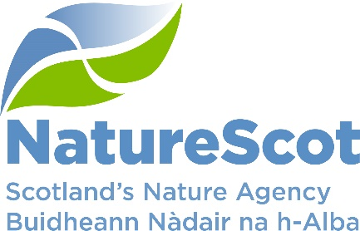

SCIENTIFIC ADVISORY COMMITTEE

DISCUSSION PAPER

Considering ethics in our science and evidence work

Purpose
- This paper is seeking the Committee’s views on how we approach ethical considerations relating to our science and evidence.

Action
- The Committee is asked to comment upon the following:
  - Have we identified the main areas of our work where ethics should be considered?
  - Have we identified the main developing technologies that pose ethical concerns?
  - Would the modified heuristic be helpful in the development of guidance for staff when considering ethical concerns relating to emerging technologies?

Preparation
- The paper was written by Alex Mackay and Clive Mitchell, with input from Martin Gaywood and Philippa Viggano. It is sponsored by Eileen Stuart.

Background
- Research ethics according to UKRI are:

‘the moral and philosophical principles that govern how researchers and innovators should carry out their work, throughout the research and innovation lifecycle.

Research ethics takes into consideration the impacts and potential harms on:
- research participants
- research and innovation teams
- broader society, the environment and animals

These principles are used to shape regulations, policies and practices, by research and innovation organisations, learned societies, funding bodies and governments.’

Areas to consider
- We want to ensure that ethical considerations are built into all our work. However, at present we do not have guidance or an organisational approach to ethical considerations relating to our science and evidence, although there is an awareness of the importance of ethics. We are supporting staff with guidance and frameworks for working through these issues.

- We have identified three different areas of our work where ethics are important, although the underlying ethical considerations of all of them overlap.

- Data ethics is ‘a branch of ethics that evaluates data practices with the potential to adversely impact on people and society – in data collection, sharing and use’ according to the Open Data Institute. Data ethics is an important area for everyone, it interacts with the law, data protection and cyber security. Our NatureScot data strategy will consider data ethics, and we are working closely with Scottish Government to ensure we are collectively inspiring trust in how we manage our data. Scottish Government are considering holistic ethics which brings together digital, AI, and data ethics.

- Environmental Social Sciences is the scientific study of people, the social environment and the natural (non-human) environment. Applied, interdisciplinary working and knowledge exchange are key to environmental social science. We work with the ACCESS (Advancing Capacity for Climate and Environment Social Science) and are a member of the UK wide, interagency Research Ethics in Environmental Organisations Network. Through this network we have been discussing how we address ethics in our organisations with the group focusing largely on environmental social science.

- Conservation biology and wildlife management are areas where animal management interventions pose ethical questions. In addition, there is a growing interest in the use of emerging technologies to support nature restoration offer many potential opportunities, including helping to eradicate invasive species, supporting species colonisation and monitoring of habitats and species. Some of these new technologies include:
- Gene Drives – for example the research being done in looking at how gene drive could be used to control grey squirrel populations. Further afield gene drives are being considered to control the spread of disease from mosquitos which has a big impact on the human population but also endangered bird species such as the Hawaiian honeycreeper.
- Cloning – starting to be applied to species conservation efforts to help increase genetic diversity (e.g. black-footed ferret and Przewalski’s horse).
- GMO release – there are recent proposals to use GMO release for conservation (rather than food production etc) purposes. In the US they are looking at reintroducing GMO blight resistant America chestnut trees to restore forests and save the species.
- Bioacoustics – the detection and measurement of species and soundscapes by collecting the sounds on land and water, with applications for soil health, marine monitoring, ornithological monitoring.
- Remote Sensing – there are some real benefits in the use of remote sensing to monitor habitats, land use change and species diversity.
- AI – can be really useful for analysing large data sets and can support the monitoring of habitats and identifying trends over time. Visual AI is being used to help identify species from camera traps in real-time.
- De-extinction technologies – at the sci-fi end of the technologies but millions of dollars now being spent on development of proxies for passenger pigeon, thylacine, dodo and woolly mammoth.

Emerging issues related to developing technologies
- While all these developments could help support nature recovery, they all come with ethical issues that need to be considered. In our decisions relating to conservation interventions, we need to ensure we consider human needs, preferences, and interests, concern for individual animal welfare, and the value of biodiversity and ecosystems are part of the discussion. We need to be aware of these issues and understand how to work through them to be able to advise Scottish Government and take part in UK, European and global discussions where required.

- The IUCN is leading work on the potential implications of synthetic biology in nature conservation, with guidance on this expected soon. In their briefing summary, they state that ‘Inclusive decision-making in synthetic biology governance must consider social, economic and cultural factors, with the Free, Prior, and Informed Consent of affected communities playing a central role.’

- In Scotland, the Scottish Animal Welfare Commission (SAWC) have a sub-committee who are looking at animal sentience and developing an ethics and justice framework, which draws on evidence relating to sentience in fish. NatureScot is represented on a number of their sub-groups.

Guidance for staff
- To help inform our understanding of ethical considerations and how to consider ethics as an integral part of our work, there are a number of models and guidance that we can use.

- Colleagues working on our data strategy are using the Data Ethics Canvas developed by the Open Data Institute (Annex 1). For our social science, the social sciences resources guide for environmental organisations developed by ACCESS (Advancing Capacity for Climate and Environmental Social Science) recommend that anyone commissioning or conducting research with human subjects should uphold six key ethical principles set out in the Government Social Research Professional Guidance (Annex 2).

- Ethical issues relating to conservation biology are increasingly recognised as being an important factor in the success of such projects. The issues are often complex and difficult to navigate, with stakeholders often holding very different values and therefore responding very differently to questions around the use of developing technologies.

- Sarah Hartley et al developed a heuristic during their stakeholder engagement work relating to gene drives in grey squirrels (Annex 3). While originally designed to look at gene drive technologies, the heuristic set out in Table 1 has been adapted to cover conservation interventions using emerging technologies.

Table 1: A stakeholder informed heuristic for exploring ethical considerations relating to the use of emerging technologies

Theme | Questions to explore with stakeholders
Problem/s | What is the conservation problem/s that needs solving?  Is there agreement on defining the problem/s or do people approach the problem in different ways?  Who are the stakeholders who hold knowledge about the problem/s?
Efficacy | What would the proposed intervention using emerging technology need to do to solve the identified problem?  What evidence is needed to demonstrate the proposed intervention addresses the problem/s?  How can non-technical understandings of efficacy be considered and addressed?
Proposed Intervention/emerging Technology (e.g. synthetic biology) | What are the possible types of proposed intervention that could address the problem/s?  How will the proposed intervention work on the species/population/habitat?  What are the merits, risks and implications of different design choices?
Alternatives | What are the alternative management interventions available for addressing the problem/s?  How does the new intervention compare with these alternatives?  Which stakeholders have expertise in these alternatives and how can they be engaged in an appraisal of alternatives?
Organisms | What organism is being targeted by the proposed intervention?  What is the nature of the relationships between this organism and humans?  What are the broad welfare considerations in the laboratory and the wild?
People/Communities of interest | How might different people/communities of interest perceive the proposed intervention and how its ability to address the problem/s.  When and how can these people/communities of interest be involved in technology governance decisions?  How will technology developers respond to public perceptions?

- This model and the guidance being developed by the IUCN could form the basis of guidance that we could use to help our staff think through ethical considerations and be better equipped to engage on them and others as they emerge.

Conclusions
- The Committee is asked to consider the paper and the questions set out in paragraph 2 and provide comments on how ethics have been effectively embedded in policy and practice elsewhere.

Contact: Alex Mackay (Alex.mackay@nature.scot)

Annex 1 – Data Ethics Canvas developed by the Open Data Institute
This is a useful tool for use in all projects where data is being collected, shared or used. It includes 15 different areas to consider including identifying the data sources, potential impacts, engagement, implementation and review. It is designed to improve project planning, grow impact and trust, complement other ethics guidelines and manage data ethics in the long-term.

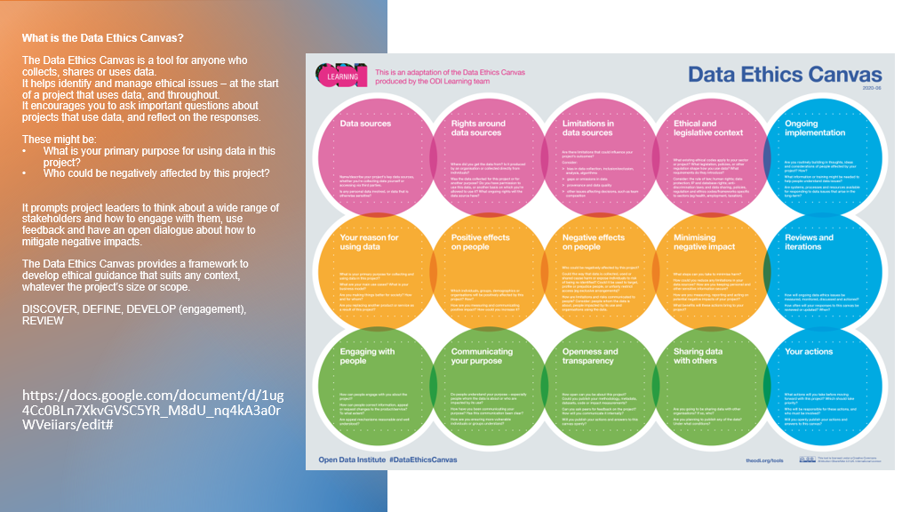

Annex 2 – Government Social Research Professional Guidance
Much of our social research is carried out using contractors and they will have their own ethics statements, but it is important that we satisfy ourselves that ethical considerations have been adequately addressed in the design of our social science projects.
The social sciences resources guide for environmental organisations developed by ACCESS (Advancing Capacity for Climate and Environmental Social Science) states that for ‘those doing or commissioning social research they should protect research participants and mitigate against risks to the organisation and wider societal impacts, by adhering to ethical research practices.
They recommend that anyone commissioning or conducting research with human subjects should uphold six key ethical principles set out in the Government Social Research Professional Guidance – see below.
Practical advice on how to consider ethics in social research can also be found in the Social Research Association guidance and our involvement in the Research Ethics for Environmental Organisations Network allows us access to advice and support from the other UK environmental agencies to help develop any guidance required.

Principle 1: Research should have a clear user need and public benefit
Principle 2: Research should be based on sound research methods and protect against bias in the interpretation of findings
Principle 3: Research should adhere to data protection regulations and the secure handling of personal data
Principle 4: Participation in research should be based on specific and informed consent
Principle 5: Research should enable participation of the groups it seeks to represent
Principle 6: Research should be conducted in a manner that minimises personal and social harm’

