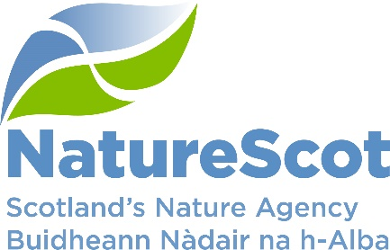

SCIENTIFIC ADVISORY COMMITTEE

DISCUSSION PAPER

AI-aided horizon scan

Purpose
- This is the regular horizon scanning item but compiled using artificial intelligence.

Action
- The SAC is invited to:
  - discuss the paper, including any additional items to note, and to identify whether a deeper dive into specific issues is required
  - comment on the artificial intelligence process, including wider potential.

Preparation
- The paper was written by Clive Mitchell and Alex Mackay with contributions from the Science and Evidence Leadership Programme. It is sponsored by Eileen Stuart.

Background: nQuire
- We have used nQuire artificial intelligence (AI) to compile this scan. nQuire is a community and citizen science platform developed by the Open University (OU). The platform was used by the OU and Parliamentary Office for Science and Technology (POST) to compile horizon scans across 12 topics in Autumn 2024. We volunteered the annual horizon scan for the SAC to see how the process works and to help to train the AI.

- Annex A details the ‘mission’ brief. In short, a ‘mission’ (task) is defined. Members of the Science and Evidence Leadership Programme were invited to contribute topics likely to impact on NatureScot’s policy and planning in the near term (0-5 years) and longer term (5+ years). Participants could enter 1-10 topics (or more by re-activating the link), based on STEEPLE or a list of suggested themes. The template allows for a heading, a brief description and a source. People were alerted to the task on 3 February and it went live on 10 February for completion by 21 February.

- AI conducts a thematic analysis on the entries and groups items into clusters (in this case, 10) for prioritisation (Annex B). Prioritisation follows the Delphi method and was carried out by the Chief Scientists Group and external experts in climate and nature. This stage ran from 3-5 March and entailed sorting topics into high-medium-low priority for both the near (0-5 years) and longer (5+ years) term.

- The results form the basis of paragraphs 12 to 23.

Background: lessons learned
- The better defined the ‘mission’, the better the input, the AI thematic analysis and the clearer the prioritisation and the final output.

- The moments of human input are important:
  - data input is not time consuming (if it is to hand), but allowing more time (e.g. 1 month, with forewarning) would allow for more and/or better-quality inputs
  - getting the records clustered into sensible categories with little or no duplication and ensuring that the entries clearly fit to the category is important to make the prioritisation more straightforward (ours could have been better)
  - allowing sufficient time for the prioritisation is important (e.g. allow 1 week, with forewarning), even though the actual prioritisation only takes minutes, to reduce the likelihood that the request clashes with other commitments.

- nQuire returns a document that includes the input data, clustering and prioritisation from which it is straightforward to compile the main part of the paper.

- Overall, we plan to use the software again provided we address the points above, allowing more time for the process and clarifying the prioritisation requirement.

Horizon scan: 0-5 years
- The top three topics in the next 5 years are:
- Climate Change and Environmental Challenges
- Renewable Energy and Environmental Impact
- Public Engagement and Decision Making.
The first is the same as 5+ years, nearer-term elements picked out below.

Climate Change and Environmental Challenges
- Compounded effects of water quality and quantity on human and natural systems – Effective water availability for human and natural systems concerns both water quantity and water quality. Increasing pollution challenges as water becomes scarcer, both locally and globally. Nitrogen enrichment in flowing and standing waters affects primary producers and can cascade throughout the food web. Anomalously high nitrogen concentrations also interact with warming, leading to hypoxia and harmful algal blooms (examples throughout Scotland).

- European laws and unintended challenges for wood production¹ – The EU’s new Regulation on Deforestation-Free Products (EUDR) requires that certain wood and wood products on the EU market must be generated without deforestation, forest degradation, and breaches of local environmental and social laws. The EU Forest Strategy for 2030 protects all European old-growth forests. These rules are intended to address fundamental drivers of biodiversity loss. Other factors may affect the EU domestic forest industry including those arising from climate risks such as wildfires, storms, and pest outbreaks. Accordingly, increasing regional wood production will be challenging. Supply chain challenges arising from the new regulations could lead to intensification of forest management, substantial afforestation, and unforeseen offshore impacts.

- Anthropogenic impacts on seabed carbon stores¹ – Marine sediments are one of the largest pools of organic carbon on Earth. Approximately 350Mt of organic carbon per year is added to marine sediments, predominantly at continental margins. Anthropogenic disturbance and resuspension of organic matter may facilitate re-mineralisation of this carbon pool, with one estimate suggesting that benthic trawling could generate emissions of 0.34-0.37PgCO₂ per year. However, considerable uncertainty remains in the depositing processes and locations of carbon in sediments and the extent to which trawling and other disturbances mineralise organic carbon (early findings from research underway at St Andrew’s university suggests different fertility for carbon in sediments on Scotland’s east and west coasts). Economic benefits and limited legal constraints have meant few restrictions to date on the expansion of benthic trawling, energy and communications engineering, and deep-sea mining despite their considerable impacts on seabed species and ecological function. When combined with growing commitments and incentives for reducing carbon dioxide emissions, the development of reliable estimates of sediment carbon loss due to industrial processes could create incentives for increased regulation of seabed impacts, with consequences for the climate, biodiversity conservation, and the growing industrial interests in the seabed.

- Source-to-sea approach – Forests, woodlands, rivers, wetlands, farmland, coasts and seas are often managed separately, but are inherently connected. Source-to-sea approaches are gaining traction as an exemplar of systems thinking, and promoted as a means of avoiding the tendency for siloed approaches whereby potential efficiencies and synergies are overlooked, and where misguided decisions in one part of the system can undermine outcomes in another part of the system including false trade-offs.

- Handling uncertainty – Good environmental management decisions can be stifled by 'uncertainty', when really we know enough to make an informed decision. Uncertainty around the detail of the conditions climate change will create is amplifying this challenge, but should certainly not be an excuse for inaction. Navigating the scientific, ethical, political and legal dimensions of this challenge will be a challenge for policy makers and regulators especially as climate shifts from stable and predictable to warming and chaotic. (Work underway relating to this includes guidance on managing uncertainty, conservation species-species, Sefari Fellowship rapid mapping exercise on the evidence base for nature-based solutions and the costs of inaction; SAC paper on the implications of climate change for species conservation.)

Renewable Energy and Environmental Impact
- Potential alteration of ocean processes by offshore wind energy infrastructure¹ – Offshore wind energy involves bottom-fixed turbines, built on the sea floor generally at depths of 60 m or more, and floating turbines anchored to the sea floor at depths up to 1500 m. Although direct impacts of off-shore wind energy infrastructure on species, such as collisions and displacement, are already acknowledged, understanding of potential indirect impacts are emerging. Both fixed and floating installations alter transfer of wind energy to water and may increase mixing of seasonally stratified waters, particularly where tidal currents are weak, affecting production of phytoplankton and carbon storage. Mixing affects temperature throughout the water column and brings nutrients closer to the surface. It also can displace phytoplankton from waters in which light penetration enables fixing of inorganic carbon. Effects of such displacement may cascade through the food web. It remains unclear whether these effects may propagate across large areas, such as the southern North Sea, or whether they are likely local and transient. Indirect effects could amplify as offshore developments accelerate in coming years (offshore wind recommended to grow six-fold from 15 GW of capacity in 2023 to 88 GW by 2040). (Beth Scott, Aberdeen University is one of the leading experts in this field)

Public Engagement and Decision Making
- Citizens assemblies, panels and juries – Conventional approaches to public consultation by government(s) struggle to achieve representative, non-biased and well-informed contributions to inform policies and environmental management actions. These challenges are amplified by misinformation. Even where processes do yield a consensus, this rarely then goes on to inform the actual decisions taken. Making better use of citizen's assembly / panel / jury methods to inform decisions while also providing a clearer route to process literacy and/or a sense of procedural justice is key to lasting transformational change in uses of the land and sea.

Horizon scan: 5+ years
- The top three topics beyond the next 5 years are:
- Climate Change and Environmental Challenges
- Water and Marine Ecosystems (see (i) – paragraphs 21-22))
- Biodiversity and Genetic Diversity.

Climate Change and Environmental Challenges
- Record Antarctic sea ice lows across the continent could lead to large-scale ecosystem alterations¹ – While losses of Arctic sea ice and terrestrial ice sheets are well documented, the Antarctic sea ice had long been thought to be stable, with no significant trends in between 1979 and 2020. However, since then, the three lowest minimum sea-ice extents have been registered, and five of the eight lowest have occurred since 2016. Ice loss is now observed all around the continent, not just in some regions. These observations could reflect a tipping point in Antarctic sea ice extent, with substantial consequences for Southern Ocean biodiversity and globally if associated freshwater inputs affect circulation patterns.

- Tipping points - Faster than predicted melting of Thwaites glacier¹ – New research indicates that the Thwaites glacier, often referred to as the Doomsday glacier due to its potential to trigger ice sheet collapse in western Antarctica, is melting substantially faster than previously understood. Complete melting of the Thwaites glacier would lead to a 0.65 m rise in global mean sea level, with subsequent collapse of areas of the West Antarctic ice sheet potentially leading to sea level rise of over 3 m. The glacier has been losing mass to the ocean rapidly since the 1990s, and models underestimated observed loss rates because of a complex set of feedback mechanisms that affect retreat at the glacier grounding line, including warmer sea incursions several kilometres under the ice leading to rapid and extensive ice loss. This alone would double the mainstream estimates for sea level rise by 2100, including those used in Scotland in the National Adaptation Plan.

Biodiversity and Genetic Diversity
- Safeguarding genetic diversity – Genetic diversity of wild species is the tool kit for nature to adapt to climate change and other pressures and underpins resilience. But it is poorly monitored or safeguarded. Globally, genetic diversity is not well protected with a poor match between protected areas and genetic hotspots and the mismatch is predicted to widen with climate change. Greater integration of genetics into conservation planning is, arguably, essential.

What is missing?
- Some suggested items did not make the priority list, including several on artificial intelligence:
  - Interpretation of images collected by ground-based sensors
  - Audio
  - Satellite and airborne remote sensing and combining datasets
  - Modelling and causal inference
  - Reviewing the literature and generating text
  - Negative consequences of AI (including directing funding away from effective traditional methods of conservation, exploitation by bad actors, absence of a code of practice to guide just use (sustainability, equity, equality, and data privacy and security)).
- Items raised with little or no supporting information but covered in earlier horizon scan papers include:
  - Misinformation around climate change and nature
  - Synthetic biology
  - (Decline in) green finance
  - Changes in sea temperature
  - Invasive species
  - Natural environment plant health
  - Human wildlife conflict
  - Climate impact on pollution
  - Future wildfire risk
  - Apex predator reintroduction
  - Paludiculture in Scotland
  - Future grazing for nature.

Conclusion
- The AI process helpfully assists compiling the paper but allowing more time for the human elements (paragraphs 8-11), examples of required input content, and clearer clusters for prioritisation would all make for a better paper. We welcome comments from the SAC on the areas in paragraph 2, including notable omissions in the content.

Contact: Clive Mitchell, clive.mitchell@nature.scot

Annex A: nQuire mission brief
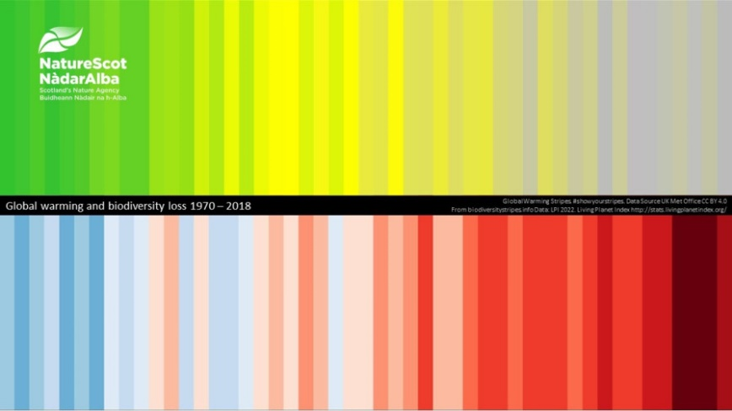
Horizon Scanning: NatureScot
Help identify topics for strategic prioritisation across climate-nature: risks, opportunities and resilience

A mission by NatureScot

This activity, led by Dr Clive Mitchell (Head of Terrestrial Science), is trialling a new horizon scanning method developed by The Open University and the Parliamentary Office for Science and Technology. The method will support compilation of the annual horizon scan paper for the Scientific Advisory Committee.

What is the mission about?
This Horizon Scanning activity identifies topics that are likely to impact on NatureScot policy and planning in the near term (0-5 years) and longer term (5+ years).

What will you be asked to do?
You will be asked to use your expert knowledge to identify 1 to 10 topics or issues that constitute key challenges or opportunities around biodiversity loss and the climate emergency in the next 0-5 years and 5+ years. For each topic you wish to put forward, provide a title and a brief description (max. 200 words) covering what the topic / issue is and how it might affect the work we do, or our approach to it. We will also ask you about the type of evidence that informed your choice (a reference / source - it doesn't need to be peer-reviewed, but preferably credible).
You should aim to complete this mission by the end of 21st February 2025.

How long will this take?
It should not take more than 30 minutes of your time in total. If you would like to save your progress, please register for a user account.

What is the benefit of taking part?
Taking part in this activity and completing this questionnaire will 1) test the application of AI to support writing routine but complex papers and 2) support the collation of evidence to feed into future planning activities.

How will the data be analysed and shared?
Your responses to this mission will be collated with the contributions of others. Once the data has been collected AI will be used to support analysis and produce a list of topics, with human oversight (i.e. validation by the Chief scientist's group).
The topics will be uploaded and shared in a follow-up mission, which will be circulated to a broader group to indicate their priorities.

Getting started
If it helps, use the STEEPLE framework (science, technology, environment, economy, politics, law, ethics). The content really doesn't need to be long or detailed.
Examples of horizon scanning topics might include:
- Climate change (effects, rates etc.)
- Biodiversity Loss (INNS, Land/Sea Management, Pesticides etc.)
- Soil health
- New technologies (genetics, 'omics', monitoring (acoustic, AI, LiDAR, Satellite etc.))
- Inequalities - power relations, concentration of power and wealth in supply chains (supply chain analysis etc); distribution of benefits and burdens; land ownership
- Attitude to nature - connection / disconnect; dominance over nature; values vs evidence;
engagement
- Impact of current policy
Only add as many topics as you want to submit (take the mission again if you want to add more), then skip through to the last section (“About you”) and then press submit.
Close

Annex B: Prioritisation

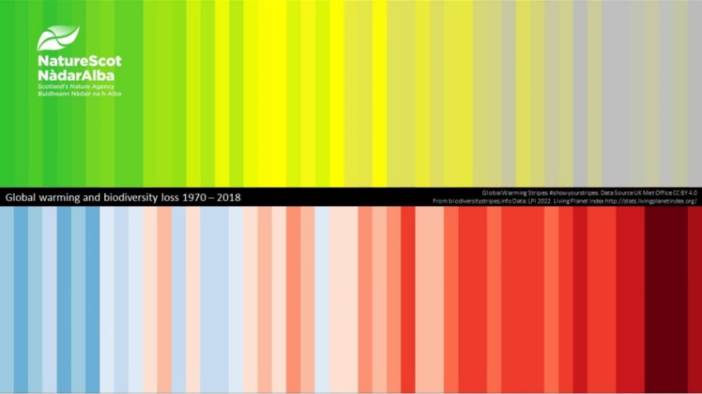
Horizon Scanning: NatureScot Prioritisation
Help prioritise topics for strategic focus across climate-nature: risks, opportunities and resilience
A mission by NatureScot

Mission Brief
This activity, led by Dr Clive Mitchell (Head of Terrestrial Science), is trialling a new horizon scanning method developed by The Open University and the Parliamentary Office for Science and Technology. The method will support compilation of the annual horizon scan paper for the Scientific Advisory Committee.

What is the mission about?
This Horizon Scanning activity prioritises topics that are likely to impact on NatureScot policy and planning.

What will you be asked to do?
You will be asked to use your expert opinion to prioritise these future topics for those most and least important in the next 0-5 years and again for 5+ years.
You should aim to complete this mission by the end of 5th March 2025.

How long will this take?
It should not take more than 5 - 10 minutes of your time. There is an information button on each topic that gives examples to help in your decision making. If you would like to save your progress, please register for a user account.

What is the benefit of taking part?
Taking part in this activity will 1) test the application of AI to support writing routine but complex papers and 2) support the collation of evidence to feed into future planning activities.

How will the data be analysed and shared?
Your responses to this mission will be collated with the contributions of others. We will analyse the responses and share them with Dr Clive Mitchell to support the compilation of the annual horizon scan paper for the Scientific Advisory Committee.

Topic prioritisation: 0-5 years
Please prioritise the topics below by importance to NatureScot policy and planning for the next 0-5 years. (required)
Move the topics into the relevant column using the arrows; you must identify the three highest and lowest importance. Select the "i" button for further information about the topic.
Low (0 of 3) – Medium (0 of 3) – High (0 of 3) - 10 to choose from
- Water and Marine Ecosystems
- Climate Change and Environmental Challenges
- Forestry and Land Use Regulations
- Renewable Energy and Environmental Impact
- Invasive Species and Ecosystem Management
- Antarctic and Glacial Changes
- Artificial Intelligence in Conservation
- Public Engagement and Decision Making
- Biodiversity and Genetic Diversity
- Misinformation and Communication Strategies

Next section: as above but for 5+ years

Sutherland et al (2024) A horizon scan of biological conservation issues for 2025Trends in Ecology & Evolution, 40 (1) 80 – 89 https://doi.org/10.1016/j.tree.2024.11.002
NatureScot research report 1343 source-sea-enabling-coherent-efficient-and-synergistic-outcomes, SIWI – source to sea platform;Plymouth Marine Lab; Environment Agency
UK CCC (2025) The Seventh Carbon Budget Advice for the UK Government
E.g. IPBES Transformative Change and Nexus (climate-nature-food-water-health) Assessments
Schmidt et al (2025, submitted) The global protected area network does not harbor genetically diverse populations
Chiocchio et al. (2024) Conserving genetic diversity hotspots under climate change: Are protected areas helpful? Biological Conservation, 299: 110828
Reynolds, SA. et al. (2025) The potential for AI to revolutionize conservation: a horizon scan, Trends in Ecology & Evolution, 40(2):191 - 207

