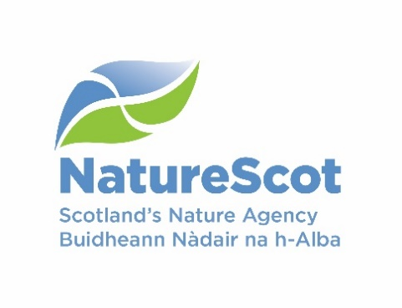
Licence application form – to kill brown hares

The Wildlife and Countryside Act 1981 (as amended)

If you need assistance filling in this form please contact the NatureScot Licensing Team:

Email: licensing@nature.scot Telephone: 01463 725364

Please answer all relevant questions fully and do not defer to other attached documents.

Who should use this application form

All persons seeking to kill brown hares during the close season in order to prevent serious damage to crops, vegetables, fruit or growing timber. The close season for brown hare is 1st February to 30th September;

All persons seeking a licence, whether applying for the first time or re-applying for a licence that has expired.

All new applications are referred to NatureScot Wildlife Management Officers for advice, and may require a site visit. If so, a NatureScot Wildlife Management Officer will contact you to arrange this.

Submission of licence returns

If you have previously held a licence and wish to apply for a new one, you must submit a licence return for your expired licence before we can process your new application.

All new licences will require a return to be submitted no later than one month from the date of expiry of the licence.

Amendments to existing licences

If you wish to amend a current licence please email the NatureScot Licensing Team (licensing@nature.scot) citing the current licence number, the details you wish to change, and the reasons for this change. If your amendment request involves significant changes we may seek advice from NatureScot Wildlife Management Officers and / or advise that you need to fill in a new application form.
Section A: Licence holder details
Please provide the name and address of the licence holder, this person will be legally responsible for ensuring that all licence conditions are met and for submitting a return to NatureScot Licensing Team at the end of the licence period.

Contact details required | Provide required information below
Title
First name
Surname
Email address
Address
Postcode
Contact telephone number(s)
Type of address | Home ☐  Work ☐
Applicant details | Land owner ☐  Land manager ☐  Land Agent / Factor ☐  Tenant ☐

Section B: Licence details

Licence details required | Provide required information below
Site name (where impact is occurring)
(this is how your application will be referred to in all future correspondence)
Address (please include the full postal address of the farm/location if different from Section A)
Farm CPH number if relevant
Six figure central grid reference
(e.g. NX100200)
Proposed start date | Click here to enter a date.
Proposed end date | Click here to enter a date.
Date you require your licence  (i.e. date when you need confirmation that a licence will be issued to allow preparation for the works) | Click here to enter a date.
Is the works area covered by a nature conservation designation & if so, what is it called? (e.g. give name of affected Site of Special Scientific Interest, Special Protection Area, Special Area of Conservation etc.) – see our website for site locations and information)

Section C: Summary of Damage and Hare Numbers
Provide details below of where damage is occurring or is expected to occur, crops/trees being damaged and numbers of brown hares causing damage. Your application must be accompanied by a map or diagram showing fields or areas where damage is occurring.

Crop/plantation type | Age of Trees (if applicable) | Field/area identifier (if known) | Approx area in hectares | Approx number of brown hare causing damage | Number proposed to be shot

Section D: Licence purpose

Describe the damage caused and/or potential damage to be caused by brown hare and how it is serious in nature or is expected to be serious in nature
(include area/proportion of crops/trees damaged, reason for expecting damage where it is not already ongoing, description of how the damage will affect the applicant)

Describe the evidence that this damage is or will be caused by brown hares and not by other herbivores
(e.g. sightings/observation or assessment of the damage indicating hare)

Describe how the number of brown hare to be shot has been determined and why you believe this number is required to resolve serious damage issues

Provide details of ongoing measures are you taking to prevent serious damage by brown hares at this location (include details of any fencing, and all scaring or other preventative methods used and their effectiveness).

Provide details of how many brown hare have been shot in the previous open season (1st October – 31st January) at this/these location(s) and what effort was taken in this regard (number of shoot days and guns in this time period). If no open season shooting has occurred, please state why.

Section E: Required documents checklist

Confirm by ticking the box below that all the information we require to assess your licence has been submitted with your application.

A location map of the property showing the area (i.e. field, area of woodland) where serious damage is occurring. The scale of the map must be at least 1:50,000

Section D: Declaration

- I understand that it is an offence under Section 17 of The Wildlife and Countryside Act 1981 (as amended) to knowingly or recklessly provide false information in order to obtain a licence, and I declare that the particulars given in this application and any accompanying documents are true and accurate to the best of my knowledge and belief, and I apply for a licence in accordance with these particulars.

- I understand that failure to comply with any conditions included on any licence granted in respect of this application may constitute an offence.

Date: Click here to enter a date. | Print name:  Electronic signature: 

Submitting your application form

This application should be submitted by email by the licence holder as named on this licence application (in which case please print name above and a signature is not required). If this application is not submitted by the licence holder, the electronic signature of the licence holder must be inserted above, and they must be copied in to the submission email. Please email the completed application form, together with all supporting information, to: licensing@nature.scot

Please do not send zip files as these may be blocked by our security system and not received.

Once we have received your application, you will receive an automated email acknowledging this. Please quote the reference number given in the email if you need to contact us in relation to your application.

If you do not have access to email, you can print out and send your application and supporting information to the postal address below. Please note if you apply by post you will not receive confirmation that your application has been received.

Licensing Section
NatureScot
Great Glen House
Leachkin Road
Inverness
IV3 8NW

How we adhere with the Data Protection Act and the Scottish Regulators' Strategic Code of Practice

