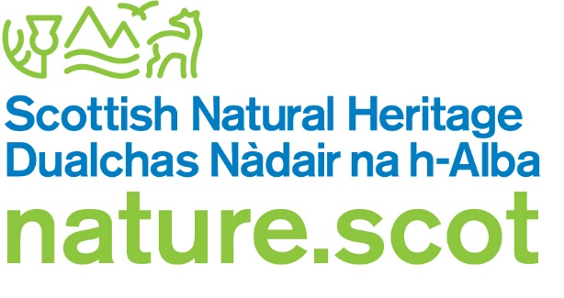

Registration form – Trap registration and meat baits

The Wildlife and Countryside Act 1981 (as amended)

If you need assistance filling in this form please contact the SNH Licensing Team:

Email: licensing@nature.scot Telephone: 01463 725364

Who should use this form
Persons wishing to obtain a trap registration number in order to use Larsen, Larsen pod, Larsen mate or multi-catch cage traps under General Licences 01 and 02.

Please note that SNH has taken over the trap registration system from the 1st April 2020 so even if you have previously held a trap registration number from Police Scotland then you must register with us to obtain a new number.

Amendments

If you wish to amend a current registration please email SNH Licensing Team with your trap registration number, the details you wish to change and the reasons for this change.

Renewals

If you wish to renew a registration that has expired, currently you must re-register in full.

Wildlife crime convictions

If you have any unspent convictions for wildlife crime you will not be eligible to register using this form. If you need to register to use traps and have unspent convictions, please contact us to discuss your requirements.

Returns
Those who register to use meat baits in their Larsen mate or Larsen pod traps will have to submit annual returns using our meat bait return form. You must keep details of: the location of the trap; what non-target species are caught; how many of each non-target species are trapped; the trap type that was used. If you fail to complete a return we will remove or suspend your right to use meat baits.

Section A: Your details

First name
Surname
Email address
Building Number or House
Address
Postcode
Contact telephone number(s)
Previous trap registration number (renewals only)

Section B: Which General Licence do you intend to work under?

GL 01/2020: To kill or take certain birds for the conservation of wild birds | ☐
GL 02/2020: To kill or take certain birds for the prevention of serious damage to livestock, foodstuffs for livestock, crops, vegetables and fruit | ☐

Section C: Meat bait
Please note that you need to be registered to use meat baits in Larsen mate and Larsen pod traps.

Will you be using meat bait in your traps?
Yes | ☐
No | ☐

Section D: Declaration

- I declare that the particulars given in this registration are true and accurate to the best of my knowledge and belief, and I apply for a registration in accordance with these particulars.

- I understand that failure to comply with any conditions included on the general licence may constitute an offence.

Date: Click here to enter a date. | Print name:  Signature: 

Submitting your form

This registration must be submitted by email by the registration holder as named on this form (in which case please print name above and a signature is not required). If this is not submitted by the registration holder, the electronic signature of the registration holder must be inserted above, and they must be copied in to the submission email. Please email the completed registration form, together with all supporting information, to: licensing@nature.scot

Please do not send zip files as these may be blocked by our security system and not received.

If you do not have access to email, you can print out and send your signed registration to the address below.

Licensing Section
Scottish Natural Heritage
Great Glen House
Leachkin Road
Inverness
IV3 8NW

Your details will be held by SNH for the purposes of licensing and for registration for the use of traps under SNH’s General Licences. We will share this information with Police Scotland for the purposes of crime prevention and detection. Please see our privacy notice for further information.

