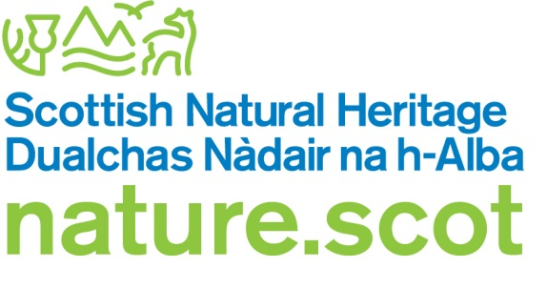

Licence application form – to kill ravens

The Wildlife and Countryside Act 1981 (as amended)

If you need assistance filling in this form please contact the SNH Licensing Team:

Email: licensing@nature.scot Telephone: 01463 725364

Please answer all relevant questions fully and do not defer to other attached documents.

Who should use this application form
This form is for new applications for anyone who wishes to take or kill ravens in order to prevent serious damage to livestock.

All new applications are referred to your local SNH office and to SGRPID for advice, and may require a site visit. If so, SGRPID will contact you to arrange this.

Amendments

If you wish to amend a current licence please email SNH Licensing Team with the licence reference number, the details you wish to change and the reasons for this change.

Renewals

If you wish to renew a licence that has expired within the last two years, you must have submitted a licence return for your expired licence before we can process your renewal. To request a renewal, send a completed application form to SNH Licensing Team, quoting your previous licence number.

If your amendment/renewal request involves significant changes to your licence (e.g. increased bag limit), we may seek advice from SGRPID.

Section A: Licence holder details
Please provide the name and address of the licence holder, this person will be legally responsible for ensuring that all licence conditions are met and for submitting a return to SNH Licensing at the end of the licence period.

Title
First name
Surname
Email address
Address
Postcode
Contact telephone number(s)
Nature of interest in farm/property (e.g. owner/tenant/manager)

Section B: Licence details

Farm name
(this is how your application will be referred to in all future correspondence)
Farm address
(please include full postal address for the farm if different from above)
Farm CPH number
Is the area covered by a nature conservation designation? (e.g. Site of Special Scientific Interest, Special Protection Area, Special Area of Conservation etc. – see our website for site locations and information)

Section C: Details of damage and preventative measures
Provide details on the location of where the damage is occurring, number of raven causing damage, where shooting will be carried out and period of shooting. Please enclose a location map of the property showing the area (i.e. specific lambing field) where damage occurs.

Number of raven causing damage | Location of where the damage is occurring  (i.e. lambing field, calving sheds) | Type of damage (e.g. loss of newborn lambs) | Period when peak damage expected (start month/end month)
Number of raven causing damage |  | Type of damage (e.g. loss of newborn lambs) | Start | End

Describe damage caused, including evidence that it was caused by ravens. Please quantify loss (include number of animals killed or injured, and value).

Provide full details of measures you have taken to prevent serious damage by ravens (include details of scaring methods used and their effectiveness).

Section D: Required documents checklist

Confirm by ticking the box below that all the information we require to assess your licence has been submitted with your application.

A location map of the property showing the area(s) where damage takes place.

Evidence of damage occurring if applicable (e.g. photos).

Section F: Declaration

- I understand that it is an offence under Section 17 of The Wildlife and Countryside Act to knowingly or recklessly provide false information in order to obtain a licence, and I declare that the particulars given in this application and any accompanying documents are true and accurate to the best of my knowledge and belief, and I apply for a licence in accordance with these particulars.

- I understand that failure to comply with any conditions included on any licence granted in respect of this application may constitute an offence.

Date: Click here to enter a date. | Print name:  Electronic signature: 

Submitting your application form

This application should be submitted by email by the licence holder as named on this licence application (in which case please print name above and a signature is not required). If this application is not submitted by the licence holder, the electronic signature of the licence holder must be inserted above, and they must be copied in to the submission email. Please email the completed application form, together with all supporting information, to: licensing@nature.scot

Please do not send zip files as these may be blocked by our security system and not received.

Once we have received your application, you will receive an automated email acknowledging this. Please quote the reference number given in the email if you need to contact us in relation to your application.

If you do not have access to email, you can print out and send your application and supporting information to the postal address below. Please note if you apply by post you will not receive confirmation that your application has been received.

Licensing Section
Scottish Natural Heritage
Great Glen House
Leachkin Road
Inverness
IV3 8NW

How we adhere with the Data Protection Act and the Scottish Regulators' Strategic Code of Practice

