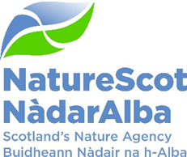

Title: Business Plan Draft 2025/26
Date: 12th February 2025

Purpose: | For Decision
Which of the current Business or Corporate Plan priorities does this topic drive forward and in what way? | This paper presents the first draft Business Plan for 2025-26 for Board review. It covers all corporate priorities.
Summary: | This paper provides an update on progress with the Business Plan for 2025/26 and seeks input from the Board following consideration of an outline structure in November 2024.
Actions: | Board to review the paper and consider its recommendations to enable business planning for 2025/26 to move into the next phase of its development.
Recommendations: | Board is asked to endorse the following recommendations:  - Note the progress being made against the Business Plan timetable (Annex 1).  - Review the Draft Business Plan, noting the outstanding issues, and agree to its structure and comment on any areas for further consideration (Annex 2).
Report Author(s): | Stephen Coulter
Sponsor: | Stuart MacQuarrie
Appendices: Please note all appendices. | Appendix 1: Business Plan 2025/26 Development Timeline  Appendix 2: Business Plan 2025/26 Draft

Purpose
- This paper provides an update to Board on progress with Business Planning for 2025/26 (Annex 1) and a first draft for review and comment (Annex 2).

Introduction
- 2025/26 is the fourth and final year covered by the 2022-26 Corporate Plan, A Nature Rich Future for All. Whilst making sure that we continue to deliver on the commitments in that Corporate Plan and set out a robust and workable plan for 2025/26, we are also taking the opportunity to pave the way to a new Corporate Plan by focusing on activities and priorities now, that will energise that new plan and give us the best opportunity to achieve our landmark targets for 2030 and beyond.

- A significant document which shapes and directs this next Business Plan is the new Scottish Biodiversity Strategy and Delivery Plan, published in late November 2024.

Financial Overview
- The current work in hand is focusing on identifying the available project budget that remains once staff costs have been deducted from the Grant-in-Aid settlement of £65.958m. Delivery plans are the vehicle by which project bids and recurring budget bids are proposed, and staff time is allocated. These will be reviewed by Strategic Resource Managers and the Head of Finance on the 13th February and a further challenge exercise will be undertaken by SLT members on the 17th February. This will inform the financial allocations to activities and the high level overview of financial allocations that form the “Our Resources” section of the Business Plan.

- Intensive work has been undertaken to examine the requirements for Fixed Term Appointments and other pressures on paybill management. The outcome of this work will inform the amount of available budget that can be allocated to project spend.

Plan Structure
- Following positive responses to the proposed structural changes made by the Board at its November meeting, the Business Plan is now structured around 4 foundation areas reflecting NatureScot’s external priorities and three internal development areas that follow through from the work that encompasses the NatureScot way.

- Following SLT’s review of the Board advice and further iterative work the 4 foundation areas now proposed are as follows:
- Drive nature positive change in agricultural practice, land use and the marine environment
- Achieve our 30x30 commitment to safeguard 30% of our land and sea by 2030
- Increase public and private sector investment in nature and ensure good development
- Promoting nature positive land and wildlife management though strengthened regulation

- Each foundation block is supported by a refined suite of actions which are broken down into quarterly milestones with a key outcome identified. There are 19 key actions in total which in turn will make quarterly reporting leaner and more focused on key priorities.

- The list of internal priorities has also been reviewed and there are now 9 key actions that cover estates, digital development, people development, communications and organisational development.
Scottish Biodiversity Strategy
- In preparing the business plan, we have been very mindful about how it links to the Scottish Biodiversity Strategy and Delivery Plan and have considered carefully how best we align the foundation areas and key actions with it. A matching exercise has been undertaken drawing on more detailed work undertaken by the SBS Delivery Plan team. The SBS is divided into 6 strategic themes, and we have found that our key actions have a good spread across 5 of these themes.

- The 6th SBS theme is concerned with the indirect drivers of bio-diversity loss and this objective is referred to in the opening narrative. The delivery plan actions (“we wills”) that relate to this theme didn’t feature in the prioritisation exercise for this Business Plan. Consideration will now turn to how we give an appropriate profile to influencing the indirect drivers of biodiversity loss in the Corporate Plan.

Opening Narrative
- The opening narrative has been developed following the Board’s agreement to the outline draft and aims to strike an appropriate balance between optimism for the future and the vital importance of hitting our targets to reverse the trend of biodiversity loss and the short term resourcing issues and longer term contextual challenges, such as climate change, that we are facing.

Performance Measures for 2025/26
- At its last meeting the Board agreed to carry forward the performance metrics from 2024-25. Comments have been added to the metrics to explain why the measure is important and what the desired outcome is for 2025-26. More detailed work on our performance framework will be taken forward as part of our new Corporate Plan development, reflecting the Board’s previous feedback, that they would need to be reworked under a new Plan.

Risk Appetite
- It was agreed at the last Board meeting to carry forward our existing statements on risk appetite. The Audit and Risk Committee will receive an update on our current plans to review our approach to risk appetite at its February meeting.

Next Steps
- Following this Board meeting and the finalisation of the project bids and budget allocation a final draft for approval will be presented at the Board meeting on 13th March. Given the challenging time lines, the Board will be invited to comment by correspondence following the SLT meeting on 25th February so that any further comments can be incorporated and if necessary, any outstanding points of contention resolved. An updated Business Plan timetable is at Annex 1.

- We understand that the Minister will attend the Board meeting on 13th March and that she will have been sighted on the draft Business Plan before then.

Conclusions/Recommendations:
- The Board is asked to consider the following recommendations:
- Note the progress being made against the Business Plan timetable (Annex 1)
- Review the Draft Business Plan, noting the outstanding issues, and agree to its structure and comment on any areas for further consideration (Annex 2)

Annex 1 – Business Plan Timeline

Business Planning timeline steps | Dates
SLT Business Plan 2025-26 approach & prioritisation | 17th Sep
Objective Measures reviewed | Sep
Draft delivery plans due | 25th Oct
SLT – 1st draft Business Plan | 19th Nov
Board - Business Plan priorities and Risk Appetite | 27th Nov
Budget Announcement (Anticipated) | 4th Dec
SLT – Budget implications | 17th Dec
SLT – Draft Business Plan | 21st Jan
Board - Draft Business Plan | 12th Feb
Objective Measures finalised | Feb
SRMs review Project Allocations | 13th Feb
Delivery plans finalised | 13th Feb
SLT Challenge Session | 17th Feb
Bidding round on BP system | 17th – 28th Feb
Budget allocations approved on system | 3rd – 7th Mar
SLT review final Business Plan | 25th Feb
Board review final Business Plan | 13th Mar
Send Business Plan to SG | 24th Mar
Publish Business Plan | 1st Apr

Annex 2: Business Plan 2025-26 – Draft for Board

Business Plan – 2025-26
Introduction
We know that the common ground is where a plan for nature recovery in Scotland will spring from. There is a climate-nature emergency in Scotland which is why this final year of our 2022 to 2026 Corporate Plan is so important as we plan for the next 5 years.
In November 2024, the Scottish Government launched the Scottish Biodiversity strategy (SBS) and six-year Delivery Plan which includes 130 actions, of which we lead 62 and support 33.
It is vital that the SBS gets off to the best possible start. This business plan for 2025-26 reflects that and sets out four foundation blocks which are essential for success:
- Drive nature positive change in agricultural practice, land use and the marine environment
- Achieve our 30x30 commitment to safeguard 30% of our land and sea by 2030
- Increase public and private sector investment in nature and ensure good development
- Promoting nature positive land and wildlife management though strengthened regulation
We will be emphasising achieving our 30x30 commitments and prioritising actions that will deliver them. To achieve this important milestone, business as usual will not be sufficient if we are to maintain and develop up to one million new hectares of safeguarded land. We will energise our own resources and partner organisations to achieve this vital important goal.
Building on 2024-25
As well as the SBS, we saw the Agriculture Act come into force. This Act legislates for the changes needed in land use for greater resilience from the impacts of climate change whilst maintaining food security. The Wildlife Management and Muirburn Act strengthens regulation to protect wildlife and recognises good land stewardship of the land. At sea, the Scottish Government will enhance management measures of marine protected areas, which we will support.
In the summer, the Flow Country in Caithness and Sutherland was accredited as a World Heritage Site by UNESCO in recognition of the global importance of its carbon and wildlife rich peat bogs. Our action on peat will accelerate the restoration we have seen in recent years.
Other funds for nature restoration are proving effective in delivering hundreds of projects, many of which are led by local communities. Public financial support for nature restoration is generous but responsible private interests investment is needed to achieve long term objectives. We are working in partnership and developing models that can provide confidence to investors, communities and the wider public.
We are also implementing the Wildlife Management and Muirburn Act and the Hunting with Dogs Act along with other regulatory frameworks. These strengthen and promote nature positive stewardship.
With tight public finances, national priorities and global pressures the value of nature positive action faces significant scrutiny. The public look to the Scottish Government and its Agencies to drive nature recovery sustainably, and give individuals, communities and business the confidence to act positively for nature too.
Our Context
Action to reduce emissions and adapt to the impacts of climate change requires a healthy and recovering natural environment. The Vision for Agriculture looks to nature to enable regenerative agriculture and build long term resilience in the sector. Marine protection offshore is a process that will support biodiversity whilst balancing the needs of fishermen, communities and tourism. Increasing the deployment of private finance to deliver public goods and to provide returns to investors is firmly in the Scottish Government’s sights.
Internationally, two significant Assessments from IPBES (the Intergovernmental Science-Policy Platform on Biodiversity and Ecosystem Services) published in December 2024 will be important in our delivery of the Scottish Biodiversity Strategy and how we support taking action on the indirect drivers of biodiversity loss. The ‘Nexus’ Assessment highlights the interdependencies across climate-nature-water-food-health. The Transformative Change Assessment examines the need and potential for transformative change emphasising: how people see their relationship with nature; equity; embedding economies in nature; inclusive governance; and, that nature is everybody’s business.
Climate Change Adaptation
Our work is being constantly challenged by climate change and the rise of global temperatures which hit a new high in 2024. We see this playing out through ‘unusual’ patterns of weather and increasingly extreme events in wildfire events, storms and flooding.
Restoring nature and preserving species in a climate that may no longer be supportive to particular fauna and flora requires new ways of thinking. We are generating new risk models and action plans with an emphasis on creating the framework for biodiversity to thrive.
Strategies
There are several Scottish Government strategies that need to reinforce each other if nature is to recover in Scotland and we are to achieve zero by 2045. These include an Environment Strategy, a Climate Change Strategy and a climate adaptation plan, the Scottish Biodiversity Strategy, an evolving framework for marine management and a Vision for Agriculture.
The SBS includes a commitment to a Natural Environment Bill including statutory nature targets. International agreements also influence our approach in particular a concordat to protect 30% of land and sea by 2030. Legislation will also be brought forward for Land reform, the circular economy and sustainability by the end of the Parliamentary session.
Key Trends
There are two interrelated key trends that are building momentum. Firstly, increasing interest in nature and the pressure it faces, and as a result clamour for change and high levels of scrutiny. Secondly, concerns about the impact of action for nature recovery on the livelihoods of people working in sectors vulnerable to change. Broadly, the benefits of action for the environment are felt generally, the impacts can be quite narrow. The tension these trends expose play out in social media, mainstream media and the political arena. We participate in these spaces and enthusiastically make the positive case for nature.
Our values and Partnership Working
Our passion for nature, our scientific expertise, and our enthusiasm for collaboration places us on the common ground, working in partnership with people and organisations interested in nature recovery based on good evidence. Our leadership in this space is powerful and we have seen success when a shared approach is adopted.
Our “Must Do’s”
Our plan is moving to a structure that focuses on a refined number of foundation areas and key actions as a pathway to a new Corporate Plan. We aim to focus our time and resources on developing and implementing the transformational changes required to reverse the trend of biodiversity loss and climate change.
However, as detailed in the financial sections of this plan, many of our resources are dedicated to the statutory functions defined by legislation and within our framework document. Some of these functions are an essential component of Scotland’s planning framework and we expect statutory consultations to rise at an increasing rate with onshore/offshore developments over next few years. We will work with developers to capture the benefits of investment in biodiversity and mitigating impacts. We have also made significant improvements in our licencing procedures that protect vulnerable species and habitats and efficiency improvements will enable us to cope with new regulations
Whilst not on a statutory footing, we also distribute significant funds to promote nature positive activity. These range from peatland restoration, nature recovery on land and sea, enhancement by farmers, and investigating feasible nature finance models.
Our Transformation
The NatureScot Way is our approach to seeing change as an opportunity for colleagues to adopt relevant, new ways of working supported by evidence to achieve our priorities.
Activity will continue to focus on our existing three pillars of Leadership, New Ways of Working and a Happy and Resilient workforce.
The emphasis on digital transformation needs a high priority specifically a new approach to business planning to drive our Organisational Development strategy and strategic workforce planning.
To secure improved outcomes across the public sector and value for money, the Scottish Government continues promote public sector reform. We are fully immersed in this work focusing on digital development and estate rationalisation.
This business plan sets out what matters, and our priorities for 2025 and 2026.

- Drive nature positive change in agricultural practice, land use and the marine environment
 | SBS Objective | Key Deliverables |  |  |  | Outcome
 |  | Q1 | Q2 | Q3 | Q4
1.1 Influence marine and coastal strategies and plans to deliver recovery and resilience of Scotland’s coasts and seas. | 1. Accelerate ecosystem restoration and regeneration | Influence policies for coastal and marine ecosystem restoration plan. | Influence policies for National Marine Plan 2, including commission on PMF policy). Begin implementing the UK Cetacean Strategy. | Begin implementing the Seabird CAP. Advice on statutory assessments for Fisheries Management Plans. | Begin implementing the coastal and marine ecosystem restoration plan. | Marine and coastal strategies and plans have strong nature positive policies.
1.2 Support SG develop measures under the four tiers of the Agriculture Support Framework | 3. Embed Nature  Positive Farming,  Fishing and  Forestry | Support SG launch 2025 agricultural reform measures | Agreed with SG amendments to AECS 2026 to ensure greater alignment with Agricultural Reform programme and SBS | Help SG finalise the Tier 2 Greening measures to be launched in 2026.  Secured ministerial approval for AECS 2025 budget and AECS 26 launch | Support SG launch 2026 agricultural reform measures | Farmers and crofters started on their transformation towards practising sustainable and regenerative farming
1.3 Deliver Agri-Environment Climate Scheme jointly with RPID. | 3. Embed Nature  Positive Farming,  Fishing and  Forestry | Scheme Application Window open – Provide pre-app advice  Draft proposed amendments to AECS 2026 to support Agricultural Reform programme | Assess all cases allocated to NatureScot | Complete application assessments and make recommendations to ministers.  Secured ministers approval for 2026 scheme and completed new amendments. | Issue contracts to successful 2025 scheme applicants | Targeted nature and climate outcomes secured on circa 200+ farms and crofts for a further 5 years.
1.4 Develop Biodiversity Audit and Farm Biodiversity Scotland tool testing with farmers and crofters. Testing to include assessment, management and monitoring functionality, and ability for users to meet SG’s Whole Farm Plan (WHP) requirements | 3. Embed Nature  Positive Farming,  Fishing and  Forestry | Support for users ahead of  release of assessment functionality of tool. | Management and monitoring stages of BA developed  Testing of these stages underway  Review user experience of tool vs other platforms for meeting WFP in 2025 | Jointly developed a trial API functionality with SG Land Parcel Information System (LPIS) team and tested with pilot users.  Review use of tool for WFP in 2026 | Updates to tool released to users ahead of Single Application Form (SAF) date in 2026  Support for users ahead of SAF date of 15 May | Farmers and crofters have an easy-to-use tool to map, measure, manage and monitor biodiversity on their holdings – as the early stage in helping them prioritise action to regenerate nature
1.5 Make the Natural Capital Tool available for use by land managers and other stakeholders to help plan nature and ecosystem regeneration at holding and landscape scale | 1. Accelerate ecosystem restoration and regeneration | Support for those using the first version of the tool  Start of pilots with farmer and crofter groups  Soft launch of NCT tool | Development of food provision model for Natural Capital Tool  Hard launch of NCT tool and subsequent engagement | Release of food provision model as part of co-design process  Additional functionality incorporated into tool through further modules  Engagement to promote the Natural Capital Tool | Release of updated version of Natural Capital Tool incorporating changes following further piloting and co-design engagement  Agreement with SG on how NCT will support delivery of ARP | Land managers and other stakeholders have access to a free-to-use tool to help them plan action to regenerate nature at a range of scales – from holding to landscape
1.6 Put over 12,000 ha of degraded peatland on the road to recovery and design a pipeline of over 12,000 ha of investable projects that can be restored in 2026/27. | 1. Accelerate ecosystem restoration and regeneration | Assess and approve Peatland restoration projects to put the 12,000 ha target within reach. | Confirm criteria for project support in 2026/27 that maximises benefits for reducing emissions, enhancing nature and managing water | Secure blended finance for projects in 2026/27 that will underpin acceleration of restoration with reduced public support. | Demonstrate/evidence the multiple benefits of restoration to facilitate integration of peatland ambitions into land use plans and operations | Contribute to target of restoring 250,000 Ha by 2030

- Achieve our 30x30 commitment to safeguard 30% of our land and sea by 2030
 | SBS Objective | Key Deliverables |  |  |  | Outcome
 |  | Q1 | Q2 | Q3 | Q4
2.1 Increase the area of land covered by Protected Areas or OECMs | 2. Protect Nature on Land and at Sea, across and beyond Protected Areas | Evaluation of OECM pilots  Commence recognition of new OECMs (post-pilot)  Publish 30x30 qualifying criteria & analysis of existing PA suite | Publish and commence action plan for bringing those protected areas at risk of non-qualification, into 30x30. | 1st OECM Process evaluation and refinement cycle | Publication and commencement of SPA review implementation plan  Designation of New Freshwater Pearl Mussel SACs | Increasing percentage of land recognised as part of 30x30 from 18.2% towards 30%
2.2 Implement our data strategy to support effective and efficient delivery of 30x30 and the SBS. | 2. Protect Nature on Land and at Sea, across and beyond Protected Areas | Release initial version of Big Biodiversity Layer  Develop Innovation Ecosystem toolkit | Publish findings of Biodiversity Metrics assessment and Habitats data needs and value report  Integrate Innovation Ecosystem into project planning approach with PMO | Launch final version of Big Biodiversity Layer | Publication of UK Habitats Regulations report | High quality data and effective use of innovative technologies  to inform decision-making (including 30x30), fulfilment of statutory reporting functions and maximising value and alignment across metrics.
2.3 Ensure that 30x30 sites are efficiently and effectively monitored and managed to deliver maximum value for nature, people and climate | 2. Protect Nature on Land and at Sea, across and beyond Protected Areas | Commence new approach to Protected Area management  Consult stakeholders on the draft Delivering Healthy Ecosystems Framework.  MPA Management measures: Commence pre-consultation stakeholder engagement | Develop prototype site documentation for monitoring and management  MPA Management measures: Mobilise evidence to support SG consultation | Publish Suite-level objectives for 30x30 sites  Publish final Delivering Healthy Ecosystems Framework  MPA Management measures – Stakeholder engagement during consultation | Finalise and commence implementation plan for Delivering Healthy Ecosystems.  MPA Management measures – Provision of evidence to support consultation response review. | The development of monitoring (delivering healthy ecosystems) and management approaches to ensure effective and efficient management of 30x30 sites.

- Increase public and private sector investment in nature and ensure good development
 | SBS Objective | Key Deliverables |  |  |  | Outcome
 |  | Q1 | Q2 | Q3 | Q4
3.1 Support and Enable nature positive developments to help deliver Scottish Governments Vision for Onshore Renewables. | 5. Invest in nature | Work with Scottish Government PARD, ECU and the DPEA to determine resourcing and training requirements to process the expected project pipeline and to ensure we and all statutory consultees have adequate resource to manage cases. | Agree through the Peatland Expert Advisory Group (PEAG) an approach to peatland and development guidance. | Provide a report on our engagement with Renewables sector as part of Pllanning Performance Framework (PPF) reporting. | Launch a consultation on a draft biodiversity metric for planning | Our engagement with the Renewables consenting process is efficient and proportionate and developments contribute significantly to tackling the twin emergencies.
3.2 Lead delivery of FIRNS 3 and strengthen the fund’s alignment with the commitments outlined in Scotland’s Natural Capital Market Framework to grow the number, scale and diversity of projects that seek to attract high integrity private investment in natural capital restoration. | 5. Invest in nature | Complete assessments and make FIRNS grant awards with Decision panel in April | Support FIRNS project delivery through technical advice and existing Community of Practice | Support continued FIRNS project delivery through technical advice and existing Community of Practice | FIRNS projects completion; grant claims paid and knowledge and experience gained transferred through publication of outcomes | Portfolio of investable projects securing investments for nature
3.3 Lead development of an Ecosystem Restoration Code building on CivTech work, to underpin significant areas of investment in nature restoration | 5. Invest in nature
3.4 Development of the Investment prospectus to deliver further significant investment into nature restoration and enhancement (this includes securing investment through strategic partnerships e.g. Nature Investment Partnership) | 5. Invest in nature | Build the prospectus following scoping work in Q4 | Test the prospectus with stakeholders and add data on projects | Rollout of prospectus | Review success and uptake, and evaluate the applicability of the approach | Investment secured through strategic partnerships
3.5 Deliver an effective programme of marine energy advice to secure compensation and nature positive development to meet Net Zero targets. | 5. Invest in nature | Influence draft Offshore Wind Sectoral Marine Plan and Energy Act provisions. | Finalise plans for implementation of cost recovery mechanism for marine energy advice. | Provide advice on three major offshore windfarm applications, plus significant pre-app and post consent advice. |  | Our advice has influenced good marine energy development, minimising its impacts and maximising benefits to nature.
3.6 Develop and promote a biodiversity metric for Scotland to enhance biodiversity in planning | 2. Protect Nature on Land and at Sea, across and beyond Protected Areas | Finalise project plan with Scottish Government and take forward workshop with internal specialist advisers. | Detail to be incorporated after current discussion with SG concluded | Detail to be incorporated after current discussion with SG concluded | Launch a consultation on a draft biodiversity metric for planning | Planning activity mitigates the impact of development on biodiversity

- Promoting nature positive land and wildlife management though strengthened regulation
 | SBS Objective | Key Deliverables |  |  |  | Outcome
 |  | Q1 | Q2 | Q3 | Q4
4.1 Deliver our growing licencing service taking a proportionate, cost effective, transparent and risk based approach to regulation | 4. Protect and support the  recovery of vulnerable and  important species and habitats | Delivery of licensing service within service standards.  Species Licensing Review submitted to SG and published.  Muirburn code published, licensing process and guidance developed. | Delivery of licensing service within service standards.  Muirburn licencing launched.  Action plan for species licensing review recommendations.  Route map and resourcing plan for online licensing – remaining functions agreed.  Review of Hunting with Dogs (yr2), Grouse licensing (yr1) | Delivery of licensing service within service standards.  Develop and publish trapping licensing Provisions.  Approach to licensing charging agreed. | Delivery of licensing service within service standards.  Trap Licencing fully developed and launched Q4 or early Q1. | Delivery of licensing service within service standards.  New licensing functions for muirburn and licensing fully developed.  Clear route map and resourcing plan for Online licensing Service.  Licensing Review recommendations implemented
4.2 Implement prioritised for mitigation and management of Scotland’s Beaver, Geese and White Tailed Eagles population | 4. Protect and support the  recovery of vulnerable and  important species and habitats | Scheme approvals and management agreements in place. | Publish Beaver management and mitigation report. | All payments for SEMS made. | All payments for Goose schemes paid. | Functioning schemes delivered within agreed budgets to meet Management and mitigation actions.
4.3 Develop and implement the Scottish Plan for non-native invasive species INNS prevention, surveillance and control, | 1. Accelerate ecosystem restoration and regeneration | Develop new project and approach for INNS in Hebridean Mink Project. | Publish Scottish INNS Action Plan |  |  | Clear plan agreed for INNS priorities and actions. Work on INNS to be fully aligned with new plan.
4.4 Focus priorities for deer with the Scottish Biodiversity Strategy and the delivery of priority Deer Working Group recommendations | 1. Accelerate ecosystem restoration and regeneration | Input into stage 1 NE Bill Deer provisions. Support Bill development  Broaden deer cull return requests from 4000 to @ 18,000 properties.  Review deer cull and population target achievement in regulatory and DMG actions.  Review incentive schemes. | Input into stage 1 NE Bill Deer provisions. Support Bill development  Set cull targets to achieve population reduction in regulatory priorities.  Implement any changes to incentive schemes (subject to funding agreed) | Input into stage 2 NE Bill Deer provisions. Support Bill development  Monitor and report on cull delivery in regulatory priorities. | Input into stage 2 &3 NE Bill Deer provisions. Support bill development  Deliver female deer reduction incentive schemes. | NE Bill – Deer provisions, better regulation and removal of barriers to effective control.  Reduced populations and impacts by deer in priority areas.  Data and information to develop approaches to incentivise population reductions.

The NatureScot Way
The NatureScot Way describes our corporate culture, our values and how we act towards each other– it’s the way we do things. We want NatureScot to have a fantastic reputation, not just for what we deliver, but also for the way we work to Protect, Restore and Value nature.
- Deliver new ways of working to stimulate achievement of our ambitions
 | Key Deliverables |  |  |  | Outcome
 | Q1 | Q2 | Q3 | Q4
5.1 Strengthen our operating model to be the flexible and responsive organisation we need to be through strategic resource deployment and workforce planning. | Strategic Resource and workforce Planning: Pilot and plan next steps | Strategic Resource and workforce Planning: Prepare to deliver | Strategic Resource and workforce Planning: Deliver in time for start of New Corp plan (30 March 2026) | Strategic Resource and workforce Planning: Deliver in time for start of New Corp plan (30 March 2026) | Our ways of working are transformed to ensure we are fit for the future creating a green, agile and flexible organisation in order to underpin successful delivery of our ambition
5.2 Develop collaborative skills for all in terms of effectively working in partnership with key stakeholders | Respond to Single Scottish Estates Inverness review | Prepare next Net Zero Plan for Nature Scot | Conclude NatureScot Estate Strategy Review | Facilitate Perth Office move
5.3 Implement Year 3 of our Estates Strategy so that our ways of working and net zero ambitions are supported by collaborative and connected workplaces. | Develop AI Strategy  Review IAR/GDPR /FOI software solutions to link with app development  Scope replacement SIEM (Cyber Security Option) for next two years (essential & critical).  GIS Programme: Prepare Business Case  ITIP: Windows 11 migration | Implement AI trial  GIS Programme: Procurement  GIS Programme:  Logical/Physical Architecture, Data, Security Designs  ITIP: Review Amazon Web Service (AWS) portfolio and assess benefits of migrating to the Scottish Government public sector Cloud platform. | Implement back office: IAR/GDPR /FOI software  Proposal for BI “Data Lake” and business case  GIS Programme:  Plan for migration of data, metadata, GIS services  ITIP: Decommission end of life bespoke and on-prem applications. This includes actions to migrate/ replace legacy CAG applications | Review AI Trial and adopt/go to tender for solution  Start review/Business case for Objective Nexus suitability for next year  GIS Programme: Infrastructure and web GIS application development
5.4 Value and encourage innovation, optimising our digital services, capabilities and accessibility to deliver our ambition. | Strategic Resource and workforce Planning: Pilot and plan next steps | Strategic Resource and workforce Planning: Prepare to deliver | Strategic Resource and workforce Planning: Deliver in time for start of New Corp plan (30 March 2026) | Strategic Resource and workforce Planning: Deliver in time for start of New Corp plan (30 March 2026)

- Transform our individual and collective leadership capability
 | Key Deliverables |  |  |  | Outcome
 | Q1 | Q2 | Q3 | Q4
6.1 Provide the right tools for managers to lead and motivate/challenge colleagues, including embedding the career conversation model within our performance framework. | Career Conversation roll-out concluded – moves to BAU. | Scoping: people management skills and leadership programmes for collective and individual leadership linked to IDGs. | Pilot: people management skills and leadership programmes for collective and individual leadership linked to IDGs. | Review pilot people management skills and leadership programmes for collective and individual leadership linked to IDG for roll out 26/27 | Bold and ambitious leadership and becoming the influential leaders in biodiversity, science and evidence leadership we aspire to be.
6.2 Deliver our science and evidence leadership programme so that we increase our impact and build on our reputation as a trusted advisor. | Leadership Development – IDG Leadership Labs Programme | Leadership Development – IDG Leadership Labs Programme | Leadership Development – IDG Leadership Labs Programme | Leadership Development – IDG Leadership Labs Programme
6.3 Embed the Inner Development Goals into our leadership community to strengthen and support delivery of the inner and outer skills needed to work with a system which is constantly transforming. | Royal Highland Show: Ensure strong NatureScot presence and priority focus on farming and enhancing wildlife.  Seasonal promotion of Make Space for Nature campaign and The Scottish Outdoor Access code’s 20th anniversary in 2025.  Accessibility: Lead contractor support for continued work to meet evolving accessibility legislation. | NatureScot Corporate Plan - 2026-30 - stakeholder engagement.  Seasonal promotion of Make Space for Nature campaign and The Scottish Outdoor Access code’s 20th anniversary in 2025.  Accessibility: Lead contractor support for continued work to meet evolving accessibility legislation. | COP30: External and internal promotion.  Virtual staff Conference  Nature of Scotland Awards: working with priority stakeholders to promote and support  Seasonal promotion of Make Space for Nature campaign and The Scottish Outdoor Access code’s 20th anniversary in 2025.  Accessibility: Lead contractor support for continued work to meet evolving accessibility legislation. | Seasonal promotion of Make Space for Nature campaign and The Scottish Outdoor Access code.  Accessibility: Lead contractor support for continued work to meet evolving accessibility legislation.
6.4 Execute the Communications and Engagement Strategy and provide Public Relations (PR) support for the Scottish Biodiversity Strategy Delivery Plan. | Career Conversation roll-out concluded – moves to BAU. | Scoping: people management skills and leadership programmes for collective and individual leadership linked to IDGs. | Pilot: people management skills and leadership programmes for collective and individual leadership linked to IDGs. | Review pilot people management skills and leadership programmes for collective and individual leadership linked to IDGs for roll out 26/27

- Sustain our focus on developing a happy and resilient workforce
 | Key Deliverables |  |  |  | Outcome
 | Q1 | Q2 | Q3 | Q4
7.1 Develop our culture in order to support a resilient workforce by equipping them with the tools to strengthen their wellbeing. | Stress Indicator Tool (SIT) survey results analysed and action plan drafted.  Test new SharePoint Learning Hub (Nature skills) | Test new SharePoint Learning Hub (Nature skills)  SIT Action plan delivery | Test new SharePoint Learning Hub (People management skills)  SIT Action plan delivery | Test new SharePoint Learning Hub (Digital skills)  SIT Action plan delivery  Roadmap for safety culture in place | We are an employer of choice, with a happy and resilient workforce which is empowered, diverse, inclusive, productive, skilled and motivated.

Additional Performance Metrics
Our success is measured through a suite of key performance indicators which, together with the milestones, provide evidence of our impact on delivery of our corporate plan outcomes. These have been assessed against our objectives and can be cross cutting, evidencing the improvements we seek to make in a number of areas. The key performance indicators are aligned with our corporate plan themes of Protect, Restore, Value and NatureScot Way.

Protect
Measure | Performance Overview | 2024-25 Actual | Why We Measure This |  | Planned Outcome for 2025-26
Stakeholder interest in MPA Information (hits on webpages) | 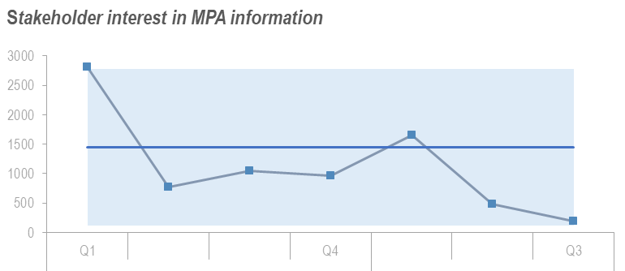 | 188 | This metric is related to the 30x30 objective and tracks the hits on Marine Protected Area webpages alongside PMF and HMPA pages. It provides evidence that People understand, promote and engage with the marine protection commitments. |  | The outcome of this measure is to identify if this section of our communications work is having the desired effect of promoting our unique marine protected areas as well as focus our comms work.
No. of restoration projects for which we’ve provided advice | 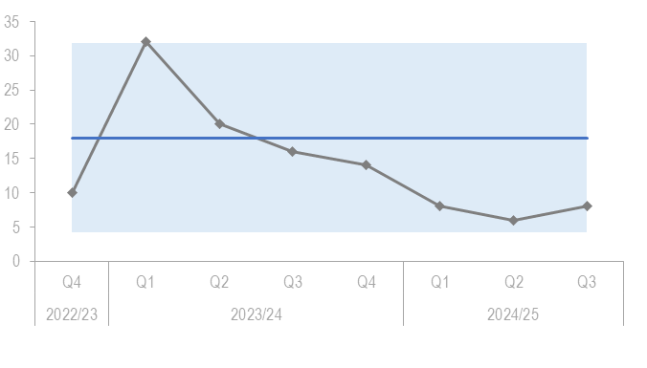 | 8 | This metric is related to the 30x30 objective and tracks the number of marine and coastal cases where we provide advice and support. This is used to help evidence the result of enhancement and recovery in marine habitats as the more consultations and advice that we give the more projects are active and pursuing correct actions to improve the environment. | Future development to better showcase the level of work involved in the team as the variety and amount of cases has increased.
License applications turnaround time within standards | 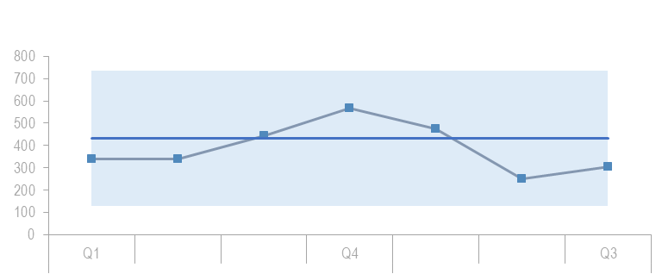 | 303 | This measure is related to our licensing goals. Between this measure and the following one they evidence the work involved in developing and expanding the use of the online licensing system as well as meeting our service standards. | The outcome of this work is to further develop and evidence the success of the online system while showcasing the level of work involved in licensing.
No. and Types of licenses that are processed through the online system | 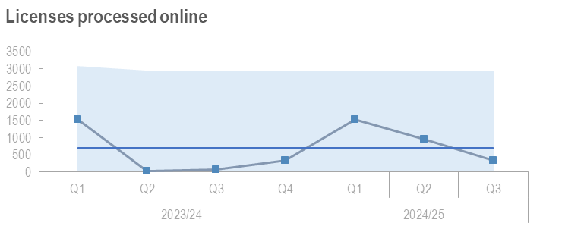 | 347 | As above |  | As above
No. of catchments with established beaver populations | 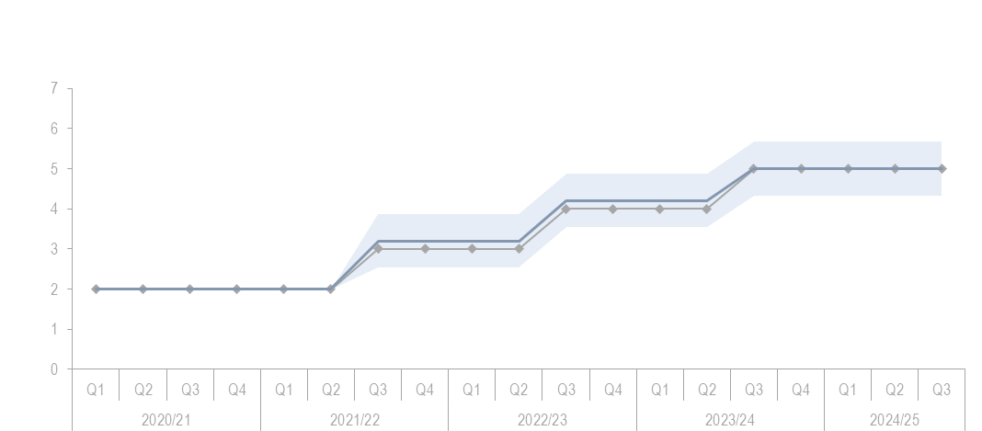 | 5 | This metric measures the priority actions set out be the Scottish Beaver Strategy. With a smaller data set this is the simplest way to measure and track the beaver translocations without more significant investment in the project. |  | Further development alongside the beaver data into something more usable and long term to show the investment in beaver strategy and its continued improvement.
% of holding objections for formal planning applications | 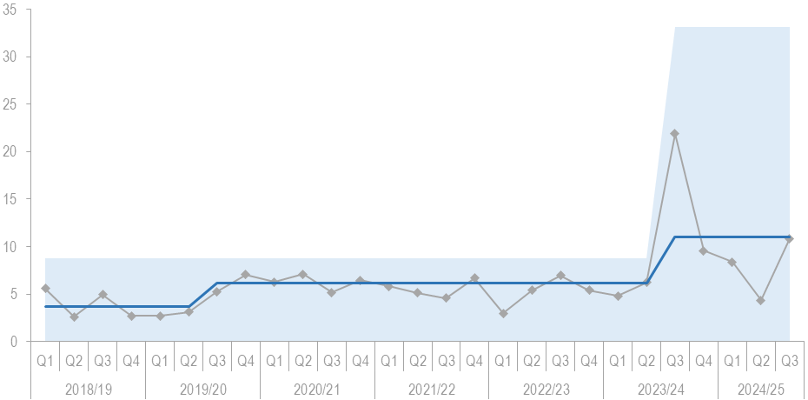 | 10.84% | This metric relates to progress we are making to ensure that developers, decision makers and the public understand our data and guidance. |  | Future monitoring will allow the team to further compare their previous work alongside the new Informed Decision AI integration into this area of work.

Restore
Measure | Performance Overview | 2024-25 Actual | Why We Measure This | Planned Outcome for 2025-26
No. of individual farm businesses that have completed a biodiversity audit | 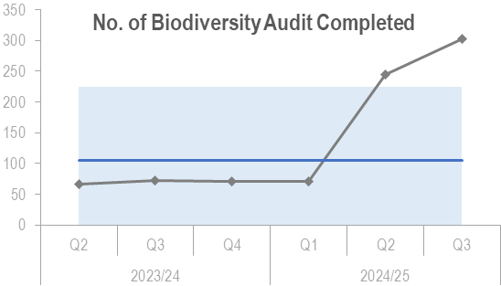 | 302 Total | This measure tracks the level of Biodiversity audits done across Scotland to evidence that Land Managers are motivated to take action and improve nature and climate relating to the objective of transforming land use. | Further understanding of the level of interest from land managers doing different levels of biodiversity audits.
No. of marine renewable energy consultations we provide advice on avoiding impacts on nature | 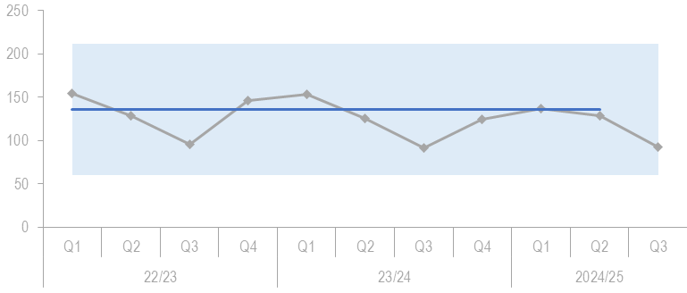 | 93 | Tracking the level of involvement in marine renewable advice consultations which is becoming increasingly time consuming. It helps the result of meeting net zero targets through the development of marine renewable energy and helping minimise the impact on nature. | To demonstrate the level of work that we provide in this advisory capacity to this specific area of work. This time expended on this work is expanding and so will need to develop a more accurate representation of time taken relative to the volume of cases.
NatureScot is in partnership with new recipients | 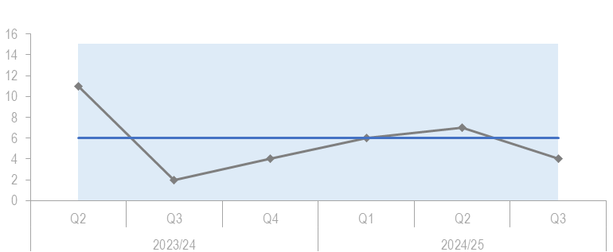 | 4 | This shows the number of new stakeholders that are involved in restoring nature. This is a simplified measure and was developed alongside the NRF program. | This will be reviewed alongside a different measure that shows the number of completed projects of NRF so we can compare all datasets to have a comprehensive overview of the progress of the NRF Program.
External funds raised by SMEEF and the amount allocated to projects. | 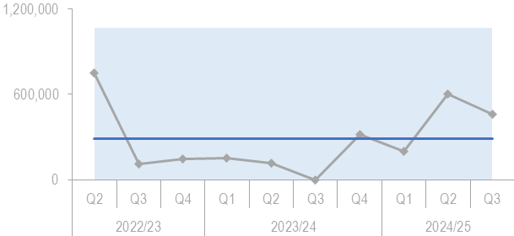 | £460,000 | This shows how well we stimulate private sector investment into nature as well as influence the regulatory policy market and institutional infrastructure needed to support private investment into nature. | To demonstrate the effectiveness of attracting public investment through the SMEEF program into relevant marine restoration programs and help highlight important areas of development and restoration.
Area (hectares) of peatland put on the road to recovery | 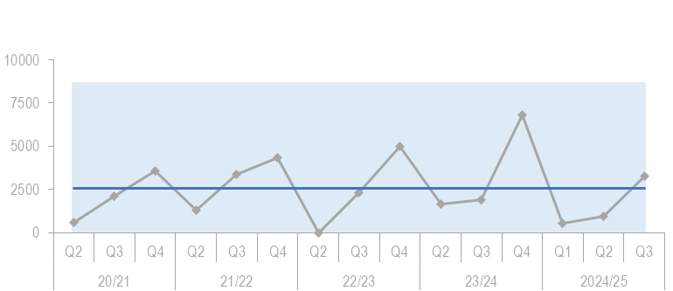 | 3287ha | This is the main metric to show the level of progress towards the Scottish Government targets set for peatland restoration | This will continue to be reported on as the main heading for peatland restoration. There are a number of contributory measures upon which this measure depends and these will continue to be refined for review by the relevant governance bodies

Value
Measure | Performance Overview | 2024-25 Actual | Why We Measure This | Planned Outcome for 2025-26
Engagement Rate on Make Space for Nature (MSFN) webpages | 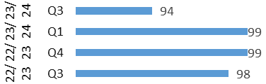 | 94% | This metric demonstrates how well we inspire people to connect with nature by measuring the level of engagement with our main public facing campaign about nature. | The future outcome for this metric depend on the way that we can measure this and develop actions to improve it as this measure has and will be effected by any changes to the algorithms that show and recommend our pages as well as the calculation done in the background by Google analytics.
No. of Landscape partnerships that NatureScot is involved in that use a natural capital approach | N/A | N/A | This metric was designed to measure the establishment of Natural Capital as an integral part of public and private business planning and investment decisions at national, landscape and landholding/business scales which tracks into the SBS and other areas to increase private and public funding into new natural capital ventures. | With the turbulence of this metric the main outcome is to establish a working tool to be measured and made public while gathering relevant data to showcase the effect that this is having on the sector to drive investment.
Nature-restoration jobs and skill development opportunities created through our activity | 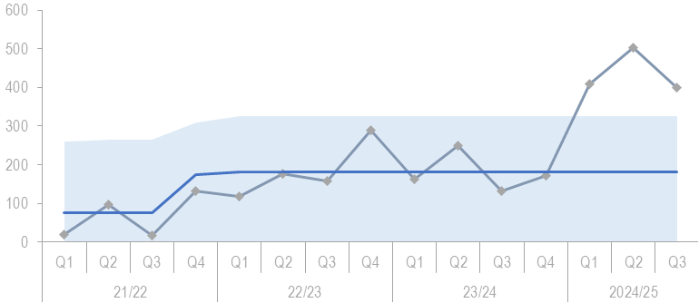 | 399 | NatureScot wants to lead in developing the skills and workforce necessary to protect and restore nature, through promoting nature-based skills and career. To make sure that natures value is recognised and that careers in nature are recognised and supported in the long term. | The planned outcome for this metric is to continue to puh the development of nature based skills and careers in all areas of Scotland and establish NatureScot as the primary entity supporting this development into our Nature-Based future.
Young People that we engage with on Skills | 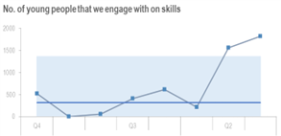 | 1814 | This is a sub-measure from the one above | We will continue to measure this metric but a decision on its future relevance at a corporate level needs consideration
National Nature Reserve online engagement | 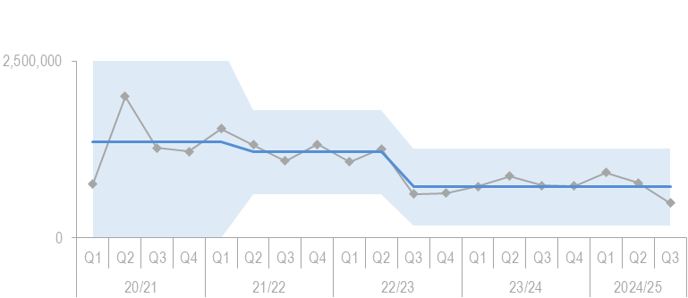 | 495590 | This metric was a proxy measure to show the increasing appreciation of nature’s value through communication of our work. This metric is specific for the pages relating to our nature reserves and gives an indication of the people and demographic breakdown that we are reaching. | As with other Comms based measures the is goal to increase engagement with the public to achieve our goals of working with people to showcase our work and nature.

The NatureScot Way

Measure | Performance Overview | 2024-25 Actual | Why We Measure This | Planned Outcome for 2025-26
Sq meterage of floorspace dedicated to NatureScot | N/A | 5883 m2 | This measure demonstrates our progress in reducing our office space in the light of greater use of home working and consciousness of the economic and environmental impact of retaining office space we don’t need | The outcomes for this metric include a range of net zero metrics and development of our offices to be fully net zero. There is ongoing to work in many areas to improve our offices for hybrid and full office workers as well as improve the overall space and carbon efficiency.
Total emissions (tCO2) | 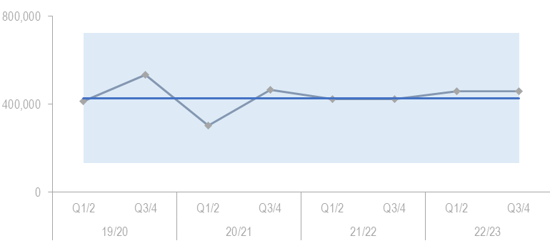 | 462,075 | This measure is a key measure that shows our overall progress to net zero. | Further development will reflect the underlying complexity of this metric which as a total is quite blunt since it doesn’t reflect issues like changes in staff numbers

Our Resources
Our funding comprises our Grant-in-Aid of £65.958m. This includes investment in key areas through funding for Nature Restoration, Scotwind licencing, FIRNS and Farming with Nature. Further funding expected for Peatland ACTION will boost our investment in peatland restoration significantly advancing our efforts to tackle climate change.

Nb – budget analysis to be confirmed

Resourcing our plan
Each year we set out to deliver the priorities set out in our Corporate Plan. To do this our resources are allocated through the activities we undertake. These activities provide the conduit for flexible working across the organisation. The tables below show the budget and resource allocation by these activities for 2025/26.

The key areas of investment include:

Tbc
We will retain flexibility throughout the year to deploy extra funds that become available through our efficiency programme and re-prioritisation that we undertake as part of our 90 day business planning process which allows us that flexibility to support our 4 key priority areas.

 | £m | FTE
Marine Ecosystems/Sustainable Coasts and Seas
Protected Areas
Supporting Good Development
Wildlife Management

 | £m | FTE
Biodiversity and Geodiversity
Natural Resource Management

 | £m | FTE
People and Places

People and Places | 2.750 | 77

 | £m | FTE
Workplace Facilities and Services
People and Organisational Development
Finance, Planning and Performance
Information and Cyber Security
Technology and Digital Services
External Funding
Communications
Executive Governance

Total

