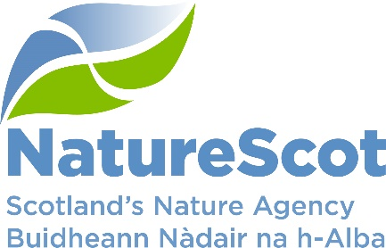

NatureScot

SCIENTIFIC ADVISORY COMMITTEE

INFORMATION PAPER

Ways of working

Purpose
- This paper updates the Committee on discussions regarding its ways of working.

Action
- The Committee is invited to note this update and the progress made in improving ways of working. Further suggestions for developing its ways of working are always welcome and we propose to have an agenda item on this at our next meeting .

Preparation of the paper
- The paper was written by Erin Garner and is sponsored by Eileen Stuart.

Background
- In September 2023, the Committee Chair undertook a series of meetings with Committee members to discuss the Committee’s working practices. These meetings were fruitful and resulted in a number of ideas for development.
- Further discussions on and progress with the development of the Committee and its ways of working have continued in the intervening 12 months.

Progress made
- Work has been ongoing to progress the feedback received. Changes made to date include the below, some of which will be discussed elsewhere at this meeting:
- Strengthening links with the Board by inviting Board members to observe Committee meetings and holding a joint SAC/Board meeting in February 2024.
- Clarifying membership of and roles within sub-groups, including that input can be sought from outwith the Committee and its Expert Panel where necessary.
- Introducing intersessional meetings to allow space for more in-depth exploration of complex issues in an informal setting. The first such meeting took place in June 2024.
- Considering updates on horizon scanning and the Science and Evidence Leadership Programme.
- Developing an overview of NatureScot’s Science and Evidence Needs.
- Exploring how to improve links with Higher Education Institutions (HEIs).
- Arranging a discussion with JNCC on international matters.
- Organising a discussion on the climate and nature emergency with the Royal Society of Edinburgh, with planning underway.

- Following consideration of the revised Committee Terms of Reference at the March Board meeting, a meeting was arranged for the Committee Chair, Board Chair and two Board members to discuss the Committee’s work further.
- The April meeting was an open discussion intended to draw on wider experience to inform the Committee’s development, including how to respond to changes in the external environment and how to support and reinforce the existing science profile and capacity within the organisation.
- A range of ideas emerged which were broadly in line with those identified by the Committee. Additional ideas discussed included:
- identifying and developing effective science communicators within NatureScot
- increasing opportunities for partnership working
- using online workshops to highlight NatureScot’s work
- maintaining an awareness of international contexts and issues
- identifying key data and information gaps.

Next steps
- Work is ongoing to further develop the Committee’s ways of working and this will continue to be discussed at future meetings. Input will also be sought from interested Board members.
- The Committee is invited to note this update and the progress made in improving ways of working.

Contact: Erin Garner, Erin.Garner@nature.scot

