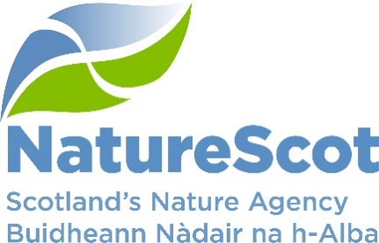

SCIENTIFIC ADVISORY COMMITTEE

DISCUSSION PAPER

Exploring Possible Processes for Facilitating Staff Interactions and Knowledge Exchange Between Scottish Higher Education Institutions and NatureScot

Purpose
- This paper explores potential mechanisms to enhance interactions between Scottish Higher Education Institutions (HEIs) and NatureScot. The proposals were set out in a concept note submitted by Professor Dan Haydon (SAC member) in May 2024 and align closely with the aspirations of the NatureScot Science and Evidence Leadership Programme (SELP).
- Commentary is provided against each of the eight processes identified, in terms of alignment (or otherwise) with existing initiatives, including SELP. The proposals that fill gaps in current activities or are felt to offer the greatest potential to facilitate interactions and the development of closer relations are highlighted.

Action
- The SAC is invited to:
- Consider and discuss the paper, which should be read in conjunction with the update on the wider NatureScot SELP programme (SAC/2024/10/Info02).
- To consider the following specifically:
  - Are there any missing areas of collaboration that we should consider?
  - Can members identify ‘ambassadors’ in their institutes?
  - Do other institutes have broadly similar approaches to institutional affiliation?
  - Is there a role for Vertically Integrated Projects (VIPs) in the delivery of NatureScot’s science and evidence needs (incl. Scottish Biodiversity Strategy (SBS) priorities)?
  - And could all HEIs use a ‘handshake’ portal if developed by the University of Glasgow etc.?

Preparation
- The paper was written by Dan Haydon, Ben James and Alex Mackay. It is sponsored by Eileen Stuart. The authors would like to thank Professor Jason Matthiopoulos for introducing a range of Vertically Integrated Projects (VIPs) currently underway at the University of Glasgow.

Background
- NatureScot established a Science and Evidence Leadership Programme in summer 2022. The aims of the programme are to increase the impact and influence of our science and reinforce our role as trusted adviser to government and other parties. The SELP was introduced to SAC shortly after it started (SAC/2022/11/04).
- SAC has long recognised the potential benefits of strong partnerships between NatureScot and the Scottish university sector. Each contains a wealth of knowledge, expertise, and capacities that are highly complementary to each other. Realising these synergies is increasingly important as resources across these spaces become increasingly limited. Underpinning the realisation of this potential is the optimal professional development of staff in each of these respective sectors, and building relationships, trust, and mutual understanding between them. This is recognised through NatureScot’s SELP, yet there are few widely understood mechanisms for how to build these constructive relationships. Here, the objective is to share some ideas for comment and discussion, including how they might be implemented, individually or in combination if deemed useful.
- It is recognised that staff in each sector are under increasing pressure to achieve more with less, and in the same time frame, and that these ideas may only have a chance of working for a subset of staff in each sector. It is also recognised that in each sector there are senior staff and early career scientists, and there is no invariant polarity (i.e. NatureScot or HEIs could serve as ‘provider’ or ‘beneficiary’ in any of these proposed relationships) - it simply depends on needs and circumstances of individuals. There will be geographical/ logistic/ disciplinary constraints on what might work which also need to be factored in.

Alignment with existing NatureScot activities including SELP
- Following preliminary discussions around the concept note, the eight possible facilitation processes were split into two broad categories as per Table 1 below.
Table 1. A broad categorisation of possible facilitation processes proposed to enhance interactions between Scottish Higher Education Institutions (HEIs) and NatureScot.
Proposals we already do to some degree and will continue but could enhance | Proposals that fill gaps, offer potential ‘quick wins’ or provide new perspectives
Professional allying | Vertically Integrated Projects (VIPs)
Peer (pre-)review service | Institutional ambassadors
Seminar programs | Institutional affiliations / honorary positions
Joint PhD projects | Implementation - ‘Handshake’ portal
- A brief description of each potential process, taken from the original concept note is provided below (‘boxed’ text at the start of each section), with a summary of current NatureScot activity in this area.

Proposals we do to some degree and will continue but could enhance

Professional allying
A structure could be developed to facilitate identification of suitable individuals in respective sectors (NatureScot and an HEI) based on an informed match-making process. Allying could look like mentoring, reciprocal mentoring, regular ‘catch-up/information exchange’ meetings, nascent research collaboration meetings - whatever is required and can be supplied on a bilateral basis.
- NatureScot understands the value of professional allying and most of the interaction mechanisms identified have evolved organically across the organisation and with a broad range of HEIs. We are acutely aware of the importance of learning and development to the delivery of our work, but also in terms of investing in our staff as individuals. The organisation has been actively promoting its offer to staff based on a broad interpretation of learning that doesn’t focus solely on training. As part of this learning package, we encourage mentoring (where staff may serve as mentors or mentees) through existing mechanisms such as the SAC mentoring scheme as well as other advertised opportunities (e.g. with MASTS PGRs), or through informal discussions as per other professional allying approaches. These discussions may be related to topics such as developing research proposals, through to more detailed discussions around technical issues where the organisation lacks expertise. SELP members are being encouraged to trial a variety of approaches so that they can then share their experiences with others and increase levels of uptake.

Peer (pre-)review service
A review service could be offered for papers or proposals whereby expertise/knowledge is exchanged between sectors prior to submission for formal review. This could involve members of SAC but go well beyond SAC to members of either sector as appropriate.
- Through SELP we have set up an informal paper writing mentoring scheme where more experienced staff support those looking for some help with publishing papers. The programme has updated the list of published papers involving NatureScot staff (see SAC/2024/10/Info02 for details of publications in 2023 and 2024) and produced guidance on this topic. Work is also underway to set out the process staff should follow for commissioning research, linking relevant guidance and highlighting available support mechanisms. A peer (pre-) review service provided by experts outside NatureScot would be a valuable addition, supporting the development of our staff and enhancing the quality of our research proposals. NatureScot could reciprocate by providing insights into emerging conservation policy applications of relevance to HEI research publications.

Seminar programs
Most departments will have seminar programs with organisers often searching for speakers. NatureScot and HEI staff willing to deliver seminars in the ‘other sector’ could sign-up to a list indicating the topic(s) on which they might speak. Such visits (and in person visits presumably much preferred) would lead to opportunities for further meetings.
- NatureScot runs monthly, internal science and evidence seminars. These have covered topics like conservation translocations, peatland restoration, the role of social science in conservation, etc. Activity teams regularly invite speakers to their meetings to share information or developments. The organisation also runs a Nature and Climate Change seminar series which has external speakers coming in to talk about a particular issue (Professor Beth Scott from the University of Aberdeen and member of the NatureScot Expert Panel will present on marine tipping points in September). Our staff also provide talks for other organisations including universities and we have talked within SELP about whether universities would welcome talks, slide decks or pre-recorded material that could be used to support their teaching. Another area we are starting to think about are broad topic discussions, where we take an in-depth look at a particular area e.g. how developments in genetics can support our work. Staff engage in regular seminars run by counterparts in JNCC, and there is appetite for increased interaction across existing seminar streams with policy teams in parts of Scottish Government. There is further scope for broadening existing approaches to raise awareness and support knowledge exchange.

Joint PhD projects
Whether through CASE partnerships, or formal involvement with sector funded DTPs/CDTs, joint PhD projects appear to be a conspicuously high value way of getting research done in areas of joint interest, while at the same time facilitating staff getting to know and work with each other. We anticipate that opportunities for industry-funded PhD studentships (fully or partly funded) will increase in the future, and there will be opportunities to register and possibly co-fund these students in HEIs. Knowledge sharing of the mechanisms by which these links can be made can be developed.
- We have a long history of working with PhD students. Due to financial constraints, we now rarely fully fund or make high percentage contributions to the costs of PhD studentships. However, we do support CASE studentships and get involved with PhD programmes by offering staff expertise where the research aligns with our priority evidence needs (see SAC/2024/10/Info02 for details of PhD engagement and SAC/2024/10/Info04 regarding our updated science and evidence needs). Through early involvement in Doctoral Landscape Awards and Doctoral Focal Awards, we can influence the direction of these programmes to ensure they will help deliver evidence needed to address key policy questions. Students also approach us for project ideas and when there is no requirement for funding from NatureScot, we do our best to identify a suitable project and supervisor. Interactions that enhance our ability to shape evolving programmes at a strategic level are of particular interest.

Proposals that fill gaps, offer potential ‘quick wins’ or provide new perspectives

Vertically Integrated Projects (VIPs)
HEIs are increasingly approaching the challenge of providing hands-on research experience to short-term cohorts of students at scale through VIPs. VIPs are long-term platforms by which cohorts of students and staff can work productively on long-term (multi-year) projects, enabling cumulative benefits to accrue (lots of information on VIPs and their widespread use available on-line). This provides a possible means of utilizing the substantial capacity provided by undergraduate honours and masters students requiring project experience that pass through Scottish HEIs. There is investment required in both the development of individual VIPs and their operation (particularly if they involve multiple organizations), but they are an increasing feature on the HEI landscape. VIPs could usefully serve NatureScot as a means of developing longer-term environmental monitoring datasets while providing HEI students the opportunity to analyse and work-up ‘real-life’ datasets with application and meaning.
- The VIPs concept, and the potential to engage cohorts of honours and masters students in the delivery of different NatureScot work areas, including longer-term environmental monitoring is very appealing. Surveillance and monitoring form an important element of our core programme (e.g. to inform statutory reporting obligations around protected area status) but are hard to sustain from funding and staff resource perspectives. Monitoring isn’t sufficiently cutting edge or novel to serve as the basis of multi-year doctorate studies but could provide an invaluable skills development ‘proving ground’ for shorter conservation-orientated courses / modules. From an organisational perspective (both an HEI and NatureScot) a recurring or similar fieldwork programme greatly simplifies logistics (e.g. access to an NNR or MPA, associated impact and H&S risk assessments, travel and accommodation arrangements etc.) and reduces the need to continually develop bespoke, short-term projects. In addition to gaining real-world experience, students benefit from not working on projects alone and a greater likelihood of being included as an author on a peer-reviewed paper after multiple academic year cohorts (all contributors to data collection elements are recognised on linked publications). An example of a University of Glasgow VIP is provided in Annex A.
- As well as seeking to introduce project opportunities to HEI-led VIPs, the concept would appear to lend itself well to the framing and delivery of NatureScot-led research under broad topic areas i.e. linking to the delivery of our revised science and evidence needs or projects under the SBS involving multiple agency, industry and academic partners.
- Further dialogue to tap into HEI expertise in this area could provide invaluable insights into project design (what works and what doesn’t, optimal project / team ‘scale’ etc.) as well as identifying potential collaborative opportunities. NatureScot’s new Project Management Office may have a role to play here, working with SELP staff to develop a small number of pilot project ideas to explore with HEIs.

Institutional ambassadors
A network of individuals (say one from each campus/location) with an identified responsibility for furthering NatureScot-HEI interactions would provide obvious entry points for more general enquiries, and a forum and ‘nudge mechanism’ for what further processes/mechanisms might be put in place to facilitate closer working.
- Through SELP we are gathering information from staff about their existing connections with academia and any ‘gaps’. We will then identify leads for specific areas of our work to act as a point of contact to reach out and bridge key gaps. The SELP will maintain an overview of the relationships and be there to support activity. The intention is to trial the approach initially to establish an effective but light-touch process. A nominated HEI ambassador serving as an entry point and willing to direct more general enquiries would likely facilitate access to a far wider range of potentially relevant and interested contacts within an HEI and reduce the need for multiple NatureScot approaches to individuals / departments.

Institutional affiliations / honorary positions
Most HEIs can offer individuals working outwith their organizations some form of adjunct association. This can have the benefits of enabling e.g. NatureScot staff to receive information on seminars, CPD opportunities, recognition on student supervision, and library access. This can be a very light touch (‘affiliation’) or more procedural (honorary fellow/lecturer/ professor), and perhaps NatureScot has (or could develop) something a bit similar.
- A comparatively modest number of NatureScot staff have some form of adjunct association with an HEI and this is an area we would like to explore in more detail. There would be benefits for NatureScot staff in terms of access to resources - both human and materials, but also in terms of being recognised as a professional working in a particular area of science. By finding out more about how affiliations and honorary positions work across the sector, the SELP could support this by providing guidance for staff. Further discussions are required to identify what reciprocal opportunities NatureScot could offer in this area beyond staff representing their affiliated HEI and potentially highlighting and encouraging academic counterparts to apply for advertised positions on NatureScot working groups and formal committees.

Implementation - ‘Handshake’ portal
One possible way the mechanisms to enhance interactions could be implemented would be through an online portal that individuals could submit information or research gaps/opportunities to about what they are willing to contribute and in what areas. This information could be used to identify ambassadors, match allies, find reviewers, indicate seminar options, identify student projects or possible VIPs, make enquiries about possible research collaborations and other questions. One affordable way to construct this would be as a project carried out by teams of HEI-based computing science students.
- The development of an online portal to facilitate interactions between NatureScot and HEIs has significant potential (an app to find the perfect science partner!) and could expedite delivery of the other ‘mechanisms’ identified (finding reviewers, identifying seminars etc.). If the build and ongoing maintenance could be delivered through cohorts of computer science students, that could be ‘win-win’ from a NatureScot perspective.
- NatureScot IT colleagues have confirmed that there shouldn’t be any technical constraints in terms of staff access to a portal hosted by another organisation and Professor Haydon has submitted an outline specification (see Annex B) to the University of Glasgow computer science programme by way of a ‘placeholder’, subject to feedback from SAC on this proposal. The submission template included a request for ongoing maintenance and refinement (informed by continuing engagement around functionality). If successful, the concept could of course have much wider application (sister conservation agencies, government departments, eNGOs, industry partners and parallels across other HEI departments and networks).

Conclusions
- Understanding who is active in different subject areas, establishing initial contacts and building a rapport over shared interests is critical. Everything flows from there. We are keen to explore the facilitation mechanisms identified in this paper in more detail, including trialling the ‘Handshake’ portal concept. We are establishing a pool of potential NatureScot ‘ambassadors’ (e.g. through SELP and STEM programmes) who are keen and well-placed to enhance existing interactions with HEIs. A portal wouldn’t replace the need for and benefits of staff continuing to engage in person via workshops and annual events (e.g. BES annual meeting and MASTS ASM later this year, etc). It offers something different, that is direct, more immediate and potentially accessible to a wider range of NatureScot staff but also less personal, so whilst it might usefully lay the groundwork for a relationship, success would ultimately depend on individuals from the respective sectors.
Contact: Ben James, Ben.James@nature.scot
Alex Mackay, Alex.Mackay@nature.scot
Professor Dan Haydon, Daniel.Haydon@glasgow.ac.uk

Annex A An example of a Vertically Integrated Project (VIP) from the University of Glasgow’s current portfolio. For information on VIPs being run by the university’s School of Biodiversity, One Health & Veterinary Medicine please contact Professor Jason.Matthiopoulos@glasgow.ac.uk
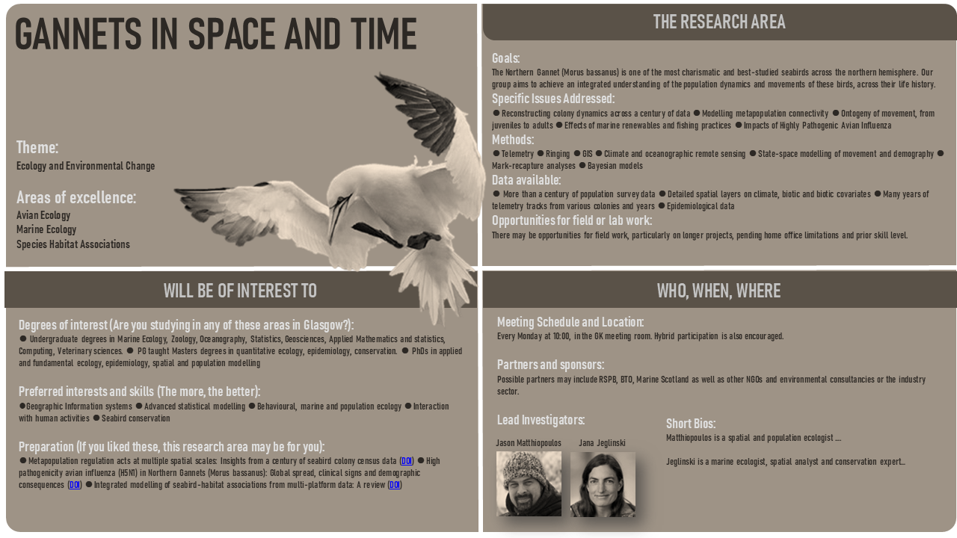

Annex B A cross-sectoral portal for integrating human resource across the Scottish HEI sector and NatureScot [Short-title: Handshake]

NatureScot is the lead public body responsible for advising Scottish Ministers on all matters relating to Scottish Natural Heritage. Their purpose is to: 1) promote, care for and improve our natural heritage; 2) help people to enjoy nature responsibly; 3) enable greater understanding and awareness of nature; 4) promote the sustainable use of Scotland’s natural heritage. NatureScot employs more than 700 people based in centres all over Scotland. There is a great deal of overlap between the work of NatureScot and the work of university departments in the Scottish Higher Education Sector (particularly in the areas of environment science, ecology, and environmental governance) but there is very little connectivity between staff working in NatureScot and staff working in Scottish universities, and the absence of more natural synergy is very significant missed opportunity.

There is a plan to identify and appoint ‘ambassadors’ in sections of NatureScot and departments in Scottish universities to lead programs to more closely integrate the two sectors (NatureScot and Scottish universities).

We wish to create a web portal to which staff in either sector can register with and indicate their willingness to engage in various joint activities.

Our basic version of this portal would have the following features:
- It would enable individuals to register a form of standardized profile containing at a minimum an individual’s: name, location, position, contact details, key words describing professional interests (perhaps off a prescribed list, in addition to free choices, and perhaps a CV and other biographical details).
- Their willingness to make themselves available for a prescribed list of joint activities that would include at a minimum: 1) to serve as a mentor or professional ally; 2) provide peer review for research papers or grants prior to submission for publication; 3) an interest in creation of an affiliation or visiting role in University; 4) an interest in joint PhD supervision; 5) an interest in engagement with vertically integrated projects; 6) willingness to visit institutions and give seminars on their work; 7) willingness to work as an institutional ambassador; 8) some permission to share this information with either ambassadors and/or visitors to the website; 9) receive communications relevant to developing synergies between the two sectors.
- It would be searchable by ‘professional interest’, or activity type, location and various other respects
- Perhaps ‘suggest’ likely matches for queries
- It could allow registration of a vertically integrated project (VIPs) by asking people trying to do so to complete a template like this (or upload a slide structured this way)
- Construct a gallery of VIPs that are submitted to date.
- And enable individuals to register their interest in such VIPs

Use of the portal would be encouraged and facilitated by the institutional ambassadors.

More information on VIPs can be found online, for example here: https://www.bath.ac.uk/guides/vertically-integrated-projects/

