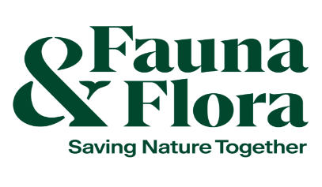



Community marine biodiversity monitoring equipment fund survey profile – 2024/2025
A completed survey profile form should be submitted with your Equipment Fund application form, and any supporting documents, to communitymarinesurvey@nature.scot.

Surveys must adhere to Covid-19 government restrictions at all times. If surveys cannot go ahead because of restrictions, grantees will need to get in touch with NatureScot staff at communitymarinesurvey@nature.scot to discuss options.

NatureScot is the operating name of Scottish Natural Heritage.

Group name:

Lead contact(s):

The survey or monitoring interest:

Objectives summary:

Why do you want to survey the marine environment?

What do you want to survey or monitor?

List methods from the handbook you are likely to use:

Why do you want to survey or monitor these particular areas or species?

Please demonstrate how your surveys are community-led. Surveys are considered community-led if they are planned and carried out by a community/local group to achieve local aims.

What information are you going to collect and how much time do you plan to spend collecting it?

Time allocated to survey or monitor (list dates annually):

Anticipated duration: ______ years

Who will analyse and use the information you collect?
Who will analyse:

Who will use:

Who will be your group’s nominated community data representative(s)? (Data representatives will validate community data, participate in relevant training and contribute towards developing and testing the project’s data journey. No prior data experience or knowledge is required.)
Name(s):
Email address (es):

Will the information you collect, and the frequency with which you collect it, meet your monitoring objectives? (If the answer is no, revise your survey plans to address this)

Will the data you collect be in a form that others (community members, academics, government etc.) can interpret and understand? (If the answer is no, revise your survey plans to address this)

Survey area
Describe the survey location(s):

Insert a map of your survey area with a survey box drawn on:


Other notes:

