SAC/2023/03/03

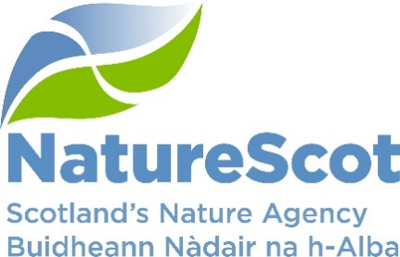

NatureScot

SCIENTIFIC ADVISORY COMMITTEE

DISCUSSION PAPER

Deer research - proposal for SAC sub-group

Purpose
- This paper proposes establishing a Scientific Advisory Committee sub-group to support staff work in developing research and evidence needs in relation to deer management in Scotland.

Action
- The Committee is asked to support the establishment of a sub-group on deer, to scope and support the research and evidence needs to deliver Scottish Biodiversity Strategy and Net Zero outcomes.

Preparation
- The paper was written by Paul Roberts. It is sponsored by Donald Fraser.

Background
- NatureScot Wildlife Management Activity is leading on a programme of deer-related work and a series of projects to support delivery of Scottish Biodiversity Strategy 2030 and 2045 targets and net zero climate change targets by 2045.

- This programme of work is based on the Deer Working Group recommendations and is being given strategic direction by an inter-agency Strategic Deer Board (and four workstream groups) which reports to the Scottish Government Biodiversity Programme Board.

- There is a need for advice and support to the Wildlife Management Activity in articulating and scoping the evidence and research base for much of this work. This will provide expert advice, additional resource and ensure policy decisions are based on sound judgements and robust evidence.

- There is also a need to coordinate this research across NatureScot to ensure consistency, economies of scale and efficiencies in delivering other work programmes, for example the Scottish Biodiversity Delivery Plan.

Proposal
- There is an opportunity for the Scientific Advisory Committee to establish a sub group to support and advise Wildlife Management Activity staff on deer-related research and evidence requirements, take a strategic view and have oversight of all deer-related research across NatureScot.

- The remit of the sub-group should include:

  - Oversight and coordination of current deer research across cross-cutting activities (DWG recommendations delivery, SBS delivery, peatlands, woodlands, green finance, future rural support mechanisms etc).
  - Scoping, identifying, commissioning and coordinating future deer research and evidence needs.
  - Advising and supporting staff members who have a role in the delivery of deer research.
  - Drive knowledge transfer of deer research both within NatureScot and with stakeholders (eg review and updating deerscotland.info)

- Examples of project where support, advice and additional evidence is required are as follows:

  - Modelling and mapping the scale, scope and extent of the cull to reduce damage and therefore deer populations across Scotland.

  - Model population responses to increased culling at a range of scales (region - DMG) and habitats (forestry, woodland, upland, low ground mixed woodland/agriculture)

  - Planned cull approval system; better understanding of what this looks like, scoping data requirements, cost-benefit analysis, assessment of feasibility and options appraisal.

  - Improve understanding of relationships between densities and impacts and how this relates to delivery of public interest outcomes, assessment of existing research with a view to better articulating likely habitat responses to different densities

  - Jobs and skills for the future; modelling future resource required to deliver the projected culls and maintain a sustainable population towards 2030 and 2045

  - Venison; support the venison sector to build greater capacity and resilience to meet projected future demand from increased culls

Contact: paul.roberts@nature.scot
Wildlife Management Team

