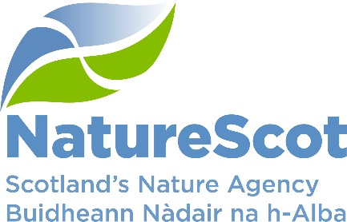

NatureScot

SCIENTIFIC ADVISORY COMMITTEE

INFORMATION PAPER

The Scottish Biodiversity Strategy - next steps

Purpose
- The paper outlines next steps with the publication of the 25-year Scottish Biodiversity Strategy.

Action
- The Committee is asked to note progress.

Preparation of the paper
- Des Thompson and Sue Haysom prepared the paper. It is sponsored by Eileen Stuart.

Background
- The formal consultation on the 25-year Scottish Biodiversity Strategy (SBS) was launched on 20th June, and closed on 12th September. Following that, the strategy will be published around the Biodiversity COP 15 (7th - 19th December). The Scottish Government has committed to publishing a Delivery Plan six months beyond publication of the strategy. Early intentions for the strategy were published in December 2020.

- The NatureScot Board has already advised on the vision and outcomes for the draft consultation, on options for the governance arrangements supporting the delivery of the strategy, and prospective targets in the proposed Natural Environment Bill. This has contributed to the work and outputs of the Programme Board overseeing the development of the strategy. Three stakeholder workshops have contributed significantly to shaping the strategy, with on-going inputs and support from the Programme Board’s Advisory Group (chaired by the Chief Scientific Adviser for Environment, Natural Resources and Agriculture in the Scottish Government).

- The provisional schedule is:

  - September-November – review consultation responses and devise strategy;

  - End of year – publication of draft 25-year SBS containing overarching vision, high level outcomes and proposed actions;

  - March 2023 - consultation on the SBS and draft Delivery Plan (covering actions, governance, indicators for measuring progress, and reporting requirements);

  - July 2023 – SBS and Delivery Plan published; and

  - 2024 - Natural Environment Bill setting statutory nature targets to underpin aspects of delivery.

- The science inputs beyond from staff, officials and stakeholders are coming from the Programme Advisory Group (which includes some former Committee members). Much work is focused on logic modelling to develop the outcomes, outputs and actions, supported by available evidence. In addition to the development of the strategy, we are contributing to the UK position in the lead in to COP15.

- Several events are in the planning stage to coincide with COP15. These are in Edinburgh, organised with a range of partners, and timed to tie in with the concluding part of COP15 and the British Ecological Society Annual Conference in Edinburgh (18-21st December).

- 21-22 November: ICLEI-Yunnan’s Department for Environment and Ecology event, with RBGE, Scottish Government and NatureScot. This involves cities from across the province (including Kunming), with: (i) Kunming Mayor signing Edinburgh Declaration; and (ii) round-table discussion to underline Edinburgh Process aims ahead of CoP15, showcasing practical steps already taken, outlining what more needs to be done with participation from biodiversity experts from Kunming/ other Yunnan cities in person, and from Scotland virtually.
- 15th December (Evening): RBGE, Gateway Centre – A Celebration of Scotland’s international contribution to biodiversity, capped by the wonderful Christmas Lights Display.
- 16th December (Day): Solutions to Nature Climate Crisis at the National Museum of Scotland, with a series of engaging talks, poster displays and panel discussion.
- 16th December (Evening): Making the economy work for nature at the Edinburgh Climate Change Institute. Just ten minutes from the NMS, this offers a lively opportunity to engage in a panel discussion on how we can ensure the economy works to revive and sustain nature.

- Depending on further inputs from the Programme Advisory Group, we may seek Committee inputs on targets, and monitoring and evaluation measures, in support of the Delivery Plan, and Natural Environment Bill.

Contact: Des Thompson des.thompson@nature.scot

