SAC/2022/03/01

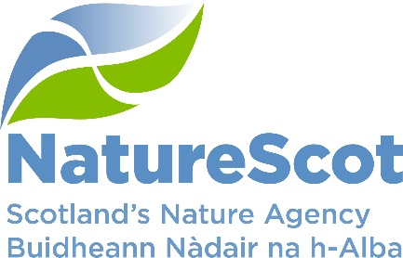

NatureScot

SCIENTIFIC ADVISORY COMMITTEE

DISCUSSION PAPER

The Environment Strategy and Indicators

Purpose

- This paper introduces a presentation from Scottish Government and NatureScot staff on Scotland’s Environment Strategy and the development of indicators to aid reporting on progress in implementation.

Background

- Scottish Government and NatureScot recognise the vital importance of evidence in underpinning policies. A key form of evidence is our suite of indicators, which both assess the status of nature in Scotland against an historic backdrop and highlight changes. Whilst the environment is subject to many interacting pressures, both positive and negative, it is sometimes possible to link changes to policy initiatives, as has been the case for freshwater quality in the years since the implementation of the Water Framework Directive (State of Nature Report Scotland 2019 p13).

- Scotland’s Environment Strategy is built around a central vision that “by 2045: By restoring nature and ending Scotland's contribution to climate change, our country is transformed for the better - helping to secure the wellbeing of our people and planet for generations to come.” The strategy includes a monitoring framework, which contains 19 indicators.

- NatureScot is the lead for producing the Marine and Terrestrial Species Indicators and the Natural Capital Asset Index (and see McKenna et al., 2019), and our staff are involved in developing a soil health indicator. Many of the other indicators also relate strongly to our work, such as access to green and blue space, Nature-based Solutions, and global impact of Scotland’s consumption. We expect the indicators to align well with the Scottish Biodiversity Strategy and with our international aspirations and obligations.

Contact:

David.obrien@nature.scot
Susie.Turpie@gov.scot

