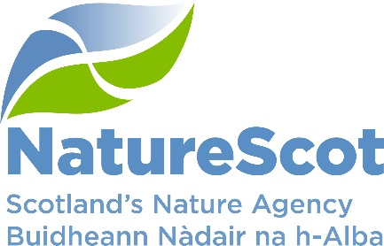

NatureScot

SCIENTIFIC ADVISORY COMMITTEE

DISCUSSION PAPER

Protected Areas Monitoring Reform

Purpose
- This paper provides an update to the SAC on Protected Area monitoring reforms and supporting systems being developed by NatureScot, and seeks comment and endorsement on the approach to reform outlined.

Action
- The SAC is asked to:
- Consider the content of this paper
- Provide comments on any of the issues raised
- Consider in particular the challenges around species monitoring (Principle 7)
- Endorse the principles of the new approach
- Advise on how they would like to be involved in future progress of this work.

Preparation
- The paper was written by Ben Ross. It is sponsored by Eileen Stuart.

Summary
- We have been monitoring the natural features of our protected areas for over two decades through a process called Site Condition Monitoring (SCM). 76% of natural features are currently in favourable or improving condition but this figure is declining. We struggle to monitor all features within each monitoring cycle and there are inherent weaknesses in the current approach. As we move to deliver 30x30 and Scottish Biodiversity Strategy commitments we propose a new approach, Monitoring to Deliver Healthy Ecosystems. This approach will be more effective at informing management interventions, more efficient and future-proofed to capitalise on new technologies and data.

Background – what we currently do and why we do it
- The purpose of Site Condition Monitoring (SCM) is to determine the condition of the natural features on each protected area. This helps inform whether the feature is likely to maintain itself in the medium-long term under current management and environmental conditions.
- Our monitoring programme has been in operation since 2000. It monitors around 5,500 individual natural features of special interest across nearly 2000 designated sites on a 6-10 year rolling programme. The first cycle conducted baseline assessments of all features across all sites. In subsequent cycles this developed into a statistical sub-sampling of features, and more recently evolved into a three-tiered risk-based approach. This tiered approach includes a basic ‘site-check’ for low-risk features and two levels where full SCM is carried out, either by staff or national contractors. We are now in the fourth cycle.
- SCM assigns each feature’s condition into one of eight categories. We also inspect sites for factors that may negatively or positively affect features. These pressures can reveal why a feature is in unfavourable condition and inform remedial action, including management agreements or supporting applications for agri-environment schemes, or similar.
- As part of the monitoring methodology, each feature is assessed against a number of direct and indirect attribute targets derived from UK common standards. Whether or not these targets are met determines overall condition. An important point to note is that attributes can be common across different features (for example, invasive rhododendron is an attribute across woodland habitat features as well as associated species assemblage features). However, the targets for those attributes (i.e. what constitutes a pass or a fail) may vary across different features.
- Monitoring results are used to produce the Official Statistic on the Proportion of Scotland’s Protected Areas in Favourable Condition, which is an indicator in Scottish Government’s National Performance Framework. They also feed into UK and international reporting, e.g. UK Habitat Regulations and Bern reporting, and provide evidence to inform protected areas casework.

Progress
- We are significantly behind in our site condition monitoring programme, 44% of features have not been fully assessed (i.e. full SCM being undertaken) in the last 10 years. In the last monitoring cycle (2013-21) 2265 features were assessed through the site-check process (42%) and 2590 features were assessed through full SCM (48%). At the same time, resources allocated to monitoring have decreased significantly (Table 1). Figure 1 shows monitoring progress. All Tables and Figures are in Annex 1.

Condition of features and pressures
- There has been a gradual but consistent declining trend in the proportion of natural features in favourable or recovering condition, from a peak of 80% in 2016 to 76% in 2023 (see Figure 2). There are a number of reasons for this and more detail can be found in the annual published official statistic.
- The official statistic also includes a summary of the negative influences, or pressures, recorded as part of the monitoring programme. These pressures are normally derived from observations made during site visits, particularly where they contribute to the failure of one or more target. The relative proportions of those different pressures identified are shown in Figure 3. An important point to draw from this information is that over 40% of those recorded pressures, under three categories (invasive species, over-grazing and climate change) operate at least at the landscape scale, i.e., within but also well-beyond site boundaries. Another important point to note is that under-grazing, which is the 5th most recorded pressure, is most often as a result of actions to mitigate high herbivore pressure at the landscape-scale (i.e. deer fencing).

The need for change
- Our approach to protected area monitoring has been the subject of review in the past and approaches have evolved over time. The most recent review, by a sub-group of the SAC in 2020 made three recommendations in relation to protected areas monitoring:
R1. A ‘3-tiered’ approach to on-land SCM should be implemented in full.
R2. Ecosystem health needs to be more clearly defined.
R6. Opportunities for implementation of new technologies citizen science in monitoring and surveillance should be pursued.

- The first of these recommendations has been implemented, the second is in progress (and forms the backbone of the work presented in this paper), and the third is in progress with our innovative technologies programme.
- In the meantime, commitments to support actions arising from the UN CBD Global Biodiversity Framework, and particularly the 30x30 commitment, as well as the emerging Scottish Biodiversity Strategy, have further emphasised the need for change.
- Delivering 30x30 requires an uplift in land safeguarded for nature of around 50% or 0.7million hectares in 6 years (from current protected area coverage of c20%). Whilst this uplift is not necessarily going to be solely delivered through protected areas (it will also use Other Effective area-based Conservation Measures, OECMs), we will still need to be able to ensure they are effective, and therefore be able to measure their effectiveness.
- 30x30 is not just about increasing the percentage of land covered by designations, it is also an opportunity to reform our approach to area-based conservation. As part of the recent Consultation on Scotland’s Strategic Framework for Biodiversity, we published the draft 30x30 Framework which sets out the key principles that will guide delivery of this work. Key principles with regard to monitoring in the Framework are:
- Monitoring should prioritise identification and assessment of the most important factors for maintaining the health and resilience of 30 by 30 sites while also taking into account gaps in knowledge.
- Monitoring will be designed with stakeholders, and for stakeholders, to ensure it is iterative and informs ongoing and adaptive land management decisions.
- Monitoring will use a combination of traditional methods and emerging technologies, with a focus on maximising the efficiency and effectiveness of data collection and analysis, while also ensuring that data quality and accuracy are maintained.
- Monitoring must meet national and international reporting obligations.

- The reforms around protected areas will not only help deliver key obligations such as 30x30 and the SBS. They will also build on past experience and the 2022 review of protected areas to ensure they deliver maximum benefit for nature. This includes ensuring that not only the rare and vulnerable features are safeguarded, but that the ecosystems they depend upon are healthy.
- Our approach to monitoring protected areas is failing. The evidence-base and confidence for informing management and statutory advice is deteriorating and the condition of those sites is falling. We struggle to monitor the suite effectively and there needs to be a stronger link between monitoring and positive interventions on the ground. This monitoring has to work at scales beyond protected area boundaries and we need to harness new and emerging technologies.
- The solution is not simply to allocate more resource to the existing approach. We need transformational change to improve effectiveness and efficiency of monitoring and to future-proof it to embrace new technologies, approaches and data. The Protected Areas Monitoring team are currently developing this new approach, Monitoring to Deliver Healthy Ecosystems.

Monitoring to Deliver Healthy Ecosystems – Developing the approach and key principles
- A proposed set of guiding principles for Monitoring to Deliver Healthy Ecosystems was developed in 2023 taking into account the issues described above. We held 26 workshops with external groups, organisations and NatureScot staff to test the principles and intent of the new approach (report in preparation).

- At the start of this process six founding key principles were proposed, and as a result of feedback, an additional four principles were added. The Principles for the new approach are summarised below:
Principle 1: Prioritise information that informs management - Refocusing monitoring to prioritise collecting data on attributes that inform management action, but ensuring a sub-sample still measure ‘response’ or ‘state’.

Principle 2: Adopt a site-based approach - Our current approach monitors features in isolation of each other. This can result in duplicated sampling of similar attributes and conflicting targets. To improve the efficiency we propose eliminating duplicate sampling by enabling a site-based approach.

Principle 3: Incorporate the wider landscape/seascape - Our existing monitoring results show that the most frequent and impactful pressures act at a landscape/seascape-scale. The new approach should gather certain information at a scape-scale to inform assessments of a site’s health and management at the most effective scale.

Principle 4: Assess attributes on a scale - Currently, we employ a simplistic pass/fail system for assigning condition at a feature level. This principle proposes to use a gradient approach (which can also work at different scales) similar to that used in an energy performance certificate (EPC).

Principle 5: Make best use of existing data - The existing SCM approach has built-up 20-years of detailed feature assessment data. The proposed rationalising of our existing attribute set (as opposed to a completely new set of indicators) will enable ongoing comparison and ensuring our continued ability to meet feature-level reporting requirements.

Principle 6: Incorporate innovative technology - New monitoring technologies are becoming more accessible due to increasing maturity and affordability and will offer significant opportunities. We will therefore explore ways of integrating new data collection methods into our national monitoring programme, e.g., EO, LiDAR, eDNA etc. This may include early adoption of less mature technologies, but with the ability to assign confidence levels (qualitatively and quantitatively) to that evidence.

Principle 7: Species monitoring considered in wider context of a species-monitoring framework - We currently monitor some species only within protected areas for which they are designated. However, many species populations are determined by larger scale processes. This is often reflected in the scale of regional and national monitoring programmes, with extracts used to inform within-site assessment.

This principle explores whether the protected area scale is the most appropriate for all species that a site is notified for. It has been added in response to the important concern that the DHE approach could result in a reduction in species monitoring on protected areas.

Principle 8: Validation against current approach - This principle helps address risks of rationalising attributes as proposed in the other principles. It emphasises the need for assurance that by primarily monitoring and informing responses to pressure and threats, we are also delivering the outcomes of the SBS, i.e. halting the loss of species and delivering functional and resilience ecosystems. Furthermore, it highlights the importance of calibrating the new approach to ensure continuity of the Official Statistic on Protected Areas.

Principle 9: Maintain ecological expertise and skills - This principle acknowledges the significance of nurturing in-house ecological skills and emphasises the value of site-visits for staff’s understanding of those sites and the cultivation of relationships with landowners.

This principle is borne out as a direct response to concerns about the loss of connection between staff and their sites alongside lower morale due to work being more desk-based.

Principle 10: Improved links with funding mechanisms - This principle acknowledges that the ability to implement effective management normally requires access to funding. Monitoring can help prioritise funding to support both on-site and wider landscape action.

Next steps
- Stages of work are shown in Figure 4. The development of the principles and SAC consideration concludes the foundational ‘consultation’ phase. There follows a feasibility exploration stage, with ecosystem working groups already set up (covering woodlands, marine and freshwater ecosystems) and potentially the formation of an external advisory group. We then move forward to a pilot phase (likely to focus on Loch Lomond and the Trossachs National Park), followed by review and roll-out of the new approach.
- Alongside this work there is an ongoing project, CivTech challenge 8.3 to develop an innovative cloud-based solution, InformedINSIGHT, to replace our existing SCM system. The platform uses innovative approaches, such as AI and Data-Lake methods, to enable a flexible evolution of our approach in a controlled manner. It will allow us to use data insights to prioritise monitoring, link new and existing data sources to multiple features, and enable analysis and assessment at a range of spatial scales. This service will play a major role in implementing our reformed approach. It will launch in the summer.

Links to other work
- Protected Areas (and 30x30 more widely) are integral to delivery of multiple outcomes of the SBS. Furthermore, the health of ecosystems and protected areas and measures of drivers of biodiversity loss are likely to be metrics to support reporting on SBS progress and new statutory targets. A new SAC monitoring sub-group (ToR in prep.) is being set up to support development of a monitoring and evaluation framework for the SBS and to agree indicators for the Bill targets. The author is a supporting member of the sub-group.

Risks and opportunities
- The new approach presents an opportunity to deliver significant benefits to the way we monitor protected areas and to address significant documented weaknesses in the current system outlined in this paper. The approach also has potential to be used in the wider countryside to support restoration work and landscape-scale interventions including deer management. It will also enable better comparisons between ecosystems inside and outside of protected areas, something which was highlighted in the last monitoring review.
- InformedINSIGHT presents significant opportunities including; the managed transition to the new monitoring approach, unifying marine and terrestrial monitoring systems, deriving new insights from existing data holdings, utilising new data, facilitating use of on-site recording devices and improving our data science capability.
- The workshops to develop the principles have generally shown wide support for the rationale for change. They have also helped identify concerns and risks. Some of the commonly voiced concerns were around recognising the need for change but ensuring that we don’t discard the ‘good points’ of the existing approach, including the loss of data-continuity on specific features (particularly species). These have helped refine the existing principles and develop principles 7-10. This will also help shape the work of the ecosystem working groups and pilot work and we will ensure continued work with stakeholders to make sure these risks can be appropriately mitigated.
- Resourcing is a key risk. Levels of resource to support development of the new approach are too low although this will be subject of an internal audit review in 2024. Resourcing issues can be split into two components; that associated with developing the new methodologies and systems and that associated with undertaking the monitoring itself.
- The greater the staff resource deployed to developing the work, the faster it will be possible to transition to the new approach. This is important in terms of delivery of our commitments, but also because we will be quicker to realise efficiency savings associated with the new monitoring approach. As it stands it costs approximately £1.5m in contracted work and c.20 500 staff days to deliver a 10 year cycle of monitoring. Preliminary analysis estimates that the new approach could reduce pro rata costs of monitoring by up to 60%. This means that moving to the new approach could potentially offset the cost of the increased monitoring burden associated with achieving 30x30.

Contact: Ben Ross ben.ross@nature.scot and Dave Genney dave.genney@nature.scot

Annex 1 – Figures and Tables

Table 1. Staff and project resources (national contracts) allocated to Site Condition Monitoring 2014/15 to 2022/23.

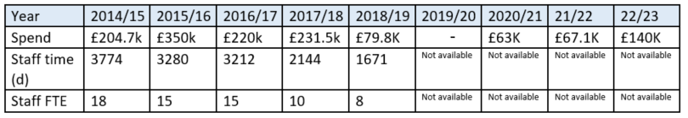

Figure 1. Number of protected area natural features assessed by Site Condition Monitoring (SCM) and site-check (1992-2022)

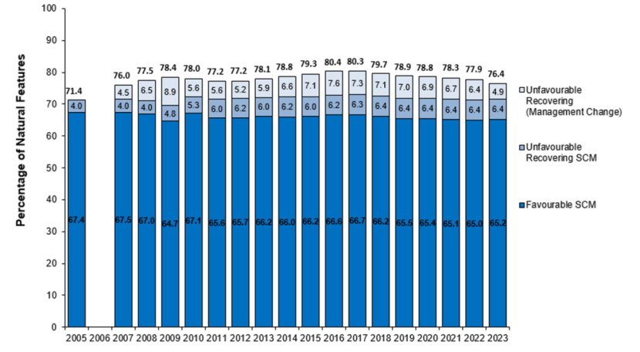
Figure 2. The percentage of natural features assessed as favourable or improving (as a result of assessment or management regime) 2005-2023.

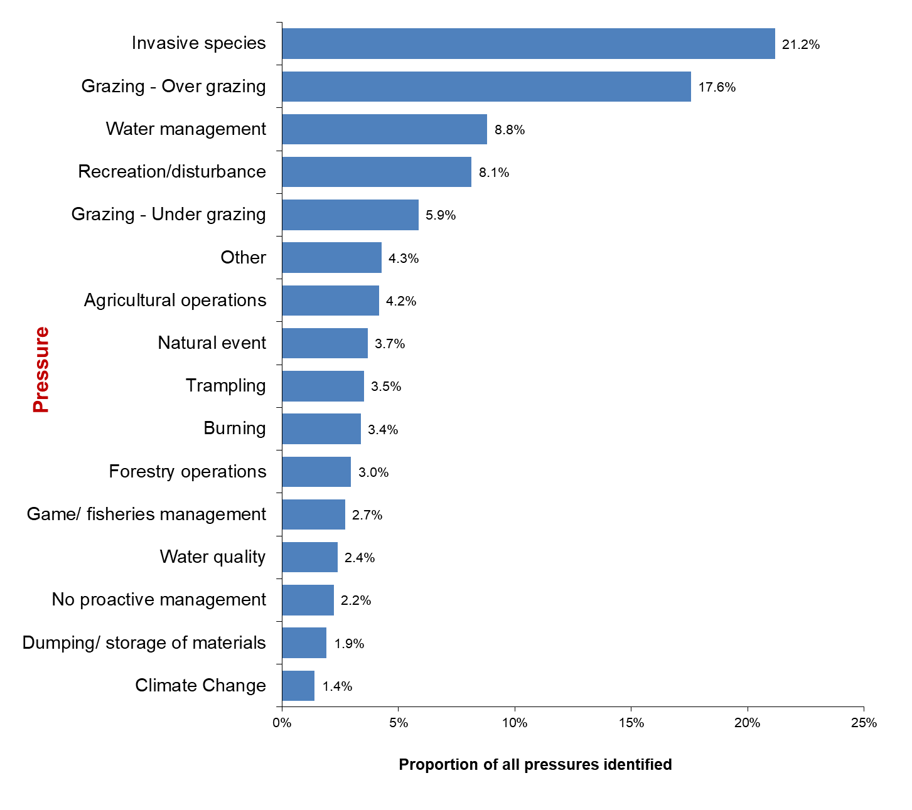
Figure 3. Recorded pressures on protected areas expressed as a percentage of all pressures identified

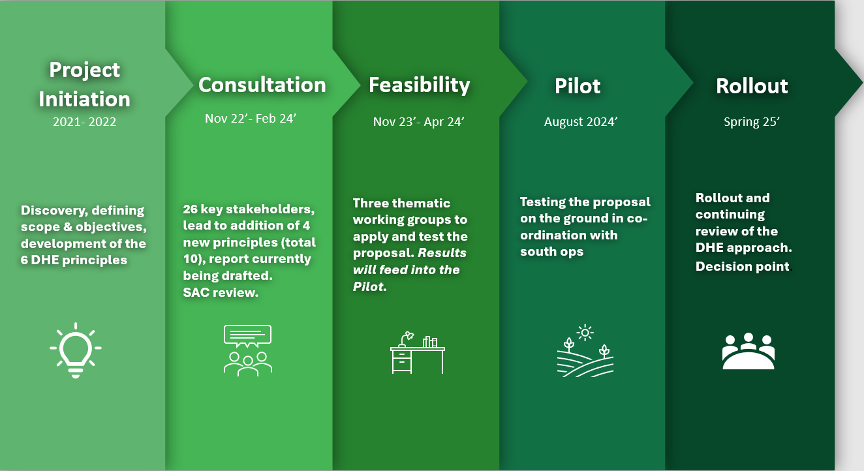

Figure 4. Monitoring to Deliver Healthy Ecosystems (DHE) work programme

Condition categories: Favourable (Maintained/Recovered/Declining), Unfavourable (No Change/Recovering/Declining), Destroyed (Partly/Totally)
‘Ensure and enable that by 2030 at least 30 per cent of terrestrial, inland water, and of coastal and marine areas, especially areas of particular importance for biodiversity and ecosystem functions and services, are effectively conserved and managed through ecologically representative, well-connected and equitably governed systems of protected areas and other effective area-based conservation measures, recognizing indigenous and traditional territories, where applicable, and integrated into wider landscapes, seascapes and the ocean,….’

