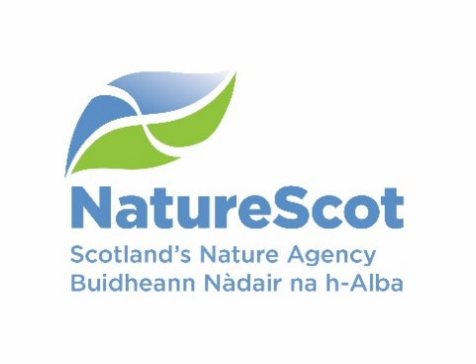
Licence application form – to kill brown hares

The Wildlife and Countryside Act 1981 (as amended)

If you need assistance filling in this form please contact the NatureScot Licensing Team:

Email: licensing@nature.scot Telephone: 01463 725364

Please answer all relevant questions fully and do not defer to other attached documents.

Who should use this application form

All persons seeking to kill brown hares during the close season in order to prevent serious damage to crops, vegetables, fruit or growing timber. The close season for brown hare is 1st February to 30th September;

All persons seeking a licence, whether applying for the first time or re-applying for a licence that has expired.

All new applications are referred to NatureScot Wildlife Management Officers for advice, and may require a site visit. If so a NatureScot Wildlife Management Officer will contact you to arrange this.

Submission of licence returns

If you have previously held a licence and wish to apply for a new one, you must submit a licence return for your expired licence before we can process your new application.

Amendments to existing licences

If you wish to amend a current licence please email NatureScot Licensing Team citing the licence reference number, the details you wish to change, and the reasons for this change. If your amendment request involves significant changes we may seek advice from NatureScot Wildlife Management Officers and / or advise that you need to fill in a new application form.
Section A: Licence holder details
Please provide the name and address of the licence holder, this person will be legally responsible for ensuring that all licence conditions are met and for submitting a return to NatureScot Licensing Team at the end of the licence period.

Contact details required | Provide required information below
Title
First name
Surname
Email address
Address
Postcode
Contact telephone number(s)
Type of address | Home ☐  Work ☐
Applicant details | Land owner ☐  Land manager ☐  Land Agent / Factor ☐  Tenant ☐

Section B: Licence details

Licence details required | Provide required information below
Site name (where impact is occurring)
(this is how your application will be referred to in all future correspondence)
Address (please include the full postal address of the farm/location if different from Section A)
Farm CPH number if relevant
Six figure grid reference
(e.g. NX100200)
Proposed start date | Click here to enter a date.
Proposed end date | Click here to enter a date.
Date you require your licence  (i.e. date when you need confirmation that a licence will be issued to allow preparation for the works) | Click here to enter a date.
Is the works area covered by a nature conservation designation & if so, what is it called? (e.g. give name of affected Site of Special Scientific Interest, Special Protection Area, Special Area of Conservation etc.) – see our website for site locations and information)

Section C: Activities to be licensed
Provide details below of where damage is occurring, crops being damaged and numbers of brown hares causing damage. Your application must be accompanied by a map or diagram showing fields or areas where damage is occurring.

Crop/plantation type | Age of Trees (if applicable) | Field/area identifier (if known) | Approx area in hectares | Approx number of brown hare causing damage | Number to be taken/killed

Section D: Licence purpose

Describe the damage caused and/or potential damage by brown hares and describe the evidence that this damage is or will be caused by hares (include area/volume of crops damaged or lost, approximate number of hares present, where and when the damage occurred or is likely to occur).

Describe how the number of brown hares to be shot has been determined.

Provide details of what measures you have taken to prevent serious damage by brown hares (include details of all scaring or preventative methods used and their effectiveness, and numbers of any hares shot during the open season).

Section E: Required documents checklist

Confirm by ticking the box below that all the information we require to assess your licence has been submitted with your application.

A location map of the property showing the area (i.e. field, area of woodland) where serious damage is occurring. The scale of the map must be at least 1:50,000.

Evidence of damage occurring if applicable (e.g. photos).

Section D: Declaration

- I understand that it is an offence under Section 17 of The Wildlife and Countryside Act 1981 (as amended) to knowingly or recklessly provide false information in order to obtain a licence, and I declare that the particulars given in this application and any accompanying documents are true and accurate to the best of my knowledge and belief, and I apply for a licence in accordance with these particulars.

- I understand that failure to comply with any conditions included on any licence granted in respect of this application may constitute an offence.

Date: Click here to enter a date. | Print name:  Electronic signature:

Submitting your application form

This application should be submitted by email by the licence holder as named on this licence application (in which case please print name above and a signature is not required). If this application is not submitted by the licence holder, the electronic signature of the licence holder must be inserted above, and they must be copied in to the submission email. Please email the completed application form, together with all supporting information, to: licensing@nature.scot

Please do not send zip files as these may be blocked by our security system and not received.

Once we have received your application, you will receive an automated email acknowledging this. Please quote the reference number given in the email if you need to contact us in relation to your application.

If you do not have access to email, you can print out and send your application and supporting information to the postal address below. Please note if you apply by post you will not receive confirmation that your application has been received.

Licensing Section
NatureScot
Great Glen House
Leachkin Road
Inverness
IV3 8NW

How we adhere with the Data Protection Act and the Scottish Regulators' Strategic Code of Practice

