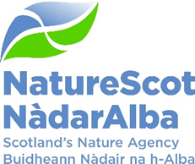

Preparing a Scottish Biodiversity Metric
13th March 2024

Purpose: | Discussion
How does this link with our corporate priorities of improving biodiversity or delivering nature-based solutions to climate change: | Our work to develop a biodiversity metric, in support of NPF4, directly contributes to:  - Protecting Nature – influencing planning and other regulatory systems, delivering effective planning advice (inc. supporting renewables and peatland restoration).  - Restoring Nature – delivering a SBS action, supporting delivery of land management outcomes.  - Valuing Nature – informing SG’s wider policy framework on use of metric’s across a range of policy areas (inc. nature finance).
Summary: | This paper outlines the issues associated with developing a Scottish biodiversity metric for the planning system and the links this has with our wider work.
Actions: | To consider and discuss the links between the SG commission and our wider work; the challenges likely to be faced in successfully delivering this commission; and the opportunity for NatureScot to position itself at the centre of the debate on planning’s role in delivering enhancement.
Recommendations: | Board is asked to consider and agree:  - the increased expectations on the planning system to contribute positively towards tackling the nature crisis, and the opportunity this provides for our work;  - the important role that an appropriately designed Scottish Planning Metric will play in supporting delivery of NPF4, and the linkages this has with other priority work; and  - the nature of the task in hand and challenges to its successful delivery.
Report Author(s): | Simon Brooks (Strategic Planning Manager) with input from Ben Ross, Kath Leys, Darren Hemsley, Peter Hutchinson.
Sponsor: | Robbie Kernahan
Appendices: Please note all appendices. | Appendix 1 – Scottish Government commission

Purpose
- This paper informs the Board of our work supporting delivery of new national planning policy, in particular to develop a Scottish biodiversity metric applicable to the planning system. The links between this work and other priorities, and the opportunities and challenges for us in delivering the commission are discussed.
Background
- NPF4 places the twin climate and nature crises at its heart, and identifies improving biodiversity as one of its key themes. This reflects in part a new statutory requirement for the national planning framework to contribute to a set of six national outcomes, one of which is “securing positive effects for biodiversity”.
- Key to delivering this is NPF4 Policy 3, which rebalances the planning system by shifting the approach from simply accepting the residual impacts of development that deplete nature, to one where development is now required to enhance biodiversity. This is to be achieved through placing a general requirement for all development to contribute to the enhancement of biodiversity, with stricter and more ambitious requirements placed on more significant developments by Policy 3(b). For the latter (national, major and EIA development), applicants are required to demonstrate enhancement using qualitative or quantitative best practice assessment methods, but the specific approach is for the applicant and planning authority to decide.
- In the absence of an established Scottish method or tool, a range of approaches including variations of England’s ‘Defra metric’ (developed to deliver ‘biodiversity net gain’ under England’s planning system) are being applied. SG have recognised that this could lead to confusion and potentially conflicting outputs depending on the particular methodology utilised, and undermine delivery of NPF4 outcomes. As a result, in December they commissioned NatureScot to develop a biodiversity planning metric suitable for use in Scotland, applicable to national, major and EIA developments.
- Despite the absence of a metric, and pre-NPF4, some developers were delivering biodiversity enhancement voluntarily (policy encouraged such actions). But what was delivered, and how much, was determined on a case-by-case basis, and it is not always clear that a net gain will be achieved in practice.
England’s Metric
- It is recognised that any biodiversity metric can only ever be a simplification of what is a very complex and diverse system. England’s metric calculates ‘biodiversity units’ for different habitats as a proxy for measuring biodiversity. It does this by multiplying the area or linear extent of each different habitat by pre-determined multipliers for each of the metric’s components (the blue and yellow boxes in the diagram below).

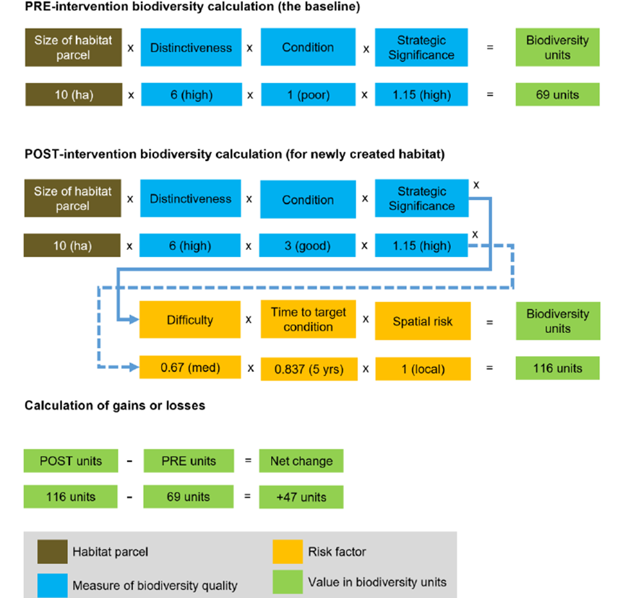

- This requires a competent person to identify the extent of different habitats within the site and assess their condition, and determine what habitats will remain, be enhanced or created in the future. Entering this information in the tool calculates the number of biodiversity units on the site at present, and what will be found post-implementation, taking into account the difficulty and uncertainty in creating or enhancing particular habitats, the time lag in reaching a defined condition, and a penalty to discourage off-site compensation in favour of on-site.
- Natural England have developed and piloted this metric through several iterations over a dozen-plus years. Its use became mandatory in England from 12th February 2024, but its voluntary application has already built up a body of experience and knowledge that we can learn from.
SG Commission to develop a Scottish Planning Metric
- In December 2023 Planning , Architecture and Regeneration Division (PARD) commissioned NatureScot to develop a Scottish planning metric suitable for use in supporting delivery of NPF4 Policy 3(b) within Scotland’s planning and related consenting regimes (commission is set out in Appendix 1). The finalised metric will be applied within existing policy (ie. its use will be one possible approach, not a mandatory requirement), to support rather than replace professional judgement and evidence based decision-making when consenting development. It will only apply to development on land (including inter-tidal), not the marine environment.
- The commission’s focus is on adapting England’s Defra metric, to better reflect Scotland’s different legislative, policy and environmental context, and supporting framework. The work will be informed by the findings of the 2023 SRUC review of approaches to measuring biodiversity (commissioned by The Scottish Government), and the experience of practitioners (planners, developers, land managers and NGOs) applying the Defra metric in Scotland.
- SRUC’s report included a deep-dive in to England’s metric and set out 14 recommendations to improve its fit with Scotland addressing:
- Omission - of Scottish data or a methodological gap that needs to be filled;
- Adjustment – to better reflect the Scottish environment and policy context; and
- Improvement – to strengthen the robustness and transparency of the metric.
- PARD have highlighted the need to take forward the work with key stakeholders, in particular the renewables sector (the work of the Peatland Expert Advisory Group will be important in this regard). It is planned to complete the work within a 12 month timescale (by January 2025), although there are unknowns with the complexity and scale of work that may be required on some components. The commission’s final outputs will be a Scottish Planning Metric tool (hosted on NatureScot’s website), supporting guidance and case studies, and set of recommendations for building capacity in its use and maintaining and updating the tool in the future.
Linkages across NatureScot’s work
- While the commission’s focus is on delivering a metric for the planning system, both the metric itself and the biodiversity enhancement that it facilitates has wider relevance across a range of our priority work.
- Scottish Biodiversity Strategy: NPF4 and specifically its role in enhancing biodiversity and the development of a biodiversity metric are recognised as key actions contributing to Objective 2 (Protect nature on land and at sea across and beyond protected areas).
- Nature Networks and 30x30: Enhancement delivered through the planning system has the potential to support delivery of Other Effective Area Based Conservation Measures (OECMs), to secure positive management on protected areas and improve connectivity between these sites (via Nature Networks). This will require the metric’s design to reflect and ‘reward’ such outcomes, while ensuring the principle of ‘additionality’ (ie. enhancements must be additional to existing requirements), is upheld.
- Nature Finance: A diverse range of metrics are under development (with or without public sector engagement) to enable private finance in nature and natural capital and the establishment of a biodiversity credits market. The distinct but complementary role that enhancement (required under the planning system in response to impacts), might play in this market is still emerging.
- Peatland Action: The metric’s design and how it calculates the enhancement required from upland development (primarily wind farms), has synergies and potentially important consequences for the delivery of the net peatland restoration outcomes (and enabling of onshore renewables development).
- Transforming agricultural support: The planning metric takes a more detailed and quantitative approach than the ‘scorecard’ approach under development in the biodiversity audit for farmers but there should still be complementarity between them
Challenges and Opportunities
- There are some challenges in progressing the work.
- Developing expertise: While Scotland is adapting a tried and tested English approach, NatureScot is yet to build the necessary depth of expertise in this area of work (building expertise will need to be shared more widely with other parts of Government). There are technical unknowns with the metric and uncertainties (particularly around engagement) in delivering this work that will require careful consideration.
- Managing expectations: Stakeholder expectations will vary, ranging from wanting a limited and quick tweak to England’s metric, to a fundamentally different approach. Our position is that England’s metric has limitations but nonetheless provides a robust approach that lends itself to relatively quick adaption (learn to walk before we run). We do not want to delay establishing a Scottish metric by requiring more prolonged fundamental changes, but do not rule out further adaptions in the future. Scottish Government will be keen to see progress that facilitates delivery of renewables and the On-shore Wind Sector Deal in particular
- Establishing a consensus: The commission will be closely informed by stakeholder views, and a consensus sought on the most appropriate approach. The renewables (onshore wind) sector have some specific concerns and already set out changes to England’s metric that they consider necessary that will require careful examination. Some of this will be addressed through the Peatland Expert Advisory Group (supporting delivery of the Onshore Wind Sector Deal).
- Wide-ranging engagement: Related to the above, we will need to ensure that a broad range of voices are heard in the metric’s development, beyond the renewables sector. Planning authorities are particularly stretched, and not all have the ecological expertise and / or metric experience to fully engage with this work. Housing developers have different objectives and controls over their development sites than large-scale renewables or linear infrastructure. Ensuring the range of development sectors can share their individual perspectives will be essential if we are to be confident that the approach established is applicable across a range of development types.
- Legacy planning: Looking ahead beyond the commission, we will need to consider options for supporting the roll out and capacity building needs required for successful implementation of the metric. This should not just be for NatureScot, but we will be expected to take a lead. Future maintenance, review and updating of the Scottish metric will also need to be considered, and the resources identified.
- Alignment: The metric commission is focused on delivering for the planning system, but should seek to build on and align itself where possible with the complex and rapidly evolving world of metrics emerging across a range of policy areas. This includes the relationship with established Carbon and Woodland Codes, contribution to SBS outcomes and future Environment Bill targets.

Nature Scot Positioning

- NPF4 provides a step-change in the planning system’s consideration of nature and climate. While built development and land-use change regulated under planning is not the most important driver of nature loss, nonetheless the new policy requirement to leave biodiversity in a better state than before the development should make a significant contribution towards delivering a nature positive future. The metric’s role in enabling this will depend on us delivering a metric that:
- works for Scottish Government – supporting delivery across policy areas;
- works for developers – enables a consistent and proportionate approach;
- works for planning authorities – reflecting their limited ecological capacity; and
- works for nature – steering delivery towards priorities, and avoiding ‘green-washing’.
- This work provides the opportunity for NatureScot to position itself at the centre of Scottish debate on a planning metric (some stakeholders appear supportive of us taking more of a lead) and nature metrics more widely. We need to consider our future role beyond this commission with regard to supporting use of the planning metric, continuing its development and monitoring its impact and compliance. Now is too early to start exploring future roles with SG and key stakeholders, but the Scottish metric could become another part of our mainstream planning work, and a core part of the toolkit delivering our priorities. This will require long-term resourcing.

Recommendations
- Board is asked to consider and agree:
- the increased expectations on the planning system to contribute positively towards tackling the nature crisis, and the opportunity this provides for our work;
- the important role that an appropriately designed Scottish Planning Metric will play in supporting delivery of NPF4, and the linkages this has with other priority work; and
- the nature of the task in hand and challenges to its successful delivery.

Appendix 1 – Scottish Government Commission

NPF4: Positive effects for Biodiversity – a Biodiversity metric for the Scottish planning system

Scottish Government wishes to commission NatureScot to develop a biodiversity metric suitable for use in supporting delivery of NPF4 policy 3b) in Scotland.

The commission will focus on adapting England’s Statutory Biodiversity Metric (hereafter ‘the English Metric’). The approach will build on existing experience of applying metrics to development proposals, particularly where this concerns the use and application of metrics within Scotland. Collaboration and engagement will be central to the approach.

Context
- NPF4
- The Town and Country Planning (Scotland) Act and associated Regulations
- Scottish Government Planning Advice and Circulars, where relevant and applicable.
- Scottish Government Draft Planning Guidance: Biodiversity (2023)
- Approaches to Measuring Biodiversity in Scotland’ (‘the SRUC report’)
- Onshore Wind Sector Deal
- Biodiversity strategy to 2045

A cross-government approach to measuring site level biodiversity

The Scottish Government is developing a cross-government approach that can inform the use of metrics in site level interventions, monitoring, and assessments to support the delivery of biodiversity outcomes. The type of measurement addressed will mainly focus at the site level. Initially in focus are terrestrial planning, biodiversity markets, conservation and agriculture.

- An overarching cross-government approach for measuring biodiversity across policy areas will be developed in phases led by a Biodiversity Metrics Framework Co-ordination group. This work will both be informed by and feed into this commission.

- The inception meeting for the Biodiversity Metrics Framework Co-ordination group will take place in December 2023 with further meetings to be arranged. NatureScot will be asked to attend meetings in an advisory capacity.

Supporting NPF4 Delivery:

A Biodiversity metric to support NPF4 delivery in the planning sector will be prioritised within the above wider Scottish Government metrics framework approach, and forms the purpose of this commission.

The respective planning systems in Scotland and in England utilise different delivery mechanisms in seeking to address the global biodiversity crisis.

In England legislative provisions requiring mandatory biodiversity net gain from development are due to come into force from January 2024, underpinned by the English Metric. In Scotland our Fourth National Planning Framework (NPF4) places climate and nature at the centre of the Scottish planning system. NPF4 policies should be read and applied as a whole. As a matter of law, all planning applications must be determined in accordance with the development plan, unless material considerations indicate otherwise. It is for the decision maker to determine what weight to attach to policies on a case by case basis, though NPF4 policy 1 is clear significant weight will be given to the global climate and nature crises when considering all development proposals. NPF4 will also be a significant consideration for other consenting regimes, including under the Electricity Act. A Scottish planning metric must be suitable for use within the Scottish Planning and consenting context as a tool to inform decision-making and will not replace the need for the application of professional judgement by the decision maker. The use and application of a Scottish Planning metric will be different to the use of the English metric.

This commission is specifically to support delivery of NPF4 policy 3b). This requires development proposals for national, major, or EIA development to demonstrate that the proposal will conserve, restore and enhance biodiversity such that it is in a better state than without intervention. NPF4 policy does not specify or require a particular measurement / assessment approach other than that ‘best practice’ methods are utilised. In the absence of an established Scottish tool, variations of the English Metric are already being utilised in Scotland. This could lead to confusion and there is potential for conflicting outputs depending on the particular methodology utilised. Ultimately this could undermine delivery of NPF4 objectives.

Onshore wind

Whilst a Scottish Planning metric will support delivery of a wide range of development proposals within scope of NPF4 policy 3b), the SRUC research identifies the need for particular consideration of proposals for onshore wind on peatland. The Peatland Advisory Expert Group (‘PEAG’) includes representatives from industry, academia and NatureScot and provides advice to the Scottish Government on matters concerning both our peatland and onshore wind aims. It is intended that PEAG will have opportunity to input to the development of a Scottish Planning metric applicable in this context.

Considerations in undertaking this Commission

- The benefit of an iterative and phased approach, which learns from and builds upon early pilots and / or modelling across a range of development types.

- The benefit of a transparent approach informed by early engagement with relevant stakeholders and of ‘advance signalling’ to industry regarding any future or proposed changes to practice in Scotland.

- Consideration will be given as to the benefits of producing technical advice on certain aspects of practice in advance of a Scottish Planning metric. This could for example include advice on the use of habitat classification systems, or more generally on the principles of practice which will apply to a metric and which can also support and inform best assessment practice in the interim.

- The benefit of early engagement with the Peatland Expert Advisory Group on matters concerning wind development on peatland and of the anticipated timing of group meetings (noting the group is currently due to conclude summer 2025).

- The benefit of developing training on the use and application of a metric.

- There is no statutory biodiversity credit scheme in Scotland. Off-site delivery of NPF4 policy 3 objectives will be within existing statutory frameworks. For a matter to be taken into account as a material consideration in a planning decision it must be relevant to planning and relate to the development proposed by the particular application under consideration.

Requirements
- The work will draw on the SRUC report and findings as well as existing practice and experience in Scotland, including – but not limited to – in the onshore wind sector. The Scottish Government and NatureScot will agree arrangements for convening an early discussion with key stakeholders to inform the work.

- The metric must be suitable for use within the existing Scottish statutory and policy planning framework. In particular, it is recognised that the use and application of a Scottish Planning metric will be different to that of the English Metric given the differing policy and regulatory context in Scotland.

- Work will be informed by early pilot approaches and / or modelling across a range of development types, including onshore wind and housing.

- Draft outputs will be subject to public consultation before they are finalised.

- Written outputs will acknowledge intellectual property considerations relevant to the English metric in accordance with advice from DEFRA. Annex A refers.

Outputs

- A Scottish Biodiversity metric which is:-

- based on current understanding of science and evidence
- clear and transparent in its workings
- accessible and easy to use by planners, ecologists and other relevant professionals, with outputs which can be clearly understood by decision makers
- a tool to inform both the siting and design of development proposals, as well as robust, evidence based decision-making by planning and consenting authorities.

- A user guide to accompany the metric: Where principles which will form part of the guide can usefully be made available in advance, these will be published in phases to support interim best practice assessment.

- Recommendations on any requirements for maintaining and updating the metric and supporting information.

Governance and oversight
- A steering group will be established comprised of Scottish Government and NatureScot. This will meet monthly or as mutually agreed.

- Additional input will be requested where appropriate, for example from the Biodiversity Technical Advisory Group (TAG), the Peatland Expert Advisory Group, and / or with wider stakeholders as required. It is anticipated that engagement with Heads of Planning Scotland will be through TAG and will include consideration of skills and capacity building / training opportunities.

Process and Timeline
 | Milestone | date
 | Commission agreed and accepted | Winter 2023
 | NatureScot to submit outline project plan to Scottish Government. This will address:  - the scope and phasing of work, including any matters to be excluded or deferred;  - the approach to stakeholder engagement; and  - how and where information including guidance will be made available. | December 2023
 | Submission of detailed project plan for agreement with Scottish Government. This will prioritise  - Matters on which input from the Peatland Expert Advisory Group will be beneficial and the timing of that input.  - Matters which will benefit from early clarification and the development of a common approach to best practice assessment in advance of a Scottish Planning metric | January

Statutory biodiversity metric tools and guides and The Biodiversity Metric Supporting Documents (JP039) (naturalengland.org.uk)
The Technical Advisory Group (TAG) includes members from CIEEM, RTPI, Improvement Service, and Heads of Planning Scotland.

