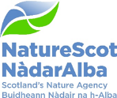

Bargeny Hill SSSI – confirmation of the SSSI designation

7 February 2024
Purpose: | Decision.
How does this link with our corporate priorities of improving biodiversity or delivering nature-based solutions to climate change: | SSSI notification is one of NatureScot’s key statutory functions. When there has been an objection, the decision on whether to confirm a notification is made by the Board, following a recommendation from the Protected Areas Committee (PAC).  Designation of Bargeny Hill SSSI seeks to protect a nationally important example of unimproved lowland neutral grassland, and therefore contributes to our corporate plan priority of protecting nature by expanding protected areas.
Summary: | Bargeny Hill SSSI, located just west of Torrance, East Dunbartonshire, was notified on 9 March 2023 to protect 5.4ha of lowland neutral grassland that is considered of national importance.  Following notification, one of the site’s two landowners submitted a scientific objection to the inclusion of his land within the SSSI. The same landowner also undertook unconsented operations (ploughing) on the day of notification, and further unconsented operations during the following days or weeks, causing damage to the feature.  Having sought independent expert advice on the condition and restorability of damaged land, the Protected Areas Committee (PAC) recommend that the SSSI is confirmed to include almost all of the objector’s land, with the exception of a small area of hardstanding at its southern boundary.  NatureScot has until 9 March 2024 to confirm, modify or withdraw the SSSI notification, taking into account the scientific objection received and the expert advice sought by the PAC.
Actions: | Decide whether or not to confirm the SSSI.
Recommendation: | It is recommended that the SSSI notification should be confirmed with a minor modification to exclude an area of hardstanding from the SSSI boundary.
Report Author(s): | Andy MacGregor
Sponsor: | David Johnstone (Chair of PAC)
Appendices: | Annex 1 – Overview and detailed maps of the SSSI with the objector’s land shown in context.  Annex 2 – Map of land (yellow) proposed for removal from SSSI before confirmation.

Purpose
- This paper asks the Board to decide whether to confirm the Bargeny Hill SSSI where there has been a scientific objection to inclusion of part of the land.

Background
- Bargeny Hill SSSI is a 5.4ha meadow near Torrance in East Dunbartonshire, and comprises one of the best remaining examples of lowland neutral grassland in south-western Scotland. Especially on the upper slopes, the site supports flower-rich vegetation typical of grassland on neutral, moderately nutrient-poor soils. A good variety of orchids is present, including the threatened greater butterfly orchid as well as northern marsh orchid, common spotted orchid, twayblade and broad-leaved helleborine. The lower slopes support areas of fen meadow and mire which add interest to the site.

- The maps forming Annex 1 show the location of the SSSI and the land belonging to the objector.

- The SSSI was notified to interested parties, including its two landowners, on 9 March 2023. Unless extended, the 12-month period for confirming or withdrawing the SSSI will end on 9 March 2024.

- The notification had been brought forward (from an original planned date during the week beginning 13 March) following a meeting on site on 8 March 2023 between NatureScot staff and the objector, during which he threatened to damage the site by ploughing.

- The objector did undertake agricultural operations (shallow ploughing, or disc harrowing) without NatureScot consent on the date of SSSI notification (9 March), and it appears that further unconsented operations took place after that date, including rotovation, application of lime and herbicide, and possibly reseeding with grass/clover.

- On 9 June 2023, the objector submitted a scientific objection to the inclusion of his land within the SSSI, supported by a botanical survey commissioned by the objector. Detailed consideration of the objection is provided below (paras. 12-18).

- No other representations were received from notified parties.

- Following initial consideration of the scientific objection, the Protected Areas Committee decided to seek independent advice on the condition of the objector’s land within the SSSI and the potential viability of restoring the protected natural feature (lowland neutral grassland) in the damaged area. To that end, the PAC appointed consultant ecologist, Professor Robin Pakeman of the James Hutton Institute, who visited the site on 21 July 2023 accompanied by the PAC Chair. During this visit Prof Pakeman was able to assess the condition of the land and speak to the objector about recent management activities.

- Prof Pakeman found evidence of extensive ground disturbance (rotovation), application of lime and herbicide but no evidence of reseeding across the western field. The result has been a substantial reduction in botanical species-richness in the field, broadly confirming the findings of the survey commissioned by the owner.

- Prof Pakeman concluded that, despite the extensive damage and loss of botanical diversity in the remaining sward, it would be possible to restore semi-natural grassland vegetation; mostly likely (and most swiftly) with targeted management including appropriate levels and timings of grazing combined with the spreading of wildflower seeds in hay gathered from the undamaged part of the SSSI.

The objection to the designation
- The objection letter was submitted alongside a report prepared by consultants for the owner describing the findings of a grassland survey carried out on 7 June 2023.

- The objection letter of 9 June 2023 made three key claims as follows, with commentary from NatureScot staff following in plain text:

Claim 1 - The SSSI designation relies on survey data that is outdated and does not reflect subsequent changes in land management.

- It is true that the case for SSSI designation rests primarily on a site survey carried out in 2014 by our then grassland advisor, Jane Mackintosh. However, Area staff did visit the site more recently, including in 2021 and 2022, to check that there had not been a loss of scientific interest in the intervening period as there had been some concern that infrequent or insufficient grazing might have promoted development of scrub or a rank, species-poor sward; neither of which had occurred.

Claim 2 – The vegetation has changed due to farming practices so that the land no longer supports the habitat and species for which it was designated.

- The reports commissioned by the objector and the PAC both confirmed major changes to ground cover and vegetation from those present prior to notification, resulting from a variety of recent management interventions including rotovation, liming, reseeding and application of herbicide. The effect is substantial loss of the special interest.

- It is clear that the current condition and composition of the vegetation largely reflects land management activities undertaken on or after the date of SSSI notification. The findings of the June survey commissioned by the objector therefore do not bear on the question of whether NatureScot was right to include the land within the SSSI based on the character of the vegetation as it was at the time of notification. Based on NatureScot’s assessments, the land in question was of SSSI quality at the time of notification and was therefore correctly included within the boundary of the SSSI.

- Furthermore, it is the expert view of Prof Pakeman that the damaged land is capable of being restored to a quality suitable for retaining within the SSSI. NatureScot staff therefore consider that the land should be retained within the SSSI at such time that the notification is confirmed.

Claim 3 – NatureScot has failed to adhere to its balancing duty to take into account the social and economic interests of the landowner.

- NatureScot has a duty to notify interested parties where land is of special interest. Its decision whether land is of special interest must reflect scientific judgement alone, and socio-economic factors cannot be taken into account when deciding whether to designate a SSSI. The balancing duty therefore does not apply in this case.

PAC meeting with the objector
- The PAC met on 11 December 2023 to review the case for the SSSI notification, including the objector’s written objection and evidence, and the evidence of their own commissioned report from Professor Pakeman. The objector was invited to attend this meeting so that the PAC could hear and understand his concerns.
- The objector attended along with his representatives, and they presented both scientific and non-scientific reasons for opposing the designation. Amongst other issues, the objector raised concerns about the designation’s impact on his ability to manage his land agriculturally, and NatureScot staff noted that agricultural management (chiefly grazing) is crucial to maintenance of species-rich grassland, albeit that such management needs to be undertaken sensitively.
- There were some differences between the objector’s and Nature Scot staff’s recollection of events leading up to the SSSI notification and around the damage caused to the site by agricultural interventions.
- Having reviewed the evidence and heard from the objector, the PAC agreed to recommend to the Board that the SSSI be confirmed, noting that NatureScot staff would have the task of securing the site’s restoration and engaging with the owners over future sympathetic management.

Conclusions/Recommendations
- In light of the scientific objection and related surveys, the PAC considered three options in relation to confirming the SSSI notification: (1) confirm the SSSI without modification; (2) confirm the SSSI with modification to the boundary to remove some or all of the objector’s land; or (3) withdraw the SSSI notification.

- At the time of SSSI notification, the land belonging to the objector supported lowland neutral grassland of special interest, as does the remaining land within the SSSI which belongs to a neighbouring landowner. The objector’s land was therefore correctly included within the SSSI.

- Although most of the objector’s land has been substantially damaged by unconsented agricultural operations, expert advice from Prof Robin Pakeman was that the damaged parts of the SSSI’s protected feature are restorable with reasonable and achievable management interventions.

- Since the objector’s land was of special interest when notified as part of the SSSI, and since the subsequent damage is considered restorable, there appear to be no grounds for removing those areas from the SSSI. The PAC therefore recommends that the SSSI should be confirmed to include the majority of the objector’s land.

- However, there is a small (<0.1ha) area of hardstanding at the southern boundary of the objector’s land which does not support the protected natural feature. This area is shown in yellow on the map forming Annex 2. Although the hardstanding has been created during the last two or three years, NatureScot staff consider that the land affected never supported part of the SSSI natural feature (lowland neutral grassland), but instead formerly supported species-poor semi-improved grassland. It was nonetheless included in the SSSI when drawing the boundary to the most readily identifiable physical boundary feature (the fence). However, a revised boundary could follow the edge of the hardstanding to exclude this area from the SSSI. Removing it from the designation would avoid needless bureaucracy around ongoing management proposals here, while also underlining the scientific nature of the decision over which land to include within the SSSI.

- The PAC therefore recommends that the SSSI notification should be confirmed with a minor modification to exclude the area of hardstanding from the SSSI boundary.

Annex 1 – Overview and detailed maps of the SSSI with the objector’s land shown in context.
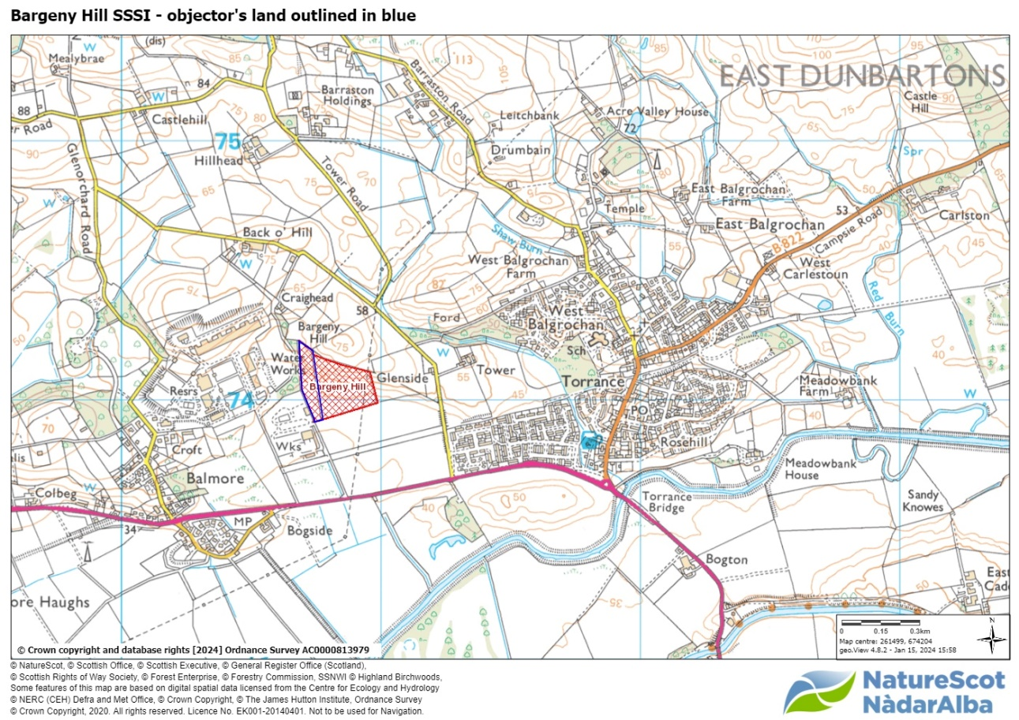
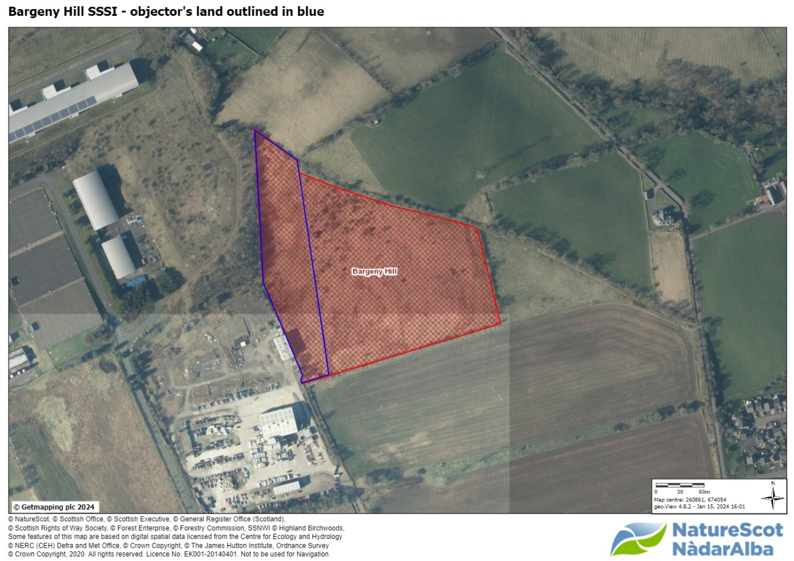

Annex 2 – Map of land (yellow) proposed for removal from SSSI before confirmation.

