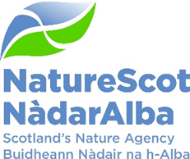

Title: Q3 Performance Report 2023/24
Date: 7th February 2024
Purpose: | Decision
How does this link with our corporate priorities of improving biodiversity or delivering nature-based solutions to climate change: | This paper presents Q3 progress towards delivery of our corporate priorities as laid out in our Business Plan, A Nature-rich future for all: Year 2.
Summary: | At the end of Q3, performance for 13 of our 15 Corporate plan objectives is rated as ‘on track’. Our Resource and Capital budgets are currently expected to outturn within tolerance at year end. There is minor slippage on overall Indirect Capital and we are continuing to manage and monitor the larger programmes to ensure that full budget spend is achieved. There was some movement in our corporate risk scores during the quarter. Risk “393 – Future Funding of NatureScot” increased from high to very high given uncertainty of outlook during November but this has now reverted to high following the Budget announcement. In the People Report, three of the seven indicators are green and four are amber.
Actions: | To agree the recommendations below
Recommendations: | The Board is asked to approve:  - The overall performance of the Corporate Plan objectives (Performance Report)  - The position of the resource and capital budgets (Finance Report)  - The performance of the corporate risks (Risk Report)  - The overall performance of the People Measures (People Report)
Report Author(s): | Authors – Directors, Deputy Directors, Outcomes Managers, Finance, Planning & Performance Team, People & OD Team
Sponsor: | Stuart MacQuarrie, Jane Macdonald
Appendices: Please note all appendices. | Annex A – Corporate Risk Register (High Risks)

Purpose
- This paper presents NatureScot’s performance for the third quarter of 2023/24. It addresses delivery of our corporate priorities by reviewing; the alignment of performance against our Business Plan, a Nature-rich future for all: Year 2; progress towards maximising our available budget; assessing risks for delivery; and people information supporting the resourcing of our work. These all support the delivery of our Corporate Plan 2022-26, A Nature-rich future for all.

Summary
Q3 highlights:
- We assessed 148 cases through the Agri-Environment Climate Scheme (AECS). The total area of the cases recommended for approval is approximately 129k hectares which represents around 2% of the total land area of Scotland. Their value is £6,051,837 if approved in full which would represent an excellent investment. 117 cases are recommended for approval pending SG funding decision and cases that end up below the threshold score will only get approval for designated site elements.
- We worked with Scottish Government to launch a major consultation on the Strategic Biodiversity Framework opening on the 7th September with a closing date of 14th December, this included:
  - The Scottish Biodiversity Strategy, setting out our vision to halt and reverse biodiversity loss;
  - First five-year Delivery Plan, containing the 150 actions to deliver the vision; and
  - Proposed Natural Environment Bill, providing a framework for establishing statutory nature targets to drive delivery and the transformational change we need.
- Looking ahead, a major analysis of SBS Consultation responses will be contracted out, but NatureScot will be sighted on and advise on the detail. The final SBS and Delivery Plan is earmarked for publication in ‘late spring’. Further post-consultation engagement is planned to reinforce the links between the climate and nature crises, follow-up on key issues, reach out to voices we haven’t heard much from and identify lead delivery partners.
- National Parks – we assisted Scottish Government with the organisation and delivery of a technical workshop attended by over 60 people from over 10 nominating groups and relevant public bodies. Next quarter we will focus on assisting with appraising the nominations.
- Nature Restoration Fund - Transforming Nature projects offered for assessment included multi-year projects on the Peffery catchment near Dingwall and on the Aline catchment in Wester Ross including restoration of the oyster beds in Loch Aline. Other projects being finalised include large Atlantic rainforest project and upland landscape scale habitat restoration. Half of the winners and highly commended projects at the Nature of Scotland awards in November received funding from the Nature Restoration Fund.
- We have been working closely with the Scottish Government Wildlife Policy and Bill team leads to take forward secondary legislative provisions on changes to the deer male close season order provisions and the firearm order provisions which will permit the use of image intensifying equipment. These provisions were enacted in Q3. The policy memorandum for the primary legislation provisions is well developed with a consultation on Bill provisions due to be launched by SG in early Q4. NatureScot will lead work throughout the 12 week consultation period to engage stakeholders in the emerging provisions.
- The wildlife Management and Muirburn Bill has progressed through stage 1 reading with the evidence sessions on muirburn and grouse licencing having taken place. The Bill will progress through stage 2 in Q4 which will again require close engagement with SG colleagues as amendments are considered. We have initiated work on the two codes of practice on grouse and muirburn with stakeholder groups formed and development is under way. Wildlife and muirburn Bill provisions move NatureScot into a more regulatory role with additional licensing provisions for grouse, muirburn and trapping. The Bill introduces a licensing scheme for the use of specific traps to catch wild birds and animals, which will require people to complete an approved training course.
Forward Look
- This Q3 report reflects substantial achievements by staff throughout NatureScot to progress a range of complex issues at pace. Q3 also saw a great deal of work preparing scenarios for possible budget settlements and a series of detailed discussions with Scottish Government colleagues. NatureScot’s budget settlement has provided us with the resources for 2024/25 to maintain our focus on delivering our priorities. Work in Q4 will draw on input from across the organisation and from our wider partners to ensure that we are continuing to deliver on the right priorities and within the resourcing envelope we have for this year and for the years beyond. We are mindful that the progress and pace we have achieved in Q3 does rely on capacity, not just within NatureScot, but also within our partner organisations and the Scottish Government. We have noted the resourcing constraints elsewhere following the budget settlement and will seek to manage the risks to our own delivery plans accordingly which may, in places, not progress as swiftly as we might anticipate.

PRIORITY PERFORMANCE | NUMBER | CORPORATE RISK | NUMBER
Objectives | 15 | Corporate Risks | 10
On Track | 13 | Increased Score | 0
Minor Slippage | 2 | Decreased Score | 0
FINANCIAL METRICS | STATUS | PEOPLE METRICS | STATUS
Resource Budget | GREEN | Wellbeing | AMBER
Capital | GREEN | Pulse Survey | AMBER
Indirect Capital | AMBER | Capacity | AMBER
Paybill | GREEN | Development | GREEN
Project Allocation | AMBER | Workforce Profile | AMBER
 |  | Internal Movement | GREEN
 |  | Retirement Profile | AMBER

PERFORMANCE REPORT

WE HAVE PROTECTED NATURE
CORPORATE PLAN OBJECTIVE | SLT LEAD | RAG SCORE | Q3 UPDATE
Lead the delivery of 30% of land and sea being protected by 2030 | Nick Halfhide | GREEN | Commenced work with Natural Environment (NE) Bill team over Protected Area legislative changes.  - Team supporting development of draft Policy instructions for NE Bill Protected Area reform largely completed by end of Quarter.  Commenced spatial data analysis to support 30x30 and Nature Networks  - This work has commenced and staff are in post for this work.  Commenced development of Nature Networks tool and toolbox  - Toolbox draft launched on NatureScot website, Nature Networks tool in development and on target currently working with 5 local authorities to produce LA level maps.  National Parks: Support Scottish Government and provision of expert advice during nominations phase (Commencing October)  - Organisation and delivery with Scottish Government of a technical workshop attended by over 60 people from more than 10 nominating groups and a number of relevant public bodies.
Build stronger collaboration reducing the impacts of deer and modernise our wildlife management and underpinning licencing functions to enable a net zero and nature positive future | Robbie Kernahan | GREEN | Deer  - Secondary legislation on image intensifying scopes and firearms order amendments have passed through parliament and been enacted. Corresponding Best Practice Guidance has also been developed and published. The primary legislation consultation is due to start in early Q4 so significant work done with SG to outline the new measures to be taken forward to enhance NatureScot regulatory functions alongside other Deer Working Group recommendations.  - Internal assessment approach developed to assess, quantify and identify Deer Management Groups (DMGs) / sites with deer density >10/km2 with damage to public interest and loss of confidence in effective Deer Management Plan (DMP) delivery. Triage approach will allow linkage with priority areas identified through the Operational Delivery Workstream (ODW). Regulatory planner to consider tools of Section 6,7,8,10 to seek resolution whist giving consideration to application, appropriateness and legal position and resourcing required. Through ODW and priority site subgroups work with partners in Forestry and Land Scotland (FLS), Scottish Forestry (SF), Loch Lomond & The Trossachs National Park (LLTNP) and Cairngorm National Park Authority (CNPA) to develop action plans for Alliance for Scotland's rainforest areas - Morvern and Appin areas, LLTNP, Central Scotland Priority Zone and CNPA. Current s7 in Caenlochan progressing on track, progression of s8 for Loch Choire has been agreed by the Board and will be progressed for Ministers approval, review of North Ross s7 April 2024. S10 action for Strathnaver pending and scoping for Northern DMG for 6A / s7 route underway.  Licensing  - Hunting with Dogs guidance published and Act commenced in November. Good progress on turnaround of all licencing applications with almost full staffing complement now in place. Data on licensing types, species taken or killed has been published via NatureScot web page. Deer online licensing is on track for delivery by end Q4 and route map for online licencing has been produced. We have supported SG colleagues and provided the Rural Affairs and Islands (RAI) committee with advice on Wildlife and Muirburn Bill at stage 1 – work on the associated Grouse shooting and Muirburn codes has been taken forward with stakeholder working groups engaged in the process.  - Beavers - We published the Strategic Environment Assessment (SEA) post adoption reports for the Beauly and Spey catchments and worked with Protected areas on the Habitats Regulations Assessment (HRAs). We worked with CNPA, FLS and RSPB Scotland to issue 3 beaver wild release licences. We supported land managers through the application for beaver licences and continue to do so for the few remaining licences that are expiring. We reviewed and implemented beaver licensing changes. We have supported Scottish Beaver Advisory Group (SBAG) that met in October and all the sub-groups have met or have meetings arranged for January.  - Geese and Sea Eagles - submitted goose policy review to ministers and took forward work on both schemes. Contentious casework progressed with SG and Rural Payments and Inspections Division (RPID) colleagues.  - SLT discussed paper on Scottish INNS Plan in October and provided a steer on scope, governance and resourcing. Met with SG Biodiversity Team towards the end of November and agreed for arrangements for a scoping workshop in early 2024.
Engage and influence planning and other regulatory systems to ensure they deliver for nature and climate | Robbie Kernahan | GREEN | - The initial pilot and business case for InformedDecision was completed and presented to SLT in November. SLT were broadly supportive of the approach but had further questions associated with costs and staffing requirements. A decision was made to seek further information and consider in light of confirmation of our budget settlement in December.  - Development Management pressures have been managed within existing tolerances during this quarter but feedback from operations colleagues indicates current pressures may be difficult to manage in the longer term.  Consultation type Total received in Q3 2023/24  Planning application consultations 131  Section 36 of Electricity Act 35  Section 37 of Electricity Act 9  Marine licence 57  Forestry 70  Controlled Activity Regulations (CAR) 2  Pre-application consultations 112  All of the above cases will be targeted at issues of potentially national interest (designated sites etc) as detailed in our guidance. Of the cases responded to during the period (which differs from received) the responses break down to 5 Outright Objections, 28 Conditional Objection and 31 Holding Objections with the bulk of other responses providing advice or Sites of Special Scientific Interest (SSSI) section 12 consents.  Everything for Earraghail is just being mobilised now, and there is no movement yet on other specific Inquiries.  - Development planning work has been focused on preparation for local development plan evidence reports and the planning team leading our efforts on the Key Agencies Group Collaborative Offer pilot on local development plan spanning 6 local authorities.
Influence the transformation of marine management through new marine planning, protection and fisheries management frameworks, and working with the marine renewable energy sector | Nick Halfhide | GREEN | Marine and coastal science  - Supported three bids to UK Research and Innovation (UKRI) 'resilient coastal communities and seas' call and two bids to a sister 'Network Plus' call.  - Evidence-Needs document - further development work progressed including discussions with specialist teams, but this will continue in Q4 to align with wider corporate Strategic Evidence-Needs document and Areas of Research Interest  Marine survey & monitoring  - Initiated survey pilot with Fishermen's Association; piloted ecosystem health approach; and finalised Wester Ross Marine Protected Area (MPA) monitoring and South Arran MPA comparative analysis  Marine data, reporting and assessment  - The Scottish Marine Biodiversity Data Review (SMBDR) implementation group reconvened. Marine Recorder migration of data ongoing and set to spill into Q4 due to error resolutions required. Completed work to identify marine species and habitats for inclusion in Marine and Terrestrial Species Indicators  Enhanced protection  Discussions continue with Marine Directorate (MD) on policy for community-led enhanced marine protection  MPA & Priority Marine Feature (PMF) management  - Worked with MD to scope inshore assessments (Habitats Regulations Assessment & MPA Assessments) and supported fisheries stakeholder meetings. Supported MD to commence finalising UK Dolphin and Porpoise Strategy and contributed to updating draft of the Scottish Seabird Conservation Strategy  Marine enhancement  - Supported MD to progress marine enhancement and restoration guidance and policy, e.g. scaling up and nature positive requirements. Exchange mechanism and Library of conservation measures contracts out to tender (MD lead, we are supporting)  Marine Fisheries Management  - This work was postponed by MD and we will now be providing input in Q4  Marine energy  - Advice provided on West of Orkney –  - Holding objection and advice provided on additional information provided on both Berwick Bank and Green Volt applications  - Ongoing pre application advice provision.  - Escalated engagement with SG for response to resourcing request.  - Increased engagement on strategic and legislation led work including Sectoral Marine Plan and Scot Gov delivery of UK Energy Act provisions  Aquaculture  - Supported further workshops on regulatory reform and on transitional arrangements for managing sea lice interactions with wild salmonids  Marine Planning  - Provided full and detailed response to National Marine Plan-2 (NMP2) scoping consultation. Funded, tendered and started partnership project (across UK-wide administrations and agencies) reviewing plan-level Cumulative Effects Assessment methods. Ongoing preparation of policy advice for NMP2 and some early provision of advice to SG  Marine Natural Capital  - Supported coastal workshop to steer improvements to the Natural Capital Asset Index. Provided marine natural capital briefing for Marine Alliance for Science and Technology for Scotland (MASTS) community. Co-developed marine natural capital science priorities workshop.  Blue Carbon, coastal ecology & adaptation  - Postponed to Q4 due to staff changes in Marine Directorate

WE HAVE RESTORED NATURE
CORPORATE PLAN OBJECTIVE | SLT LEAD | RAG SCORE | Q3 UPDATE
Co-lead the production of the new Scottish Biodiversity Strategy (SBS) and develop targets to include in a new Natural Environment Bill | Nick Halfhide | GREEN | - Major consultation on Strategic Biodiversity Framework launched on 7th September (closing date 14th December). Involved close working between SG and NatureScot staff. Covers:  - Scottish Biodiversity Strategy, setting out our vision to halt and reverse biodiversity loss;  - First five-year Delivery Plan, containing the 150 actions to deliver the vision; and  - Proposed Natural Environment Bill, providing a framework for establishing statutory nature targets to drive delivery and the transformational change we need.  - During Q3 we have continued to work closely with SG engaging with stakeholders (e.g. Scottish Gamekeepers Association and Scottish Environment LINK), developing governance options, and developing detail around agriculture actions, and scoping work on soils actions (which are currently minimal in the Delivery Plan).  - On-going work on frameworks for species prioritisation and monitoring.  - Inputs at UK level through JNCC to Global Biodiversity Framework  - Substantial work on the Natural Environment Bill targets, involving the Programme Advisory Group and a sub-group of the Scientific Advisory Committee (SAC). Seven target topics identified and being considered by Policy colleagues prior to submission to Ministers.
Scale up Peatland Restoration by delivering Peatland ACTION funding to projects | Robbie Kernahan | GREEN | Delivery  - We have issued contracts for undertaking over 8500ha of peatland restoration. Taking into account operational constraints, this should be sufficient for us to meet our target of 6,100ha (which represents a 20% increase on output from last year).  We are laying the foundations to accelerate delivery in 2024/25 by:  - Stimulating new demand through support for demonstration events that target landowners with the largest areas of degraded peatland;  - Refreshing our technical compendium on how to restore with a focus on guidance that extends the operating season;  - Rolling out a new scheme to incentivise and de-risk project design at a landscape scale, with over 10,000ha supported under the Project Design Support Scheme; and  - Increasing contractor capacity through our entrants training scheme with 10 new plant operators to be trained and mentored by existing experienced peatland contractors.  Policy Shaping  - We presented Peatland Action at two parliamentary receptions to reiterate the broad benefits from peatland protection, restoration and management.  - We inputted to discussed to secure greater agricultural support for peatland Management; and led discussions on peat and renewables Expert Advisory Group.  Finance  - We attracted £0.8m of additional funding from the EU’s Shared Islands Fund working across Ireland, Northern Ireland and Scotland to support biodiversity on peatland sites.  Monitoring & Evidence  - We continued to explore the applicability of satellite imagery to assess peatland condition and change.  - We funded the Racks Moss monitoring proposal to support our shift to assessing the impact of our work on outcomes for nature.  - The success of our work was reflected in winning the Nature & Environment category at the Holyrood Climate Awards and being highly commended at the Nature of Scotland Awards (Landscape Restoration Category).
Lead, enable and convene others around the development of ambitious and coherent actions to restore nature. Deliver a major Nature Restoration Fund (NRF) targeted at high impact nature recovery projects and seeding greater investment from the private sector | Nick Halfhide | GREEN | Nature Restoration Fund (NRF)  - We made Transforming Nature funding awards in Q3 for the projects we awarded at the end of Q2 (September). These have resulted in six offers either being agreed, or in the process of being finalised, for multi-year projects. These include the Peffery Catchment Restoration project, which will reduce flood risk to Dingwall and deliver a range of Nature based Solutions across the catchment. The Aline catchment restoration project is also now underway by Ardtornish Estate, to deliver wide scale habitat restoration, herbivore reduction and the introduction of 70,000 native oysters to Loch Aline. Other projects being finalised include large Atlantic rainforest projects and upland landscape scale habitat restoration.  - We also made panel decisions on funding awards at the end of Q3. These will be offered in Q4. We have now allocated the bulk of NRF capital funding for multi-year projects, and strongly encouraging development projects to maintain the now steady pipeline of nature restoration projects.  - At the Nature of Scotland awards in Q3, half of the winners and highly commended projects received funding from our Nature Restoration Fund, alongside other proactive comms. This will also include commissioning promotional video and other material in Q4 and beyond to raise awareness of the work within NRF.  Species prioritisation work will continue in partnership with an anticipated commission for the Scottish Biodiversity Strategy list coming in Q3.  - We are continuing to work with eNGOs on the Species at Risk work. This will form the likely basis of a Scottish Biodiversity List (SBL) so an agreed 'single point of truth' is important. We held an initial meeting with SG to discuss scope of the SBL and will progress this (under their agreement) prior to a presentation on our approach at a meeting of the Biodiversity Steering Group in January.  Flood Resilience Strategy.  - We have attended the Board and technical specialist group for Flood Resilience. The work of the groups has been disrupted by the flooding associated with Storm Babet but we are making good progress.  Natural Environment Bill.  - We have provided SG with technical expertise in the identification and selection of nature targets. In Q3, this has included work with JNCC on the value of international targets.
Demonstrate how agriculture can be transformed with new approaches to deliver targeted outcomes for nature and climate | Robbie Kernahan | GREEN | - Agri-Environment Climate Scheme (AECS) - completed assessments of 148 NatureScot cases. Awaiting SG budget approvals to progress to contract issue in Q4  - Farming with Nature (FwN) - Farm Biodiversity Scotland (FAB Scotland) audit tested with Piloting an Outcomes Based Approach in Scotland (POBAS) farmers and crofters and 10 key score cards being finalised in Q4 ready for further testing in 2024  - FaBScot App purchased from Sabbio and now owned and managed by NatureScot with technical support from former members of Sabbio. App functionality continues to be developed to allow user to complete a habitat map and undertake habitat assessments for further testing in 2024  - Agriculture Reform Programme - Provided advice and evidence to support SG Whole Farm Plan, Tier 1 (Peatland and Wetland Good Agricultural and Environmental Condition (GAEC)) and Measures Discovery processes. Contributed to final reports and recommendations going to the Agricultural Reform design authority and board in Q4.  - Provided evidence to the Rural Affairs Committee on stage 1 of the Agriculture Bill.  - Whole Farm Plan (WFP) - Both the Measures and WFP discovery programmes were completed just before Christmas and NatureScot contributed significantly to the reports and outcomes of each. The WFP results were presented to the Cabinet Secretary for approval and we await feedback on what she will announce in coming weeks. Measures discovery results are being fed into a measures workstream reconvening in Q4 that NatureScot participates in.  - Support Agriculture and Rural Economy Directorate to recruit and train climate/nature policy leads - We have met and now supporting new C1 who is now leading a new Tier 3 workstream kicking off in Q4. No further progress on the B3 post as far as we are aware.

THE VALUE OF NATURE IS RECOGNISED
CORPORATE PLAN OBJECTIVE | SLT LEAD | RAG SCORE | Q3 UPDATE
Inspire people to connect with nature, increasing appreciation of nature’s value through impactful delivery and communication of our work | Nick Halfhide | AMBER | - Structure Funds (SF) - All projects now completed. All claims paid to applicants by end of Q3. ,  - NNRs - Phase 2 Peatland restoration project completed at Ben Wyvis and visitor interpretation installed at Noss; Good progress with visitor management at key sites including Muir of Dinnet, Beinn Eighe and Forvie; Successful roll out of community deer stalking at Creag Meagaidh and Beinn Eighe and eNGO deer management training day held at Creag Meagaidh; and well received volunteer programme on 4 NNRs delivered for 30 staff from Education Scotland and the Scottish Qualifications Authority.  - Visitor Management - proposals for managing open fire developed with VMS co-ordination group including simplified messaging and signing approach.  - Scottish Outdoor Access Code (SOAC) - Heading for the Scottish Hills website updates with new information on deer stalking published to support expanded deer seasons.  - Scotland’s People and Nature Survey (SPANS) progressing (runs to March 2024), NOS and SOAC completed for 2023 with publication planned for Q4.  - Just Transition - Discussion paper with graphics prepared for December Board – now delayed until March. Input made to Just Transition sector discussion papers on land-use and agriculture, marine and Grangemouth. NatureScot response to the SG consultation on human rights legislation, including the right to a healthy environment, submitted and input made to SG wider implementation legislation group.  - Better Places Fund - Slight delay on claims because of need to resource Structural Fund work, but most claims have been processed and evaluation report in preparation with publication planned for Q4.  - Nature Discovery Map Scotland - Project commissioned with funding agreed with SG.
Influence the regulatory, policy, market and institutional infrastructure needed to stimulate private sector investment into nature | Robbie Kernahan | GREEN | - Facility for Investment Ready Nature in Scotland (FIRNS) contracts in place: Parliamentary Reception held to celebrate their launch. Good political coverage.  - Hampdens: Continued negative publicity and press/ Parliamentary Questions. We are working on a proactive targeting of briefing to head off some of this, e.g. MSPs. South of Scotland Enterprise funding for Wetland Health Evaluation Program Feasibility study now secured.  - Scottish Marine Environmental Enhancement Fund (SMEEF): SMEEF has a settled Contributions Acceptance Policy which challenges high risk donors on their approach to Just Transition and Scope 1-3 emissions reduction. Currently putting 10 companies through due diligence. Won Highly Commended at Nature of Scotland Awards and shortlisted for Green Energy Awards. FIRNS and SMEEF Insights projects both initiated. Flow Country: Scottish Charitable Incorporate Organisation Registration submitted to the Office of the Scottish Charity Regulator, Peatland Officer in place, Project Manager recruitment taking longer than planned but recent interview means offer being made on a day rate basis - still to be agreed.  - Private Investment in Natural Capital (PINC) engagement - a number of the NatureScot team attended recent finance training with PINC colleagues at Edinburgh Business School; with staffing now in place in PINC team we hope to build up continued relationship
Drive the establishment of Natural Capital as an integral part of public and private business planning and investment decisions at national, landscape and landholding/business scales | Robbie Kernahan | GREEN | - Completed Natural Capital Asset Index re-basing workshops  - Initiated a landscape partnership prioritisation exercise to inform natural capital and nature finance expertise input priorities.  - Confirmed contractors to advise on digital platform models for landscape natural capital tool  - Advised public land cluster partners on natural capital approaches  - Supported re-fresh of Scottish Forum on Natural Capital terms of reference.
Promote understanding and awareness of skills and capacity needs for the nature-based sector | Nick Halfhide | GREEN | Careers Week  - 9 videos launched with very positive feedback.  - online event for >100 undergraduates delivered  Scotsman Green Jobs Conference  - Delivered panel session as part of with over >100 attendees  Other  - Peatland Pathways Graphic completed  - NatureScot committed to Force for Nature Campaign to support increasing diversity in our sector  - Science, Technology, Engineering & Mathematics (STEM) strategy review has concluded and draft strategy is with SLT leads for sign-off.  - Make your mark webpages - Rebranding designs agreed though further work needed on nature content of branding and portal.

WE HAVE TRANSFORMED HOW WE WORK
CORPORATE PLAN OBJECTIVE | SLT LEAD | RAG SCORE | Q3 UPDATE
Deliver new ways of working to stimulate achievement of our ambitions | Jane Macdonald | GREEN | Q3 has once again seen good progress with both the transformational and business as usual aspects of our enabling Objectives which support and facilitate progress across the full remit of our delivery plans.  - We have moved apace with our Estates Strategy work having been given notice to quit from out landlords at both Clydebank and Cupar. Options appraisals for these sites are now being taken forward and this has meant a rescheduling of the programme. The Workplaces Programme Board will also take a decision on Dunoon early in the New Year. Work is continuing on the implementation of the decision to move our Battleby presence to Strathearn House. All options actively look at our Estates needs in the wider context of Public Service Reform. In terms of specific Net-zero works on our buildings, all the new photovoltaics (PV) have been installed on the east and south roofs of GGH, including cabling, inverters and batteries. The West wing PV repairs have been completed; and new mains cables and electrical boards were installed before Christmas.  - Following the closure of the Silvan House Data Centre in Q2, this Quarter has seen continued focus on network re-design, together with the resumption of work to address a number of outstanding security related tasks. This work is fundamental to ensuring the new network operates efficiently and also underpins the automated processes Technology and Digital Services (TDS) are currently implementing to more efficiently build, secure, deploy and manage devices and applications. Work on the ZPA Pilot has been deferred to 2024/25and will now include a review of the Microsoft Entra PA (as per recommendations from the recent M365 Roadmap refresh).  - We have completed our procurement of replacement Storage Area Network Servers to budget and these will be installed in Q4. Work is also substantially complete, with full spend, on the AC unit replacement for the server room. This will not however be switched on until mid Feb as we need to plan for a date when all power to the building can be switched off. We are now 80% of the way through this year’s planned laptop replacement. The final batch of laptops has been ordered concluding 2023/24 spend on end-user devices.  - Good progress has been made on reviewing data needs from across the organisation and we are looking at ways to more fully integrate the findings of this work with system requirements.  - We have engaged in monthly cyber tests to ensure security of internal IT services and external websites also supporting external agencies such as National Biodiversity Network (NBN) Atlas and JNCC Marine Recorder team and have been able to support the Beaver damage application to go live. We have also stood-up our winter business continuity protocols, including testing our emergency response / SMS Service. We continue to deliver against our Freedom of Information/Environmental Information Regulations and Records Management responsibilities meeting targets on compliance.  - Much effort this quarter has gone into budget scenario planning and embedding our strategic resource management approach in decision making processes, including in the commissioning of a new Transformation and Resourcing Sponsor Group which will be reinforced by a Programme Management Office (PMO). This team will also have responsibility for supporting wider project and programme management across the organisation. The annual report and accounts were signed off by ARC, and laid before Parliament in December. We will feedback our experiences of the new external audit (Mazars) contract to Audit Scotland and SG.  - Our commissioned survey of MSPs demonstrated that most MSPs think favourably of NatureScot with two thirds having reasonable knowledge of our work. However, other measures showed more mixed perceptions amongst Parliamentarians. Survey results to be shared with SLT and the Board and used as basis to shape NatureScot’s engagement with MSPs and Scottish Parliament.  - A well-attended Scottish Parliamentary reception was held on the importance of nature finance with focus on the FIRNS programme, in collaboration with the National Lottery Heritage Fund. It was well promoted to MSPs and senior stakeholders including the Minister for Energy and the Environment.  - NatureScot sponsored and co-hosted the Nature of Scotland Awards and had strong profile through our support of winning and highly commended projects with NatureScot partnership and funding. Discussion is ongoing as to our level of sponsorship/participation for next year’s awards  - The Scottish Land and Estates Helping It Happen awards further affirmed NatureScot’s close working relationship with SLE. NatureScot were headline sponsors at this important engagement opportunity with key stakeholders.  - We will consider the implications of the budget outcome before SLT make decision on a 2024 staff conference.  - Our draft NatureScot Climate Change Adaptation Plan is due to be reviewed by the Climate Nature Forum on 31 January, with final publication now delayed until end Q4.

CORPORATE PLAN OBJECTIVE | SLT LEAD | RAG SCORE | Q3 UPDATE
Transform our individual and collective leadership capability | Jane Macdonald | GREEN | - Inner Development Goals (IDGs) have been presented to Extended Leadership Team (ELT) and SLT with a commitment to explore further in 2024/25. An application has been submitted for places on the Global Leadership for Sustainable Development Course which starts in early 2024.  - The majority of ELT have undertaken an Insights discovery assessment, and the Head of People and Organisational Development (POD) is now trained in Insights delivery. Next steps for Insights to be scoped for 2024/25 once the new Organisational Development (OD) Manager joins in Feb 2024.  - Work to review the embedding of the new operating model is underway, with the Allocations Task Group nearing completion of proposals re vacancy management processes, and the Strategic Workforce Planning Group has been set up.
Sustain our focus on developing a happy and resilient workforce | Jane Macdonald | AMBER | Things have moved slightly more slowly than planned with some elements of our work to deliver a Happy and Resilient Workforce, hence the Amber rating. This slippage is considered to be recoverable in Q4.  - Talent programme may need to be paused with some aspects prioritised and others placed on hold given the current external recruitment freeze.  - We have paused the selection of a new Flexi system provider to allow time to embed meaningful conversations with leaders on the trends based on Power BI data; and to consider IT risks, which will be detailed in an updated paper.  - A Career MOT training provider booked for courses in early Q4 and an open invitation shared to the wider organisation.  - Contract with current lone working provider has been confirmed for the next year. We will review future requirements ahead of the next procurement exercise. Focus on H&S Coordinator role will now shift to embedding development and training.  - Continuous improvement forum set up in POD. Priority for Q4 will be on providing clarity of approach and focus on tasks.

PERFORMANCE DASHBOARD

A dashboard is a high level overview of performance. For more information please click on the measure title that will take you to the source data. RAG status has been removed from the dashboard until we have mature measures.

WE HAVE PROTECTED NATURE
Measure | Performance Overview | Actual | Cause | Response
Stakeholder interest in MPA Information (hits on webpages) | 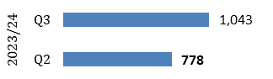 | 1043 | Our page on Enhancing the protection of our seas received 111 views this quarter. While our page on Marine Protected Areas (MPAs) received 932 page views. | We reviewed this measure this quarter and concluded that as it is a new measure with little data to date we will continue with this measure for the time being.
No. of restoration projects for which we’ve provided advice | 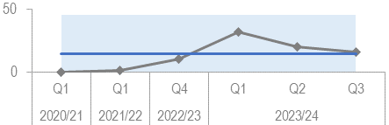 | 16 | We have continued to provide advice to existing projects e.g. Restoration Forth but we have also been providing advice on new projects and development cases that are looking at enhancement options to address impacts and be nature positive. We expect this kind of casework advice to increase. | We have continued to provide advice to internal and Scottish Government colleagues and have shared our experiences with others through conferences, UK level Statutory Nature Conservation Body (SNCB) meetings and OSPAR best practice.
License applications turnaround time within standards | 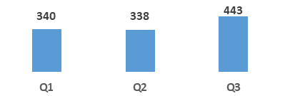 | 443 | The only data we have around this measure is the number of applications that have been issued this quarter which is 443. Until we can report the turnaround time within standards we will report on the number or applications issued in the quarter. | We are not able to advise whether the licences have been issued in accordance with an agreed turnaround time – as we do not as yet have a service level statement with an agreed turnaround time. The aim is to be able to report by in Q4.
No. and Types of licences that are processed through the online system | 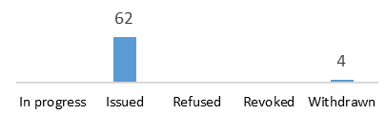 | 66 | There were a total of 66 licence applications in Q3. 49 were Scottish Forestry Operations, 13 were for Traps, 4 were gulls and 4 were withdrawn. | The 4 licences that were withdrawn were because they applied for a licence too early and therefore we couldn’t issue a licence.
No. of catchments with established beaver populations | 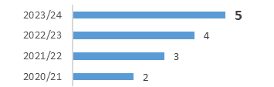 | 5 | The licence for the Spey catchment was issued in December and the beavers were released in late December | The release of beavers took place in late December. The Beauly application has stalled but we are anticipating it, there have early discussions about a release in Abriachan.
No. of successful resolutions to the mitigation requests | Not Ready to Report |  | Progress on this measure had stalled but the Beaver and Planning and Performance teams will be meeting in Q4 to further develop this measure.
% of holding objections for formal planning applications | 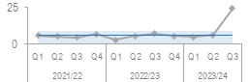 | 24.7% | There has been a large increase in the number of holding objections in Q3 (4-5x the norm). This is partly because of the growing number of Shared Rural Network (SRN) mast applications being submitted with insufficient information (11 out of the 29 holding objections). | We are hoping to see an improvement as result of ongoing liaison with SRN programme coordinators. But there was still a doubling of the number of holding objections that we have come to expect from all other types of development - something to investigate if a trend emerges.

WE HAVE PROTECTED NATURE
Measure | Performance Overview | Actual | Cause | Response
No. of individual farm businesses that have completed a biodiversity audit |  | 72 | 72 individual farm businesses completed a Biodiversity Audit this quarter. 64 through NatureScot Management Agreement’s and there are an additional 8 with Game and Wildlife Conservation Trust. | The NatureScot Biodiversity Audit is still in its development phase so it's difficult to make forward predictions just now.
No. of marine renewable energy consultations we provide advice on avoiding impacts on nature | 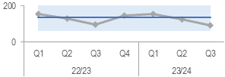 | 92 | Includes the following significant consultation responses issued: Berwick Bank s36 additional information, West of Orkney s36 application, Pentland s36 variation, Spiorad na Mara Scoping, Nova Sound of Islay Scoping. | Appointed two new trainee C-grade marine ornithologists. December budget has included additional monies to support Marine Energy staff resources from April 2024.
NatureScot is in partnership with new recipients | 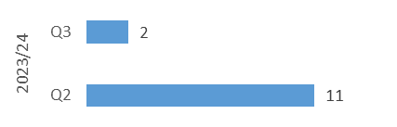 | 2 | 2 new recipients of NRF funding (out of 5 new grants) - both Helping Nature. Other 3 grants offered during this quarter were to existing NRF recipients - 1 for Helping Nature and 2 for Transforming Nature. | The figure is lower this quarter because the majority of awards were offered and accepted in Q3 and the figure depends on when NRF decision meetings take place and the negotiation period that follows.
External funds raised by SMEEF and the amount allocated to projects. | 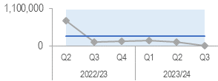 | 0 | No funds committed to SMEEF, one grant was awarded to the University of Glasgow under the Nature Enhancement at Marine Offshore Energy Sites (NEMOUS) research programme. | Initial commitment to SMEEF from contributors of £4.1m over the next 5 years, plus another £75,000 early in Q4
Area (hectares) of peatland put on the road to recovery | 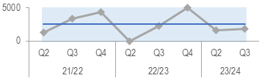 | 1896 ha | The figure of 1,896ha is projects completed to date. | We have 75 current applications for projects totalling 8,730ha. The number of these forecast for delivery in 2023/24 with confidence ratings applied total 5,814ha. We are confident of converting remaining projects to meet the target of 6,100ha.

THE VALUE OF NATURE IS RECOGNISED
Measure | Performance Overview | Actual | Cause | Response
Engagement Rate on Make Space for Nature (MSFN) webpages |  | 98% | Social media influencer Chris Lawlor created MSFN content, which reached 185k views. Q3 activity exceeded KPIs, with autumn results returning 15k web hits, 98% engagement rate, 1.27% Click Through Rate and 185k views of collaborative social media posts. | Q4 activity includes similar social plans, with accompanying podcasts. The podcast series now sits at 34 episodes and 12.3k total downloads.
No. of Landscape partnerships that NatureScot is involved in that use a natural capital approach | Not Ready to Report |  | There is no data for the Natural capital design for this quarter. The data set has been investigated by the team and upon further work will gather historic data. | We’re liaising with the Natural Capital delivery plan team and Operations team members about having the operation areas update the partnership data on whether or not it includes a natural capital element in the project.
Nature-restoration jobs and skill development opportunities created through our activity | 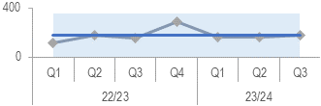 | 175 | 175 jobs and skills development opportunities created this quarter. 172 of these are through peatland, 1 is CEMVO and 2 is for Programme for Youth Employment which are due to finish in Q1 2024/25. | Meetings are scheduled in January to review this measure and expand where possible using the PuMP process.
National Nature Reserve online engagement | 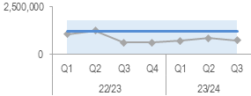 | 741,966 | Steady level of engagement consistent with what is expected. Slight drop due to seasonal nature of some sites. | New Meta measures no longer counting engagement on shared NNR page so seeing a significant drop in count for this page

WE HAVE TRANSFORMED HOW WE WORK
Measure | Performance Overview | Actual | Cause | Response
Sq meterage of floorspace dedicated to NatureScot | N/A | N/A | The benchmarking is out of date and there is a lack of resource funding and skills to refresh this information. | There will be discussions and reviews in Q4 to review the way the data is measured to establish a baseline. Looking to report in Q1.
Total emission reduction (tCO2) | 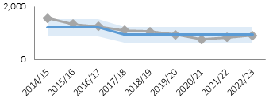 | 915 tCO2 | Total emissions for 2022/23 were 915tCO2 – up by 73tCO2 on year before. This is due to changes to reporting guidelines in apportionment and the increase of general activity across the organisation in fully opening after Covid, and an increase in staff numbers. A rise in carbon has also been reported widely through our Collaborators group. | The tCO2 per FTE was 1.28 (increased by 0.04tCO2 from last year), there was an increase in the homeworking formula used to calculate this estimated figure which is still lower than pre-covid. Each year the reporting mechanism changes, becomes more accurate, includes elements not previously, so not directly comparable to previous years. This will increase further over the next couple of years, when guidance for Scope 3 emissions is issued and we will need to prepare for the calculation of supply chain and capital asset carbon figures
Workforce Diversity | Age  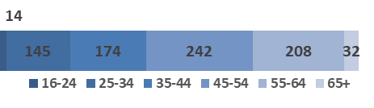  Disability  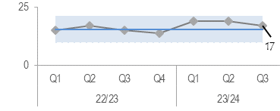  Ethnicity  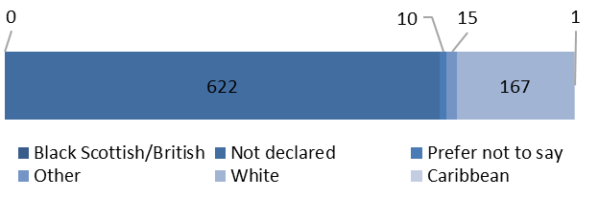 |  | Cultural norms remain. We continue to work in Partnership to tackle these | We will continue to work on Equality, Diversity and Inclusion (EDI) actions and increase opportunities within diverse communities. In Q3 EDI questions have been included in the Q3 Pulse Survey, in Q4 the POD Senior Adviser will launch a campaign to encourage staff to complete their EDI data the questionnaire has been redesigned, to encourage a higher response rate.
% Of Implemented Audit Recommendations | 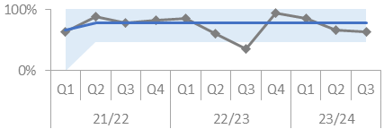 | 63% | The overall implementation rate is 63%, but the priority 1 implementation rate has stayed at 100% | In relation to other recommendations, there are six that are delayed, and these relate to NatureScot's H&S framework, Stakeholder Engagement framework (the completion of a skills learning analysis) and the Net Zero Plan.

FINANCE

Overview
- The position at the end of Q3 is consistent with previous years where minor underspends are expected. Progress in January indicates that Paybill and Project Allocation will outturn within their target range. The budget for Farming with Nature has reduced to £2.1m during January and will outturn much closer to its target range than was previously reported.

Financial Metrics (£m) | Measure | Budget | Forecast | Variance | Rating
Resource Budget | Outturn within 1% of final budget | 60.8 | 60.5 | 0.3 | ON TRACK
Capital | Outturn within 5% of final budget | 2.2 | 2.3 | (0.1) | ON TRACK
Indirect Capital | Outturn within 5% of final budget | 16.6 | 15.9 | 0.7 | MINOR SLIPPAGE
Paybill | Outturn within 1% of final budget | 38.9 | 39.3 | (0.4) | ON TRACK
Project Allocation | Outturn within 1% of final budget | 13.8 | 14.2 | (0.4) | MINOR SLIPPAGE
Peatlands | Outturn within 1% of final budget | 14.2 | 13.8 | 0.4 | ON TRACK
Farming with Nature | Outturn within 1% of final budget | 2.1 | 2.0 | 0.1 | ON TRACK
Better Places Fund | Outturn within 1% of final budget | 0.9 | 0.8 | 0.1 | MINOR SLIPPAGE
Nature Recovery Fund | Outturn within 1% of final budget | 8.3 | 7.5 | 0.8 | MINOR SLIPPAGE
FIRNS | Outturn within 1% of final budget | 1.8 | 1.7 | 0.1 | MINOR SLIPPAGE
*Operating under 1% - on track, up to 10% minor slippage, over 10% major slippage (** Capital under 5% / up to 10%)
Financial graphs | summary of performance
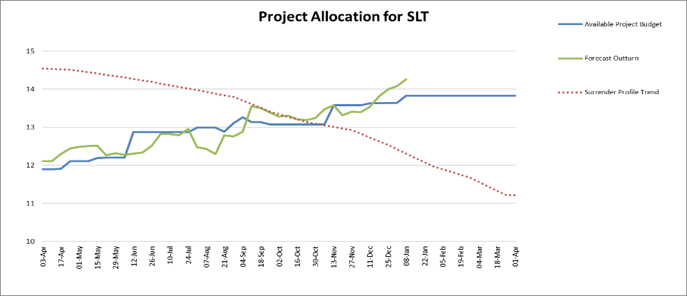  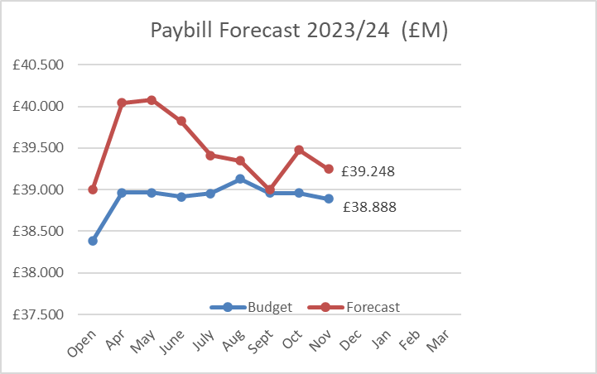 | The project budget is £13.830m with a current forecast of £14.263m. This forecast reflects confidence levels applied (valued at £1.94m) which we are confident can be reduced to zero by the end of the financial year. The Project Allocation Forecast Tracker does not include any ring-fenced funds so NRF, BPF, Peatlands, FIRNS and FwN are stripped out.  The controllable project budget is based on a current core paybill budget of £32.619m. The paybill forecast is currently £0.4m above the gross budget of £38.9m. We expect sufficient savings to be realised through leavers and vacancy gaps to remove this variance by year end.

Finance

Resource Budget Performance
- An underspend of £0.270m is currently forecast on the Resource budget. It is anticipated that we will end the year within our target outturn (1% of final budget). At the same point in 2022/23, an underspend of £0.317m was forecast.
- We have received confirmation of our final in-year budget allocations from SG. The 23/24 budget of £80.4m represents an 11% increase compared to last year.
- We continue to use confidence levels against the Corporate Plan Objectives (current value £1.936m). The Objective Leads are expected to reduce the allocation for their Objective programme in line with budget by year end.
- Finance team colleagues engage with Objective Leads on a monthly basis to review progress and financial performance for their objectives.
- Our Farming with Nature (FwN) budget is £2.07m. SG confirmed the £1.5m SRDP retention can be retained and used to deliver the Farming with Nature programme along with an additional allocation of £0.77m received in-year from SG. £0.2m has been released from resource (staff costs) to bring the figure down from £2.27m.
- The Facility for Investment Ready Nature in Scotland (FIRNS) budget remains at £1.8m with a forecast underspend of £0.098m.
- The paybill outturn is currently projected to exceed the budget by £0.36m. This includes the pay increase offered by SG and following early approval of staffing requirements for 2023/24 in response to identified resourcing pressures. It is anticipated that sufficient savings will be achieved over the remainder of the year to meet the Paybill budget.
- The budget management exercise began in early Q2, challenging uncommitted budgets and ensuring that allocations are optimised with respect to high priority work considered achievable during the remainder of the year.
- We will continue to monitor project surrenders throughout the year, using our knowledge and experience of previous slippage patterns to ensure that appropriate demand is ready to allocate when funds become available.
- The Annual Report and Accounts (ARA) for 2022/23 was approved for signing by the Audit & Risk Committee on 2 November 2023. Mazars completed their final audit review and checks, and the ARA was signed off on 13 December and laid before Parliament on 19 December 2023.

Indirect Capital Funding Programmes (including Peatlands)
- An overall underspend on Indirect Capital of £0.748m is currently forecast.
- The budget for Peatland Restoration for 2023/24 is £14.25m (£4.25m Resource, £10m Indirect Capital).
- The latest Peatlands forecast is £13.822m (£3.871m Resource, £9.951m Indirect Capital), an overall underspend of £0.428m. This forecast includes £0.9m of income from the Shared Islands Fund – excluding this income, forecast spend would have been approximately £14.6m against the budget of £14.25m.
- The Nature Recovery Fund (NRF) budget for 23/24 is currently £8.35m. This is split £1.75m Resource and £6.6m Indirect Capital. We received the additional £1.6m of Indirect Capital in Q3 (the budget originally advised for the year was £5m).
- The overall current forecast for NRF is £7.564m, a forecast underspend of £0.087m on the Resource budget and an underspend of £0.699m on the increased Indirect Capital budget.
- Due to uncertainty in Q3 over future funding of NRF, some decisions on multi-year awards were delayed until January. This has reduced the expenditure that can be achieved in the 2023/24 financial year.
- There was also a misallocation between financial years in the forecast previously provided for one large project. This accounts for the remaining underspend on indirect capital compared to the increased budget allocation for the year.
- The financial position reflects confidence levels which have been introduced to calculate the forecast expenditure on the funded programmes. These are monitored and reviewed regularly by the relevant programme teams.

Structural Funds Programmes
- Final payments to grantees were made before the deadline of 31 December 2023. NatureScot now has until 31 January to submit the final claims to the Managing Authority. These will value approximately £23m with reimbursement to be made by 30 June 2024.
- Reflected within the forecast for the resource budget is an expense of £0.284m for an abandoned claim value relating to Structural Funds. The Managing Authority changed the advice provided for apportionment after we had agreed contracts with our grantees. This leaves us unable to recover this sum from ERDF or from the recipients.

Capital Budget Performance
- An overspend of £0.073m is forecast on the capital budget.
- We will continue to review and actively manage the capital budget to ensure outturn can be brought in line with budget for the year.

RISK
Corporate Risks | Risk Changes
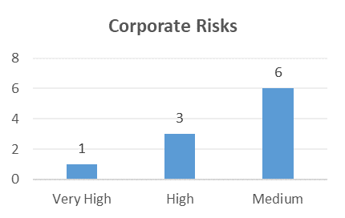 | Changes to Corporate Risk Scores  ↑ 0 Gone Up  ↓ 0 Gone Down  Change to Corporate Risk Register - proposed  ↗ 0 New Corporate Risks  ↘ 0 Risk De-Escalated

Risk
- The Corporate Risk Register holds the current corporate risks for NatureScot. The position of the high and very high rated Corporate Risks are detailed in the Corporate Risk Register in Annex A. Activity and project risks are managed within the risk management system, which underpins the corporate risk register. All risks are managed in line with the Risk Management Policy and monitored regularly for compliance and visibility of impact.
- There are currently 10 approved Corporate Risks, 6 medium, 3 high and 1 very high. During Q3 the overall score for risk 393 - Future Funding of NatureScot increased from high to very high due to assumption of a reduction to our budget but this has since been reverted to high following SLT discussion about the budget settlement .

- During Q3, the Corporate Risks have been reviewed to ensure that they still require to be managed at the corporate level. None of the current corporate risks have been required to be archived or de-escalated this quarter.

PEOPLE
People Metrics | Status
Wellbeing - Accidents and Near Misses are slightly out with our target levels | Amber
Key Messages:
- Our Health & Safety engagement theme for Q3 was on slips, trips, and falls.

Accidents & Near Misses
- Target: to stay within variations around the mean (4.4 for number of accidents & 5.8 for number of near misses)

Q3: Accidents = 10; Near Misses = 8

XmR charts for Accident and Near-miss reporting in Q3 indicate that accidents reported in Q3 are above the mean target but within acceptable bounds of variation. Near-misses are maintaining their increased level outside the bounds of variation which may be due to the increased engagement on incident reporting.

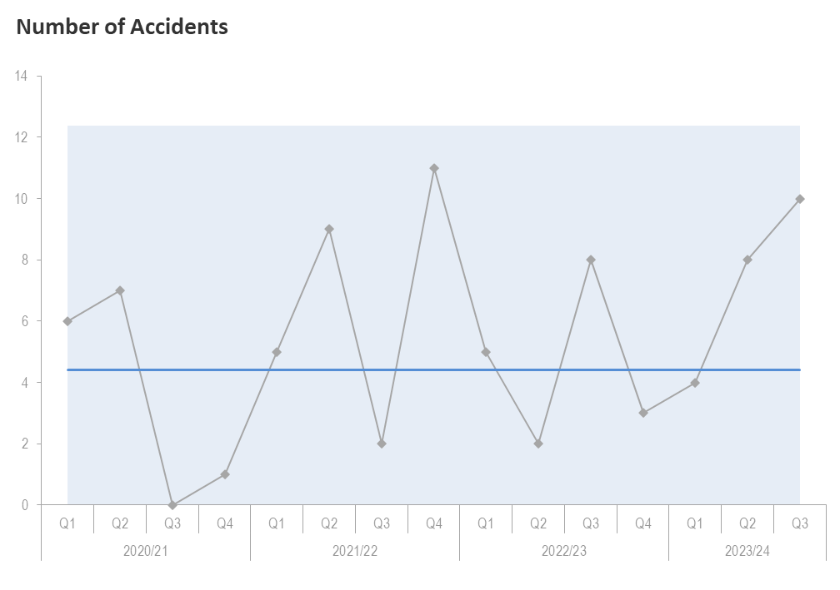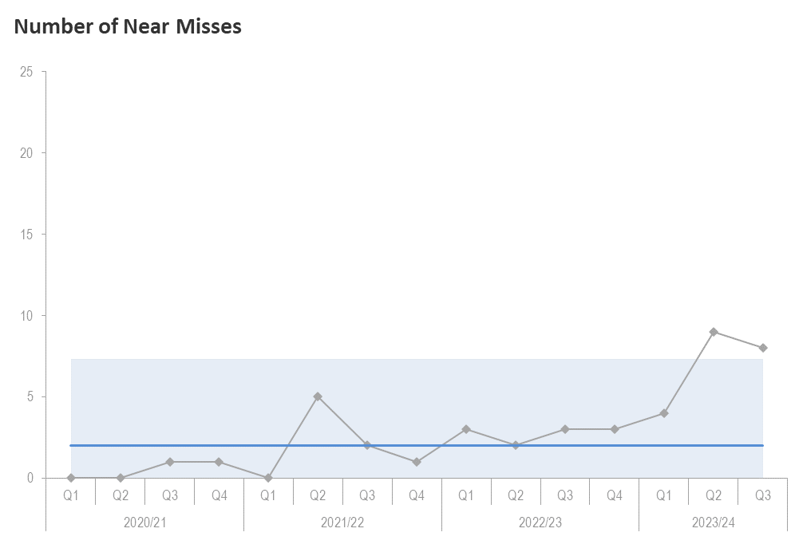
(This graph shows number of accidents) (This graph shows number of near misses)

The engagement theme for Q4 is Safety Culture.

Pulse Survey – Workload Management, Safety Culture, Equality, inclusion, and diversity | Green
Key Messages:
- The Q3 pulse survey closed on 16th Jan; with a much-improved response rate of 78%.

Capacity | Amber
Key Messages:
- Sickness is within target and annual leave is on target from a corporate perspective, however 6.5% of employees have over half their leave balance remaining.

Sickness – Target: less than 2 days per person per quarter

- Q3: 1.95 days per person sickness (1.60 days in Q2; ↑0.35days). Although the number of days lost to sickness has increased, the rolling annual average days lost is maintained at 6.4 days which is below the annual UK average days lost to sick absence of 7.8 days.
- Short-term absences continue to be the bulk of working time lost in Q3; 1.3% of 383 sick absence occurrences in Q3 were long term.
- The top reason for short-term sickness reason in Q3 was coronavirus, with 320 days (199 days in Q2; ↑121 days). An increase (of 36%) in days lost for the same reason from 2022/23 Q3 (222 days).

Annual Leave
- Q3: 76% of holiday leave booked or taken; this is on target for Q3 in terms of accrued leave booked or taken i.e., 75%.
- Although the overall leave figure is on target, there are 53 employees (6.5% of our employees), who have more than 50% of their leave accrual remaining at the end of Q3. Of these employees, 8 are due to long term absences.

Development | Green
Key Messages:
- Formal casework remains low with 5 open cases (as outlined below). Therefore we are within target in terms of the comparison of formal and informal casework, i.e. 17.2% of cases are formal.
- Informal casework categories are health & wellbeing; in terms of cases relating to short- and long-term absences.

Formal Casework – Target <=50% of informal casework
- Q3: 5 cases with three new cases in health and wellbeing and a job evaluation with ongoing cases in the following categories: dignity at work, and employment tribunal. The two ongoing cases are long term casework involving external parties.

Informal Casework
- Q3: remains static with 29 cases. The majority of cases in Q3 were health & wellbeing, short and long-term absences categories.
- In Q3 we saw 5 new cases in the health and wellbeing category, which increased our overall cases in this category to 12 (9↑3 cases).

Workforce Profile | Amber
Key Message:
- Turnover has decreased; headcount is increasing; the number of recruitment exercises are reducing; with no change to the retirement profile.

Turnover – target: increase maintain in the range of 8-10%
- Q3: average turnover is 10% (over last 12 months), with 15 leavers in Q3.
- 31% of leavers left for personal reasons, 27% were colleagues leaving for alternative employment and 12% of these were retirements/early retirements.
- The graph below shows a reduction in turnover this quarter, however it is too soon to see if this will be a continued trend in Q4 due to fixed term contracts coming to an end.
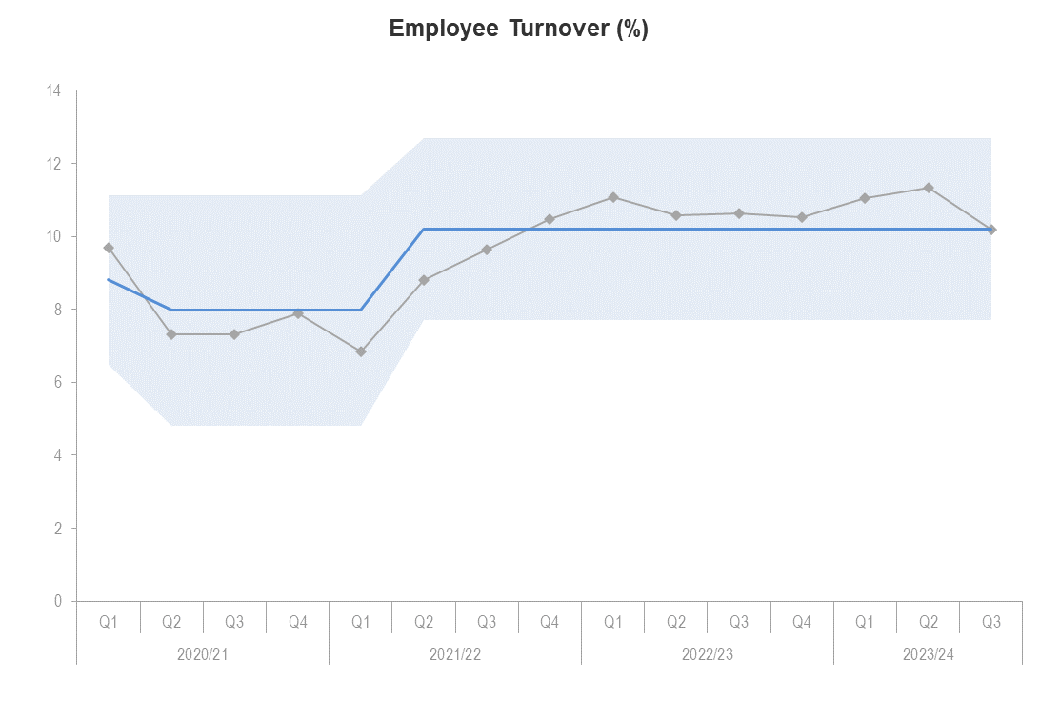
(This graph shows the employee turnover)

- We have seen a 50% return rate for exit questionnaires in Q3 (7 in total), (Q2 91%; ↓41%). There are no significant issues emerging from the feedback so far.
- In 2022/23 we saw 31% of leavers go to alternative employment. The year-to-date figure for 2023/24 is at 27%, a reduction from 2022/23 of 4%.
- Leavers by grade – To date in 2023/24 most of our leavers come from B (23) and D (13) grades (out of a total of 51 leavers to date) and this is consistent with the same period in 2022/23.

Internal Movement | Green
Target: increase internal moves
- Q3: Internal moves have reduced again this quarter, with 23 internal moves (Q2 - 34↓11). This is 3% of our headcount of employees moving into alternative roles through promotion or same grade reassignments. It includes those returning to their substantive post following a temporary reassignment.
- In Q3 there have been 25 recruitment campaigns (Q2 – 42↓17); 1 has failed to attract a successful candidate, which is a significant reduction from Q3 22/23 (8↓7). Recruitment exercises in Q3 have reduced compared to previous months which is predicted to continue into Q4, in light of the current external recruitment freeze. Of the recruitments which have gone live this quarter, 6 recruitment campaigns have been filled internally, 5 have been filled by external candidates.
- In Q3 there have been 25 new starts; 16 of them on fixed term contracts and 9 are on permanent contracts; of which 19 are in core positions and 6 in project-funded roles. Of the core positions 10 are fixed term contracts.

Headcount and FTE

- In Q3 the headcount was 815 and FTE was 751.
- The new operating model will enable resources to be moved as and when needed and to support the management of headcount more proactively.

Headcount and FTE
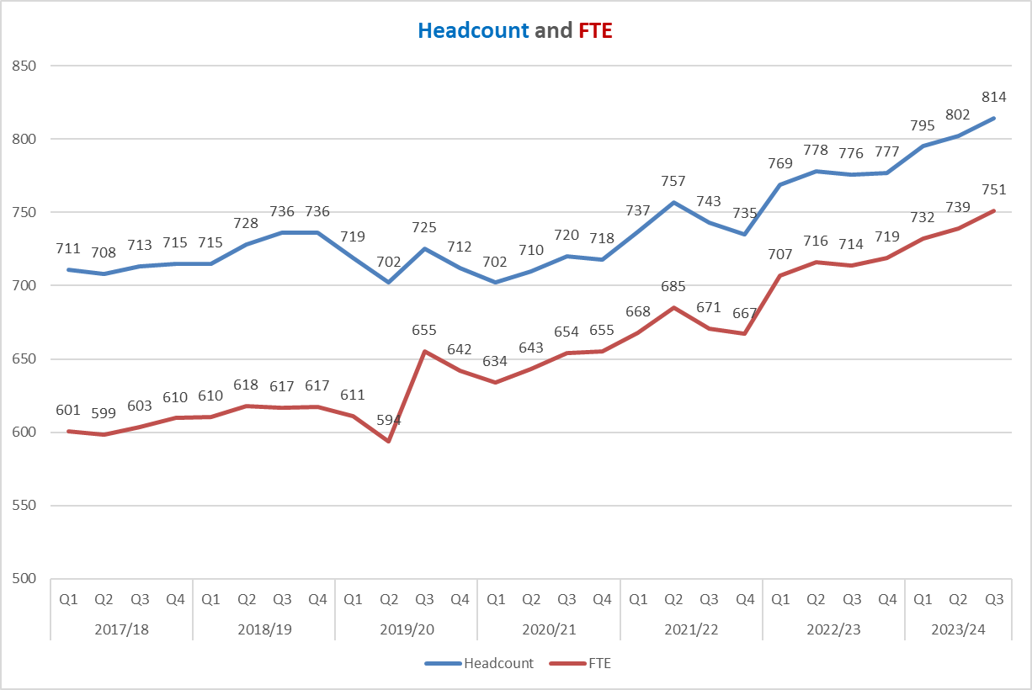

(This graph shows the trend of the organisations headcount and FTE to date)

Retirement Profile | Amber
- Q3: 188 employees are aged 57+. This is predicted to rise to 237 in 2025/26 (29% of current headcount).
- In Q3, 3 employees retired (21% of leavers in Q3). The average retirement age for Q3 is 63. There were an additional 7 retirements notified during Q4 to date. The forecasted retirements for 2023/24 is 14, and actual retirements including future dated retirements for 2023/24 are slightly above forecast at 15.
- P&OD promoted Career MOT facilitator training with the Institute of Leadership and Management in Q3. Two cohorts will progress in Q4.

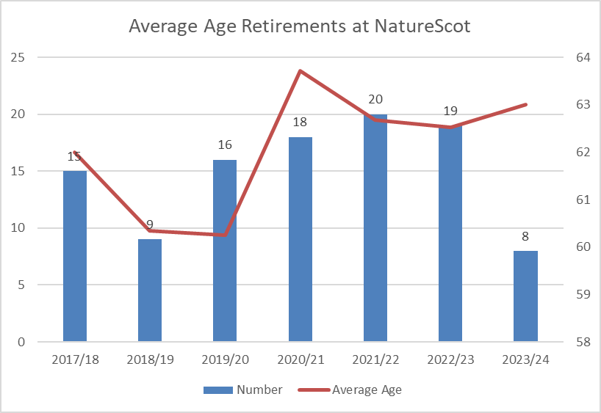

(This graph shows average of employees retiring)

Annex A – Corporate Risk Register (High and Very High Risks)
Risk Title | DESCRIPTION | CONTROLS | IMPACT | LIKLE-HOOD | RISK LEVEL | Comment
47 - Computer Virus/Malware | As a result of inadequate protection, or inappropriate system use, including accidental activation of email links by that lead to malware downloads, there is a risk that NatureScot systems becoming infected with a malware or virus agent, resulting in NatureScot systems and data become unavailable, encrypted or corrupted, significant system downtime and huge operational impacts | *All file servers are protected by Sophos anti virus protection. Upgrades are performed automatically and can also be applied in an ad-hoc manner  *All PCs are protected by Sophos anti virus protection. Upgrades are received on a live basis but can be applied ad-hoc  *All incoming emails are scanned for viruses.  *All internet access, are scanned for viruses via Zscaler service.  *Raise staff awareness of potential risks relating to email links and infected documents through regular communications.  *Control/restriction of USB devices  *Awareness raising with staff via Blogs and update articles  *Incident Management Group in place  *Corporate data backed up to cloud  *Zfilter showing us user behaviour and stopping internet threats  * regular meetings of TDS/ICS to check on patching levels and compliance issues. | 4 | 3 | High | As the middle east conflict develops we continue to be on exceptionally high alert. Especially on the back of ~Western Isles Council and British Library incident which is a reminder of the constant threat of hacking and malware. There has been an increase in very sophisticated phishing attacks (hand crafted) recently, combined with social engineering. We must ensure staff at all levels of the organisation are aware or the risks.
253 - Peatland restoration target and budget. | As a result of the immature and complex operating environment, there is a risk to: meeting the annual Peatland ACTION restoration hectare target; and spending the annual budget. | • Realistic planning  • Invigorating demand  • Real-time monitoring  • Increasing resilience to change in projections  • Regular and robust review and control  • New Guidance on operating during nesting season being update to allow risk based approach to operations during that period. | 4 | 3 | High | The risk remains at 3 following governance Board discussion. Although, - more stringent/robust programme planning/reporting: - greater stimulating of demand through updated communications plan and more targeted engagement with land management interests; - alignment of PA, PDR and PDR prior-notification processes – no further work, but the design sector is now more comfortable with the three processes. - increased support to IUCN for the Peatland Code process (there is no-longer a backlog with PC verification); - a protocol to allow operating in the bird breeding season (we delivered over 500 ha during the BBS in 2023); - expanded PO network/capacity – we have recruited 4 additional delivery-focused posts in 2023; - POs focused on converting current demand into projects to be delivered in 23/24 – the PAOs understand that delivery is their focus. - expanded contractor capacity as a result of skill development and training, no tenders failed due to contractor capacity; - provision of technical guidance – peat slide risk assessment process published; - accelerating PDSS to bring forward projects into 2023/24 – part of awards made on condition of delivery in 2023/24. The programme output (ha delivered and spend) is still dependent on weather/favourable operational conditions and continued availability/capacity of staff. The latter has had a 25% churn during the year and a number of projects have been delayed. As a result, our confidence rating is 95% on the 6,100 ha and 97% on the full spend of 15.1m budget (funds from Scottish Government and Shared Island Fund). Both point retention of a risk likelihood score of 3.
393 - Future Funding of NatureScot | As a result of on-going reductions in public expenditure there is a risk we may receive significant reductions in our grant-in-aid settlement. Unless other funding sources are secured this could result in an inability to adequately resource delivery of agreed priorities, leading to failed outcomes and reputational damage. | * Ensure that our priorities are aligned with published Programmes for Government and ministerial portfolio priorities, specifically those aligned to the Programme for Government and Bute House Agreement  * Provide realistic and evidenced assessment of the impact of possible cuts in our grant-in-aid budget through the annual Spending Review process.  * Develop and put forward proposals, through the annual Spending Review process and other avenues with Scottish Government, for delivering more and better outcomes for nature and people through wider Scottish Government funding.  *Reduce expenditure in some business areas through budget setting processes aligned to business planning cycle.  * Have an effective communications strategy in place which promotes the added value of our work.  * Identify and implement opportunities to generate income from the services we provide.  * Identify and implement opportunities for external funding of NatureScot-led work through the business planning process (including at Outcome and Activity levels) and at the project development stage for significant scale projects.  * Develop proposals for new, preventative projects that can help deliver a wider set of SG priorities, and build awareness and support of these.  * Develop and refresh a short, medium and longer term financial plan based on potential financial scenarios. | 4 | 4 | High | Risk escalated to Very High in Q3 and then reverted to High as planning assumptions for a budget cut which don't cover statutory/fixed costs did not materialise for 2024-25. Discussions will continue with Scottish Government over various scenarios for future years. SLT have implemented an external vacancy freeze since November and are reviewing our approach to FTA renewals and we are refining our prioritisation.

CIPD Health and Wellbeing Report 2023

