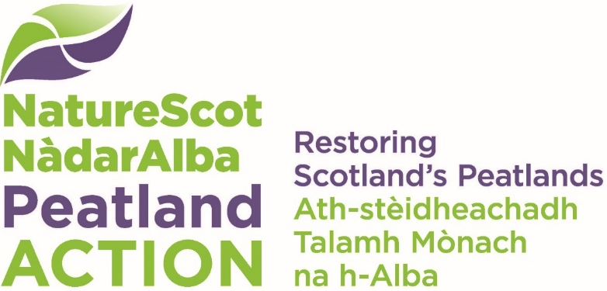

Species Protection Plan Template
  - Breeding Birds

Introduction
All wild birds are protected by law under the Wildlife & Countryside Act 1981. Under some, limited, circumstances, it may be possible to extend restoration work into the main bird breeding season, however as a matter of rule, this cannot be accepted without an agreed Species Protection Plan (SPP). Please refer first to guidance Peatland Restoration and Breeding Birds - Undertaking work in the bird breeding season to establish whether the necessary criteria for working during the Breeding Bird season are met.

It is recommended that, as a default approach, restoration work should be programmed to occur outside the main bird breeding season (April - July). The NatureScot website provides information on writing a good Species Protection Plan. Your main aim should be to evidence how to avoid disturbing any protected species present on site, for example by changing the location, timings or details of planned restoration work. Generally, the relevant appointed ecological field surveyor or Ecological Clerk of Works (ECoW) and Peatland ACTION project officer (or land agent if such survey costs are included in their contract) for each project would be jointly responsible for submission of this form.

It is an expectation that all projects include regular site visits by an ECoW throughout the relevant period of works (as identified in Section A), to ensure all environmental mitigation relevant to protected birds is delivered. The relevant ECoW may be required to review whether residual impacts are likely to affect protected birds and, if so, have the power to stop restoration works.
Further information is available on the NatureScot website Protected Species: birds.

Please submit this form to Peatlandaction@nature.scot stating ‘Species Protection Plan - Breeding Birds’ alongside the FE number and the grant reference number (if available). If you require assistance with this form, please contact Peatlandaction@nature.scot.

Species Protection Plan Breeding Birds

Section A – General Information

Project Name:

Location:

FE number:

Peatland Action grant code:

When is the SPP needed for and duration?:

Breeding species affected by works:

Section B – Protection Plan

Information on breeding bird activity
Please give the findings of at least two appropriate ornithological surveys and any pre-existing information, considering species or signs recorded (including grid refs, and distance from site restoration works), suitability of habitat, and survey constraints/limitations. If possible, attach a pdf/jpg map of the area affected, and mark key locations including GIS data.

Impact assessment
Detail the types of impacts expected without mitigation as a consequence of the restoration works, and the probability of these happening. Give a magnitude and duration of these impacts, likely long-term impacts and potential reversibility. Note any assumptions made and references to evidence or advice used.

Avoidance and Mitigation activities
Provide detail of actions and measures that will be put in place to avoid harm or disturbance, or to mitigate harm or disturbance. List these activities in hierarchical order of lowest to highest impact on birds of concern. Include points pertaining to timing and phasing of works, use of appropriate disturbance buffer protection zones, re-routing access and any other intended changes to the agreed project design. Include a map detailing key points and provide GIS data where available.

Compensation measures
If avoidance and mitigation activities detailed above are likely to be insufficient to reduce risk of disturbance to near zero, as a last resort compensation measures could be considered, Please detail here how restoration work can ensure connectivity (e.g. to suitable alternative habitat) is safeguarded.

Summary of residual risk
Please detail any risks that cannot be mitigated by actions detailed above.

NatureScot Comments on the Species Protection Plan
Comments on the Species Protection Plan should be sought from NatureScot (via Area Officers). See NatureScot Office website for a map showing local offices and current email addresses for contacts. Please detail here any advice you received and from whom to inform this Species Protection Plan. You may attach emails or links to your email. If no advice was sought, please provide brief reasons/justification.

Additional information
Please provide any additional information you feel is useful in the assessment.

