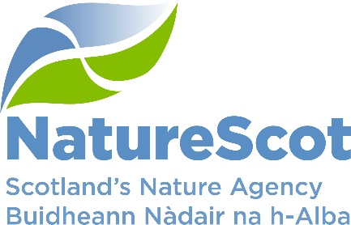

SCIENTIFIC ADVISORY COMMITTEE: SIXTY SIXTH MEETING – 18 SEPTEMBER 2023
AT: Edinburgh

AGENDA – OPEN SESSION

Further information on items in this agenda can be obtained from NatureScot in advance of the meeting, and a member of the public may make a written representation on any item to the Committee up to 24 hours in advance. If that is not possible it will be tabled at the meeting. For further information please contact: Paul Robertson, Nature & Climate Change Director Support Team, Paul.robertson@nature.scot

Teas/Coffee from 10.45

- Welcome, apologies for absence and declarations of interest 11.00

- Minutes, action points and matters arising from the meeting held 11.05
on 27 March 2023
To confirm the minutes of the previous meeting, update the SAC on
action points and other matters arising.

- Oral update on NatureScot Board business 11.10
Chair to update the Committee

Discussion Papers

- Horizon scanning – marine 11.15
(Clive Mitchell, Beth Scott, Ben James, Sarah Cunningham) (SAC/2023/09/01)

- Building systems thinking into how NatureScot commissions research and 11:40
evidence work
Presentation by Wayne Powell (Board member and Head of SRUC)

- SAC sub group update 12:10
(Sarah Hutcheon, Des Thompson) (SAC/2023/09/02)

- Board/SAC meeting – Feb 2024 12:20
(Eileen Stuart) (SAC/2023/09/03)

- CASE studentships in NatureScot 12:35
(Alex Mackay) (SAC/2023/09/04)
- Information Papers 12:50
(Short papers presented for information and for SAC members’ questions for clarification).

SAC/2023/09/Info01 Indirect drivers of biodiversity loss - report (Alan Cameron)

- AOB 12:55

End of Open Session

