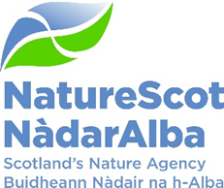

Title: Q1 Performance Report 2023/24
Date: 23rd August 2023

Purpose: | Decision
How does this link with our corporate priorities of improving biodiversity or delivering nature-based solutions to climate change: | This paper presents Q1 progress towards delivery of our corporate priorities as laid out in our Business Plan, A Nature-rich future for all: Year 2.
Summary: | At the end of Q1, performance for 14 of our 15 Corporate plan objectives are rated as ‘on track’. Our Resource and Indirect Capital budgets are expected to outturn within tolerance at year end. Awards are currently being agreed for Nature Restoration Fund and Peatlands, with an over-allocation approach to ensure that full budget spend is achieved. Direct Capital is forecasting above tolerance due to a forecast for systems build. This is at the review stage and we expect the forecast to be adjusted. There have been two changes to the corporate risk scores this quarter and one corporate risk is proposed for de-escalation. In the People Report, eight of the nine indicators are green and one remains at amber.
Actions: | To agree the recommendations below
Recommendations: | Board are asked to:  - Note the overall performance of the Corporate Plan objectives (Performance Report)  - Note the position of the operating and capital budgets (Finance Report)  - Note the performance of the corporate risks (Risk Report)  - Note the overall performance of the People Measures (People Report)
Report Author(s): | Authors – Directors, Deputy Directors, Outcomes Managers, Finance, Planning & Performance Team, People & OD Team
Sponsor: | Stuart MacQuarrie, Jane Macdonald
Annex | Annex A - National Performance Framework Indicators  Annex B – Corporate Risk Register

Purpose
- This paper presents NatureScot’s performance for the first quarter of 2023/24. It addresses delivery of our corporate priorities by reviewing; the alignment of performance against our Business Plan, a Nature-rich future for all: Year 2; progress towards full prioritised targeting of available budget; assessing risks for delivery; and reviewing people information supporting the resourcing of our work. These support delivery of our Corporate Plan 2022-26, A Nature-rich future for all.

Summary
- Q1 saw the conclusion of our organisational design implementation phase. As such our new approach to 90 day planning was activated and this focussed decision making on balancing resource across priorities as they have moved over the quarter. A comprehensive closure report was completed and actions to review progress agreed later in the summer.
- In the field, Avian Flu continued and, although at lower intensity than last year, the impact of last year’s outbreak remains highly visible in seabird colonies both in terms of reduced numbers and behaviours. NatureScot staff continue to be heavily involved in work to understand the virus pathways, monitor impacts and advice on mitigation, especially long-term conservation measures.
- Momentum also continues to build with support of our strengthened approach to deer management with two Section 7 control agreements (Caenlochan and Loch Choire) now at similar stages of development/implementation.
- A number of foundational policy frameworks have also made strong progress this quarter specifically with the Scottish Biodiversity Strategy, 30x30 and Nature Networks. We report amber against one Corporate Plan objective reflecting the changing course of action on Highly Protected Marine Areas and the knock-on implications for other marine work such as Marine Protected Areas and Priority Marine Features.
PRIORITY PERFORMANCE | NUMBER | CORPORATE RISK | NUMBER
Objectives | 15 | Corporate Risks | 11
On Track | 14 | Increased Score | 1
Minor Slippage | 1 | Decreased Score | 1
FINANCIAL METRICS | STATUS | PEOPLE METRICS | STATUS
Resource | On Track | Wellbeing | On Track
Project Allocation | Minor Slippage | Capacity | On Track
Paybill | Minor Slippage | Development | On Track
Capital | Major Slippage | Workforce Profile | Minor Slippage

PERFORMANCE REPORT

Protecting Nature

Outcome: Strengthened protection of existing biodiversity
Lead the delivery of 30% of land and sea being protected by 2030 – Nick Halfhide - GREEN
- Frameworks for 30x30 and Nature Networks completed but consultation now scheduled for July. Implementation plan discussions with SG (Scottish Government) commenced.
- Accelerator phases of CivTech Nature Network and Protected Area Data projects complete – Minimum Viable Product (MVP)/Wireframes developed for both Protected Area data management system and Nature Networks tool. Decision to be made on entering into pre-commercial agreement pending business analysis of nature networks and natural capital tools and availability of funding.
- Data Analysis and Commence Ecosystem Health development - Recruitment underway/Ecosystem health work developing but needs additional resource.
- Advice submitted to Scottish Government on legislative change for Protected Areas to inform Natural Environment Bill consultation.
- National Parks Interest - Advice provided to SG and stakeholders on a range of issues, and comments on Statutory Environmental Assessment (SEA) made as statutory consultee.

Measure | Performance Overview | Cause | Response
Stakeholder interest in MPA Information |  | 2817 clicks - These are the latest statistics using Google Analytics. | From next quarter, statistics will be obtained using a new system. Due to differences in the way these different systems interpret data a drop in the number of views is to be expected.
Number of restoration projects for which we’ve provided advice | 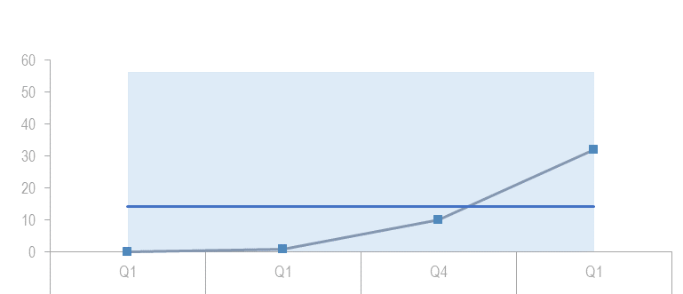 | The 32 Active Restoration Projects need a lot of help with licencing and we have had a large influx of projects alongside projects asking for advice that are in the very early stages of development. | Another marine enhancement advisor has been recruited to handle this rise as well as the secondment of another team member.
Build stronger collaboration reducing the impacts of deer and modernise our wildlife management and underpinning licencing functions to enable a net zero and nature positive future – Robbie Kernahan - GREEN
- SG, based on NatureScot advice, have written to stakeholders outlining intent to make changes to the Deer Firearms Order to reduce bullet weight and permit image intensifying scopes for culling deer and also change the Deer close season order to remove close seasons for male deer. These are expected to be laid in Parliament over summer and applied in Q3.
- We signed a Section 7 agreement with 10 properties in the South Grampian (Caenlochan) area to reduce deer number to 10 deer/km2. A further Section 7 agreement control agreement has been sent to Loch Choire Estate to underpin future management to achieve 7 deer/km in line with East Sutherland Deer Management Group (DMG) plan.
- The draft Goose Policy Review has been shared and discussed with the National Goose Forum in line with Ministers expectations. This is being finalised before being submitted to SG in July. Request for approval for the Annex 1 goose schemes has been submitted to SG.
- Beaver licensing has been reviewed with changes requiring applicants to fill out application forms and the requirement for provision of beaver carcasses for post mortem will be conditioned on licences. Second Scottish beaver Advisory Group (SBAG) meeting has been held and Jill Robbie (NatureScot Board) is due to take on chair role in August. Terms of Reference (TOR) for the four task groups on Woodland, Fisheries, Research and Communications have been shared with SBAG and aim to have these groups formed in Q2. SEA for the Beauly and Spey catchments have been published and are now out for consultation.
- Wildlife and Countryside Act Schedule 2 Review has been delayed slightly due to Highly Pathogenic Avian Influenza (HPAI) demands and input into the Wildlife Bill Rural Affairs and Islands (RAI) committee call for evidence but due to have finalised early Q1 for submission to SG.
- Hunting with dogs guidance has been drafted and due to be shared with stakeholders before the end of Q1. We have given evidence to three Rural Affairs and Islands Committee sessions on the Wildlife (Grouse) Bill in June.
- We have initiated discussion with SG to set out a commission for the development of an Invasive Non-Native Species (INNS) action plan for terrestrial, coastal and marine involving surveillance, prevention, control and eradication of plant and animal INNS.

Measure | Performance Overview | Cause | Response
No. of catchments with established beaver populations | 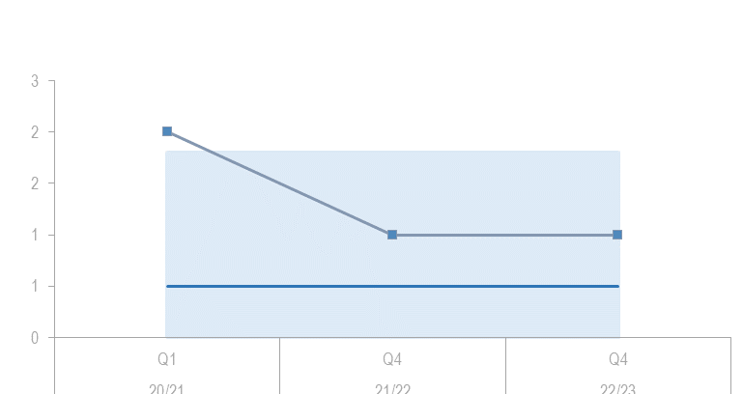 | This quarter no licences were issued for beaver translocations and no new beaver populations were discovered. | It is anticipated we will receive an application shortly for the Beauly and Spey catchments. To reinforce the 4 currently in place.

Measures in development – anticipated Q2
No. of license applications that have a turnaround time within standards
No. and Types of licences that are processed through the online system
No. of successful resolutions to the mitigation requests

Engage and influence planning and other regulatory systems to ensure they deliver for nature and climate – Robbie Kernahan – GREEN
- InformedDecision: delivery revised (schedule & budget) partly in response to the need to safeguard issues with internal systems. Requires further development and preparatory work and a new project timeline is in place which extends to October for delivery of a platform business case to go to Senior Leadership Team - recoverable.
- Inquiries - no further engagement beyond Narachan inquiry this quarter - on target.
- National Planning Framework (NPF4) - guidance updates all on target
- Sector Deal - liaison with SG and industry on target and agreeing next stages.
- Positive effects for biodiversity - paper has been delivered for assessment and our engagement with the SG Technical Advisory Group is positive. A lot of awareness raising and discussion with renewables industry and links to Scottish Biodiversity Strategy discussions - on target
- Development Management - casework loading being managed but pressures high in some areas - on target
- Development Planning - beginning of work on prep for new Local Development Plans (LDPs), with liaison on Key Agencies Group (KAG) collaboration pilot - on target.

Measure | Performance Overview | Cause | Response
Formal Applications provide all the necessary information for us to fully advise | 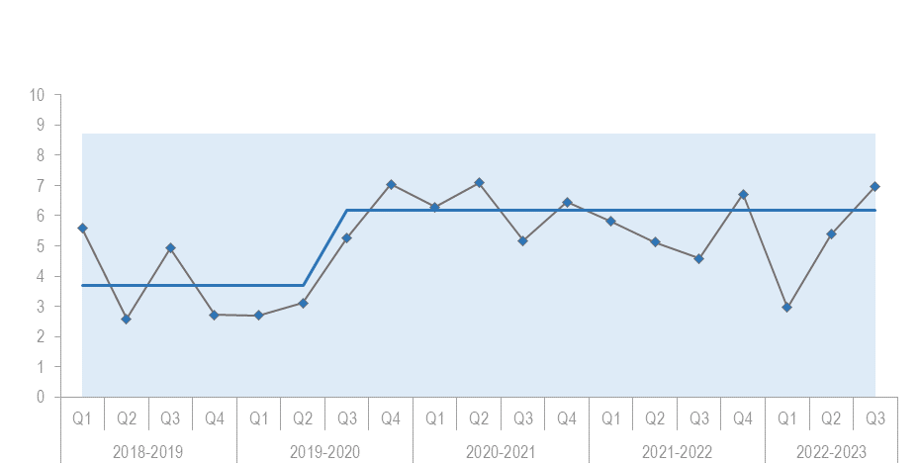 | The annual figure for 2022/23 was 5.19% which is at the lower end of our amber classification (4-8%) and the figure for Q1 this year is 5.42% and so not far off green. | Awaiting the results of the Informed Decision trial to see what effect that has, and if it is to be rolled out.

Influence the transformation of marine management through new marine planning, protection and fisheries management frameworks, and working with the marine renewable energy sector – Nick Halfhide – AMBER
- Marine and coastal science - Initial meeting series underway with teams / receptors group specialists. Draft report will be completed in Q2.
- Marine survey & monitoring- Survey work on track (Alba survey complete) and planning for small boat work underway. Marine Management Plan (MMP) not yet re-started.
- Enhanced marine protection - work started on the review of responses to the Scottish Government-led consultation on Highly Protected Marine Areas (HPMAs) and discussions with officials on future policy direction.
- Marine Protected Areas (MPA) & Priority Marine Features (PMF) fisheries management - support to Marine Directorate on the development of draft management measures for future public consultation, including preliminary stakeholder conversations and support for Marine Directorate at engagement events.
- Marine enhancement - NatureScot comments on contract statement of requirements returned to SG Marine Nature Enhancement Team.
- Marine Fisheries Management - Input provided to Inshore Fisheries Group chairs induction event and Fisheries Management and Conservation Group (FMAC) core group and working groups.
- Marine Energy - Advice provided to over 20 ScotWind/Innovation and Targeted Oil and Gas (INTOG) and other offshore wind projects including Berwick Bank (with statutory advice on derogation package - current objection), Green Volt – initial objection, requesting additional information and Pentland - worked with all parties and initially consented for 10 years.
- Aquaculture - Provided input to consenting workshop and revised draft Vision.
- National Marine Plan - Informal written advice provided on vision, objectives and principles for National Marine Plan 2 (NMP2), which has been picked up by Marine Scotland, and we contributed to two objective setting workshops with other statutory consultees. We have also given initial SEA scoping and methodological advice.
- Marine Natural Capital (MNC) - Explored scope for MNC partnership work, including links to HPMA and enhancement workstreams.
Measure | Performance Overview | Cause | Response
No. of marine renewable energy consultations where we have provided advice on avoiding impacts on nature | 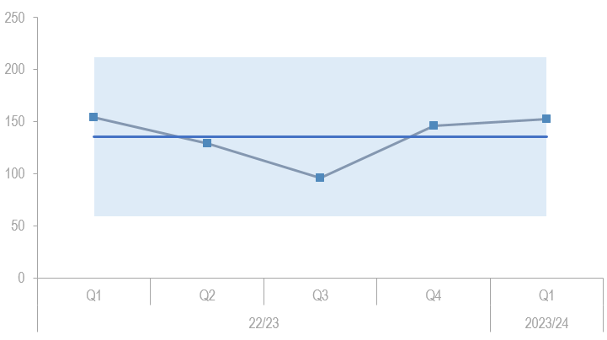 | 153 - Significant increase in ScotWind and InTOG casework. A Marine Ecologist left post. | Bid for additional ScotWind staff resources further updated and resubmitted to Offshore Wind Directorate.

Restoring Nature
Outcome: Halt the loss of biodiversity by 2030 and restore nature by 2045
Co-lead the production of the new Scottish Biodiversity Strategy (SBS) and develop targets to include in a new Natural Environment Bill – Nick Halfhide – GREEN
- Q1 saw detailed and intense work with SG to draft the Delivery Plan (as part of a wider consultation also including the revised biodiversity strategy and proposals for a new National Park and Natural Environment Bill targets). We held stakeholder workshops with a wide range of partners, as well as one-to-one meetings to develop the detail on delivery actions (150+). The Programme Board meeting on 1st June signed off on progress. During June further work with Scottish Government policy leads ensured the draft Delivery Plan was sufficiently worked up for approval by Ministers (in early Q2). Specialist staff across NatureScot have been involved in drafting detailed actions.
- During Q1 work began on devising the process for drafting targets for the Natural Environment Bill. These are predicated on the content of the Delivery Plan. The Programme Board’s Advisory Group (chaired by the Chief Scientific Adviser, Environment, Natural Resources and Agriculture) will support Scottish Government and NatureScot policy leads in devising Bill targets. A workshop with the Advisory Group to input to draft targets is confirmed for mid Q2, and following this advice will be sought from NatureScot’s Scientific Advisory Committee.
Scale up Peatland Restoration by delivering Peatland ACTION funding to projects – Robbie Kernahan - GREEN
- Continued to stimulate demand for peatland restoration through publication of good practice case studies/videos and promotion of Peatland Action (PA) at events such as Royal Institution of Chartered Surveyors, Scottish Land & Estates conferences and Royal Highland Show.
- Recruited 2 Project Managers to increase our capacity to turn the demand for peatland restoration into project design and delivery. To support this, we launched a new grant scheme to incentivise project design and continued to commission feasibility studies and provide training to contractors.
- Delivery continued earlier than in previous years through 9 projects using the new protocol to allow operation in the Bird Breeding Season.
- Finalised our Monitoring Strategy (for publication in August) and made our data accessible through a new open access portal.
- Finalised our programme plan of actions/tasks for 2023/24 in line with confirmed budget of £14.3m and continued to brief/explore options for process improvement with SG.
- Agreed extension of staff contracts to 2026 to increase continuity and resilience in the workforce.
Measure | Performance Overview | Cause | Response
Area (hectares) of peatland put on the road to recovery | 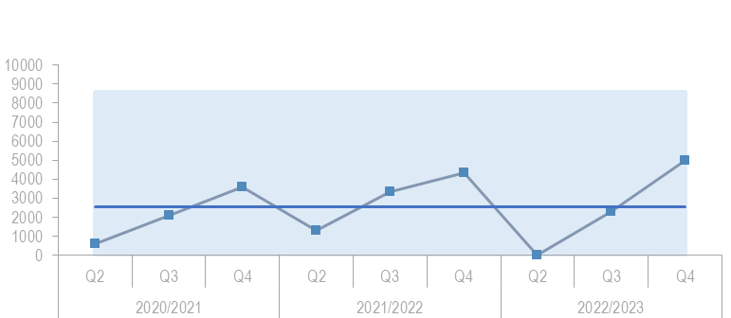 | 5000 hectares from Q4 2022/23. Still ongoing though no update in Q1 as usual. | Will Continue reporting and updates in Q2.

Lead, enable and convene others around the development of ambitious and coherent actions to restore nature. Deliver a major Nature Restoration Fund (NRF) targeted at high impact nature recovery projects and seeding greater investment from the private sector – Nick Halfhide – GREEN
- We received 40 applications for funding to the Nature Restoration Fund, and teams across NatureScot have been contributing to the assessment and prioritisation of those bids. This is leading to funding decisions on those applications being made at the end of the quarterly reporting period.
- We discussed species prioritisation internally with the Senior Leadership Team in a workshop in April and externally with Scottish Environment LINK in May. Specialist advisors are working on checking and refining the database before further consultation with SE LINK.
- The National Species reintroduction forum met for the first time in over a year and discussed their conservation translocation priorities. We published a position statement jointly with other Statutory Nature Conservation Bodies on sourcing pine martins for translocation projects.
- Species on the Edge project has all the core staff in place now and the launch event was on Saturday 3rd June at Logie Quarry near Tain.
- The Scottish Invasive Species Initiative (SISI) end of project celebration event is planned for early July with invitations to partner organisations, landowners, volunteers and to the Minister, Ms Slater.

Measure | Performance Overview | Cause | Response
Area (hectares) improved for habitats and species through the nature restoration fund | 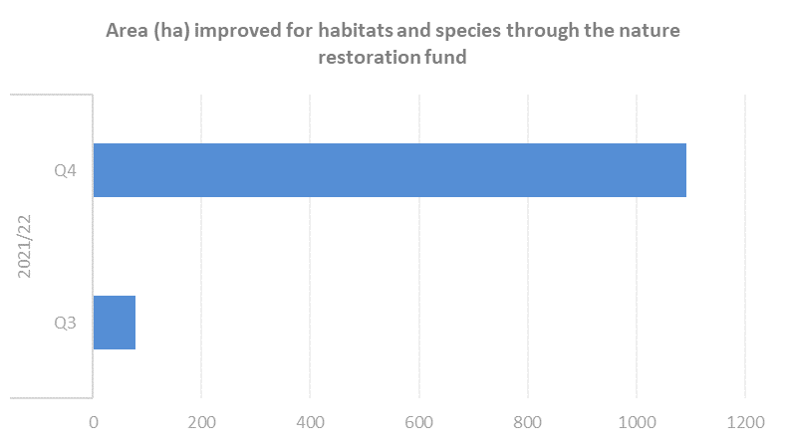 | Data is unable to be collected on a quarterly basis due to the manner of reporting from projects. | We expect to receive data when NRF2 Helping Nature projects complete later this year and in early 2024.

Measures in development – anticipated Q2
NatureScot is in partnership with more/new applicants

Demonstrate how agriculture can be transformed with new approaches to deliver targeted outcomes for nature and climate - Robbie Kernahan – GREEN
- Agri-Environment Climate Scheme (AECS) delivery - applicant advice and support on track; applicant deadlines and hence main Q1 case allocation and initial assessments shifted to Q2 to facilitate Scottish Government announcements.
- Farming with Nature (FwN) - key projects commenced to ensure field work coincides with summer conditions. Consequently all existing FwN activities continued on schedule and meeting Q1 targets.
- The number of individual farms involved in testing NatureScot's Biodiversity Audit yet to be expanded as planned for Q1. This should be back on track in Q2.
- Considerable input to development of principles and intervention logic adopted by the future support framework to ensure it embraces the breadth and depth of measures required to deliver SG’s nature, climate and sustainable agricultural production ambitions. This greatly helped by new SG governance bedding in and responsive to NatureScot's advice.
- SG led Biodiversity App discovery phase yet to be completed and contract for App development not yet let. However, the biodiversity audit process continues to be tested using the Piloting Outcome Based Approach Scheme (POBAS) app (extended) and the target of 10 habitat score cards have now been developed and in use in farmer testing.
- POBAS reports almost complete. Results to be disseminated in Q2.
- New POBAS outcome groups (sheep/deer/sea eagle clusters, geese, beavers) continue to be explored
- The Natural Capital Holding Template results shared with stakeholders at workshop on 12 June 2023.

Measure | Performance Overview | Cause | Response
No. of individual farm businesses that have completed a biodiversity audit |  | 62 farm businesses were offered MAs to undertake Biodiversity Audit work (acceptances not all received yet). | Most of these will have a Biodiversity Audit later in the year.

Valuing Nature

Outcome: The value of nature is reflected throughout public and private sector policy, underpinning care for nature and investment towards a wellbeing economy

Inspire people to connect with nature, increasing appreciation of nature’s value through impactful delivery and communication of our work – Nick Halfhide – GREEN
- Progress satisfactory across all major elements of work
- All bar three Green Infrastructure and Natural and Cultural Heritage Fund (NCHF) projects completed, and NCHF best practice show case event successfully delivered.
- Better Places funding of £900k was invested in 24 countryside, coast and island projects across Scotland, enabling an additional 62 staff to be employed this summer across Scotland.
- National Nature Reserves (NNR) - seasonal staffing in place and trained for new season
- Scottish Outdoor Access Code spring campaign (paid social media and radio) complete, social media influencer video campaign launched.
- A new suite of communication messages developed with National Access Forum (NAF) sub-group to enable deer management and public access to the hills to co-exist positively during key stalking periods.
- Our Make Space for Nature campaign web page was visited by almost 67,000 people and was the top visited page in April, with over 56,000 page views - a significant 42,000 more than the NatureScot homepage.
- Piloting of the Nature Discovery Map Scotland Map completed and revised Learning for Sustainability action plan which we contributed to via the leaders group published by SG.
- NatureScot co-ordinated Green Health Week (13-19 May) achieved 32,400 views of our social media posts and included Highland's Greenhealth Partnerships stakeholder event with input from the Chief Medical Officer, and a public-facing Green Health Activity Day at Eglinton country park in North Ayrshire.
Measure | Performance Overview | Cause | Response
Average time spend on the Make Space for Nature Webpage & No. of visits | 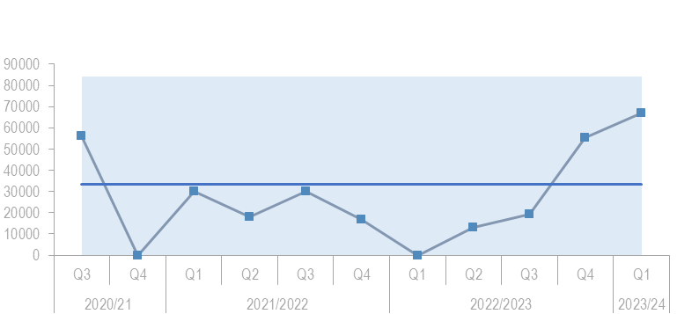 | 66816 clicks - Q1 activity continued to exceed campaign KPIs (3 mins avg dwell time/1% CTR) with spring results returning 9 mins and 2.43%. | Q2 activity includes a summer 5 week campaign, and additional social media influencer work and podcasts.

Influence the regulatory, policy, market and institutional infrastructure needed to stimulate private sector investment into nature – Robbie Kernahan – GREEN
- The Facility for Investment ready Nature in Scotland (FIRNS) is proceeding on timetable despite slight delays in decisions due to the higher than expected volume of demand. Over 70 Expressions of Interest received and responded to. Work in progress to design and operationalise Community of Practice (including FIRNS projects)
- The announcement of our partnership with Hampden & Co, Lombard Odier and Palladium created significant work (FoIs and Parliamentary Questions). The partnership is on target.
- Work on investing in peatland will re-start when a post is recruited and budget confirmed. We are reviewing the governance options for the Flow Country Green Finance Initiative – recoverable.
Measure | Performance Overview | Cause | Response
External funds raised by *SMEEF and the amount allocated to projects. | 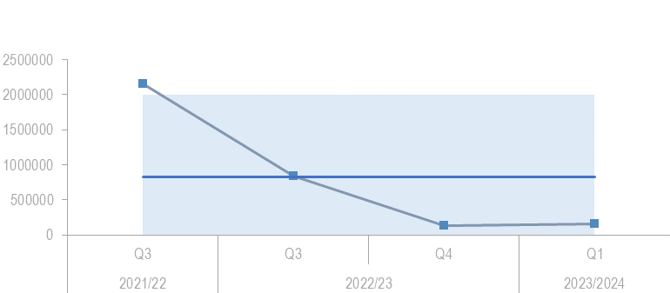 | £160k negotiated private finance now received. 21/22 High was NRF Money facilitated by SMEEF where currently the money is only SMEEF Funds. | Fundraising ongoing, grants expenditure underway.
*SMEEF is managed through our marine team but forms part of the Private Investment objective delivery plan

Measures in development – anticipated Q2
No. of hectares of natural habitat put on the road to recovery using private finance (recognised codes and standards)
Drive the establishment of Natural Capital as an integral part of public and private business planning and investment decisions at national, landscape and landholding/business scales – Robbie K – GREEN
- Role description for Natural capital E grade Manager agreed and recruitment underway.
- Stakeholder co-design workshops progressed on co-design of Natural Capital Landscape Tool.
- Agreement established with Liverpool John Moores University to use their free-to-use Nat cap tool development software to develop the Natural Capital Landscape Tool
- Business analysis of the Natural Capital Landscape Tool project and Nature Networks Civtech funded engagement with Architecture, Engineering, Construction, Operations and Management (AECOM) tool underway.
- Natural Capital Asset Index update published.
- Prioritisation of public land landscape clusters progressing.
- Some knowledge transfer events on natural capital staged internally across activity and national ops teams.
- Natural Capital landholding template workshop held with SG policy leads.
Measures in development – anticipated Q2
No. of Landscape partnerships that NatureScot is involved in that use a natural capital approach

Promote understanding and awareness of skills and capacity needs for the nature based sector – Nick Halfhide – GREEN
- Progress satisfactory across all major elements of work. Parallel work on skills and jobs for peatland and wildlife management are picked up in these delivery plans
- Published 23/24 NatureScot Nature-based Jobs and Skills Action Plan. Provided leadership to the refresh of Climate Emergency Skills Action Plan (CESAP) through developing a ToR for CESAP Land Management Sub-group and convened first meeting.
- Raised awareness of nature-based careers by delivering a 'Nature-based Jobs' session as part of Developing the Young Workforce (DYW) Live Summers Careers Fair.
- Built nature-based learning into the Land-based Apprenticeship Development Programme led by SDS. The Skills Team prepared 6 new Work Situations (building blocks of apprenticeships) that have now been accepted by the Technical Expert Group
- Began scoping of a new volunteering management framework for NatureScot.
- The Science, Technology, Engineering & Mathematics (STEM) outputs have been delayed in order to widen engagement from other Activity Teams. Delay is recoverable by end of Q3.
Measure | Performance Overview | Cause | Response
Nature-restoration jobs and skill development opportunities created through our activity | 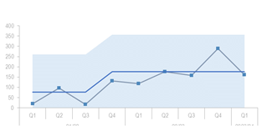 | 162 - Only a small reduction in Peatland trainee numbers which in fact points to a consistent delivery of training throughout the year. A new tranche of WWR placements will be in place by Q1 of 23/24. | 2 New to Nature Jobs will start in Q1 23/24 plus 12, 6 Month Working with Rivers Placements.

The NatureScot Way
Outcome: Our passion, inspiration and expertise will put nature at the heart of Scotland’s future

Deliver new ways of working to stimulate achievement of our ambitions – Jane MacDonald – GREEN
- Evidence given to the Public Administration and Finance Committee on NatureScot’s progress and approach to Public Sector Reform.
- 2 staff conferences held with excellent attendance and positive feedback both during and after events.
- Progress towards Silvan House move also on track – Virtual Private Network (VPN) and firewall servers moved to Inverness. We are still experiencing network issues arising from running hybrid working through legacy architecture but we are making progress towards resolving these; major changes to VPN architecture associated with their move to GGH have so far seen a marked improvement in stability & performance. This supports the previous Information Technology Implementation Programme (ITIP) decision to prioritise network re-design over further troubleshooting. Objective cloud move will be complete by end of quarter which should mitigate eRDMS issues.
- Property focus has also been primarily on Silvan House move but Battleby business case is complete. Clydebank and Dunoon to follow.
- GGH AC Units project has been instructed. We are currently negotiating internally on the specification required to cover the existing and possible future loads. A decision is imminent and we should be able to confirm contract specification in next couple of weeks and then plan the work around resource availability following the Silvan House move.
- 90 day planning process becoming embedded. Work with Mazars to deliver 2022/23 Annual accounts on track - Annual Report substantially complete.
- Net-zero GGH PV and Battery Project has commenced on-site. This project should be completed early in Q3.

Measure | Performance Overview | Cause |  |  |  | Response
Sq meterage of floorspace dedicated to NatureScot |  |  | 2725.6m2 - The headline news is that we have made a reduction in space occupied of 637m2. |  | In addition to this we have made some success in selling vacant space with the inward collocations of partners into NatureScot offices across Scotland which is helping to offset the space handed back to us in GGH when partners downsized.
Total emission reduction | 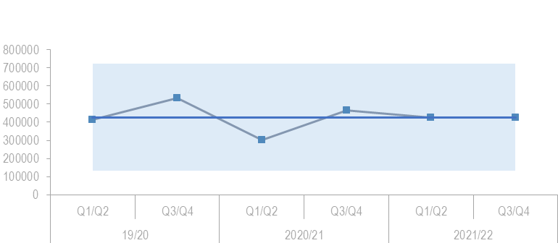 |  |  | 424,500 Measure updated every 6 months due to timing of data collection.

Transform our individual and collective leadership capability – Jane MacDonald - GREEN
- Have progressed Learning & Development strategy and work underway to engage and promote our learning framework and leadership skills (insights work).
- Skills capacity and requirements for objectives continues and phase 1 complete for this, phase 2 has commenced.
- Coaching offer continues and clients being coached.

Sustain our focus on developing a happy and resilient workforce – Jane MacDonald – GREEN
- Lone working options presented to Health Safety & Wellbeing Committee and look to review options.
- Employment law cost - case now filed and therefore may be an increase in costs.
- People Strategy and Programme developed to include work package teams and team development.
- Performance Management Review completed and guidance updated to reflect new operating model and 90 day business planning process.
- Learning Framework promotion
- Career MOTs progressed.

Measure | Performance Overview | Cause | Response
Protected Characteristics reported | 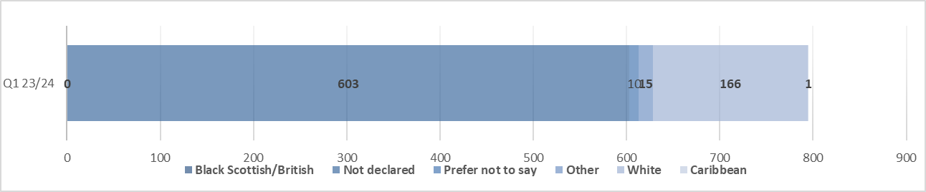 | Disclosure continues to remain low, further campaigns to encourage disclosure is key. | In 2023/24, there will be continued work on EDI actions and increasing disclosure through campaign and visible support.
Workforce Diversity – Disability | 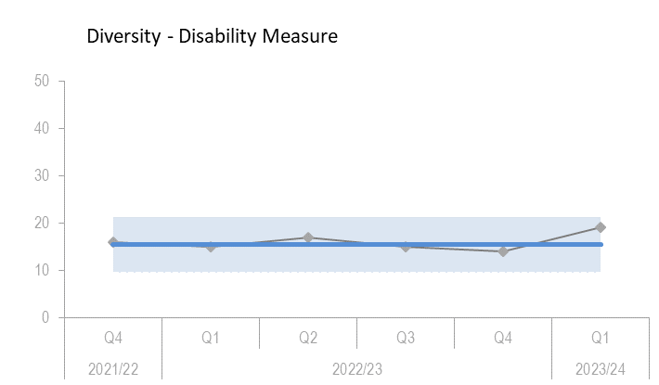 | 19 - remains cultural norms. We continue to work in Partnership to tackle these. | In 2023/24, there will be continued work on EDI actions and increasing opportunities within diverse communities.
Workforce Diversity – Age | 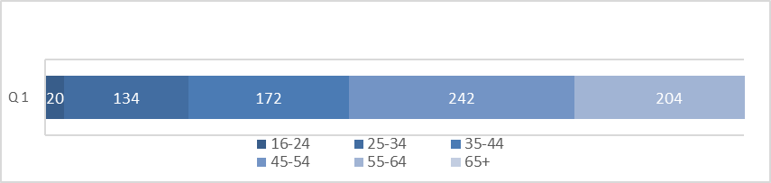 | Small changes from previous quarters but it remains a similar range | In 2023/24, there will be continued work on EDI actions and increasing opportunities within diverse communities.
Workforce Diversity – Ethnicity | 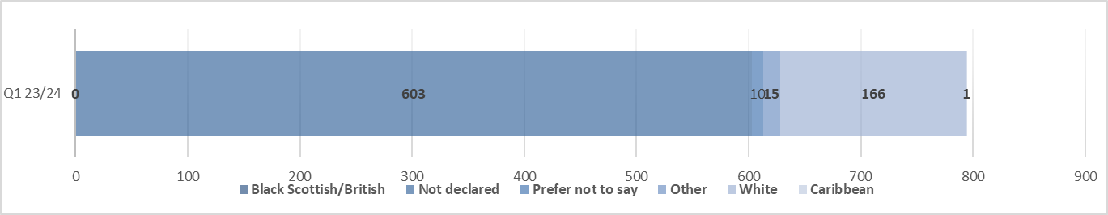 | Still a large population have not declared. | In 2023/24, there will be continued work on EDI actions and increasing opportunities within diverse communities.

FINANCE

Financial Metrics (£m) | Measure | Budget | Forecast | Variance | Rating
Resource Budget | Outturn within 1% of final budget | 59.9 | 60.1 | (0.2) | ON TRACK
Capital | Outturn within 5% of final budget | 1.8 | 2.2 | 0.4 | MAJOR SLIPPAGE
Indirect Capital | Outturn within 5% of final budget | 15.0 | 14.5 | 0.5 | ON TRACK
Paybill | Outturn within 1% of final budget | 38.9 | 40.1 | (1.2) | MINOR SLIPPAGE
Project Allocation | Outturn within target allocation range | 12.9 | 12.5 | 0.4 | MINOR SLIPPAGE
Peatlands | Outturn within 1% of final budget | 14.3 | 14.3 | 0.0 | ON TRACK
Farming with Nature | Outturn within 1% of final budget | 0.2 | 0.2 | 0.0 | ON TRACK
Better Places Fund | Outturn within 1% of final budget | 0.9 | 0.9 | 0.0 | ON TRACK
Nature Restoration Fund | Outturn within 1% of final budget | 6.7 | 6.1 | 0.6 | MINOR SLIPPAGE
FIRNS | Outturn within 1% of final budget | 1.8 | 1.8 | 0.0 | ON TRACK

*Operating under 1% - on track, up to 10% minor slippage, over 10% major slippage (** Capital under 5% / up to 10%)
Financial graphs | ummary of performance
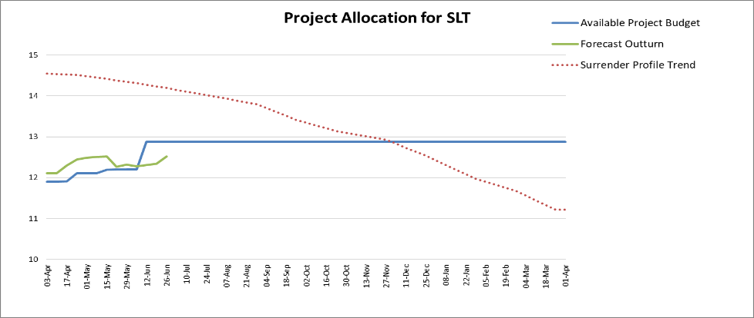  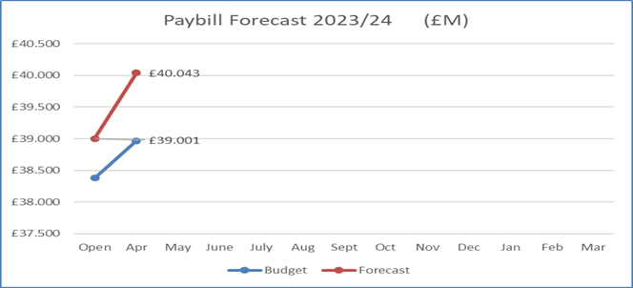 | The Project Allocation Forecast Tracker reflects the newly introduced strategic resource management approach with confidence levels (£2.8m) applied to the budget for each corporate plan objective. It does not include ring-fenced funds so NRF, BPF, Peatlands, FIRNS and FwN are stripped out. The project budget and target is £12.874m with a current forecast of £12.515m at this early stage of the year.  The paybill forecast is currently £1.1m above budget. We expect sufficient savings to be realised through leavers and vacancy gaps to remove this variance by year end.

Resource Budget Performance
- An overspend of £0.235m is currently forecast on the Resource budget, however it is anticipated that we will end the year within our target outturn. At the same point in 2022/23 an overspend of £0.550m was forecast.
- Having introduced the new strategic resource management approach this quarter, we have applied confidence levels to the budget for each Corporate Plan Objective (total £2.8m). The Objective Leads are working towards bringing their Objective programme in on budget (and therefore reducing the allocations arising from these confidence levels) by the end of the year.
- We have just received confirmation of our Farming with Nature (FwN) budget (£1.285m resource). This is not yet reflected in the financial metrics with just £0.2m allocated from the SRDP retention for now.
- We received confirmation in May from SG of £1.8m funding for 2023/24 for the delivery of the Facility for Investment Ready Nature in Scotland (FIRNS).
- The budget management exercise will begin in early Q2, challenging uncommitted budgets and ensuring that allocations are optimised with respect to high priority work considered achievable during the remainder of the year. This will build on the recommendations of the internal audit on forecasting concluded last year.
- The paybill outturn is currently projected to exceed the budget by £1.135m. This follows the early approval of staffing requirements for 2023/24 in response to identified resourcing pressures. This proactive approach ensures that we can respond to the developing needs of the organisation in the right timeframe. It is anticipated that sufficient savings will be achieved throughout the year to meet the paybill budget.

Indirect Capital Funding Programmes (including Peatlands)
- We are forecasting an underspend on Indirect Capital of £0.500m to reflect the risk of slippage on NRF – 10% of forecast outturn split against the indirect capital (£0.5m) and resource (£0.15m) budgets.
- However, awards are currently being agreed for the Nature Restoration Fund and Peatlands with an over-allocation approach to ensure that full budget spend is achieved.
- The Peatland Action budget for 23/24 is £14.25m, split £4.25m resource and £10m indirect capital.
- The Nature Recovery Fund (NRF) budget for 23/24 is £6.750m, split £1.750m resource and £5m indirect capital.

Structural Funds Programmes
- ERDF Claims: NatureScot has paid £7.0m to grantees in advance of these claims being submitted to SG. The penultimate claim will be submitted to the Managing Authority in early July.

Capital Budget Performance
- An overspend of £0.429m is currently forecast on the capital budget.
- This is primarily due to the projected cost of developing the NatureScot Licensing System. A business case for the development of the system is currently being drafted as we consider next steps.

RISK

Corporate Risks | Risk Changes
Changes to Corporate Risk Scores
↑ 1 Gone Up
↓ 1 Gone Down
Change to Corporate Risk Register - proposed
↗ 0 New Corporate Risks
↘ 1 Risk De-Escalated

Risk
- The NatureScot Corporate Risk Register holds the current corporate risks for NatureScot. Activity and project risks are managed within the risk management system, which underpins the corporate risk register. All risks are managed in line with the Risk Management Policy and monitored regularly for compliance and visibility of impact.
- There are currently 11 approved Corporate Risks, 6 medium and 5 high. During Q1 the likelihood score changed within 2 risks: 21 – Budget management (increased) and 253 – Peatland restoration and target (decreased), but this hasn’t impacted the overall risk ratings.

- During Q1, the Corporate Risks have been reviewed to ensure that they still require to be managed at the corporate level. Risk 691 – Lack of support for Fusion was proposed for de-escalation and this decision was supported by SLT. This is as a result of the recruitment and embedding of new FUSION team members.

Board are requested to note the performance of the corporate risks and the de-escalation of risk 691.

PEOPLE

People Metrics | Status
Wellbeing – Accidents and Near Misses are within target levels
Accidents & Near Misses: Target: to stay within variations around the mean which are 4.4 for accidents & 5.8 for near misses  - Q1: Accidents=4, Near Misses=4. This is within the targets set and is also in line with previous years in terms of Q1 results (except 2018/19 were the accidents reported exceeded the target with 19 accidents recorded).  - Our Health & Safety engagement theme for Q1 was improving the reporting of accidents and near misses, which may have resulted in the increase in reporting from Q4. | Green
Health, Safety, Wellbeing – Work Life Balance Pulse Survey  - 90% of pulse survey respondents confirmed they are confident NatureScot takes Health & Safety seriously. This is a slight decrease from the July 2022 survey, which gave a result of 87%.  - 80% feel confident that NatureScot takes Wellbeing seriously.  - 56% of respondents stated that they rarely feel pressured to work extra hours. This is unchanged from July 2022. However, 62% stated they disagreed with the statement that they rarely worked extra hours; this may reflect the continuing issue of managing down excess flexi balances.  - 77% of the respondents felt that they are supported to take control of their wellbeing while at work. When asked if they wish to highlight key areas, 29% responded linking this directly to workloads and lack of resourcing.  - There were also a notable number of comments around frustrations in terms of IS systems. The move to the Objective Nexus Cloud during Q1 has taken pressure off the network, which will address some of the stressors indicated in the pulse survey.  - It is anticipated that the new operating model and 90-day business planning process will address resourcing pressures, enabling more flexibility in terms of the movement of our people resource around the organisation | Green
Capacity – Sickness is within target levels and holiday leave is ahead of target
Sickness – Target: under 2 days per person per quarter  - Q1: 1.29 days per person sickness (down from 1.59 days in Q4), which is below the target per quarter and is still below the pre pandemic absences rate of 1.33 days.  - Most of the absences in Q1 were short-term; 2.4% of 208 sick absences in Q1 were long term, an increase of 0.6% from Q4.  - The top short-term sickness reason in Q1 was Mental Health – Personal Stress/ Depression/ Anxiety, with some employees having multiple short-term absences.  - Figures for Q4 have been amended due to some late data entries. POD are working to reduce these through engagement & communication. | Green
Annual Leave: Q1 Target 25%  - Q1: 31% of holiday leave booked or taken; this is ahead of target for Q1 in terms of accrued leave booked or taken. | Green
Development – Key areas of casework relate to short and long term absences
Formal Casework – Target <=50% of informal casework  - Q1: 19.4% (6 cases), with the key category linked to long-term sickness absences.  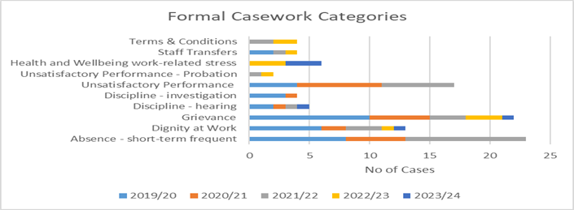  (This graph shows number of formal casework for each type) | Green
Informal Casework  - Q1: 31 cases.  - Q1 has seen a decrease of 5 cases from Q4. The decrease in Q1 is in relation to various categories however, there has been an increase in informal casework related to short-term absences in Q1. | Green
Workforce Profile - Turnover is increasing.
Increased proportion of employees under 30 years old
Turnover – target: maintain in the range of 8-10%  - Turnover is increasing. We are also continuing to see movement around the organisation through promotion or level transfers; there is no change in the retirement profile.  - Q1: average turnover is 11% (over last 12 months), with 15 leavers in Q1.  - 53% left for personal reasons, 27% were colleagues leaving for alternative employment and 14% of these were retirements.  - The graph below shows that there has been a steady increase in the turnover rate since the lockdown restrictions were lifted and the recruitment market became more competitive.  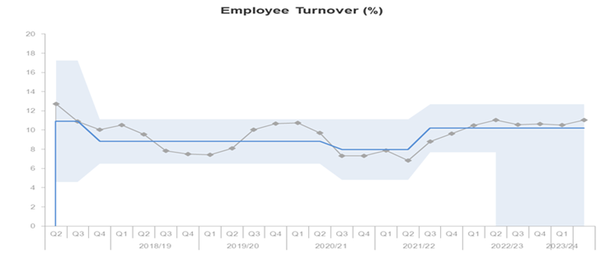  (This graph shows the employee turnover)  - This quarter, most of our leavers have left due to personal reasons (53%), followed by staff moving to alternative employment (27%). There are no significant issues emerging from the exit questionnaire feedback so far.  - Since 2020 we have seen an increase in the percentage of staff leaving to go to alternative employment. | Green
Internal Movement – target: increase internal moves to acceptable level  - Q1: Internal moves have reduced, with 37 internal moves. This is 5% of the headcount of employees moving into alternative roles through promotion or level transfers and returning to their substantive post following a reassignment.  - To date in 2023/24 there have been 54 recruitment campaigns, 6 (11%) of which have failed to attract a successful candidate. In comparison, there were 60 recruitment campaigns in Q1 of 2022/23, and 14 (23%) failed campaigns.  - 17 recruitment campaigns have been filled internally, 7 have been filled by external candidates, 6 have failed to appoint and the remaining 24 vacancies are currently in progress.  - In Q1 there have been 44 new starts, with the majority being full-time and fixed term posts, which is consistent with the previous quarter.  - 32 of our new starters are in core positions and 11 are project-funded roles.  - The greatest proportion of new starts in Q1 matched Q4, in terms of their age range (25-34). This has resulted in the proportion of employees under the age of 30 almost doubling since Q1 2020/21.  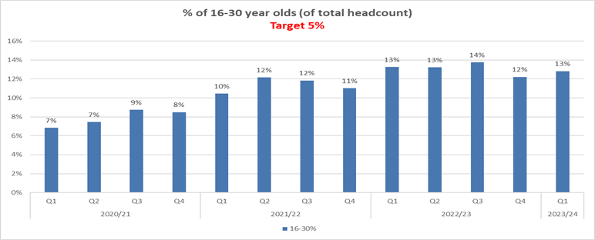  (This graph shows percentage of 16-30 year olds per headcount)  Programme for Youth Employment  - The 2-year period for our first Programme for Youth Employment will end in Q2; there have been some notable successes of the programme in terms of bringing new talent into NatureScot.  - The programme hosted 17 modern apprenticeships, 3 trainee Operations Officers, 9 Project Placements and 5-part funded placements from CEMVO and UHI Trainee Rangers.  - 20 have moved into other roles within NatureScot in terms of both permanent and fixed term roles; 4 of them are moving into nature-based roles in other organisations. 7 from the Programme left NatureScot with other plans.  - The partnership with UHI is continuing and 2 new Trainee Rangers started in Q1. We also have part funding from New to Nature for a 12-month placement, who started in Q1.  - In Q4 2022/23 we saw youth employment being mainstreamed into the organisation’s recruitment process, with five positions recruited to. This is 4% of the total recruitments since the beginning of the year.  - Future investment in youth employment will be a key element in our strategic workforce planning going forward. | Green
Retirement Profile  - Q1: 178 employees are aged 57+. This is predicted to rise to 227 in 2025/26 (28.55% of current headcount).  - In Q1, 2 employees retired (14% of leavers in Q1). The average retirement age for Q1 is 65; however, this may reduce during the reporting year as shown in the graph below and may be linked to the cost-of-living crisis and employees staying in employment longer.  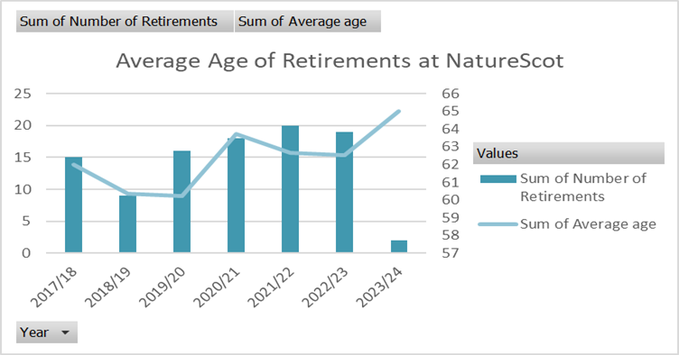  (This graph shows average of employees retiring) | Amber

Recommendations

- Board are asked to:

  - Note the overall performance of the Corporate Plan objectives (Performance Report)
  - Note the position of the operating and capital budgets (Finance Report)
  - Note the performance of the corporate risks noted in paragraph 5 (Risk Report)
  - Note the overall performance of the People Measures (People Report

Annex A – National Performance Framework Indicators
NPF Indicator (NatureScot lead reporting on) | Status | Latest Update
Improve the condition of protected nature sites | Performance Worsening | March 2023
Biodiversity | Maintaining | 2016
Increase natural capital | Maintaining | July 2023

NPF Indicator (NatureScot contribute towards) | Status | Latest Update
Increase people’s use of Scotland’s outdoors | To be confirmed | 2020
Improve access to local green and blue space | To be confirmed | 2020
Reduce Scotland’s carbon footprint | Maintaining | July 2023
Progress on each Indicator is undertaken annually and where an update occurs we shall provide a report below. Where the status states to be confirmed, this is because, as a result of the Covid-19 pandemic, the approach to gathering the data has changed and it is therefore not directly comparable with previous years.
Protected nature sites
This indicator reports the percentage of natural features on protected nature sites found to be in favourable condition.
By the end of March 2023, 76.4% of natural features were assessed as being in a favourable condition, 1.4 percentage points lower than recorded in March 2022 and 0.4 percentage points higher than recorded in 2007.
Biodiversity
This indicator is a combination of trends for three measures of Scottish species, index of abundance of marine species (based on seabirds), index of abundance of terrestrial species and index of occupancy of terrestrial species.
All three measures were stable over the period 2015 to 2016. The index of abundance of marine species rose by 2.7%, the index of abundance of terrestrial species fell by 4.8% and the index of occupancy of terrestrial species rose by 0.8%.
Over the longer term, between 1994 and 2016, the index of abundance of marine species fell by 36%, the index of abundance of terrestrial species fell by 31% and the index of occupancy of terrestrial species rose by 24%. The marine elements of the indicator continue to be under development as new species data becomes available. Breakdowns for the three measures are available for the main taxonomic groups.

Natural Capital
The Natural Capital Asset Index (NCAI) monitors the quality and quantity of terrestrial habitats in Scotland, and tracks their potential to deliver ecosystem services now and into the future. It is a composite index, based (i.e. equal to 100) in the year 2000. The NCAI in 2021 at 102.7 unchanged from its 2020 value and 0.2 points higher than its 2018 value.
It is recognised that at this point in time, the NCAI still requires further development and refinement to produce a fully satisfactory measure. Despite this it is seen as a valuable addition to the indicator set. We will continue to work closely with key stakeholders over time to develop the NCAI and other potential future measures.

Annex B – Corporate Risk Register (High Risks)
RISK TITLE | DESCRIPTION | CONTROLS | IMPACT | LIKLE-HOOD | RISK LEVEL | COMMENTS
47 - Computer Virus/Malware | As a result of inadequate protection, or inappropriate system use, including accidental activation of email links by that lead to malware downloads, there is a risk that NatureScot systems becoming infected with a malware or virus agent, resulting in NatureScot systems and data become unavailable, encrypted or corrupted, significant system downtime and huge operational impacts | *All file servers are protected by Sophos antivirus protection. Upgrades are performed automatically and can also be applied in an ad-hoc manner  *All PCs are protected by Sophos antivirus protection. Upgrades are received on a daily basis but can be applied ad-hoc  *All incoming emails are scanned for viruses.  *All internet access, are scanned for viruses via Zscaler service.  *Raise staff awareness of potential risks relating to email links and infected documents through regular communications.  *Sandbox controls/ environment implemented  *Control of USB devices  *Awareness raising with staff via Blogs and update articles  *Incident Management Group in place  *Corporate data backed up to cloud | 4 | 3 | High | Continue to monitor Zscaler and initial deployment of SIEM environment. Further plans to strengthen the infrastructure and reduce complexity underway by the closure of SH house and removal/redesign of CAG service and shift to inverness. Extensive amount of technical redesign is about to take place so we are looking at a large amount of pen testing to ensure the new solution is secure.
253 - Peatland restoration target and budget. | As a result of the immature and complex operating environment, there is a risk to: meeting the annual Peatland ACTION restoration hectare target; and spending the annual budget. | • Realistic planning  • Invigorating demand  • Real-time monitoring  • Increasing resilience to change in projections  • Regular and robust review and control  • New Guidance on operating during nesting season being update to allow risk based approach to operations during that period. | 4 | 3 | High | Likelihood of risk reduced to 3 by: - Realistic planning - targets reduced and Programme Plan in place to deliver full spend. • Invigorating demand - clarified that PA and PC can operated in tandem. Delays in Code validation reduced by two additional validators. • Real-time monitoring - good. Programme Plan Monitoring allowed for return of £2.5m • Increasing resilience to change in projections - resilience still poor. Our pipeline is not sufficient to cope with slippage. • Regular and robust review and control - monthly reports identifying slippage • New Guidance on operating during nesting season being update to allow risk based approach to operations during that period. - Guidance published, 9 projects operating in the bird breeding season.
393 - Future Funding of NatureScot | As a result of on-going reductions in public expenditure or new cost pressures there is a risk our grant-in-aid settlement may not match statutory and fixed costs as well as corporate plan priorities. Unless other funding sources are secured this could result in an inability to adequately resource delivery of agreed priorities, leading to failed outcomes and reputational damage. | * Ensure that our priorities are aligned with published Programmes for Government and ministerial portfolio priorities, specifically those aligned to the Programme for Government and Bute House Agreement  * Provide realistic and evidenced assessment of the impact of possible cuts in our grant-in-aid budget through the annual Spending Review process.  * Develop and put forward proposals, through the annual Spending Review process and other avenues with Scottish Government, for delivering more and better outcomes for nature and people through wider Scottish Government funding.  * Reduce expenditure in some business areas through budget setting processes aligned to business planning cycle.  * Identify efficiencies and savings in our current spending and ways of working to maximise the resources available for front line delivery.  * Have an effective communications strategy in place which promotes the added value of our work.  * Identify and implement opportunities to generate income from the services we provide.  * Identify and implement opportunities for external funding of NatureScot-led work through the business planning process (including at Outcome and Activity levels) and at the project development stage for significant scale projects.  * Develop proposals for new, preventative projects that can help deliver a wider set of SG priorities, and build awareness and support of these.  * Develop and refresh a short, medium and longer term financial plan based on potential financial scenarios. | 4 | 3 | High | Risk continues to be High for NatureScot. Additional effort this month submitting a response to the Strategic Approach to Budgeting exercise and a request for a follow up discussion with Scottish Government. Additionally, Objective leads are developing drop/defer/delay plans in preparation for 24/25 planning.
691 - Lack of support for Fusion | Due to the specialised nature of Oracle Fusion and the interface with NatureScot’s Business Planning System, as a result of key system support staff leaving the organisation, there is a risk that there will be insufficient knowledge and ability to operate key processes or to develop the system and reports. This may result in an inability to adapt the system to changing business needs, reporting delays or to operational inefficiencies and payment challenges that could affect all users of the system. | - Engage in a shared service arrangement with other organisations using Fusion e.g. HES, SLAB  - Make use of the support arrangement from Inoapps currently utilised by POD. There may not be sufficient knowledge from Inoapps to initially support some finance and procurement processes.  - Explore potential for a third party to provide level 2 support to assist that provided by NatureScot staff.  - Recruit to the two vacant functional analyst positions.  - Recruit to the vacant Oracle Cloud Service Manager position  - Draw on finance staff with an awareness of Fusion and the interface with Business Planning as well as the functional analysts who support the POD elements of Fusion, in order to support the finance elements of Fusion. It should be noted that this will not provide all of the specialist knowledge required.  - Implement a networked team approach to involve staff from a wider group to share knowledge and provide resilience in future. | 4 | 3 | High | Of the four vacant positions at the start of the year, we have recruited to three of these positions. The two FPP support analysts and the Oracle Cloud Services Manager are now in post. Recruitment for the remaining vacant POD support analyst position is progressing. The development of the current support analyst to take on a wider ranging role developing support arrangements for NatureScot is underway.  Work on the procurement tender document for Fusion support is moving forward and will include a focus on knowledge transfer to ensure that the skills of NatureScot staff are developed. We have also discussed the potential for shared service arrangements with SG colleagues who are implementing an Oracle solution in April 2024. We are also discussing ways to working together and sharing knowledge with fellow Fusion users. A workstream with the Oracle User Group that is dedicated to senior responsible officers in a number of organisations has been established.  It is proposed that this risk is de-escalated from corporate risk status.

