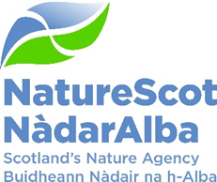

Title: Q4 Performance Report 2022/23
Date: 10th May 2023

Purpose: | Decision
How does this link with our corporate priorities of improving biodiversity or delivering nature-based solutions to climate change: | This paper presents Q4 progress towards delivery of our corporate priorities as laid out in our Business Plan, A Nature-rich future for all: Year 1.
Summary: | At the end of Q4, performance for 14 of our 15 Corporate plan objectives are rated as ‘on track’. The score for one corporate risk scores has reduced this quarter. There are no new corporate risks for escalation or de-escalation. Our Resource budget is expected to outturn below tolerance due to two factors outwith our control - delivery on Farming with Nature (FwN) was delayed pending input from SG and additional budget was allocated by SG for depreciation as we transition to a new accounting standard (IFRS-16). Direct Capital is expected to outturn below tolerance due to large projects slipping into 23/24. Indirect Capital is on track. In the People Report, eight of the nine indicators are green and one remains at amber.
Actions: | To agree the recommendations below
Recommendations: | Board are asked to:  - Approve the overall performance of the Corporate Plan objectives (Performance Report)  - Approve the position of the operating and capital budgets (Finance Report)  - Approve the performance of the corporate risks (Risk Report)  - Approve the overall performance of the People Measures (People Report)
Report Author(s): | Authors – Directors, Deputy Directors, Outcomes Managers, Finance, Planning & Performance Team, People & OD Team
Sponsor: | Stuart MacQuarrie, Jane Macdonald
Annex | Annex A – Progress on Corporate Plan at the end of Year 1  Annex B – Corporate Risk Register

Purpose
- This paper presents NatureScot’s performance for the final quarter of 2022/23. It also provides an over view of progress across the year and how this connects to our Corporate Plan. It addresses delivery of our corporate priorities by reviewing; the alignment of performance against our Business Plan, a Nature-rich future for all: Year 1; progress towards maximising our available budget; assessing risks for delivery; and reviewing people information supporting the resourcing of our work. A short assessment is provided in Annex 1 of progress against delivery of our Corporate Plan 2022-23, A Nature-rich future for all.

Summary – Review of 22/23

- 2022/23 has been a significant year for NatureScot. The Bute House Agreement provided a renewed focus for investment in nature/climate with some key priorities central to underpinning progress against our corporate plan this past year, including:
- Publication of a new draft biodiversity strategy to deliver COP15 commitments and early preparation for a Natural Environment Bill
- Further work towards binding targets to halt the rapid decline of Scotland’s nature by 2030 and set nature on track to recovery on land and at sea.
- Advice delivered to Ministers on the establishment of a new National Park(s)
- Public consultation on a world-leading suite of Highly Protected Marine Areas (HPMAs) covering at least 10% of our seas.
- Sharper focus on our wildlife management duties with emerging new responsibilities across a range of activities including hunting with dogs, Grouse Moor management and muirburn.
- Strengthened approach to Deer Management.
- A new National Planning Framework setting requirements for biodiversity enhancement for all developments
- Further developmental work on nature friendly agricultural practice based on outcomes aligned to nature restoration.
- Fresh, new progress towards opening up green finance markets manifest in our partnership with Hampden and Co, Lombard Odier Investment Managers and Palladium as well as IRNS follow on Facility for Investment Ready Nature in Scotland (FIRNS).

- This hasn’t however come without challenge. Rising costs as a result of inflation and significant additional resource impacts have put pressure on NatureScot financially and will continue to do so in coming years. The Organisational Design Programme has focussed on how to manage this internal pressure and a new 90 day planning approach will be formally implemented in 2023/24 to ensure prioritisation and workload management remain at the forefront of decision making but there will be difficult choices ahead in the light of potentially significant budget reductions in future years.

- Annex A - Progress on Corporate Plan at the end of Year 1, summarises our progress on our Corporate Plan ambition at the end of the first year.

- The table below reflects the Corporate Plan objectives and risks, finance and people metrics.

PRIORITY PERFORMANCE | NUMBER | CORPORATE RISK | NUMBER
Objectives | 15 | Corporate Risks | 11
On Track | 14 | Increased Score | 0
Minor Slippage | 1 | Decreased Score | 0
FINANCIAL METRICS | STATUS | PEOPLE METRICS | STATUS
Resource | Minor Slippage | Wellbeing | On Track
Project Allocation | On Track | Capacity | On Track
Paybill | On Track | Development | On Track
Capital | Major Slippage | Workforce Profile | Minor Slippage

PERFORMANCE DASHBOARD
RAG status will be available once 5 data points are collected. Bar charts are used until this point and initial data is noted without a graph

WE HAVE PROTECTED NATURE
Score | Measure | Performance Overview | Actual | Cause | Response
GREEN | Reducing Deer Numbers | 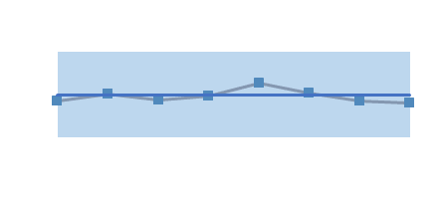 | No. deer culled 102728 | Ongoing deer management practices continue to manage numbers at a comparable level. Annual figure, next available Q1 2023/2 4. | This management activity continues alongside advancement of legislative and policy work to transform deer management to reduce overall impact to allow species and habitats to restore naturally.
RED | Area (ha) of woodlands restored (% of woodlands in favourable condition) | 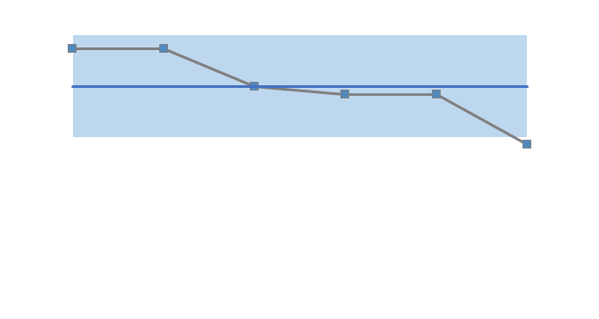 | 33.7% | The poor/declining condition of woodland sites is overwhelmingly driven by chronic overgrazing – to be specific, high herbivore impact especially by wild deer. Annual figure, next available Q1 2023/24. | NatureScot is addressing these issues through the SBS Delivery plans, through deer management planning and in collaboration with Scottish Forestry.

WE HAVE RESTORED NATURE
Score | Measure | Performance Overview | Actual | Cause | Response
 | Funds raised and Allocated by SMEEF | 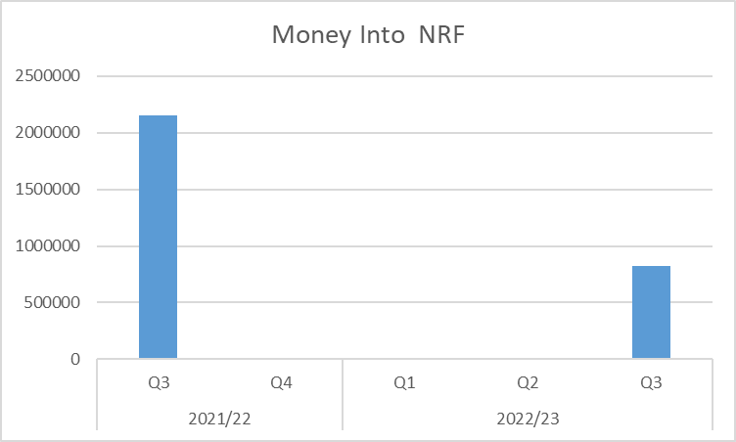 | 823,038 | NRF money only and reflective of the breaks in between funding rounds. | NRF money only and reflective of the breaks in between funding rounds. The fund is not at the point to record private investment. This measure will come into place in 2023/24.
 | Ha of land managed under plans supported through agricultural support schemes | 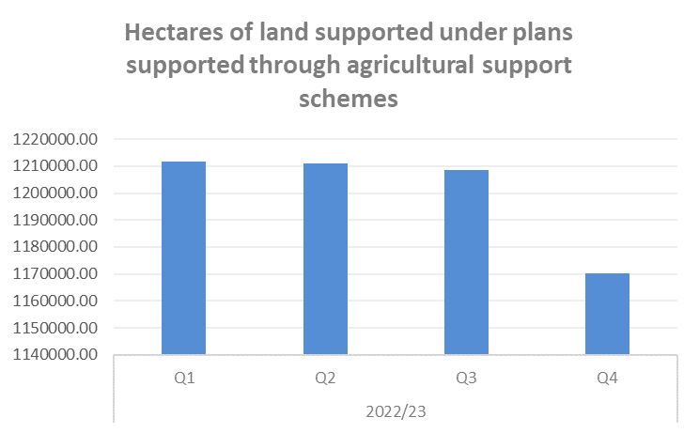 | 1,170,298 | In response to the restricted budget there was a restricted ACES round in 2021. This has resulted in the area of land able to be supported through the ACES scheme has been reduced. | The budget remains under pressure however funding for designated land continues to be prioritised.
 | Area (ha) improved for habitats and species through the nature restoration fund | 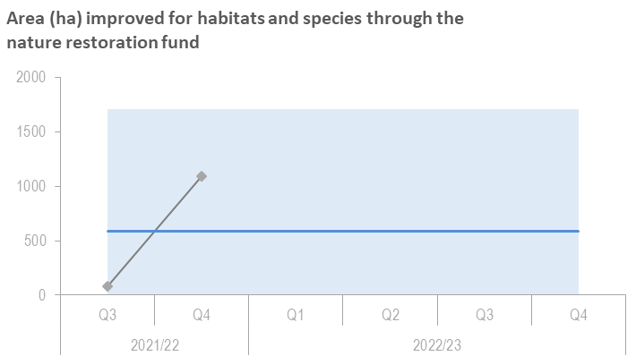 |  | A change in approach during 2022/23 has meant that data has not been recovered for grant claims on a quarterly basis. Annual figures (not yet available) will be provided for the Annual Report. | We expect to receive data when NRF2 Helping Nature projects complete later this year and in early 2024. We will also review the reporting process to collect this data on a quarterly basis. We expect the data to show a significant increase in hectares restored through a number of successful projects.
GREEN | Area (ha) of peatland put on the road to recovery | 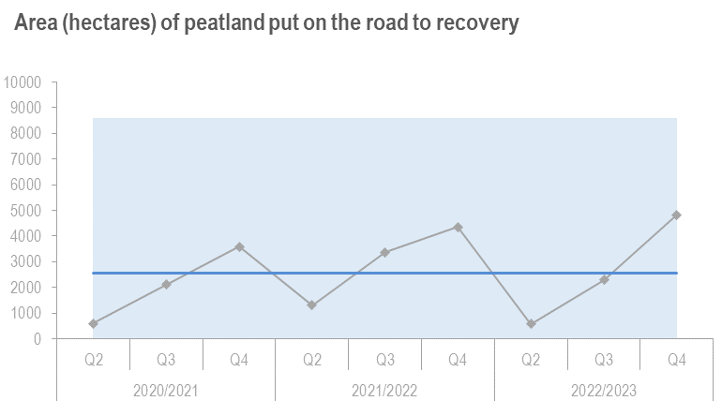 | 4700 | As expected, more projects are completed in this quarter due to seasonality of work (not all verified yet)- The final numbers are likely to increase further within the coming weeks (Late report submissions) | We are expecting to meet our ha target

THE VALUE OF NATURE IS RECOGNISED
Score | Measure | Performance Overview | Actual | Cause | Response
GREEN | Hectares of Green infrastructure Restored | 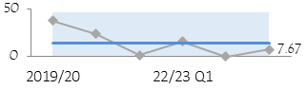 | 7.67 | No projects expected to complete this quarter. | Remaining projects have all started construction. Only one project, Foresterhill, is predicted to not complete 100% of their construction until 31 August 23. Only expenditure up to end June 2024 will be eligible for ERDF grant, and we will therefore be claiming less grant from the Managing Authority. NatureScot’s grant contract with the Managing Authority is not at risk because all of our targets have either been met or exceeded.
GREEN | Nature-based jobs and skills opportunities | 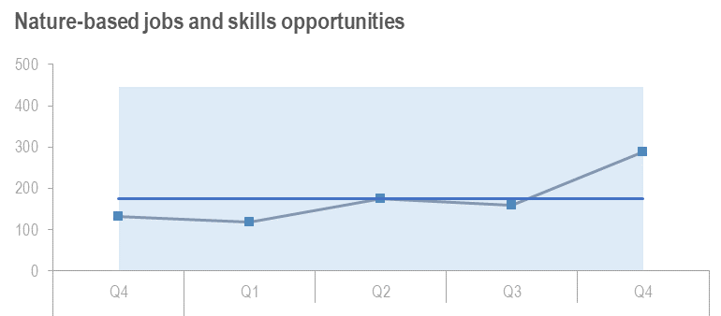 | 289 | People attending following Peatland Action Events - 2 day training events = 123. Practical training through new entrant scheme = 11. 2 hour online courses (including those in Skills Week) = 121 | 2 new to Nature Jobs will start in Q1 23/24 plus 12, 6 Month Working with Rivers Placements
 | % of landholdings undertaking a publicly supported Natural Capital approach | No audits undertaken during Q4 |  | No additional farms undertaking Natural Capital Assessments through NatureScot Project 117814. | The farm level natural capital assessment template project is paused, while we are in a phase of engagement with Scottish Government to disseminate the learnings of the project, and seek to influence them to incorporate natural capital approaches into the future rural support framework.
GREEN | National Nature Reserves online engagement | 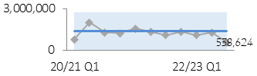 | 538,624 | There has been a significant drop in engagement across the reserves.  We expect some decrease over autumn winter as online engagement reflects the level of visits on the ground. | Further investigation needed as to why the drop has been more significant this quarter. We will follow up with reserves where social media posts are lower than expected.

WE HAVE TRANSFORMED HOW WE WORK
Score | Measure | Performance Overview | Actual | Cause | Response
N/A | Workforce diversity - Age | 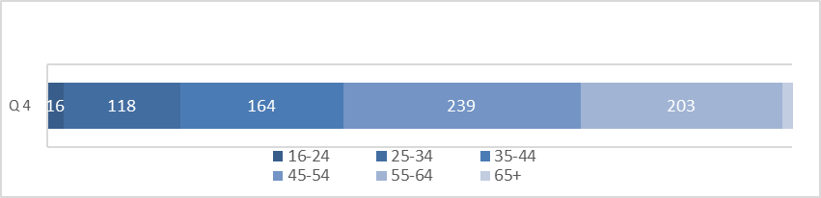 |  | Over the financial year compared to 21/22 there has been an increase all age ranges except 45-54 & 65+, the most significant increase was in the age range 25-34 with a change of 93 | In 23/24 as part of the People Programme, there will be a review of our talent acquisition and recruitment process and main streaming Programme for Youth Employment (PYE) is key.
AMBER | Workforce diversity - Disability | 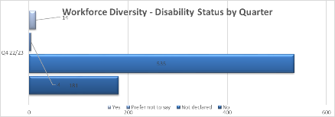 |  | Disclosure continues to remain low, further campaigns to encourage disclosure is key | In 2023/24, there will be continued work on Equality, Diversity & Inclusion (EDI) actions and increasing disclosure through campaign and visible support.
AMBER | Workforce diversity - Ethnicity | 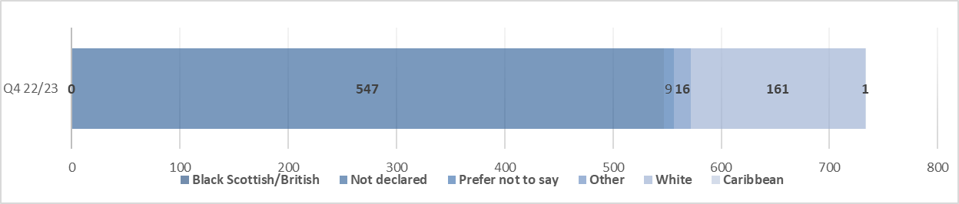 |  | Cause remains cultural norms. We continue to work in Partnership to tackle these. | In 2023/24, There will be continued work on EDI actions and increasing opportunities within diverse communities.
GREEN | Total emissions | 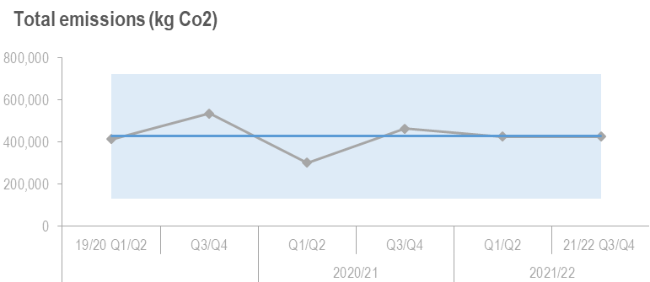 | 424,500 | These fluctuations were due to Covid-19 regulations and so we have returned to normal levels pre-Covid and so in the future we are likely to increase emissions. | There is ongoing work through Net Zero Projects to reduce building emissions although this is a long process in early days. There is also work transitioning to an electric fleet of vehicles. Organisational approach will affect travel emissions in the future.
GREEN | Reach in mainstream media | 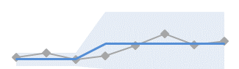 | 228  Million | These results continue the strong coverage trend of climate change and nature with similar but higher figures to Q1 (346m) and Q3 (361) but are down from Q2 (519m). This is line with expectations, as Q2 included all media coverage of the avian flu situation at its peak | We will continue our work developing strong stories for the media, focussed particularly on biodiversity, marine and wildlife management and expect strong interest in climate change-related issues, HPMA, avian flu and deer management in particular.
GREEN | Impact of public facing campaigns | 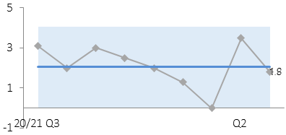 | 3.7 Million | Summer campaign covered Q1&2. Very strong dwell time on campaign web pages and social media Click Through Rate | Social media and radio boosts to Click Through Rate and web traffic with continued targeted campaigns

PERFORMANCE REPORT

WE HAVE PROTECTED NATURE
CORPORATE PLAN OBJECTIVE | SLT LEAD | RAG SCORE | Q4 UPDATE
Lead the delivery of 30% of land and sea being protected by 2030 | Nick Halfhide | GREEN | - National Parks - advice finalised and published (target met) with support to Scottish Government in taking forward the next steps under way.  - 30x30 and Nature Networks: Framework consultation planned for Q1 2023. On target to achieve this. Ready to move to next Phase of work (Policy development, Legislation, Systems, Approach).  - Marine protection: Consultation on Highly Protected Marine Areas (HMPA) policy framework and site selection guidelines completed including online stakeholder events.  - HPMA strategic group established between NatureScot and Marine Scotland (MS), to develop shared oversight and understanding of risks.  - Special Protected Areas management advice delayed. Deadline for Marine Protected Areas & Priority Marine Features work – revised from March 2024 to end 2024.
Build stronger collaboration reducing the impacts of deer and modernise our wildlife management and underpinning licencing functions to enable a net zero and nature positive future | Robbie Kernahan | GREEN | - The Strategic Deer Board is now well established with follow up engagement with Deer Management Round Table. Legislative proposals and incentive options are progressing for Ministerial steer. Operational Priorities have been agreed to achieve 10 deer/ km in Deer Management Groups with highest densities. Regulatory measures utilised in Loch Choire and S7 agreement secured at Caenlochan.  - The Hunting with Dogs Bill has concluded and our licensing approach and guidance is nearing completion.  - Online licensing progressing but competing demands for limited staff resource has slowed progress. General licence restrictions have been put in place on 3 properties.  - Scottish Beaver Advisory Group has been established and will meet on a quarterly basis. Trapping and translocations have increased over the year, figures are due to be published end Q1.  - Ongoing work to support Scottish Task Force on HPAI with plans for monitoring impact and effects being taken forward.
Engage and influence planning and other regulatory systems to ensure they deliver for nature and climate | Robbie Kernahan | GREEN | - The primary point of slippage is the NaturePlanner/Informed Decision project pilot which has been delayed by a combination of NatureScot’s internal IT issues and time needed to encourage Scottish Forestry on board to participate. The scheduled timescale for the project now likely to extend to end of Q2 2023/24.  - Good progress has been made on working through the policy implications of National Planning Framework 4 (NPF4) and what our approach to casework in particular needs to be. Interim guidance on casework has been issued.  - We have formally withdrawn from a number of current or ongoing Inquiries on the basis of the change to policy on Wild Land and also withdrawn a number of objections. Participation in Narachan windfarm inquiry affecting NSA resource should be completed by end of Q4.  - S36 applications – in principle discussions agreed that we will streamline input and acknowledgement that we can’t supply the service Energy Consents Unit (ECU) have relied on. Example letters for planning cases being collated to provide assurance this will deliver the value that ECU actually need.  - Positive Effects for Biodiversity - Work needed to clearly manage expectations of others as to our engagement on individual proposals. We have had regular engagement and comment as part of the oversight of Scottish Government’s SRUC commission on biodiversity metric. Ongoing risk associated with possible assumption by industry that positive effects represent business as usual.  - Development Planning – discussions with Local Authorities on nature network requirements and beginning of Local Delivery Plan drafting process.
Influence the transformation of marine management through new marine planning, protection and fisheries management frameworks, and working with the marine renewable energy sector | Nick Halfhide | GREEN | - Formal advice submitted on Berwick Bank Offshore Wind Farm application, including on the first marine derogation case in Scotland for seabird impacts.  - Wider marine energy casework load is escalating rapidly and we are discussing additional staff capacity and resourcing issues with Marine Scotland.  - Work has begun to scope the vision and objectives for National Marine Plan 2. We have provided Marine Scotland with advice to inform the vision & objectives, use of marine natural capital approaches in Strategic Environmental Assessments and on assessing cumulative impacts.  - We helped to shape a Blue Economy Vision and Delivery Plan which recognise that economy and wellbeing are embedded within nature.

WE HAVE RESTORED NATURE
CORPORATE PLAN OBJECTIVE | SLT LEAD | RAG SCORE | Q4 UPDATE
Co-lead the production of the new Scottish Biodiversity Strategy (SBS) and develop targets to include in a new Natural Environment Bill | Nick Halfhide | GREEN | - On schedule to consult on the Delivery Plan in Q1 of 23/24. Plans have been developed through close working with Scottish Government Policy leads and Rural and Environment Science and Analytical Services Division (RESAS).  - Work on-going with SG colleagues to develop the timeline for the timing of the the Natural Environment Bill.  - Publication of the final Biodiversity RouteMap report detailing more than 70 projects for the previous Biodiversity Strategy.
Scale up Peatland Restoration by delivering Peatland ACTION funding to projects | Robbie Kernahan | AMBER | - Work continues to drive up demand for restoration, raising awareness through a variety of conferences, publications and workshops.  - We have commissioned an expanded programme of feasibility studies; rolled out of new entrants scheme, supported new Scottish Rural College (SRUC) training course and published a new technical compendium;  - We have concluded delivery of restoration on 51 projects putting over 4700 ha on road to recovery;  - helped with revisions/guidance on new version of Peatland Code  - Budgets have been submitted for 2023/24 to 25/26; and we have initiated recruitment of additional posts to support acceleration of restoration.
Lead, enable and convene others around the development of ambitious and coherent actions to restore nature. Deliver a major Nature Restoration Fund (NRF) targeted at high impact nature recovery projects and seeding greater investment from the private sector | Nick Halfhide | GREEN | - Grant offers from the Transforming Nature round have been sent to successful applicants and signed by them. The award of money to successful applicants was announced by the Minister on 24th Feb.  - The first meeting of the Nature Restoration Fund oversight board will be held on 9th March.  - The next round of Expressions of interest for the Helping Nature fund has been launched.
Demonstrate how agriculture can be transformed with new approaches to deliver targeted outcomes for nature and climate | Robbie Kernahan | GREEN | - Biodiversity App tender progressing to accommodate an additional SG governance requirement (discovery phase) before SG approve capacity for App to engage with their Land Parcel Information System (LPIS).  - Piloting Outcome Based Approach Scheme (POBAS) score card farmer testing completed and project reports are being compiled.

THE VALUE OF NATURE IS RECOGNISED
CORPORATE PLAN OBJECTIVE | SLT LEAD | RAG SCORE | Q4 UPDATE
Inspire people to connect with nature, increasing appreciation of nature’s value through impactful delivery and communication of our work | Nick Halfhide | GREEN | - Make Space For Nature (MSFN) campaign delivered, consistently exceeding the NatureScot campaign KPIs and delivering 104,840 website visits over the year and 8.5k downloads of the 25 podcast library.  - Better Places Fund 2022 delivered support to circa 150 seasonal rangers across Scotland contributing to a successful visitor management season, with 2023 fund launched with further funding from SG  - National Access Forum Guidance on wildlife disturbance finalised and key messages developed for promotion throughout 2023  - SOAC spring campaign (paid social media and radio) underway, work with social media influencers in progress, communications plan for 2023/24 drafted. SOAC highlights for 2022/3 include: a refreshed resources for schools launched: SOAC on-line education pack; Phase 2 summer radio activity reached over 1.3m adults and social media (paid-for) delivered over 1.8m impressions; and continuing work with partners to increase impact and reach – e.g. Ramblers Scotland’s video campaigns targeting late teens and young adults aged 16-24.
Influence the regulatory, policy, market and institutional infrastructure needed to stimulate private sector investment into nature | Robbie Kernahan | GREEN | - Investment Ready Nature Scotland (IRNS) - Claims concluded. We will bring the projects together and begin to establish Community of Practice to learn from progress made and challenges faced.  - Hampden & Co - Ministerial announcement in January. The Upper Tweed scoping report completed.  - Scottish Marine Environmental Enhancement Fund (SMEEF) - Project development/baseline survey grant round successfully completed with £245k of private finance distributed to 10 projects. Web developers working on presentation. Reputational risk associated with contributions from oil and gas industry is being addressed in a ministerial submission.  - FIRNS - Launched by Ministerial announcement in January. Gateway activity begun - raising awareness and understanding and encouraging/preparing potential grant applicants. Grant scheme ready for first expressions of interest in April 2023. Recruitment to Funding Team underway.  - It is not yet clear what milestones will be set for the 'landscape scale private investment in peatland pilot' but we are working, with SG, to develop criteria for candidate restoration projects and the design of the blended finance mechanism. New Peatland Investment Manager post will take this on once in post. We will develop our thinking on the resources (FTE, skills and knowledge) that we require to progress this objective. Work underway.
Drive the establishment of Natural Capital as an integral part of public and private business planning and investment decisions at national, landscape and landholding/business scales | Robbie Kernahan | GREEN | - Priority public land hotspots were agreed early in Q4, and work groups set up to progress these. Next step is to agree future governance, priority and aims.  - We have advised the Borderlands natural capital programme which includes 5 projects( testing treasury Green book NC guidance) and helped steer the Hunterston Strategic Development on their recent Natural Capital Assessment. Scottish Water are also progressing a number of natural capital based initiatives  - Further stakeholder workshops on Landscape Tool development - stakeholder group engagement on going sufficient to test tool once developed.
Promote understanding and awareness of skills and capacity needs for the nature based sector | Nick Halfhide | GREEN | - Nature Restoration Jobs and Skills Conference held with 350 registrations, 8 External Speakers, Ministerial attendance.  - Nature Restoration Skills Week –23 Training Events delivered, including 12 in person events. Total of 350 people trained.  - Nature-based Jobs Showcase – 6 schools attended online event.  - Working with Rivers Project - 12 placements recruited for 6 months with 11 employers each funded through Graduate Career Advantage Scotland (GCAS).  - Make Your Mark volunteer campaign refreshed and nature-branded.  - Over 20,000 volunteers supported through NatureScot funding for TCV, YoungScot, John Muir Trust and Volunteer Matters and other eNGOs.

WE HAVE TRANSFORMED HOW WE WORK
CORPORATE PLAN OBJECTIVE | SLT LEAD | RAG SCORE | Q4 UPDATE
Deliver new ways of working to stimulate achievement of our ambitions | Jane Macdonald | GREEN | - A strong quarter, and overall very good progress this year across all the programmes of work to enable new ways of working, despite resource & capacity challenges.  - Workplaces – Edinburgh business case completed and submitted to SG. Recommendation to move to Meadowbank House is the focus of staff engagement and we are now moving to the implementation phase. Work on Perth and Inverness business cases has been delayed due to this, however recruitment of a Programme Manager should mitigate further delays.  - Network security – all 888 windows laptops are now being protected, filtered and monitored by the new Zscaler service. Rollout of the ZPA service has now been deferred to 23/24, as the recent network problems and investigations have significantly impacted progress.  - Cloud Migration - We have renewed our license with Oracle, saving £82.8k. We are also making good progress with enabling our single sign-on/multifactor authentication for Fusion. Work is ongoing on designing the move of our GIS provision to a Cloud Service. We anticipate saving c£25k through decommissioning kit and licence rationalisation as a result.  - We have implemented our unified comms approach, moving eMail to the cloud, rolling out soft phones and new handsets.  - We are making good progress on moving our Objective document and records management system to the cloud. Implementation is on track for Q1.  - Net-zero - further electrification of our fleet and installation of photovoltaic panels at Golspie. This now has an A+ energy certificate rating and a negative score making it officially our first net-zero office.  - We achieved sign-off the 21/22 Annual Report and Accounts in December. We commenced our Business Intelligence project bringing a new skill set to aid our strategic decision making.
Transform our individual and collective leadership capability | Jane Macdonald | GREEN | - People Strategy and delivery programme due to be finalised in early Q1. Minor slippage.  - Learning framework publicised and also new learning packs created for managers and employees.  - We are working on the transition of the organisation design work in to the wider organisational development programme.  - Although no set budget allocation for Programme for Youth Employment, work continues on improving the offering and how we can mainstream this into core vacancies.
Sustain our focus on developing a happy and resilient workforce | Jane Macdonald | GREEN | - Equality Report completed endorsed by Board. Due to be published by end of April.  - Employee Assistance Programme review underway.  - People policy suites have slipped (minor). To be picked up in Q1.

- Over the last quarter we are on track to achieve 14 out of the 15 Corporate Plan objectives, the reasons for the slippage can be noted in the above tables. There is only one objective marked as amber at this point:
  - Scale up Peatland Restoration by delivering Peatland ACTION funding to projects
    - This is as a result of a reduced hectare target and Peatland Code delays.

FINANCE
Financial Metrics (£m) | Measure | Budget | Forecast | Variance | Rating
Resource Budget | Outturn within 1% of final budget | 58.3 | 56.6 | 1.7 | MINOR SLIPPAGE
Capital | Outturn within 5% of final budget | 2.3 | 2.0 | 0.2 | MAJOR SLIPPAGE
Indirect Capital | Outturn within 5% of final budget | 11.6 | 11.8 | (0.2) | ON TRACK
Paybill | Outturn within 1% of final budget | 34.6 | 34.5 | 0.1 | ON TRACK
Project Allocation | Outturn within target allocation range | 16.7 | 17.0 | (0.2) | ON TRACK
Peatlands | Outturn within 1% of final budget | 10.4 | 10.5 | 0.0 | ON TRACK
Farming with Nature | Outturn within 1% of final budget | 2.9 | 1.9 | 1.0 | MAJOR SLIPPAGE
Better Places Fund | Outturn within 1% of final budget | 1.3 | 1.2 | 0.1 | MAJOR SLIPPAGE
Nature Restoration Fund/BCF/SMEEF | Outturn within 1% of final budget | 5.8 | 5.5 | 0.3 | ON TRACK
*Operating < 1% - on track, up to 10% minor slippage, over 10% major slippage (** Capital < 5% / up to 10% )
inancial graphs
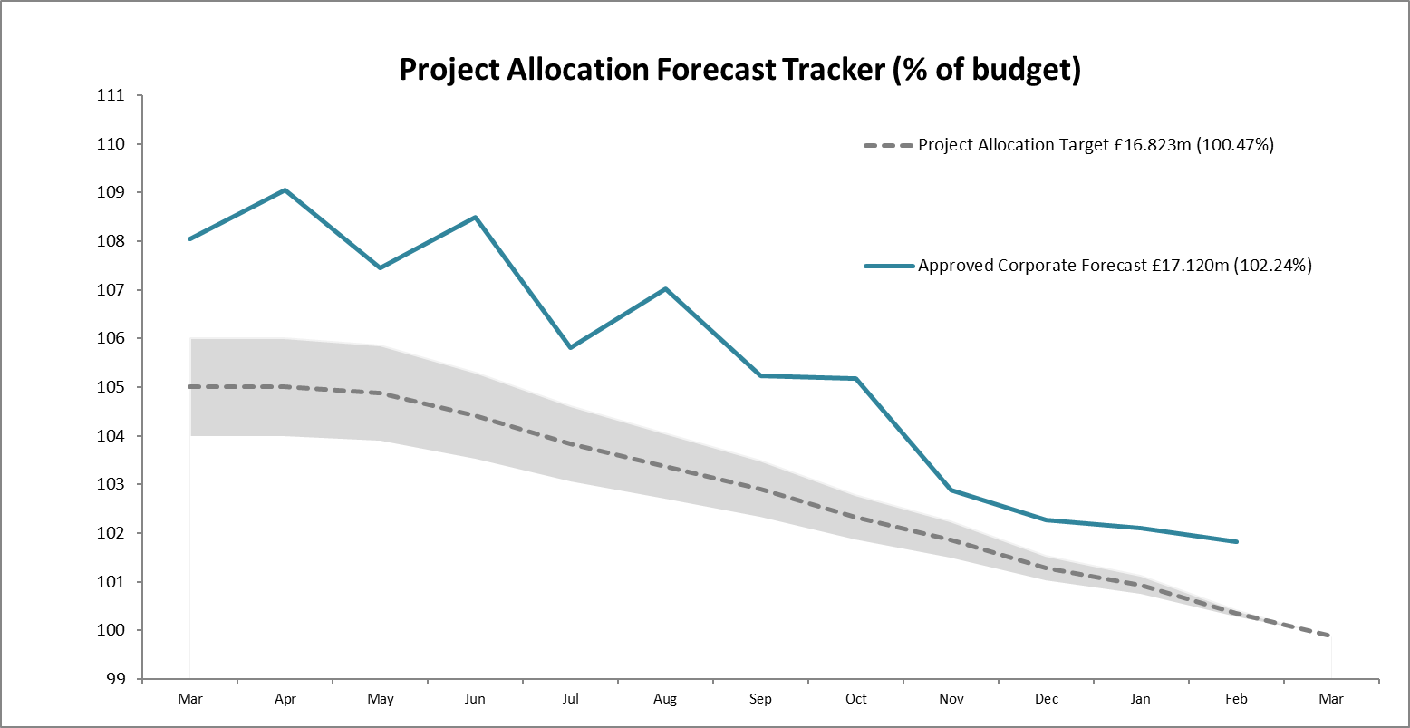  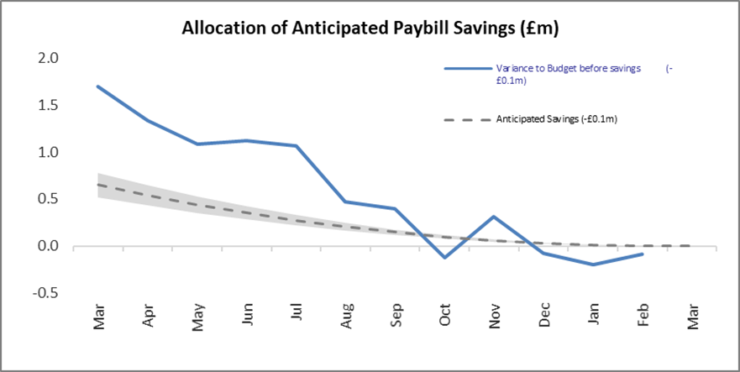 | The Corporate Forecast on Projects is £0.173m above target at the end of a year with considerable inflationary uplifts as well as pressure on the projects budget from the additional cost of the pay settlement for 22/23. The Project Allocation Forecast Tracker does not include ring-fenced funds (NRF, BPF, Peatlands and FwN are removed).  The paybill forecast is currently £0.1m below budget although this underspend may potentially reduce pending the outcome of final discussions on the 22/23 pay settlement. The budget was increased following the transfer from FwN (£0.65m) and BPF (£0.19m) as agreed by SG to help cover the additional costs arising from the pay settlement.

Finance

Resource Budget Performance

- Of the £1.749m underspend reported on the Resource budget:
  - £0.041m relates to our core grant in aid budget of £49.445m;
  - £1.209m is attributable to underspends on three of our Ring-fenced programmes (Peatlands, Farming with Nature and Better Places Fund);
  - £0.5m has resulted from IFRS16 adjustments to the non-controllable cash budget (Depreciation).
- The Paybill forecast of £34.510m (including the ring fenced programmes) represents an underspend of £0.091m following the addition of budget transfers from Farming with Nature (£0.650m) and Better Places Fund (£0.190m) as agreed by SG.
- Late in 2022, a welcome but unexpected additional budget allocation of £0.490m was made which has been factored in to the forecast outturn.
- Of the £1.209 resource underspend on ring-fenced programmes, the majority is recorded against Farming with Nature (£0.951m). Delays in decisions / input required from SG was the main contributing factor here.
- Business partnering continued into Q4. The Budgets team challenged uncommitted budgets to ensure that allocations were optimised with respect to high priority work considered achievable during the remainder of the year.

Indirect Capital Funding Programmes (including Peatlands)
- We are forecasting an overall overspend on Indirect Capital of £0.184m.
- The Peatlands budget is £10.440m. The current forecast is £10.481m with an underspend of £0.196m on Resource and an overspend of £0.237m on Indirect Capital.
- The NRF budget is £5.779m. The current forecast is £5.528m with an overspend of £0.061m on Resource and an underspend of £0.312m on Indirect Capital.
- The BPF budget is £1.31m. The current forecast is £1.187m with an underspend of £0.122m on Resource. It is worth noting that further demand of approx. £0.2m was not taken forward during the year due to anticipated budget pressures at that point.
- Slippage from 2021/22 Biodiversity Challenge Fund (BCF) grants is being funded from the Nature Restoration Fund budget: Indirect Capital budget (£0.347m) and Resource budget (£0.016m).
- The Scottish Marine Environmental Enhancement Fund is also being funded from the Nature Restoration Fund Indirect Capital budget (£0.863m).
- The impact of slippage on large value programmes presents a risk to spend levels. The anticipated corporate slippage now applied at the end of the financial year is based on the remaining commitment (£0.209m). This is split against Indirect Capital (£0.157m) and Resource (£0.052m).
- SG confirmed that they wouldn’t be funding the 21/22 slippage of £0.150m for GovTech. We are funding this from the anticipated corporate slippage.
- We are also funding slippage from 2021/22 Wee Forests Pilot of £0.109m from the anticipated corporate slippage.

Structural Funds Programmes
- NatureScot has paid £4.9m to grantees in advance of these claims being submitted to SG. However, since the Managing Authority has informed us that it would only accept two more claims from each fund, these claims have not been submitted to the MA yet, but are being held back (and added to) to form part of the penultimate claim for each fund.
- We have been advised that an arrangement to provide cover for the risk of de-commitment over the remainder of the programme will not be forthcoming. However, a recent external Scottish Government audit of our claims process provides reassurance that risks of de-commitment are being well managed.

Capital Budget Performance
- Our reported underspend on Direct Capital has reduced to £0.216m due to a proportion of the GGH PV project being able to progress, the IFRS-16 lease expenditure and a Capital grant in-kind being included in the numbers.
- We have included the sale of Glencripesdale in the NBV figures which has increased our ability to spend on Capital projects by £0.750m.

RISK

Corporate Risks | Risk Changes
Changes to Corporate Risk Scores
↑ 0 Gone Up
↓ 0 Gone Down
Change to Corporate Risk Register - proposed
↗ 0 New Corporate Risks
↘ 0 Risk De-Escalated

Risk
- The Annex A - Corporate Risk Register holds the current corporate risks for NatureScot. Activity and project risks are managed within the risk management system, which underpins the corporate risk register. All risks are managed in line with the Risk Management policy and monitored regularly for compliance and visibility of impact.
- There are currently 11 approved Corporate Risks, 6 medium and 5 high. During Q4 the likelihood score changed within 1 risk – Lack of support for Fusion but that hasn’t impacted the overall risk rating.

- During Q4, the Corporate Risks have been reviewed to ensure that they still require to be managed at the corporate level. There are no new corporate risks proposed for escalation.

- Over the year the corporate risks have remained relatively static on the register with the main focus on Structural funds, funding for NatureScot and internally, the support of the FUSION system.

Board are requested to note the performance of the corporate risks.

PEOPLE
People Metrics | Status

Wellbeing
Accidents & Near Misses – target: to stay within variations around the mean which are 4.4 for accidents & 5.8 for near misses  Q4: Accidents=3, Near Misses=3. Annual 2022/23: Accidents=18, Near Misses=11 Q4 saw a reduction in accidents compared to Q3, the annual figures show a reduction in accidents compared to 2021/22 but an increase in near misses. It was reported in Q3 that the reported accidents were returning to Pre-Covid figures however the annual figure shows that there is a reduction overall. This could be due new ways of working and low numbers of employees in the offices. | Green
Workload Management Pulse Survey – there was a 57% response rate from the organisation. Of those respondents, 81% stated that they had had a PDC in 2022/23; however, 19% stated they had not had a PDC when asked if they had a PDC booked before the end of 2022/23. Of those 19% 61% stated, they did not have a PDC booked. In the survey, 66% found a PDC was useful in prioritising their workload and 53% are able to maintain a manageable workload. 65% feel trusted and empowered at work. 46% indicated that they rarely feel stressed. The new Performance approach launching in April will ensure that there is a more formal approach to recording PDC’s and ensuring that conversations are undertaken. Career MOT’s will also be an opportunity for employees to explore their professional development/pathways. In December and January, we ran the Road to Well programme which replaced the previous winter carnival. The programme focused on personal development and wellbeing; it included a wide range of different events and engagement opportunities: mindfulness sessions, decider skills training | Green
Capacity
Sickness – Target: under 2 days per person per quarter.  Q4: 1.48 days, with an annual figure of 6.2. This is above the Civil Service average working days lost which is 6.1. However, we are starting to return to the pattern we saw pre-pandemic, where annual days lost were 6.62 days, compared to 3.94 in 2020/21. The majority of the absences are short-term; only 1.38% of sick absences are long term (an absence of 12 weeks or longer). | Green
Q4: 91% of holiday leave taken; this is within target. The notional target at the end of the holiday leave year is 100%, however as we allow a 5 day carry-over, an acceptable level is 88% or higher. | Green

Development
Formal Casework - target <=50% of informal casework  Q4: 16.7% (6 cases) with an annual average of 27.85%, well within normal range for this type of casework. | Green
Informal Casework  Q4: 27 cases. Well within the normal range for this type of casework, however Q4 has seen an increase of 9 cases. This is in line with the trend for Q4 since 2019/20. The increase in Q4 is in relation to health and wellbeing casework. | Green

Workforce Profile
Turnover – target: maintain in the range of 8-10%  Q4: average turnover is 10.52% (over last 12 months).The leavers in total are 28 in Q4, with 81 leavers to date. Of the leavers in Q4, 21.43% were retirements and 37.71% were employees going to alternative employment. In 2022/23 24.69% of leavers were retirements and 30.86% were employees leaving for alternative employment. For our exit questionnaire, in 2022/23 we have had a 43% response rate (35 responses from 81 leavers). This shows further promotion of the exit questionnaire is required for 2023/24. There are no broader corporate issues emerging from the feedback so far. | Green
Internal Movement – target: increase  Q4: Internal moves have reduced in this quarter, with 41 internal moves compared to 50 in the previous quarter. In 2022/23 there have been 145 internal moves, (an average of 4.7% of the headcount), into alternative roles through promotion or level transfers. There were a number of failed internal recruitments, which meant posts moving to external recruitment. To date in 2022/23 there have been 231 recruitment exercises. This is comparable to 2021/22 (229 recruitment exercises). Of the 231 exercises, there have been 34 failed recruitments; 17 of those were successful when re-advertised. The failed recruitment rate has increased from 8.7% in 2021/22 to 14.7% in 2022/23. 2022/23 has seen the highest number of new starts in the last 4 years, with a total of 114 new employees. The majority of these were in full-time, fixed term posts which is similar to previous years. The greatest proportion of new starts was in the 25-34 age range. | Green
Retirement Profile  Q4: 177 employees are aged 57+ currently, predicted to rise to 227 in 2024/25 (21% of current headcount). A further 6 retirements were confirmed for the rest of the financial year, with a total of 19 retirements in 2022/23.This is lower than the predicted figure of 34. The average retirement age for Q4 is 59.5; however the year to date average retirement age is 63. | Amber

Internal Movement
Q4 saw an increase in recruitment exercises and, positively, an increase in the number of applications for the vacancies being advertised. The number of applications went up by 124% from 329 in Q3 to 807 in Q4. This may be due to the increase in people looking for alternative employment after the New Year and the decrease in the number of vacancies nationwide for applicants to apply for, as reported by ONS in December 2022.
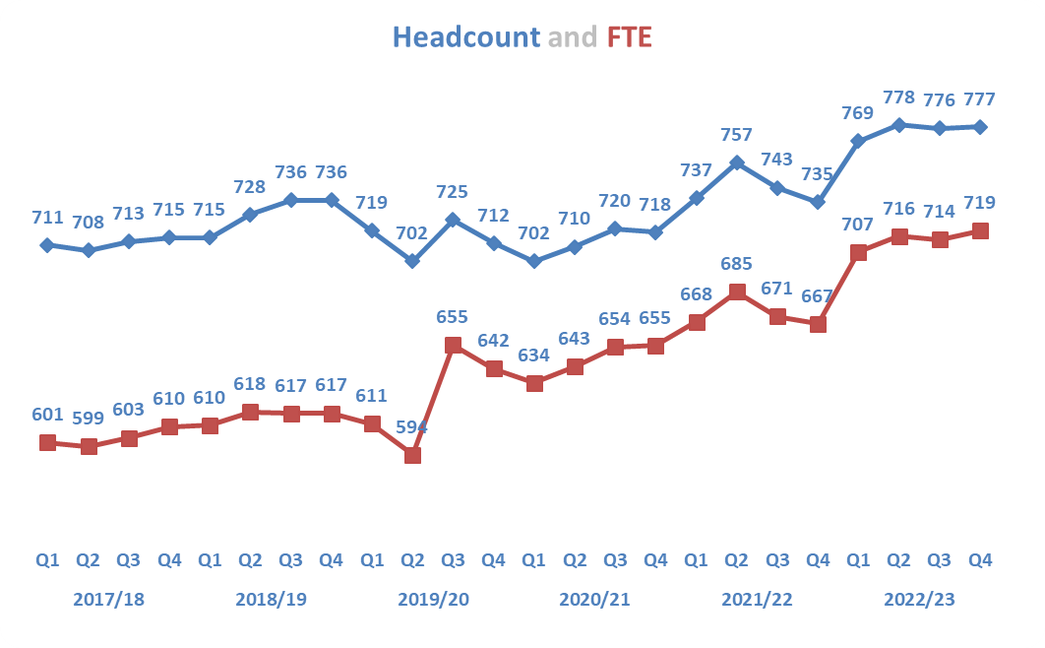
The head count and FTE has been steadily increasing since 31 March 22, by 31 March 23 the headcount had increased by 42, and an increase of 52 in FTE. The increase in FTE indicates that in 22/23 there has been an increase in full-time employees compared to March 2022.
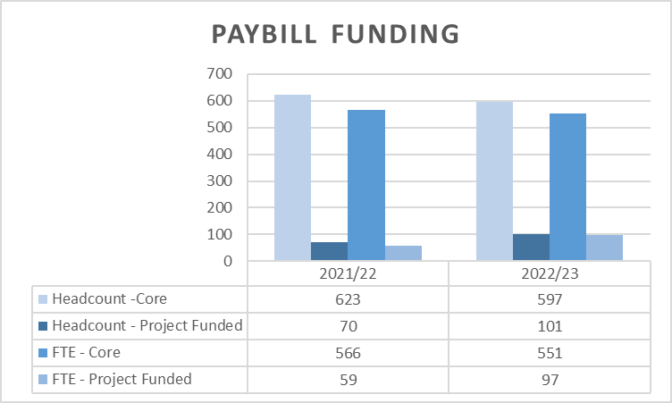
2022/23 saw an increase in project funded posts, which will have contributed to the increase in the headcount during this financial year.

Equality Report Highlights -
- Gender Pay gap has reduced to 7.5%, from 15.01% in 2017, going beyond the target of 9% in our Equality Outcomes.
- As at the 31st March 2023 our gender headcount is:

Gender | Headcount | FTE
Female | 462 | 414
Male | 315 | 305
Total | 777 | 719

This is broadly in line with 20/21 & 21/22, with females being 59% of the headcount in each reporting year.
- During the period of the Equality Report 2021/21 to 2022/23, 19 employees took maternity leave, with 18 employees taking paternity leave.
- Disclosure of protected characteristics remains very low, with only approximately 25% of employees disclosing the information. A low disclosure rate means that NatureScot is unable to provide a full picture of our workforces protected characteristics. This may lead to equality actions not being fully responsive to the needs of our workforce.

Retirement Profile

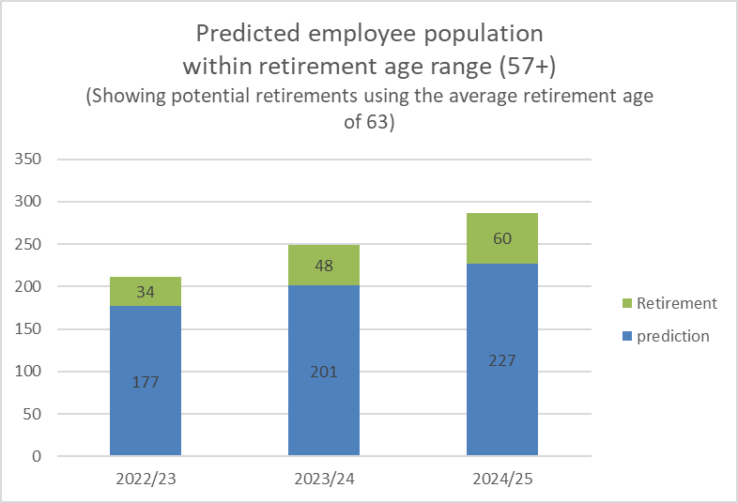

- People & Organisational Development (POD) continue to work with Activity and National Operations Team leaders to look at age profiles within teams, to highlight particular resilience and skills gap risks. We are encouraging open conversations about future plans and needs.
- Through the People Programme into 2023/24 we will be reviewing our talent acquisition and recruitment processes to ensure we have the right people in the right roles, attracting and retaining the best people.
- We will be piloting a Career MOT service in April to support colleagues in fulfilling their aspirations, at whatever stage in their careers they are. Alongside partial retirement and flexible hours, this is intended to help manage the transition to retirement.

Recommendations

- Board are asked to:

  - Approve the overall performance of the Corporate Plan objectives (Performance Report)
  - Approve the position of the operating and capital budgets (Finance Report)
  - Approve the performance of the corporate risks noted in paragraph 12 (Risk Report)
  - Approve the overall performance of the People Measures (People Report)

Annex A - Progress on Corporate Plan at the end of Year 1

- At the end of this first year of ‘A nature-rich future for all’, we can be confident that the significant blocks of effort which underpin our Corporate Plan either are on track, or gathering traction. This is encouraging in the context of meeting the ambition of the Bute House Agreement. However, there are headwinds being experienced in a number of areas and uncertainty as to whether they will abate or potentially slow progress in the year ahead towards our 2030 targets. We will provide a fuller analysis of this and return to Board later this year.

- A common feature of the first half of this Plan is laying down the policy framework and consultation processes which enable delivery of the actions in the second half of the Plan period and beyond. In particular we have made significant progress in developing a new overarching Biodiversity Strategy for Scotland, and developing its delivery right across Government.

- There have been recognised challenges in getting to this point in year one, including building resilience and resource in existing teams in new areas. We finish the year having made strong progress in areas which will underpin nature’s recovery. What follows is a short assessment of the headline themes against the Plan.

Protect
- A key strand of work this year has been the delivery of the underpinning principles in support of our drive towards 30x30 co-produced with a range of organisations and a building block towards nature recovery. Attention now turns to the data analysis needed to identify potential sites, work to develop new approaches to monitoring and work with stakeholders to ensure effective communication. More resource in-year may have allowed us to move at greater pace and in parallel with the scoping work but we stand well prepared now to move into this next phase.

- We know that our licencing functions are central to delivering high quality wildlife regulatory functions, particularly in support of the legislative timetable over the period of our Plan. Progress has been made towards modernising Deerline and online licensing development and in some instances we have needed to move at the pace of others, including Scottish Government, where they have faced capacity issues. In parallel, a clear signal has been evident in our regulatory action both in terms of direct action (as seen at Loch Choire) but also working through legislative processes, such as Section 7 agreements at Caenlochan. Both these examples, and other engagement through Deer Management Groups, reflect a more robust stance at the end of this first year.

- Additional marine protections are a key theme in this corporate plan. Work to implement the new Scottish fisheries management framework has commenced and whilst timescales have been adjusted within Marine Scotland, we are now engaging with groups set up to progress the new approach. A welcomed injection of funding aligned to Scotwind in the past year has allowed us to build some further capacity in teams to handle the significant additional advice associated with the growth in marine renewables. Onboarding has been a slow process across the sector but this has driven closer collaboration between organisations which will help with the future implementation of Marine Protected Areas. At the end of this first year, we are seeing more focussed engagement on Highly Protected Marine Areas and this will be a significant feature of the coming year.

Restore
- We know that the legislative programme for nature and climate in this Parliamentary term is necessarily ambitious. At the end of the year, that remains the case. We have used the process to influence key stakeholders on the significance of land use and nature based solutions to tackling the nature/climate crises. Whilst there remains uncertainty on the timing and scope of the Environment Bill, that hasn’t stopped us gathering evidence on key components of the Bill and influencing synergies with key bills (such as the Agricultural Bill).

- The Nature Restoration Fund and Peatland Action both continue to make strong and steady progress, with the latter restoring 4,700ha over the year. This was in line with expected outturn agreed with Scottish Government. At the end of the year, there are signs of wider public awareness emerging around the significance of nature based solutions and peatland restoration in driving Scotland towards a net zero economy. Advances have been made in the Peatland code and the development of private investment during 2022/23 which will allow the expansion of Peatlands in future years in line with proposed targets.

- New governance arrangements around agriculture reform during Q4 will allow us to feed in to the necessary workstreams as we approach the Agricultural Bill in the year ahead. The Agricultural Bill will be vital to our ambition particularly beyond 2030 so a significant milestone remains on track in support of building the conditions for ongoing nature friendly farming.

Value
- Whilst this area of our Plan has modest resource attributed, we can point to progress arguably beyond expectation in this first year. We have brokered a first-of-its-kind £2bn agreement with UK private bank Hampden & Co, Lombard Odier Investment Managers and global impact firm Palladium to drive nature restoration through natural capital investment. Alongside this we have developed our innovative £2m Facility for Investment Ready Nature in Scotland (FIRNS) and Investment Ready Nature Scotland (IRNS) fund. This will expand the possibilities for future private investment in nature and open doors to increase funding to benefit nature and tackle climate change in a time when public sector funding is reducing.

NatureScot Way
- Public finances have remained under significant challenge over the year with NatureScot needing to respond to enhanced pay offers on the back of the cost of living crises. Despite that, we report strong progress against our Net Zero Plan, including our first net zero office, remaining on track to meet our 2035 target. Our Estates Strategy has yielded £250k of saving in-year with targeted action at a number of sites with a Programme now in place to drive transformation in our workplaces.

- 2022/23 saw the home and hybrid working practices that began during the Covid Pandemic become business as usual for a significant proportion of the NatureScot workforce. ICT solutions that were implemented and rolled out very rapidly in response to the pandemic have been adopted at scale and monitoring shows that upwards of 75% of the NatureScot workforce now connects to corporate systems from non-office locations as a matter of course.

- As a consequence, supporting legacy systems and technologies has proven to be a continuous challenge, especially when coupled with high levels of cyber threat. The result of NatureScot’s growing ICT infrastructure technical debt was apparent at various points in 2022/23, particularly where unresolved network performance issues impacted business operations (especially the eRDMS & GIS performance issues on-going throughout much of 2022).

- Balancing the competing demands of reactive systems support vs proactive work to progress strategic priorities has led to ongoing pressures, but, on balance, 2022/23 still saw good progress achieved in most of the highest priority areas of work.

- A significant amount of work has also been undertaken during the year led by our organisational design programme. We start the next year of this corporate plan with an operating model designed to address the challenges of resources and prioritisation ensuring that we can continue to meet the ambition set for the remainder of the Plan.

Annex B – Corporate Risk Register (High Risks)
RISK TITLE | DESCRIPTION | CONTROLS | IMPACT | LIKLE-HOOD | RISK LEVEL | COMMENTS
47 - Computer Virus/Malware | As a result of inadequate protection, or inappropriate system use, including accidental activation of email links by that lead to malware downloads, there is a risk that NatureScot systems becoming infected with a malware or virus agent, resulting in NatureScot systems and data become unavailable, encrypted or corrupted, significant system downtime and huge operational impacts | *All file servers are protected by Sophos antivirus protection. Upgrades are performed automatically and can also be applied in an ad-hoc manner  *All PCs are protected by Sophos antivirus protection. Upgrades are received on a daily basis but can be applied ad-hoc  *All incoming emails are scanned for viruses.  *All internet access, are scanned for viruses via Zscaler service.  *Raise staff awareness of potential risks relating to email links and infected documents through regular communications.  *Sandbox controls/ environment implemented  *Control of USB devices  *Awareness raising with staff via Blogs and update articles  *Incident Management Group in place  *Corporate data backed up to cloud | 4 | 3 | High | Quite a bit of infrastructure has changed since the last update. Email is now checked by a cloud based system managed by Sophos and we ensure that any external email is highlighted by banner alerting that it is from an external source. Zfilter continues to give us a huge amount of data on user behaviour. We have implemented a SIEM and are starting to pull through system logs so we can see the current state of the infrastructure.
253 - Peatland restoration target and budget. | As a result of the immature and complex operating environment, there is a risk to: meeting the annual Peatland ACTION restoration hectare target; and spending the annual budget. | • Realistic planning  • Invigorating demand  • Real-time monitoring  • Increasing resilience to change in projections  • Regular and robust review and control  • New Guidance on operating during nesting season being update to allow risk based approach to operations during that period. | 4 | 4 | High | • Realistic planning, We are still being over ambitious.  • Invigorating demand - demand stalled by uncertainty over carbon market and delays in Code validation  • Real-time monitoring – good. Monitoring allowed for return of £2.5m  • Increasing resilience to change in projections - resilience still poor. Our pipeline is not sufficient to cope with slippage.  • Regular and robust review and control - monthly reports identifying slippage  • New Guidance on operating during nesting season being update to allow risk based approach to operations during that period. - Guidance published, but requires contractors/land owners to get used to operating in the BBS
393 - Future Funding of NatureScot | As a result of on-going reductions in public expenditure or new cost pressures there is a risk our grant-in-aid settlement may not match statutory and fixed costs as well as corporate plan priorities. Unless other funding sources are secured this could result in an inability to adequately resource delivery of agreed priorities, leading to failed outcomes and reputational damage. | * Ensure that our priorities are aligned with published Programmes for Government and ministerial portfolio priorities, specifically those aligned to the Programme for Government and Bute House Agreement  * Provide realistic and evidenced assessment of the impact of possible cuts in our grant-in-aid budget through the annual Spending Review process.  * Develop and put forward proposals, through the annual Spending Review process and other avenues with Scottish Government, for delivering more and better outcomes for nature and people through wider Scottish Government funding.  * Reduce expenditure in some business areas through budget setting processes aligned to business planning cycle.  * Identify efficiencies and savings in our current spending and ways of working to maximise the resources available for front line delivery.  * Have an effective communications strategy in place which promotes the added value of our work.  * Identify and implement opportunities to generate income from the services we provide.  * Identify and implement opportunities for external funding of NatureScot-led work through the business planning process (including at Outcome and Activity levels) and at the project development stage for significant scale projects.  * Develop proposals for new, preventative projects that can help deliver a wider set of SG priorities, and build awareness and support of these.  * Develop and refresh a short, medium and longer term financial plan based on potential financial scenarios. | 4 | 3 | High | Work ongoing preparing resourcing plans to support our Business Plan for the coming year. Impacts have been shared with Scottish Government in advance of Board approving the business plan mid-March. No change to scores.
691 - Lack of support for Fusion | Due to the specialised nature of Oracle Fusion and the interface with NatureScot’s Business Planning System, as a result of key system support staff leaving the organisation, there is a risk that there will be insufficient knowledge and ability to operate key processes or to develop the system and reports. This may result in an inability to adapt the system to changing business needs, reporting delays or to operational inefficiencies and payment challenges that could affect all users of the system. | - Engage in a shared service arrangement with other organisations using Fusion e.g. HES, SLAB  - Make use of the support arrangement from Inoapps currently utilised by POD. There may not be sufficient knowledge from Inoapps to initially support some finance and procurement processes.  - Explore potential for a third party to provide level 2 support to assist that provided by NatureScot staff.  - Recruit to the two vacant functional analyst positions.  - Recruit to the vacant Oracle Cloud Service Manager position  - Draw on finance staff with an awareness of Fusion and the interface with Business Planning as well as the functional analysts who support the POD elements of Fusion, in order to support the finance elements of Fusion. It should be noted that this will not provide all of the specialist knowledge required.  - Implement a networked team approach to involve staff from a wider group to share knowledge and provide resilience in future. | 4 | 3 | High | Of the four vacant positions at the start of the year, we have recruited to three of these positions. The two Finance, Planning and Performance support analysts are now in post and another individual has accepted the Oracle Cloud Services Manager position. The People and Organisational Development support analyst position is currently being advertised. The development of the current support analyst to take on a wider ranging role developing support arrangements for NatureScot is underway. Work on the procurement tender document for Fusion support is progressing and will include a focus on knowledge transfer to ensure that the skills of NatureScot staff are developed. We have also discussed the potential for shared service arrangements with SG colleagues who are implementing an Oracle solution in April 2024. We are also discussing ways to working together and sharing knowledge with fellow Fusion users. A workstream with the Oracle User Group that is dedicated to senior responsible officers in a number of organisations is currently being established. It is proposed that this risk is de-escalated from corporate risk status once the Oracle Cloud Services Manager is in post.

