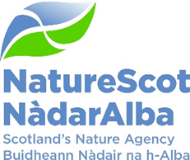

Title: Board Q3 Performance Report
Date: 26th January 2023

Purpose: | Decision
How does this link with our corporate priorities of improving biodiversity or delivering nature-based solutions to climate change: | This paper presents Q3 progress towards delivery of our corporate priorities as laid out in our Business Plan, A Nature-rich future for all: Year 1.
Summary: | At the end of Q3, performance for 14 of our 15 Corporate plan objectives are rated as ‘on track’. One corporate risk has increased their risk score and one has decreased in the last quarter. There are no new corporate risks for escalation or de-escalation. Our Resource budget is currently forecasting an underspend due to additional unexpected but welcomed funds received from SG in Q3. We are forecasting an underspend on Direct Capital due to supply issues on a large Net Zero renewable installation project although we are working to recover our position. We continue to monitor all projects and hope to bring forward demand to outturn within tolerance by year end. In the People Report, eight of the nine indicators are green and one remains at amber.
Actions: | To note the recommendations below
Recommendations: | Board are asked to:  - Note the overall performance of the Corporate Plan objectives (Performance Report)  - Note the position of the operating and capital budgets (Finance Report)  - Note the performance of the corporate risks and confirm the de-escalation of corporate risk noted in paragraph 9 (Risk Report)  - Note the overall performance of the People Measures (People Report)
Report Author(s): | Authors – Directors, Deputy Directors, Outcomes Managers, Finance, Planning & Performance Team, People & OD Team
Sponsor: | Stuart MacQuarrie, Jane Macdonald
Annex | Annex 1 – Corporate Risk Register  Annex 2 – Performance Dashboard

Purpose
- This paper presents NatureScot’s performance for the third quarter of 2022/23. It addresses delivery of our corporate priorities by reviewing; the alignment of performance against our Business Plan, a Nature-rich future for all: Year 1; progress towards maximising our available budget; assessing risks for delivery; and reviewing people information supporting the resourcing of our work. These support delivery of our Corporate Plan 2022-23, A Nature-rich future for all.

Summary
- The outbreak of avian influenza (AI) is still critical and continues to divert staff resource to lead a task force, working with Scottish Government and conservation organisations to develop an effective overall strategy and produce the most up to date advice to reduce spread and manage the impact where possible.

- In December the Climate Change Committee published its annual progress report on Scotland's efforts to reduce carbon emissions by 75% by 2030, and net zero by 2045. It praised the ambition but concluded that the policy framework for delivery is falling short and delivery too slow, particularly in the land use sector.

- Q3 has also seen the publication of the draft Scottish Biodiversity Strategy with a period of consultation coming in Q4. This milestone comes as the Conference of Parties 15 in Montreal saw nations agree to protect a third of the planet for nature by 2030 in a landmark deal aimed at safeguarding biodiversity. There will be targets protecting vital ecosystems such as rainforests and wetlands and the Scottish Biodiversity Strategy will develop measures as part of the finalising the version to be published in Summer 2023.

- The Organisational Development programme continues to review how to evolve the shape of the organisation to set us up for successful delivery of our corporate plan ambitions. A structure proposal came to SLT in December including further development of our 90 day planning process. These will embed more agile and flexible ways to plan and allocate our resources across the organisation. The next step is to engage in a period of communication which will pave the way to implementing active planning in Q1 2023/24 whilst ensuring continued support for learning & development to underpin our knowledge, expertise & skills for the future.

- A review of the performance measures confirmed for the Corporate Plan and Business Plan has identified the need for closer realignment with the objectives. This work has been ongoing over the last few months and some measures will be archived as stronger measures of performance measurement are included. The Dashboard has been Annexed in the meantime and once the new measures are confirmed, the dashboard will be updated and brought back into the body of the paper.

- The table below reflects the Corporate Plan objectives and risks, finance and people metrics.

PRIORITY PERFORMANCE | NUMBER | CORPORATE RISK | NUMBER
Objectives | 15 | Corporate Risks | 11
On Track | 14 | Increased Score | 1
Major Slippage | 1 | Decreased Score | 1
FINANCIAL METRICS | STATUS | PEOPLE METRICS | STATUS
Resource | On Track | Wellbeing | On Track
Project Allocation | On Track | Capacity | On Track
Paybill | On Track | Development | On Track
Capital | Major Slippage | Workforce Profile | Minor Slippage

PERFORMANCE REPORT

WE HAVE PROTECTED NATURE
CORPORATE PLAN OBJECTIVE | SLT LEAD | RAG SCORE | Q3 UPDATE
Lead the delivery of 30% of land and sea being protected by 2030 | Nick Halfhide | GREEN | - Highly Protected Marine Areas consultation on high-level policy framework and site selection guidelines now live. Additional advice submitted on Marine Protected Areas & Priority Marine Features management to Marine Scotland - and joint workshop held to review progress, discuss issues and agree ways of working. Work on Special Protected Areas management measures remains on hold due to pressures on ornithology time.  - 30x30 and Nature Network workshops completed. Sense-check group reviews complete. Skeleton framework will not be completed by end December due to team member attending Conference of Parties 15 but do not foresee any significant delay as a result.  - New National Parks. Consultation successfully delivered with circa 240 responses received and 150 people attending three online consultation events. The analysis of responses will be concluded by the end of quarter with our advice for the Minister finalised by the end of January.
Build stronger collaboration reducing the impacts of deer and modernise our wildlife management and underpinning licencing functions to enable a net zero and nature positive future | Robbie Kernahan | GREEN | - Deer - Work has been developed on all four workstreams with future legislative opportunities for primary and secondary legislation scoped, the outline of how regulatory approaches and future incentives can be better integrated including within future rural support (Agriculture Bill) have also been scoped and Agriculture and Rural Economy Directorate (ARE) engaged in this to ensure a holistic land Management approach. Work on aligning current regulatory mechanisms (Deer Act, Forestry Act, Cross compliance) ongoing with casework being taken forward. Deer Management Round Table sub groups meet end Dec to ensure wider stakeholder engagement in Policy areas.  - Wildlife Management (Grouse) Bill consultation and Stage 2 of the Hunting with Dogs Bill concluded in December.  - Goose Policy Review consultation closed with follow up work in with Local Goose Groups and key stakeholders.  - Beavers - Beavers in Scotland Strategic Environmental Assessment, drafted, consulted and published in December with first meet of Scottish Beaver Advisory Group in January.  - Licencing team now at full complement and licensing response times under 10 days for most applications.  - Avian ‘Flu - NatureScot taking lead role in co-ordination and working across Scottish and UK Government departments, with stakeholder involvement in key groups.
Engage and influence planning and other regulatory systems to ensure they deliver for nature and climate | Robbie Kernahan | GREEN | - Ongoing engagement with Inquiries - more than expected and being managed in the face of changing Policy in National Planning Framework 4 (NPF4). Adhering to service level statement but with areas of pressure from Operation team resource.  - Informed decision pilot on schedule but ongoing issues with our NatureScot system have increased the risk of delayed testing. Engagement with Energy Consents Unit (ECU) (S.36) ongoing but has slowed due to recent publication of draft NPF4.  - NPF4 work taking up bulk of end of Q3 beginning of Q4 including finalisation of Developing for Nature guidance to be published with approved NPF4 and ongoing development of biodiveristy metric work with SG. NPF4 draft published November and a lot of effort involved in assessing implications and developing an action plan to deal with what it means for NatureScot.  - Public consultation on Hagshaw Development Framework completed, will be adopted early in Q4. Case study confirmed to be included in Onshore Wind Policy Statement, due for publication in December
Influence the transformation of marine management through new marine planning, protection and fisheries management frameworks, and working with the marine renewable energy sector | Nick Halfhide | GREEN | - We have provided pre-application advice to a number of ScotWind and other marine energy developers. Work on both the National Marine Plan and the Offshore Wind sector plan revision was delayed by Marine Scotland so our input is moved to Q4.

WE HAVE RESTORED NATURE
CORPORATE PLAN OBJECTIVE | SLT LEAD | RAG SCORE | Q3 UPDATE
Co-lead the production of the new Scottish Biodiversity Strategy (SBS) and develop targets to include in a new Natural Environment Bill | Nick Halfhide | GREEN | - Draft strategy published on 13th December. Two stakeholder events held on the Delivery Plan framing. On-going discussions with Scottish Government Policy leads on key actions in the draft Delivery Plan (Agriculture; Forestry and woodlands; and Uplands and peatlands) in first tranche for these discussions. Integration of SBS delivery across the forthcoming legislative/policy programme.
Scale up Peatland Restoration by delivering Peatland ACTION funding to projects | Robbie Kernahan | RED | - While peatland work is not on track to deliver the target for peatland restoration, many of the key building blocks for progressing peatland action are in place. Scaling up delivery will take time to come to fruition. Peatland Delivery Plan testing with key stakeholders agree with identified actions. NatureScot staff led the convening of a Peatland Partnership Forum to provide a common platform with 80 people across all partners. Increasing staff capacity and an increased budget bid awaits decision from SG, which would allow us to progress a number of new posts to deliver the accelerated approach. Insufficient demand leads to our peatland restoration target slipping, despite colleagues supporting design of projects with 24 new applications submitted. The Peatland Code continues to stall a number of projects and we are working with IUCN to seek to improve aligning the processes required to address this. Key outputs include supporting Ms McAllan on a site visit; publication of new guidance to address Bird Breeding Season publication of the Technical Compendium for peatland restoration techniques; and expanding the skills and capacity of the peatland workforce with plans to run further courses in Q4.
Lead, enable and convene others around the development of ambitious and coherent actions to restore nature. Deliver a major Nature Restoration Fund (NRF) targeted at high impact nature recovery projects and seeding greater investment from the private sector | Nick Halfhide | GREEN | - Grants panel held for the Transforming Nature Fund on 30th November. This allocated funding to both development phase and delivery projects. Discussions have begun about the timing of the next round of competitive funding and, as we are anticipating a slight underspend this year, will also be writing to Edinburgh Process recipients to offer top up money for projects (in the face of rising delivery costs).
Demonstrate how agriculture can be transformed with new approaches to deliver targeted outcomes for nature and climate | Robbie Kernahan | GREEN | - Template progressed to a spreadsheet/paper version and now being tested with Piloting Outcome Based Approach Scheme (POBAS) farmers and crofters in the field.  - The Bio App not yet tendered but expect to be out to tender early Q4 - dependent on securing the technical help from SG/NatureScot.  - Enhanced conditionality measures significantly progressed and due to be published by SG before Christmas.  - POBAS App continues to be tested by farmers and feedback being collated for end of project phase reports.  - Management Agreement works all underway or being completed.  - Although there is an underspend on the ring-fenced Farming with Nature budget overall, this has not negatively impacted delivery of the programme

THE VALUE OF NATURE IS RECOGNISED
CORPORATE PLAN OBJECTIVE | SLT LEAD | RAG SCORE | Q3 UPDATE
Inspire people to connect with nature, increasing appreciation of nature’s value through impactful delivery and communication of our work | Jason Ormiston | GREEN | - Autumn Make Space For Nature (MSFN) campaign completed, exceeding the planned volume of traffic across social media beyond the summer rates experienced with over 20k visitors during the autumn campaign phase including £7.6k downloads. Biodiversity messages continue to be supplied to, and form part of, the Scottish Government’s Net Zero campaign. Background research and sourcing are currently underway to find appropriate social media influencers to collaborate with during the January/February winter campaign.  - Evaluation report of the outcomes from the first three years of Green Health Partnership activity published and promoted and £300k of SG funding allocated to greenspace and biodiversity improvements on the NHS estate.  - Research on attitudes and behaviours towards informal camping published by SG and feeding into planning Scottish Outdoor Access Code (SOAC) communications for next year;  - Better Places Fund successfully delivered - 47 projects costing £1.4 m and supporting 94 seasonal rangers and 15 visitor operations staff  - Senior level discussion with Education Scotland to scope joint working to embed climate and nature literature in the heart of the review of education;  - Pilot work underway in Dundee, South Lanarkshire and elsewhere to develop outdoor learning practice and a new digital nature mapping tool for schools – with a view to informing bigger SG and ES funded programmes of work;  - Lessons learned report of the Future Routes Fund finalised and Wilding Our Parks case studies published https://www.nature.scot/wilding-our-parks-case-studies
Influence the regulatory, policy, market and institutional infrastructure needed to stimulate private sector investment into nature | Robbie Kernahan | GREEN | - Esmée Fairbairn Foundation approved 7 FIRNS grants to investment readiness projects to the value of £580,000 (£100,000 from NatureScot). The innovation enabled by these grants will accelerate the establishment of environmental markets and  - Signed the memorandum of understanding (MoU) with Hampden & Co, Lombard and Palladium and begun scoping the Upper Tweed element, to pave the way to unlocking substantial investment in the expansion of native woodland.  - Further discussions with University of Edinburgh and contributed to a further draft of an MoU. The delay is not significant for this objective's progress.  - SMEEF awarded an additional £136,000 in grants from NRF to 5 enhancement and restoration projects. £285,000 accepted from private contributors. Announced second grant round in November, funding research and baseline survey projects with the private contributions.  - We completed the project pipeline insight report for workstream 2 of SG's Private Investment Natural Capital (PINC) programme. The report's recommendations will inform the work of all 6 workstreams.  - The business case for FIRNS has been agreed at the PINC Programme Board and submitted to the Minister. A working group of NatureScot, SG and National Lottery Heritage Fund (NLFH) is developing plans for delivery with a roster of subject specialists. FIRNS will, along with NLHF grants, provide £5-6m to further accelerate the development new business models, helping to unlock the huge potential for private investment in nature.  - An additional important strand of work emerged in Q3. We have collaborated with SG on a concept note for a 'landscape scale private investment in peatland pilot', to aggregate and finance peatland restoration at scale, with a reduced rate of Scottish Government public finance intervention. The concept was agreed at the PINC Programme Board. This intervention will change the whole landscape of peatland restoration finance and begin to unlock £m's of private investment.
Drive the establishment of Natural Capital as an integral part of public and private business planning and investment decisions at national, landscape and landholding/business scales | Robbie Kernahan | GREEN | - Two meetings of natural capital on public land group held. The scoping of natural capital investment opportunities on public land has been completed including identification of 'hotspots'. This will enable us to make best use of public land as a test bed for private investment in natural capital, and prioritise resources.  - Limited progress procuring contracted in support for Leven LENS with a mix of internal/external funds. Discussions over another ongoing.  - Public sector leaders roundtable held (focussed on cc adaptation and private investment).  - Slow progress. Concept developing between Natural Capital, West Central and EDIT teams, and linking in with Organisational Development work and other spatial prioritisation e.g. deer and peat. Need to ensure all of this is integrated and coherent.  - Intro workshop on landscape scale natural capital tool delivered.  - High level liaison held with Scottish Water on natural capital assessment and investment. Presentation on natural capital and finance delivered to Chartered Institute of Ecology and Environmental Management (CIEEM) conference.
Promote understanding and awareness of skills and capacity needs for the nature based sector | Nick Halfhide | GREEN | - Funding for a " New to Nature" placement has been successful with funding secured for a 1 year placement focussed on practical work on National Nature Reserves  - Working with Rivers Placements - 13 Expressions of interest with 16 placements. Next stage is to hold an information event for all potential applicants in December followed by an application process for graduates Q4.  - Peatlands - Development, promotion and launch in partnership with SRUC, of a short course in peatland restoration design. Creation of a training site for hand labour techniques in the Lowther Hills. 8 trainees will be mentored and gain experience in restoration by hand. Delivered event at Creag Meagaidh NNR focused on how to design a restoration scheme on bare peat. The course was fully-booked with 20 attending. Intensive in-person training delivered via the Crichton Carbon Centre to c.40 participants (landowners, contractors, consultants, whisky industry) in Islay and Jura over 4 days in October. Online courses have reached an additional 40 people for an introduction to peatland restoration principles and practices.  - Nature Restoration Skills Conference: A programme has been completed and speakers confirmed (Incl. Francesca & Ms Slater). Half day online event in Q4  - Volunteering: Mark Your Mark delivered "Natural Heritage Volunteering for All" Knowledge Share Event.  - Other Strategic Engagement: Submitted Evidence to Review of Scotland's Skills Delivery Landscape and helped shape the Report of the Commission for Land -based Learning Review. Also worked with Skills Development Scotland to help shape the emerging Careers Service Delivery Model. Contributed to a range of Careers Week events and engaged with c.500 school students and undergraduates.

WE HAVE TRANSFORMED HOW WE WORK
CORPORATE PLAN OBJECTIVE | SLT LEAD | RAG SCORE | Q3 UPDATE
Deliver new ways of working to stimulate achievement of our ambitions | Jane Macdonald | GREEN | - Our Winter Wellbeing Programme for 2022: The Road to Well, focuses on wellbeing and personal development through a series of events including stress and workload management techniques. Clear messages from senior leaders have been posted on the Intranet about Zero-tolerance approach to bullying and harassment and will be reinforced within teams in response to the recent survey.  - A business case has been prepared for the relocation of staff from Silvan House following a number of staff engagement sessions – undergoing review internally  - On Net Zero we have completed the photovoltaic installation at our Golspie Office.  - Staff are gaining confidence in the new Intranet and reports suggest people find it easier to navigate than the old site.  - We have implemented our move to soft phones with all calls now being made and received through Teams. This is already realising a significant saving. Alongside this we have purchased and configured 400 mobile handsets which will be integrated with our soft phones allowing Teams calls to be received on smartphones. There has been some slight slippage but new call/data plan contracts are all in place with a deployment plan for Q4.  - Technology and Digital Services staff have implemented ZScaler to remove unnecessary traffic from the network. This should help to improve the network issues being experienced.  - On the OD side SLT have confirmed that major restructuring will not be necessary for 23/24. Focus is instead on better prioritisation and movement of resources, including a more fluid networked teams approach supported by recommendations from the NatureScot Way groups.
Transform our individual and collective leadership capability | Jane Macdonald | GREEN | - We have undertaken initial engagement with some Business Services and Transformation Directorate colleagues. The People Strategy was signed off and the detailed Delivery Plan will follow by correspondence in early Q4. Thereafter we will undertake engagement across Directorates and Extended Leadership Team.  - Learning framework plans for launch done and engagement plan in place. Work continues on NatureScot Way and our sector based skills group, with strong links established and working together on what this looks like for NatureScot placement programme. Resourcing group paper in Q4.  - We have been successful at securing additional income funded roles which target under-represented groups and increase our diversity, in place end Q4.
Sustain our focus on developing a happy and resilient workforce | Jane Macdonald | GREEN | - Employee Assistance Programme review has slipped but will be reviewed Q4  - Recommendations from the review of our performance management approach has been completed and we will be taken forward in Q4.  - Work continues on our people policies and the Consultation and Negotiation Committee are now working on the last suite of 4 (Wellbeing) Complete Q4  - We have taken a different approach to our winter carnival and have introduced the road to wellness events running now until the end of January.

- Over the last quarter we are on track to achieve 14 out of the 15 Corporate Plan objectives, the reasons for the slippage can be noted in the above tables. There is only one objective marked as red at this point:
  - Scale up Peatland Restoration by delivering Peatland ACTION funding to projects
    - Overall progress against the hectare target has slipped.
    - Peatland Code continues to stall a number of projects.

FINANCE
Financial Metrics (£m) | Measure | Budget | Forecast | Variance | Rating
Resource Budget | Outturn within 1% of final budget | 58.3 | 58.0 | 0.3 | ON TRACK
Capital | Outturn within 5% of final budget | 1.8 | 1.5 | 0.3 | MAJOR SLIPPAGE
Indirect Capital | Outturn within 5% of final budget | 11.6 | 11.6 | 0.0 | ON TRACK
Paybill | Outturn within 1% of final budget | 31.2 | 31.4 | (0.2) | ON TRACK
Project Allocation | Outturn within target allocation range | 16.7 | 17.1 | (0.4) | ON TRACK
Peatlands | Outturn within 1% of final budget | 10.4 | 10.3 | 0.1 | MINOR SLIPPAGE
Farming with Nature | Outturn within 1% of final budget | 2.9 | 2.5 | 0.4 | MAJOR SLIPPAGE
Better Places Fund | Outturn within 1% of final budget | 1.3 | 1.3 | 0.0 | MINOR SLIPPAGE
Nature Restoration Fund/BCF/SMEEF | Outturn within 1% of final budget | 5.8 | 5.6 | 0.2 | MINOR SLIPPAGE
*Operating under 1% - on track, up to 10% minor slippage, over 10% major slippage (** Capital under 5% / up to 10%)
Financial graphs | ummary of performance
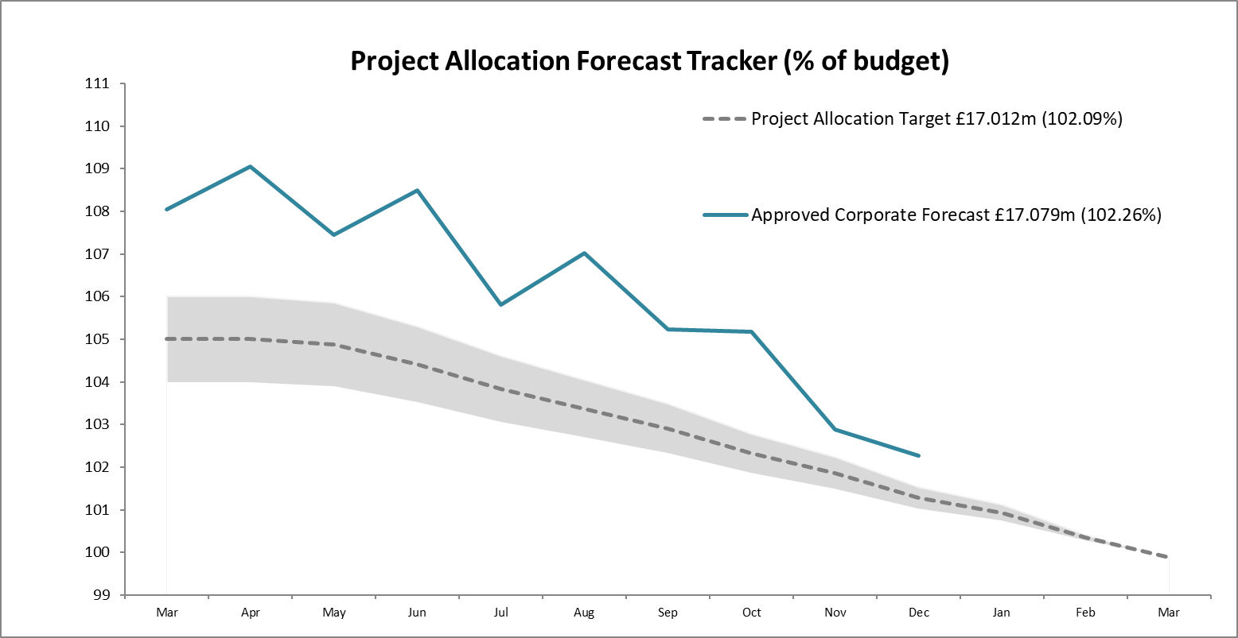  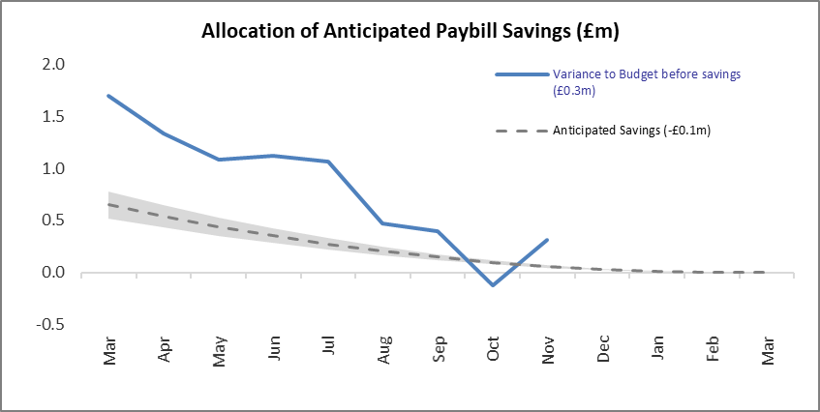 | The Project Allocation Forecast Tracker does not include any ring-fenced funds so NRF/BCF/SMEEF, BPF, Peatlands and FwN are stripped out. The controllable project budget is based on a Core Paybill budget of £27.913m. The budget figure was set £0.5m below the starting forecast in anticipation of savings to be realised through leavers and vacancy gaps.  The paybill forecast is currently £0.2m above budget having included additional costs of £1.1m for the payment settlement agreed in December. It is anticipated that additional savings will be achieved over the remaining months of the year.

Finance
Resource Budget Performance
- An underspend of £0.279m is currently forecast on the Operating budget. The underspend is lower following a reduction of £0.890m to the budget for the Nature Restoration Fund. It includes a reported underspend on Farming with Nature of £0.35m which has arisen as the scope of SG’s National Test Programme has evolved. At the same point in 2021/22 an overall overspend of £0.597m was forecast.
- The net underspend of £0.279m reflects an overspend on Core GiA of £0.166m and an underspend on Ring-fenced programmes of £0.445m. The additional budget allocation of £0.5m notified by SG late in 2023 has increased our risk of an underspend for the full year, although we are proactively pursuing options to bring forward project demand.
- The Paybill forecast has been increased by £1.065m in respect of additional costs of the final pay settlement.
- SG confirmed the transfer of budgets from Farming with Nature (£0.650m) and Better Places Fund (£0.190m) to cover the pay settlement.
- Business partnering continues into Q4. The Budgets team challenge uncommitted budgets and ensure that allocations are optimised with respect to high priority work considered achievable during the remainder of the year.
- We will continue to monitor project surrenders throughout the year, using our knowledge and experience of previous slippage patterns to ensure that appropriate demand is ready to allocate when funds become available.
- The paybill outturn is currently projected to exceed the budget by £0.254m after inclusion of the final 2022/23 pay award. This anticipated outturn follows the early approval of staffing requirements for 2022/23 in response to identified resourcing pressures. This proactive approach ensures that we can respond to the developing needs of the organisation in the right timeframe. It is anticipated that additional savings will be made over the remainder of the year.

Indirect Capital Funding Programmes (including Peatlands)
- We are forecasting an overall break even position on Indirect Capital.
- The total budget for Peatlands is £10.440m following a budget reduction in December of £2.5m based on the latest forecast of £10.343m. The Peatlands forecast continues to be reviewed regularly.
- The total budget for Nature Restoration Fund (NRF) is now £5.779m. This is split £1.321m Resource and £4.458m Indirect Capital. We are forecasting an underspend on Indirect Capital of £0.159m.
- Slippage from 2021/22 Biodiversity Challenge Fund (BCF) grants is being funded from the Nature Restoration Fund Indirect Capital budget (£0.336m).
- The Scottish Marine Environmental Enhancement Fund is also being funded from the Nature Restoration Fund Indirect Capital budget (£0.701m).
- The impact of slippage on large value programmes such as NRF/BCF/SMEEF presents a risk to spend levels. The anticipated corporate slippage is 4% of the forecast outturn (£0.215m). This is split against NRF/BCF/SMEEF Indirect Capital (£0.179m) and Resource (£0.036m) budgets.
- SG confirmed they won’t be funding the 21/22 slippage of £0.150m for GovTech. We are funding this from the anticipated corporate slippage.
- We are also funding slippage from 2021/22 Wee Forests Pilot of £0.109m from the anticipated corporate slippage.

Structural Funds Programmes
- ERDF Claims: GI claim 9 and NCHF claim totalling £3.2m are due to be submitted to SG shortly. Claimants are being reimbursed by NatureScot in advance of claims being submitted to SG.
- We have been advised that an arrangement to provide cover for the risk of de-commitment over the remainder of the programme will not be forthcoming. However, a recent external Scottish Government audit of our claims process provides reassurance that risks of de-commitment are being well managed.

Capital Budget Performance
- An underspend of £0.3m is forecast on the capital budget due to the GGH PV Increase and Batteries project being delayed to 2023/24. The replacement of AC units in the GGH Server Room (£0.3m) has been brought forward in to 2022/23 and should reduce this underspend but has not been reflected in the figures as yet.
- Funding of £0.051m has been secured from Hermaness Hill Path and Welcome Area and £0.015m from St Cyrus NNR - RTIF bid for car park.
- We have included the sale of Glencripesdale in the NBV figures which increases our ability to spend on Capital projects by £0.750m.
- The potential proceeds of the sale of Kinloch Castle are not currently reflected in the numbers but will also be considered in any additional capital expenditure plans.

RISK
Corporate Risks | Risk Changes
Changes to Corporate Risk Scores
↑1 Gone Up
↓ 1 Gone Down
Change to Corporate Risk Register - proposed
↗ 0 New Corporate Risks
↘ 0 Risk De-Escalated

Risk
- The Annex A - Corporate Risk Register holds the current high risk corporate risks for NatureScot. Activity and project risks are managed within the risk management system, which underpins the corporate risk register. All risks are managed in line with the Risk Management policy and monitored regularly for compliance and visibility of impact.
- There are currently 11 approved Corporate Risks, 6 medium and 5 high. During Q3 the impact and likelihood scores have changed within 2 risks but that hasn’t impacted their risk rating.

Board are requested to note the performance of the corporate risks and to confirm the de-escalation of risk 646.

PEOPLE
People Metrics | Status

Wellbeing
Accidents & Near Misses – target: to stay within variations around the mean which are 4.4 for accidents & 5.8 for near misses  Q3: Accidents=8, Near Misses=3. This is starting to return to the pre-pandemic levels. There is no single cause for the increase, however suggests that there is a need for awareness raising around PPE and Tick resistant clothing. | Green
Dignity at work Pulse Survey – there was a 56% response rate from the organisation. Of those respondents, 90% recognise NatureScot as an inclusive workplace. 72% felt comfortable to call out bad behaviour to themselves or others and 77% felt comfortable about escalating it to POD/Manager. There were 9% who said they had personally experienced bullying and or harassment over the last 12 months and 6% had experienced discrimination. Of the cases reported and investigated, 47% of the cases were resolved. There were 8 raised to POD in 2022/23 | Green
Capacity
Sickness – Target: under 2 days per person per quarter.  Q3: 1.48 days - an increase from Q2. However, we are starting to return to the pattern we saw pre-pandemic at the same time of year in 2019/20. The majority of the absence are short-term, only 3.37% of sick absences are long term (an absence of 12 weeks or longer) | Green
Q3: 77% of holiday leave taken, this is within target. P&OD will continue to follow up with individual teams on any variations. | Green

Development
Formal Casework - target <=50% of informal casework  Q3: 37% (10 cases), well within normal range for this type of casework | Green
Informal Casework  Q3: 27 cases. Well within the normal range for this type of casework, however Q3 has seen an increase of 7 cases, which is higher than Q3 2019/20 pre-pandemic. The increase in Q3 is in relation to health and wellbeing casework | Green

Workforce Profile
Turnover – target: increase  Q3: average turnover is 10.63% (over last 12 months).The leavers in total are 24 in Q3, with 53 leavers to date. Of the leavers in Q3, 37.5% were retirements and 8.34% were employees going to alternative employment. 54.17% were categorised as other reasons, for example personal reasons & end of contract. In Q3 we have had a 45.84% response rate for our Exit Questionnaires. This is an increase from Q2 response rate. The year to date the response rate is 35.85% (19 responses from 54 leavers).This shows further promotion of the exit questionnaire is required. Two issues have been flagged and these have been picked up with the line managers. There are no broader corporate issues emerging so far. | Green

Internal Movement – target: increase  Q3: Positively, internal moves have increased in this quarter with a total of 50 internal moves compared to 19 in the previous quarter. There were a number of failed internal recruitments which meant posts moving to external recruitment. To date in 2022/23 there have been 154 recruitment exercises. This is slightly less than the same time in 2021/22 when there were 170 recruitment exercises. Of the 154 exercises, there have been 27 failed recruitments; 8 of those failed internally first but were then filled externally. The failed recruitment rate has increased from 7.6% in 2021/22 to 12.3% year to date (there were only 13 failed recruitments in 2021/22). | Green
Retirement Profile  Q3: Given the predicted increase in the number of retirements over the next few years, due to our workforce demographic profile, we are focusing effort on a number of solutions to support succession planning and talent management. This will help mitigate the business risks associated with the loss of expertise as colleagues retire. It is interesting to note that the average retirement age is slowly rising. Year to date (2202/23) average retirement age is 63. For 2021/22 it was 62. There were 9 retirements in Q3 (an increase on Q2), and with 5 retirements confirmed for the remainder of the year, we anticipate a total of 18 retirements will have happened in 2022/23. This is lower than the predicted figure (34), and we have also seen an increase in the number of new starts in the 57+ age range. | Amber

Internal Movement
Whilst we are seeing increased internal movement which is supporting employees to enhance their skills and experience, we are not managing to fill all vacancies internally. When we do recruit externally we are operating in a very challenging job market, competing with both public and private sector organisations. To try to address these challenges, particularly around salary, we have undertaken salary benchmarking for key skills where we are failing to recruit. We are also reviewing our recruitment approach, to see where it can be strengthened, to attract a stronger field of diverse candidates. To support this further, a review of our recruitment approach is also scheduled within the internal audit programme for 2023/24.

Retirement Profile
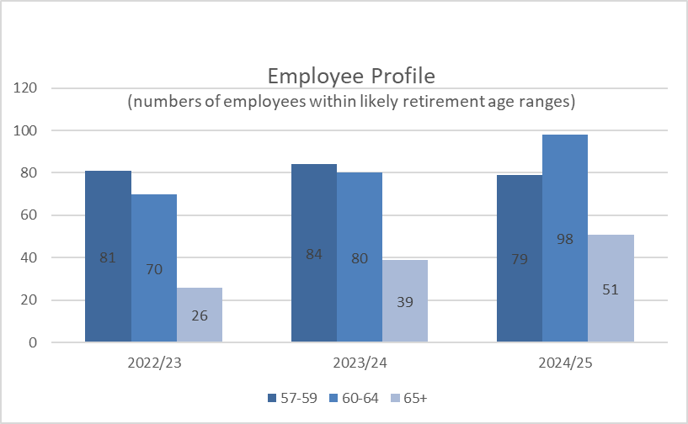
- In order to mitigate the impact of our workforce demographic profile (increasing 57+ age group as a proportion of our workforce), and consequential corporate risks around the loss of talent and expertise as colleagues retire, we are focusing on a number of actions. Through talent management and succession planning, we are aiming to minimise the loss of knowledge and talent throughout the organisation.
- People & Organisational Development (POD) are working with Activity and National Operations Team leaders to look at age profiles within teams, to highlight particular resilience and skills gap risks. We are encouraging open conversations between line managers and individuals to understand their aspirations around the timeline to retirement, so that effective planning and mitigations can be put in place. This includes opportunities for knowledge transfer and options such as mentoring.
- This will ensure succession planning is in place and that the breadth of knowledge and experience within the 60+ age group is transferred as part of the succession planning process. From the November pulse survey, 90% of the employees who responded indicated that they would welcome a focus on retirement with some information around wellbeing.
- We are introducing new Career MOT service to support colleagues in fulfilling their aspirations, at whatever stage in their careers they are, as well as supporting partial retirement and flexible hours, to help manage the transition to retirement.
- This information will feed into our strategic workforce planning and the NatureScot Way Skills group, and will complement other actions such as encouraging internal moves and our investment in young people through our Programme for Youth Employment.
- The launch of Career MOT’s will also be a key tool to enhance our regular performance development conversations (PDCs) and support a stronger focus on personal and career development.

Recommendations

- Board are asked to:

  - Note the overall performance of the Corporate Plan objectives (Performance Report)
  - Note the position of the operating and capital budgets (Finance Report)
  - Note the performance of the corporate risks and confirm the de-escalation of corporate risk noted in paragraph 9 (Risk Report)
  - Note the overall performance of the People Measures (People Report)

Annex A – Corporate Risk Register (High Risks)
RISK TITLE | DESCRIPTION | CONTROLS | IMPACT | LIKLE-HOOD | RISK LEVEL | COMMENTS
47 - Computer Virus/Malware | As a result of inadequate protection, or inappropriate system use, including accidental activation of email links by that lead to malware downloads, there is a risk that NatureScot systems becoming infected with a malware or virus agent, resulting in NatureScot systems and data become unavailable, encrypted or corrupted, significant system downtime and huge operational impacts | *All file servers are protected by Sophos anti virus protection. Upgrades are performed automatically and can also be applied in an ad-hoc manner  *All PCs are protected by Sophos anti virus protection. Upgrades are received on a daily basis but can be applied ad-hoc  *All incoming emails are scanned for viruses.  *All internet access, where possible, is scanned for viruses (not https sessions).  *Raise staff awareness of potential risks relating to email links and infected documents through regular communications.  *Sandbox controls/ environment implemented  *Control of USB devices  *Awareness raising with staff via Blogs and update articles  *Incident Management Group in place  *Corporate data backed up to cloud | 4 | 3 | High | Since the last report there has been a Scottish Public Sector incident which has impacted an organisation, however, the victim has not been publicised as yet. On the way up to Christmas we need to ensure our users are aware and awake to the current high cyber risk, in particular to phishing emails. There have been quite a few Android related incidents with apps in the Android Store (where what appears to be legitimate apps are infected either with malware or used to extract information from user devices) which is why we have restricted access to only essential / core applications. The festive period is a high risk time for all public sector organisation and we plan a pre-Christmas campaign to alert our colleagues of potential risks.

RISK TITLE | DESCRIPTION | CONTROLS | IMPACT | LIKLE-HOOD | RISK LEVEL | COMMENTS
253 - Peatland restoration target and budget. | As a result of the immature and complex operating environment, there is a risk to: meeting the annual Peatland ACTION restoration hectare target; and spending the annual budget. | • Realistic planning  • Invigorating demand  • Real-time monitoring  • Increasing resilience to change in projections  • Regular and robust review and control  • New Guidance on operating during nesting season being update to allow risk based approach to operations during that period. | 4 | 4 |  | The likelihood of the risk remains 4 (high) and we have advised the Scottish Government that our outturn is likely to be around 5,900 hectares. Whilst we have a pipeline of almost 10,000 ha, and there has been progress on the speed of PDR prior-notification process and operating in the bird breeding season, there is an ongoing risk of not meeting the hectare target because of a combination of over-ambition; limited contractor capacity and potential applicants holding back pending clarity on agriculture/land reform and Peatland Code verification/carbon markets. This has an implication on the capital element of the budget. There is less risk on the resource budget due to: - more rigorous programme/business planning; - expanded staff capacity. Thus, the focus of our controls are on: 2. Invigorating demand. We are targeted promotion through the key stakeholder representative bodies; explaining the multiple benefits of restoration, the open application system and the scope for multi-year offers. We are also developing a new grant for coordinating delivery of large scale restoration projects. 3. Real-time monitoring - we are monitoring our pipeline of restoration projects - informed by grant application status and risk to delivery from project complexity; vulnerability to extreme weather conditions; and applicant/agent track record of delivery. We are holding regular site visits with contractors. 4. Increasing resilience to change in projections – we are overcommitting by 10%. 5. Regular and robust review and control - There is quarterly assessment of risk by the Peatland ACTION Governance Board, with a remit to provide assurance on the likelihood of risk and recommend [to the Programme Manager] additional controls to reduce the likelihood to 2. 6. Using new Guidance on operating during nesting season to allow risk based approach to operations during that period. In addition, our skills development work – through training, on site ‘training plus’, pre-apprenticeship and publication of a Technical Compendium – is aiming to expand the contractor capacity.
RISK TITLE | DESCRIPTION | CONTROLS | IMPACT | LIKLE-HOOD | RISK LEVEL | COMMENTS
393 - Future Funding of NatureScot | As a result of on-going reductions in public expenditure or new cost pressures there is a risk our grant-in-aid settlement may not match statutory and fixed costs as well as corporate plan priorities. Unless other funding sources are secured this could result in an inability to adequately resource delivery of agreed priorities, leading to failed outcomes and reputational damage. | * Ensure that our priorities are aligned with published Programmes for Government and ministerial portfolio priorities, specifically those aligned to the Programme for Government and Bute House Agreement.  * Provide realistic and evidenced assessment of the impact of possible cuts in our grant-in-aid budget through the annual Spending Review process.  * Develop and put forward proposals, through the annual Spending Review process and other avenues with Scottish Government, for delivering more and better outcomes for nature and people through wider Scottish Government funding.  *Reduce expenditure in some business areas through budget setting processes aligned to business planning cycle.  * Have an effective communications strategy in place which promotes the added value of our work.  * Identify and implement opportunities to generate income from the services we provide.  * Identify and implement opportunities for external funding of NatureScot-led work through the business planning process (including at Outcome and Activity levels) and at the project development stage for significant scale projects.  * Develop proposals for new, preventative projects that can help deliver a wider set of SG priorities, and build awareness and support of these.  * Develop and refresh a short, medium and longer term financial plan based on potential financial scenarios. | 4 | 3 |  | Our draft budget for 23/24 has been published and whilst we have received an uplift for key corporate plan priorities and pay pressure, core grant in aid continues to remain at flat cash. Likelihood has been reduced to 3 based on additional funding being secured in new areas.

RISK TITLE | DESCRIPTION | CONTROLS | IMPACT | LIKLE-HOOD | RISK LEVEL | COMMENTS
691 - Lack of support for Fusion Financial and Procurement Modules | Due to the specialised nature of Oracle Fusion and the interface with NatureScot’s Business Planning System, as a result of key system support staff leaving the organisation, there is a risk that there will be insufficient knowledge and ability to operate key processes or to develop the system and reports. This may result in an inability to adapt the system to changing business needs, reporting delays or to operational inefficiencies and payment challenges that could affect all users of the system. | - Engage in a shared service arrangement with other organisations using Fusion e.g. HES, SLAB  - Make use of the support arrangement from Inoapps currently utilised by POD. There may not be sufficient knowledge from Inoapps to initially support some finance and procurement processes.  - Explore potential for a third party to provide level 2 support to assist that provided by NatureScot staff.  - Recruit to the three vacant functional analyst positions.  - Recruit to the vacant Oracle Cloud Service Manager position.  - Draw on finance staff with an awareness of Fusion and the interface with Business Planning as well as the functional analysts who support the POD elements of Fusion, in order to support the finance elements of Fusion. It should be noted that this will not provide all of the specialist knowledge required.  - Implement a networked team approach to involve staff from a wider group to share knowledge and provide resilience in future. | 4 | 4 | High | The recent recruitment round for the two FPP support analyst positions has yielded one successful candidate who has accepted the position and started with NatureScot in January. We are engaging with a specialist recruitment agency for the remaining position and for the Oracle Cloud Manager role with a number of potential individuals identified. Recruitment for the POD support is ongoing.  The development of the current support analyst to take on a wider ranging role developing support arrangements for NatureScot is underway. We have also confirmed with InoApps that support will be provided for FPP queries. Work on the procurement tender document for Fusion support is progressing and will now explore the possibility of providing level 2 support to assist NatureScot staff while recruitment is underway and then the skills of staff developed.  We have discussed the potential for shared service arrangements with SG colleagues who are implementing an Oracle solution in 2023. An initial meeting / forum will take place in January with fellow Fusion users to explore how this can best be managed in future, along with shared recruitment and training opportunities.

Annex B - PERFORMANCE DASHBOARD

RAG status will be available once 5 data points are collected. Bar charts are used until this point and initial data is noted without a graph

WE HAVE PROTECTED NATURE
Score | Measure | Performance Overview | Actual | Cause | Response
 | Reducing Deer Numbers | 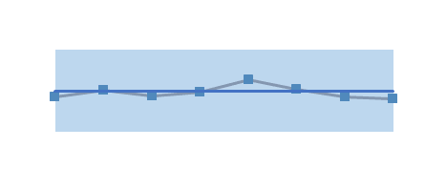 | No. deer culled 102728 | Annual figure, next available Q1 2023/24.
 | Area (ha) of woodlands restored (% of woodlands in favourable condition) | 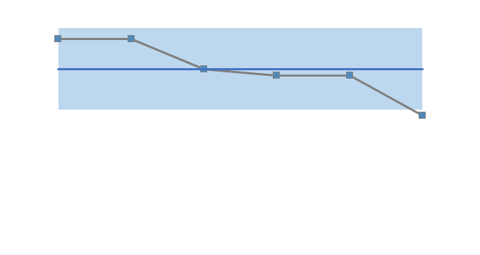 | 33.7% | Annual figure, next available Q1 2023/24.
 | Number of MPAs that we have monitored | Bi Annual Measure |  | Not yet in a position to have reported for Q3 (this will be a quarter behind), we are still developing our approach and have capacity issues. | Ongoing internal discussions to address resourcing issues
 | % of licenses issued that comply with the conditions required of them | No data |  | Lack of resource to carry out compliance checks | Ongoing internal discussions to address resourcing issues
 | Are we seeing raptors where we should be? | This measure has not been developed |  | As a result of ongoing discussions on the complexities of this measure it will need to be replaced. | A new wildlife management measure will be confirmed as part of the measures development process in Q4.

WE HAVE RESTORED NATURE
Score | Measure | Performance Overview | Actual | Cause | Response
 | Area (ha) of enhancements through SMEEF | Data to be provided in Q4 |  | SMEEF is still in development and measures are expected in Q4. | SMEEF measures are in development and are now expected in Q4.
 | Ha of land managed under plans supported through agricultural support schemes | 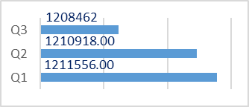 | 1.2mha | This is only a small change in comparison to the overall amount and is in line with expectations at this point in the year. | As the nature of the schemes is annual, this is an annual measure as there is no significant movement between quarters. We are continuing to monitor.
 | Area (ha) improved for habitats and species through the nature restoration fund | None reported this quarter |  | The claims received haven’t confirmed any ha improved. | We expect to receive data when NRF2 Helping Nature projects complete later this year and in early 2024. We will also review the reporting process to collect this data on a quarterly basis.
 | Area (ha) of peatland put on the road to recovery |  | 686

THE VALUE OF NATURE IS RECOGNISED
Score | Measure | Performance Overview | Actual | Cause | Response
GREEN | Hectares of Green infrastructure Restored | 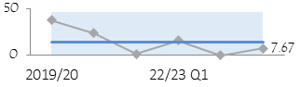 | 7.76 | Project delivery is proceeding as planned with all GIF projects due to complete by June 2023. | Continue focus on delivery of projects, processing of claims and collation of data from final reports as they are submitted
 | Nature-based jobs and skills opportunities |  | 158 | Only a small reduction in Peatland trainee numbers which in fact points to a consistent delivery of training throughout the year. | A new tranche of WWR placements will be in place by Q1 of 2324
 | % of landholdings undertaking a publicly supported Natural Capital approach | No audits undertaken during Q3 |  | No additional farms undertaking NC Assessments through NatureScot Project 117814. | The natural capital assessments are on pause until 2023/24. Habitat condition assessment scorecards related to the biodiversity audit will be tested on farms from November to March.
GREEN | National Nature Reserves online engagement | 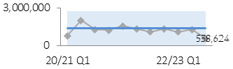 | 538,624 | There has been a significant drop in engagement across the reserves.  We expect some decrease over autumn winter as online engagement reflects the level of visits on the ground. | Further investigation needed as to why the drop has been more significant this quarter. We will follow up in Q4 with reserves where social media posts are lower than expected.

WE HAVE TRANSFORMED HOW WE WORK
Score | Measure | Performance Overview | Actual | Cause | Response
N/A | Workforce diversity - Age | 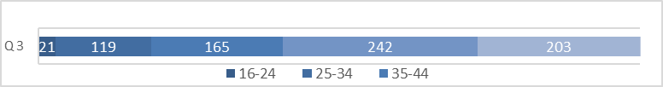 |  | Both 16-24 and 55-64 saw a decrease in Q3 | Positive exits and succession planning, to main stream the PYE programme as part of resource planning, are key.
AMBER | Workforce diversity - Disability | 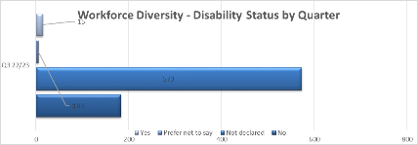 |  | Disclosure remains low, but further disclosure campaign planned in Q4 to tackle. | Continue work on EDI actions and increasing disclosure through campaign and visible support.
AMBER | Workforce diversity - Ethnicity | 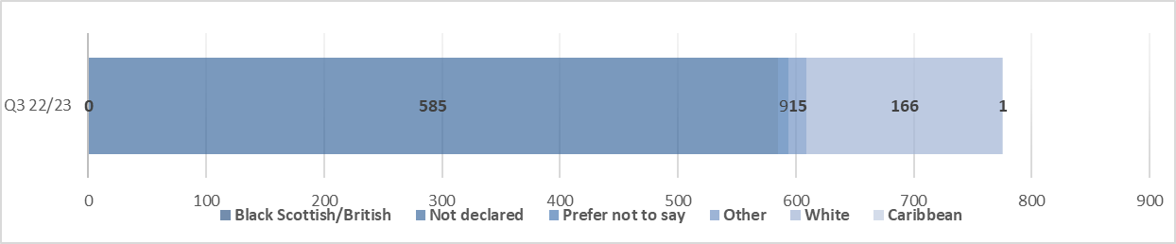 |  | Cause remains (as per Q2) cultural norms. Working in Partnership to tackle these. | Continue work on EDI actions and increasing opportunities within diverse communities.
GREEN | Total emissions | N/A |  | It has been agreed to report this in Q4. | There is a shift in how we are calculating emissions (building splits) so we are unable to provide data until Q4.
GREEN | Reach in mainstream media
GREEN | Impact of public facing campaigns | 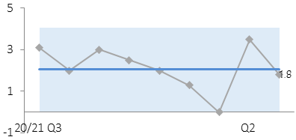 |  | Summer campaign covered Q1&2. Very strong dwell time on campaign web pages and social media Click Through Rate | Social media and radio boosts to Click Through Rate and web traffic with continued targeted campaigns

