Appendix 1: Hamilton Low Parks SSSI Citation
CITATION
HAMILTON LOW PARKS
SITE OF SPECIAL SCIENTIFIC INTEREST
South Lanarkshire & North Lanarkshire
Site code: 761
NATIONAL GRID REFERENCE: NS 718574, NS 727567
OS 1:50,000 SHEET NO: Landranger Series 64
1:25,000 SHEET NO: Explorer Series 343
AREA: 105.9 hectares
NOTIFIED NATURAL FEATURES
Biological: Birds: Grey heron, Ardea cinerea, breeding

DESCRIPTION
Hamilton Low Parks SSSI, lying immediately to the east of Hamilton, supports one of the largest grey heronries in Scotland. The site comprises woodland, open water/grassland habitats and a section of the River Clyde. The grey heron Ardea cinerea nest within the mixed plantation woodland.

NOTIFICATION HISTORY
First notified under the 1949 Act: 1956, 1971
Re-notified under the 1981 Act: 31 January 1986 with a 41.2 ha decrease in area
Notification reviewed under the 2004 Act: 16 September 2010
REMARKS
Measured area of site corrected from 107.6 hectares.

Appendix 2: SSSI Condition & Roe Deer Management: Strategic & Legal Context
This section sets out the strategic context to the work presented in this report, with specific regard to the condition of designated sites, such as Sites of Special Scientific Interest (SSSIs), and roe deer management. This is only a broad summary of key legislation and guidance, such that it is recommended for those wanting more detail that they check the original documents.
2.1. Scottish Government Targets for SSSI Condition:
Since 2007, the Scottish Government has produced a National Performance Framework (NPF), which allows the public to judge how Scotland is performing against a wide range of key national indicators covering all aspects of life in Scotland. The indicators provide a broad measure of national and societal wellbeing, incorporating a range of economic, social and environmental indicators and targets which are updated as soon as the data are available.
There are several indicators that cover the environment in Scotland, and in terms of designated sites (SSSIs), the key current indicator is National Indicator (NI) 44: Improve the condition of protected nature sites. To measure progress against NI44, the Scottish Government has set a specific target for the proportion of natural features in favourable or recovering condition, which is known as the ‘condition target’.
For the purposes of the condition target, ‘favourable or recovering condition’ includes natural features that are:
- either assessed in favourable or 'unfavourable recovering' condition
- or have the necessary management measures in place, such that SNH believe the land will – in time, reach favourable condition, termed recovering.
Until 2010, the condition target was precise, with the aim to ‘Increase to 95% the proportion of protected nature sites in favourable condition’. However, this was reviewed in 2011, and in order to better reflect the fact that many sites have no on-site remedy, a more general target, NI 44, was included in the list of national indicators: ‘Improve the condition of protected nature sites’.
Scottish Natural Heritage has the main responsibility for delivering National Indicator 44, with a significant contribution also coming from Forestry Commission Scotland.
The results of SNH Site Condition Monitoring programme assessments made between 1999 and 2005 have formed the baseline for the condition target. In 2005, 71.4% of Scotland’s natural features were in favourable or recovering condition, whilst by March 2017, this had risen to 80.3%, as a result of focussed efforts by many organisations and landowners to address negative management pressures upon SSSIs. One of the most common of these management pressures comes from overgrazing, including overgrazing by deer.
Therefore, SNH continue to have a duty to address management issues which affect SSSI condition, with their priority being to investigate and implement solutions to remedy adverse impacts upon SSSIs where this is practically possible. One of these sites includes Hamilton Low Parks SSSI.

2.2. Scotland’s Wild Deer: A National Approach’ (WDNA):
Deer management in Scotland has and continues to be the focus of much attention, due to the importance of deer shooting to the economy of many rural communities, deer welfare issues, and the adverse impacts of deer populations upon forestry, agriculture and both internationally and nationally important nature conservation interests.
In order to address these issues, and in response to the recommendations of the Rural
Affairs, Climate Change and Environment Committee of the Scottish Parliament, the Scottish Government requested that Scottish Natural Heritage (SNH) carry out a detailed review of deer management in Scotland. This review, titled ‘Deer Management in Scotland: Report to the Scottish Government from Scottish Natural Heritage 2016’, was completed in October 2016. The review report was undertaken in the context of existing key policy documents for the management of deer including ‘Scotland’s Wild Deer: A National Approach’ (or WDNA) and the ‘Code of Practice on Deer Management’ (Section 2.4 below).
The WDNA report was first published in 2008, setting out the Scottish Government’s 20 year vision for the sustainable management of deer. The vision, to be achieved by 2030, covered the following key aspects:
1). There will be widespread understanding and achievement of sustainable deer management, such that:
- Deer will be valued as part of Scotland’s natural heritage, in balance with their habitats and will contribute to a high-quality, robust and adaptable environment;
- Deer will be a resource for diverse sustainable economic development with adverse impacts on other land being minimised;
- Deer management will promote social wellbeing through enjoyment of the outdoors and healthy lifestyles.
2). Wild deer will be managed in an inclusive way with knowledge used to underpin all decisions.”
The WDNA report was subsequently reviewed in 2014, and the following set of priorities were brought in, building upon initial proposals. Of particular relevance to this Hamilton plan, the following priorities and challenges were set for 2015-2020, based around:
- collaboration and effective deer management planning and implementation
- healthy ecosystems
- lowland and urban deer
- economic and community development
- training and deer welfare.
These priorities are also set out in an annual Action Plan.

2.3. Legal Context of Hamilton Low Parks Roe Deer Management Planning
Legislation has been in place relating to deer in Scotland for many decades now. However, the main legislation protecting and regulating wild deer in Scotland is the Deer (Scotland) Act 1996. This Act consolidated and replaced the Deer (Scotland) Act 1959. The 1996 Act was further amended by the Wildlife and Natural Environment (Scotland) Act 2011 (WANE) and the Land Reform (Scotland) Act 2016. The full wording of all this legislation can be downloaded from the web, such that they will not be set out in great detail here.
However, these Acts did charge Scottish Natural Heritage (SNH), the government’s nature and countryside agency (now encompassing the Red Deer Commission for Scotland), with certain statutory duties and powers with respect to deer management.
One of the key aspects of the legislation is that it confers powers on SNH to intervene to address damage or likely damage to different public interests; specifically, the risk of damage to:

- woodland
- agricultural production including livestock or serious overgrazing of pasture
- welfare of deer
- the natural heritage
- public interests of a social, economic or environmental nature
- public safety.

This includes ensuring that statutory designated nature sites, such as Hamilton Low Parks Site of Special Scientific Interest (SSSI), are maintained in favourable condition. Of particular note, SNH will work with land managers, such South Lanarkshire Council, to address adverse deer impacts on the Hamilton site and will also work with other bodies, such as Transport Scotland, to address matters relating to DVCs. In addition, SNH has a regulatory role and can directly intervene in deer management issues and has the statutory power to take regulatory action, if required. However, SNH’s preference is to work in partnership with other interests to resolve deer management issues and have therefore commissioned this work to address the roe deer issues around the Hamilton Low Parks area.

2.4. Code of Practice on Deer Management
The WANE Act 2011 also required SNH to prepare a code of practice for the purpose of providing practical guidance in respect of deer management. The subsequent guidance, ‘The Code of Practice on Deer Management’, aka the Deer Code, was produced and approved by Scottish Parliament, and came into force in 2012. A full copy of the code can be found at the following address: https://www.nature.scot/professional-advice/land-seamanagement/managing-wildlife/managing-deer/code-practice-deer.

The Code sets out clearly what must be done in respect of sustainable deer management as well as setting out what is expected in terms of best guidance.

In summary, the Deer Code applies to all who own or manage land where wild deer occur, and applies to all four species of wild deer, including roe deer, and all habitats. It primarily aims to:

- Manage deer as a resource sustainably;
- Minimise negative deer impacts upon public interests; - Safeguard deer welfare.

The Deer Code is a statutory document, with SNH and other public bodies having a duty to follow the Code (although it is not an offence to breach it). Non-public bodies do not have a duty to comply with it but if damage due to deer is identified, whether or not the Deer Code has been followed will be taken into full account when considering if SNH will exercise its duty to intervene as required. SNH has a duty, through the recent Land Reform Act, to ‘review the extent to which the Deer Code is being followed’ every 3 years. In addition to the Code of Practice on Deer Management, a further source of advice and guidance for deer managers is the well-respected Best Practice Guides developed by SNH in collaboration with the industry: www.bestpracticeguides.org.uk

Appendix 3: SNH Thermal Count Map (9th January 2018):

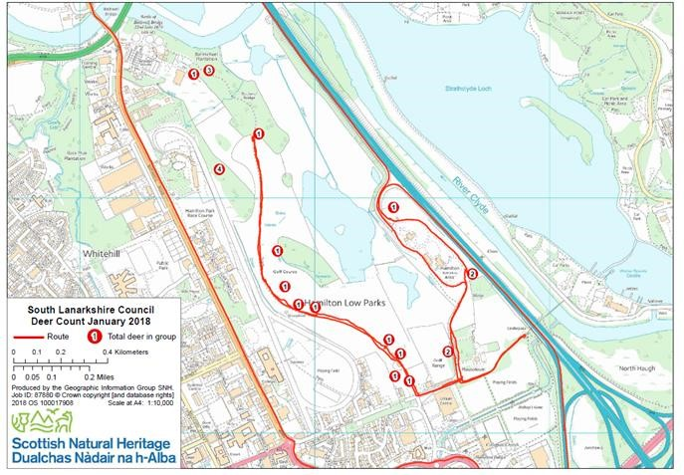

RESULTS
 | Male | Female | Juvenile | Unclassified | Total
Total | 1 | 6 | 0 | 15 | 22

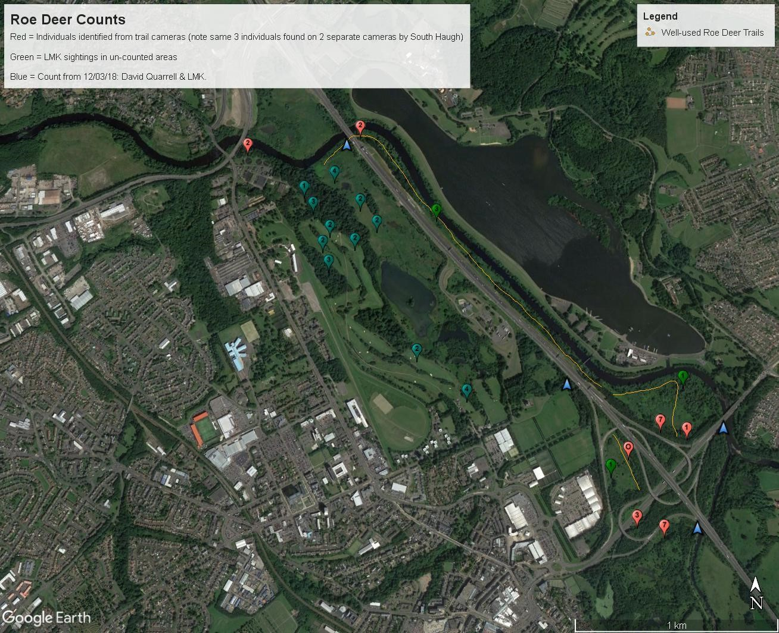

Blue Pointers = Underpasses Appendix 4: Deer-Vehicle Collision Data (2000-2016): Source: SNH
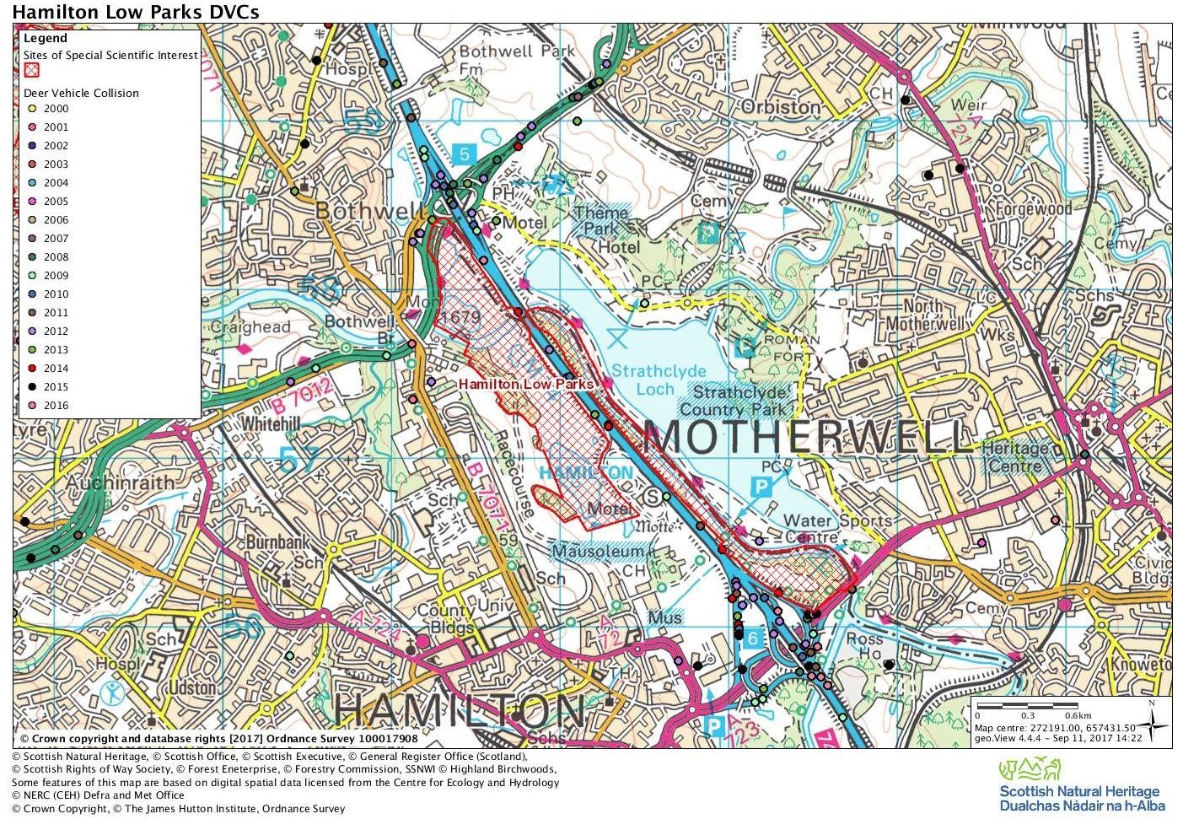
Appendix: 5: Woodland Herbivore Impact Assessment Field Sheets and Photos: Hamilton Low Parks: 2018
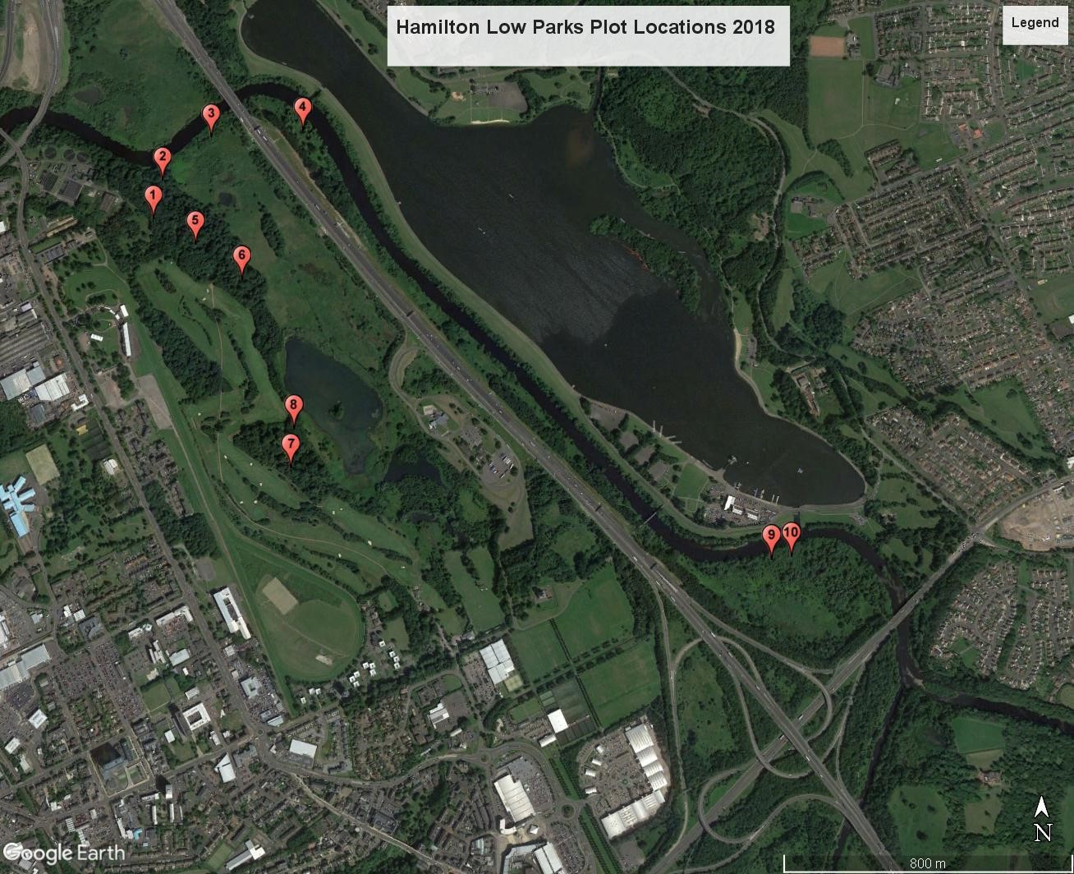
Hamilton Low Parks Plot 1:
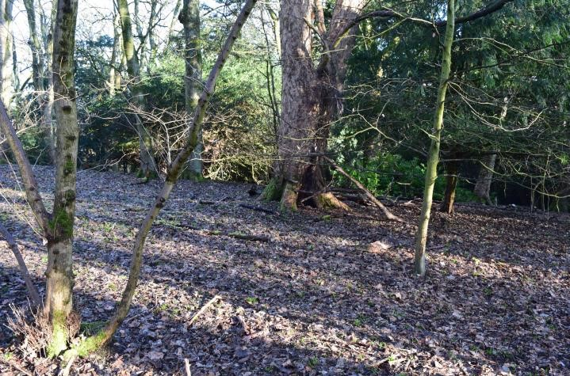
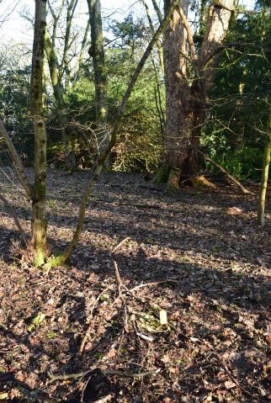
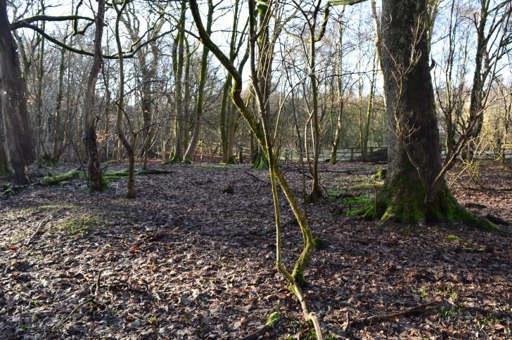
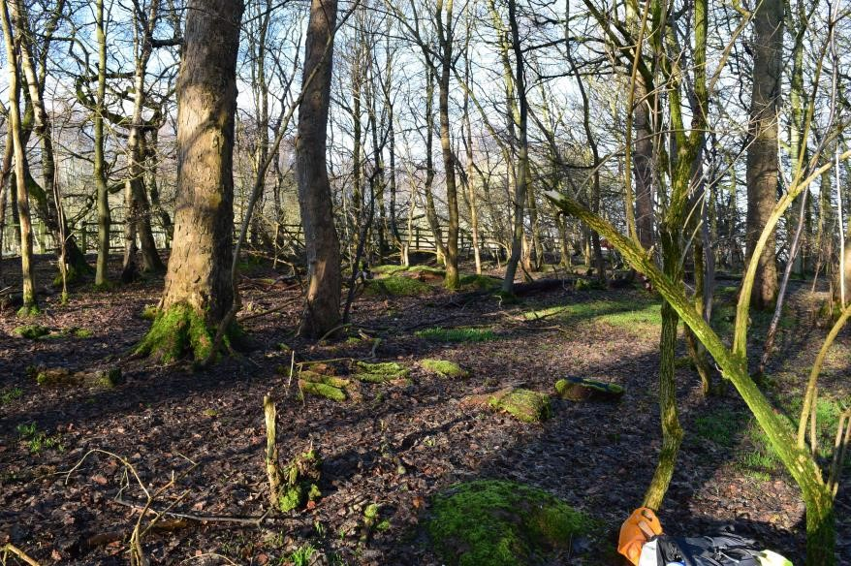
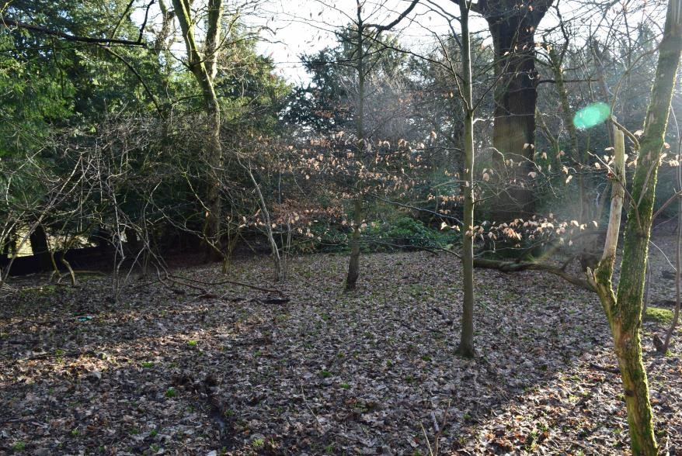
South
North

Post

West

East
Herbivore Impact Assessment Field Sheet – Level 2 |  |  | Woodland name: Hamilton Low Parks |  | Area name: South Lanarkshire
Date: 08/03/18 |  | Surveyor: Lindsay Mackinlay & D.Stevenson |  | Stop number: 1 |  | Grid ref.: NS 71585 57464
 | Impact | Species of tree /plant seen plus browsing /grazing rate. Other notes e.g. signs of older impacts.
Basal shoots | High | Holly – Heavy  Sycamore – Heavy (occasionally Very Heavy)  Ash – Heavy Elm – Heavy Hazel - Heavy
Epicormic and lower shoots | High | Holly (lower branches) – Heavy  Rhododendron (lower branches) – Light (but localised Moderate in places)  Ash – Moderate Looks like deer going up on hind legs in places.
Seedlings and saplings | Medium | Beech (3 old seedlings) - Heavy  Hawthorn (2 seedlings) – Moderate  Ash – (Many little seedlings = Light; ‘old seedlings’ = Moderate) Holly (1 seedling – Ungrazed)
Preferentially browsed or grazed plants | Very High | Bramble – Very Heavy  Buckler-fern – Very Heavy  No Ivy or Honeysuckle present.
Bark stripping, fraying & stem breakage | Medium | Lot of fraying on hazel stems as well as evidence of older fraying
Sward | High | Approx. 40% of new bluebell shoots grazed.
Ground disturbance | No impact | No trails or scrapes but ground generally bare anyway, due in all probability, to effects of shade from mature Beech and Sycamore in area.

Level 2 Extra Information:
Tree & Shrub Species | DAFOR Density Seedlings (<50cm tall) | DAFOR Density Saplings (50-200cm tall) | Extra Notes
Oak (R) | - | - | Some old tree tubes present within plot.  Mature Holly – most lower branches with shoot tips browsed.
Beech (F) | R (3 seedlings) | O (5 saplings)
Elder (F) – much dead | - | R (2 saplings)
Elm (F) - young | - | -
Hazel (F) | - | R (2 saplings)
Sycamore (R) | - | O (9 saplings)
Silver Birch (O-LF) | - | -
Hawthorn (O) | R (2 seedlings) | O (4 saplings)
Holly (R) | R (1 seedling) | -
Ash (O) | O | -
Rhododendron (R) | - | -
Yew (R) - at edge of plot | - | -

Brief Ground Flora Description: [Average Sward Height = 3cm ]
Species | DAFOR | Species | DAFOR | Extra Notes
Dryopteris dilatata | R | Allium ursinum | R (LF) | Much Sycamore and Beech leaf litter  Lots of bare ground/leaf litter = A
Hyacinthoides non-scripta | A | Bramble | O (LF)
Ranunculus ficaria | F | Bryophyte spp | F

Woodland Structure Class:  Mature woodland, understorey regeneration & mature woodland, no understorey  (probable past planting has pushed this area from 6 towards 5) | 6(5) | Signs of Herbivores | Pellets, fraying, browsing
 | 6(5) | No. of Dung/Deer Pellet Groups | 4
 | 6(5) | Bracken present? If so, impact from herbivores? | n/a
 | 6(5) | Past browsing pressure? | Lots of evidence of old basal shoots being hammered in the past. Hazel present few-stemmed to one-stemmed in places.
 | 6(5) | Historic herbivore impacts? | Some saplings look like they got away about 10-15 yrs ago but were also planted, with tree tubes – see main report.
Hamilton Low Parks Plot 2:
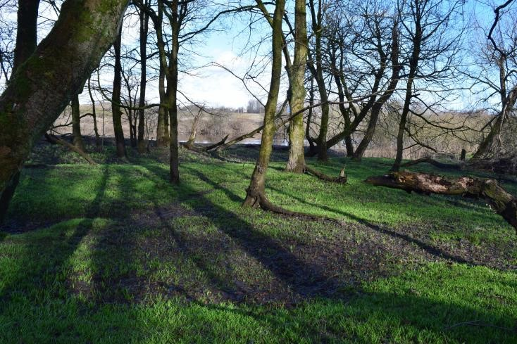North 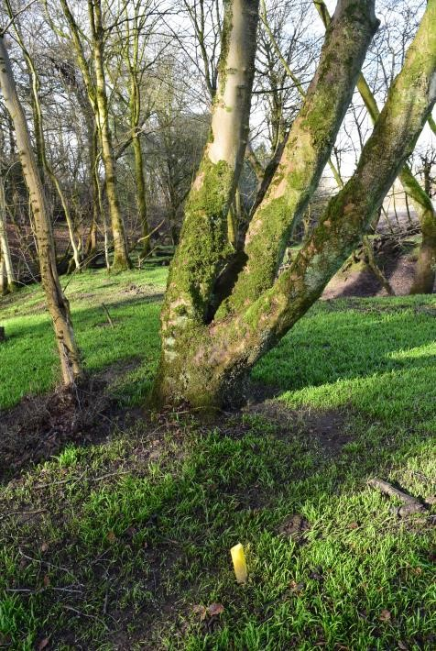Post 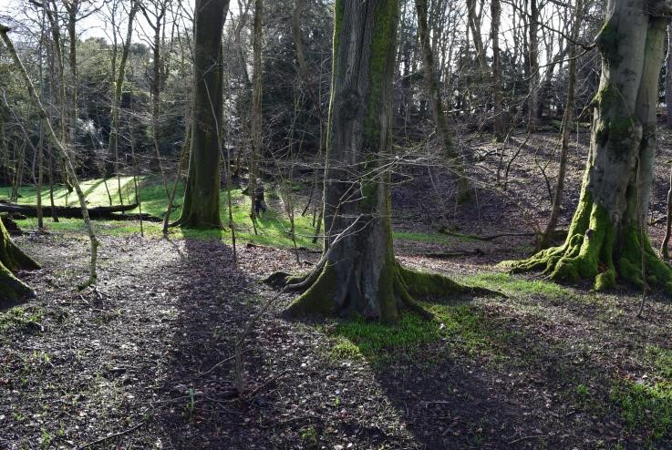South

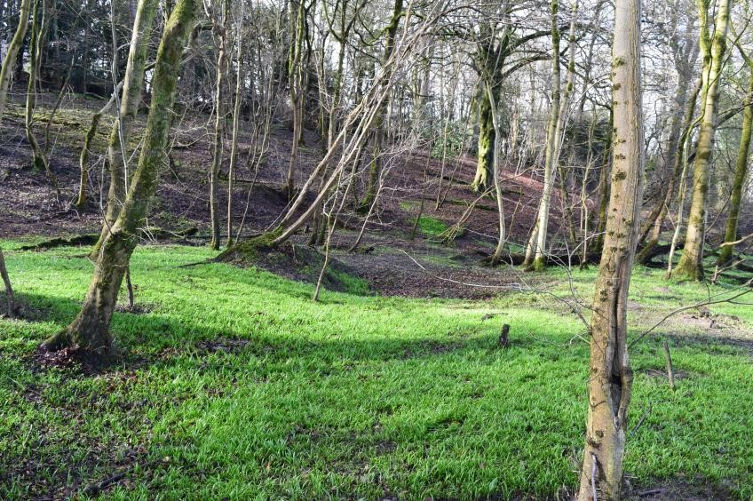West 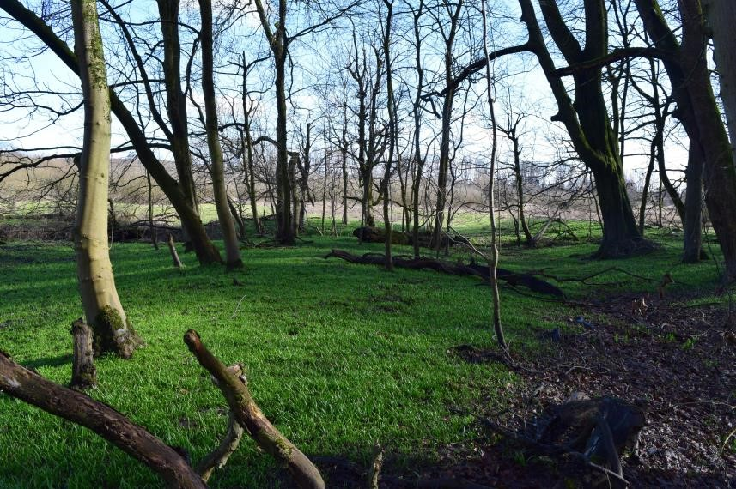East
Herbivore Impact Assessment Field Sheet – Level 2 |  |  | Woodland name: Hamilton Low Parks |  | Area name: South Lanarkshire
Date: 08/03/18 |  | Surveyor: Lindsay Mackinlay & D.Stevenson |  | Stop number: 2 |  | Grid ref.: NS 71574 57602
 | Impact | Species of tree /plant seen plus browsing /grazing rate. Other notes e.g. signs of older impacts.
Basal shoots | High | Elm – Heavy  Ash – Heavy  Sycamore - Heavy
Epicormic and lower shoots | Medium | Elm – Moderate  Ash (rarely present) - Moderate
Seedlings and saplings | Medium | Holly (~ 5-10 seedlings) – Moderate Sycamore (small seedlings = Light; 1 large seedling = Heavy) Ash (lot of small seedlings = Light (~20% browsed); Older seedlings = Moderate) Hawthorn (several small seedlings – Light)
Preferentially browsed or grazed plants | n/a | None present except 1 flat small Buckler-fern - Light
Bark stripping, fraying & stem breakage | Low | Small amount of old fraying damage
Sward | Low | Light grazing of Bluebells only
Ground disturbance | Low | 1 trail and 1 scrape (<5%)  Most bare soil due to river flooding activities and extensive shade from Beech and Sycamore.  Some badger activity (as setts in woodland)

Level 2 Extra Information:
Tree & Shrub Species | DAFOR Density Seedlings (<50cm tall) | DAFOR Density Saplings (50-200cm tall) | Extra Notes
Beech (F) | - | R (2 saplings) | Some Sycamore and Elm saplings (off dead/fallen trees) of ~3-4m tall but little else between them and mature trees.  Most seedlings small (<10cm tall)
Sycamore (F) | R | O (5 saplings)
Elm (F) | - | R (2 saplings)
Holly (R) | R/O (~5-10 seedlings) | -
Ash (F) | F (~ 200 seedlings) | R (1 sapling)
Hawthorn (R) | R | R (1 sapling)

Brief Ground Flora Description: [Average Sward Height = 7cm ]
Species | DAFOR | Species | DAFOR | Extra Notes
Allium spp. (inc Ramsons) | A/LD | Chrysosplenium oppositifolium | O (LF) | On River Clyde floodplain.  Bare ground/Leaf litter = A
Dryopteris dilatata | R | Bryophyte spp. | O | On River Clyde floodplain.  Bare ground/Leaf litter = A
Hyacinthoides non-scripta | O (LF) | Petasites spp. (Butterbur) | O (LF) | On River Clyde floodplain.  Bare ground/Leaf litter = A
Ranunculus ficaria | O |  |  | On River Clyde floodplain.  Bare ground/Leaf litter = A

Woodland Structure Class:  Mature woodland, no understorey but some  understorey due to frequent  Syc saplings from about 5-10 yrs ago, so elements of 5. | 6(5) | Signs of Herbivores | Trail, scrape and pellets
 | 6(5) | No. of Dung/Deer Pellet Groups | 2
 | 6(5) | Bracken present? If so, impact from herbivores? | n/a
 | 6(5) | Past browsing pressure? | No seedlings have got away in last 5-10 years.
 | 6(5) | Historic herbivore impacts?

Hamilton Low Parks Plot 3:
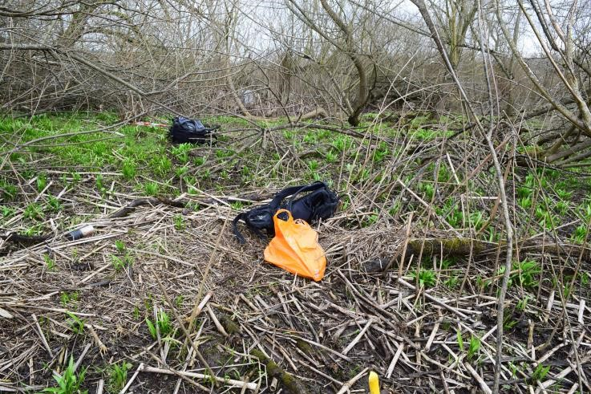North 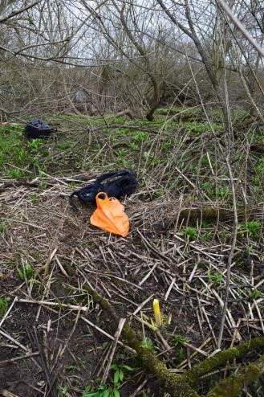Post 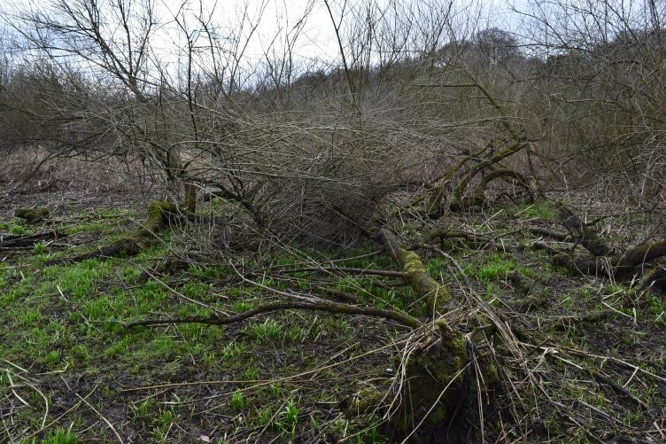South

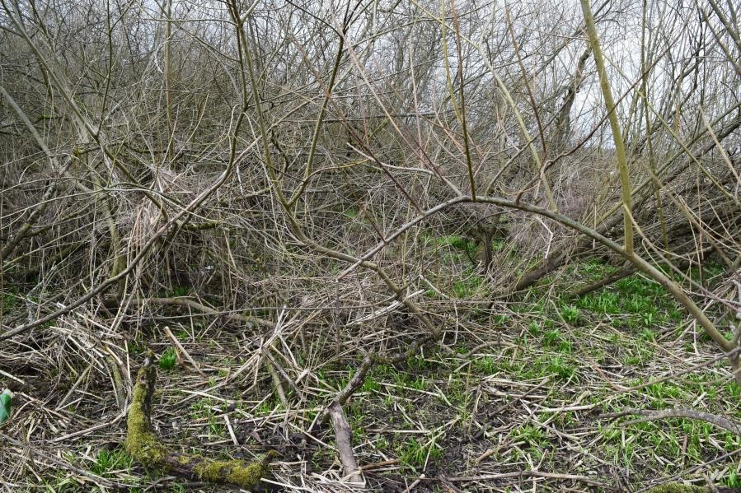West 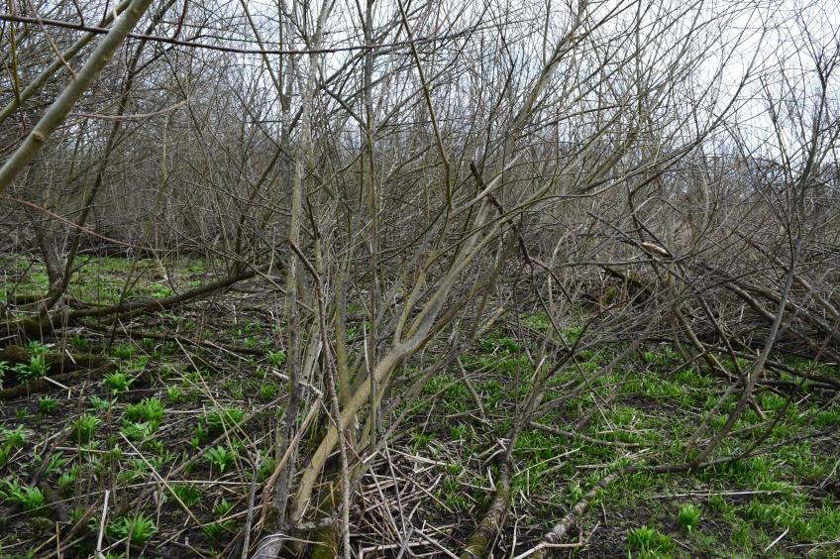East
Herbivore Impact Assessment Field Sheet – Level 2 |  |  | Woodland name: Hamilton Low Parks |  | Area name: South Lanarkshire
Date: 08/03/18 |  | Surveyor: Lindsay Mackinlay & D.Stevenson |  | Stop number: 3 |  | Grid ref.: NS 71680 57682
 | Impact | Species of tree /plant seen plus browsing /grazing rate. Other notes e.g. signs of older impacts.
Basal shoots | High | Willow – Heavy (but too many shoots)
Epicormic and lower shoots | Medium | Willow – Moderate (occasionally Heavy), when lower shoots within browsing reach only. Most shoots are healthy and outwith this reach as growing from fallen trunks and were already too tall for deer to browse heavily when trunks came down in all probability.
Seedlings and saplings | n/a | No seedlings (field notes not clear about presence of willow saplings cf. lower shoot growth so not included in the assessment here)
Preferentially browsed or grazed plants | n/a | None present
Bark stripping, fraying & stem breakage | Low | Two broken willow stems considered due to roe deer activity.
Sward | n/a | Not grazed
Ground disturbance | Medium | ~3-4 main trails as well as regular hoof marks within thicker willow area. Plot within floodplain area of River Clyde so well-disturbed as a result of river’s activities.

Level 2 Extra Information:
Tree & Shrub Species | DAFOR Density Seedlings (<50cm tall) | DAFOR Density Saplings (50-200cm tall) | Extra Notes
Willow | - | A (this could relate to lower shoots – tbc) | Willow will persist healthily because of its growth habit.

Brief Ground Flora Description: [Average Sward Height = 10cm ]
Species | DAFOR | Species | DAFOR | Extra Notes
Allium spp. | A |  |  | Allium spp just starting to grow.  Abundant bare ground and old tall herbs (but only just starting to show any growth)

Woodland Structure Class:  Mature woodland, understorey regeneration  (mature thick, willow scrub) | 5 | Signs of Herbivores | Trails, hoof marks, etc.
 | 5 | No. of Dung/Deer Pellet Groups | 5
 | 5 | Bracken present? If so, impact from herbivores? | n/a
 | 5 | Past browsing pressure? | Some areas of the willow showing stubby stems in very localised places.
 | 5 | Historic herbivore impacts? | See main report (willow not present ~ 70 years ago)

Hamilton Low Parks Plot 4:
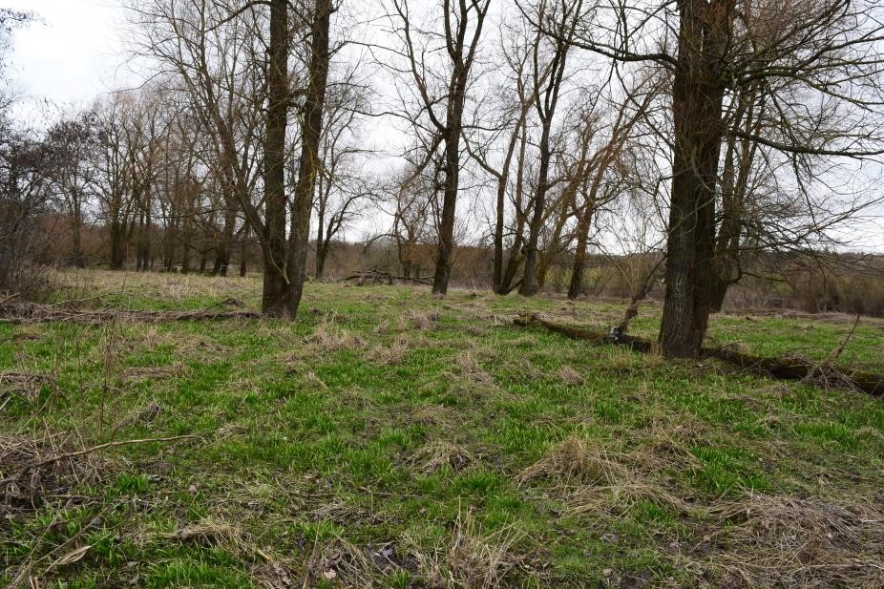North 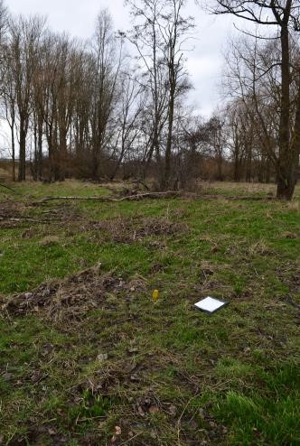Post 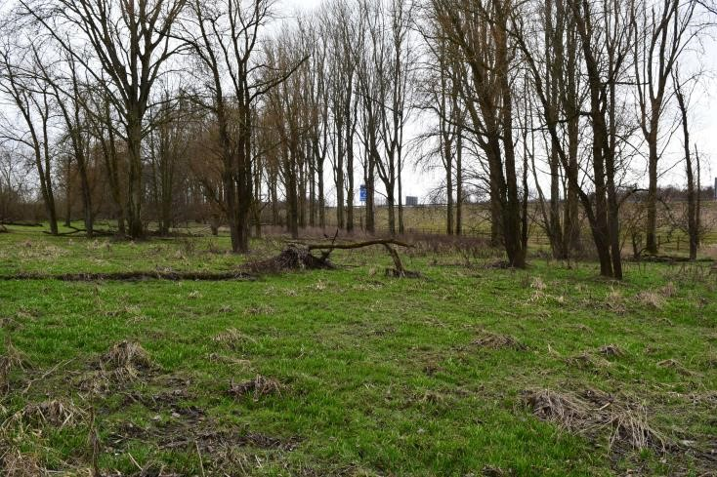South

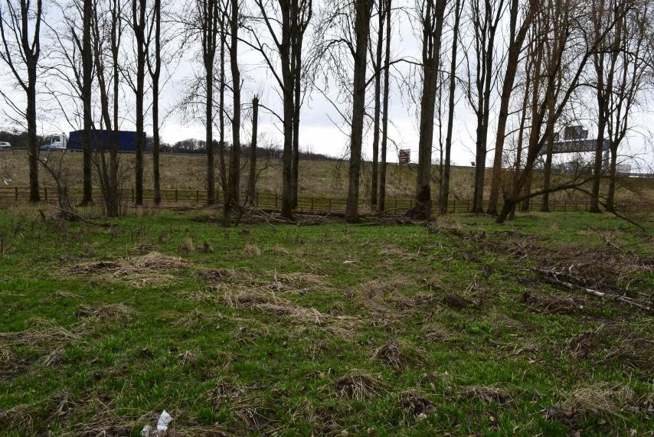West 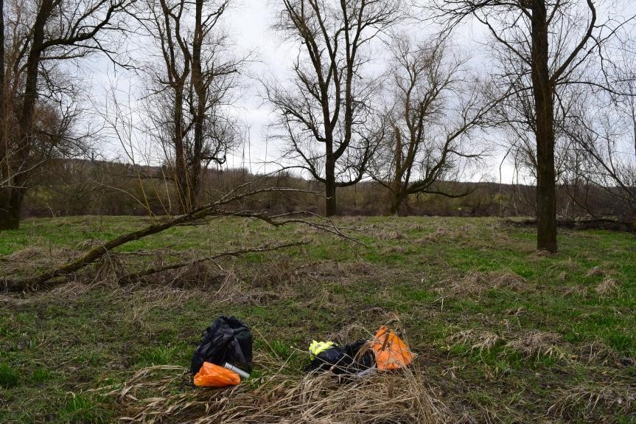East
Herbivore Impact Assessment Field Sheet – Level 2 |  |  | Woodland name: Hamilton Low Parks |  | Area name: South Lanarkshire
Date: 08/03/18 |  | Surveyor: Lindsay Mackinlay & D.Stevenson |  | Stop number: 4 |  | Grid ref.: NS 72024 57707
 | Impact | Species of tree /plant seen plus browsing /grazing rate. Other notes e.g. signs of older impacts.
Basal shoots | n/a | n/a – none present
Epicormic and lower shoots | Medium | Willow – Moderate (v. few accessible stems – majority on fallen trunks too tall and beyond browse reach_
Seedlings and saplings | No Impact | Alder (suckers) – (frequent sapling/tall seedling-sized suckers by mature trees) – Ungrazed, but this is normal with  Alder
Preferentially browsed or grazed plants | n/a | No Ivy, honeysuckle, bramble present  1 Buckler-fern present but no shoots to graze on as all dead – Ungrazed/n/a.
Bark stripping, fraying & stem breakage | Medium | A lot of old fraying damage on older Alder suckers, with fresh fraying on fallen willow stems (with one broken stem) – only stems suitable in the plot for this activity.
Sward | No impact | No grazing evident
 |  | No obvious trails.
Ground disturbance | No impact

Level 2 Extra Information:
Tree & Shrub Species | DAFOR Density Seedlings (<50cm tall) | DAFOR Density Saplings (50-200cm tall) | Extra Notes
Alder (R) | - | F (suckers) | Many Alder suckers growing near to the base of 2 mature Alders.  Willow growing from fallen stem.
Willow (O) | - | R

Brief Ground Flora Description: [Average Sward Height = 14cm ]
Species | DAFOR | Species | DAFOR | Extra Notes
Allium spp (inc Ramsons) | A |  |  | Area regularly flooded by River Clyde.
Holcus spp. | A |  |  | Area regularly flooded by River Clyde.
Urtica dioica | F |  |  | Area regularly flooded by River Clyde.
Dryopteris dilatata | R |  |  | Area regularly flooded by River Clyde.
Phalaris arundinacea | O (LA) |  |  | Area regularly flooded by River Clyde.

Woodland Structure Class:  Open canopy, open-grown trees, simple | 10 | Signs of Herbivores | Fraying, droppings.
 | 10 | No. of Dung/Deer Pellet Groups | 2
 | 10 | Bracken present? If so, impact from herbivores? | n/a
 | 10 | Past browsing pressure? | Little present but would have expected more willow in the area.
 | 10 | Historic herbivore impacts? | Any woodland there has appeared via planting (relating to adjacent M74) or colonisation in last 70 years (see main report)

Hamilton Low Parks Plot 5:
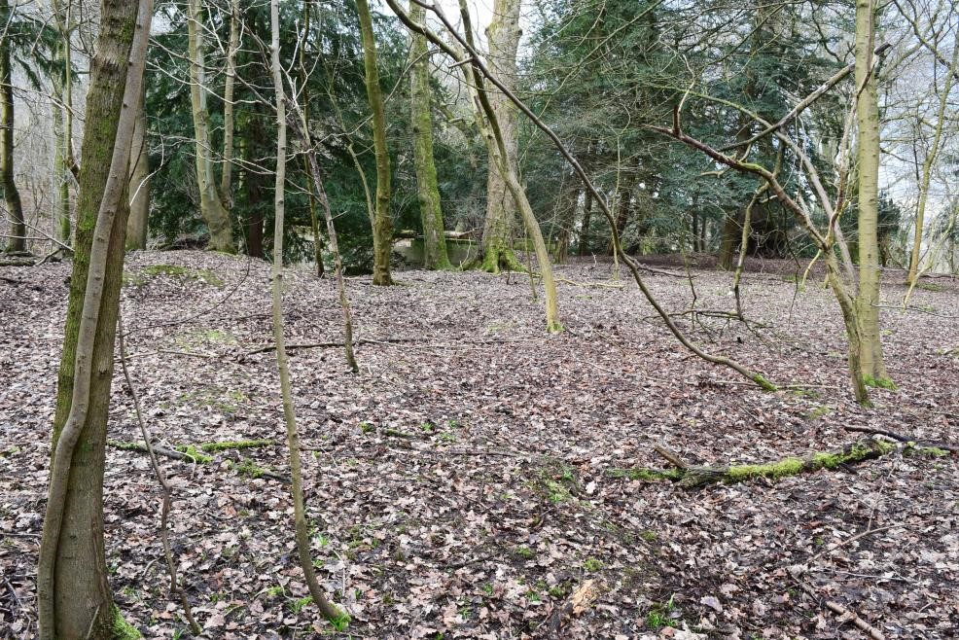North 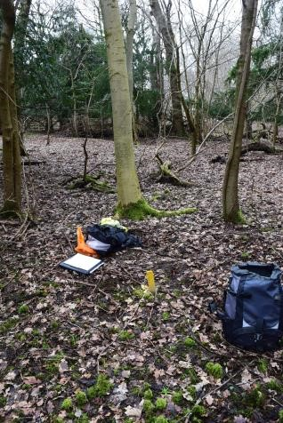Post 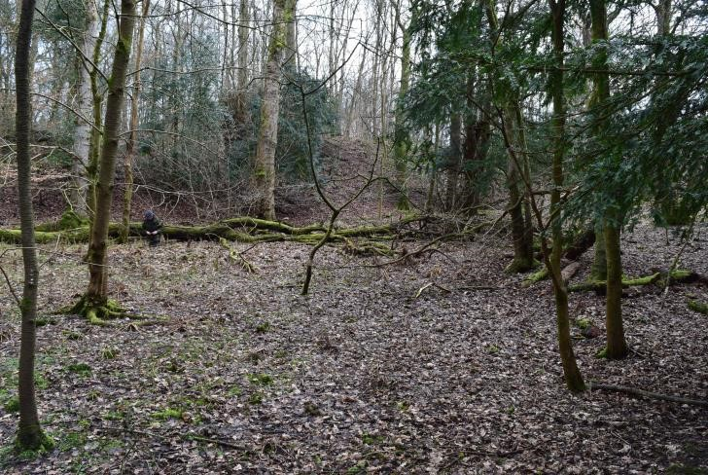South

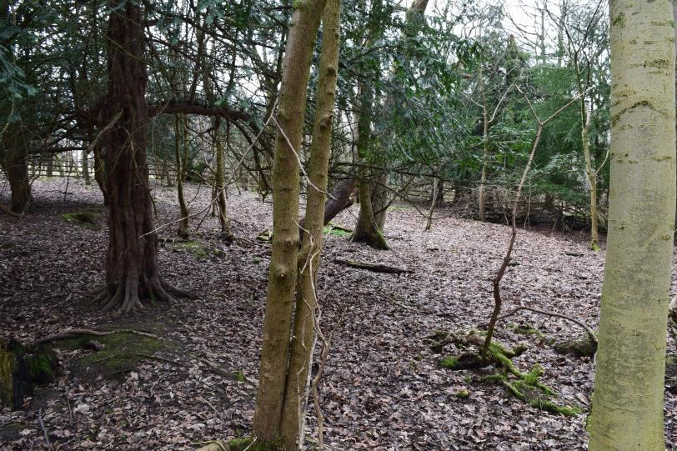West 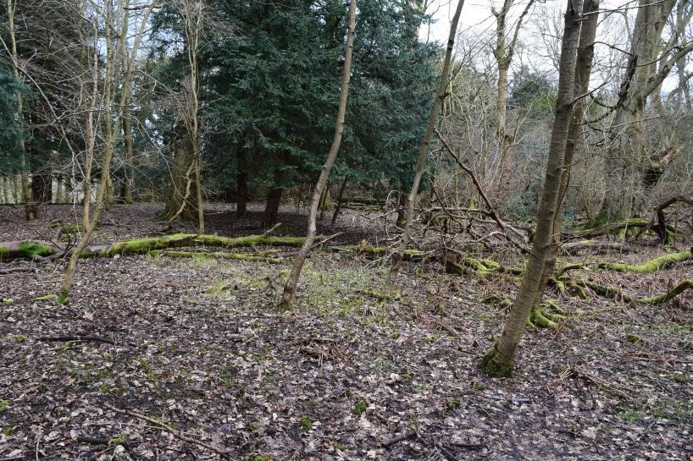East
Herbivore Impact Assessment Field Sheet – Level 2 |  |  | Woodland name: Hamilton Low Parks |  | Area name: South Lanarkshire
Date: 08/03/18 |  | Surveyor: Lindsay Mackinlay & D.Stevenson |  | Stop number: 5 |  | Grid ref.: NS 71668 57392
 | Impact | Species of tree /plant seen plus browsing /grazing rate. Other notes e.g. signs of older impacts.
Basal shoots | High | Elm – Heavy  Sycamore – Very Heavy  Hawthorn - Moderate
Epicormic and lower shoots | Medium | Holly (lower branches) – Moderate  Elm – Moderate  Hawthorn – Light (but many thorns) Sycamore – n/a as epicormic shoots too tall now for roe deer to reach
Seedlings and saplings | High | Ash (seedlings and old seedlings) – Heavy (Very Heavy in places) Ash (saplings – inc amongst seedlings) - Heavy
Preferentially browsed or grazed plants | Very High | Buckler-fern – Very Heavy Bramble (R/O) – Very Heavy
Bark stripping, fraying & stem breakage | No impact | Some old fraying but no fresh evidence.
Sward | Low | Lightly-grazed Bluebell
 |  | 1 trail; no scrapes
Ground disturbance | Low

Level 2 Extra Information:
Tree & Shrub Species | DAFOR Density Seedlings (<50cm tall) | DAFOR Density Saplings (50-200cm tall) | Extra Notes
Elm (F) | - | R (1 sapling) | One tall Holly sapling (~3m tall) present. Occasional Sycamore sapling also ~3m tall.  Some dead standing timber.  Gean probably planted.  Old tree tubes scattered around the place.
Silver Birch (R) | - | -
Ash (F) | O (LA) | O (17 saplings)
Gean (O-LF) | - | -
Hawthorn (R) | - | -
Holly (R) | - | -
Sycamore (F) | - | -
Yew (F) | - | -
Beech (O) | - | R (2 saplings)

Brief Ground Flora Description: [Average Sward Height = 3cm ]
Species | DAFOR | Species | DAFOR | Extra Notes
Allium ursinum | R (LF) | Chrysosplenium oppositifolium | O(LF) | Abundant to Locally Dominant bare ground/leaf litter in plot.
Dryopteris dilatata | O (LF) | Bryophyte spp. | F
Carex spp. (prob C.sylvatica) | R (LF)
Hyacinthoides non-scripta | F

Woodland Structure Class:  Mature woodland, no understorey & post-mature woodland, dead canopy  trees, complex – mainly due  to patches of saplings (~5-10 yrs old) and planted trees. | 6(7) | Signs of Herbivores | Trail, pellets, browsing.
 | 6(7) | No. of Dung/Deer Pellet Groups | 6
 | 6(7) | Bracken present? If so, impact from herbivores? | n/a
 | 6(7) | Past browsing pressure? | The patches of ash seedlings and small saplings present like walking through a miniature forest garden (severe chronic browsing evident)
 | 6(7) | Historic herbivore impacts? | Multi-stem sycamores suggesting lead shoots browsed off in early years.

Hamilton Low Parks Plot 6:
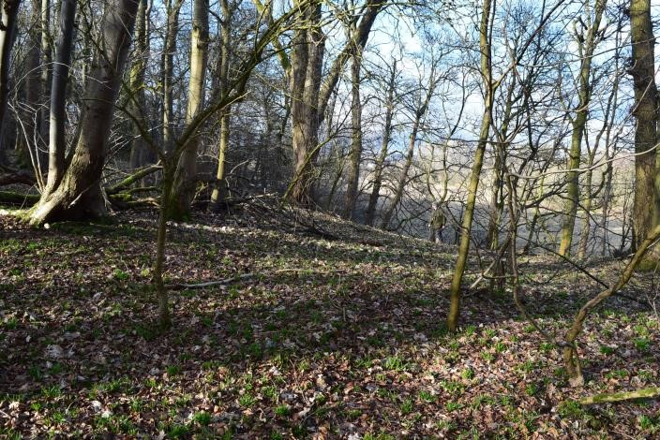North 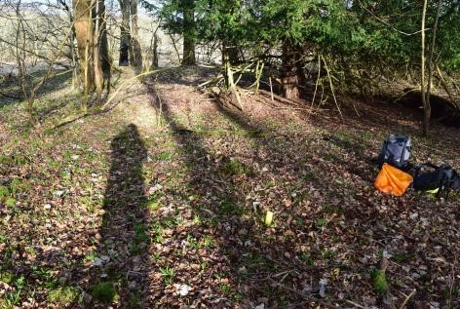Post 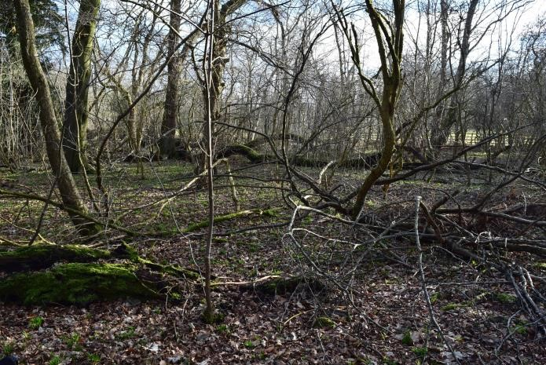 South

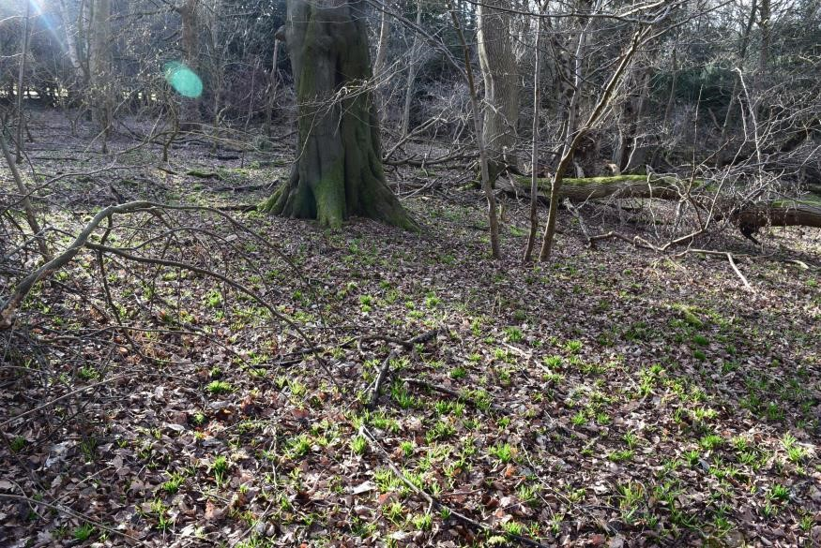West 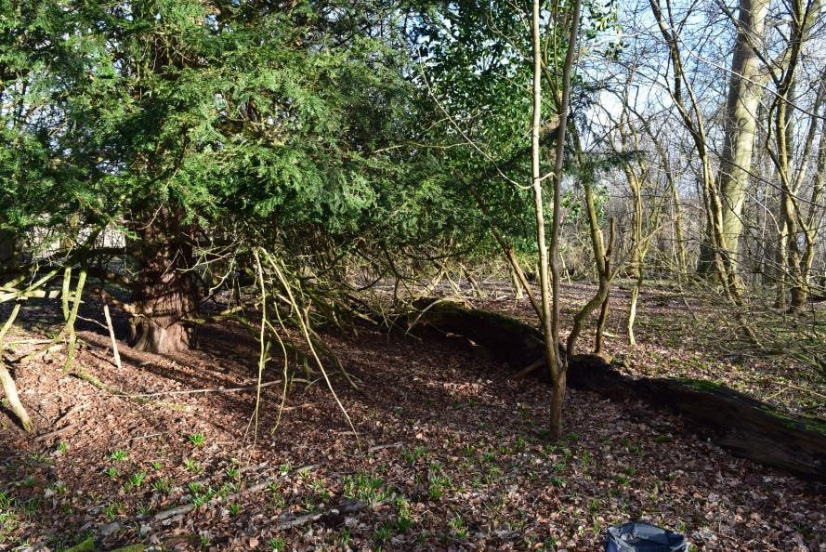East
Herbivore Impact Assessment Field Sheet – Level 2 |  |  | Woodland name: Hamilton Low Parks |  | Area name: South Lanarkshire
Date: 08/03/18 |  | Surveyor: Lindsay Mackinlay & D.Stevenson |  | Stop number: 6 |  | Grid ref.: NS 71821 57278
 | Impact | Species of tree /plant seen plus browsing /grazing rate. Other notes e.g. signs of older impacts.
Basal shoots | High | Downy Birch – Heavy  Sycamore – Heavy (to Very Heavy in places)  Elder – Heavy Elm - Heavy
Epicormic and lower shoots | High | Downy Birch – Moderate  Holly – Very Heavy (classic browse-line present) Elm - Moderate  Sycamore – Heavy (though most growth above browse-line) Hawthorn – Light (lot of thorns!)
Seedlings and saplings | Medium | Ash saplings – Heavy (although, despite this, some have got away)  Ash ‘old’ seedlings – Moderate  Beech saplings – Moderate Hawthorn saplings - Moderate
Preferentially browsed or grazed plants | Very High | Buckler-fern – Very Heavy Bramble – Very Heavy
Bark stripping, fraying & stem breakage | Low | Rabbit/hare bark damage on 1 Sycamore & 1 Hawthorn sapling. Old fraying on Ash and Beech saplings as well as Hawthorn.
Sward | Low | ~ 20% of Bluebells grazed.
Ground disturbance | Medium | 2 trails & 1 scrape (~5-15%)

Level 2 Extra Information:
Tree & Shrub Species | DAFOR Density Seedlings (<50cm tall) | DAFOR Density Saplings (50-200cm tall) | Extra Notes
Sycamore (F) | - | O (5 saplings) | A lot of 3m tall saplings of Sycamore, Elder & Beech.  Patch of Ash seedlings and saplings about 10m by 10m.
Hawthorn (O-LF) | - | O (8 saplings)
Yew (mature) | - | -
Elder | - | O (4 saplings)
Beech (mature) | - | R (2 saplings)
Ash (mature) | A | F
Silver Birch (mature) | - | -
Elm | - | -
Downy Birch (mature) | - | -

Brief Ground Flora Description: [Average Sward Height = 5cm ]
Species | DAFOR | Species | DAFOR | Extra Notes
Hyacinthoides non-scripta | A |  |  | Nothing growing under the Yew in the general area.  Abundant to Locally Dominant bare ground/leaf litter in plot.
Dryopteris dilatata | O
Bramble | R

Woodland Structure Class:  Mature woodland, no understorey & post-mature woodland, dead canopy  trees, complex – mainly due  to patches of saplings (~5-10  yrs old) | 6 (7) | Signs of Herbivores | Dead roe deer in plot
 | 6 (7) | No. of Dung/Deer Pellet Groups | 10
 | 6 (7) | Bracken present? If so, impact from herbivores? | n/a
 | 6 (7) | Past browsing pressure? | The patches of ash seedlings and small saplings present like walking through a miniature forest garden (severe chronic browsing evident); Major topiary growth on beech saplings close to the plot.
 | 6 (7) | Historic herbivore impacts? | Multi-stem sycamores suggesting lead shoots browsed off in early years.
Hamilton Low Parks Plot 7:
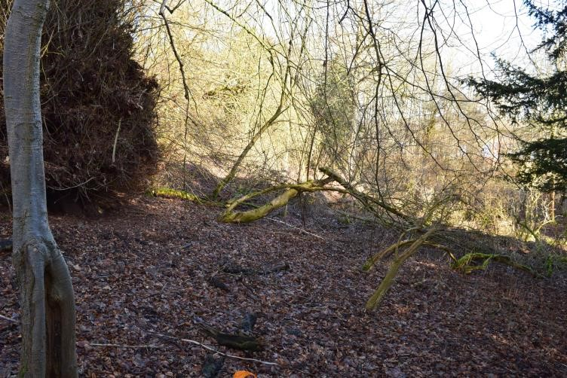North 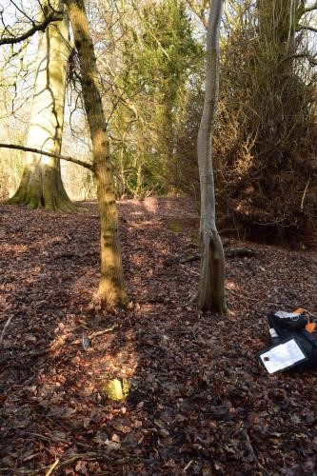Post 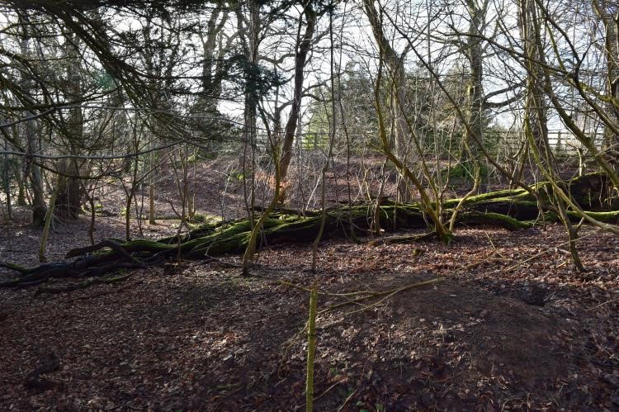South

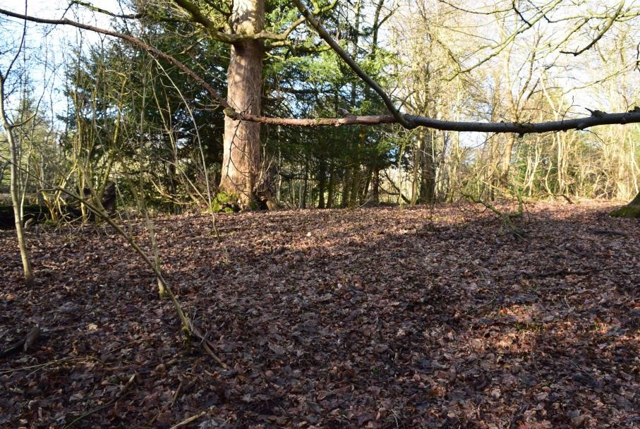West 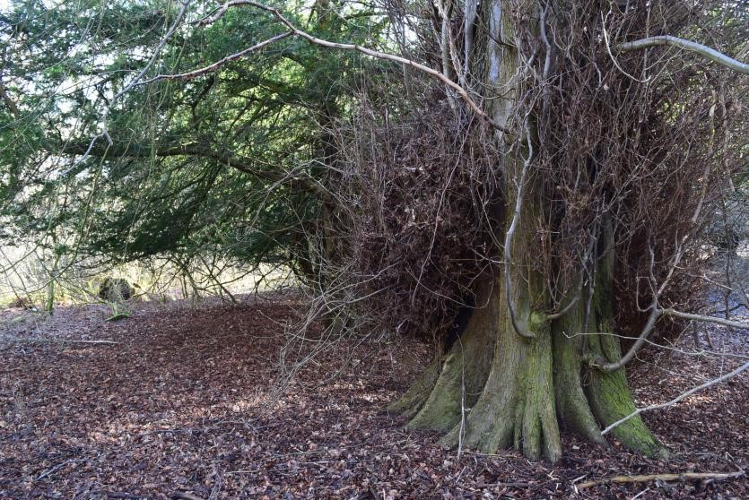East
Herbivore Impact Assessment Field Sheet – Level 2 |  |  | Woodland name: Hamilton Low Parks (Low Park Wood) |  | Area name: South Lanarkshire
Date: 09/03/18 |  | Surveyor: Lindsay Mackinlay |  | Stop number: 7 |  | Grid ref.: NS 71955 56726
 | Impact | Species of tree /plant seen plus browsing /grazing rate. Other notes e.g. signs of older impacts.
Basal shoots | High | Elm – Heavy  Sycamore – Heavy  Lime (basal suckers) – Moderate - also includes abundant natural dieback, probably from recent heavy snow.
Epicormic and lower shoots | Medium | Elm – Moderate  Lime – Light  Elder – Light (stems from fallen trunks that had got away)
Seedlings and saplings | Medium | Beech saplings – Light Sycamore sapling – Light Elder – Light Holly – Light  Ash seedlings (lot of young & ‘old seedlings’) – Heavy; Ash saplings - Light
Preferentially browsed or grazed plants | High | Bramble – Heavy (but 2 plants relatively ungrazed as they were growing on top of fallen trunk; very little, partially hidden bramble plants ungrazed)  Raspberry – Heavy (big patches with many tall stems, but grazing evident in several plants)  Golden-scaled Male-fern – Very Heavy Buckler-fern – Heavy, where browsed (but many ungrazed tussocky patches due to no visible recent/current growth/horizontal fronds only).
Bark stripping, fraying & stem breakage | No Impact | Some old fraying on beech, ash and sycamore saplings.
Sward | Low | Light Bluebell grazing
Ground disturbance | Medium | Big trail with hoof marks (travelling through site to adjacent golf course); 1 scrape. Active badger sett in plot

Level 2 Extra Information:
Tree & Shrub Species | DAFOR Density Seedlings (<50cm tall) | DAFOR Density Saplings (50-200cm tall) | Extra Notes
Elm (F) | - | - | Where shaded, little regeneration.  ~3m tall poles of yew on fallen, horizontal branches.  Regeneration of ~5-10 yrs old good in gaps in canopy  Some Ash saplings ~3-4m tall, again indicative of a burst of regeneration activity ~ 10-15 yrs ago.
Beech (mature) (F) | - | O (7 saplings)
Lime (mature) (F) | - | -
Yew (mature) (F) | - | -
Sycamore (mature) (F) | - | R (2 saplings)
Elder (F – LA) | - | R ( 3 saplings)
Hawthorn (O-LA) | - | O (5 saplings)
Ash (F) | A (2 big patches) | O (6 saplings)
Holly (R) | R (1 seedling) | -

Brief Ground Flora Description: [Average Sward Height = 4cm ]
Species | DAFOR | Species | DAFOR | Extra Notes
Hyacinthoides non-scripta | F | Dryopteris affinis | R | Ground flora impoverished due to heavy yew, beech and sycamore presence (inc leaf litter).  Badger activity may well be helping raspberry regeneration.  Bare ground/leaf litter = Dominant
Dryopteris dilatata | O (LA)
Bramble | O
Raspberry | O (LF)

Woodland Structure Class:  Mature woodland, no understorey & post-mature woodland, dead canopy  trees, complex – mainly due  to patches of saplings (~5-10 yrs old) in gaps. | 6(7) | Signs of Herbivores | 7 roe deer seen on nearby golf fairway
 | 6(7) | No. of Dung/Deer Pellet Groups | 1
 | 6(7) | Bracken present? If so, impact from herbivores? | n/a
 | 6(7) | Past browsing pressure? | Lime showed signs of long-term browsing on lowest basal shoots.
 | 6(7) | Historic herbivore impacts? | See main report

Hamilton Low Parks Plot 8:
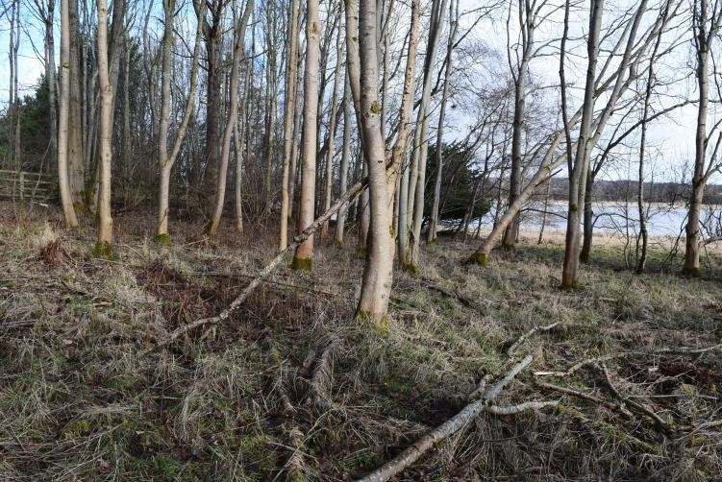North 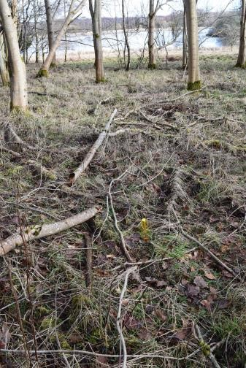Post 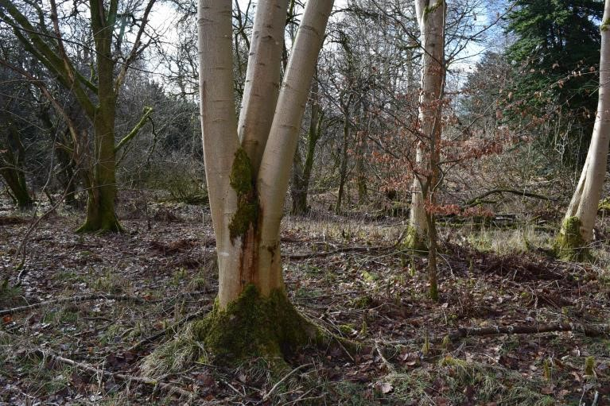South

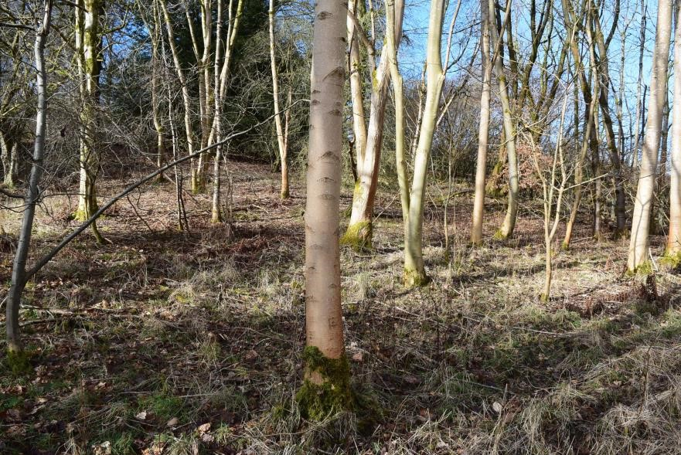West 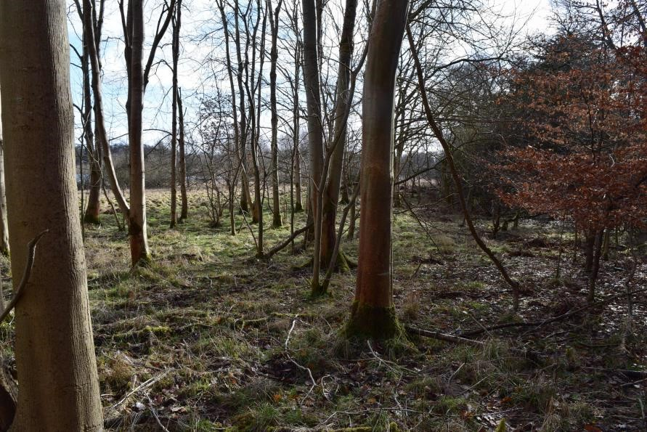East
Herbivore Impact Assessment Field Sheet – Level 2 |  |  | Woodland name: Hamilton Low Parks (Low Park Wood) |  | Area name: South Lanarkshire
Date: 09/03/18 |  | Surveyor: Lindsay Mackinlay |  | Stop number: 8 |  | Grid ref.:NS 71984 56799
 | Impact | Species of tree /plant seen plus browsing /grazing rate. Other notes e.g. signs of older impacts.
Basal shoots | High | Hazel – Heavy (several old stems (~10yrs old) but recent growth hammered) Hawthorn – Heavy  Sycamore – Heavy Ash – Moderate (but v.little basal growth)
Epicormic and lower shoots | Medium | Hawthorn – Moderate (stems growing from fallen tree) Elder - Light
Seedlings and saplings | High | Ash (many ‘old seedlings’) – Heavy Ash saplings – Heavy  Hawthorn saplings – Light (thorns doing their job) Holly – Light (protected by Hawthorn growth around it)  Hazel (1 ‘old seedling’) - Moderate
Preferentially browsed or grazed plants | High | Raspberry – Heavy (on shorter plants - although many old tall raspberry canes)  Bramble – Very Heavy (small plants lying prostrate = Light)  Buckler-fern – Moderate (many stems lying on ground - mainly vertical ones getting browsed)
Bark stripping, fraying & stem breakage | Medium | Much fraying on several hazel, hawthorn, beech and ash sapling-sized stems.
Sward | Low | Very limited grazing evident on Bluebell shoots.
Ground disturbance | Medium | 2 big trails; no scrapes

Level 2 Extra Information:
Tree & Shrub Species | DAFOR Density Seedlings (<50cm tall) | DAFOR Density Saplings (50-200cm tall) | Extra Notes
Ash (A/D) | A/D | O | Most Ash saplings present ~3-4m tall  Heavily browsed Holly saplings/’bushes’just outside plot.  Sycamore saplings mainly ~4m tall  1 beech sapling ~4m tall  Exact no. of hawthorn and sycamore saplings in 50-200cm range not noted on field sheet but was considered ‘Rare’.
Gean (R-LF) – prob. planted | - | -
Hazel (R-LF) – prob. planted | R (1 seedling) | -
Downy Birch (R) – prob. planted | - | -
Beech (O) | - | -
Larch (mature) | - | -
Sycamore (O) | - | R
Elder (O) | - | -
Hawthorn (F) – old hedge | - | R
Holly (R) | R (2 seedlings) | -
Brief Ground Flora Description: [Average Sward Height = 15cm ]
Species | DAFOR | Species | DAFOR | Extra Notes
Grasses (inc Deschampsia cespitosa & Dactylis glomerata) | D | Bramble | F | Abundant bare ground/leaf litter.
Hyacinthoides non-scripta | R | Raspberry | A | Abundant bare ground/leaf litter.
Dryopteris dilatata | F | Bryophyte spp. | A | Abundant bare ground/leaf litter.

Woodland Structure Class:  Mature woodland, no understorey  (predominantly mature plantation ash) | 6 | Signs of Herbivores | 2 roe deer spotted beside plot.
 | 6 | No. of Dung/Deer Pellet Groups | 1
 | 6 | Bracken present? If so, impact from herbivores? | n/a
 | 6 | Past browsing pressure? | Multi-stemmed mature ash saplings – almost hazel-like – suggestive of lead shoots being browsed in the past. Hazel with many older stems, suggesting that browsing maybe not a major issue around 10 yrs ago. Bigger Sycamore sapling & Elder also showing signs of past browsing.
 | 6 | Historic herbivore impacts? | Relatively new woodland area as a plantation area. See main report.
Hamilton Low Parks Plot 9:
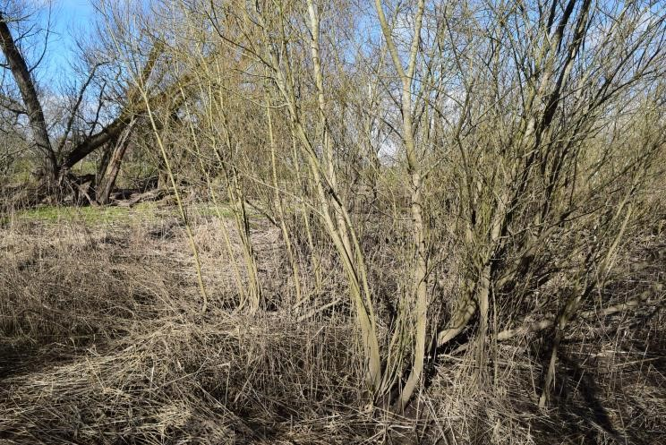North 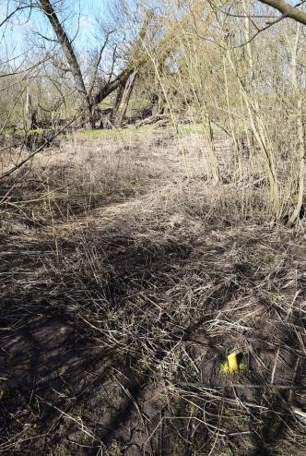Post 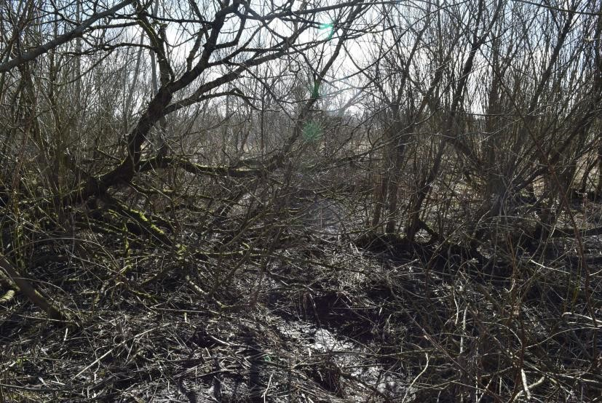South

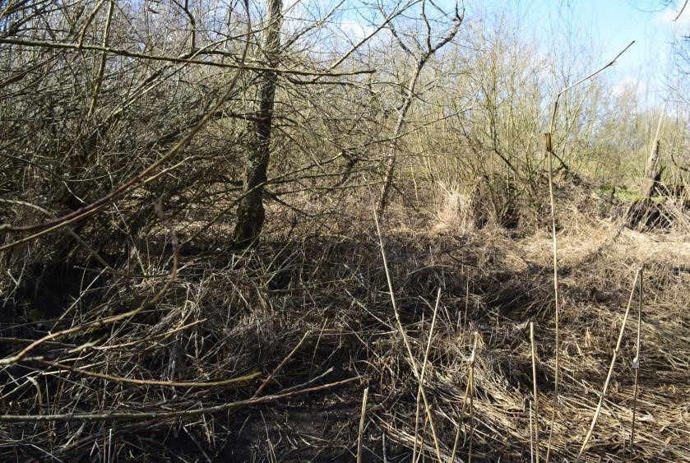West 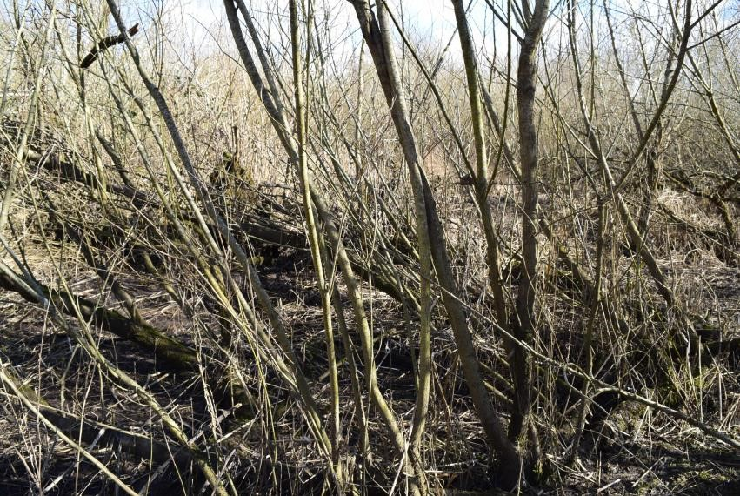East
Herbivore Impact Assessment Field Sheet – Level 2 |  |  | Woodland name: Hamilton Low Parks (North Haugh) |  | Area name: South Lanarkshire
Date: 09/03/18 |  | Surveyor: Lindsay Mackinlay |  | Stop number: 9 |  | Grid ref.: NS 73365 56379
 | Impact | Species of tree /plant seen plus browsing /grazing rate. Other notes e.g. signs of older impacts.
Basal shoots | n/a | n/a – Willow – plenty basal growth but no sign of browsing.
Epicormic and lower shoots | Medium | Willow – plenty of lower branches from fallen trunks but no signs of browsing – n/a Ash – Moderate (shoots from horizontal trunk browsed)
Seedlings and saplings | n/a | Willow – none present.
Preferentially browsed or grazed plants | Medium | Buckler-fern – Very Heavy (two small plants on fallen trunk within browse reach)  Bramble – Heavy (not grazed where plants above browse-line, such as growing from the top of fallen trunk) Rosehip – Ungrazed (multi-stemmed)
Bark stripping, fraying & stem breakage | Low | Fraying on willow stems very rare, but present.
Sward | Low | Few grazing signs – rare on tall herb leaves nearby and a few Ramsons (Wild garlic) shoots browsed, but majority untouched.
Ground disturbance | Low | 1 trail; on R.Clyde floodplain so much disturbed soil and sandy substrate. A few hoof marks present.

Level 2 Extra Information:
Tree & Shrub Species | DAFOR Density Seedlings (<50cm tall) | DAFOR Density Saplings (50-200cm tall) | Extra Notes
Willow (D) | - | A (lower shoots) | Largely healthy willow scrub- most saplings are phoenix stems/growing from horizontal stems.  Adjacent hawthorn scrub sitting within grassland mosaic has seen localised heavy browsing. Also a big healthy, impenetrable Blackthorn thicket nearby.  Ash saplings = Phoenix stems - mainly got away from one fallen branch Rosehip ~ 2m tall
Sycamore (R) | - | -
Alder (R) | - | -
Ash (R) | - | O
Rosehip (R) | - | R

Brief Ground Flora Description: [Average Sward Height = 7cm ]
Species | DAFOR | Species | DAFOR | Extra Notes
Allium spp. (mainly Ramsons) | A | Bramble | O (LF) | Abundant bare ground (mud and sand)
Urtica dioica | O | Japanese Knotweed (Fallopia japonica) – by river. | O | Abundant bare ground (mud and sand)
Dryopteris dilatata | R |  |  | Abundant bare ground (mud and sand)

Woodland Structure Class:  Mature woodland, understorey regeneration  (mature willow scrub) | 5 | Signs of Herbivores | Trail, hoof marks, dropping
 | 5 | No. of Dung/Deer Pellet Groups | 1
 | 5 | Bracken present? If so, impact from herbivores? | n/a
 | 5 | Past browsing pressure? | Rosehip – did show signs of past browsing on a dead stem nearby but little otherwise
 | 5 | Historic herbivore impacts? | Little woodland in this area 70 years ago (from aerial photos)

Hamilton Low Parks Plot 10:
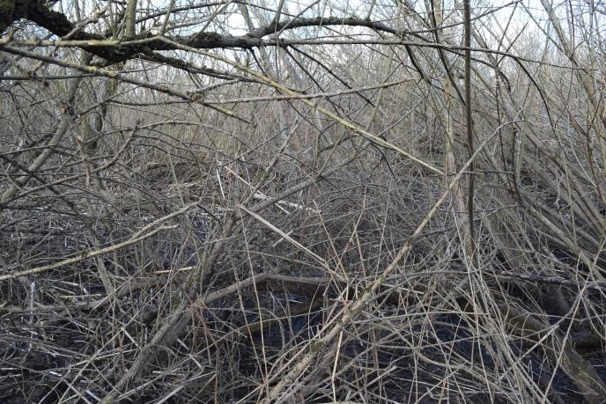North 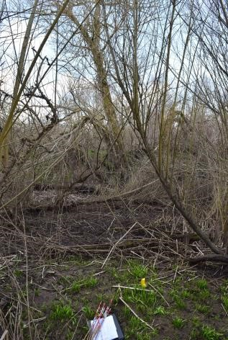Post 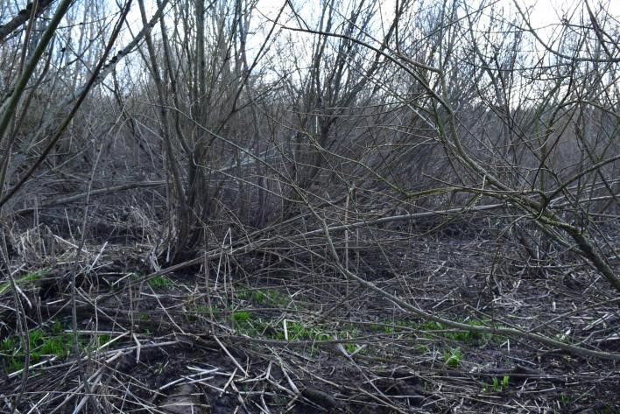South

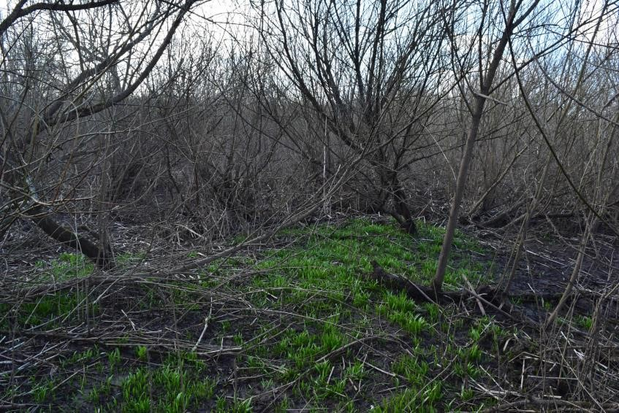West 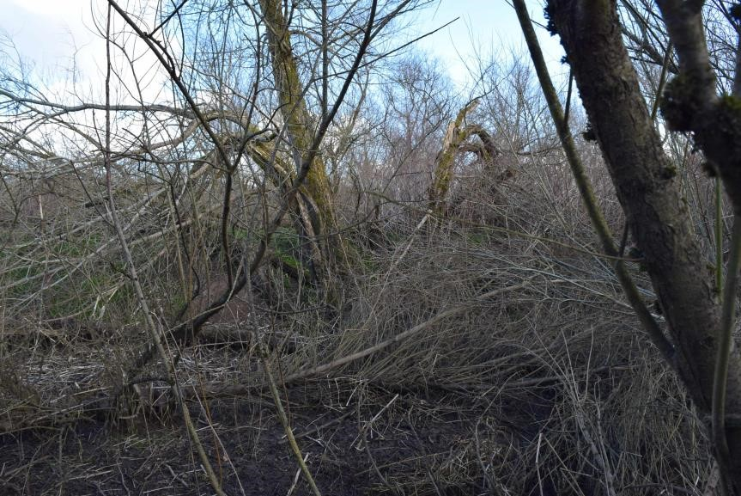East
Herbivore Impact Assessment Field Sheet – Level 2 |  |  | Woodland name: Hamilton Low Parks (North Haugh) |  | Area name: South Lanarkshire
Date: 09/03/18 |  | Surveyor: Lindsay Mackinlay |  | Stop number: 10 |  | Grid ref.:NS 73457 56397
 | Impact | Species of tree /plant seen plus browsing /grazing rate. Other notes e.g. signs of older impacts.
Basal shoots | Low | Willow – Light (rare given quantity of basal growth in area)
Epicormic and lower shoots | Low | Willow – Light (Moderate on a few plants, especially the ones at the lowest point on a fallen trunk)
Seedlings and saplings | n/a | n/a (very occasional Willow sapling not attached to an existing tree with no signs of browsing)
Preferentially browsed or grazed plants | n/a | n/a - None present
Bark stripping, fraying & stem breakage | n/a | No signs
Sward | No Impact | No signs upon Wild Garlic nor other ‘greenery’ in plot.
Ground disturbance | Low | Big deer path heading towards plot then slight trail within it; much disturbance from River Clyde flooding activity, including large areas of shallow standing water.

Level 2 Extra Information:
Tree & Shrub Species | DAFOR Density Seedlings (<50cm tall) | DAFOR Density Saplings (50-200cm tall) | Extra Notes
Willow (D) | - | O | Willow scrub looked healthy  Most saplings are phoenix stems/growing from horizontal stems.

Brief Ground Flora Description: [Average Sward Height = 7cm ]
Species | DAFOR | Species | DAFOR | Extra Notes
Allium ursinum (Ramsons) | F (LA) | Ranunculus ficaria | O
Japanese Knotweed (Fallopia japonica) – in areas of plot closest to river | F (LD) | Snowdrop patch | R
Phalaris arundinacea | LA

Woodland Structure Class:  Mature woodland, understorey regeneration  (mature willow scrub) | 5 | Signs of Herbivores | Hoof marks, trails
 | 5 | No. of Dung/Deer Pellet Groups | -
 | 5 | Bracken present? If so, impact from herbivores? | n/a
 | 5 | Past browsing pressure? | None obvious
 | 5 | Historic herbivore impacts? | Little woodland in this area 70 years ago (from aerial photos)

Appendix 6: Relative Palatability of Tree and Non-tree Plant Species

(Source: Armstrong H., Black B., Holl K. & Thompson R (2017): ‘Assessing Herbivore Impact in Woodlands: An Observation-based Method’; Revised 21 December 2017

 | Table 4. Relative palatability of non-tree plant species*
Season | Very palatable | Moderately palatable | Unpalatable
All year | Bramble, Honeysuckle, Ivy, Blaeberry, Greater woodrush, Common Bent, Red Fescue,  Yorkshire fog | Hard fern, Bog myrtle, Heather (Ling), Bell heather, Sheep’s fescue | Hard fern, Greater woodrush, Purple moor-grass, Mat grass, Tufted hair-grass, Soft and Sharp-flowered rush, Cross-leaved heath
Spring -  Summer | As above. In addition: Valerian,  Meadowsweet, Angelica, Dog’s mercury, Raspberry, Buckler ferns | Devil’s-bit scabious, Purple moor-grass, Soft and Sharp-flowered rush, Lemon-scented fern, Lady fern | Buckler ferns, Lemon-scented fern, Lady fern, Primrose
*bold = cattle only, italics = deer only, Normal font = all other large herbivore species. More detailed information can be found here.

Table 5. Relative palatability of different tree species
Palatability (Innate attraction of the species to being browsed) |  | Resilience (ability to survive being browsed & continue to grow)
1 – Most palatable | Aspen, Willow, Rowan | 1 – Most resilient | Eared Willow, Birch, Alder
2 | Ash, Holly | 2 | Holly, Juniper
3 | Hazel, Oak, Douglas Fir, Larches | 3 | Hazel, Oak, Rowan, Ash
4 | Scots Pine, Western Hemlock | 4 – Least resilient | Scots pine and non-native conifers
5 | Birch, Hawthorn, Lodgepole Pine | More detailed information can be found here.
6 | Beech, Juniper
7 – Least palatable | Alder, Rhododendron, Sitka Spruce

