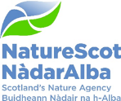

Title: Extensions to Strathmore Peatlands SSSI and Rumsdale Peatlands SSSI

Date: 22 June 2023

Purpose: | This paper is for Decision.
How does this link with our corporate priorities of improving biodiversity or delivering nature-based solutions to climate change: | SSSI notification is one of NatureScot’s key statutory functions. When there has been an objection, the decision on whether to confirm a notification or extension to a site is made by the Board, following a recommendation from the Protected Areas Committee (PAC).  Work to restore areas of the Caithness and Sutherland peatlands damaged by conifer planting began in the 1990s. Some of this land is now restored enough to add to the existing protected areas. This will provide protection to the restored areas and encourage further funding for necessary follow-up work. Peatland restoration and maintenance has clear benefits to climate change mitigation, and this work provides additional biodiversity benefits in the iconic Flow Country.
Summary: | In 2022, there was a statutory public consultation on the extension of 10 SSSIs to underpin extensions to the Caithness and Sutherland Peatlands SAC, SPA and Ramsar site. A landowner made a scientific objection to extension to two of these SSSIs. Following two PAC meetings and a site visit, the PAC recommends that the Board should confirm the extensions to the two SSSIs where there has been an objection. The PAC has already decided to confirm the extensions to the eight SSSIs where there has been no objection.
Actions: | Decide whether or not to confirm the extensions to the two SSSIs where there has been an objection.
Recommendations: | The PAC considers that the areas of land owned by Aquila Capital meet the SSSI selection criteria and recommends that they should be included within Rumsdale Peatlands SSSI and Strathmore Peatlands SSSI.
Sponsor: | David Johnstone
Appendices: | Annex 1 – Maps of the extension areas

Purpose
- This paper asks the Board to decide whether to confirm extensions to two SSSIs (Strathmore Peatlands SSSI and Rumsdale Peatlands SSSI) where there has been an objection.

Background
- Forest to bog restoration in parts of the Caithness and Sutherland Peatlands started in 1996, funded by two EU LIFE projects. In connection with this funding, the Scottish Government gave a commitment to extend Caithness and Sutherland Peatlands SAC and SPA to include areas that had been restored when they met the required criteria for designation. The previously designated SAC and SPA are underpinned by SSSIs and are designated as a Ramsar site, so it is logical that the extensions should be too. The overall extension covers 2,446 ha, a 1.7% increase to the overall Caithness and Sutherland Peatlands protected area (see maps in Annex 1).

- In 2022, we held a statutory public consultation on extension of Caithness and Sutherland Peatlands SAC, SPA and Ramsar site on behalf of the Scottish Government, and also for extending 10 underpinning SSSIs. There was one objection, from Aquila Capital, the owner of the extensions to Strathmore Peatlands SSSI and Rumsdale Peatlands SSSI.

- In February 2023, the Protected Areas Committee (PAC) decided to confirm the extensions to eight SSSIs where there was no objection and asked for a site visit to obtain further information on the two SSSIs where there was an objection. The PAC Chair, a representative of Aquila Capital and NatureScot staff made a site visit on 30 March 2023. On 24 May 2023, the PAC met to consider the new information from the site visit and to give a representative of Aquila Capital an opportunity to state the case for their objection to the designations. Following careful consideration of the evidence, the PAC decided that SSSI site selection criteria were met and therefore recommends that the Board confirms the extensions to the two SSSIs where there has been an objection.

- The decision taken by the Board regarding this objection will influence our advice to the Scottish Government on the extension of Caithness and Sutherland Peatlands SAC, SPA and Ramsar sites over the same land.

Aquila Capital objection to the designations
- There were two scientific and two socio-economic elements to the objection from Aquila Capital.
The Property does not match the criteria for an area having to become designated.
- The extensions were assessed against the UK selection criteria for SACs and SPAs, and have been determined to meet the SSSI selection criteria through the axiomatic clause (features of international importance are considered to be of national importance, see paragraph 6.3 of the SSSI Selection Guidelines).

- In summary, the SAC selection guidelines do not require all areas to be in pristine condition, as the criteria allow for an assessment of restoration potential. The success of the LIFE project elsewhere shows that restoration is possible. Parts of the areas where Aquila Capital has objected to extending the SSSIs already contain unmodified peatland and pool systems. Although extensive conifer regeneration requires control in other parts of the extensions, peatland vegetation is also found here and there is excellent restoration potential given appropriate management. Funding is available for this, for example through Peatland ACTION.

- The PAC considered that these extensions meet the scientific criteria for designation.

Commercial Forest Areas very often are excluded from designated areas
- It is correct that SSSIs in the Flow Country avoid areas of commercial plantation where the management aim is to grow mature trees for timber production. However, this is not the case in the extensions which cover land that was either not planted or where restoration from past afforestation started when the trees were young enough that much of the original habitat and hydrology remained. Aquila Capital does not plan to re-plant within or adjacent to the extensions according to the Long-Term Forest Plan submitted in March 2023. Peatland ACTION funding is available to continue restoration (by blocking furrows/drains and removing conifer regeneration).

- The PAC considered that these extensions meet the scientific criteria for designation because they have excellent restoration potential and there are known means to fund and carry out appropriate restoration management.

Loss in land value to be avoided
AND
Impairment due to Site Designations on the adjacent land
- Aquila Capital have raised concerns about the distance from the protected area boundary where they will be able to replant commercial forestry due to application of edge effect buffer by Scottish Forestry and presented a map showing areas removed from their forest plan at the meeting on 24 May.

- Designation of land within a protected area has to be based on scientific judgement alone, and socio-economic objections such as loss in value of land cannot influence the final decision if the scientific case for designation has been made.

- The PAC considered that these are not relevant considerations for designation.

Conclusion and Recommendation:
- The Board needs to make a decision on whether or not to confirm the extensions to the two SSSIs where Aquila Capital has objected to the designations. The PAC considers that the areas of land owned by Aquila Capital meet the SSSI selection criteria and recommends that they should be included within Rumsdale Peatlands SSSI and Strathmore Peatlands SSSI.

Annex 1 – Maps of the extension areas
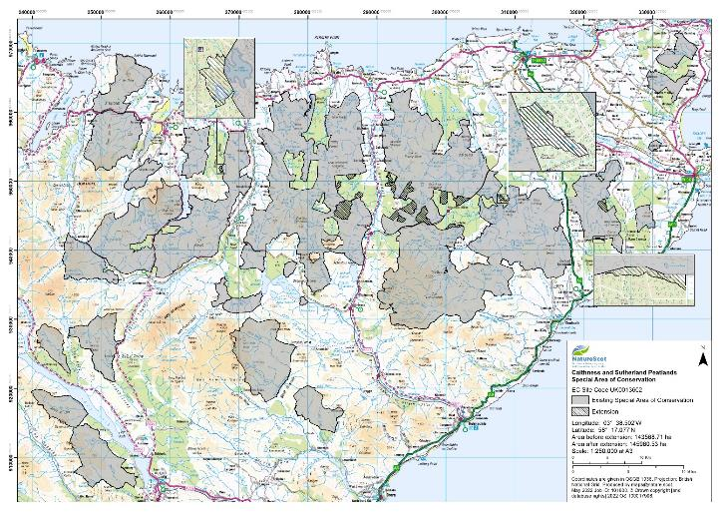
Extension to Rumsdale Peatlands SSSI
Extension to Strathmore Peatlands SSSI
Figure 1. Caithness and Sutherland Peatlands SAC and extensions. The two extension areas owned by Aquila Capital – to Strathmore Peatlands SSSI and Rumsdale Peatlands SSSI – are labelled and circled in red. The extensions to the eight SSSIs that the PAC has already decide decided to confirm are shown hatched.
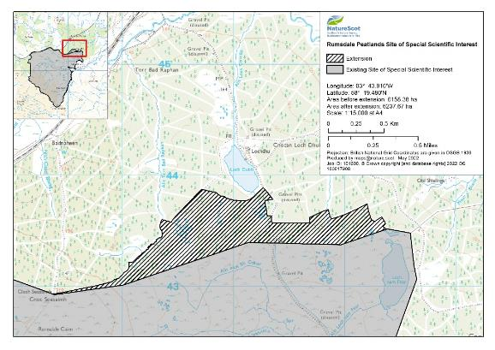
Figure 2. The extension to Rumsdale Peatlands SSSI. Aquila Capital’s Long Term Forest Plan states that all the forestry shown on this map is due for felling and that there will be no replanting in the extension or adjacent ground.
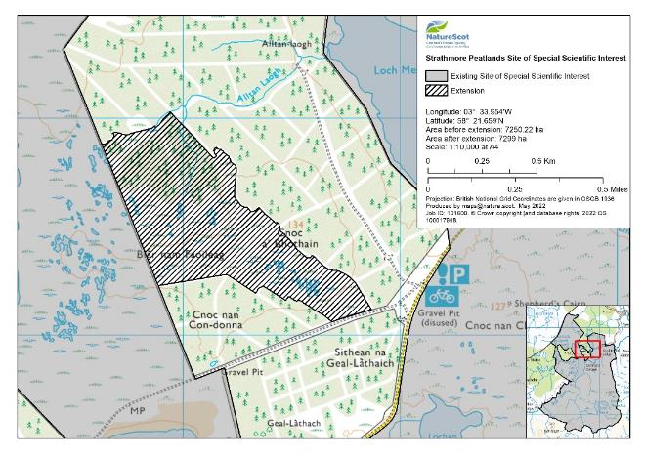

Figure 3. The extension to Strathmore Peatlands SSSI. All the forestry adjacent to the extension has been felled and Aquila Capital’s Long Term Forest Plan states that there will be no replanting in the extension or adjacent ground.

https://data.jncc.gov.uk/data/5d20b480-9cc1-490f-9599-da6003928434/sac-selection-background-t37-v4.pdf

