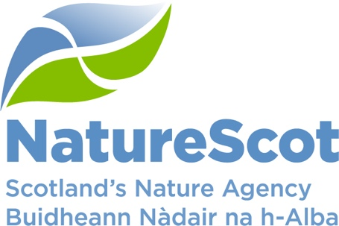

Comments on the River Spey catchment Environmental Report
Please submit your completed document to BeaverSEAConsultation@nature.scot

I am responding as...
An individual
An organisation

If you are responding as an organisation, please tell us which

- Does the River Spey ER address they key environmental effects that are likely to arise from beaver presence – is there anything missing from the ER?

2. Are there benefits likely to arise from beaver presence in the River Spey catchment that have not been included?

3. Are there negative effects likely to arise from beaver presence in the River Spey
catchment that have not been included?

4. Do you have any specific comments to make with regard to effects or the management of effects on: Biodiversity interest, Water quality resource and ecological status, Population and human health, Cultural heritage, Material assets or Infrastructure

5. Do you agree with the assessment of the likelihood and significance of the effects in the River Spey catchment identified? If no please provide a reasoning.

6. Does the proposed mitigation and monitoring provide assurance that negative impacts can be adequately addressed?

7. Do you have any information to add to the River Spey catchment ER? If so please specify details.

