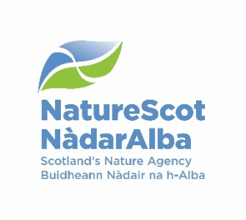

**Flow Chart of process.**

On receipt of recommendation from the BTO group, Senior SNCB HPAI Group sign off suspension of ringing/research in certain region/sites and/or species.

BTO notify that ringing permits are suspended as per Senior SNCB sign off

Is your activity suspended?

Continue research/ringing/monitoring activities implementing BTO HPAI protocols.

No

Yes

Licences/consent revoked eg. NNR permit, SSSI consent

Request to cease monitoring (no longer reasonable access)

Ringing permit for defined area/species suspended

If you wish to proceed despite suspension

Request NatureScot to review project using HPAI Assessment proforma by contacting [HPAI@nature.scot](mailto:HPAI@nature.scot)

Review –An independent panel, chaired by NatureScot, may review the HPAI Assessment.

Project exempt with possible further mitigation prescribed. Some projects may be able to continue with enhanced biosecurity (may include limiting people numbers, extra biosecurity, stress reduction for birds, limiting project scope etc.)

Suspension confirmed

Do you wish a review?

No

Yes

For BTO controlled activities BTO Permit remains valid.

Await notification from BTO regarding review of suspended activities as signed off by SNCB