The Scottish wildcat is a critically endangered species with already alarmingly low numbers in the wild. Scottish Wildcat Action (SWA), a partnership of over 20 organisations, are jointly working to conserve this iconic species. This survey is being conducted by SWA to improve our understanding of farming and crofting practices that might affect the Scottish wildcat.
Your responses will help us understand how farming and crofting practices could benefit wildcats and improve future conservation efforts. Your responses will be invaluable even if you do not have any direct experience with wildcats.
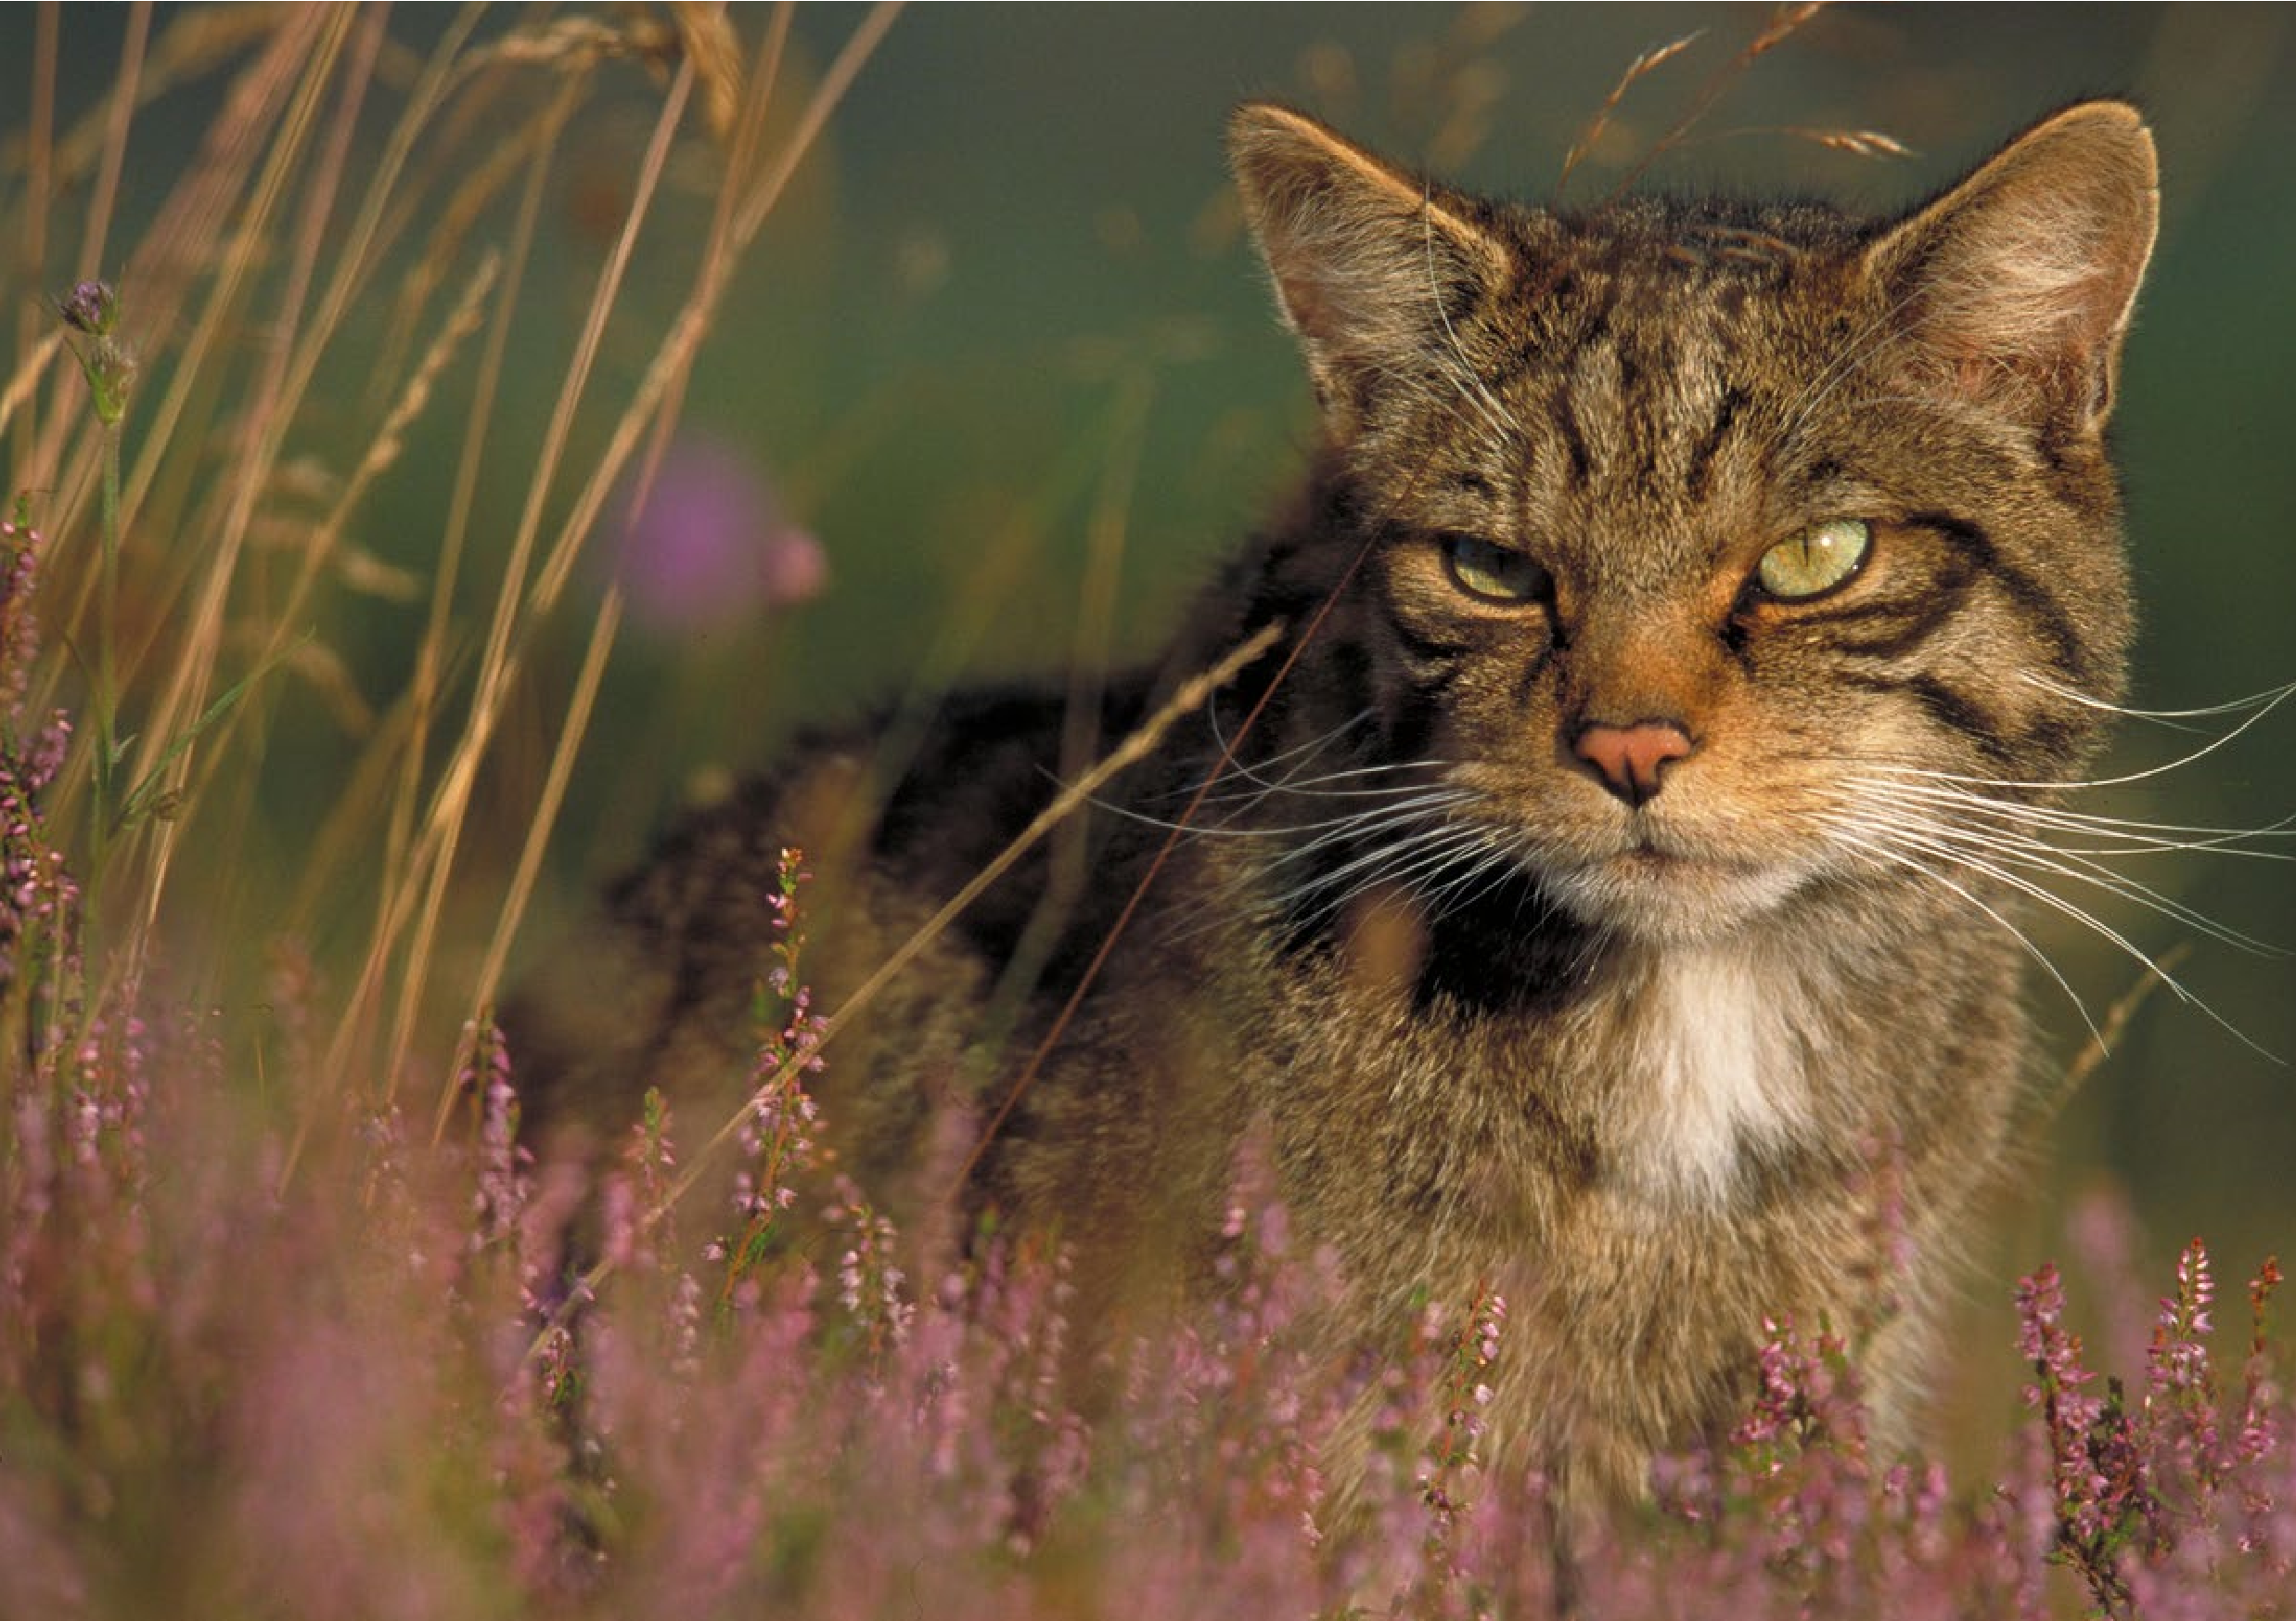
We would be very grateful if you could take just 15 minutes of your time to complete this survey and return it to us by 01/08/2016 using the free post envelope provided. Participating in this survey is completely voluntary and all information you provide will remain strictly confidential and anonymous.
A survey on farming practices related to
cat management.
Credit photo: Pete Cairns.
If you have any questions or need assistance in completing this survey, please contact Martha Gavan using the contact details below.
On behalf of the entire team at Scottish Wildcat Action, thank you for taking the time to complete this survey.
Martha Gavan

Part A: Background Information
1a) What is the location of your farm? Please give the first 3 or 4 digits of the postcode.
Eg. PH23, AB45, IV7 Note: This information will be used only to determine how many responses we got from different areas of Scotland but will not be linked to your responses.
1b) What location classification does your farm fall under?
Lowland farm Upland farm Hill farm Mixed
Other Please specify: .......................................................
1c) What type of farming do you practise? Please tick all that apply.
For all livestock please include the estimated number of animals.
Cereals  General cropping  Horticulture  Permanent crops | Pigs  Poultry  Dairy  Sheep | Nº: ……..…  Nº: ……..…  Nº: ……..…  Nº: …….… | Cattle  Other | Nº: ……...…  (Please specify):  …………………….......................
1d) What is the size of your farm/croft (in hectares)? Please tick one answer only.
0 - <5ha 5 - <10ha 10 - <25ha 25 - <50ha
50 - <100ha 100 - <200ha 200 - <300ha 300ha +
1e) Do you have game bird shoots on your land? Please tick one answer only.
Yes No
2a) Do you currently participate in any agri-environmental schemes? Please tick one answer only e.g. SRDP-RP, AECS
Yes No Don’t know
2b) If you answered "Yes" to 2a), what agri-environmental schemes do you participate in?
Please detail below.
3a) When do you think would be the best time of year to speak to farmers/crofters about some of the issues in this survey?
As we would want to avoid taking up valuable time during the busiest periods please tick the months where you are least busy and would potentially have the time to discuss issues relevant to wildcats.
January | February | March | April
May | June | July | August
September | October | November | December
4a) How important are wildlife concerns to you? Please tick one answer only.
Not at all important Not very important Neither important nor unimportant
Fairly important Very important
4b) How important is wildcat conservation to you? Please tick one answer only.
Not at all important Not very important Neither important nor unimportant
Fairly important Very important
4c) Have you seen any evidence of wildcats in the past 12 months?3OHDVHWLFNRQHDQVZHURQO\
Yes No Don’t know
4d) If you answered “Yes” to 4c), what evidence of wildcats have you seen?
Please tick all that apply.
Sighting of cat Caught in a trap Road kill carcass
Faeces Paw prints Other (Please specify): …………………………………

Part B: Domestic Cats
From this point on cats will be referred to as:
- Pet cats i.e. a family pet who is fed and allowed inside the home
- Farm cats i.e. cats who are fed and/or encouraged to live on the farm
- Unowned cats i.e. cats that seem to live or spend a lot of time on the farm but you take no ownership of them
5a) Are there any cats living on your farm? Please tick one answer only.
Yes No Don’t know
If you answered “Yes” please continue to question 5b), if you answered “No” skip to question 5i).
5b) On your farm, what are the current numbers (estimates if not sure) of:
Pet cats ……… Farm cats ……… Unowned cats ………
5c) To the best of your knowledge, have these cats been neutered?
Note: Feral cats that have been previously neutered by vets will have the tip of one of their ears removed in order to distinguish lllllllllthem as neutered. Please tick one answer for each type of cat.
Yes No Don't know
Pet cats
Farm cats
Unowned cats
5d) To the best of your knowledge, have these cats been vaccinated?
Please tick one answer for each type of cat.
Yes No Don't know
Pet cats
Farm cats
Unowned cats
5e) To the best of your knowledge, have any of these cats had kittens within the past year?
Please tick one answer for each type of cat.
Yes No Don't know
Pet cats
Farm cats
Unowned cats
5f) Are there any reasons why you would choose not to neuter and vaccinate cats living on your farm?
P Please tick all that apply.
Put off by the cost Don't have the time Think it is an unnatural process
Want to keep breeding cats to produce further litters Not your responsibility
Don't have easy access to a vet Other Please specify: ................................................
5g) If any of the cats on your farm did have kittens in the past year what did you do with the kittens?
Please detail below
5h) What are your main reasons for keeping/encouraging cats to live on your farm?
Please detail below.
5i) Are there any reasons why you would choose to not have cats on your farm?
Please tick all that apply.
No, I like keeping cats on the farm Cost of keeping a cat Wildlife concerns
Not a cat person Don't want the responsibility of having cats
Concern for toxoplasmosis in livestock Other (Please specify): ......................................................

Part C: Rodent management
The following questions in parts C to E will ask about farming and crofting practices related to the management of rodents, rabbits and predators.
6a) Please tell us which of the following you store, and write in the corresponding box how you store it.
Please tick one answer (box) only for each
type of feed. If applicable, please tell us how you store each type of feed in the corresponding text boxes.
Do store Do not store
Grain
Hay
Other feed
6b) Have you experienced problems with rodents accessing any of the areas where you store your feed?
Yes No Don’t know
7a) Do you use rodenticides as a method of rodent control?
Yes No
If you answered “Yes” please proceed to 7b), if you answered “No” skip to question 8.
7b) What rodenticide brands/products do you use? Please detail below.
7c) If known, which of these chemicals are in the rodenticides you use? Please tick all that apply.
Alphachloralose  Bromadiolone  Flocoumafen | Difenacoum  Difethialone  Brodifacoum | Bromadiolone/difenacoum  Not sure what chemicals are in the rodenticide I use  Other (Please specify): ………………………………………
7d) One of the risks associated with some rodenticide products is the risk of secondary poisoning to other animals. We would like to know if farmers and crofters are using any measures to minimise this risk and use this information to design a guide with best practice examples.
Please detail below what measures, if any, do you take to minimise the risk of secondary poising from rodenticide products?
7e) Please tell us who applies rodenticide on your farm? Please tick one answer only.
Only an external pest control professional applies rodenticide Only I apply rodenticide
Both I and an external pest control professional apply rodenticide Other Please specify: ......................................................
7f) Are you a qualified pest control professional yourself? Please tick one answer only.
Yes No
8a) Do you use any non-chemical methods of rodent control? Please tick one answer only.
Yes No
If you answered “Yes” please proceed to 8b), if you answered “No” skip to question 9.
8b) What method of non-chemical rodent control do you use?
Please tick all that apply.Please tick all that apply.
Lethal traps Dogs Unowned cats Other (Please specify):
Non-lethal traps Pet cats Shooting …………………………………….............

Ferrets Farm cats Rat/mouse scarer Part D: Rabbit Management
9a) Do you have problems with rabbits as a pest species on your farm? Please tick one answer only.
Yes No Don’t know
9b) Which of the following methods, if any, do you use to suppress the rabbit populations on your farm. Please tick all that apply.
Pet cats  Farm cats  Unowned cats  Dogs | Ferrets  Snares  Shooting  Fungicides | Live traps  Kill traps  None, I don't actively suppress the rabbit population  Other (Please specify): ……………………………………….......

Part E: Predator Management
10a) Which of the following predator species, if any, have you experienced problems with on your farm? Please tick all that apply.
Foxes  Cats Badgers  Wildcats | Birds of prey  Crows  Magpies  Pine martens | None, I don't experience any problems with predator species  Other Please specify: .............................................................................
10b) If you have experienced problems with predator species, what are the main problems they cause?
Please detail below.
10c) Which of the following methods, if any, do you use to lawfully kill or remove predators from your farm? Please tick all that apply.
For more information on the wider background of this project , see the Scottish Wildcat Conservation Action Plan,
downloadable at:
ht
tp://www.snh.gov.uk/publications-data-and-research/publications/search-the-catalogue/pubalication-detail/?id=2050
If you would like to get
involved with wildcat conservation in your area please visit the Scottish Wildcat Action website: http://
www.scottishwildcataction.org
Cage trapping and killing  Cage trapping and releasing elsewhere | Shooting  Snares | None, I don't use any method to lawfully kill or remove predators  Other (Please specify): .......................................................
Lamping

Part D: Further Comments
11a) If you have any additional comments/questions/concerns please detail them below.
Thank you for your time.
Please return your survey using the provided freepost envelope.

