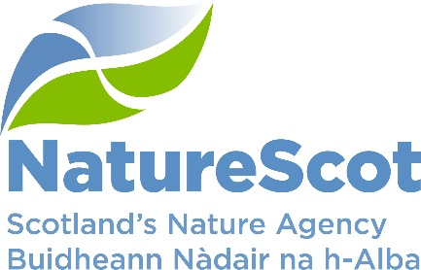

NatureScot

SCIENTIFIC ADVISORY COMMITTEE

DISCUSSION PAPER

Peatland ACTION monitoring and research issues

Purpose
- This paper provides an update on Peatland ACTION’s monitoring and research. It seeks advice on a number of issues associated with monitoring peatland restoration outcomes including biodiversity benefits.

- Action
The Committee is asked:
- To note work being undertaken to monitor our peatland actions;
- To advise on the monitoring and research challenges/issues raised; and
- To advise on whether it wishes to be engaged in consideration of complex or novel research and monitoring projects.

Preparation
- The paper was prepared by Sally Blyth and Lucy Elliff of the Peatland ACTION Data and Evidence Team. It is sponsored by Peter Hutchinson Peatland ACTION Programme Manager and Eileen Stuart.

Background
- Peatland ACTION is the government partnership established to support the delivery of peatland restoration in Scotland. It is working to the Infrastructure Investment Plan target of 250,000 hectares of peatland put on the road to recovery by 2030. Other delivery partners are Forestry and Land Scotland, the two National Parks, and Scottish Water.

- NatureScot has two roles in the partnership:
- Leadership/coordination of the common functions that all delivery partners require – communication, technical advice, training/capacity building, funding procedures/protocols, private finance, and data/monitoring. Research is led by Scottish Government, but with significant input from NatureScot including contribution to their Peatland Scientific and Technical Advice Group (STAG).

- Managing delivery of restoration. We helped put almost 4000 ha on the road to recovery in 2021/22, approximately 75% of the 5,300 partnership total. The outputs from 2022/23 are currently being examined, but it is hoped that a 20% increase in restoration will have been achieved.

Restoration monitoring Strategy and Network
- Given the level investment in peatland restoration, the government must ensure we have a robust monitoring framework in place for its Peatland ACTION. Pillar IV of the Scottish Government’s Delivery Plan (2022-25) outlines actions in relation to monitoring, research and analysis. Action 24 states:

Action | Lead | Elaboration/Milestone
23. We will monitor and evaluate the impact of peatland restoration projects to measure progress towards targets and understand efficacy of restoration in reducing emissions and providing other co-benefits. | NatureScot | We will consult on a strategy for both: Output monitoring (what are we doing?) – identifying measures/indicators that reflect the implementation and outputs of peatland restoration actions; and Outcome monitoring (is it working?) – identifying measures/indicators that represent the objectives of peatland restoration in delivering multiple benefits and the effectiveness of the implemented restoration actions.  We will consult on and establish a monitoring network to set up cost-effective, repeatable, long-term monitoring across a representative sample of sites.

- Understanding the impact of interventions is also key to our wider work to stimulate the demand for restoration. Stakeholders, particularly land managers and the public, are increasing asking for evidence that the interventions and the associated public investment are making a difference and realising the broad benefits that underpin the case for transforming our approach to restoration.

- Progressing this action is one of the leadership roles assigned to NatureScot. For this, we have developed a Peatland ACTION Monitoring Strategy. We consulted on this in 2022/23 and a revised document will be published shortly. The Strategy distinguishes between Output monitoring (what are we restoring where?) and Outcome monitoring (is our restoration working?).

Figure 1 The Monitoring Strategy overall aim and three objectives.

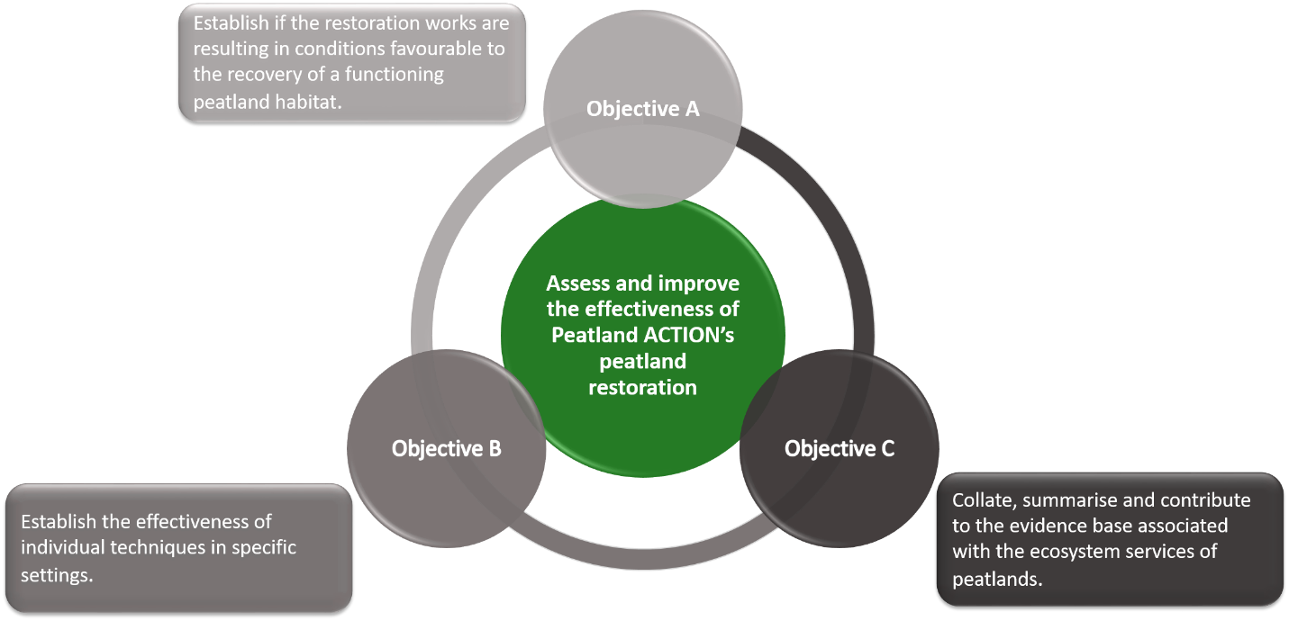

- The overall aim of the Strategy is to assess and improve the effectiveness of peatland restoration through three objectives (A, B and C in Figure 1).
- Objective A includes establishing a Monitoring Network and support for remote sensing/Earth observation tools to enable large-scale monitoring;
- Objective B includes establishing monitoring projects to better understand peatland restoration techniques; and
- Objective C which links to our work with RESAS and the Scientific and Technical Advisory Group.
- The Strategy will be implemented through a Monitoring Network. This will monitor a representative sample of Peatland ACTION sites across Scotland. The work programme will assess the effectiveness of various restoration techniques on actively eroding blanket bog, drained blanket bog, drained raised bog and forestry to bog. We will be rolling out the finalised programme of monitoring on our first suite of sites this field season.

Monitoring work
- The monitoring projects to support this Strategy and Network – with external organisations and through partnerships - are extensive and summarised in Annex 1.

Challenges/issues in peatland restoration research and monitoring

- The right projects. There are many challenges with monitoring peatland restoration including designing projects that will generate robust data perhaps decades after initial inception (what data to collect, defining success, ensuring repeatability, the use of reference or true controls etc.). We need to ensure we are designing our monitoring effectively and progressing the right projects to support it. Advice from the SAC on this – are there any gaps; are some more important – would be we welcome.

- Working in partnerships. Some projects are more complicated and often involve working with multiple partners. A developing partnership project looking at the benefits of peatland restoration on upland birds is a topical example - the Game & Wildlife Conservation Trust are leading on project design which is being developed with our input. We need to ensure the design is robust and is in line with our objectives and also represents good value for money given the significant Peatland ACTION investment that may help to fund this work, but we also need to ensure that partner interests are respected. Is this partnership approach appropriate or should NatureScot be focused on its own projects which it can directly control?

- Tolerating the risk from novel work. Peatland ACTION continue to invest in complex and novel research work being conducted by the University of Nottingham and others which is looking at how InSAR-derived satellite data can help map peatland condition, restoration and compliance monitoring, for example. The technique is innovative and explained more fully in a NatureScot Research Report. Again, there is a significant level of investment in this research and we need to ensure that tools and products generated are effective and widely available to those restoring peatland. Whilst we put in controls to realise this, there is a latent risk of non-delivery that we are tolerating. Is this tolerance of risk appropriate or should NatureScot focus on tried and trusted techniques?.

- Alignment with other research. There are a number of government bodies, academic/research institutions and eNGO’s examining peatland with similar questions asked/answered. Given the immaturity of the peatland restoration industry, this is good from an ‘exploratory’ perspective. However, to provide a stronger framework for alignment and associated efficiencies, we are pushing the Scottish Government to use their Delivery Plan to provide a stronger steer on the monitoring, research and analysis work required for the industry. This does not rule out opportunities for greater NatureScot collaboration or synergy with work in other organisations and the SAC may want to highlight connections/linkages that we should be making to support this alignment.

SAC engagement in considering complex or novel research and monitoring projects
- Whilst SAC members were given the opportunity to comment on the evolving Strategy and Network and will be provided with updates during 2023/24, there is scope to involve members in the projects listed in Annex 1. If Members are interested in this greater involvement, they should contact Sally Blyth or Des Thompson in the first instance.

Contact:
Sally Blyth Sally.blyth@nature.scot
Des Thompson des.thompson@nature.scot

Annex 1: Monitoring Strategy projects: Peatland ACTION monitoring projects currently underway

Objective | Lead Organisation | Project details and progress update
A | NatureScot | Title: Restoration Monitoring Network (RMN)  Currently in development with the aim of implementation from 2023/24 onwards.
A & B | NatureScot | Title: Peatland ACTION Hydrological Monitoring  Ongoing data capture, review of hydrological monitoring design as part of the comprehensive review of Peatland ACTION hydrology data
B | NatureScot | Title: A comprehensive review of Peatland ACTION hydrology data  Project to complete shortly and options will then be reviewed.
A | NatureScot | Title: Peat Condition Assessments  Ongoing as part of restoration planning
A & B | NatureScot | Title: Tracking bare peat change  Project to complete shortly and options will then be reviewed
A | NatureScot / Nottingham University / FLS / University of Highlands and Islands | Title: Using peat surface motion (bog breathing) to monitor Peatland ACTION sites  Aiming to integrate remote sensing monitoring tools into the Restoration Monitoring Network and wider monitoring of peatland restoration by 2024/25.
A | University of Stirling - Scotland’s International Environment  Centre (SIEC) | Title: Developing a toolkit for monitoring the success of peatland restoration projects using remote sensing (“Forth ERA”)  Project to complete January 2024
C1 | Galloway Fisheries Trust | Title: Evidencing of the impacts of forest to bog peatland restoration activities on water quality in South West Scotland  Project nearing completion and then review and comment on report
C1 & C2 | RSPB | Title: Monitoring of the water quality and discharge rates associated with restoration works at the Abernethy  Data capture ongoing.
C5 | Scotland’s Rural College (SRUC) | Title: The cost of peatland restoration in Scotland  Ongoing with annual update as part of the SRP CentrePeat 2022 - 2027
C6 | JHI | Title: Greenhouse gas monitoring of Peatland ACTION restoration sites (JHI)  Data capture ongoing.
C6 | UK Centre for Ecology & Hydrology (UKCEH) | Title: Forestry GHG flux tower CCC/UKCEH/NatureScot (Racks Moss)  Project completion with installation of equipment due in 2023/24.
C6 | UK Centre for Ecology & Hydrology (UKCEH) | Title: Hare Moss - Installation of an eddy covariance tower for monitoring of greenhouse gases (GHGs) from a peatland before, during and after restoration  Equipment installation completed by end of 2023/24. Final report due in 2025/26.
C6 | JHI | Title: Strategic Research Programme (SRP) ‘CentrePeat’  To provide input and strategic direction as required throughout 2022 - 2027  .
C6 | JHI | Title: Greenhouse gas monitoring equipment for peatland restoration  Data capture ongoing

