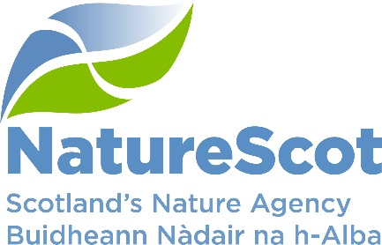

SCIENTIFIC ADVISORY COMMITTEE

DISCUSSION PAPER

‘One Health’: discussion on applications in NatureScot

Purpose
- A presentation by Professor Anna Meredith will outline some potential applications of ‘One Health’ in NatureScot.

Action
- The Committee is asked to consider the concept of ‘One Health’ and how it might be adopted as part of lexicon in NatureScot.

Preparation
- The paper was written by Des Thompson. It is sponsored by Eileen Stuart.

Background
- The World Health Organisation (WHO) describes ‘One Health’ as: ‘an integrated, unifying approach that aims to sustainably balance and optimize the health of people, animals and ecosystems. It recognizes that the health of humans, domestic and wild animals, plants, and the wider environment (including ecosystems) are closely linked and interdependent.’ Earlier this year The Lancet published a series of articles under the heading ‘One Health: a call for ecological equity’ which makes compelling points about disease control.

- Given the importance of the underlying importance of the approach, we wish to discuss it with the Committee. Our work on HPAI, has brought into sharp focus the importance of understanding the relationships between human and other animal diseases, and the wider ecosystem impacts of these. Again, quoting the WHO: ‘By linking humans, animals and the environment, One Health can help to address the full spectrum of disease control – from prevention to detection, preparedness, response and management – and contribute to global health security.’
- Professor Anna Meredith OBE FRCVS is Professor of Conservation Medicine at the University of Edinburgh, has worked closely with us on several species conservation issues (e.g. red squirrels, white-tailed eagles) and is a member of our Committee sub-group advising on HPAI. Professor Meredith will introduce the Committee to the formal term of ‘One Health’, and discuss applications of it.

- Whilst the term is not part of the formal lexicon used by NatureScot, we would welcome advice from the Committee as to whether it should be. We refer to ‘Our Natural Health Service’ and ‘Green Health Partnerships’ but do not refer to ‘One Health’.

Contact: Des.Thompson@nature.scot

