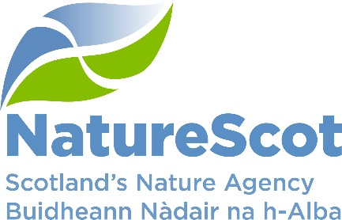

NatureScot

SCIENTIFIC ADVISORY COMMITTEE

DISCUSSION PAPER

HORIZON SCANNING: PLANT HEALTH, March 2023

Purpose
- Following discussion in November 2022, The SAC requested a deep dive into plant health in semi-natural systems. This paper focuses on the science and evidence: resourcing questions will be raised through other relevant channels (Resourcing Group/SLT).

Action
- The SAC is asked to note that, and/or comment on:
  - Plant pests and pathogens are currently causing biodiversity declines and losses. Future plant pests and pathogens (non-native; not currently present; those currently present but whose severity may change due to climate change) pose a significant risk to native plants and their associated biodiversity and ecosystem services. Although details of exact impacts, such as number of associated species affected, are unknown in many cases, there are potential risks to plans to enhance carbon removals into biological systems, the management of climate risks and the state of nature, including ecological restoration (paras 4-10)

  - The framework to guide future work (paras 11-13).

  - The responsibilities for plant health in semi-natural habitats is unclear and should be clarified in conjunction with appropriate organisations, especially the Plant Health Centre, initially through a mapping exercise, learning from emergency response protocols in better known areas such as INNS and avian influenza. (para 14-18)

  - Plant health is a large and potentially complex risk to manage. We suggest learning-by-doing, for example: identify business-critical areas for NatureScot (e.g. habitat restoration or creation projects); initial focus on c.10 key foundation plants to target for a trail monitoring of plant health (para 14-18)

Preparation
- The paper was written by Clive Mitchell based on notes by Ruth Mitchell and Duncan Stone from a Plant Health Workshop held on 23 February. It is sponsored by Eileen Stuart.

Background
- This paper follows the first meeting/workshop held to discuss plant health issues in more natural vegetation systems and draws on a joint fellowship between NatureScot and Plant Health Centre.

- Plant health is the plant health consequences of biotic agents, i.e. pests and pathogens (include bacteria, fungi, insects, mites, nematodes, oomycetes, phytoplasma, viruses and viroids) - collectively referred to as pests throughout this paper. The paper excludes the impact of poor management, vertebrate herbivores, poor soils, direct impact of changes in climate on plants (although climate change will impact pests/pathogens severity/distribution).

- Plant health activities in semi-natural habitats currently focus on woodlands, but there are a range of other habitats that could be impacted e.g. peatlands, moorlands, aquatic habitats.

- Defra plant health risk register (PHRR) lists the pests currently known that could impact plant health in the UK, but the register is biased towards pests of commercial plants (horticulture, forestry and agricultural).

- There are 916 pests in the PHRR that could be hosted by plant genera that occur in semi-natural habitats in the UK at more than 25% cover. Of these, 91 have the highest likelihood of occurring (4 or 5 in the risk register). There are other pests and hosts not listed in the PHRR that are relevant to semi-natural habitats (e.g. a literature review revealed 142 additional pests on heathlands not in the PHRR).

- Plant health affects more than just the host, with cascading effects on the biodiversity associated with that host and acute effects for obligate species¹. For example, ash trees host 955 species, 45 of which are only found on ash. In addition, declines of multiple host plants due to disease will have cumulative impacts on biodiversity. Plant diseases caused by non-native pests have been described as an insidious, mostly overlooked threat to biodiversity and the cause of extinction cascades.

- Recent work by the Plant Health Centre Fellowship revealed a lack of awareness of plant health risks during habitat creation/restoration. In a survey attracting 224 respondents involved in habitat creation/restoration, half either didn’t know or didn’t have a risk assessment for biosecurity, 22% didn’t check if biosecurity best practise was followed and 60% either didn’t have or didn’t know if anyone was responsible for biosecurity in their organisation. This includes peatland restoration.

Framework for promoting plant health
- The number of pests and hosts precludes monitoring everything. A plant health framework (Figure 1) has been developed to (a) prioritise which plants/habitats to focus on and (b) identify activities to promote plant health (these can be progressed simultaneously). The framework is explained in the following paragraphs.

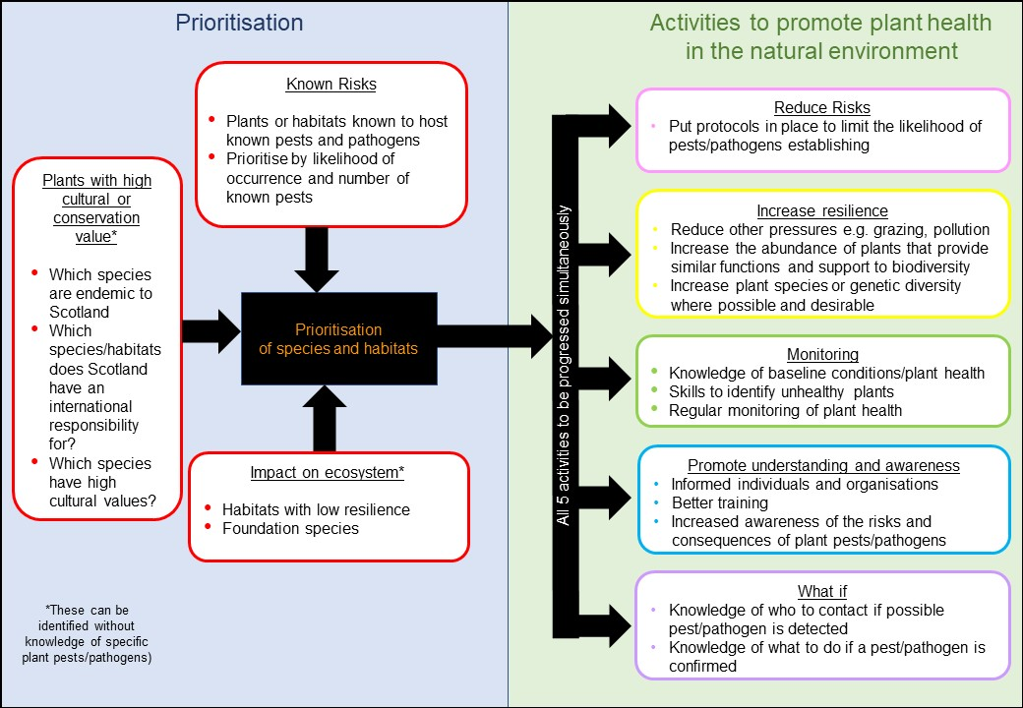
Figure 1. A plant health framework. See text for detail.
- Prioritisation: which plant species or habitats to prioritise for action can be based on: i) plants with high cultural or conservation value, ii) known risks – the plants or habitats known to host the most pests listed in the PHRR or iii) the potential ecological impact (impact on associated species and ecosystem services). Prioritisation via ii) or iii) leads to very different lists as the PHRR is biased towards species of commercial importance. Method ii) does not account for known unknowns, whereas method iii) does. For further information see SEFARI case-study and preprint.

- Activities to promote plant health in the natural environment includes actions grouped into 5 activities:
  - Reduce risks: action to reduce risks includes risk assessments and appropriate biosecurity for habitat creation/restoration works, especially those that are publicly funded, to lead by example. Free-trade rules (‘most favoured nation status’) may make prohibition of imported plants for restoration difficult unless there are known risks, but raising awareness of the benefits of sourcing plants grown in the UK, to reduce risks and associated costs, is encouraged.

  - Increase resilience: if habitats are more resilient then they are likely to better withstand pest/pathogen attack. Where possible activities to reduce other pressures, would increase resilience to pest/pathogen attack. We can learn from vulnerabilities in commercial (monoculture) systems; and resilience in (more diverse) natural systems.

  - Monitoring: There is currently no system for monitoring plant health in the wider environment, outside of woodlands. Developing a system requires knowledge of baseline conditions and what a healthy plant looks like and the skills to identify the causes of the plant ill-health, e.g. distinguish between effects of drought and effects of pests/pathogens.

  - Promote understanding and awareness: awareness of the risks associated with plant health is often lacking, from the potential sources of pests/pathogens to cascading effects on biodiversity. For example, in the Plant Health Centre survey, the 224 participants ranked “neighbouring habitat” as the greatest risk and ranked mature plants and seeds and equal risk, in contrast to the literature.

  - What if: We need to know what to do if a suspected pest/pathogen establishes in the semi-natural habitats outside of woodlands. Roles and responsibilities are currently unknown (workshop findings, including Gerry Saddler, Chief Plant Health Officer). Once a quarantine pest (i.e. of concern) is identified there are procedures and legislation to remove plants/restrict access to land/attempt to eradicate pests. But the route to raise awareness of potentially unhealthy plants and the relevant diagnostic skills and resources for identification is unclear.

Recommendation: moving to a wild plant health monitoring and response system
- A coherent wild plant health monitoring and response system is likely to involve:
  - Prioritization – a small number of plants which are 1) at risk of pest attack, and 2) have characteristics such that pest impact would have negative consequences over large areas, or result in a cascade of dire consequences for dependent species.

  - Field Assessment – to gather information on plant health from the wider environment, possibly a combination of professionals and Citizen Science. Guidance on how to identify potential pest impacts without generating excessive false positive outcomes needs some work – such as photographic guides of ‘normal’ and disease/pest appearance. Laboratory resources within FERA/SASA/FR to confirm pest impacts are scarce and expensive, and need to be considered in any flow of information on possible pest/disease occurrence.

  - Outbreak management – clarity and preparation on roles and responsibilities, probably based on clear contingency planning to allow appropriate action to be taken if pest/disease outbreaks are confirmed.
- Implementing such a system for a small number of plant species is likely to be most helpful to raise awareness, test elements of the system, and build staff expertise.

- There are clear connections to our work on animal disease outbreaks, like avian influenza and INNS, and these should inform NatureScot’s approach to plant health.

- The range of species covered by any agency-based health monitoring and response system is likely to be small because of competing demands on our resources. However, we could construct such a system with an open architecture that would allow other organisations - perhaps focused interest on particular habitats - to maintain their own field assessment systems which could feed into the overall plant health monitoring and if necessary response. For example the ‘Riverwoods’ partnership is planning monitoring of riparian woodland, and it would be relatively simple to add a commitment to monitor plant health of key species, such as alder.

- This approach is likely to be a necessary part of delivery of the Scottish Biodiversity Strategy, especially targets to restore 30% degraded ecosystems by 2030 (COP15, Global Biodiversity Framework). Similarly for activities required to deliver biological sequestration for the Climate Change Plan including peatland restoration which involves a small number of contractors operating over a wide area and moving from place to place.

Contact: Clive Mitchell, clive.mitchell@nature.scot, 07917 552548

Mitchell, R.J., et al. (2019) Collapsing foundations: The ecology of the British oak, implications of its decline and mitigation options. Biological Conservation 233, 316-327.
Mitchell, R.J., et al. (2014). Ash dieback in the UK: A review of the ecological and conservation implications and potential management options. Biological Conservation 175, 95-109.
Mitchell, R.J., et al. (2022) Cumulative impact assessments of multiple host species loss from plant diseases show disproportionate reductions in associated biodiversity. Journal of Ecology 110, 221-231.
Jonsson, M.T., Thor, G. (2012) Estimating Coextinction Risks from Epidemic Tree Death: Affiliate Lichen Communities among Diseased Host Tree Populations of Fraxinus excelsior. Plos One 7, (9): e45701.
Hultberg, T. et al. (2020) Ash dieback risks an extinction cascade. Biological Conservation 244, e108516.
Mitchell, R.J., et al. (2023) Plant Health, Biosecurity, and Conservation Translocations, In Conservation Translocations. eds M. Gaywood, J.G. Ewen, P.M. Hollingsworth, A. Moehrenschlager, pp. 241-270. Cambridge University Press, Cambridge.

