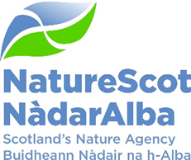

Extensions to Caithness and Sutherland Peatlands SAC, SPA, Ramsar and underpinning SSSIs – actions following the statutory consultation – confirmation of eight sites

Date: 10 February 2023

Purpose: | This paper is for Decision.
How does this link with our corporate priorities of improving biodiversity or delivering nature-based solutions to climate change: | SSSI notification is one of NatureScot’s key statutory functions. The final decision on whether to confirm a notification or extension to a site is made by the PAC, or where there are scientific objections by the Board.  Work to restore areas of the Caithness and Sutherland peatlands damaged by inappropriate conifer planting has been going on since the 1990s. This has reached the point in many areas that the land can be added to the existing protected areas. This will provide protection to the restored areas and encourage further funding for follow-up work needed. Peatland restoration and maintenance has clear benefits to climate change mitigation, and this work provides additional biodiversity benefits in the iconic Flow Country.
Summary: | Following the conclusion of the statutory public consultation to the extension of 10 SSSIs to underpin proposed extensions to the Caithness and Sutherland Peatlands SAC, SPA and Ramsar site, the PAC is asked to agree the next steps in the designation process.
Actions: | Approve the confirmation of extensions to 8 SSSIs where there has been no objection.
Recommendations: | Recommend confirmation of extensions to 8 SSSIs.
Report Author(s): | Rachel Horsburgh, John Kerr, Sally Ward
Sponsor: | Nick Halfhide
Appendices: | Annex 1 – Maps of the extensions  Annex 2 - Why this protected area should be extended to this land now  Annex 3 – Table of Responses to public consultation on these eight sites

Purpose
This paper is to ask the Protected Areas Committee to take the next steps in the statutory process to notify the extensions to 8 SSSIs underpinning proposed extensions to the Caithness & Sutherland Peatlands SAC, SPA and Ramsar sites.

Background
Forest to bog restoration in the extensions started in 1996, funded by two EU LIFE projects. RSPB was the lead partner. NatureScot and the Scottish Government committed to consider designating the land as part of the funding bid.

Action Required by PAC and Issues to resolve
To approve the confirmation of the extensions to 8 SSSIs which underpin part of the extension to Caithness and Sutherland SAC, SPA and Ramsar site (Ben Griams SSSI, East Halladale SSSI, Forsinard Bogs SSSI, Loch Caluim Flows SSSI, Shielton Peatlands SSSI, Sletill Peatlands SSSI, West Halladale SSSI, and West Strathnaver SSSI). No objections were received on these proposed extensions.

The PAC are asked to deal separately with the objection to the extension of two SSSIs – Strathmore Peatlands and Rumsdale Peatlands.

Stakeholder engagement
The extensions to these eight sites have two owners (RSPB and FLS) and 6 tenants. We started to develop the case for extending the protected areas in 2015, and have been in regular contact with all of the relevant landowners and their agents.

Conclusions/Recommendations:
There were no objections to the extensions of 8 of the SSSIs and the PAC can approve the confirmation of these immediately.

Annex 1 – Map of the extension areas
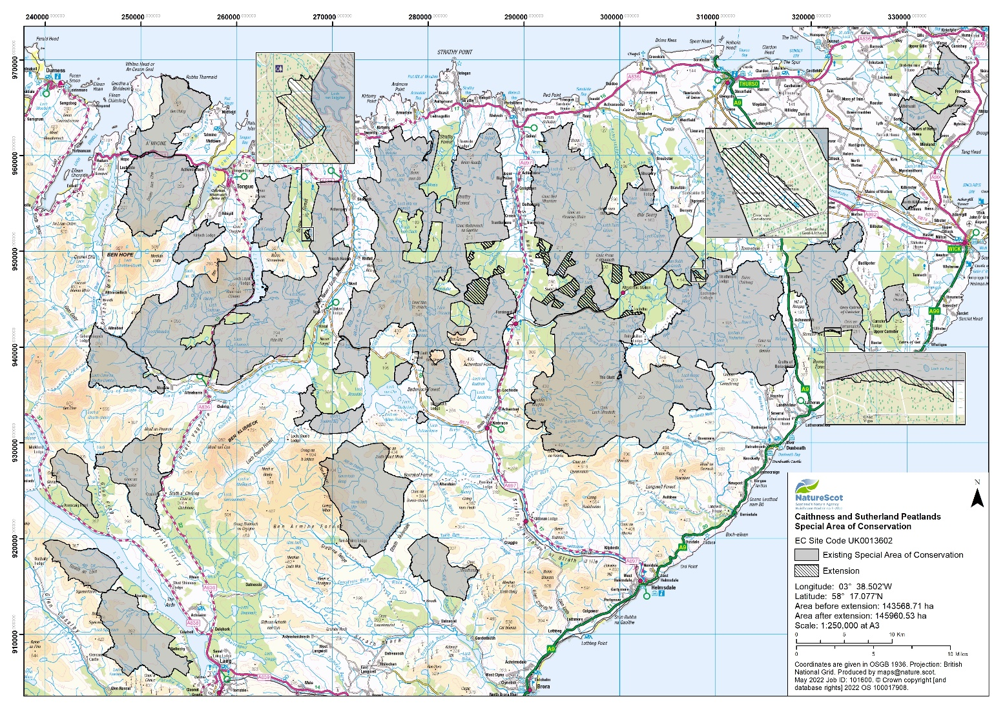
Extension to Rumsdale Peatlands SSSI
Extension to Strathmore Peatlands SSSI
Figure 1. Caithness and Sutherland Peatlands SAC and extensions. The two extension areas where an objection has been received are labelled and circled in red. The remaining extensions to the 8 SSSIs where there has been no objection and which can be confirmed immediately are shown hatched.

Annex 2

Why this protected area should be extended to this land now

What was the consultation about?
The public consultation on extension of Caithness and Sutherland Peatlands SAC, SPA and Ramsar site and 10 underpinning SSSIs was open between 25 August and 29 November 2022. The extension areas cover 2446 ha, a 1.7% increase to the overall Caithness and Sutherland Peatlands protected areas.

Why are we doing this now?
Conifer plantations were felled to restore blanket bog with EU LIFE funding in 1996-2006. As part of the funding application, both SNH and Scottish Government made commitments to the European Commission to consider designating the restored ground when it meets site selection criteria. In 2014 Scottish Government asked SNH for advice on whether to extend the protected area. Following approval by the PAC and SAC, we advised Scottish Government that site selection criteria were met and that the land restored with EU LIFE funds should be added to the protected areas. In 2022 Scottish Government asked us to carry out a public consultation on extension of the SAC, SPA and Ramsar site. We simultaneously consulted on extending 10 underpinning SSSIs across the same land.

Why the extensions met site selection criteria in 2015
We considered that SSSI and Ramsar site selection criteria were met due to the ‘axiomatic clause’. This means that if SAC and SPA site selection criteria are met, SSSI and Ramsar site selection criteria are automatically met for the relevant features.

SAC site selection criteria acknowledge that “many sites may require adjustments to management or a modification of human impacts over part of their area” and that “in these cases the likelihood of restoring structure and function has been a helpful consideration”. Thus site selection criteria specifically allow areas that are recovering to be included in an SAC when habitat restoration is possible.

SAC site selection criteria for blanket bog were met in all the extensions to the protected area in 2015.

SPA site selection criteria were met because SPA birds use areas of suitable blanket bog and dubh lochan habitat. The extensions already meet the habitat preferences of greenshank. Golden plover and dunlin are expected to find the extensions attractive for breeding as habitat recovery progresses. The extensions currently form a valuable foraging area for raptors and owls and will continue to do so once recovery is complete.
Annex 3 Table of responses to public consultation on eight sites proposed for confirmation

Consultee | Nature of response | NatureScot Response
Forest and Land Scotland | Acknowledgement | Thanked for their contribution to the consultation, explaining the next steps of the consideration of all consultation responses.
Jamie Stone MP | Acknowledgement | Thanked for their contribution to the consultation, explaining the next steps of the consideration of all consultation responses.
Maree Todd MSP | Acknowledgement | Thanked for their contribution to the consultation, explaining the next steps of the consideration of all consultation responses.
Liz Albert | Support from non-owner/occupier | Thanked for their contribution to the consultation, explaining the next steps of the consideration of all consultation responses.
Scottish Ministers per Brian Eardley | Acknowledgement | Thanked for their contribution to the consultation, explaining the next steps of the consideration of all consultation responses.
Scottish Woodlands per Lorna Stewart | Acknowledgement | Thanked for their contribution to the consultation, explaining the next steps of the consideration of all consultation responses.
Lord Thurso | Support from owner of previously designated SSSI who does not own land in the extensions, and to point out confusing naming on the SAC extension map | Thanked for their contribution to the consultation, explaining the next steps of the consideration of all consultation responses.  Agreed that use of ‘Blar nam Faoileag’ on the OS 1:25,000 map backdrop is confusing and can be solved by using the 1:50,000 OS map.
Scottish Forestry, per John Risby | No comment consultation response | Thanked for their contribution to the consultation, explaining the next steps of the consideration of all consultation responses.
RSPB per Bea Ayling | Support, to request designation of additional land and in relation to 'edge effect' policy. | Thanked for their contribution to the consultation, explaining the next steps of the consideration of all consultation responses.  Also indicated that we would pass their comments on conifer seeding into peatland restoration areas and required forest edge pullback from protected areas edge to Scottish Government.
Strath Halladale Partnership per Reuben Sweeting | Support and request that more emphasis is given to protection of salmon spawning grounds in site documentation. | Thanked for their contribution to the consultation, explaining the next steps of the consideration of all consultation responses.  Also agreed to add more information on protection of salmon spawning grounds to SSSI Site Management Statements.

https://data.jncc.gov.uk/data/5d20b480-9cc1-490f-9599-da6003928434/sac-selection-background-t37-v4.pdf - see section 1.5.4.1.3, page 17-18

