National Parks Commission SAG 1-3 – Proposals for Consultation

Aim of Paper

1 This paper briefly outlines proposals for engagement and consultation as part of the work to develop advice to Government on new National Park(s).

Background

“It is essential to the acceptability and eventual credibility of a National Park that throughout this process there is consultation and involvement from the key interests at both national and local levels.” (‘National Parks for Scotland’ Scottish Natural Heritage’s Advice to Government (1999) (paragraph 2.6))

2 The establishment of Scotland’s first two national parks was subject to extensive consultation and debate about the two geographic areas - involving the local communities of these areas, the relevant local authorities and range of national stakeholders. Preceding this had been a phase of widespread consultation work by NatureScot (then Scottish Natural Heritage) in 1998-99 on proposals for legislation for National Parks and how this could be could be applied in Loch Lomond & the Trossachs, the Cairngorms and elsewhere. Similar work involving engagement with relevant stakeholders and communities was also undertaken by NatureScot in its preparation of advice in 2006 on establishing Coastal and Marine National Parks.

3 The establishment of new National Parks will need similar effort. For this to happen, stakeholder engagement must be comprehensive and as representative of the people of Scotland as possible. A range of groups at national and local levels needs to be involved; and modern and creative methods of engagement deployed to help people express what, and where, is important to them. Particular attention is needed to ensure traditionally under-represented groups are engaged – local communities, young people, people from black and ethnic minority groups and people with disabilities – as well as the traditional stakeholders. Annex A provides an initial overview of relevant groups.

4 The process leading to the designation of at least one new National Park by 2026 will involve the following:

Non-statutory  Phase |  | Target date  (end of)
Stage 1  National Discussion | Crowdsourcing of ‘Expectations’ for National Parks using Scottish Government Dialogue online platform | May 2022
 | Refinement of ‘Expectations’ through face to face engagement supported online by Citizen Space to establish Role and Function of National Parks in Scotland – NatureScot to lead | November 2022
Stage 2  Evaluation Framework | Delivery of Evaluation Framework for New National Park(s)  - SG lead | March  2023
Stage 3  Nomination & Evaluation | Nomination of Proposed areas and Evaluation against Framework, including support for putting together a nomination  - SG let and managed contract | August  2023
 | Nominations evaluated against Evaluation Framework by Independent Panel and report to SG  - same contract as above | September 2023

Annex B summarises the main stages of the statutory process.

Advice stage (the current stage, presently scheduled to finish November 2022)

5 The main issues to address for the advice stage consultation options are ensuring that:
- everyone who wishes to can comment;
- a range of communities of place and of interest are included;
- inclusivity is achieved;
- the methods used are appropriate and practical, whilst noting that this could be an opportunity for them to be innovative too

This first phase also needs to raise awareness of the plans of the three further stages of engagement and consultation that will follow between 2023 and 2026.

6 While there are parallels with NatureScot’s work to prepare advice to Scottish Government in 1999, the key difference is that no areas have yet been identified. In addition, inclusivity, sectoral interests and the climate change, nature / biodiversity and health crises are more recognised than twenty years ago with parallel work also proceeding that will involve similar stakeholders. This includes Highly Protected Marine Areas, nature networks and achieving 30% of Scotland’s land and sea managed for nature by 2030 (also known as 30 x 30). .

7 In addition to the Stakeholder Advisory Group (discussed in paper 1-2), the main elements we are proposing to engage and consult with stakeholders at this Advice stage are as follows:

- Online engagement on the Scottish Government Dialogue website (completed – see separate analysis paper)
- Online consultation on the Scottish Government website, supported by a background information paper (August-September).
- Geographic consultation events involving local authorities and key regional organisations and communities – Highlands and Islands; Southern Scotland, Central Scotland (August-September).
- Sectoral consultation events e.g. local authorities, planning, land-use, marine (August-September).
- Attendance at meetings organised by others (on-going)
- Engagement work with young people, ethnic minority/Ability/Well-being etc. (August-September).

There will also be related communications and public relations aspects to this work which will need to be developed including:

- Preparing press briefings and articles for newsletters to increase awareness of our work and the opportunities for engagement.
- Developing specific National Park pages on the NatureScot web-site, with key discussion papers, research findings and updates of progress posted on it.

Recommendation

8 Stakeholder Advisory Group members are asked to:
- Note and comment on the elements of engagement and consultation work proposed for this advice stage (1-6 in paragraph 7);
- Suggest any additional consultees for this advice stage and the need or otherwise for sector specific meetings or the potential to join sector meetings during this period; and
- Suggest alternative methods for engagement and consultation during this advice stage

NatureScot
July 2022

Annex A Key stakeholder interests and groups (updated 15 August 2022)

Sector | Stakeholder group | Other
National, Local, Community Government | - Scottish Government (SG) natural resources division  - Convention of Scottish Local Authorities (COSLA)  - Heads of Planning Scotland (HoPS)  - Scottish Land Commission  - Community Land Scotland | - SG planning and architecture  - SG Climate Change  - Transport Scotland  - Scottish Environment Protection Agency (SEPA)  - Royal Town Planning Institute  - Society of Local Authority Chief Executives (SOLACE)  - Individual local authorities  - Cairngorms NP  - Loch Lomond & Trossachs NP  - Community Planning Partnerships  - Bord na Gaidhlig  - Scottish Canals
Natural and cultural heritage | - Association for the Protection of Rural Scotland/Scottish Campaign for National Parks  - Scottish Environment LINK  - Scotland’s Landscape Alliance  - Trees for Life  - Historic Environment Scotland  - Europarc Federation | - National Trust for Scotland  - Scottish Wildlife Trust  - John Muir Trust  - Royal Society for the Protection of Birds (RSPB)  - Biological Recording in Scotland (BRISC)  - Landscape Institute Scotland  - British Geological Survey  - Scottish Geodiversity Forum  - Archaeology Scotland  - Built Environment Forum Scotland  - Royal Zoological Society, Scotland  - Royal Botanic Gardens, Edinburgh  - Amphibian and Reptile Conservation  - Buglife, Bumblebee Conservation Trust  - Scottish Local Biodiversity Action Plan Network  - Flora and Fauna International  - Greenspace Scotland  - Keep Scotland Beautiful  - Green Action Trust  - National Biodiversity Network  - Sea Mammal Research Unit  - Wildlife and Wetlands Trust  - Borders Forest Trust  - Chartered Institute of Ecology and Environmental Management  - Clyde Climate Forest
Recreation, sport and health | - Ramblers Scotland | - SportScotland  - Mountaineering Council of Scotland  - Paths for All  - Sustrans  - Scottish Kayak Association  - Royal Yachting Association  - Public Health Scotland  - Cycling Scotland  - Scottish Countryside Rangers Association  - Scottish Association of Country Sports  - British Horse Society  - Scottish Sub Aqua Club
Business and tourism | - South of Scotland Enterprise  - Highland and Islands Enterprise  - VisitScotland | - Scottish Council for Development and Industry  - CBI Scotland  - Individual Chambers of Commerce  - Visitor Destination organisations  - Wild Scotland  - Scottish National Investment Bank  - Scottish Rural Network
Land and sea use | - Forestry and Land Scotland  - National Farmers Union (NFU)  - Scottish Land and Estates  - Marine Scotland  - Marine Conservation Society  - Scottish Renewables Forum | - Scottish Forestry  - Scottish Forestry Society  - Crown Estate  - Crofting Commission  - Scottish Coastal Forum  - Salmon Scotland  - Scottish Shellfish Growers Association  - Scottish Salmon Producers Organisation  - Regional Inshore Fisheries Groups  - Scottish Gamekeepers’ Association  - Game and Wildlife Conservation Trust  - British Association for Shooting and Conservation  - Association of Deer Management Groups  - Confederation of Forest Industries  - Fisheries Management Scotland  - Moorland Forum  - Scottish Water  - Scottish Federation of Housing Associations  - Homes for Scotland  - Rivers and Fisheries Trusts of Scotland  - Scottish Fishermen’s Federation  - Scottish Countryside Alliance  - Nature Friendly Farming Network  - Sustainable Inshore Fisheries Trust  - COAST  - Open Seas
Youth | - Young Scot | - YouthLink  - LGBT Youth Scotland  - Ocean Youth Trust Scotland  - Scottish Youth Parliament
Ethnic Minority (EM), Disabilities | - Council of Ethnic Minority Voluntary Sector Organisations (CEMVO)  - Disability Equality Scotland | - Black and Ethnic Minority Infrastructure in Scotland (BEMIS)  - Backbone CIC  - Ebony Hikers  - Climate Reframe  - Black Environment Network (BEN)  - Inclusion Scotland  - See Me Scotland
Other |  | - Colleges / universities – Scotland’s Rural College, FRS Marine Laboratory  - Countryside Agencies  - UK National Parks  - ClimatexChange  - Heritage Lottery Fund  - Education Scotland  - Skills Development Scotland  - James Hutton Institute  - Zero Waste Scotland  - Police Scotland  - The Conservation Volunteers  - Volunteering Matters  - Volunteering Scotland  - Inspiring Scotland  - Scottish Alliance of Regional Equality Councils  - Royal Institute of Chartered Surveyors  - Creative Scotland  - MOD  - Maritime and Coastguard Agency

Annex B Summary of the Statutory Process for Establishing a National Park
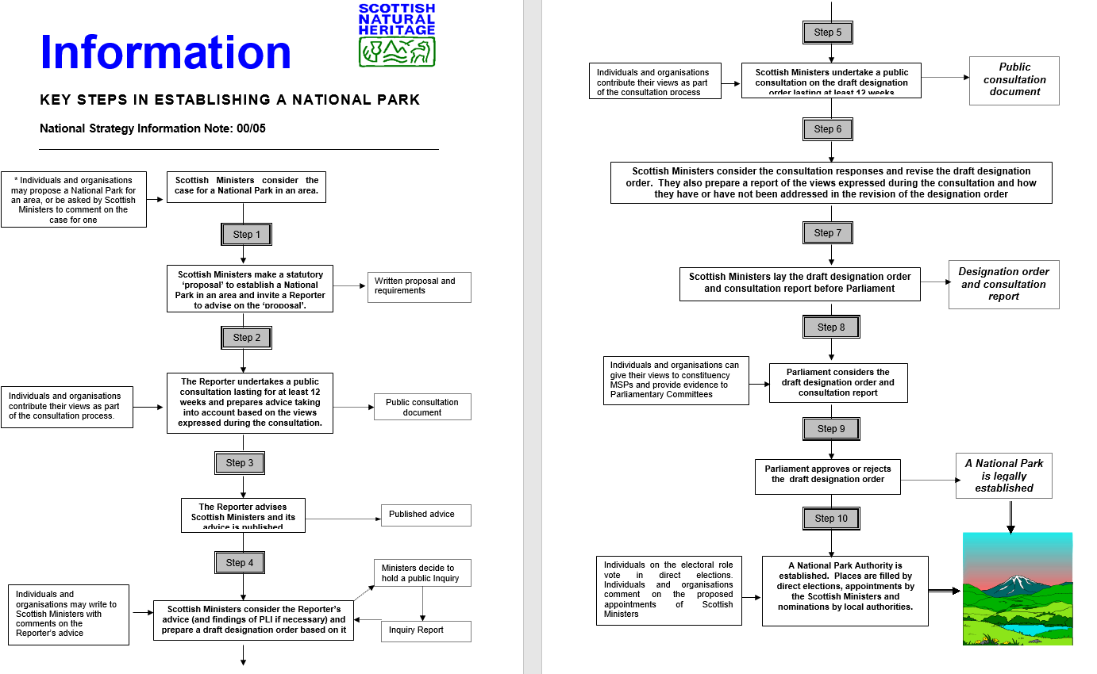
Notes
Individuals and organisations include: public agencies, local authorities, community councils, voluntary bodies and those individuals and organisations who are representative of those who work or carry out business in the area to which the proposal relates.
Rather than appoint a reporter at Step 1, Scottish Ministers may choose to undertake the consultation on the proposal themselves.
The legislation also sets out a similar approach to revising designation orders (for example to amend the boundary to increase the size of the Park area) or withdrawing them.

