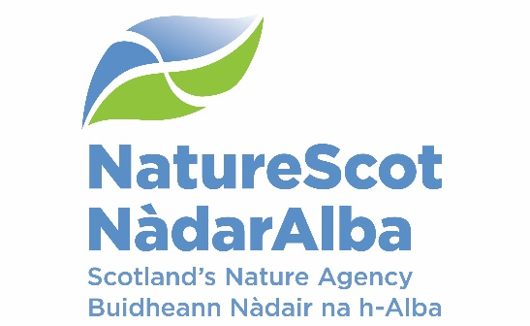

Title: BOARD Q2 Performance Report

Date: 07 December 2022
Purpose: | Decision
How does this link with our corporate priorities of improving biodiversity or delivering nature-based solutions to climate change: | This paper presents Q2 progress towards delivery of our corporate priorities as laid out in our Business Plan, A Nature-rich future for all: Year 1.
Summary: | At the end of Q2, performance for 14 of our 15 Corporate plan objectives are rated as ‘on track’. 1 corporate risk has increased their risk score in the last quarter. There are no new corporate risks for escalation or de-escalation. Our Resource and Capital budgets are currently expected to outturn within tolerance at year end although this could be affected by unresolved areas including paybill, inflationary increases and the retention of Glencripesdale capital proceeds. The Peatlands forecast is being reviewed with an underspend compared to the indirect capital budget expected. In the People Report, nine of ten indicators are green and one is amber.
Actions: | To note the recommendations below
Recommendations: | Board are asked to:  - Note the overall performance of the Corporate Plan objectives  - Note the position of the operating and capital budgets (Finance Report)  - Note the performance of the corporate risks  - Note the overall performance of the People Measures
Report Author(s): | Authors – Directors, Deputy Directors, Outcome Managers, Finance, Planning & Performance Team, People & OD Team
Sponsors: | Stuart MacQuarrie, Jane Macdonald
Annex | Annex A – Corporate Risk Register

Purpose
- This paper presents NatureScot’s performance for the second quarter of 2022/23. It addresses delivery of our corporate priorities by reviewing; the alignment of performance against our Business Plan, a Nature-rich future for all: Year 1; progress towards maximising our available budget; assessing risks for delivery; and reviewing people information supporting the resourcing of our work. These support delivery of our Corporate Plan 2022-23, A Nature-rich future for all.

Summary
- The outbreak of avian influenza (AI) is still critical and continues to divert staff resource to lead a task force, working with Scottish Government and conservation organisations to develop an effective overall strategy and produce the most up to date advice. Central to this is gaining a good understanding of the present situation and putting in place means to mitigate against its future recurrence. This response attempts to reduce spread and manage the impact where possible.

- The UK government released its mini budget which has an impact, not only on this year’s funding by reducing our commitments in employer national insurance payments, but also in to next year. This is welcome given the emerging current and future pressures playing out in Scottish Government. An Extended Leadership Team meeting in September focused on the need to prioritise for next year, to maximise the benefits for nature and climate, whilst ensuring that we can continue to manage the volatility in our funding package.

- The Organisational Development programme continues to review how to evolve the shape of the organisation to set us up for successful delivery of our corporate plan ambitions, with a focus on more agile and flexible ways to plan and allocate our resources across the organisation. Senior Leadership Team (SLT) agree that we need an organisational design that is built around a robust focus on delivery, centred on the Delivery Plans, and ensuring our priorities are clearly communicated and collectively understood. They are also committed to ensuring strong support for learning & development to underpin our knowledge, expertise & skills for the future.

- The table below reflects the Corporate Plan objectives and risks, finance and people metrics.

PRIORITY PERFORMANCE | NUMBER | CORPORATE RISK | NUMBER
Objectives | 15 | Corporate Risks | 13
On Track | 14 | Increased Score | 1
Major Slippage | 1 | Decreased Score | 0

FINANCIAL METRICS | STATUS | PEOPLE METRICS | STATUS
Resource | On Track | Wellbeing | On Track
Project Allocation | Minor Slippage | Capacity | On Track
Paybill | Minor Slippage | Development | On Track
Capital | On Track | Workforce Profile | Minor Slippage

PERFORMANCE DASHBOARD

RAG status will be available once 5 data points are collected. Bar charts are used until this point and initial data is noted without a graph

WE HAVE PROTECTED NATURE
Score | Measure | Performance Overview | Actual | Cause | Response
 | Reducing Deer Numbers | Annual measure Q4 |  | No report as Annual Measure | Data for previous years will be presented in the Q3 report until the next data point can be collected.
 | Area (ha) of woodlands restored | Annual measure Q4 |  | No report as Annual Measure | Data for previous years will be presented in the Q3 report until the next data point can be collected.
 | Number of MPAs that we have monitored | Bi Annual Measure |  | Not yet in a position to have reported for Q1 (this will be a quarter behind), we are still developing our approach and have capacity issues. | Ongoing internal discussions to address resourcing issues
 | % of licenses issued that comply with the conditions required of them | No data |  | Lack of resource to carry out compliance checks | Ongoing internal discussions to address resourcing issues
 | Are we seeing raptors where we should be? | Annual measure Q4 |  | No report as Annual Measure | Data for previous years will be presented in the Q3 report until the next data point can be collected.

WE HAVE RESTORED NATURE
Score | Measure | Performance Overview | Actual | Cause | Response
 | Area (ha) of enhancements through SMEEF | Data to be provided in Q3 |  | N/A | SMEEF measures are in development and are now expected in Q3.
 | Ha of land managed under plans supported through agricultural support schemes | 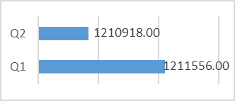 | 1.2mha | This is only a small change in comparison to the overall amount and is in line with expectations at this point in the year. | As the nature of the schemes is annual, this is an annual measure as there is no significant movement between quarters. We are continuing to monitor.
 | Area (ha) improved for habitats and species through the nature restoration fund | None Reported this quarter |  | The claims received haven’t confirmed any ha improved. | Most projects deliver during Q3 and Q4. We are anticipating ha. recovered to start being visible from Q3.
AMBER | Area (ha) of peatland put on the road to recovery |  | 572 | The main two causes of this are:  1- Slow speed of Peatland Code Verification – as a result of backlog of applications. Applications are not going ahead until IUCN have verified their project. Some applicants maintain this position even after being informed they can proceed with this step.  2- Limited contractor capacity - Agent capacity does not have enough time to develop the project to application stage | Most projects deliver during Q3 and 4. Based on our pipeline of projects and current applications, we are projecting an outturn of 5,866 ha for 2022/23 which is below the target of 8,800ha.

THE VALUE OF NATURE IS RECOGNISED
Score | Measure | Performance Overview | Actual | Cause | Response
GREEN | Hectares of Green infrastructure Restored | 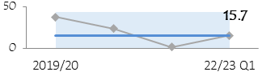 | 0 | Project delivery is proceeding as planned with all GIF projects due to complete by June 2023. | Continue focus on delivery of projects, processing of claims and collation of data from final reports as they are submitted
 | Nature-based jobs and skills opportunities |  | 175 | Working with Rivers (WWR): 3 month placement scheme ended in June. Very successful with many of the 21 placements securing jobs either with the Fisheries Trust employer or another employer. CEMVO Placements: Scheme ended in in Q1. Peatland Action Trainees - This is due to the successful delivery of Peatland Action Training courses at Marr lodge, Creag Meagaidh and Forestry and Land Scotland courses. | WWR - We are setting up a similar scheme next year for 10 placements, but for 6 months in partnership with Graduate Career Advantage Scotland (GCAS). Placements will start next April. CEMVO - We are setting up a similar scheme next year for 10 placements, but for 6 months in partnership with GCAS. Placements will start next April. Peatland - Further courses are due to be delivered in subsequent quarters.
 | % of landholdings undertaking a publicly supported Natural Capital approach | No audits undertaken during Q2 |  | No additional farms undertaking NC Assessments through NatureScot Project 117814. | The natural capital assessments are on pause until 2023/24. Habitat condition assessment scorecards related to the biodiversity audit will be tested on farms from November to March.
GREEN | National Nature Reserves online engagement |  | 1.260m | Increase in overall level of engagement across platforms. Overall reach has increased and more people are connecting with platforms. | Trend continues to be an increase in engagement - a positive direction. Our platforms are bringing more people into virtual contact and allowing ongoing engagement with audiences.

WE HAVE TRANSFORMED HOW WE WORK
Score | Measure | Performance Overview | Actual | Cause | Response
N/A | Workforce diversity - Age |  | N/A | 16-24 remains steady and 55-64 continues to increase. | Positive exits and succession planning, along with proposal on future PYE programme, are key.
AMBER | Workforce diversity - Disability |  | 17 | Disclosure remains low, but disclosure campaign planned in Q3 to tackle. | Continue work on EDI actions and increasing disclosure through campaign and visible support.
AMBER | Workforce diversity - Ethnicity | 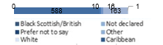 | 18 | Cause remains (as per Q1) cultural norms. Working in Partnership to tackle these. | Continue work on EDI actions and increasing opportunities within diverse communities.
GREEN | Total emissions |  | 372,124(kgCo2) | It has been agreed to report this in Q4. | There is a shift in how we are calculating emissions (building splits) so we are unable to provide data until Q4.
GREEN | Reach in mainstream media |  | 519  million | Increased media coverage due to Avian flu crisis and increased recognition of NatureScot brand | Continued proactive and reactive work on Avian flu and other topics
GREEN | Impact of public facing campaigns | 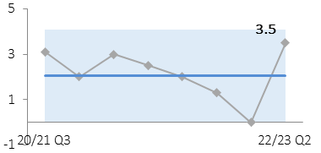 |  | Summer campaign covered Q1&2. Very strong dwell time on campaign web pages and social media Click Through Rate | Social media and radio boosts to Click Through Rate and web traffic with continued targeted campaigns

PERFORMANCE REPORT

WE HAVE PROTECTED NATURE
CORPORATE PLAN OBJECTIVE | SLT LEAD | RAG SCORE | Q2 UPDATE
Lead the delivery of 30% of land and sea being protected by 2030 | Nick Halfhide | GREEN | Initial discussions on draft Highly Protected Marine Areas (HMPA) selection guidelines with key stakeholders completed, and Deputy Director has signed-off final version for public consultation. Recruitment of 1 HPMA adviser remains outstanding and is impacting our ability to start preparatory work for site selection. 30x30/Nature Networks Discovery workshops were also held during Q2.
Build stronger collaboration reducing the impacts of deer and modernise our wildlife management and underpinning licencing functions to enable a net zero and nature positive future | Robbie Kernahan | GREEN | Deer Communications plan developed with Minister and NatureScot for media coverage. Deer Policy Manager recruited and the operations delivery managers posts being progressed. Grouse Moor Bill consultation expected to be published by SG very shortly. Beaver Strategy produced, agreed with SG and published on 21st September - additional guidance on Translocation also published. Awaiting word from SG on Licensing review Terms Of Reference and next steps.
Engage and influence planning and other regulatory systems to ensure they deliver for nature and climate | Robbie Kernahan | GREEN | Glen Dye Inquiry successfully completed and awaiting Reporters report - our team happy with the case made at inquiry. Planning for Nature Guidance consultation complete and work on finalisation ongoing alongside timetable for National Planning Framework 4 (NPF4). Paper on charging for NatureScot services completed and with Minister/Special Adviser comments back are minor, licencing charge option to be taken forward as part of the licencing review. Development Planning work on target. Ongoing short/medium term measures to further reduce Development Management pressures. Ongoing wider work on a biodiversity metric moving forward now with support from Scottish Government (SG). SG timetable for NPF4 and parliamentary scrutiny likely to slip by a month, as will our milestones associated with NPF4.
Influence the transformation of marine management through new marine planning, protection and fisheries management frameworks, and working with the marine renewable energy sector | Nick Halfhide | GREEN | We have had strong input to Marine Scotland’s Blue Economy work (high level phase 1 plan to be published shortly) and to work on aquaculture regulatory reform.

WE HAVE RESTORED NATURE
CORPORATE PLAN OBJECTIVE | SLT LEAD | RAG SCORE | Q1 UPDATE
Co-lead the production of the new Scottish Biodiversity Strategy (SBS) and develop targets to include in a new Natural Environment Bill | Nick Halfhide | GREEN | Consultation on the strategy closed on 12th September, as planned. A draft rather than completed strategy will be published in December.
Scale up Peatland Restoration by delivering Peatland ACTION funding to projects | Robbie Kernahan | RED | As a result of: limited demands for restoration/funds; slow speed of Peatland Code verification and processes; perceived constraint of limited operating season; and limited contractor capacity, we are projecting an outturn of ~ 5,866 ha for 2022/23, less than the target of 8,800 hectares
Lead, enable and convene others around the development of ambitious and coherent actions to restore nature. Deliver a major Nature Restoration Fund (NRF) targeted at high impact nature recovery projects and seeding greater investment from the private sector | Nick Halfhide | GREEN | We launched the first round of the Transforming Nature (large value) fund with an Expressions of Interest stage. 55 were received and have been assessed with successful ones being invited to submit full applications with a closing date in early October. We met with the Green Finance initiative to discuss how NRF could support and interact with potential private finance. We held an internal meeting to discuss opportunity mapping and the development of coherent actions for nature.
Demonstrate how agriculture can be transformed with new approaches to deliver targeted outcomes for nature and climate | Robbie Kernahan | GREEN | Biodiversity Audit template drafted and process agreed with Preparing for Sustainable Farming (Track 1) programme team. First 5 basic habitat assessment criteria drafted. Agreed scope and process for procuring Biodiversity App and development work on Scottish Government's Land Parcel Identification System (LPIS) required to engage with App once built. Prepared and agreed list of enhanced conditionality measures under the Testing for Sustainable Farming (TSF) Programme (Track 2) sufficient for further measure description work to be finalised in Oct 2022 for rolling out to TSF participants in Q3. POBAS App testing and participant farm scoring largely completed.

THE VALUE OF NATURE IS RECOGNISED
CORPORATE PLAN OBJECTIVE | SLT LEAD | RAG SCORE | Q1 UPDATE
Inspire people to connect with nature, increasing appreciation of nature’s value through impactful delivery and communication of our work | Jason Ormiston | GREEN | Summer Make Space for Nature (MSfN) campaign implemented; Scottish Outdoor Access Code (SOAC) campaign implemented; refresh of SOAC educational material completed; Future Routes and Better Places funds successful delivered; visitor management on National Nature Reserves (NNR’s) delivered; new commissions from SG education (nature education parks) and health (natural capital assessment of NHS greenspace) received and started
Influence the regulatory, policy, market and institutional infrastructure needed to stimulate private sector investment into nature | Robbie Kernahan | GREEN | We have launched the Investment Ready Nature in Scotland grant fund (IRNS) and received a good number of applications, including from projects in which NatureScot has an interest (Flow Country Green Finance Initiative and Scottish Landscape Enterprise Network coordinator, Nature Finance Fife).  Discussions with Hampden & Co to develop a partnership to deliver £100s millions of finance for native woodland creation and peatland restoration have proceeded to a high level meeting involving Senior Leadership Team members Hampden, Lombard and Palladium. Funds secured for a scoping study on landscape scale woodland investment in upper Tweed catchment to inform the 1st phase of investment. Continuing discussions with University of Edinburgh about collaboration with their plans to deploy nature based solutions (NbS) to offset future emissions from necessary travel.
Drive the establishment of Natural Capital as an integral part of public and private business planning and investment decisions at national, landscape and landholding/business scales | Robbie Kernahan | GREEN | Public land cluster mapping exercise completed. Further 5 potential Landscape Enterprise Network’s (LENs) partnerships identified and initiated. Natural Capital Approach Pilot (NCAP) forum meeting organised for Q3. NCAP landscape tool project officer recruited and stakeholder engagement on tool co-design underway. NCAP landholding template lessons learned report preparation underway.
Promote understanding and awareness of skills and capacity needs for the nature based sector | Nick Halfhide | GREEN | Publication of refresh of NatureScot action plan - https://www.nature.scot/doc/nature-based-jobs-and-skills-action-plan-2022-2023; evaluation of working with rivers skills programme completed and next stage of work scoped; input made to review of land based learning; scoping of peatland restoration skills action plan

WE HAVE TRANSFORMED HOW WE WORK
CORPORATE PLAN OBJECTIVE | SLT LEAD | RAG SCORE | Q1 UPDATE
Deliver new ways of working to stimulate achievement of our ambitions | Jane Macdonald | GREEN | As people settle into their working preferences we are focusing attention on how hybrid working affects the workplace experience and what returning to our offices for those people that do so will look and feel like. Alongside this we have been focusing on mental health, wellbeing, workload management and work-life balance through our pulse surveys, audit programme and themed months.  We are midway through our review of what our estate will need to look like in order to support our new ways of working, and underpin our net zero ambitions. This review will inform investment decisions on net-zero implementation plans. Work on the reduced footprint and space sharing with Scottish Enterprise at our Clydebank office is progressing well.  Further significant milestones have been realised in ensuring ongoing connectivity, with Email cloud migration substantially complete (<10 accounts are requiring additional intervention); the launch of our new Intranet and Yammer to further collaborative working; purchase and roll-out of over 400 new mobile devices for our Company Owned Personally Enabled (COPE) enterprise mobility model. We are also making substantive progress on soft-phones whereby calls will be made and received through MSTeams enabling significant savings on our telephony costs.  We have now signed off our “Innovate for Nature” strategic partnership with CivTech to identify challenges and work on solutions using the CivTech Accelerator.  We have appointed Graham Neville as Organisational Design Programme Manager to take forward implementation of our organisation design outcomes. Generic role profiles have been drafted and will now be subject to review and engagement with Extended Leadership Team colleagues and others.
Transform our individual and collective leadership capability | Jane Macdonald | GREEN | Draft People strategy has been produced, next stage is to engage on contents before it is finalised. Learning Framework has been published, however needs to be further promoted and 'launched' - this will happen during Q3. Work has progressed on phase two of the leadership development programme, although implementation has slipped. This will progress further during Q3.
Sustain our focus on developing a happy and resilient workforce | Jane Macdonald | GREEN | Review of Personal Development Conversations (PDC) process is underway and consultation is taking place with other NatureScot Way groups (along with linking to results from latest pulse surveys, workload management and prioritisation audit report to incorporate into the review) Aligned with this, work continues on our coaching and mentoring approach. The Employee Assistance Programme (EAP) review will now take place in Q3.

- Over the last quarter we are on track to achieve 14 out of the 15 Corporate Plan objectives, the reasons for the slippage can be noted in the above tables. There is only one objective marked as red at this point:
  - Scale up Peatland Restoration by delivering Peatland ACTION funding to projects
    - As a result of: limited demands for restoration/funds; slow speed of Peatland Code verification and PDR processes; perceived constraint of limited operating season; and limited contractor capacity, we are projecting an outturn of ~ 5,866 ha for 2022/23, less than the target of 8,800 hectares

FINANCE
Financial Metrics (£m) | Measure | Budget | Forecast | Variance | Rating
Resource Budget | Outturn within 1% of final budget | 58.2 | 58.8 | (0.6) | ON TRACK
Capital | Outturn within 5% of final budget | 1.8 | 1.8 | 0.0 | ON TRACK
Indirect Capital | Outturn within 5% of final budget | 15.1 | 15.0 | 0.1 | MINOR SLIPPAGE
Paybill | Outturn within 1% of final budget | 30.8 | 31.1 | (0.3) | MINOR SLIPPAGE
Project Allocation | Outturn within target allocation range | 14.8 | 15.5 | (0.7) | MINOR SLIPPAGE
Peatlands | Outturn within 1% of final budget | 12.9 | 13.2 | (0.3) | MINOR SLIPPAGE
NCAPP | Outturn within 1% of final budget | 3.5 | 3.2 | 0.3 | MINOR SLIPPAGE
Better Places Fund | Outturn within 1% of final budget | 1.5 | 1.4 | 0.1 | MINOR SLIPPAGE
Nature Recovery Fund/BCF/SMEEF | Outturn within 1% of final budget | 7.2 | 6.9 | 0.3 | ON TRACK
*Operating under 1% - on track, up to 10% minor slippage, over 10% major slippage (** Capital under 5% / up to 10%)
Financial graphs | of performance
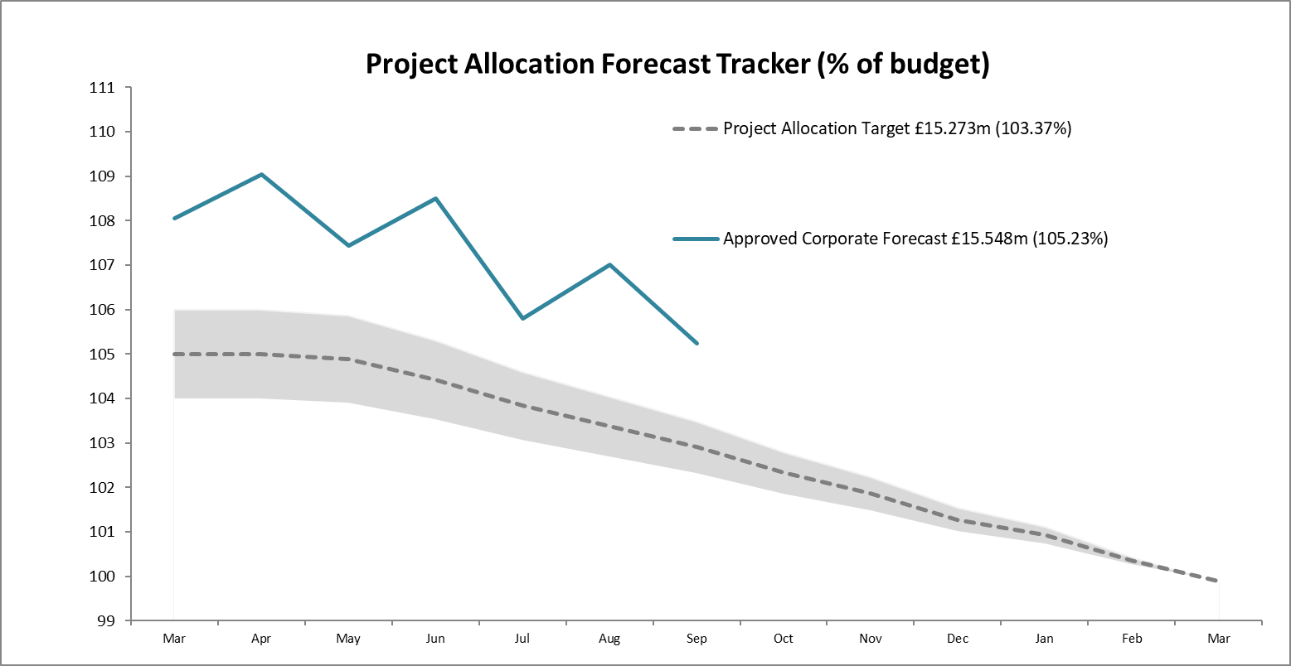  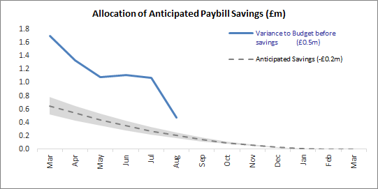 | Although the resource budget is on track, further pressure is expected from delayed project demand, additional paybill expense and cost of living / inflationary increases. Slippage is expected on the indirect capital budget following recent peatland restoration estimates for the year.  The controllable project budget is based on a core paybill budget of £29.1m which was set £0.5m below the starting forecast to reflect savings to be realised through leavers/vacancy gaps. The paybill forecast is currently £0.3m above budget. Additional savings and project surrenders are anticipated to allow expenditure to match the budget for the year.

Finance
Resource Budget Performance
- An overspend of £0.591m is currently forecast on the Operating budget, however it is anticipated that we will end the year within our target outturn. At the same point in 2021/22 an overspend of £0.338m was forecast.
- SG have advised on additional budget allocations to be received at ABR and SBR but full confirmation is awaited. We are set to receive £17.676m at ABR and £7.895m at SBR.
- Along with additional paybill costs and inflationary pressures, there is also upwards pressure on the forecast from delayed project demand yet to be allocated. Whilst we are currently forecasting that expenditure will match budget for the year, these variables and measures to address them are still to be resolved.
- The budget management exercise began in early Q2, challenging uncommitted budgets and ensuring that allocations are optimised with respect to high priority work considered achievable during the remainder of the year.
- We will continue to monitor project surrenders throughout the year, using our knowledge and experience of previous slippage patterns to ensure that appropriate demand is ready to allocate when funds become available.
- The paybill outturn is currently projected to exceed the budget by £0.365m. This follows the early approval of staffing requirements for 2022/23 in response to identified resourcing pressures. This proactive approach ensures that we can respond to the developing needs of the organisation in the right timeframe. It is anticipated that additional savings will be achieved throughout the year.

Indirect Capital Funding Programmes (including Peatlands)
- We are currently forecasting an overall underspend on Indirect Capital of £0.070m.
- SG have made £12.940m available to NatureScot to fund Peatland Action restoration, conservation, management and associated employee costs for 2022/23. The Peatlands forecast is currently being reviewed and an underspend compared to budget is expected.
- Awards are being agreed for Nature Recovery Fund (NRF) with an over-allocation approach to ensure full budget spend is achieved, which will reduce the current underspend.
- Slippage from 2021/22 Biodiversity Challenge Fund (BCF) grants is being funded from the Nature Recovery Fund Indirect Capital budget (£0.341m).
- The Scottish Marine Environmental Enhancement Fund is also being funded from the Nature Recovery Fund Indirect Capital budget this year (£0.666m).
- The impact of slippage on large value programmes such as NRF presents a risk to spend levels. The anticipated corporate slippage is 4% of the forecast outturn (£0.278m). This is split against NRF/BCF/SMEEF Indirect Capital (£0.220m) and Resource (£0.056m) budgets.
- SG confirmed they won’t be funding the 21/22 slippage of £0.150m for GovTech. We are funding this from the anticipated corporate slippage.

Structural Funds Programmes
- Green Infrastructure claim 8 and NCHF claim 1 were paid during Q2. The next claims for each programme totalling £3.2m will be submitted during Q3. Claimants will be reimbursed by NatureScot in advance of this submission to SG. Discussions are ongoing with Sponsor around an arrangement to provide cover for the risk of de-commitment over the remainder of the programme.

Capital Budget Performance
- An underspend of £0.019m is forecast on the capital budget.
- We have included the sale of Glencripesdale in the NBV figures which increases our ability to spend on Capital projects by £0.750m. SG have yet to provide approval this year that we can retail the proceeds for the sale (although it was agreed for 21/22). This does present a risk as commitments to capital projects have already been made.
- The potential proceeds of the sale of Kinloch Castle are not currently reflected in the financial position but would be considered in any additional capital expenditure plans.

RISK
Corporate Risks |  | Risk Changes
Changes to Corporate Risk Scores
↑1 Gone Up
↓ 0 Gone Down

Change to Corporate Risk Register - proposed
↗ 0 New Corporate Risks
↘ 0 De-Escalated

Risk
- The Annex A - Corporate Risk Register holds the current corporate risks for NatureScot. Activity and project risks are managed within the risk management system, which underpins the corporate risk register. All risks are managed in line with the Risk Management policy and monitored regularly for compliance and visibility of impact.
- There are currently 13 approved Corporate Risks, 8 medium, 4 high and 1 very high. The risk rating has increased from medium to high for “As a result of on-going reductions in public expenditure there is a risk we may receive significant reductions in our grant-in-aid settlement.” This is due to the budget pressures evident within the Scottish Government and the uncertainty of additional funding to support new commitments.

- During Q2, the Corporate Risks have been reviewed to ensure that they still require to be managed at the corporate level. There are no risks proposed for escalation.

- Board are requested to note the performance of the corporate risks.
People Metrics | Status

Wellbeing
Accidents & Near Misses – target: to stay within variations around the mean which are 4.4 for accidents & 5.8 for near misses  Q2: Accidents=2, Near Misses=2 (these continue the low trend of the past two years), in the July pulse survey 92% felt confident that NatureScot takes Health and Safety seriously. | Green
Work-life balance – target: 75% of employees feeling that their work-life balance is good  Q2 In the Pulse survey 87% reported that they felt NatureScot takes wellbeing seriously, with 76% feeling supported to take control of their work wellbeing. | Green
Capacity
Sickness – Target: under 2 days per person per quarter.  Q2: 1.26 days (early indications show there has been a rise in autumn/winter numbers. This trend returns to the pattern we saw pre-pandemic) | Green
Q2: 57.54% of holiday leave taken, this is within target half way through the holiday leave year. P&OD will follow up with individual teams on any variations. | Green

Development
Formal Casework - target <=50% of informal casework  Q2: 35% (7 cases), well within normal range for this type of casework | Green
Informal Casework  Q2: 20 cases, well with normal range for this type of casework | Green

Workforce Profile
Turnover – target: increase  Q2: average turnover is 10.57% (over last 12 months), which is a slight decrease since Q1. This is due to the increase in average headcount, although the trend is still progressing in line with target.  We have relaunched Exit Questionnaires as part of our leaver process. Of those who have already responded 66.7% put alternative employment as the leaving reason. 83.4% stated that they felt they had the resource and support to accomplish their work. In Q2 a full benchmarking review was carried out. This showed that NatureScot salaries are broadly in line with other public sector organisations. | Green
Internal Movement – target: increase  Q2: Internal moves have slowed down in this quarter with a total of 19 internal moves compared to 35 in the previous quarter. There were a number of failed internal recruitments which meant posts moving to external recruitment. | Green
Retirement Profile  Q2: 148 employees are aged 57+ currently, predicted to rise to 153 in 2024/25 (19.9% of current headcount). Retirements seem to be steady and not increasing significantly as yet, however with the development of a positive exit strategy ensuring employees are more informed of their retirement options we may see an increase in numbers of retirements. | Amber

PEOPLE

Retirement Profile
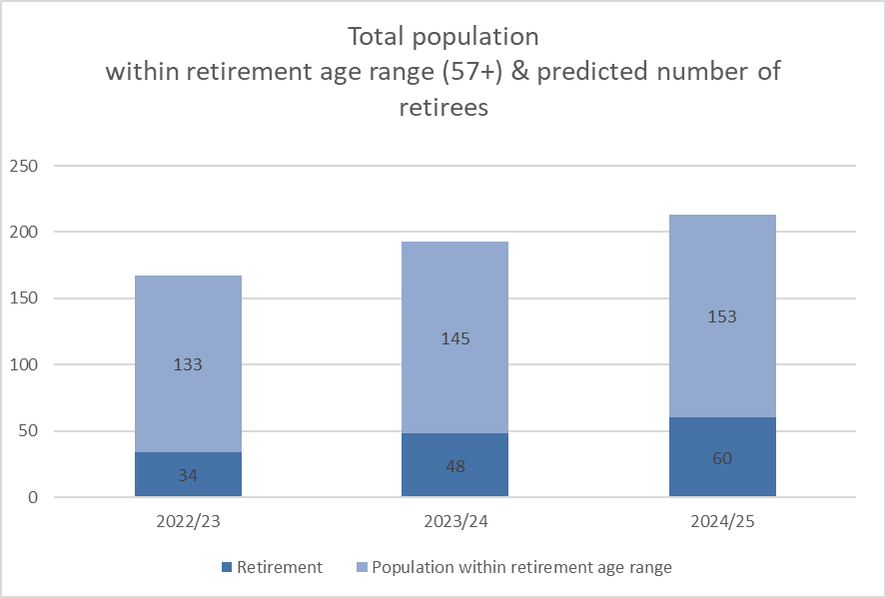

To address the corporate risk of the rising retirement profile, and the loss of knowledge and talent throughout the organisation, we are working on developing a talent management framework within NatureScot. This will include talent acquisition, retention and succession planning, along with positive exit strategies, and associated work packages to enable NatureScot to meet current and future organisational objectives.

Along with this work, we are also actively working on the following areas to address this risk:-
- The use of career MOT’s – we are exploring, with Skills Development Scotland, how to make support and guidance available to employees on their career progression, and how to take stock of where they are in their career. The MOT’s have been offered to a number of employees as a pilot.

- The Skills NatureScot Way working group are looking at future skills and linking this into the wider skills delivery plan (which is focused on sector skills) to equip us for the future. From an internal perspective, we are looking to work through engagement with the education sector, and young people, to influence numbers and the curriculum on skills, to then attract talent to NatureScot, retain those skills and also grow our own skills through knowledge transfer from those leaving NatureScot.

- Programme for Youth Employment - although there has not been an agreed programme of 2022/23 the PYE project team are looking at positive action to encourage vacancy managers to explore the use of apprenticeships into core roles. In Q2 our first technical apprentice was recruited in to a team administrator role. We are applying to Graduate Career Advantage Scotland (GCAS) for external funding to fund two 6 month placements. We are also applying to the New to Nature fund for support for two, 1 year placements.

- Exit questionnaires, as mentioned previously, are another method to ensure that we capture knowledge and experience from those leaving NatureScot and use this feedback to improve our approach.

- Partial Retirements – over 2020/21 & 2022/23 there have been 7 partial retirements, with P&OD actively promoting this type of flexible working. This includes running MyCSP Power Pension sessions as part of Pension Awareness week. These sessions give guidance to employees and work with them on exploring their pension options.

RISK TITLE | DESCRIPTION | CONTROLS | IMPACT | LIKLE-HOOD | RISK LEVEL | COMMENTS
47 - Computer Virus/Malware | As a result of inadequate protection, or inappropriate system use, including accidental activation of email links by that lead to malware downloads, there is a risk that NatureScot systems becoming infected with a malware or virus agent, resulting in NatureScot systems and data become unavailable, encrypted or corrupted, significant system downtime and huge operational impacts | *All file servers are protected by Sophos anti virus protection. Upgrades are performed automatically and can also be applied in an ad-hoc manner  *All PCs are protected by Sophos anti virus protection. Upgrades are received on a daily basis but can be applied ad-hoc  *All incoming emails are scanned for viruses.  *All internet access, where possible, is scanned for viruses (not https sessions).  *Raise staff awareness of potential risks relating to email links and infected documents through regular communications.  *Sandbox controls/ environment implemented  *Control of USB devices  *Awareness raising with staff via Blogs and update articles  *Incident Management Group in place  *Shared Service with Scottish Government that takes forward Network Scanning for unusual activity in place. | 4 | 3 | High | We continue to closely monitor our network environment. We have had a collection of staff who have recently fallen victim to phishing links and have had to have their devices replaced, meaning data on their C drives that was not stored in corporate repository was lost. These should be rated as "near miss" incidents, as the devices were successfully compromised by phishing emails and a part of the payload was deployed. We have new tools being deployed on the gateway to give us further protection, but these are not foolproof, so we must continue to remain alert. Our cyber training continues to be rolled out and this is very important for maintaining awareness amongst staff. Completion rates are still very good. Our controlled Phishing tests continue but will be reviewed at next Information Security Forum for a view on whether we should continue to use them. We still get staff clicking on links for these emails so it is an indicator of risk (however, it does take a significant amount of staff time to run them).

Annex A – Corporate Risk Register (High Risks)

RISK TITLE | DESCRIPTION | CONTROLS | IMPACT | LIKLE-HOOD | RISK LEVEL | COMMENTS
253 - Peatland restoration target and budget. | As a result of the immature and complex operating environment, there is a risk to: meeting the annual Peatland ACTION restoration hectare target; and spending the annual budget. | • Realistic planning  • Invigorating demand  • Real-time monitoring  • Increasing resilience to change in projections  • Regular and robust review and control | 4 | 4 | High | The likelihood of the risk remains 4 (high) and we have advised the Scottish Government that our outturn is likely to be around 5,900 hectares. Whilst we have a pipeline of almost 10,000 ha, and there has been progress on the speed of PDR prior-notification process and operating in the bird breeding season, there is an ongoing risk of not meeting the hectare target because of a combination of over-ambition; limited contractor capacity and potential applicants holding back pending clarity on agriculture/land reform and Peatland Code verification/carbon markets. This has an implication on the capital element of the budget. There is less risk on the resource budget due to: - more rigorous programme/business planning; - expanded staff capacity. Thus, the focus of our controls are on: 2. Invigorating demand. We are targeted promotion through the key stakeholder representative bodies; explaining the multiple benefits of restoration, the open application system and the scope for multi-year offers. We are also developing a new grant for coordinating delivery of large scale restoration projects. 3. Real-time monitoring - we are monitoring our pipeline of restoration projects - informed by grant application status and risk to delivery from project complexity; vulnerability to extreme weather conditions; and applicant/agent track record of delivery. We are holding regular site visits with contractors. 4. Increasing resilience to change in projections – we are overcommitting by 10%. 5. Regular and robust review and control - There is quarterly assessment of risk by the Peatland ACTION Governance Board, with a remit to provide assurance on the likelihood of risk and recommend [to the Programme Manager] additional controls to reduce the likelihood to 2. 6. Using new Guidance on operating during nesting season to allow risk based approach to operations during that period. In addition, our skills development work – through training, on site ‘training plus’, pre-apprenticeship and publication of a Technical Compendium – is aiming to expand the contractor capacity.
RISK TITLE | DESCRIPTION | CONTROLS | IMPACT | LIKLE-HOOD | RISK LEVEL | COMMENTS
393 - Future Funding of NatureScot | As a result of on-going reductions in public expenditure there is a risk we may receive significant reductions in our grant-in-aid settlement. Unless other funding sources are secured this could result in an inability to adequately resource delivery of agreed priorities, leading to failed outcomes and reputational damage. | * Ensure that our priorities are aligned with published Programmes for Government and ministerial portfolio priorities, specifically those aligned to the Programme for Government and Bute House Agreement  * Provide realistic and evidenced assessment of the impact of possible cuts in our grant-in-aid budget through the annual Spending Review process.  * Develop and put forward proposals, through the annual Spending Review process and other avenues with Scottish Government, for delivering more and better outcomes for nature and people through wider Scottish Government funding.  *Reduce expenditure in some business areas through budget setting processes aligned to business planning cycle.  * Have an effective communications strategy in place which promotes the added value of our work.  * Identify and implement opportunities to generate income from the services we provide.  * Identify and implement opportunities for external funding of NatureScot-led work through the business planning process (including at Outcome and Activity levels) and at the project development stage for significant scale projects.  * Develop proposals for new, preventative projects that can help deliver a wider set of SG priorities, and build awareness and support of these.  * Develop and refresh a short, medium and longer term financial plan based on potential financial scenarios. | 4 | 4 | High | Active engagement with Scottish Government continues this quarter with a scenarios paper submitted to Scottish Government. There is no additional funding flowing to support new commitments. In addition the cost of living crises is placing new pressure on paybill and purchasing power. Flat-cash at Portfolio level is the best outlook but at that, we will need to pace existing commitments. Discussions continue in that regard.

RISK TITLE | DESCRIPTION | CONTROLS | IMPACT | LIKLE-HOOD | RISK LEVEL | COMMENTS
691 - Lack of support for Fusion Financial and Procurement Modules | Due to the specialised nature of Oracle Fusion and the interface with NatureScot’s Business Planning System, as a result of key system support staff leaving the organisation, there is a risk that there will be insufficient knowledge and ability to operate key financial processes or to develop the system and reports. This may result in an inability to adapt the system to changing business needs, reporting delays or to operational inefficiencies and payment challenges that could affect all users of the system. | - Engage in a shared service arrangement with other organisations using Fusion e.g. HES, SLAB  - Make use of the support arrangement from Inoapps currently utilised by POD. There may not be sufficient knowledge from Inoapps to initially support some finance and procurement processes.  - Explore potential for a third party to provide level 2 support to assist that provided by NatureScot staff.  - Recruit to the two vacant functional analyst positions.  - Recruit to the vacant Oracle Cloud Service Manager position  - Draw on finance staff with an awareness of Fusion and the interface with Business Planning as well as the functional analysts who support the POD elements of Fusion, in order to support the finance elements of Fusion. It should be noted that this will not provide all of the specialist knowledge required.  - Implement a networked team approach to involve staff from a wider group to share knowledge and provide resilience in future. | 4 | 4 | High | Having been unsuccessful in an initial recruitment round for the functional analyst, this is to be readvertised. Recruitment for the Oracle Cloud Manager roles is currently live. We have also confirmed with InoApps that support will be provided for FPP queries. Work on the procurement tender document for Fusion support is progressing and will now explore the possibility of providing level 2 support to assist NatureScot staff while recruitment is underway and then the skills of staff developed. If our recruitment efforts continue to be unsuccessful then we will revisit this model and potentially have to be more active in sourcing 3rd party assistance, which will come at a higher cost.  The recent issues with Fusion would not have been resolved more speedily if the team was up to full complement. However, they did highlight the need to have someone lead the relationship with Oracle. A focus on this relationship and on managing the support for Fusion across both FPP and POD will be the main priorities for the new Oracle Cloud Service Manager before then moving on to new areas of development. Exploring the potential for a shared service with fellow Fusion users in SG will also be advanced once the current recruitment and procurement activity eases. This is likely to take some time to progress and will most likely focus initially on developing staff across the participants rather than immediately helping with resilience.

