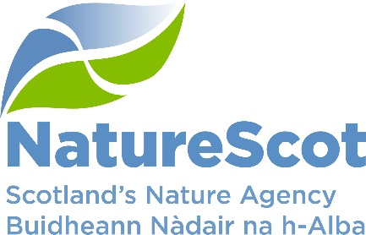

NatureScot

SCIENTIFIC ADVISORY COMMITTEE

DISCUSSION PAPER

HORIZON SCANNING

Purpose
- To inform a discussion on potential benefits of horizon scanning to NatureScot and how the SAC might approach this as a standing agenda item.

Action
- To agree the benefits of, and an approach to, horizon scanning

Preparation
- The paper was written by Clive Mitchell. It is sponsored by Eileen Stuart.

Background
- The principal benefit of horizon scanning is doing it. Not because it allows you to see the future, but because it acclimatises practitioners to change and the need to change plans to accommodate a changing external environment. A rapidly changing operating environment makes horizon scanning even more useful and relevant.

- Horizon scanning currently features in two main areas of NatureScot’s business:
  - Monthly SLT meetings
  - Quarterly Audit and Review Committee meetings
The proposal is to add 6 monthly SAC meetings to this mix. Overall the process should work to integrate horizon scanning across the three timescales so that each complements the others.
- In addition to horizon scanning in NatureScot, we contribute to wider activities, mainly:
  - Annually to Bill Sutherland’s horizon scan for UK environmental legislation and policy (jointly produced across UK nature agencies and published via the British Ecological Society)
  - Ongoing via the ESRC’s ACCESS (Advancing Capacity for Climate and Environment Social Science) hub, together with horizon scanning teams in Natural England, Natural Resources Wales, Forest Research and the Environment Agency.
  - We are members of the Scottish Futures Group, coordinated by Ewan Mearns (Scottish Enterprise), which brings various agencies together with the SG Strategy Unit.
  - Over the last year we contributed to the RSE’s work on Post-Covid Resilience
  - We also follow the UK Government’s Foresight activities including their trend decks.

- The UK Government Office for Science publishes a very useful Futures Toolkit.
The SAC and Horizon Scanning
- There are a range of approaches to horizon scanning and we feel that there are benefits in establishing a process that is light touch but has been tried and tested elsewhere.

- STEEPLE is a widely used framework to gather future issues in a structured manner across social, technological, economy, environment, political, legal and ethical spheres (‘PESTLE’ is similar, but without the ethics).

- Other techniques might be useful for specific pieces of work (e.g. to future-proof commissions carried out by sub-groups).

- In order that we undertake horizon scanning in a manner that informs and influences our work it is critical that we are clear on why we are undertaking this exercise.

- Key questions on which we would like the view of the SAC are:
  - Purpose: to influence the work of the SAC including future agenda items; the Board and Corporate Plan delivery, including work plan and future joint Board/SAC discussions
  - Scope: for NatureScot or for the wider environment (plus implications for NatureScot)
  - Who to involve: the SAC plus/minus the Expert Panel
  - Should the SAC (nominee) lead this work – drawing in relevant staff as needed, or staff lead with SAC nominee? We will develop the first session in Jan ‘23 to be run in Feb for a discussion at March SAC.
  - Approaches that are operating effectively elsewhere.

Contact: Clive Mitchell, clive.mitchell@nature.scot; 07917 552548

