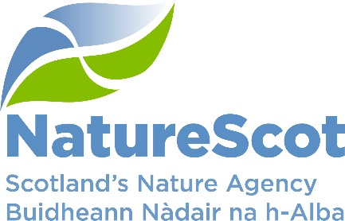

NatureScot

SCIENTIFIC ADVISORY COMMITTEE

DISCUSSION PAPER

Offshore Wind Development – understanding the implications for seabird populations

Purpose
- This paper provides the Committee with an overview of work arising from the development of offshore wind projects in Scottish waters (out to 200nm), and seeks to outline the issues and complications we will need to resolve as we continue to provide evidence-led, enabling advice to Marine Scotland. It also provides an opportunity to plan for future engagement with the Committee on those areas where we anticipate the need for further input.

Action
- Initial feedback is sought on the following key areas to inform our planning for future work with the Committee:
- our approach in considering the effectiveness of proposed compensation measures for marine seabirds in response to cumulative effects from offshore wind on marine birds both for individual projects and at a more strategic level;
- our approach in considering the implications of the avian influenza outbreak and how we should take account of this in our offshore wind casework advice.

Preparation
- The paper was prepared by Erica Knott, Karen Taylor, Cathy Tilbrook, and Emma Philip. It is sponsored by Eileen Stuart.

Background
Offshore wind development
- Scottish Government – Marine Scotland has identified the need for offshore wind in the move to low carbon electricity production to meet both Scottish and UK government targets. In January this year, an announcement was made on the ScotWind process, resulting in Crown Estate Scotland (CES) lease awards for 17 developers / sites in Scottish waters. A further three project leases were announced on 22 August for an area east of Shetland - see Figure 1 in Annex 1. These leases are all located in the Plan Option areas identified in the Sectoral Marine Plan (SMP) for Offshore Wind (SMP-OW 2020), published by Marine Scotland in 2020. However the overall scale of development is significantly greater than was anticipated, with approximately 27 GW awarded compared to the 10GW capacity that was assessed as part of the SMP process.

- This discrepancy in capacity has led Marine Scotland to initiate a comparative assessment of the capacity differences as part of the Iterative Plan Review (IPR) process, including a revised Sustainability Appraisal. This will require Marine Scotland to revisit the Strategic Environmental Assessment (SEA) and Habitats Regulation Appraisal (HRA) conclusions. In the original assessment of the SMP, the HRA was not able to conclude that there would be no adverse effects on site integrity to several bird features of Special Protection Areas (SPAs) in relation to development option areas along the East coast of Scotland.

- In addition to the SMP-OW (2020), Marine Scotland and Crown Estate Scotland are also taking forward a further leasing auction and Plan to help identify sites for Innovation and Targeted Oil and Gas decarbonisation (SMP – INTOG) for projects that will reduce emissions from North Sea oil and gas installation as well as boosting innovation. This process has started- bidding for leases opened in August 2022 and exclusivity leases of up to a 4.6GW limit will be announced in March 2023. Marine Scotland will be undertaking a SEA and HRA for this Plan and it is anticipated that both the SMP – OW and SMP – INTOG will be combined to have one SMP for Scottish Offshore Wind to be adopted by the end of 2023.

- These new sites are in addition to the existing ten consented / constructed offshore windfarms in Scottish waters as well as those projects still going through the planning process, including Berwick Bank proposals (4.1GW), due to be submitted later this year (see Figure 2 in Annex 1) which will include our first marine derogation case.

- In our assessment of these earlier projects, the key nature issues that raise most concern for us relate to the predicted impacts to seabird populations from the operation of windfarms. Key impact pathways are collision risk, displacement and barrier effects. In our advice we advised that there were likely to be adverse effects on site integrity to several SPAs, due to the cumulative and in combination nature of impacts from several of the proposed developments. The key species of concern to date are gannet, kittiwake, puffin, razorbill and guillemot. In 2015, RSPB challenged the consents granted for the Forth and Tay cluster (Inch Cape, Neart na Gaoithe and Seagreen) leading to a Judicial Review.

- The SMP – OW (2020), HRA has identified concerns around further cumulative impacts and as such identified seven plan option areas affecting ten developments awarded Option Area Agreements where ornithological constraints need to be resolved prior to award of any consent – See Figure 3 in Annex 1. It also identified that for these developments to be able to proceed they should take account of current understanding and knowledge from monitoring bird interactions around operational offshore windfarms and / or the need to consider a derogation case under the Habitats and Birds Directives and subsequent compensatory measures.

Ornithological Impact Assessment
- The ability to advise on Offshore Wind planning applications requires an understanding of how developers (and others) collect and use baseline data collected from development sites, current / up to date breeding colony counts and an understanding of bird movements within and between seasons. In addition, the tools and techniques used to predict the impacts both from an individual windfarm and then cumulatively with other windfarms / projects are complex, with a reliance on predictive modelling tools with multiple parameters and choices, as well as subsequent population modelling using population viability analysis (PVA) to understand the longer term consequences on the populations from year on year predictions during the operational lifespan of the windfarm (25-50 years).

- Our experience to date is that all of these predictive tools and techniques have elements of uncertainty, either within the choices for parameters and /or in the choice of tools as well as the range of outputs. Different tools exist to inform collision risk modelling, displacement and population modelling. Although offshore windfarms have been operational in UK waters for over 20 years, to date there have been very few, actual monitoring studies devised and implemented at operational windfarms to validate whether these models and outputs are accurate or not. The models are also constantly undergoing review and upgrades.

- Marine Scotland and NatureScot have been instrumental in commissioning studies and tools to try to reduce this uncertainty in impact assessment predictions and also in bringing about and advising on monitoring studies. However, studies in Scottish waters around operational windfarms have only been in existence for the last 2-3 years and it is still too early to determine whether the impact assessment predictions are accurate or not. This ongoing uncertainty continues to influence our advice.

- An added disadvantage is that our knowledge of seabird species can lag behind reality in terms of colony census counts and population trends (nationally, regionally and locally). The assessments of the previous round of windfarms relied on data collected in the 1990’s at colonies. Our knowledge of seabird behaviour was also largely limited to breeding adults. However, recent development in the use of smaller tags, now enables longer term tracking data of birds which has improved our understanding of seabird movements all year round and has placed new focus on impact assessment in the non-breeding season.

- There is much anticipation within industry for the release of a Cumulative Effects Framework tool commissioned by Marine Scotland. This tool, which is due to be published later this year, should enable developers and advisers to understand the impacts from an individual windfarm across all impact pathways which can then be added to the outputs from existing and other planned windfarm to identify the cumulative effects more quantitatively.

- However this is still a predictive tool and there may still need to be interpretation of the results and this is where detailed understanding of the model outputs and assumptions will be required by NatureScot in delivering our consultation advice to Marine Scotland.

- A further complication going forward is the current outbreak of avian influenza. This is raising questions around how we will be able to differentiate between the impact of avian influenza on seabird populations and the impacts from windfarms, and it changes the baseline upon which impact assessment will need to be made.

Compensatory Measures
- Some of the planned offshore wind developments are within areas that have been identified as having major environmental constraints due to the potential for impacts to seabirds from collision and / or displacement. Under the Habitats Directive, provision exists to allow a proposal to be consented despite an adverse effect on site integrity, provided that: there are no viable alternatives; there are imperative reasons of overriding public interest (known as ‘IROPI’); and necessary compensatory measures can be secured. Given the high priority on meeting net zero and energy security targets, it is likely that some offshore wind projects will be consented via the IROPI derogation provision and that appropriate compensation measures will be required. To date there have been no marine IROPI cases in Scottish waters.

- We are currently engaged in a significant, collaborative programme of work with Marine Scotland to identify possible compensation approaches to offset potential impacts. Such measures could include measures to increase prey availability, e.g. through fisheries management; predation control at breeding colonies; habitat management at breeding sites; and reduction of disturbance at breeding colonies.

- There are considerable issues to be addressed, such as ensuring that measures are effectively targeted to the particular species or groups of species likely to be impacted, and in an appropriate location which provide benefit at a level appropriate to the predicted impact. Measures must be additional to any management identified and /or planned within site management plans. Based on current casework, we foresee a likely difficulty in identifying sufficient appropriate measures to deliver the amount of compensation predicted to be required for the planned development. For many measures, we view that a new mechanism will be needed to deliver compensation at a strategic / plan-level scale rather than individually by developers progressing small-scale projects for each development, to ensure the measure delivers maximum benefit. Lastly, for some species where impacts are associated with development located in English waters, compensation is being sought in Scotland which potentially reduced the availably of said measure for Scottish developments and species.

- We continue to engage with DEFRA on the British Energy Security Strategy and associated Offshore Wind Environmental Improvement Package for English waters, particularly in regard to potential implications for the development of offshore wind in Scottish waters. At present the direction of travel on elements such as HRA reform, strategic compensation, design based standards and a marine recovery fund remains unclear.

Avian Influenza
- We are still in the emergency response phase of the avian influenza outbreak, but along with partners are starting to consider the potential implications of this event. This includes considering how to understand the impacts of mortality rates for different species on populations (such as input to models used to predict offshore wind impacts); and the impacts that emergency controls on access to seabird colonies may have on long term population monitoring work that is used to understand population dynamics and informs our casework advice.

- In particular, we urgently need to consider what advice to input to the sector plan review and to give individual developers on considering avian influenza impacts within their assessments, and how to handle those assessments where baseline data on bird populations has been collected prior to recent avian influenza mortalities. Gannet, kittiwake and guillemot have been particularly hard hit by the virus as well as species such as great skua and Manx shearwater, which have previously not been considered at risk from offshore windfarms but with new lease areas in the north and west, interactions may become apparent. We will also consider the potential development of avian influenza recovery measures within the wider discussion on strategic compensation measures mentioned above.

Scientific Advisory Committee Input
- The key aspects on which we welcome SAC initial feedback, and future engagement are as follows:

  - Does the committee have any views on the direction of travel of work outlined on compensatory measures, including the emphasis on strategic, rather than individual project, level compensation? Are there any other broad types of compensation measures for marine birds that we should be considering – or examples from other countries or sectors we could learn from?

  - How much should we consider adaptive management and how should we monitor compliance / success of compensatory measures with the added complexity of population effects from avian flu?

  - Building on the success of the recent SAC sub-group review of digital aerial survey, how can the Committee best provide ongoing support to NatureScot staff on the novel and contentious aspects of science that inform our advice on offshore wind development?

- NatureScot leads the SG Avian Influenza task force, which is informed by the new SAC sub group. What role could this sub-group play in providing staff with advice on the implications of the outbreak for our offshore wind casework advice, including the specific points raised above?

Contact: Erica Knott – erica.knott@nature.scot
Karen Taylor – karen.taylor@nature.scot
Cathy Tilbrook – cathy.tilbrook@nature.scot
Emma Philip – emma.philip@nature.scot

Annex A

Figure 1: ScotWind Option Area Agreements as per August 2022. Twenty developments across15 Plan Option areas.

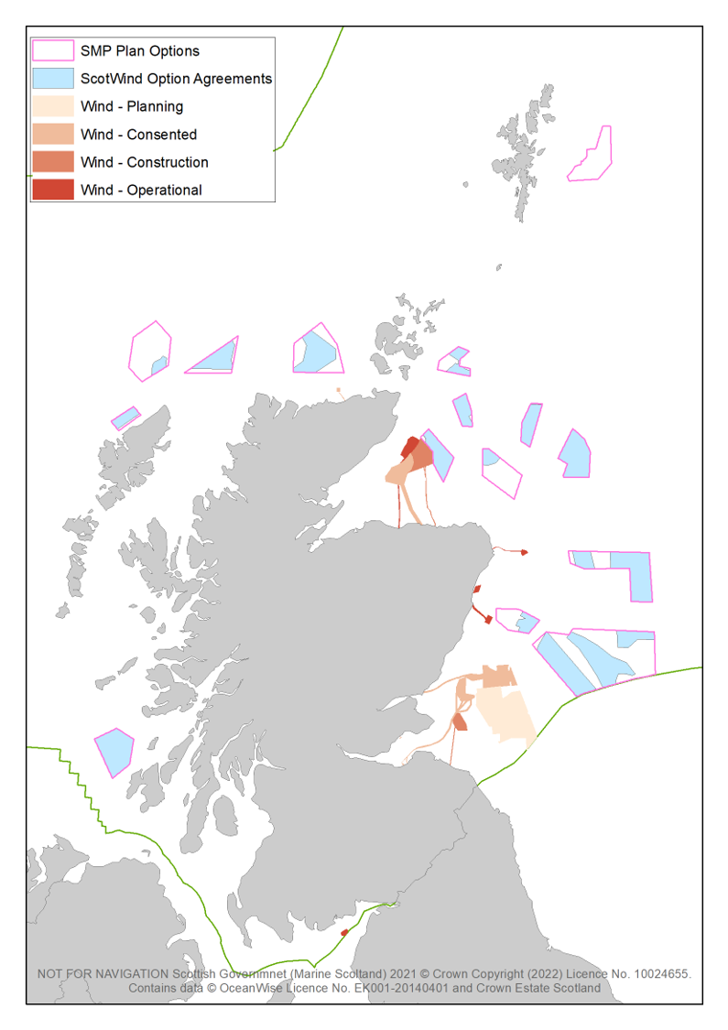

Figure 2: ScotWind Plan Option areas in relation to other offshore wind developments – N.B. this map was created in March 2022 prior to the NE1 clearing results so does not show the 3 development sites within the NE1 East of Shetland Plan Option area.

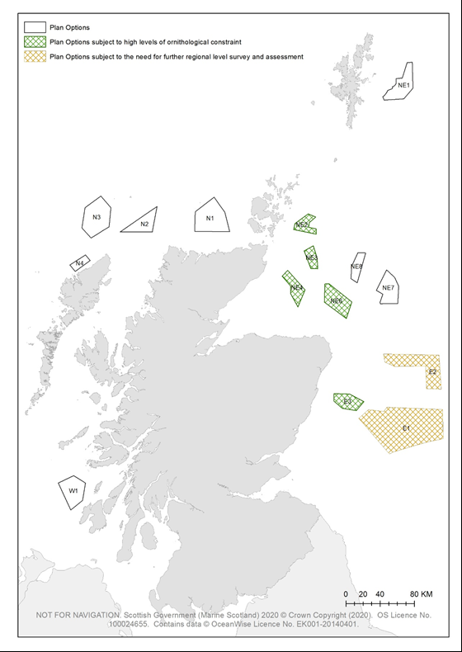

Figure 3: ScotWind Plan Option areas demarking those that are subject to plan-level mitigation.

ScotWind is the leasing mechanism run by Crown Estate Scotland for offshore wind. The lease applications were judged on set criteria and were constrained to plan option areas identified in the Sectoral Marine Plan for Offshore Wind published by Marine Scotland.
https://www.crownestatescotland.com/news/three-shetland-scotwind-projects-announced
https://www.crownestatescotland.com/news/new-offshore-wind-leasing-opens-intog-aims-to-to-encourage-innovation-and-decarbonise-north-sea
https://www.berwickbank.com/project
https://www.gov.uk/government/publications/british-energy-security-strategy/british-energy-security-strategy

