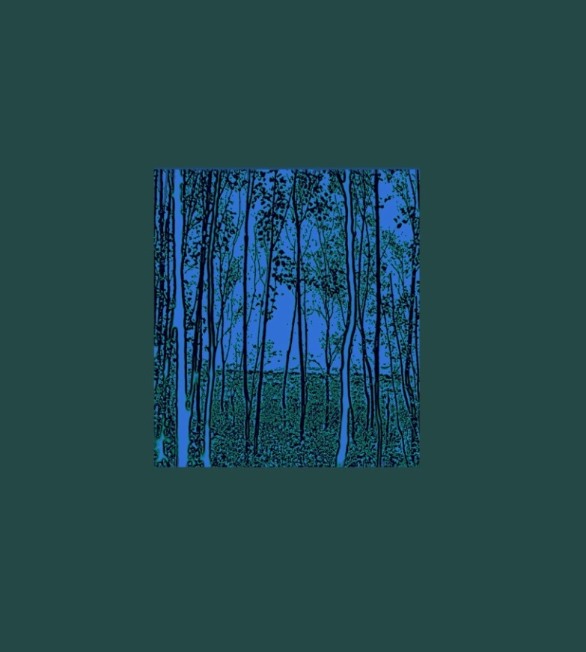

Please note we have transcribed the text as precisely as possible from the
original handwritten notebook but cannot, in some cases, guarantee the
accuracy of the content. The notebook covered the period
August 2019 – December 2020

NatureScot would like to thank Lochgilphead High School pupils who took part in Snapberry #lifeinlockdown during the summer of 2020 and for the use of their images in this book, and most especially to Arthur Ker for the beautiful cover illustrations.

www.nature.scot www.artmapargyll.com
caroline.anderson@nature.scot artmapargyll@gmail.com

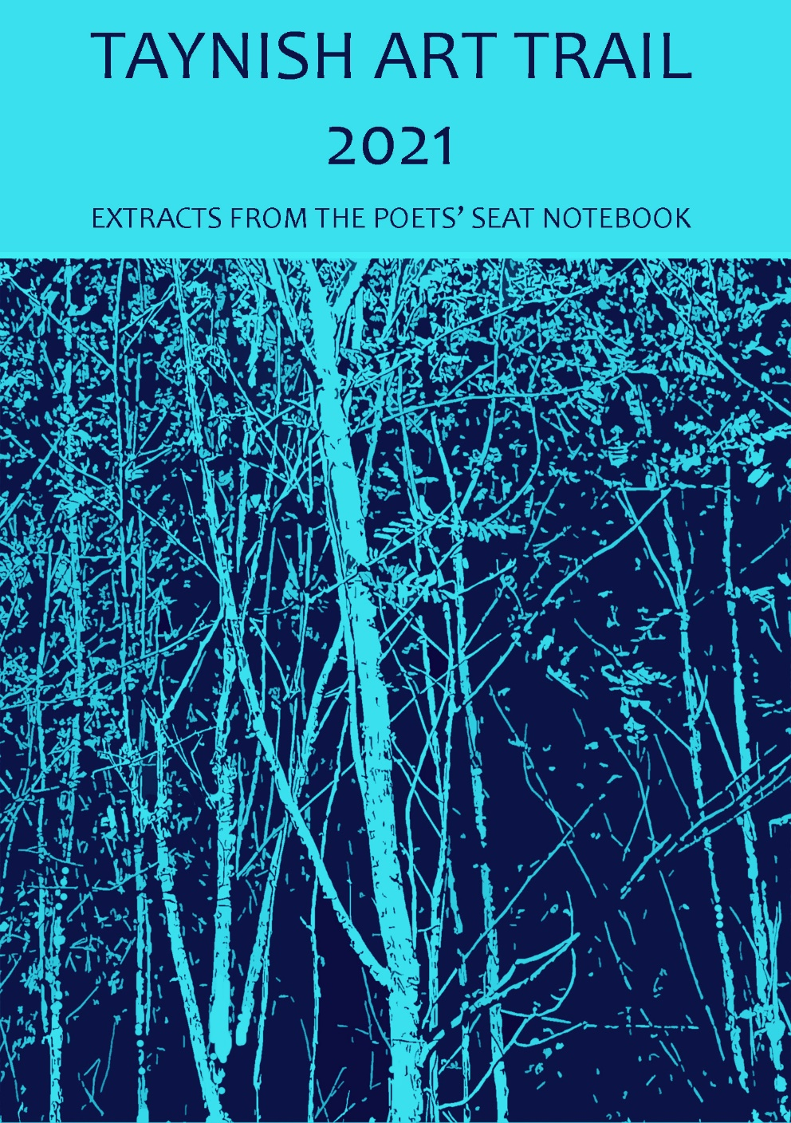

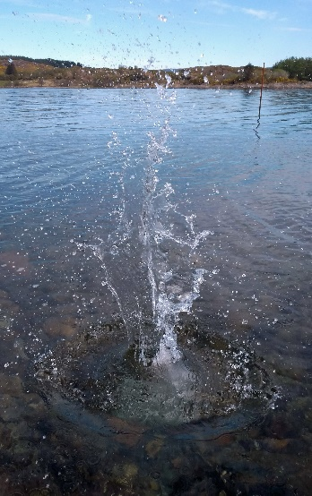

A goodbye visit on a beautiful sunny evening. Our holidays are over and soon we must go home, but we have had a super time in our favourite place – who could ask for more?

Last year we said goodbye and this year we remember
John Joseph Proud
2.6.40 – 25.5.18

I came here four years ago and it is still beautiful.

Came here with our doggies. Enjoyed the view, peace and calm (relative with 1 x lurcher plus 1 x collie) a really nice reflective spot for us.

I love it! It is lovely, it is my first time hear for me and Doogle. Love to sit in the sea.

A pleasant evening stroll towards a breath-taking view of waves crashing against the rocks as the wind whispers through the trees.
Beauty. Scotland.

We came to Scotland for a family wedding and have been spoilt by the wonderful scenery and wildlife, with fabulous weather as well. This place is quiet and beautiful and a lovely place to stop and just be!

Run down to the sea
I’m lucky – me!

We had a great time and it’s a great view and we have a big collection of shells. Thank you!

Peaceful! Lovely!

We sat and relaxed in the sun, watched the white clouds drift by, enriched by the love of nature and the green of the season. The beauty of the wild yellow of the flowers and pink of the blossom.

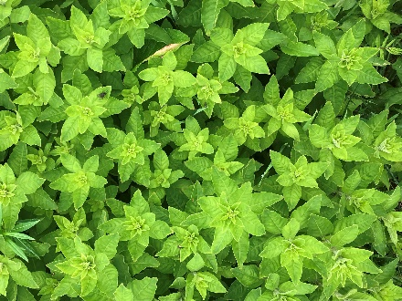

It is always worth that further step
That added turn and another fork
On the path in the woods
The destination is always there
At the end of some unknown path
Walk longer than you intended and
Find that stone seat by the shore
Sit and be at peace on your own
For you are here, where you were
And where you will return one day.

What started out as a stormy, rain soaked day in Tayvallich has turned into a sunny afternoon down by the water. Always look on the bright side. What a lovely spot.

Fond memories of my mother Joyce Parker who passed away peacefully last month aged 91 years. She would have loved it here and she will always be remembered. Rest in peace mama. “The peace that passeth all understanding”

The water is running, nature all around me
My heart is here now.

Spades of green rise high
Meeting water and the sky
Beauty fills my life.

Washed up
Falling, tumbling down
Lost and then found
The shore is no home
But holds us still

I can hear the soft flow of the burn meeting the spotty rock.

First visit to this beautiful spot. So calm with only the sound of the running water, perfect!

Found my first Geocache.

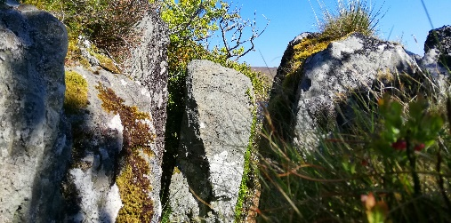

Since more than twenty years we are coming nearly every year to Scotland
Today it’s my birthday. By chance we discovered this way. So we were lucky having found it. Thank you very much.

Tight lines
Means fine dines
Make a wish
Get a fish
Great times at Taynish
Buckfast
To make memories last….
Or not!
A Fishy Tale
Seven years past we sat on this very spot when I noted a large sea trout attacking a shoal of sand eels. I immediately legged it back to the car, swiftly assembled my fly rod, legged it back before the sea trout departed. I presented my teal blue and silver to the fish, and it duly accepted the offer. It unceremoniously knocked on the head with my priest. I gave the fish to three men from Galway who were in Scotland erecting wind turbines.

I love Scotland. My grandad owns a cottage here. Sadly he has died, but we still know when we come to Scotland he is here with us and he will always be with us. My grandad was John Liggett.

I was brought to this place this time last year and landed by boat. This time I brought myself by car – the place is still as magical. My last trip changed my life. I now work up here and travel to beautiful places by boat. I thank the crew who changed my life.

The water is brown
I am white
Welcome to Scotland

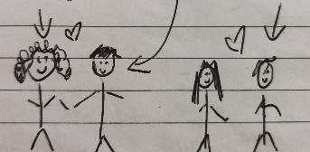

I love floating in my floaty in the rock pool!

Nelly is very, very happy here.

In the sunset, alone and a long way from home… (Southern France) we enjoy the pass and peace and appreciate the settings. Just Great!

The sun beats down on the empty shore
Why would one yearn for anything more?

The cold freezes ones hands and feet
The perfect place for friends to meet.

A wet dog
Splintered stick
Salty sweet
Bunch of grapes
And Alison.

Here are two mothers, each of their daughters
Here are those six daughters, and their two fathers.
Nine of us in all.
Sharing in the magic of the rocks, trees and waters, which we will share for all our grandchildren.

I’ve always come here
And I never get bored of the scenery. Decided to bring a friend this time, enjoying being away from the hustle and bustle.

Me and my family come to Scotland from New York every year – beautiful every time.

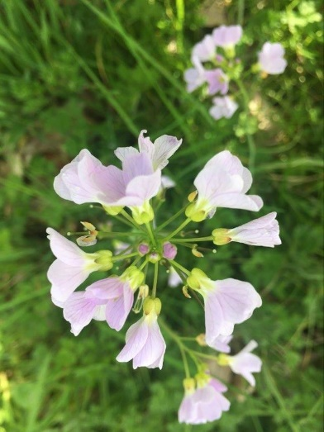

One day while having a potter
My husband said “look, there’s an otter”
Oh how I did moan
Cos the otter was stone!
He can be such a rotter!

Food for the soul.

Wild and woolly
Still and peaceful
Always beautiful
Back home with my memories once again.

The sea goes against the rocks,
The rocks against the sea,
And standing at the top of the shore there, are we, anonymous human being and BFG.

Flowers, showers with their powers, up in towers, they travel down wind, they find dens in the wind. They find dens in the wend.

As the river flows,
I hear you no more.
As the sun shines,
I feel my heart sing.
Watching you all,
Gives me the strength
That I need, to grow
Into …who I should be.

My family and I are visiting this are for the first time. We love the woodlands and all its beauty. The running water is so peaceful and the dragonflies have been fun to watch. The shore is a wonderful sight, even the midges feasting upon us.

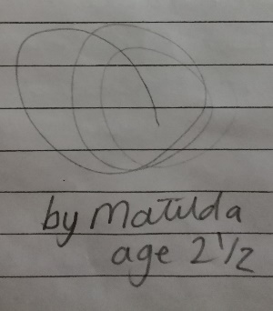

Rivers of water run down to the sea
Filling the lochs the river streams
The sky so blue today the earth
The green hills across shaky tree boughs
Boats ply their way to and fro
Yachts sail gracefully most tall and proud
And here we are in solitude and alone
Communing with nature and filling our soul.

Wow, wow, wow!
What an amazing place.
The weather today is fantastic, hot and sunny with a gentle breeze.
We could sit here for hours and enjoy the peace and calm.
The sound of the water is so relaxing.
One to return to in the future.

Completely at peace and so happy watching my husband and children throw stones in the loch.
I am so lucky.

First time here for him and me.
Sitting here so peacefully.
The sights, the sounds, the smell.
Makes you realise, everything is well.

We live a dream in Scotland.

Saw an otter right in front working its way down the loch.

Tainted in Brexit, I made my exit
Leaving Boris, I headed for Dorus (Mhor)
But talking to Hamish he said try Taynish
On the way down Loch Sween, we were living the dream
On arrival crabs sacrificed their own survival and not one to gloat, they practically jumped on my boat.

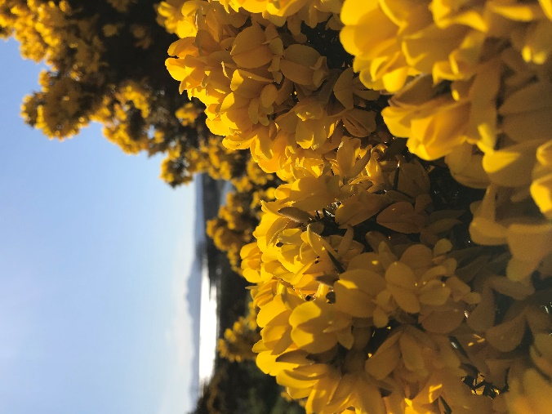

And the air is full of the roar…
And the thunderous voice of waters…
Just sitting here is so soul soothing!

Taynish, Taynish
Me and our lass
Kayaked to Taynish

The wilds of the wilderness
Convinced my heart to stay…
Be you a highland or a lowland man…
Go never far away

A beautiful place to stop and enjoy…
The views, the sounds and the smiles of precious friends.

Ripple in the water
Like the train of thoughts
Flowing down and out
Cleaning the mind
Rejuvenating the soul, taming the mind
Nature untouched
Is the remedy unprescribed

A heron flew up as she came to the shore
Its wings spread out wide to the air
He landed, not far and
Surveyed her from here as
She cooled her toes in the water and warmed her heart in the sun.

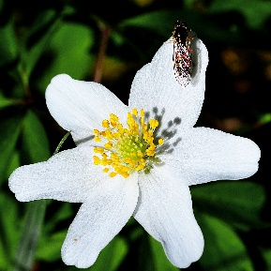

Coming from the Canary Islands
We thought we could visit the Highlands
But we found a bit of a detour
On a cycle among the moors
We thought about Scottish roots
And West Coast little gem routes
Decided we explore Argyll and Bute
And we love our great Tayvallich tour
Where we continue our tour d’amour

Sitting here watching the mist gently find its way along the loch.
The working week beckons…but not yet… just not yet.

I’m not very good and poetry so I won’t try. However, I will say how wonderful this place is. Not only the natural beauty but all the other stuff: the art work, the information boards, the activities all brilliant. We look after community woodland – South Staffordshire and have been inspired by a lot we’ve seen here and will certainly be copying what you’ve done here.

Sitting here in the tail of storm Dorian
Feeling at one with the elements
If we ever thought we had lost our connection with nature, you find it in a place like this.

A beautiful mill
All is still
Save a babbling brook
Take time to look…

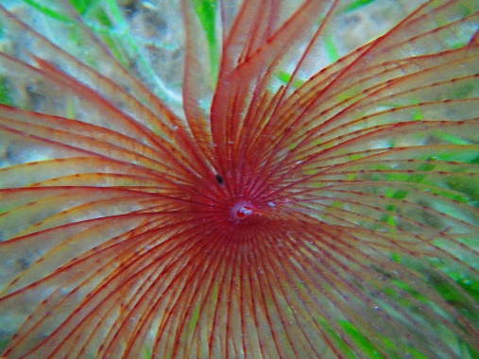

How beautiful, tranquil

Sitting in the brisk south westerly breeze, watching the black-white gannets thrust, turn and dive into the white caps. Basking in the sunshine listening to the swish, swoosh of the waves above the rushing stream. Here comes a misty veil of rain. Time to go.
Peace, tranquillity and beauty
Who can ask for more
God is good!

A McGugan from North Carolina came to visit!
Thank you!

Never seen so many dragonflies and damselflies of different kinds. Makes it feel primeval.
Superb area.

What a stunning spot to listen to the water and watch the dogs sunbathing and relive memories of our son and daughter-in-law’s wedding in Tayvallich on Saturday. This place is very special.

Yada me mateys
Shiver me timbers

Your health is your wealth.

The wind is bringing the tide in
A smell of autumn bonfire is in the air
I can feel the seasons turning
Sitting here without a care.

It feels so magical
The woods and the lake
The river is so beautiful
It does happiness make.

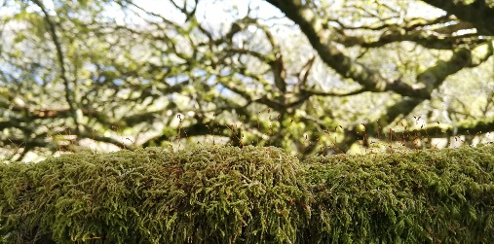

Talk about magical colours
Where do the guillemots go?
Nobody knows where the guillemots go.

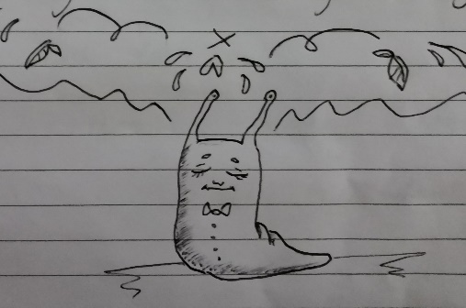

A tiny pocket of heaven along the shore.
We could stay forever.

Where fresh meets salt
And tree meets sea
We’re blessed and inspired
By natures harmony.

With views of glistening shores and sounds of bubbling waters, I take a moment away from the rush of everyday life. Soul filled and spirit lifted.

Second outing of the summer to beautiful Taynish.
Once found, never forgotten.

Misty hills, jumping fish
Tiny crab, peaceful, beautiful,
Enjoying time with my nature-loving five year old son.
Special times.

I love this place.

Cathy, Faraid, Colin and Sally’s arty adventure at Taynish, Soon for a snorkel at the narrows.
Blackberries, bees and maerl galore.

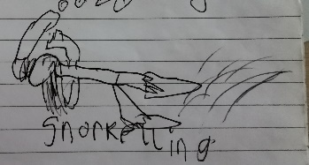

To sit on this with a wonderful view and to listen to the water’s gurgling spew. It is a wonderful image that more to see, people do not fully realise how beautiful their own country can be.

An unexpected afternoon’s delight
In the company of Mother Nature
And God’s wonderful creation
Life rushes by
Like the babbling brook
But inside
I am calm and at peace.

The loch is calm
‘cept for ripples from the rib
Waves crash on the kelp
Receding back to calm.

We are truly lucky to know Taynish, a tranquil spot, to make a wish.
But really it is all you could wish for in a beautiful hidden place.

All the way from Ynys Môn
To sit against this shore,
Each and every time we do,
We love it more and more.

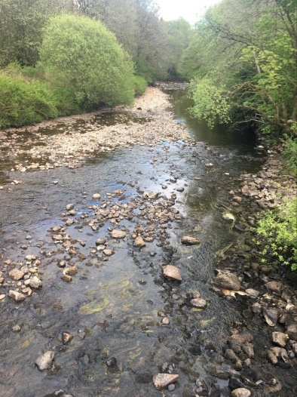

Quiet
Water runs free and loud
And wind howls
Waves crash and collide
And birds sing
Branches shuffle and sway
And leaves tumble in a wonderful display
But still
My mind is quiet.

Thank you for letting us visit, even though we weren’t invited! Even though there was no art work today it was still a beautiful place to visit even if its windy, cold and raining. I loved coming here with my family. There wasn’t much wildlife but that doesn’t matter. “Home is where the heart is” actually let me rephrase that, “home is where the art is”. Yet again I loved visiting this wonderful place of art. It’s not my first time visiting because my family have a caravan im Tayvallich. But every time I visit there is always a surprise just around the corner. And next time I come I hope to see the wonderful nature as well as the amazing art!

Torn apart and cast of alone
I have come to the places
Where I feel alive…
The mountains, the sea and the shore
All here, all beautiful.

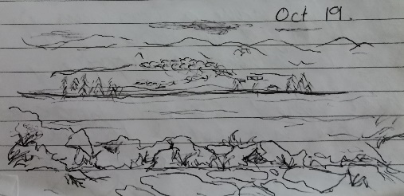

My dad has died
The children together in sound
You, me, Bill and Ted
Out on an excellent adventure
The shore track too steep for them we go up and through the portal
And into the ancient
woodland, acorns and hazelnuts brown bracken, copper russet lemon and gold and green leaves not yet turned. Legs happy, up to the top where if you were on eagle you could soar out over the sea to Jura where we didn’t get this time. The nested hollow where I pretend we could be foxes snuggled round each other. The raven soaring overhead, signs of squirrels and deer though we don’t see them. I am alive and so is my love and nothing can stop the love people have for this earth and our need to live in balance with care. Extinction rebellion! Stop ecoside! Why is there not a poetic way to say that? I can imagine being able to drink from any stream, of knowing all the food I eat is organically and sustainably and locally grown.. Walk with beauty.

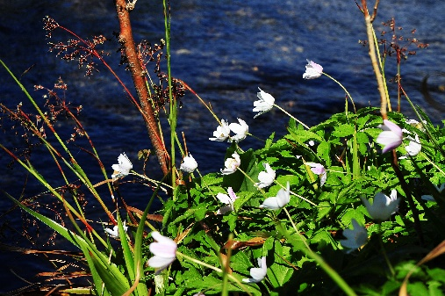

Stillness and peace
Flowering and cold
Calm and relaxed
Wild and beauty
The beauty of nature
Deep in our hearts

I love the ocean and beautiful coloured trees.

Dear poets seat, at Taynish NNR,
I am writing to tell you that I am not good at poetry at all so this isn’t going to be good but here goes…
Water is a strange thing, that is either hot or cold, it makes everything you add to it taste nice even cheese (I personally hate cheese).

The Mill, the river, the stream
and the sea…
Just serves to remind me,
I still need a wee!

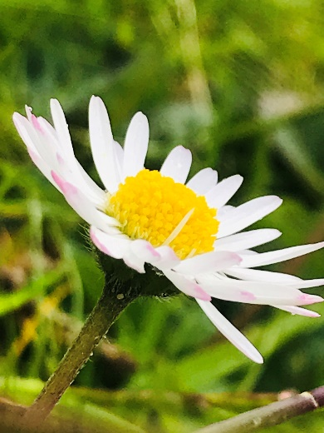

A wee jaunt up from Glasgow to visit good friends.
We have had wonderful time relaxing, collecting shells and rocks,
Beautiful, peaceful place.

Here in the woodland, dappled and still
Binkies a badger, on a hill
Tumbling, ruling, bear of the wood
Foraging, digging, stripy humbug.
Here in the woodland dark and deep
He’s humble hedgehog sound asleep
He slumbers on till the come of spring
For now his alarm not wanting to ring
Here on the woodland mossy and green
He’s sneaky stoat, seldom seen,
A flash of white or brown or grey
Is all that you will see today.
Here in the woodland, humming with birds
Scurries a squirrel, jumping in blurs
After hoarding his nuts curls up in an oak
Moss as scarf, tail as cloak

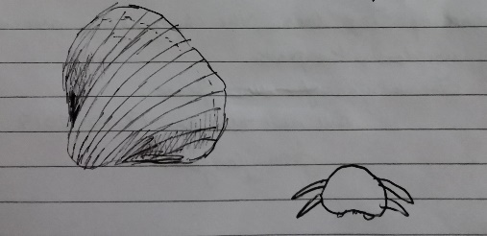

Here, thanks to a family gift for my 70th. Cannot believe we have discovered this beautiful place for the first time. As a young child my mother spent summers on a farm near Tayvallich. Loch Sween is also engraved on our family psyche. I can just visualise everyone going into swim here. This is in memory of family who have gone – especially our son, Ewan, who went too soon. This morning I saw an otter with flounder in its mouth, just outside Crinan harbour. Here’s to the falling leaves of autumn, the colours, the sun on the water, the sound of the burn, the chaffinches preceding us down the path. Thank you for this place.

The sun’s orange warmth through my closed my closed eyelids.

What a special spot, so glad to have come here.

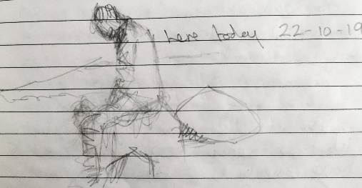

Just Think!
While you sit or have a drink, take time to really look and think, what makes this place so divine? A gem among the planted pines. We’ve overstocked the hills with sheep, the amount of deer now make me weep. When you really know our countryside, you’ll understand its wildlife genocide. You can do something to change this – you are hope!

Celebrating 38 years if wonderful marriage tomorrow. Where better to sit than here with the love of my life. Happiness is precious. If you find it with someone, keep it.

Beautiful places, with surreal surroundings.
Running water is so peaceful!
Lovely place.

Through a mist of vanities to the sea.

Suddenly I stop
And I know it’s too late
I’m lost in a forest
All alone
The girl was never there
It’s always the same
Running towards nothing
Again and again and again…

Moya and me
We came from the sea
To sit up on the spot
To sit and muse
And enjoy the views
It always fills me with glee
My doggy and me.

We could be anywhere in the world here; so much to see. The calmness of the water and the stillness of the forest is a true delight. My husband walks along the coast edge, whilst the dog stands in the middle of him and I, wondering why we are not walking together. The view and the sun are why I to stay on the Poet’s Seat – savouring the precious moment that is now.

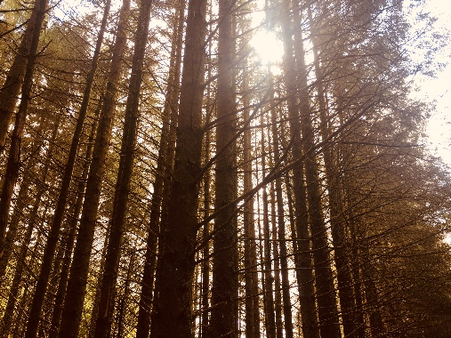

Me and Ollie under an autumny tree on a beautiful cold day. The yellow red trees make me smile. Across the sea is an island of wildlife and wonders is a beautiful sight. The waterfall is satisfying and full of wonder. The end.

We are visitors from down south – enjoying the amazing places in Scotland – so picturesque. This secret spot is one of the best!

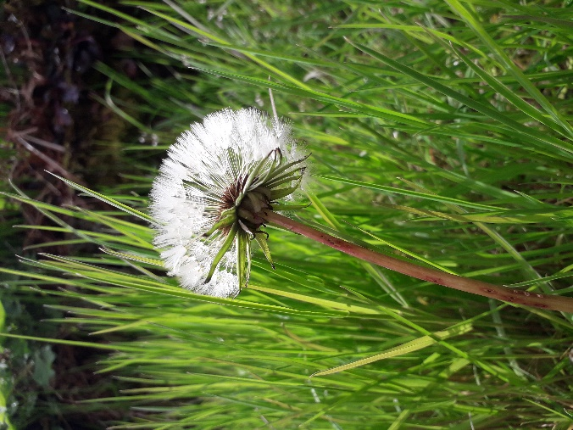

I stayed in Taynish House 52 years ago and this is my first time back. The sun is beating down and the Loch is glittering with diamonds. The sound of the water’s busy flow is creating a perfect setting. We must rejoice in this beautiful planet.

On the day England lost the Rugby World Cup Final and Brexit tangle’s seemingly endless, it’s so reassuring to know this place cares not a wit, and washes it all out into the big old ocean.

Back again, can’t keep away
If only once, we could come to stay,
Forever
In
Our
Hearts

Three gals from Fife,
Escaped the trouble and strife,
By jumping in a car,
To start a new life,
We’re down in the mill,
Starting to chill,
The wine is fine,
In the sunshine.

There was a wee seat in Argyll,
On which I parked my butt for a while,
I picked up a pen and then wondered when,
I’d be back here again.

Cold and nippy – the colours astound. Peace in a busy world just for a few minutes not even an hour. Stop and reflect nature at its best.

Amongst the wren and the bunting I wandered with intent: to admire another neuk of creation. Now history fills my mind, grinding over an imagined past as mill water gurgles in my ears. As twilight dims the golden pine, I wait. Will she? Won’t he? The elusive otter needs to eat and I, if so fortunate would be so nourished in soul should my eyes get to feast upon a sighting. So I sit and wait. No instant gratification on demand. Patience, Peace. Just being is enough.

A beautiful spot in a wonderful world. How lucky we are… I am haunted by waters.

Shake the tree
Fruit won’t always
Fall from the tree
Sometimes we need
A shake to shake to set it free
Stretch and squeeze
Jump pray
Twist and tease
Dreams won’t always
Fall at our feet
Sometimes we need
Belief to be complete
Acts of faith
In time you will see
Determine now
Go shake the tree

For Pops
Sa a coo walking doon the street
Nay a Bull BEGOD!

Beautiful walk on a gorgeous, sun-filled day. So grateful for moments like there. Take a moment to enjoy the sounds, the views, the water, the trees.

What a lovely day
For a walk along
The shore of
Loch Sween
Thanks you.

Charlotte’s first visit to Argyll age 7 months.

Cannae believe I’ve never been led down here before, all the years visiting Argyll. My brothers were remiss!

Joan has brought us a walk, stunning views, enjoying with all the family. Great place.

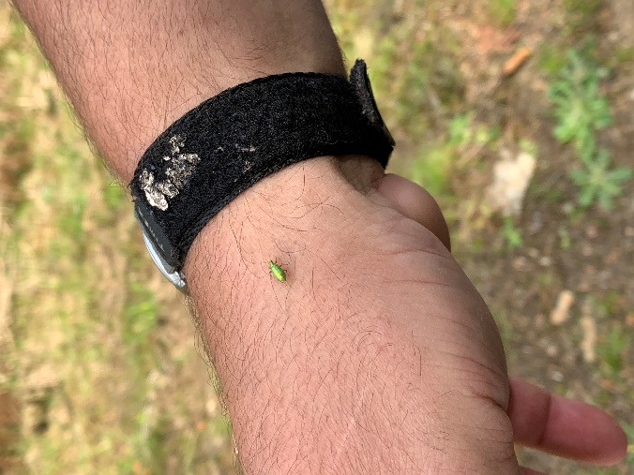

The Adventure Continues
Here we are in pink and blue
Cycling adventure like our love
Has brought us here to this beautiful place
As we gaze into the distant hills
We know our adventure has a long way to go.

Here sit six Kentish folk
Blue sky, oaks and babbling brooke
New Year friends in joy!

Sitting enjoying the view on the last day of 2019. Getting married on 2020 and can’t wait to bring in the New Year! Local to Campbelltown and Lochgilphead.

Bobbing heads, break the waves, whisken twitch, eyes brave sleek and swift catching prey
The otter surely wins the day.

What an incredibly beautiful spot to find. The tranquillity and peace are breath-taking and the sound of the flowing river gives you goose bumps. We are lucky to live in the most beautiful country that is Scotland.

Pale sun, warm and gentle
Air fragrant, heavy with moss
Buds on branches, beginning to plump, too early perhaps.
It’s only January, but the beauty abounds in the brace branches, plump moss and the ferns still resplendent. Calm water
Bliss.

So still, so calm, so silent.
Every breath further from everyday reality.
How else to say I wish to get away.

For the love ♥ of nature.
Happy Burns Day.

Here with my love
No tears with my love
By the sea
Her and me
She is enough.

Cool wind
The sound of rushing water
A yacht taking an early sail
A respite from the news
Of a spreading virus.

So happy to be here again
Enjoying brief bursts of the sun
And even the rain
I just love this place.

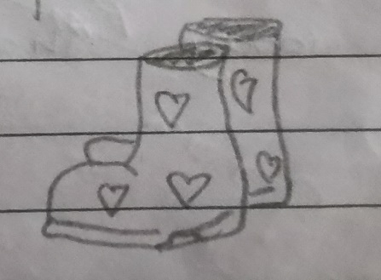

Sat here with Kevi, Pete and Paul and Fig
Hoping to see otters.

I like the rocks
I like the trees
I like the river
And I also like the sea

A place of calm amongst the
Strangeness in our world today,

Bright morning the perfect spot for Easter Sunday.

I can’t think of a better place to be on a day like this.

We went to Durham
And then Barnard Castle
But all we got was loads of hassle
So we decided to go
To somewhere we’d never been
And landed up here in lovely Loch Sween
But we couldn’t understand
A word anyone said
So we “up sticks” and went back
To London instead.

Stranger times I’ve not know
But comfort in the waves
The wind and the sky
The mist rolls in
Soon, again, it will be clear.

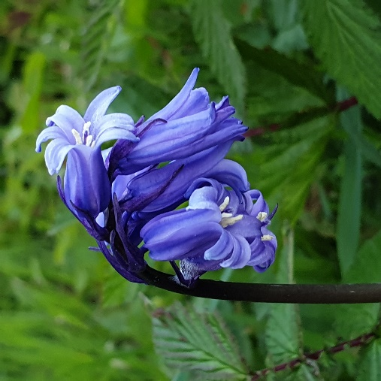

Sat on the poets seat
A 1 o’clock you’ll find
“Stress free rock”
Climb on top and forget the lot.

Grant and Sarah, survived coronavirus
Enjoyed the views and the stillness.

I live in Kllmelford and I have never been to such a lovely place. The walk is one of the most peaceful walks I’ve ever had.

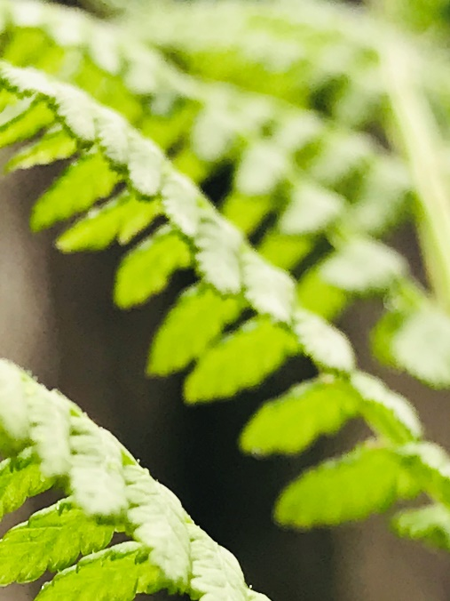

Coronavirus cancelled everyone’s lives but we enjoyed this walk.

Words can’t express the crazy and wonderful trip along and though the woods we have just had. This spot is perfect. So wonderful to be here after lockdown. ♥

Travelled from Glasgow
When the lockdown restrictions were eased.
We stayed over at Castle Sween
When we are in this wonderful part of the world.
First time doing this walk and it is so peaceful.

The water keeps moving and is never the same
But the rocks on this river never change on this lane
As children we stripped down and build up a dam
Now adults more cautious we
Hold rocks in our palm
Each pebble we place builds the jigsaw of our youth
Calm after the storm – our love builds a rooms.
We now hop on our bike and follow separate paths
Not knowing what lies ahead but there will always be laughs.
As I sit here and admire the shore
Oh how I wish I could stay forever more
When the wind blows through the green grass
Oh I wish this time would never pass.

We listen to the water rush,
As the blue sky and sun looms,
Scotland’s scenery is so lush,
And yet, people stay in their rooms.

Deeply beautiful,
The stream drifting one into a state of completely profound dreaming that one can only drift back into reality as the surreptitious sun beams dare to break through the futile clouds.
The only place keeping me sane.

Had our first walk to the mill since lockdown, hooray!

Paradise in Scotland
My favourite spot.

Splashy splishy stream
I like to skim the smooth rocks
Yeety Yeet

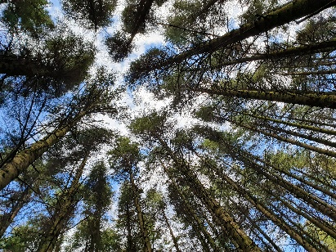
Breathe in the trees
Take in the world
Let it grow in your body
Let it flow through your mind
Let it out through your pores
Speak of it when you return home
Never forget this place.
Breathe in, breathe in….

A tree, the sea and company
A smile, a smell and all is well.

We have travelled from Flint, North Wales – rivers, lakes, mountains wildlife, we have much to admire back home. On our first family trip to Scotland we have been truly spoilt by the abundance of wildlife, views, lochs, mountains, forests and coasts to explore. This area is stunning, unspoilt, tranquil and peaceful. A beautiful spot to sit and take in all in.

Hopefully I haven’t caught covid from reading this notebook.

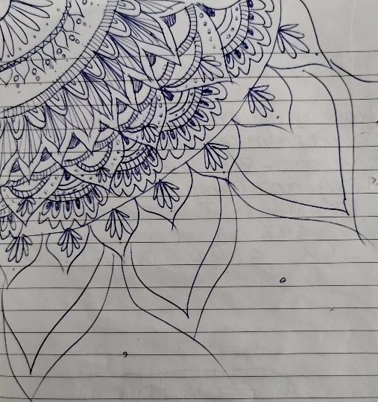

I went to Scotland – by Skye aged 6

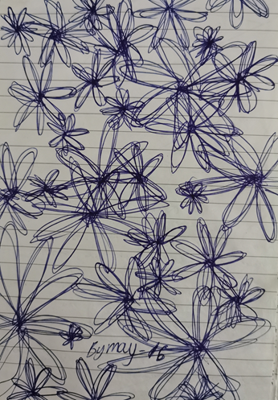
I came to Taynish with a stone in my heart
A sadness that I fear will never part
Of many happy memories gone forever
Memories I will treasure
For 30 years we have all come to Taynish
And enjoyed its peace
I can sit with my grief in this special place and still feel my father’s embrace.

Pandemic came, and all was gloom, but lockdown eased, and lifted the doom.
Fiona and I from the Wirral came and walked these paths until lame,
The Scotland that we know and love will never yield to pest or foe, and we’ll return like nature’s tides until our passing, which no one hides.

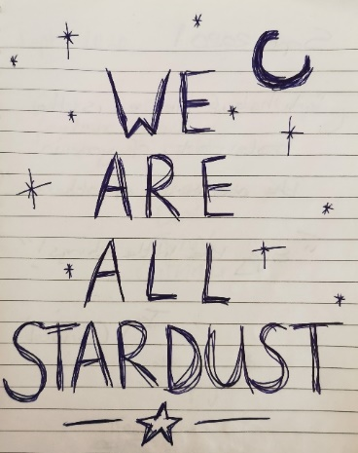

“What if Heaven is the best pasts of you in the memories of others…”

“Enjoy the little things!”

Great weather, great company, fantastic place. Wish we could retire.

We are all on the same page.

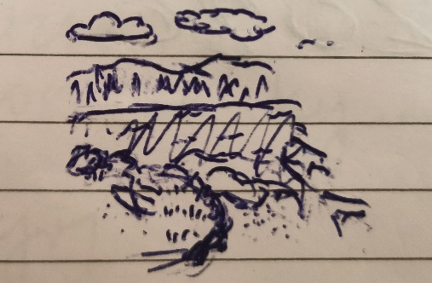

Falling in love with Scotland is so easy.

If I’ll look at everything through the magic of my heart the whole world will receive the kindness and love we need.

KCCR Picnic
listening to the murmur of the water, watching the clouds float across the sky…”

Me and my family came from Castle Sween up the loch and it is so beautiful here all the effort and hard work in this amazing we especially love the Mill it is so cool and it is so enjoyable!! Writing in this book is an honour and I hope it is to you. Enjoy the rest of your day.

I’m Anna I am 7 and I love pandas!

Beautiful
Peaceful
Tranquil
Joyful We come often to sit and ponder
The world around even yonder.
An icy day
Jack Frost at play
Taynish
An icy day
Jack Frost at play
Taynish at its best
Sit back and rest
Heavy snow clouds in the sky
With 2020 goodbye!
Sun in my face x

Great Heaven in the sky!
Flying
Bye!

Stopped here for a rest
By the forest
Is that what it means?

This place is perfect.

Here on our 26th wedding anniversary. Such a beautiful and tranquil place leaving the scary and troubled world behind for just a while.

Couple a Ayr buoys love it.

This is a place to view the world as it is truly AWSOME.

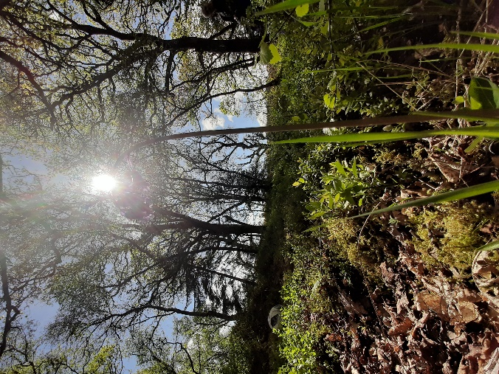

The Bellford family visited today to admire the views all the way from our exotic hometown in Lochgilphead. Sun was out between the showers. Good time had by all.

Saw a seal swimming and watching us!!

Just having a nice walk with the dogs,

I never felt magic crazy as this
I never saw moons knew the meaning of the sea
I never held emotion in the palm of my hand
Or felt sweet breezes in the top of a tree
But now you're here
Brighten my northern sky.

Seals barking
Heron watching
As the trawlers
Lays its baskets
For the days catch
Sit on the cool stone seat
And trace the ridge of the hills
Watch the water ripple and change.

Sun shimmering on the sparkling water,
Is that a seal?
No, I think it’s an otter!!

Love this place, will be back again.

There is no place in the world I would rather be than sitting here in gratitude for all that I have and that I see. The best things in life are free.

Will ye no come back again?

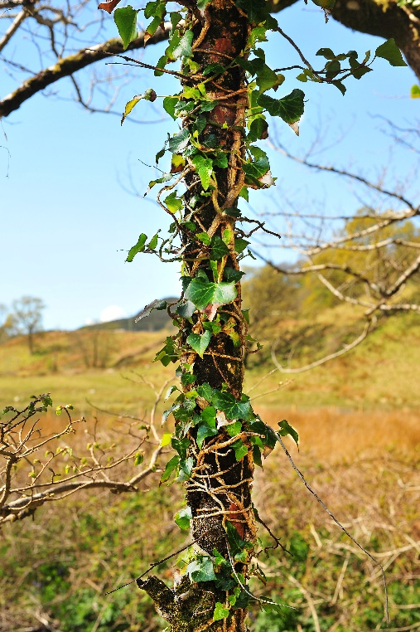

Taynish: a special place.
The gurgling burn,
Dark, brooding waters of the loch,
Autumn colours around,
The mystery of an ancient forest stillness.

I’m a builder from Dumfries, Scotland and worked for Scottish Heritage repointing the mill 10 years ago. Always said I would like to come back for a special visit so I brought my family and have enjoyed it.

Tha brougha Alba agam s’tollern non lochan agus on Mara (tha ach Gaelic beagan agam).

When I sit on the stone,
A great rocky throne
I pull off my backpack
I look out to the seas,
And plants in the breeze
And I eat my shortbread snack.

A crab is a clue
When you’re 4 or 2
Each hole is a trap
Monsters in branch snaps
“The elves told me in the middle of the night there’s elf chocolate. I talked to them Mummy. Phone them Mummy. Why does the water lead to the sea? Where is the whirlpool? How far is it? What’s that line in the water? Can I have the pen? MY PEN! Theres chocolate hidden, I’ll phone them. MY PEN!” Mummy just wants two minutes to write…

Scotland is cool full of walks, ruins, nature and more. Scotland is the place to be at holidays in October,
SO come and see.

Down for a week from Invereill,
We were so worried that a
second lockdown would stop us coming back to visit this magical place.

Skiving off from work, picked a good place to do it! Also do yourself a favour and listen to CARDIACS.

All very beautiful and peaceful. Golden Eagle over Barr Mhor.

Tranquil and amber afternoon at the Loch. Such an open quiet place. Bit of rest for intense time in the world! Down from Aberdeen to see the ancient woodland, Annabel got ambushed by an owl in the forest. Loving this seat in a beautiful nook of the world.
Awe this wae and nae chippy!

What a wonderful place to come for a picnic on Sue’s 60th Birthday!

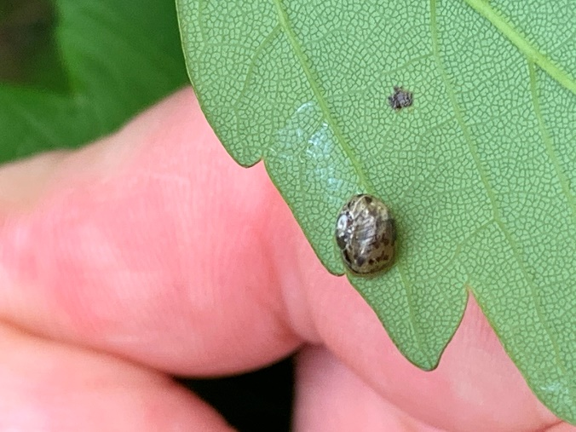

Beautiful!

There he was, a hairy man of the sea.
Dirty ragged and smelling of moss.
Not one for thinking, not of philosophy.
He checks the news on his phone and doesn’t give a TOSS!

Primary school class P1-3 visited. It was a lovely frosty morning and it was sunny. Everything was sparkling.

Beauty in the moment
The air fresh
A time for reflection
Peace in the moment
Perfection

We visited Hogmanay 2019/20 and are back to say we survived 2020.

Beauty beyond magnificent
Beauty beyond me
Scotland is a place of mystery
Come and see with me.

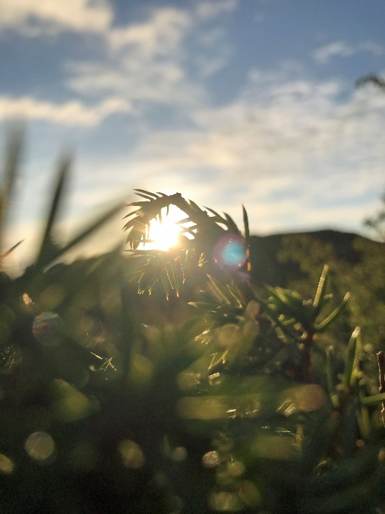

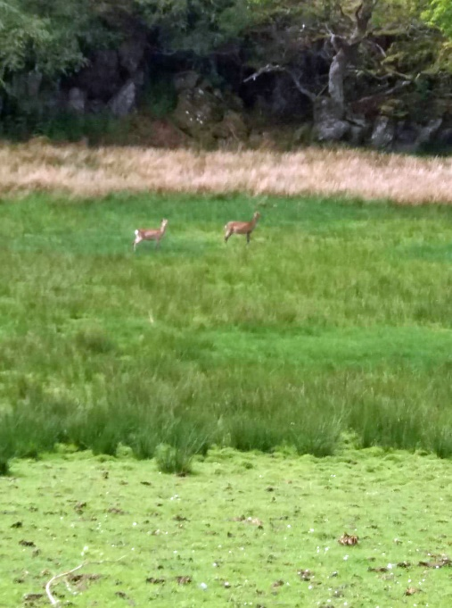

Just enjoyed a sunset dip in the Loch – chilly but beautiful. A long way from home (Cornwall) but feeling so blessed to be in this beautiful place.

Perfect peace in a crazy covid world. Thank you.

Taynish it’s always tranquil and beautiful.

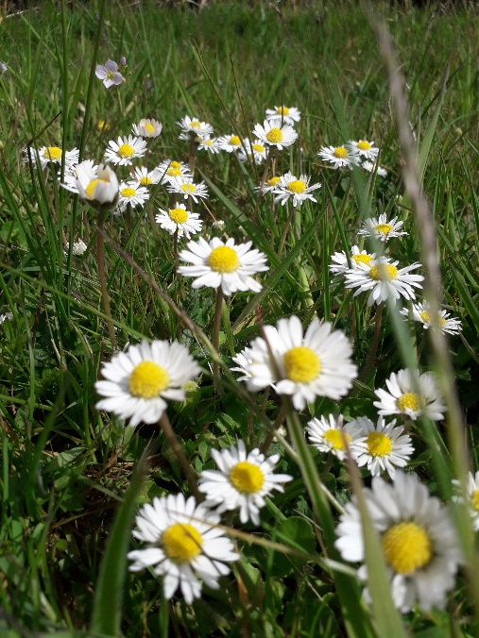

There was a young man from Australia,
Who painted his bum like a dahlia,
In colours and hues,
Of red, white and blues,
But the smell that came out was a failure.
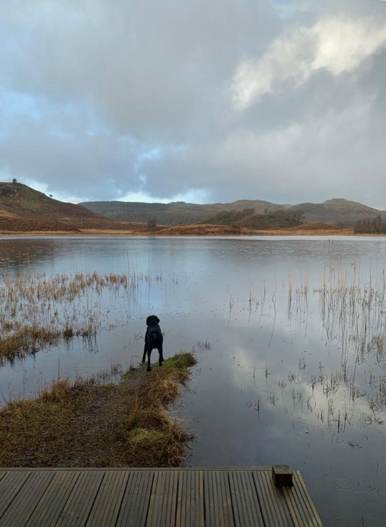

To live on in the hearts of those we love is not to die ♥

